Running title: Horseweed survey
A survey evaluating the spatial and temporal distribution of horseweed (Conyza canadensis) late season in Ohio soybean (Glycine max) fields from 2013 to 2017

Alyssa I. Essman¹, Mark M. Loux², Alexander J. Lindsey³, Bruce A. Ackley⁴, Emilie E. Regnier⁵

¹Research Associate, Department of Horticulture and Crop Science, The Ohio State University, Columbus, OH, USA; ²Professor, Department of Horticulture and Crop Science, The Ohio State University, Columbus, OH, USA; ³Assistant Professor, Department of Horticulture and Crop Science, The Ohio State University, Columbus, OH, USA; ⁴Extension Program Specialist, Department of Horticulture and Crop Science, The Ohio State University, Columbus, OH, USA; and ⁵Associate Professor, Department of Horticulture and Crop Science, The Ohio State University, Columbus, OH, USA.

Supplemental Materials

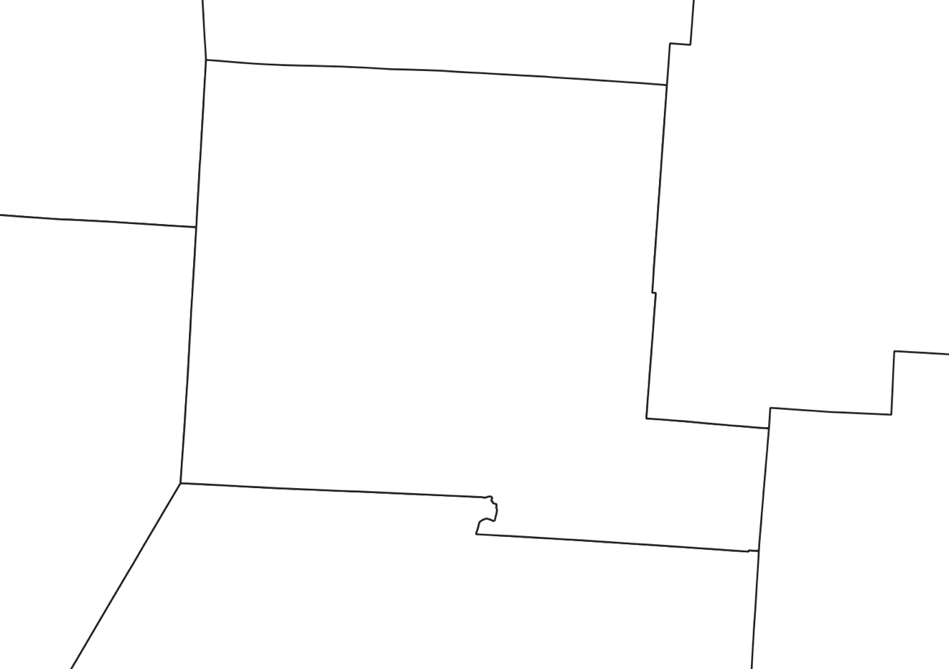
Start
Mid-point
Finish

Supplementary Figure S1. Example driving route within Pickaway County, OH illustrating diagonal transects driven in each county.

A
B

C
D

Supplementary Figure S2. Example diagram of field rating levels taken from edge of field. Large green squares represent a single field. Small green circles represent a single horseweed plant. Zero – not present (A); one – single, isolated weeds scattered in the field (B); two – clustered groups dispersed throughout the field (C); and three – dense, widespread clusters, indicative of an infestation (D).

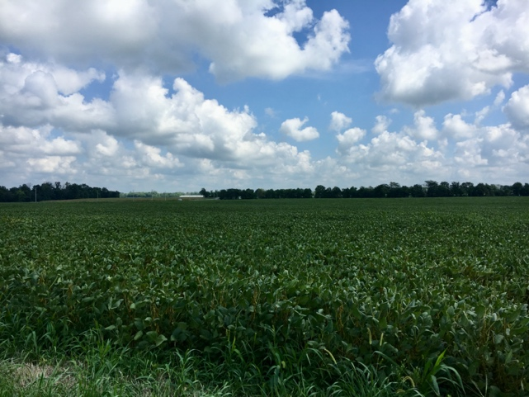
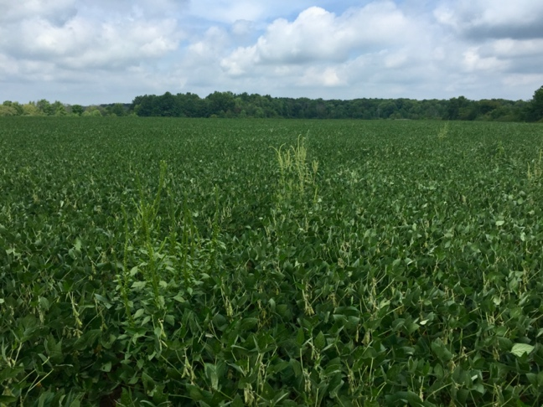
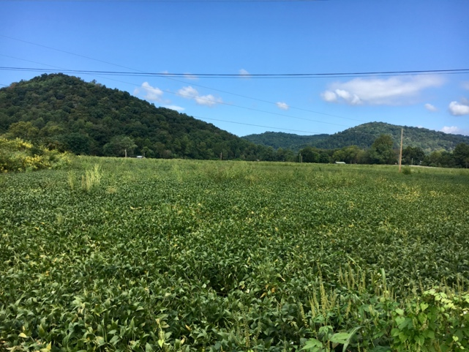
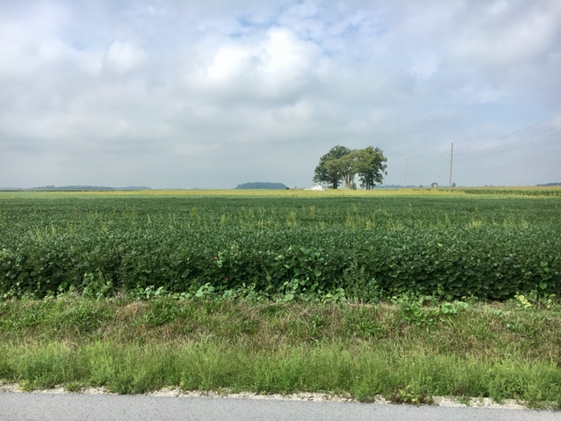
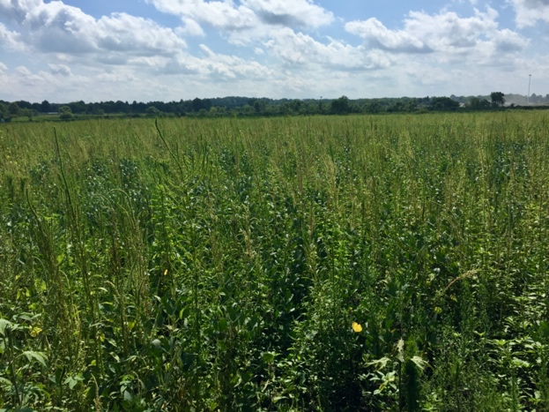
A
B
C
D
E

Supplementary Figure S3. Pictures representing rating levels. Fields with pigweeds at the various rating levels for illustration. Horseweeds were the species rated for this study. Zero – not present (A); one – single, isolated weeds scattered in the field (B); two – clustered groups dispersed throughout the field (C and D); and three – dense, widespread clusters, indicative of an infestation (E).

