Supplementary Figure S1 – Observation of regrowth in E. plana plants after 60 days of glyphosate (312g ae ha⁻¹) treatment at greenhouse (A) and field conditions (B and C). In field conditions is shown unsatisfactory control of E. plana in burndown operations using glyphosate (1,920g ae ha⁻¹) in soybean fields (Santana do Livramento, RS, Brazil).
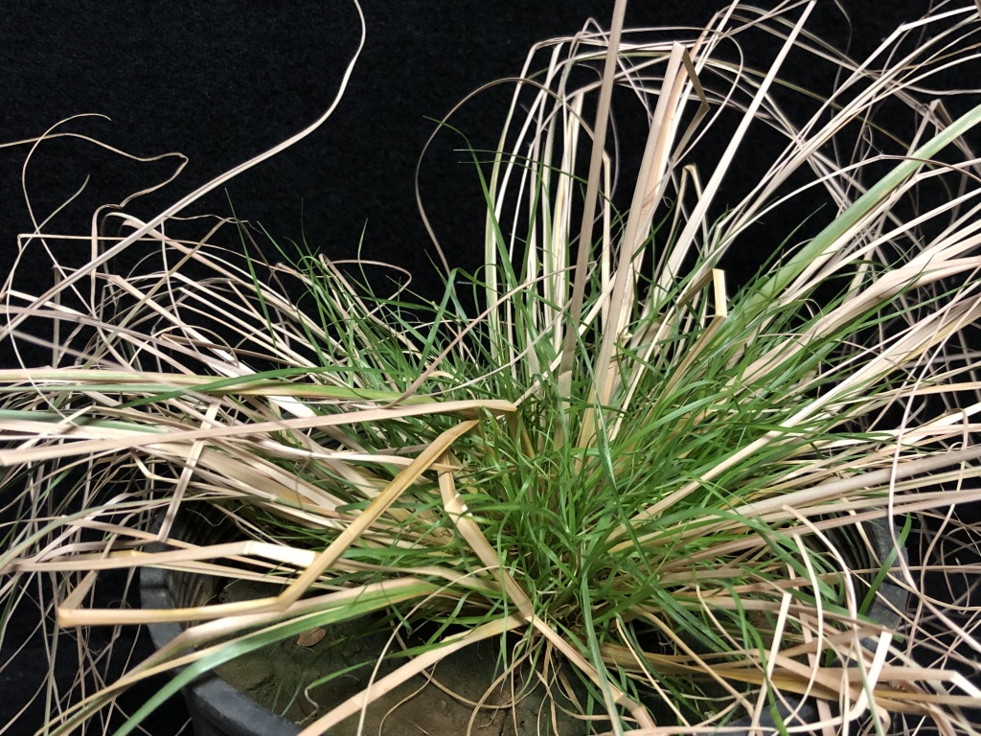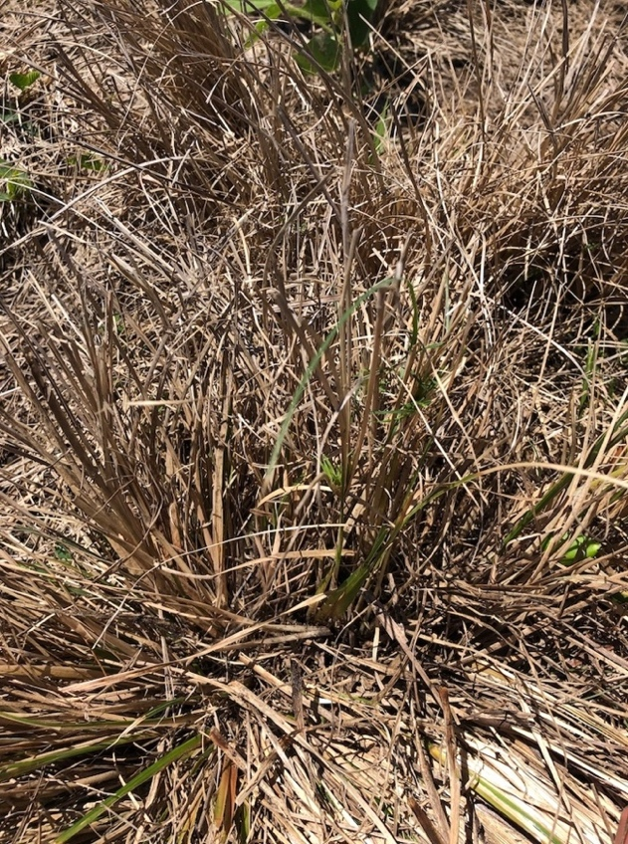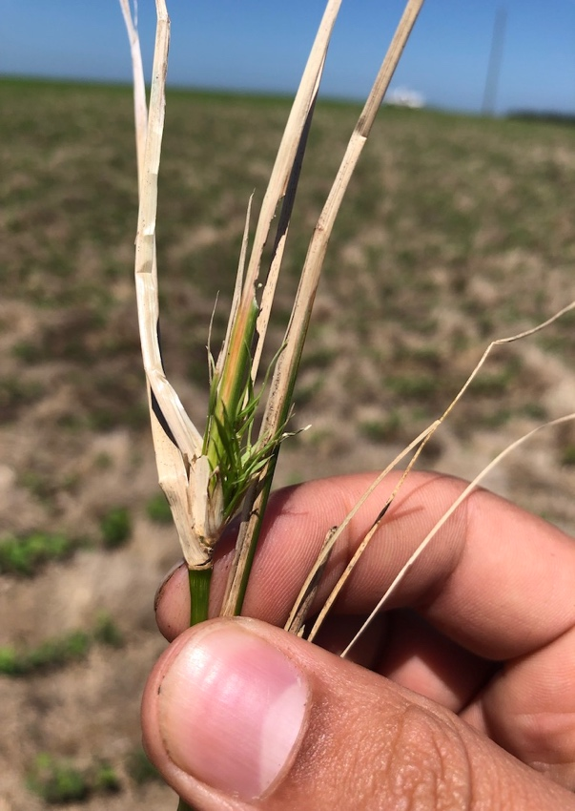
A
C
B

Supplementary Table S1– measurements of Total Dissolved Solids, Conductivity and pH of water used in spray solutions.

TDS  (ppm) | Conductivity  (uS/cm) | pH
131 | 261 | 8.16

Supplementary Table S2 – Log-logistic parameters from the dose response regression fitted to the shoot dry mass data for E. colona. Data were best described with a non-linear log–logistic, four-parameter regression, $y=c+\left\{\left(d-c\right)/\left[1+{\left(\frac{x}{e}\right)}^{b}\right]\right\}$.

Variable | Slope  (b) | Lower limit  (c) | Upper limit  (d) | GR₅₀ ª  (g ha⁻¹)
Shoot dry mass | 2.7 ± 1.9 ^{b} | 3.3 ± 1.2 | 14.3±1.8 | 48.45 ± 15.4
ª GR₅₀ – Herbicide dose that caused 50% of shoot dry mass reduction.
^{b} Standard error.

