Supplementary material
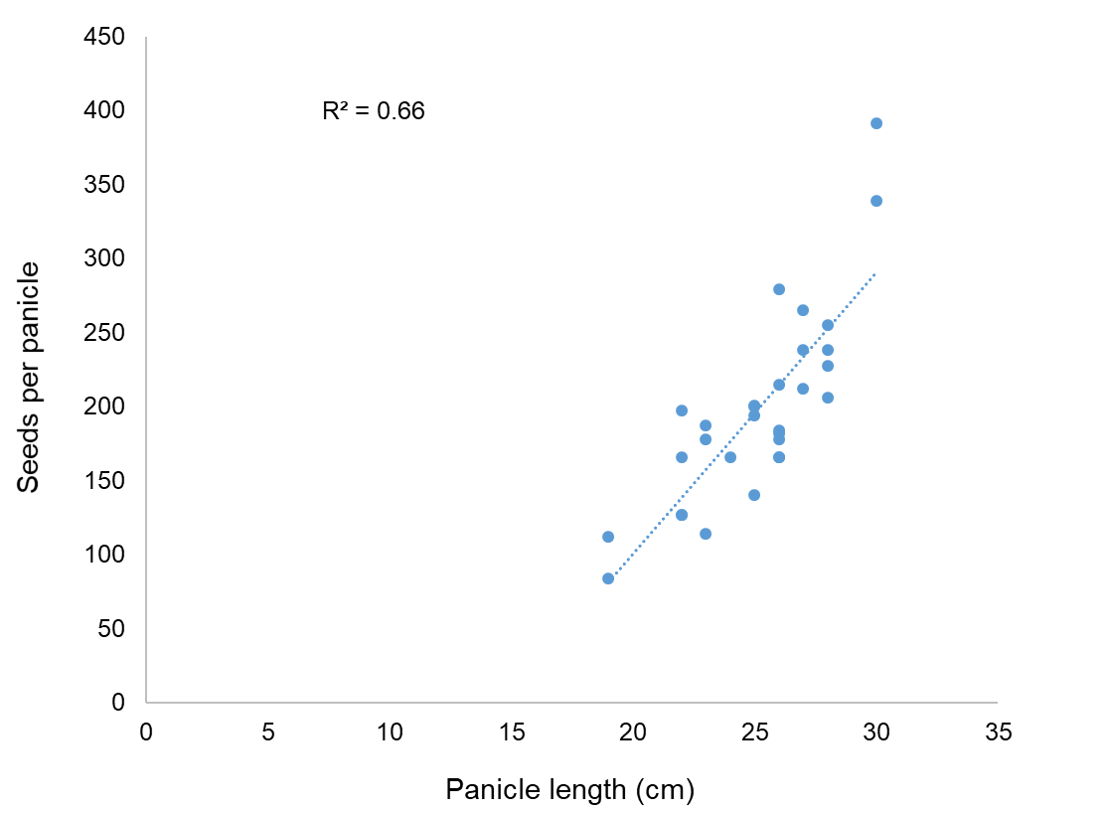
Figure 1 Relationship between seeds per panicle and panicle length for V. myuros growing with winter wheat in 2017/18 (A) and 2018/19 (B).
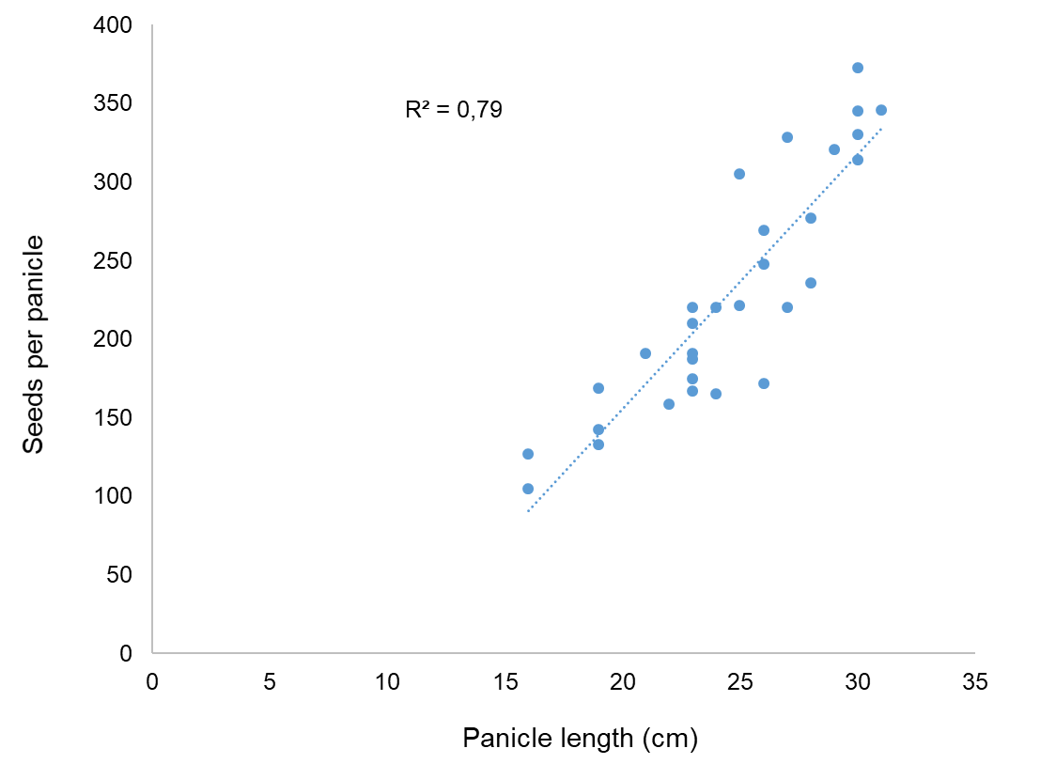
A
B

Figure 2. A dense mat of Vulpia myuros stems and panicles on winter wheat plants at grain filling (A) and maturity (B) stage.
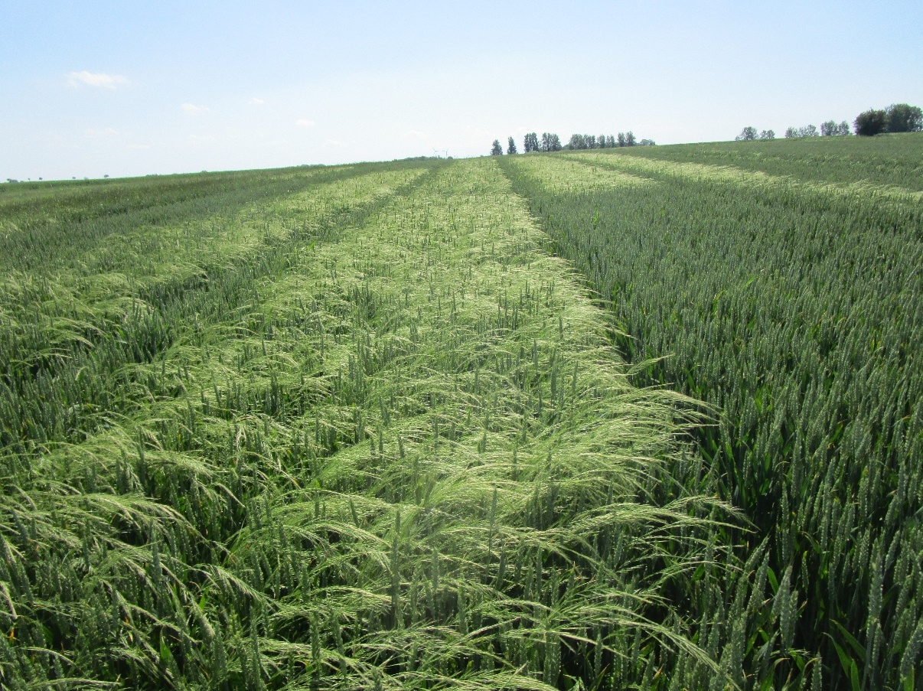
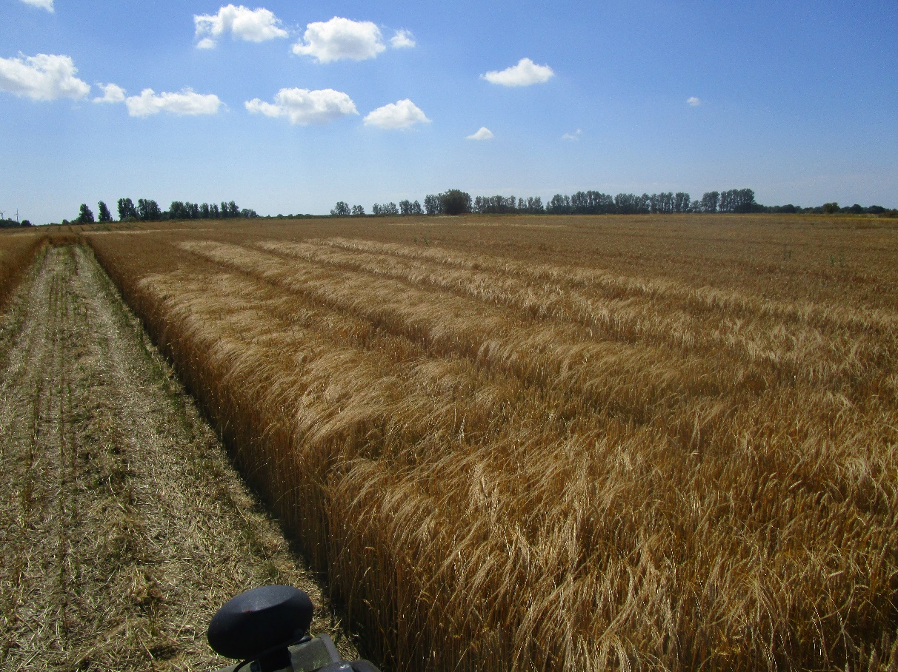
A
B

