Soybean density and Palmer amaranth (Amaranthus palmeri) establishment time: Effects on weed biology, crop yield and economic returns.
Nicholas E. Korres¹, Jason K. Norsworthy², Andy Mauromoustakos³, Martin M. Williams II⁴
¹ORISE Research Scientist, Global Change and Photosynthesis Research, USDA-ARS, 1102 S. Goodwin Ave., Urbana, IL, USA, ²Distinguished Professor, Department of Crop, Soil and Environmental Sciences, University of Arkansas, Fayetteville, AR, USA, ³Professor, Department of Crop, Soil and Environmental Sciences, Agricultural Statistics Annex, Fayetteville, AR, USA; ⁴Ecologist, Global Change and Photosynthesis Research, USDA-ARS, 1102 S. Goodwin Ave., Urbana, IL, USA.

Supplemental Table 1. Parameter estimates of the linear regression model for the effects of crop density on A. palmeri height (at harvest) in weeks after (crop) emergence (WAE) of the weed relative to soybean emergence
WAE | Intercept | Slope | Intercept Std Error | Slope Std Error | Intercept t Ratio | Slope t Ratio
0 | 142.9 | -6.1E-05 | 4.542 | 2.03E-05 | 31.456 | -2.986
1 | 125.5 | -9.8E-05 | 4.231 | 1.92E-05 | 29.664 | -5.068
2 | 103.3 | -0.00016 | 4.272 | 2E-05 | 24.184 | -7.901
4 | 55.1 | -0.0001 | 4.228 | 1.96E-05 | 13.013 | -5.223
6 | 48.0 | -9.4E-06 | 4.243 | 1.94E-05 | 11.323 | -0.484
8 | 51.1 | -3.4E-05 | 4.253 | 1.96E-05 | 12.005 | -1.742

Supplemental Table 2. Parameter estimates of the two-parameter exponential decay model for the effects of crop density on A. palmeri dry weight (at harvest) in weeks after emergence (WAE) of the weed relative to soybean emergence
WAE | Upper value | Slope | Upper value Std Error | Slope Std Error | Upper value t Ratio | Slope t Ratio
0 | 175.3 | -4.2E-06 | 9.718 | 4.92E-07 | 18.042 | -8.620
1 | 135.4 | -9.7E-06 | 9.305 | 1.54E-06 | 14.555 | -6.277
2 | 94.6 | -1.6E-05 | 9.361 | 5.06E-06 | 10.106 | -3.184
4 | 12.3 | -1.4E-05 | 9.353 | 3.15E-05 | 1.312 | -0.458
6 | 1.2 | -1.5E-06 | 8.196 | 4.04E-05 | 0.142 | -0.037
8 | 0.610934 | -1.2E-06 | 8.098 | 7.32E-05 | 0.075 | -0.016

Supplemental Table 3. Parameter estimates of the two-parameter exponential decay model for the effects of crop density on A. palmeri seed production (at harvest) in weeks after emergence (WAE) of the weed relative to soybean emergence
WAE | Upper value | Slope | Upper value Std Error | Slope Std Error | Upper value t Ratio | Slope t Ratio
0 | 352817.5 | -5.5042E-06 | 11688.823 | 3.87343E-07 | 30.184 | -14.210
1 | 248035.2 | -9.8853E-06 | 12855.638 | 1.13049E-06 | 19.294 | -8.744
2 | 236084.7 | -1.7437E-05 | 17110.988 | 3.10137E-06 | 13.798 | -5.622
4 | 1830.093 | 1.30592E-06 | 13293.131 | 2.58329E-05 | 0.138 | 0.050
6 | 543.0582 | -2.4689E-06 | 26062.138 | 0.00023618 | 0.021 | -0.010
8 | 108.5907 | 4.35036E-06 | 7952.0331 | 0.00022556 | 0.014 | 0.019

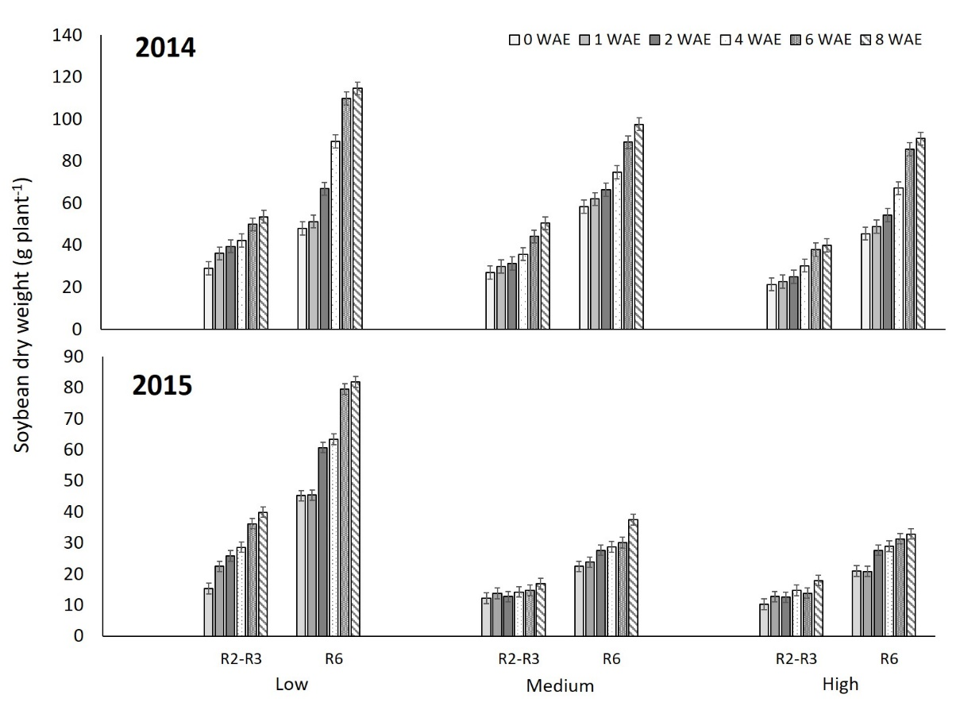
Supplemental Figure 1. Effects of A. palmeri establishment time × soybean density on soybean dry weight at R2-R3 and R6 reproductive crop growth stages. Vertical bars indicate the LSD value for mean separation between soybean densities and each reproductive stage only at P<0.05.
Average low density achieved for 2014 was 121302 plants ha⁻¹ (120311, 122292) and for 2015 was 98437 plants ha⁻¹ (96117, 100758); average medium achieved for 2014 was 242604 plants ha⁻¹ (241302, 243906) and for 2015 was 198229 plants ha⁻¹ (193724, 202735) and finally average high density achieved for 2014 was 389333 plants ha⁻¹ (386401, 392266) and for 2015 was 323167 plants ha⁻¹ (314202, 332132). Numbers in the parentheses indicated the lower and upper 95 % mean respectively.
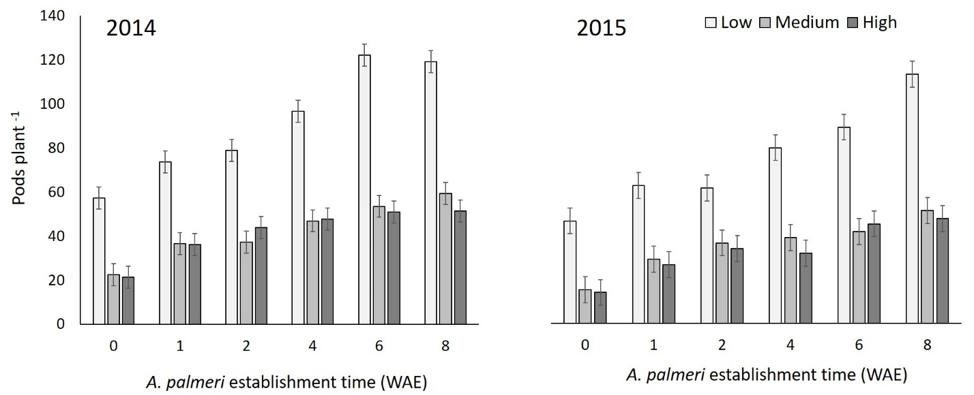
Supplemental Figure 2. Effects of A. palmeri establishment time × crop density on pod production plant⁻¹ in weeks after emergence (WAE) of the weed relative to soybean emergence. Vertical bars represent LSD values for mean separation at P<0.05.
Average low density achieved for 2014 was 121302 plants ha⁻¹ (120311, 122292) and for 2015 was 98437 plants ha⁻¹ (96117, 100758); average medium achieved for 2014 was 242604 plants ha⁻¹ (241302, 243906) and for 2015 was 198229 plants ha⁻¹ (193724, 202735) and finally average high density achieved for 2014 was 389333 plants ha⁻¹ (386401, 392266) and for 2015 was 323167 plants ha⁻¹ (314202, 332132). Numbers in the parentheses indicated the lower and upper 95 % mean respectively.

