Supplementary information
Table S1. Some information about weedy and cultivated rice.
Population | Tiller (n) | Flag-leaf  length (cm) | Flag-leaf  width (cm) | Average temperature  on the day of flowering (℃)
TZWR | 24.6A | 33.3A | 1.80A | 25.5
TZCR | 12.6B | 20.83B | 1.77A | 25
YZWR | 18.45A | 32.7A | 1.67B | 26.5
YZCR | 16.07B | 32.53A | 1.97A | 26.5
MMWR | 12.23A | 27.27A | 1.80A | 24.5
MMCR | 10.57B | 28.23A | 1.67A | 25.5
DDWR | 12.12A | 32.07B | 1.33B | 25.5
DDCR | 8.82B | 24.23A | 2.23A | 24

Different capital letters in columns indicate statistically significant differences between the weedy rice and associated cultivated rice accessions.

Table S2. Comparison of plant traits between weedy and cultivated rice accessions
Population | Plant height, cm | Panicle length, cm | 1000-grain weight, g | Seed setting rate (%) | Yield/ plant | Shattering rate (%)
TZWR | 86.93A | 23.97A | 22.90B | 81.15B | 42.60A | 35.86A
TZCR | 89.93A | 14.45B | 25.65A | 98.66A | 33.49B | 0.49B
YZWR | 85.53B | 21.74B | 22.83B | 88.41B | 23.71B | 31.23A
YZCR | 108.53A | 28.95A | 26.78A | 92.70A | 43.42A | 19.89B
MMWR | 166.97A | 28.50A | 21.29B | 93.60A | 41.16A | 41.69A
MMCR | 97.64B | 24.00B | 25.02A | 92.10A | 37.34A | 24.74B
DDWR | 105.53A | 18.66A | 21.49B | 91.85B | 25.14A | 49.25A
DDCR | 98.20B | 19.86A | 25.49A | 97.85A | 28.73A | 0.33B
Different capital letters in columns indicate statistically significant differences between the weedy rice and associated cultivated rice accessions.

Table S3. Phenological period of the experimental weedy and cultivated rice accessions used in the experiments

Population | Flowering date | Maturity date | Grain-filling  period (days) | Growth period  (days)
TZWR | 2015-8-27 | 2015-10-5 | 39 | 132
TZCR | 2015-9-7 | 2015-11-1 | 55 | 159
YZWR | 2015-8-28 | 2015-10-2 | 35 | 129
YZCR | 2015-8-30 | 2015-10-18 | 49 | 145
MMWR | 2015-8-24 | 2015-10-2 | 39 | 129
MMCR | 2015-8-27 | 2015-10-11 | 45 | 138
DDWR | 2015-7-24 | 2015-9-3 | 41 | 100
DDCR | 2015-8-20 | 2015-10-12 | 53 | 139

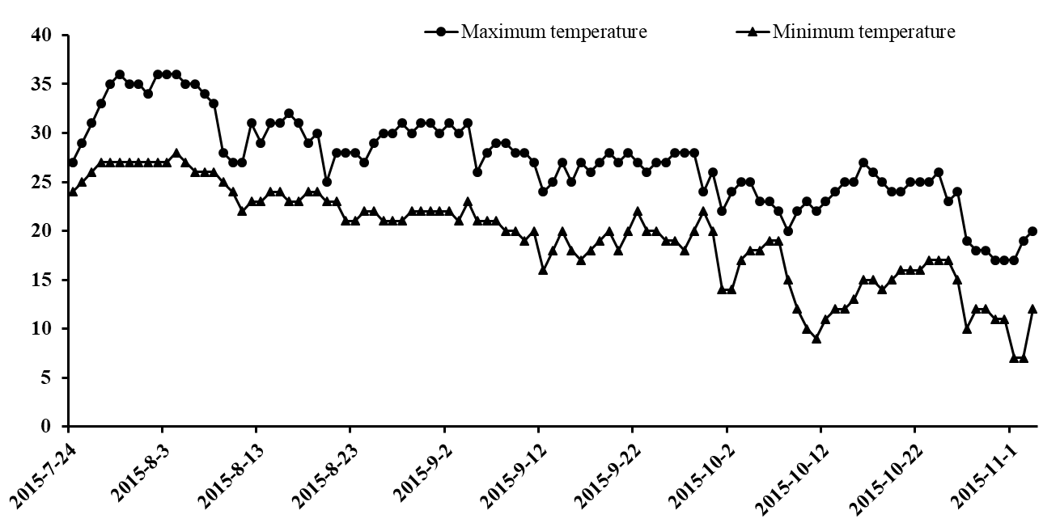

Fig. S1. The maximum and minimum temperature per day from flowering to maturity of weedy and cultivated rice in 2015 at Nanjing (from July 24 to November 2).

