Supplementary Material
Supplementary Figures
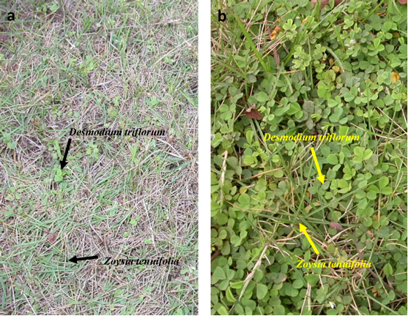
Supplementary Figure S1. Photos of the Desmodium triflorum - Zoysia tenuifolia symbiotic system showing a low coverage level (a) and a high coverage level (b) of Desmodium triflorum in the lawn.

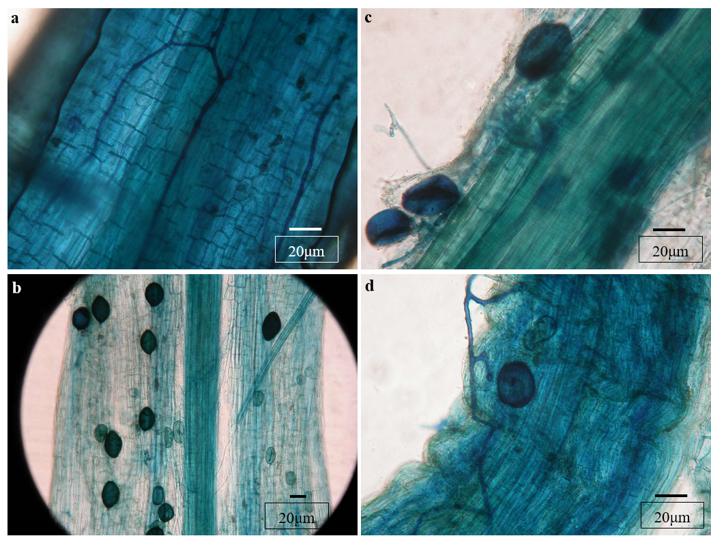
Supplementary Figure S2. Hyphal and vesicular structures in the roots of Zoysia tenuifolia (a, c) and Desmodium triflorum (b, d).

Supplementary Tables
Supplementary Table S1. Summary of the latin name, family name and genus name of the weeds in the lawn.
N_{O}. | Latin Name | Family | Genus
1 | Phyllanthus urinaria L. | Euphorbiaceae | Phyllanthus
2 | Cassia mimosoides L. | Fabaceae | Cassia
3 | Desmodium triflorum (L.) DC. | Fabaceae | Desmodium
4 | Alysicarpus vaginalis (L.) DC. | Fabaceae | Alysicarpus
5 | Lygodium scandens (L.)Sw | Lygodiaceae | Lygodium
6 | Imperata cylindrica (L.) P. Beauv. | Poaceae | Imperata
7 | Axonopus compressus (Sw.) P. Beauv. | Poaceae | Axonopus
8 | Cynodon dactylon (L.) Pers. | Poaceae | Cynodon
9 | Digitaria radicosa (J. Presl) Miq. | Poaceae | Digitaria
10 | Sacciolepis indica (L.) Chase | Poaceae | Sacciolepis
11 | Paspalum orbiculare L. | Poaceae | Paspalum
12 | Ageratum conyzoides L. | Asteraceae | Ageratum
13 | Conyza canadensis (L.) Cronquist | Asteraceae | Conyza
14 | Vemonia cinerea (L.) Less. | Asteraceae | Vemonia
15 | Emilia sonchifolia (L.) DC. | Asteraceae | Emilia
16 | Tridax procumbens L. | Asteraceae | Tridax
17 | Aster subulatus Michx. | Asteraceae | Aster
18 | Ophioglossum vulgatum L. | Ophioglossaceae | Ophioglossum
19 | Hedyotis corymbosa L. | Rubiaceae | Hedyotis
20 | Centella asiatica (L.) Urb. | Apiaceae | Centella
21 | Hydrocotyle sibthorpioides Lam. | Apiaceae | Hydrocotyle
22 | Fimbristylis gracilenta Hance | Cyperaceae | Fimbristylis
23 | Fimbristylis schoenoides (Retz.) Vahl | Cyperaceae | Fimbristylis
24 | Cyperus rotundus L. | Cyperaceae | Cyperus
25 | Kyllinga brevifolia Rottb | Cyperaceae | Kyllinga
26 | Alternanthera sessilis (L.) R. Br. ex DC. | Amaranthaceae | Alternanthera
27 | Lindernia anagallis (Burm. F.) Pennell | Scrophulariaceae | Lindernia

Supplementary Table S2. Pearson correlations among the root mycorrhizal colonizations, AM fungal spore densities and soil properties in different coverage levels of Desmodium triflorum. pH: soil pH; EC: electrical conductivity; TOC: total organic C; AP: available phosphorus; TP: total phosphorus; AN: available nitrogen; TN: total nitrogen. ZTC, ZHC and ZVC indicate the total colonization, hyphal colonization and vesicular colonization of Zoysia tenuifolia, respectively. DTC, DHC and DVC indicate the total colonization, hyphal colonization and vesicular colonization of Desmodium triflorum, respectively. SD: AM fungal spore density. The table shows the correlation coefficients, while *, ** and *** indicate the correlation is significant at p < 0.05, p < 0.01 and p < 0.001 levels, respectively. The minus sign indicates a negative correlation.
 |  | pH | EC | TOC | AP | TP | AN | TN | JHC | JVC | JTC | SHC | SVC | STC | SD
Level-1 | pH | 1 | -0.377 | -0.301 | 0.455* | -0.065 | 0.469* | -0.172 | -0.207 | -0.130 | -0.214 | -0.210 | -0.290 | -0.372 | -0.387
 | EC |  | 1 | 0.153 | 0.142 | 0.257 | 0.006 | 0.307 | 0.171 | 0.127 | 0.135 | 0.062 | 0.007 | 0.138 | 0.122
 | TOC |  |  | 1 | 0.069 | 0.590** | 0.370 | 0.701** | -0.376 | -0.345 | -0.371 | -0.220 | -0.211 | -0.155 | -0.071
 | AP |  |  |  | 1 | 0.445* | 0.614** | 0.432 | 0.002 | 0.036 | 0.026 | -0.039 | -0.259 | -0.087 | -0.206
 | TP |  |  |  |  | 1 | 0.447* | 0.833** | -0.029 | -0.037 | -0.041 | -0.161 | -0.222 | -0.095 | 0.244
 | AN |  |  |  |  |  | 1 | 0.483* | -0.440 | -0.431 | -0.465* | -0.222 | -0.270 | -0.249 | -0.336
 | TN |  |  |  |  |  |  | 1 | -0.032 | 0.001 | -0.045 | -0.296 | -0.229 | -0.173 | 0.257
 | JHC |  |  |  |  |  |  |  | 1 | 0.965** | 0.979** | 0.499* | 0.355 | 0.418 | 0.603**
 | JVC |  |  |  |  |  |  |  |  | 1 | 0.975** | 0.468* | 0.334 | 0.382 | 0.608**
 | JTC |  |  |  |  |  |  |  |  |  | 1 | 0.492* | 0.350 | 0.412 | 0.593**
 | SHC |  |  |  |  |  |  |  |  |  |  | 1 | 0.782** | 0.934** | 0.147
 | SVC |  |  |  |  |  |  |  |  |  |  |  | 1 | 0.900** | 0.159
 | STC |  |  |  |  |  |  |  |  |  |  |  |  | 1 | 0.204
 | SD |  |  |  |  |  |  |  |  |  |  |  |  |  | 1
Level-2 | pH | 1 | -0.385 | -0.340 | 0.243 | -0.558* | -0.007 | -0.414 | -0.185 | -0.417 | -0.274 | -0.400 | -0.303 | -0.442 | -0.571**
 | EC |  | 1 | 0.451* | 0.470* | 0.539* | 0.018 | 0.712** | 0.211 | 0.216 | 0.264 | 0.389 | 0.558* | 0.508* | 0.149
 | TOC |  |  | 1 | 0.289 | 0.611** | -0.066 | 0.654** | 0.009 | -0.037 | 0.013 | 0.381 | 0.144 | 0.344 | 0.331
 | AP |  |  |  | 1 | 0.193 | -0.018 | 0.418 | -0.295 | -0.146 | -0.280 | -0.173 | -0.085 | -0.188 | -0.157
 | TP |  |  |  |  | 1 | 0.312 | 0.854** | 0.110 | 0.098 | 0.168 | 0.436 | 0.256 | 0.404 | 0.392
 | AN |  |  |  |  |  | 1 | 0.212 | 0.438 | 0.173 | 0.431 | 0.388 | 0.291 | 0.343 | 0.272
 | TN |  |  |  |  |  |  | 1 | 0.177 | 0.140 | 0.232 | 0.413 | 0.484* | 0.487* | 0.352
 | JHC |  |  |  |  |  |  |  | 1 | 0.623** | 0.990** | 0.614** | 0.476* | 0.611** | -0.027
 | JVC |  |  |  |  |  |  |  |  | 1 | 0.686** | 0.292 | 0.382 | 0.355 | -0.028
 | JTC |  |  |  |  |  |  |  |  |  | 1 | 0.606** | 0.508* | 0.622** | 0.003
 | SHC |  |  |  |  |  |  |  |  |  |  | 1 | 0.656** | 0.935** | 0.208
 | SVC |  |  |  |  |  |  |  |  |  |  |  | 1 | 0.860** | 0.191
 | STC |  |  |  |  |  |  |  |  |  |  |  |  | 1 | 0.276
 | SD |  |  |  |  |  |  |  |  |  |  |  |  |  | 1
Level-3 | pH | 1 | -0.158 | -0.248 | 0.320 | -0.227 | -0.069 | -0.332 | 0.002 | -0.388 | -0.142 | -0.132 | -0.032 | -0.166 | -0.619**
 | EC |  | 1 | 0.082 | 0.339 | 0.108 | -0.321 | 0.503* | -0.323 | -0.163 | -0.292 | -0.116 | 0.041 | -0.052 | -0.024
 | TOC |  |  | 1 | -0.145 | 0.303 | 0.314 | 0.545* | 0.373 | 0.265 | 0.413 | 0.158 | 0.076 | 0.154 | 0.354
 | AP |  |  |  | 1 | 0.280 | -0.023 | 0.241 | -0.309 | -0.303 | -0.309 | -0.071 | -0.022 | -0.059 | -0.109
 | TP |  |  |  |  | 1 | 0.005 | 0.631** | -0.292 | 0.095 | -0.183 | -0.122 | -0.161 | -0.116 | 0.388
 | AN |  |  |  |  |  | 1 | -0.012 | 0.468* | 0.171 | 0.488* | 0.346 | 0.262 | 0.357 | 0.107
 | TN |  |  |  |  |  |  | 1 | -0.210 | 0.091 | -0.124 | 0.050 | 0.083 | 0.071 | 0.499*
 | JHC |  |  |  |  |  |  |  | 1 | 0.459* | 0.972** | 0.594** | 0.437 | 0.585** | -0.164
 | JVC |  |  |  |  |  |  |  |  | 1 | 0.614** | 0.114 | 0.044 | 0.088 | 0.212
 | JTC |  |  |  |  |  |  |  |  |  | 1 | 0.535* | 0.385 | 0.530* | -0.055
 | SHC |  |  |  |  |  |  |  |  |  |  | 1 | 0.781** | 0.986** | -0.153
 | SVC |  |  |  |  |  |  |  |  |  |  |  | 1 | 0.840** | -0.244
 | STC |  |  |  |  |  |  |  |  |  |  |  |  | 1 | -0.147
 | SD |  |  |  |  |  |  |  |  |  |  |  |  |  | 1
Level-4 | pH | 1 | -0.260 | -0.155 | 0.399 | 0.118 | -0.049 | -0.167 | 0.063 | -0.117 | -0.037 | -0.020 | -0.179 | -0.100 | -0.713**
 | EC |  | 1 | 0.579** | 0.385 | 0.382 | 0.346 | 0.470* | 0.371 | 0.445* | 0.391 | 0.333 | 0.479* | 0.404 | 0.301
 | TOC |  |  | 1 | 0.127 | 0.554* | 0.232 | 0.531* | 0.291 | 0.299 | 0.272 | 0.287 | 0.468* | 0.328 | 0.376
 | AP |  |  |  | 1 | 0.568** | 0.476* | 0.229 | 0.305 | 0.205 | 0.291 | 0.216 | 0.219 | 0.234 | -0.281
 | TP |  |  |  |  | 1 | 0.370 | 0.556* | 0.408 | 0.464* | 0.430 | 0.476* | 0.402 | 0.509* | 0.339
 | AN |  |  |  |  |  | 1 | 0.504* | 0.284 | 0.207 | 0.282 | 0.032 | 0.134 | 0.050 | 0.222
 | TN |  |  |  |  |  |  | 1 | 0.406 | 0.468* | 0.464* | 0.212 | 0.346 | 0.253 | 0.508*
 | JHC |  |  |  |  |  |  |  | 1 | 0.876** | 0.980** | 0.696** | 0.682** | 0.685** | 0.215
 | JVC |  |  |  |  |  |  |  |  | 1 | 0.933** | 0.625** | 0.644** | 0.658** | 0.404
 | JTC |  |  |  |  |  |  |  |  |  | 1 | 0.656** | 0.656** | 0.666** | 0.290
 | SHC |  |  |  |  |  |  |  |  |  |  | 1 | 0.839** | 0.984** | 0.385
 | SVC |  |  |  |  |  |  |  |  |  |  |  | 1 | 0.869** | 0.394
 | STC |  |  |  |  |  |  |  |  |  |  |  |  | 1 | 0.449*
 | SD |  |  |  |  |  |  |  |  |  |  |  |  |  | 1
Level-5 | pH | 1 | 0.025 | -0.335 | -0.058 | -0.203 | -0.406 | -0.296 | -0.050 | -0.022 | -0.040 | -0.629** | -0.444* | -0.638** | -0.501*
 | EC |  | 1 | 0.544* | -0.033 | 0.067 | 0.739** | 0.282 | 0.424 | 0.203 | 0.408 | .451* | 0.381 | 0.450* | .188
 | TOC |  |  | 1 | 0.214 | 0.362 | 0.622** | 0.453 | 0.494* | 0.207 | 0.422 | 0.544* | 0.420 | 0.531* | .285
 | AP |  |  |  | 1 | 0.354 | 0.109 | 0.379 | -0.129 | -0.253 | -0.200 | 0.109 | -0.086 | 0.075 | -.126
 | TP |  |  |  |  | 1 | -0.033 | 0.441 | -0.071 | -0.217 | -0.135 | -0.009 | -0.172 | -0.037 | .040
 | AN |  |  |  |  |  | 1 | 0.504* | 0.512* | 0.371 | 0.503* | 0.707** | 0.721** | 0.750** | 0.487*
 | TN |  |  |  |  |  |  | 1 | 0.308 | 0.095 | 0.245 | 0.405 | 0.309 | 0.430 | -.054
 | JHC |  |  |  |  |  |  |  | 1 | 0.801** | 0.990** | 0.685** | 0.651** | 0.677** | .365
 | JVC |  |  |  |  |  |  |  |  | 1 | 0.867** | 0.458* | 0.513* | 0.488* | 0.522*
 | JTC |  |  |  |  |  |  |  |  |  | 1 | 0.659** | 0.655** | 0.660** | .416
 | SHC |  |  |  |  |  |  |  |  |  |  | 1 | 0.698** | 0.969** | 0.493*
 | SVC |  |  |  |  |  |  |  |  |  |  |  | 1 | 0.797** | 0.498*
 | STC |  |  |  |  |  |  |  |  |  |  |  |  | 1 | 0.571**
 | SD |  |  |  |  |  |  |  |  |  |  |  |  |  | 1

Supplementary Table S3. Relative abundance of fungal phylum in the fungi community of soils from different coverage levels of Desmodium triflorum.
Fungal phylum | D. triflorum spread level
/Relative abundance (%) | level-1 | level-2 | level-3 | level-4 | level-5
Ascomycota | 68.99 | 88.35 | 32.12 | 51.00 | 57.62
Basidiomycota | 22.71 | 5.61 | 12.63 | 9.92 | 35.37
Glomeromycota | 0.38 | 1.55 | 0.79 | 0.61 | 0.48
Zygomycota | 1.90 | 0.03 | 0.11 | 0.13 | 0.12
unidentified | 4.22 | 3.98 | 4.60 | 4.78 | 3.78
Others | 1.79 | 0.47 | 49.75 | 33.56 | 2.63

