Supplementary Information
Supplementary Table 1. Resistant species, herbicide applications made to corn, soybean, cotton, rice, and wheat between 1990 and 2015, and resistant species per million herbicide applications for each herbicide site of action (listed by Weed Science Society of America group number). Resistant species data from Heap (2017). Herbicide applications estimated from USDA-NASS (2017).
WSSA group | Resistant species | Estimated herbicide applications (millions) | Resistant species per million herbicide applications
1 | 15 | 395 | 0.0380
2 | 51 | 1920 | 0.0266
3 | 6 | 600 | 0.0100
4 | 10 | 1693 | 0.0059
5 | 27 | 1618 | 0.0167
6 | 1 | 310 | 0.0032
7 | 9 | 190 | 0.0474
8 | 4 | 74 | 0.0541
9 | 17 | 3037 | 0.0056
10 | 1 | 50 | 0.0200
11 | 1 | 18 | 0.0556
12 | 1 | 51 | 0.0196
14 | 4 | 478 | 0.0084
15 | 1 | 1296 | 0.0008
16 | 1 | 53 | 0.0189
17 | 1 | 46 | 0.0217
22 | 5 | 48 | 0.1042
26 | 1 | 11 | 0.0909
27 | 3 | 335 | 0.0090

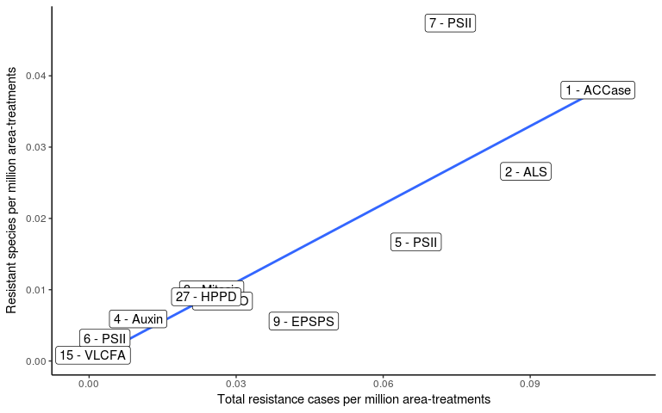
Supplementary Figure 1. Relationship between all reported herbicide resistance cases (Y-axis) and number of herbicide-resistant species (X-axis) in the United States. Herbicide sites of action with at least 100 million applications on corn, soybean, cotton, rice, or wheat between 1990 and 2015 are included (Pearson's correlation coefficient = 0.85, P = 0.001). Resistance data assembled from Heap (2017) and herbicide use data estimated from USDA-NASS (2017).

