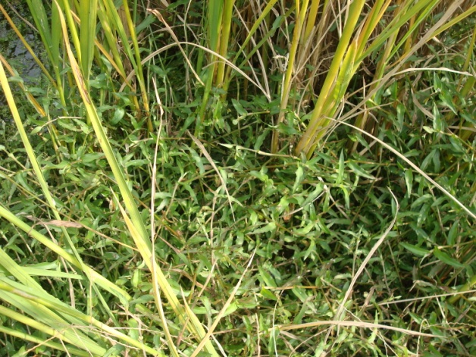
Figure 1. Triquetrous murdannia in rice field. Photographed by Wei Tang, October, 2014.
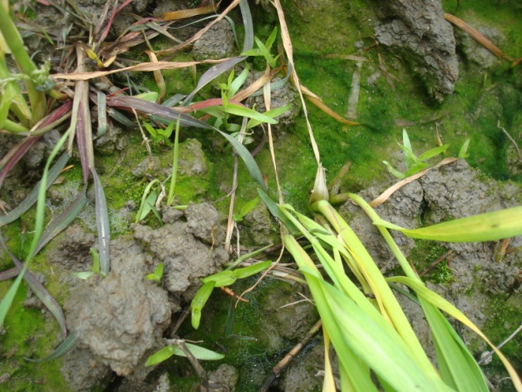
Figure 2. Emergence of triquetrous murdannia in the field. Photographed by Wei Tang, March, 2015.
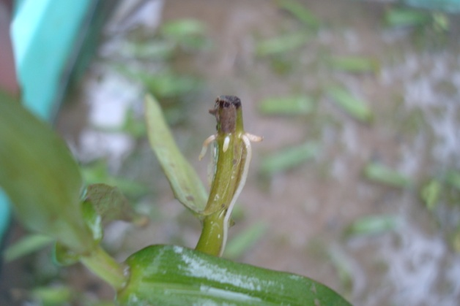
Figure 3. A stem fragment of triquetrous murdannia developed new roots and survived in paddy soil. Photographed by Wei Tang, April, 2015.

