Supplementary Material

Marine Corrections
The contribution of marine protein in the diet was calculated using δ¹³C values, following the methodology laid out by Jarman et al 2018. The following formula was applied, using a value of -21.0‰ for a fully terrestrial diet (δ¹³C_{terr}), and -12.5‰ for a fully marine diet (δ¹³C_{mar}):
$f_{m=}\frac{δ^{13}C_{n}-δ^{13}C_{terr}}{δ^{13}C_{mar}-δ^{13}C_{terr}}$
A standardized error of ±10% was used. In R, mixed curves were created using

KDE Models without marine correction
Overall, there is very little difference between the KDE models where marine corrections were applied, and those where they were not.
The most notable differences come in the fourth century. The models for all furnished burials, male burials both furnished and unfurnished, furnished burials in the north and west, isolated burials, and small groups of burials, are all higher in the fourth century when marine corrections are not applied. The affect of correcting for marine shifts some of those fourth century dates later, resulting in steeper increases in the fifth century where relevant, or less pronounced troughs in the fifth century.
Subtler patterns are also affected; the notable dip in unfurnished burial around 600AD is not visible without the marine corrections, and for female furnished burial, the decline across the seventh century is sharper without marine corrections.
Perhaps the most notable differences when marine corrections are not applied is the richly furnished burials. Here, richly furnished burials notably peak around 600AD, and decline across the seventh century, showing no persistence into the eighth century. Given that this was the smallest sample, with correspondingly large error ranges, it is not surprising that it is the most vulnerable to change. It is also worth noting that nearly all of the richly furnished burials have reliable δ¹³C values.
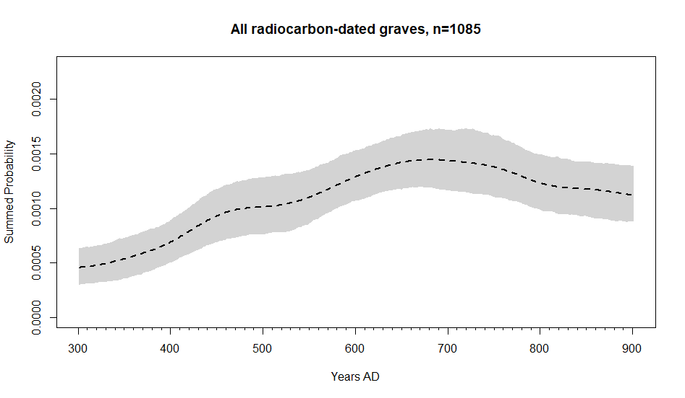
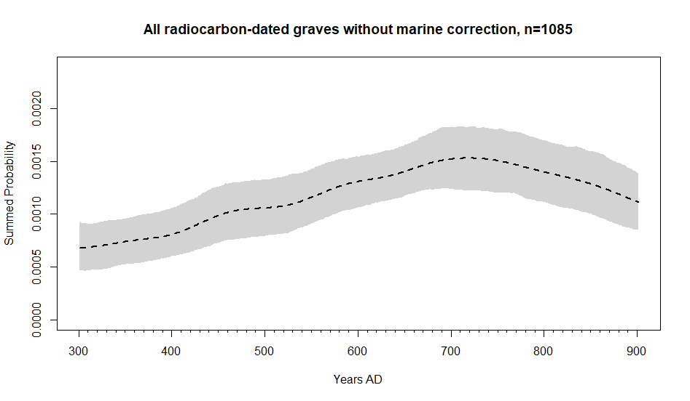
Figure S1: KDE of all radiocarbon dated burials with and without marine reservoir.
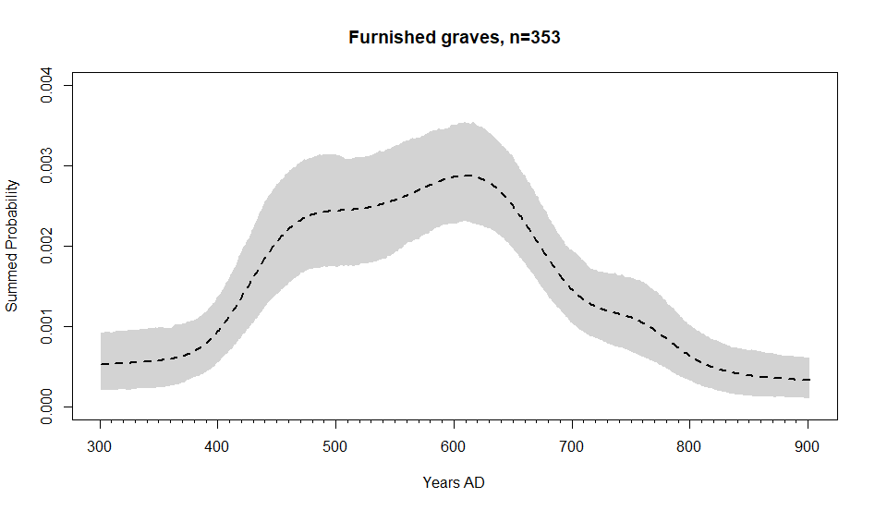

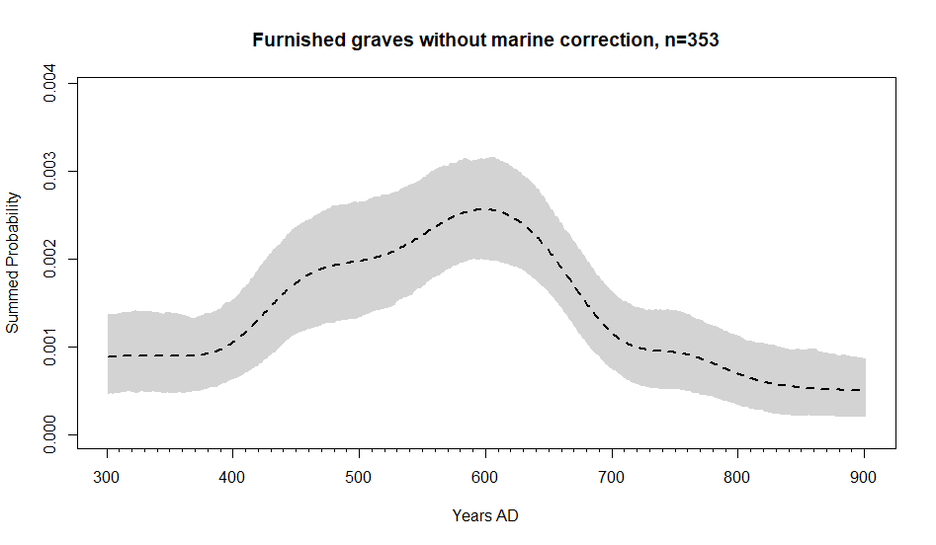
Figure S2: KDE of all furnished burials with and without marine reservoir.
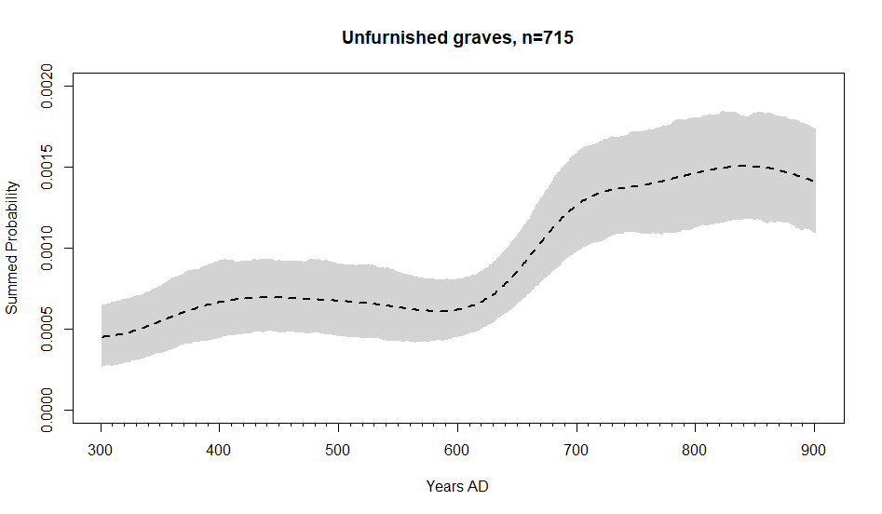
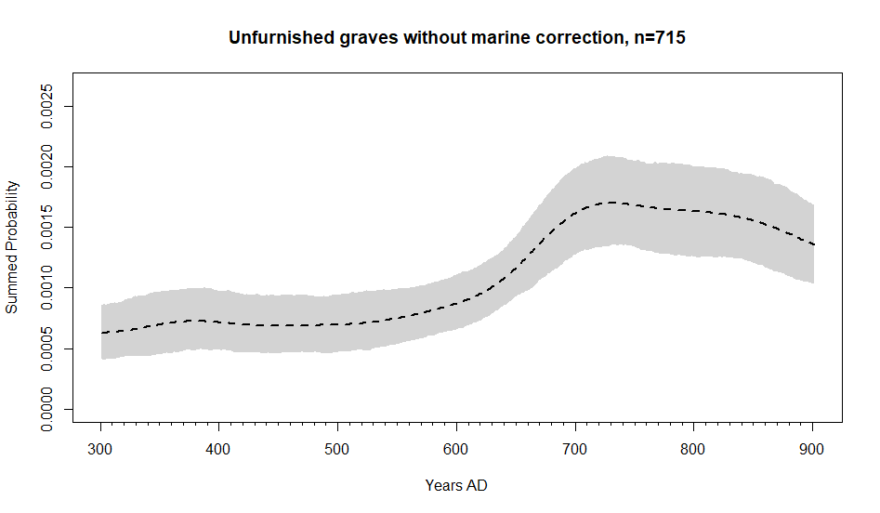
Figure S3: KDE of all unfurnished burials with and without marine reservoir.
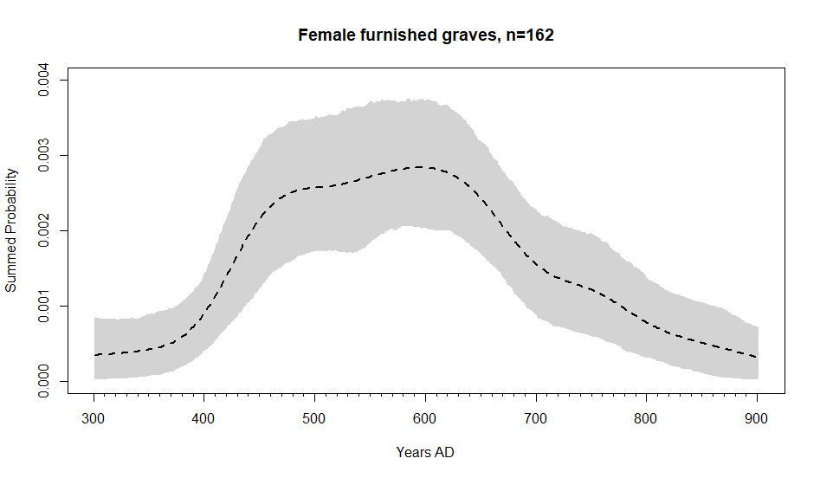
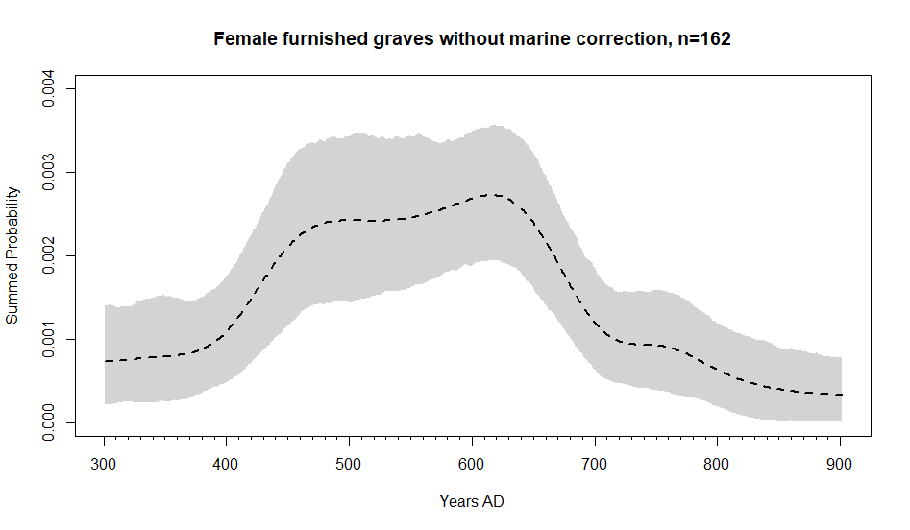
Figure S4: KDE of female furnished burials with and without marine reservoir.
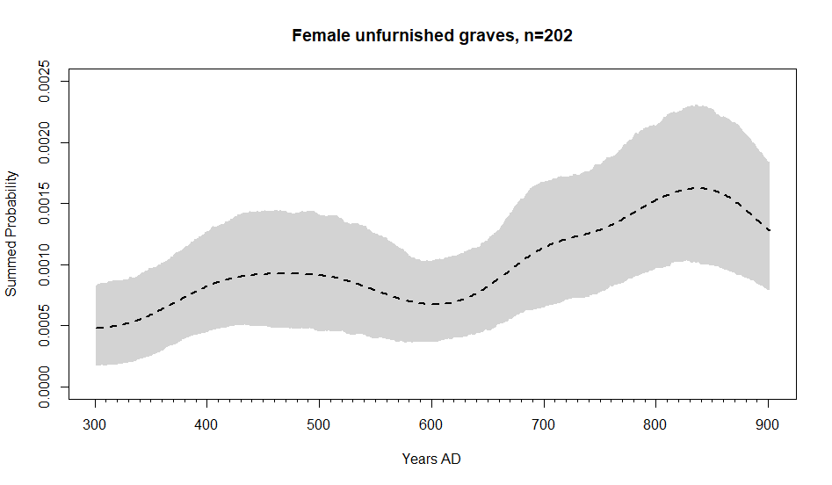
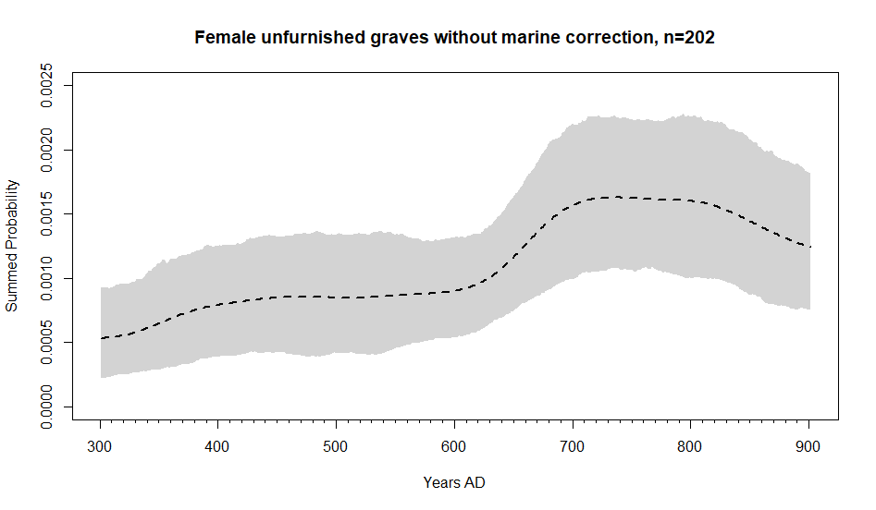
Figure S5: KDE of female unfurnished burials with and without marine reservoir.

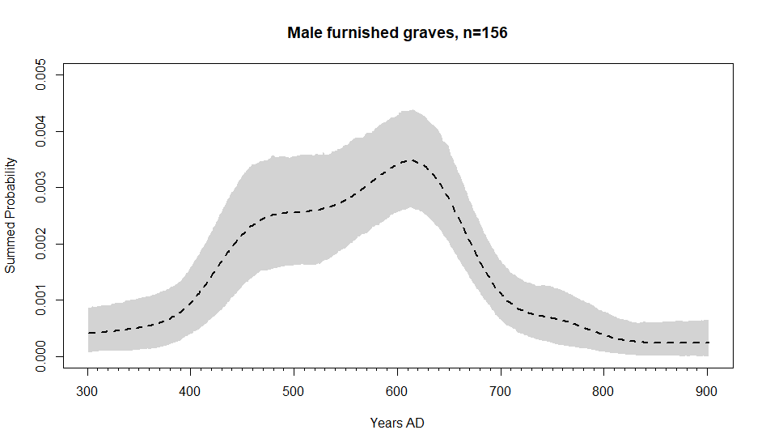
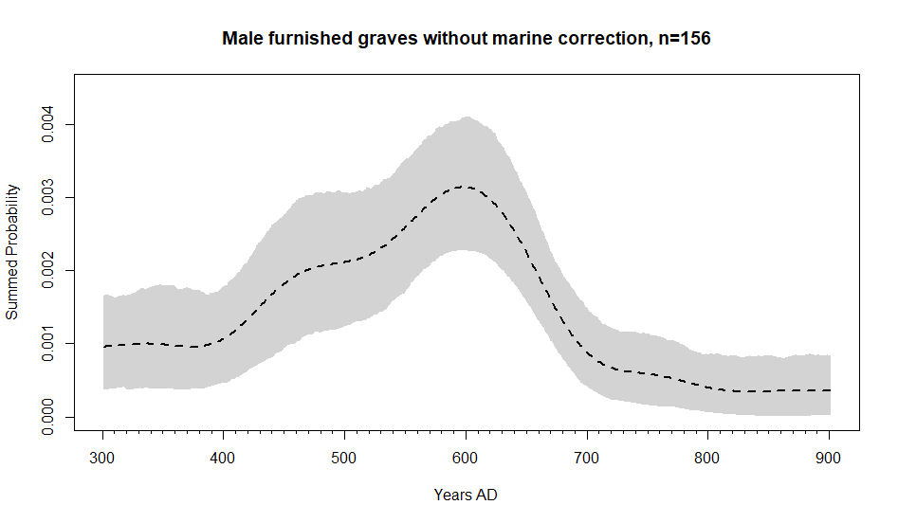
Figure S6: KDE of male furnished burials with and without marine reservoir.
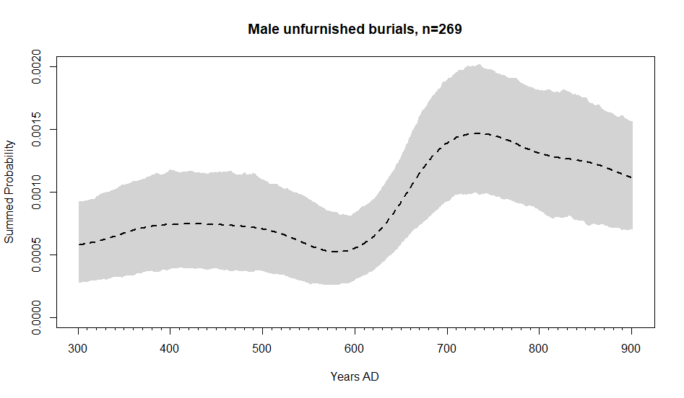
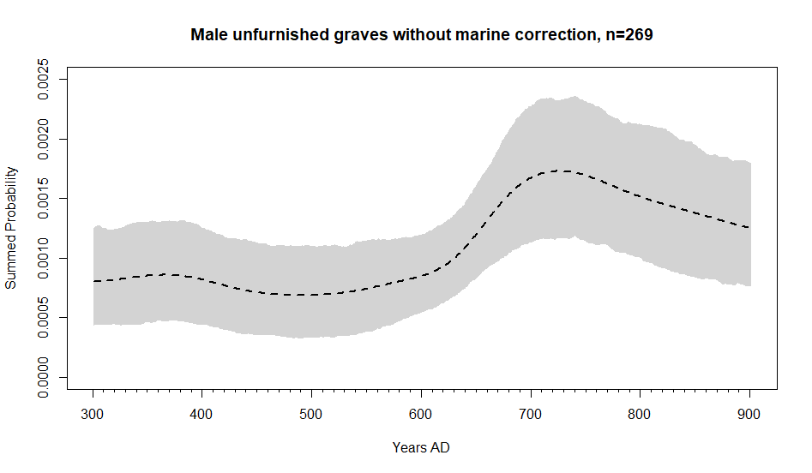
Figure S7: KDE of male unfurnished burials with and without marine reservoir.
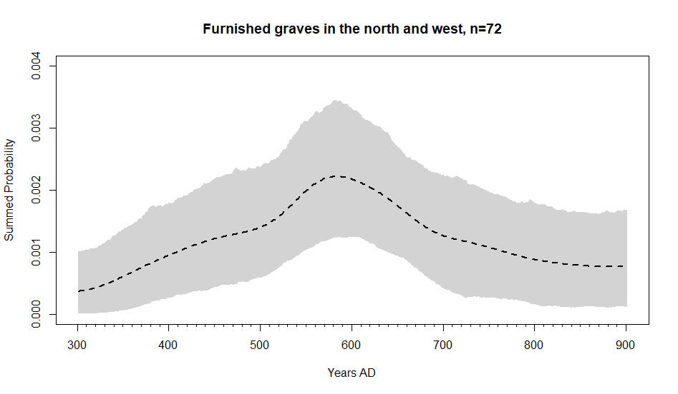

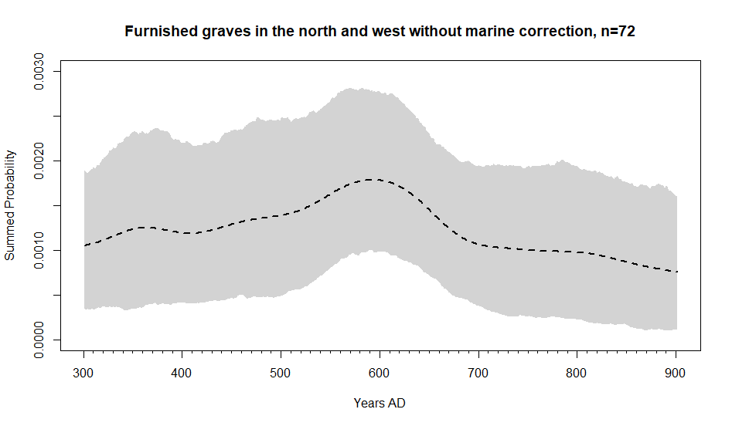
Figure S8: KDE of furnished graves in the north and west with and without marine reservoir.
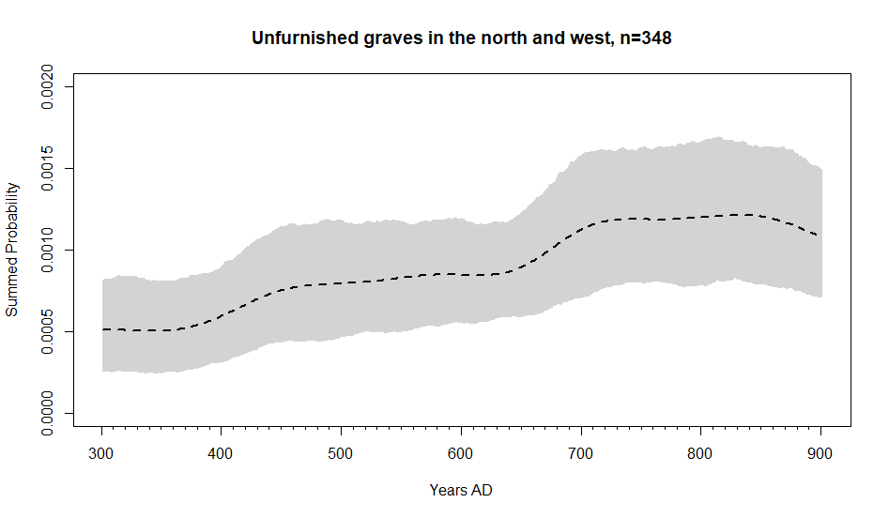
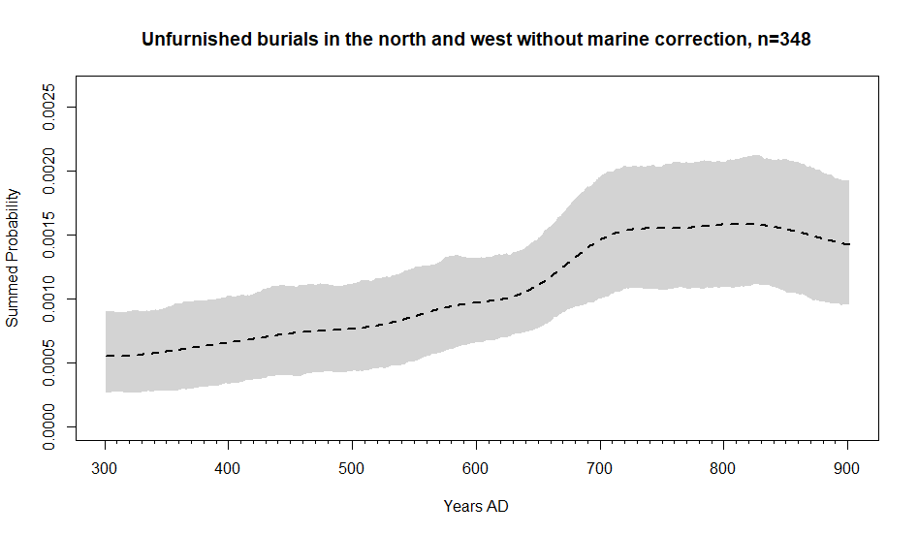
Figure S9: KDE of unfurnished burials in the north and west with and without marine reservoir.
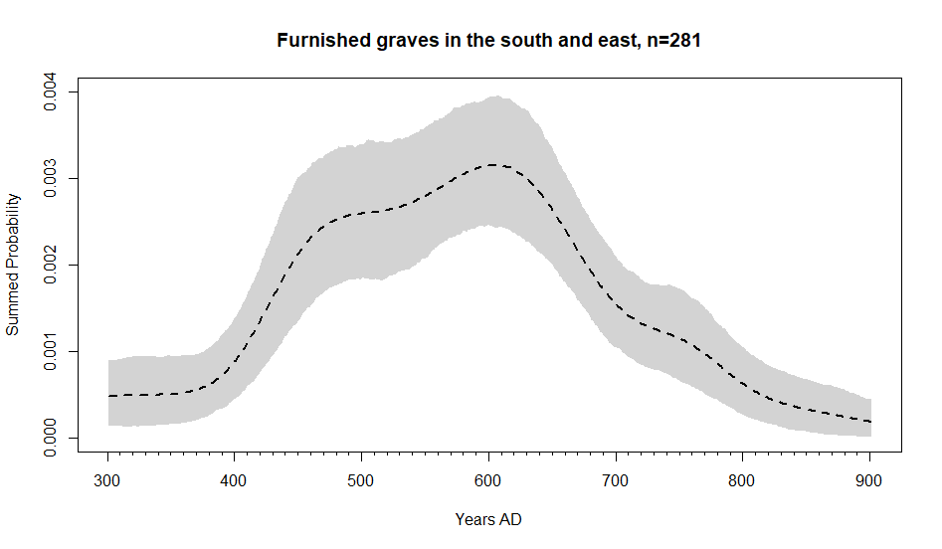
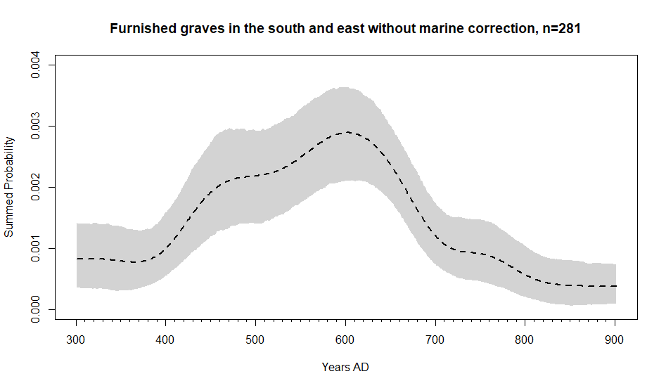
Figure S10: KDE of furnished graves in the south and east with and without marine reservoir.
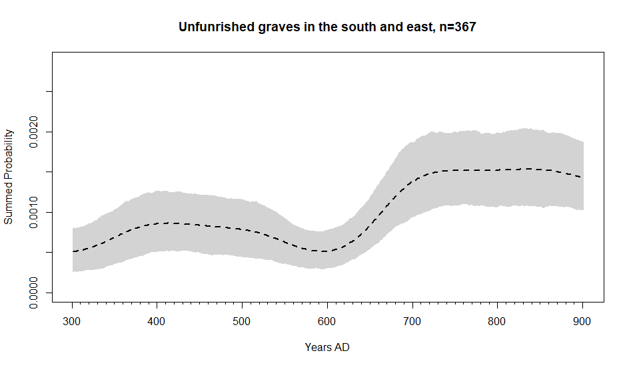
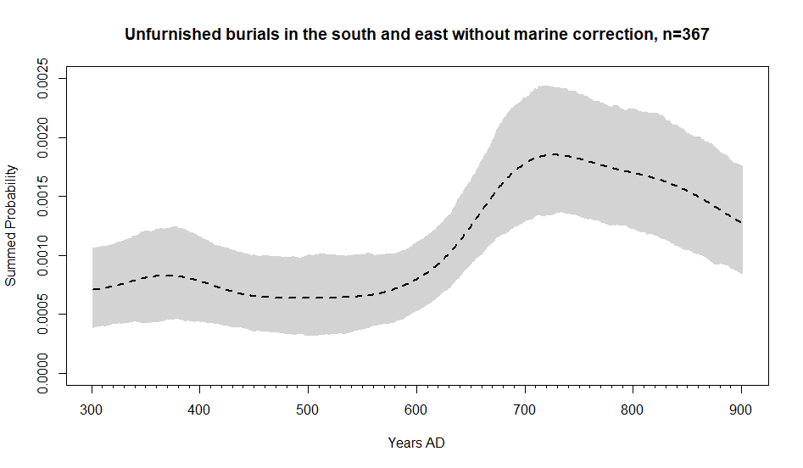
Figure S11: KDE of unfurnished burials in the south and east with and without marine reservoir.
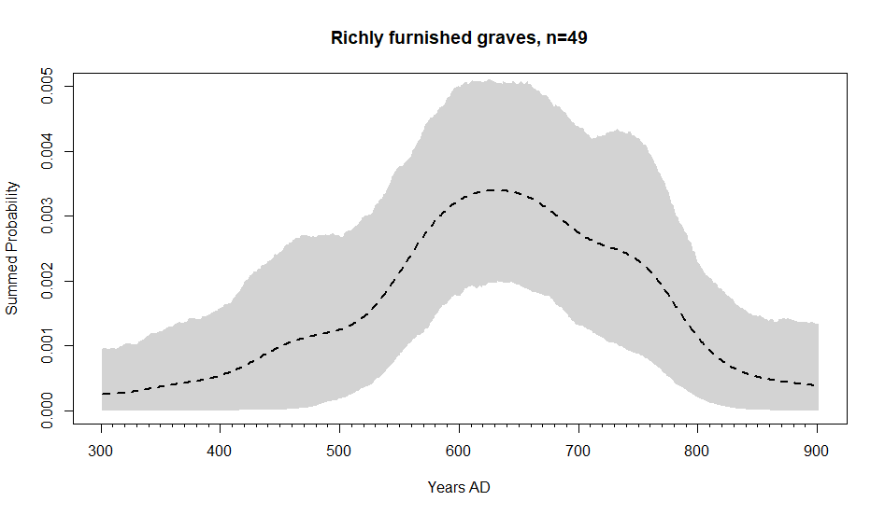
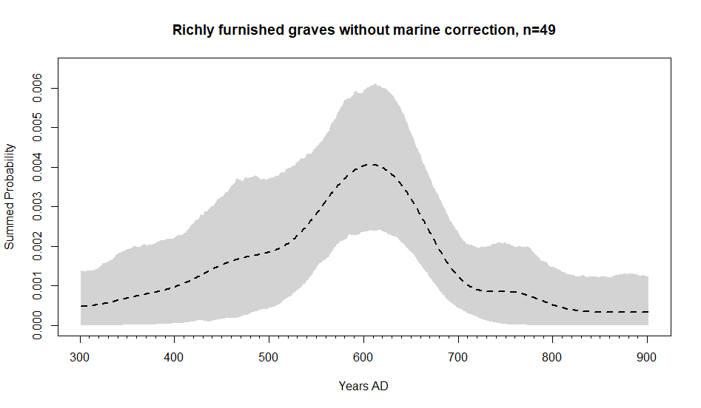
Figure S12: KDE of richly furnished graves with and without marine reservoir.
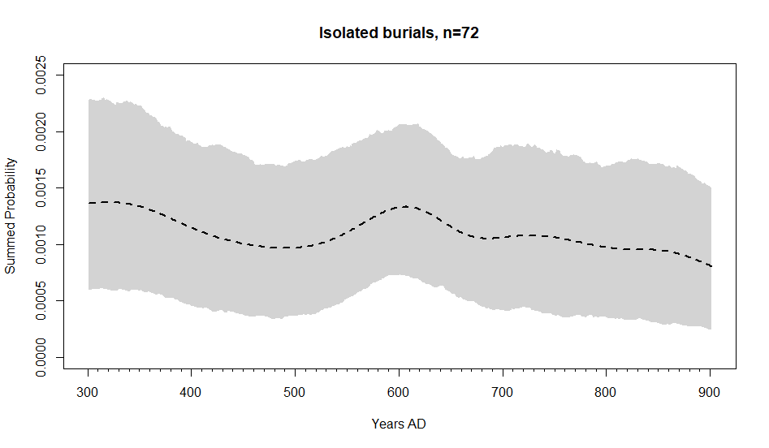
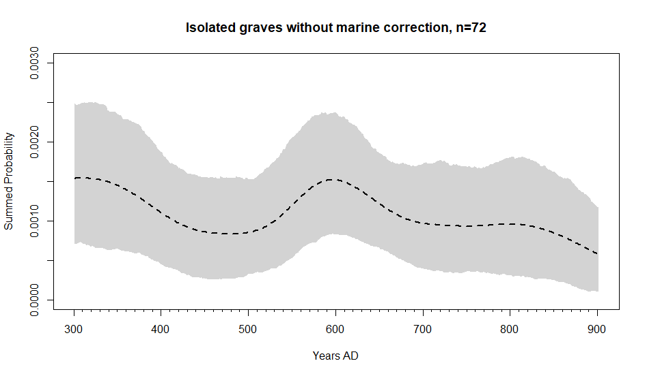
Figure S13: KDE of isolated graves with and without marine reservoir.
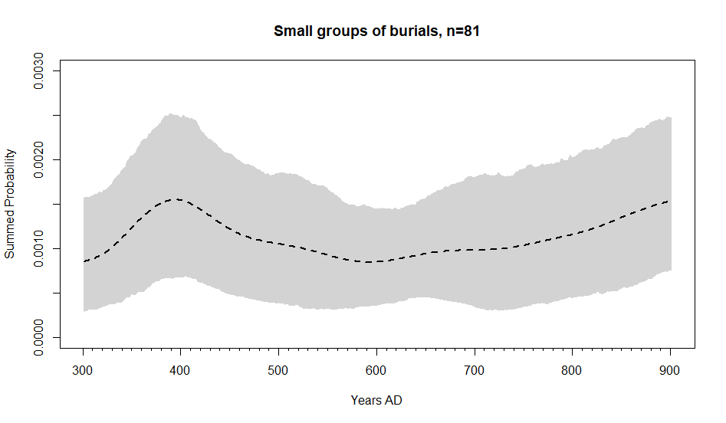
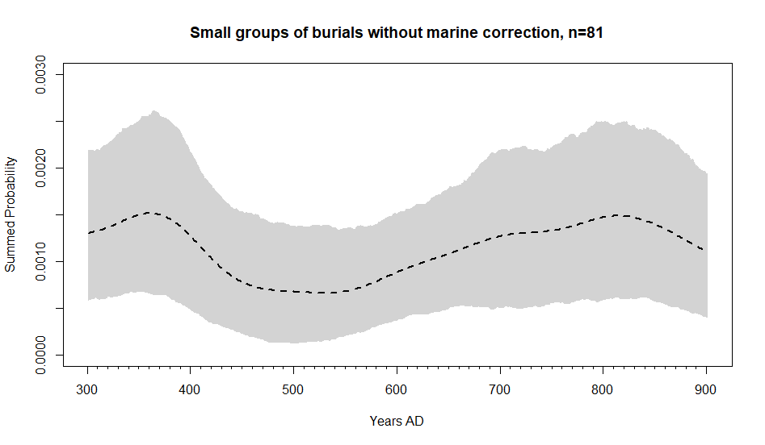
Figure S14: KDE of small groups of burials with and without marine reservoir.
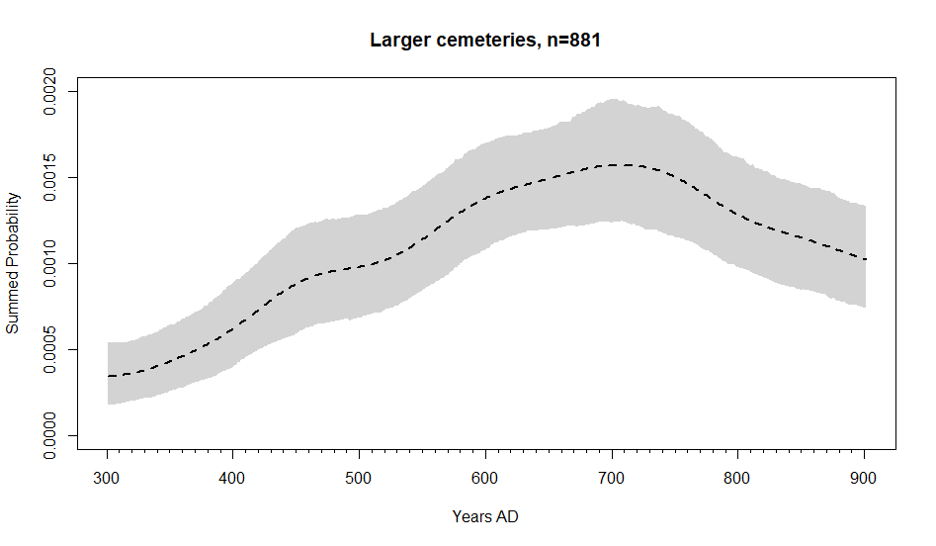
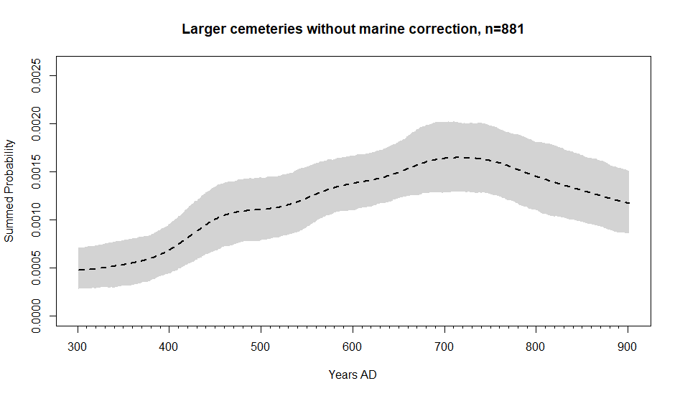
Figure S15: KDE of large cemeteries with and without marine reservoir.

KDE of Execution Cemeteries
Execution cemeteries are most common in the eighth and ninth centuries, increasing from the middle of the seventh century onwards. There are also a small number of burials in execution cemeteries dating to the fourth century. However, they are almost completely absent from the fifth and sixth centuries AD.
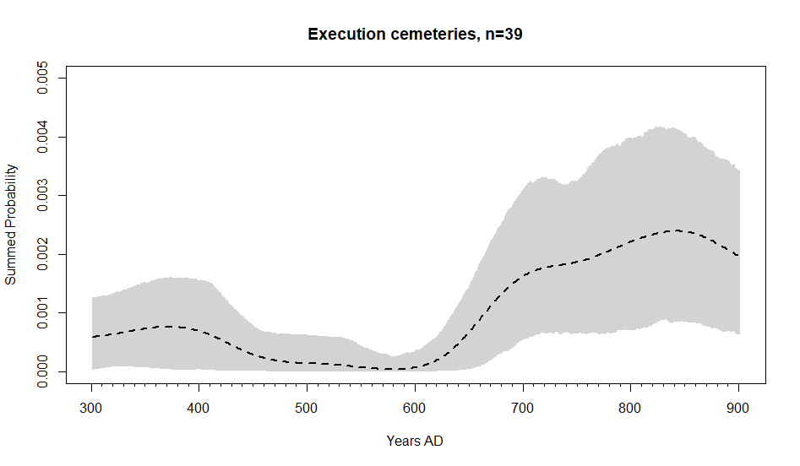
Figure S16: KDE of execution cemeteries

KDE of graves dated from projects other than the ASCF
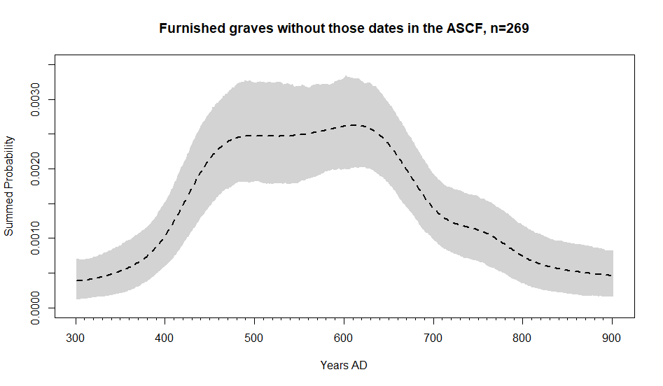
Figure S17: KDE of furnished burials, excluding those radiocarbon dated as part of the Anglo-Saxon Chronological Framework.

