Progress towards a Byzantine-Medieval Historic Buildings Tree-Ring Chronology
from Cyprus using dendrochronology and radiocarbon

Sturt W. Manning, Brita Lorentzen, Nikolas Bakirtzis, Mehmetcan Soyluoğlu

Supplementary Material: OxCal runfiles and alternative graphic presentations of the wiggle-match results

OxCal runfile for Figure 2:

Options()
{
Resolution=1;
Curve="intcal20.14c";
};
Plot()
{
D_Sequence ("PAF-6 + KPAN-3 for BCPM")
{
Date("BCPM RY943 start CSZ and BCPM");
Gap(25);
Date("BCPM RY968 start PAF");
Gap(38);
R_Combine("PAF-6+KPAN-3 RY1004-1008 @1006")
{
R_Date("GrM-16750 RY1004-1008 @1006",620,20);
R_Date("GrM-16752 RY1004-1008 @1006",588,19);
};
Gap(72);
R_Combine("PAF-6+KPAN-3 RY1076-1080 @1078")
{
R_Date("GrM-16751 RY1076-1080 @1078",515,19);
R_Date("GrM-16828 RY1076-1080 @1078",535,20);
};
Gap(11);
Date("RY 1089");
Gap(9);
R_Date("GrM-19053 KPAN RY1096-1100 @1098",448,19);
Gap(50);
R_Date("GrM-19054 KPAN RY1146-1150 @1148",367,19);
Gap(58);
Date("BCPM RY1206");
};
};

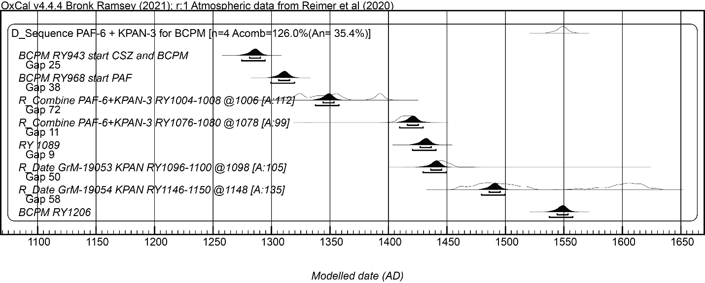

Alternative presentation of the wiggle-match results from Figure 2 in the main text. Hollow histograms show the non-modelled probability; smaller dark histograms show the modelled probability – the upper and lower lines under these indicate respectively the 68.3% hpd and 95.4% hpd modelled ranges. A values are the OxCal Agreement indices for each element in the model which should be >60.

OxCal runfile for Figure 3a:

Options()
{
Resolution=1;
Curve="intcal20.14c";
};
Plot()
{
D_Sequence ("TIMT2+3+17+70 RY976-1113")
{
Date("First Extant Ring RY976");
Gap(32);
R_Date ("VERA-6356 TIMT-2 Rings 1006-1010 @1008",817,35);
Gap (35);
R_Date ("VERA-6357 TIMT-2 Rings 1041-1045 @1043",799,38);
Gap (24);
R_Date ("VERA-6358 TIMT-2 Rings 1064-1068 @1067",739,34);
Gap (46);
Date ("Last Extant Ring RY1113");
};
};

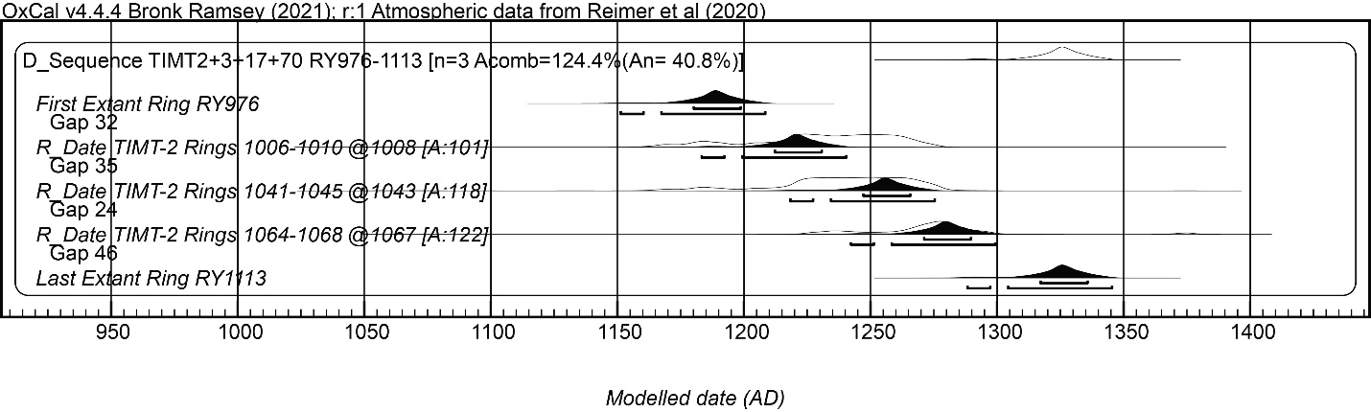

Alternative presentation of the wiggle-match results from Figure 3a in the main text. Hollow histograms show the non-modelled probability; smaller dark histograms show the modelled probability – the upper and lower lines under these indicate respectively the 68.3% hpd and 95.4% hpd modelled ranges. A values are the OxCal Agreement indices which should be >60.

OxCal runfile for Figure 3c:

Options()
{
Resolution=1;
Curve="intcal20.14c";
};
Plot()
{
D_Sequence ("TIMT5")
{
R_Date ("VERA-6359 TIMT-5 Rings 1001-1005 @1003",549,35);
Gap (50);
R_Date ("VERA-6360 TIMT-5 Rings 1051-1055 @1053",394,34);
Gap (49);
R_Date ("VERA-6361 TIMT-5 Rings 1100-1104 @1102",321,38);
Gap (29);
Date ("Date Last Extant Tree Ring RY1131");
};
};

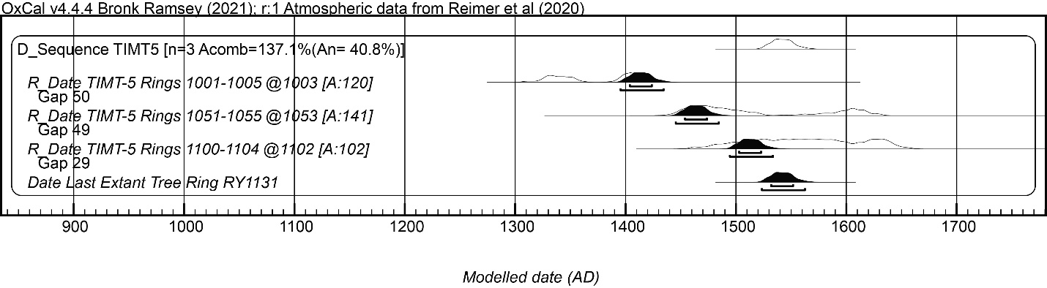

Alternative presentation of the wiggle-match results from Figure 3c in the main text. Hollow histograms show the non-modelled probability; smaller dark histograms show the modelled probability – the upper and lower lines under these indicate respectively the 68.3% hpd and 95.4% hpd modelled ranges. A values are the OxCal Agreement indices which should be >60.

OxCal runfile for Figure 3e:

Options()
{
Curve("IntCal20","intcal20.14c");
Resolution=1;
};
Plot()
{
D_Sequence("TIMT-10A + 20")
{
Date("TIMT RY1001");
Gap(15);
R_Date("GrM-27164 TIMT-10A RY1015-1017 @1016",1188,24);
Gap(26);
R_Date("GrM-27165 TIMT-10A RY1041-1043 @1042",1135,18);
Gap(87);
R_Date("GrM-27166 TIMT-10A RY1128-1130 @1129",1087,18);
Gap(209);
Date("TIMT RY1338");
};
};

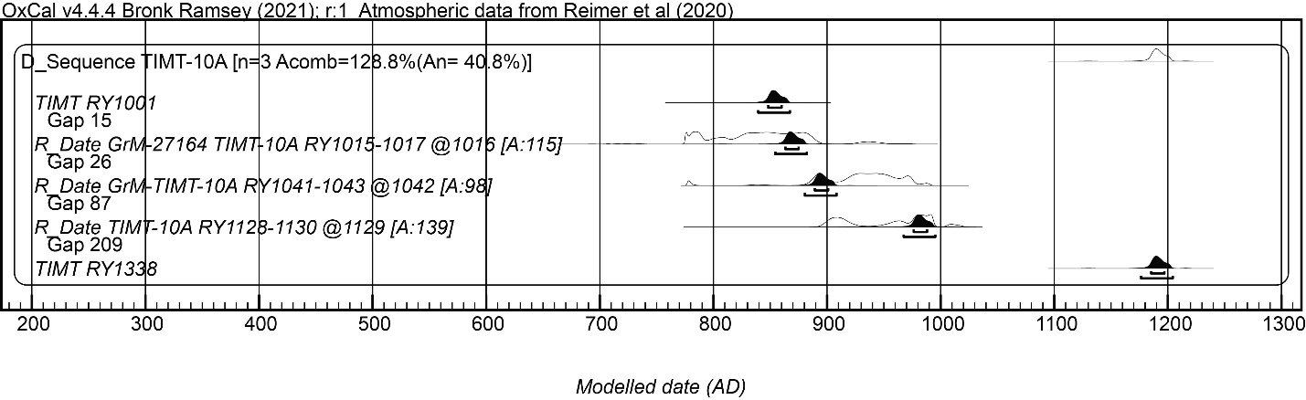

Alternative presentation of the wiggle-match results from Figure 3e in the main text. Hollow histograms show the non-modelled probability; smaller dark histograms show the modelled probability – the upper and lower lines under these indicate respectively the 68.3% hpd and 95.4% hpd modelled ranges. A values are the OxCal Agreement indices which should be >60.

OxCal runfile for Figure 4:

Options()
{
Resolution=1;
Curve="intcal20.14c";
};
Plot()
{
D_Sequence ()
{
R_Date ("VERA-6353 TIMT-1 Rings 1001-1005 @1003",1166,35);
Gap (51);
R_Date ("VERA-6354 TIMT-1 Rings 1052-1056 @1054",1156,36);
Gap (93);
R_Date ("VERA-6355 TIMT-1 Rings 1145-1149 @1147",1095,38);
Gap (16);
Date("Last Ring RY1163");
};
};

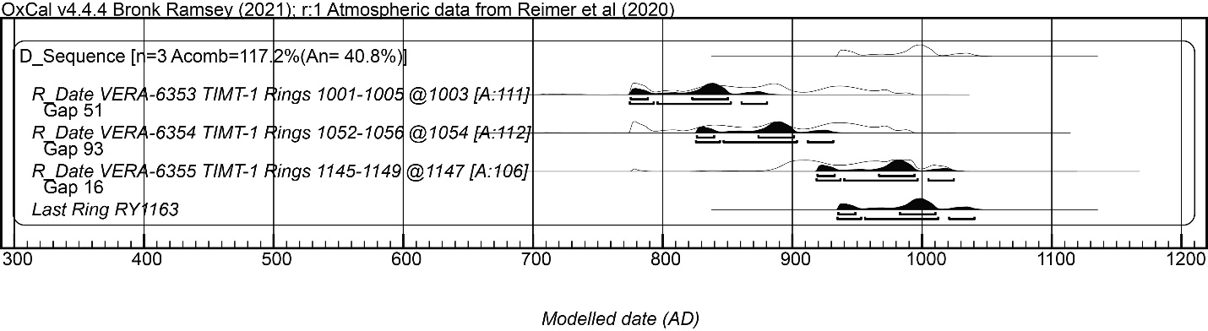

Alternative presentation of the wiggle-match results from Figure 4 in the main text. Hollow histograms show the non-modelled probability; smaller dark histograms show the modelled probability – the upper and lower lines under these indicate respectively the 68.3% hpd and 95.4% hpd modelled ranges. A values are the OxCal Agreement indices which should be >60.

OxCal runfile for Figure 5b:

Options()
{
Resolution=1;
Curve="intcal20.14c";
};
Plot()
{
D_Sequence ("PAF-6 + KPAN-3 for BCPM and GPAN P. nigra at crossdate")
{
R_Date("GrM-26362 GPAN-13c 1271-1274 crossdate @930.5",750,20)
{
color="red";
};
Gap(12.5);
Date("BCPM RY943 start CSZ and BCPM");
Gap(25);
Date("BCPM RY968 start PAF");
Gap(38);
R_Combine("PAF-6+KPAN-3 RY1004-1008 @1006")
{
R_Date("GrM-16750 RY1004-1008 @1006",620,20);
R_Date("GrM-16752 RY1004-1008 @1006",588,19);
};
Gap(42);
R_Combine("GPAN 1388-1392 crossdate @1048")
{
color="red";
R_Date("GrM-26294 GPAN-13c 1388-1392 crossdate @1048",618,19);
R_Date("GrM 26299 GPAN-9c 1388-1392 crossdate @1048 i",605,20);
};
Gap(30);
R_Combine("PAF-6+KPAN-3 RY1076-1080 @1078")
{
R_Date("GrM-16751 RY1076-1080 @1078",515,19);
R_Date("GrM-16828 RY1076-1080 @1078",535,20);
};
Gap(11);
Date("RY 1089");
Gap(9);
R_Date("GrM-19053 KPAN RY1096-1100 @1098",448,19);
Gap(7.5);
R_Date("GrM-26300 GPAN-9c 1445-1450 crossdate @1105.5",441,18)
{
color="red";
};
Gap(42.5);
R_Date("GrM-19054 KPAN RY1146-1150 @1148",367,19);
Gap(58);
Date("BCPM RY1206");
};
};

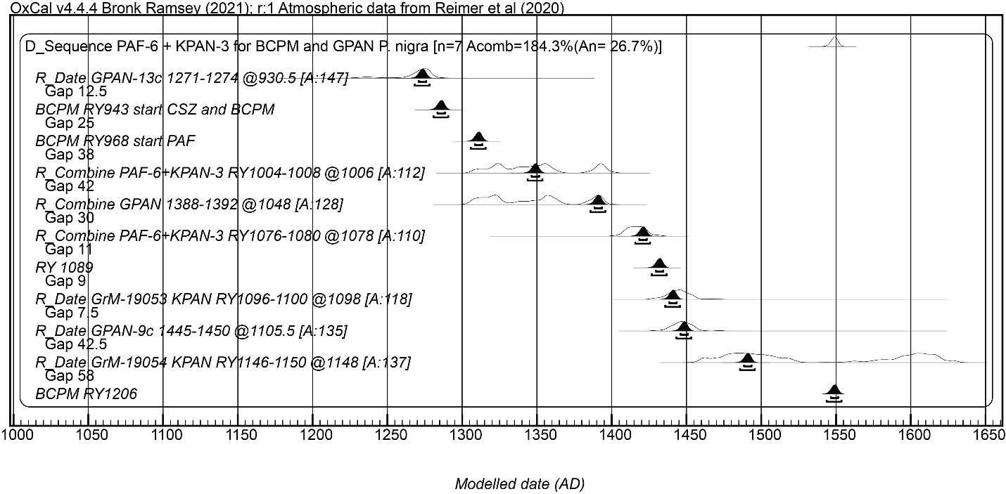

Alternative presentation of the wiggle-match results from Figure 5b in the main text. Hollow histograms show the non-modelled probability; smaller dark histograms show the modelled probability – the upper and lower lines under these indicate respectively the 68.3% hpd and 95.4% hpd modelled ranges. A values are the OxCal Agreement indices which should be >60.

