Supplement material

Radiocarbon concentration in sub-annual tree rings from Poland around 660 BCE

Andrzej Z. RAKOWSKI¹, Jacek PAWLYTA², Hiroko MIYAHARA³, Marek KRĄPIEC², Mihail MOLNAR^{4,5}, Damian WIKTOROWSKI², Masayo MINAMI⁶

- Silesian University of Technology, Konarskiego 22B str., 44-100 Gliwice, Poland
- AGH University of Science and Technology, Mickiewicza Av. 30, 30-059 Krakow, Poland
- Humanities and Sciences/Museum Careers, Musashino Art Universally, 1-736 Ogawa-cho, Kodaira, Tokyo, 187-8505, Japan
- Hertelendi Laboratory of Environmental Studies, Institute of Nuclear Research of the Hungarian Academy of Sciences (ATOMKI), H-4026 Debrecen, Hungary
- Isotoptech Zrt., H-4025 Debrecen, Hungary
- Institute for Space-Earth Environmental Research, Nagoya University, Furo-cho, Chikusa-ku, Nagoya,
464-8601, Japan

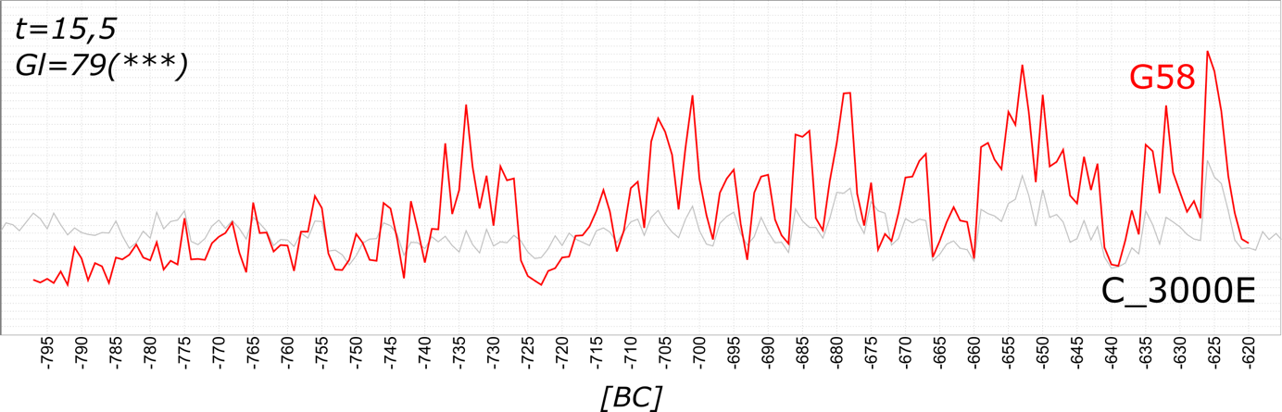

Figure S1. Cross-matching of the subfossil oak sample G58 and standard chronology C_3000E, which was established trough teleconnection with Becker’s German oak chronology for southern Germany (Becker 1993, t=7.7) and Leuschner’s and Delorme’s oak chronology for central Germany (Leuschner and Delorme, 1988, t=6.8). The t-value represents the significance of the correlation of two series in relation to their overlap, which should not drop below 3.5 to maintain dating confidence (Baillie and Pilcher 1973). The GL (Gleichläufigkeit) was developed as a special tool for the cross-dating of tree-ring series. The degree of similarity based on the positive or negative trend of each width is expressed as a percentage of the number of intervals (Eckstein and Bauch 1969).

Table S1. pMC and Δ¹⁴C in EW and LW tree rings of Quercus robur (Core 68) from Grabie village near Kraków (SE Poland). LW samples form 663 and 660 BCE, and 658 BCE have been divided into two sub-samples

Year | Ring | pMC | u(pMC) | Δ¹⁴C  % | Δ Δ¹⁴C  %
664 BCE | EW | 73,31 | 0,16 | 5,8 | 2,2
664 BCE | LW | 73,28 | 0,16 | 5,3 | 2,2
663 BCE | EW | 73,34 | 0,16 | 6,0 | 2,2
663 BCE | LW1 | 73,94 | 0,15 | 14,3 | 2,1
663 BCE | LW2 | 74,11 | 0,16 | 16,6 | 2,2
662 BCE | EW | 74,16 | 0,15 | 17,2 | 2,1
662 BCE | LW1 | 73,98 | 0,17 | 14,7 | 2,3
662 BCE | LW2 | 74,15 | 0,15 | 17,0 | 2,1
661 BCE | EW | 74,31 | 0,16 | 19,1 | 2,2
661 BCE | LW1 | 74,09 | 0,16 | 16,1 | 2,2
661 BCE | LW2 | 74,31 | 0,15 | 19,1 | 2,1
660 BCE | EW | 74,23 | 0,16 | 17,9 | 2,2
660 BCE | LW1 | 74,15 | 0,15 | 16,8 | 2,1
660 BCE | LW2 | 74,19 | 0,16 | 17,3 | 2,2
659 BCE | EW | 73,86 | 0,17 | 12,7 | 2,3
659 BCE | LW | 74,09 | 0,14 | 15,8 | 1,9
658 BCE | EW | 74,09 | 0,16 | 15,7 | 2,2
658 BCE | LW1 | 74,19 | 0,14 | 17,1 | 1,9
658 BCE | LW2 | 74,23 | 0,16 | 17,6 | 2,2

Table S2. pMC and Δ¹⁴C in tree rings of Quercus robur from Grabie village near Kraków (SE Poland). Revised data from G58 core published by Rakowski et al (2019).

Year (BCE) | pMC | u(pMC) | Δ¹⁴C (‰) | Δ Δ¹⁴C (‰)
669.5 | 73.97 | 0.22 | 7.2 | 2.2
668.5 | 73.97 | 0.22 | 7.0 | 2.2
667.5 | 73.40 | 0.21 | -0.8 | 2.1
666.5 | 73.57 | 0.22 | 1.4 | 2.2
665.5 | 73.38 | 0.23 | -1.3 | 2.3
664.5 | 73.26 | 0.22 | -3.1 | 2.2
663.5 | 73.88 | 0.19 | 5.2 | 1.9
662.5 | 73.85 | 0.25 | 4.7 | 2.5
661.5 | 74.62 | 0.28 | 15.0 | 2.8
660.5 | 74.71 | 0.26 | 16.1 | 2.6
659.5 | 74.71 | 0.22 | 16.0 | 2.2
658.5 | 74.69 | 0.26 | 15.6 | 2.6
657.5 | 74.21 | 0.26 | 9.0 | 2.6
656.5 | 74.32 | 0.27 | 10.3 | 2.7
655.5 | 73.82 | 0.22 | 3.4 | 2.2
654.5 | 74.64 | 0.25 | 14.4 | 2.5

References

Baillie MGL, Pilcher JR. 1973. A simple cross dating program for tree-ring research. Tree-Ring Bulletin 33:7–14

Eckstein D, Bauch J. 1969. Beitrag zur Rationalisierung eines dendrochronologischen Verfahrens und zur Analyse seiner Aussagesicherheit. Forstwissenschaftliches Centralblatt 88:230–50.

