APPENDIX 2: Stratigraphic Information

Cerro del Gentil
The stratigraphic relationships for the Cerro del Gentil samples were derived from information published by the Proyecto Arqueológicos de Chincha (Tantaleán et al. 2016; Tantaleán and Stanish 2017). Additional detail can be found in the original publications.
Three construction phases were identified at Cerro del Gentil. These phases are well-defined and plainly observable in profile drawings produced by PACH (Tantaleán et al. 2016 Figure 10). The samples from the Brown Phase were collected from items which were ritually deposited during the site’s decommissioning.

Sample Lab Code | Stratigraphic Order  (youngest to oldest) | Construction Phase | Ceramic Phase | Context Description
UCIAMS-162413  UCIAMS-162410  UCIAMS-137884  UCIAMS-137885  UCIAMS-131979  UCIAMS-162412  UCIAMS-162407  UCIAMS-162408  UCIAMS-162409 | I | Brown Phase  (Fase Marrón) | Ocucaje 8-9 | A platform was constructed over the sunken patio of the Grey phase, measuring 7x4 m, and as high as the Grey phase walls.  This phase was used briefly, and is interpreted as being related to the site’s ritual abandonment.  Samples collected from this phase derive from final ritual offerings associated with the site’s abandonment.
UCIAMS-162404  UCIAMS-137882  UCIAMS-162414 | II | Gray Phase  (Fase Gris) |  | Second construction phase in which the sunken patio’s size was reduced to approximately 7x7 m, with walls 2.4m high.
UCIAMS-162403  UCIAMS-162406  UCIAMS-162415 | III | Yellow Phase  (Fase Amarilla) | Ocucaje 5-7 | Initial 12x12 m sunken patio within the platform mound, with walls 2.5 m high. A clay floor was laid down atop a level of angular stones and botanic remains.

Jahuay
Stratigraphic relationships for Jahuay samples were determined based on excavation data from the Proyecto de Investigación Arqueólogica de Jahuay, Quebrada de Topará. Stratigraphic relationships between excavation contexts were recorded in a Harris Matrix, which is in the authors’ possession.
The dates presented here were sampled from Units 35, 40, and 41, within a block of excavation units in Sector B at the site of Jahuay (Figure A). This area was a community production area associated with the Jahuay settlement. Workspaces were defined with low stone walls and informal stamped earth floors. These spaces were frequently renovated over the course of the site’s occupation, with new construction levels placed on top of old ones, resulting in nearly 4 meters of stratified deposits. Samples were collected from informal flood surfaces (apisonados). Additional detail on these spaces can be found in dissertations by Osborn (2022) and Weinberg (2023).
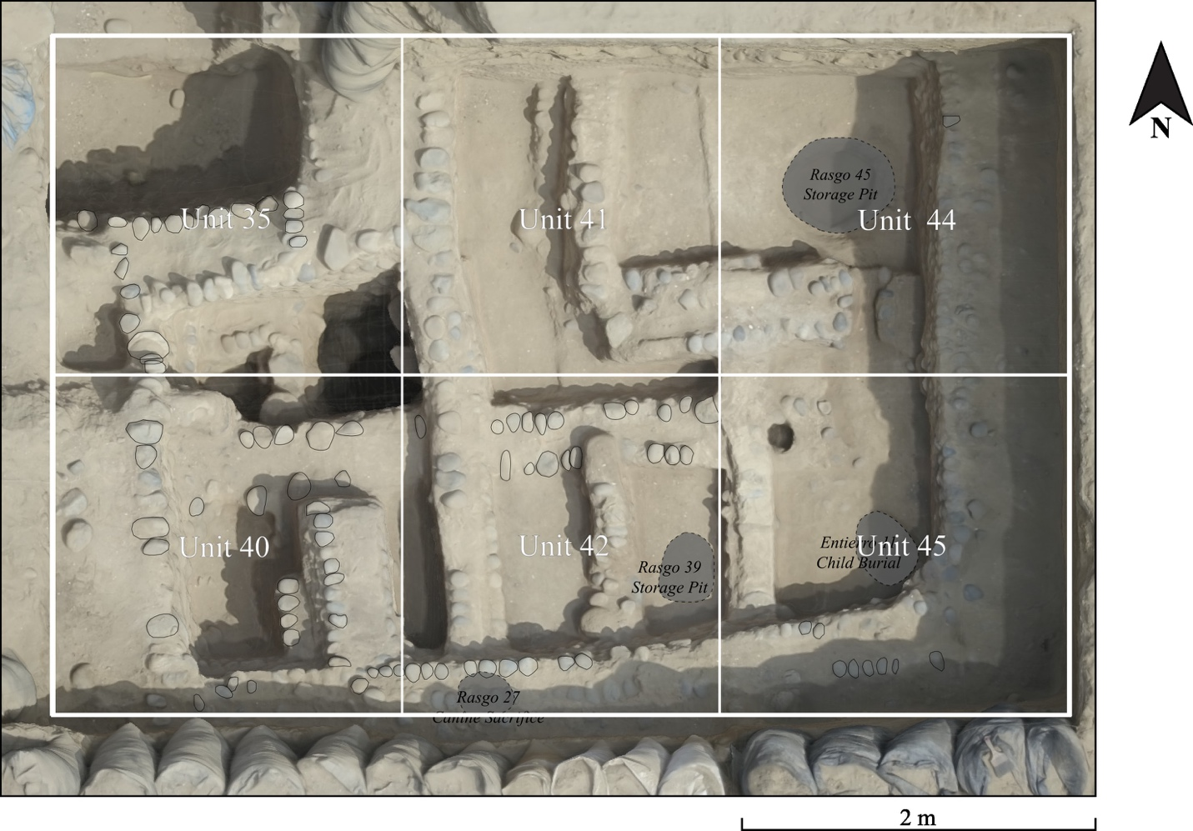
Figure A. Excavation Units 35, 41, 44, 40, 42, and 45 at Jahuay. The samples presented in this paper were collected from contexts located at the intersection of Units 35, 40, and 41.
Stratigraphic Order  (youngest to oldest) | Sample Lab Code | Excavation Context | Context Description
I | D-AMS 033290 | Locus 248  Unit 41 Level 6 | Stamped earth (“apisonado”) with inclusions of ash and salt crystallization (salitre)
II | D-AMS 040502 | Locus 257  Unit 41 Level 8 | Semi-compact level (apisonado) with stone inclusions (cantos rodados)
III | D-AMS 040501 | Locus 321  Unit 44 Level 7 | Semi-compact level (apisonado) with stone and mollusk shell inclusions
IV | D-AMS 040503 | Locus 220  Unit 35  Feature 35 Level 14 | Compacted silt level (apisnado) associated with a storage pit.
V | D-AMS 040504 | Locus 317  Units 35, 40, & 41  Feature 44 Level 16 | Semi-compact level of mixed soil and sand with inclusions of heavily fragmented mollusk shell.
 | D-AMS 033293
 | D-AMS 033289
VI | D-AMS 040505 | Locus 328  Units 35, 40, & 41  Feature 44 Level 17 | Compacted level of mixed soil and sand containing inclusions of stones and decomposed organic material.
VII | D-AMS 040506 | Locus 332  Units 35, 40, & 41  Feature 44 Level 18 | Semi-compact earth level with inclusions of fragmented ceramics.
Jauranga
The stratigraphic relationships for the Jauranga samples were derived from information published by Unkel (2006). More detail about the excavation context can be found in the original text, as well as in work by Reindel and Isla (2013).
Units 1 & 4
Based on Unkel (2006: 68 Table 5)
Sample Lab Code | Sampled Context | Level | Settlement Phase | Construction Phase | Ceramic Phase
Surface Level and Level A (Unsampled)
- | Grave 9 | B | VI | IX | Ocucaje 8/9
HD-24232  ET438 | Hearth 1 | C |  | VIII
ET376  ET377 | Hearth 2 | D  (E) | V | VII | Ocucaje 8
ET462 | Material from Level F | F | IV | VI
ET378  HD-24209  HD-24234 | Hearth 3, 4; Wall 4 | G  (H)
- | - | I-K | III | V
- | Wall 20 | L | II | IV
ET379  ET463 | Hearth 5, 6; vessel; Hearth 28; Layer K | (M)  N |  | III | Ocucaje 7/8
ET466 | Walls 25 and 27  Grave 18 | O  (P) |  | II | Ocucaje 6/7
HD-24264 | Material from Level Q | Q | I | I | Ocucaje 5/6
Units 2
Based on Unkel (2006: 69 Table 6)
Sample Lab Code | Sampled Context | Level | Construction Phase | Ceramic Phase
Surface Level and Levels A-B (unsampled)
- | Intrusive graves 61-62 | C3 | V | Ocucaje 9
ET381 | Material from Level E | (D)  E | IV | Ocucaje 8/9
ET382  ET431 | Graves 64, 66, 67 | F | III | Ocucaje 8
HD-24263  ET432 | Hearths 9, 11 | G
ET433 | Hearth 12 | E*
- | - | H | - | -
ET446  ET447  ET448  ET449  ET451  ET452  ET458 | Hearths 13, 14, 16, 17, 18, 19, 20, 21; and vessel | I | II | Ocucaje 7/8
 | Wall 39 | - |  | Ocucaje 6/7
ET454  ET457 | Hearths 22, 23, 24 | J/K
 | Wall 40 | - | I
Unkel notes that Level E* is distinct from Level E, and that the confusion stems from level names assigned across different architectural units.

Estaquería
The stratigraphic relationships for the Estaquería samples were derived from information provided by Unkel (2006: 73–74). More detail about the excavation context can be found in the original text, as well as in work by Isla and Reindel (2018).
Unit 1
Sample | Level | Level Description
- | Surface | Unit surface
- | A | Fine layer of dark brown soil with containing a hearth and coprolites
- | B | Sediment level with plant remains and coprolites
- | C | Level of stamped earth (“Stampflehm”)
HD-24066  ET364 | D | Layer of stamped earth (Floor 1).  Two posts were sampled.
- | E | Hard compact stamped earth layer with a substructure of sediments mixed with ash, stones, and plant remains. (Floor 2)
- | F and H | 10-15 cm fill level of sediment mixed with charcoal, stones, and plant debris. Wall 3 was built atop this layer.
HD-24073  HD-24072  HD-24071  ET366 | I | Stamped earth layer (Floor 3) connecting two walls (Walls 1 and 2) which formed a platform. Floor 3 was crossed by a drainage canal which was contained earth and organic material. In this canal 3 posts were identified, apparently part of a quincha (wattle-and-daub) wall.  The 3 posts were sampled.

