Supplemental material

Anatomy of a book
European bookbinding in the early 17th century already carried on several hundred years of traditions from long before books began to be printed in the 15th century. Materials used in book production were of both plant and animal origin with small exception of metal elements. The preparation of materials for book binding was a task particular to a specific trade or guild. Given the fact that Venice in the beginning of 1600s was one of the biggest cities in Europe (Panciera, 2006), and a centre for printing and bookmaking all materials needed for bookbinding, with very small exceptions, would be, most probably, produced in the city and its surroundings rather than being imported.
Paper that was produced at the time was hand-made from recycled rags that were carefully selected, macerated, beaten up to form, with added water, a fibre pulp. This pulp was then sieved out from vats by wire screens also called moulds. Construction and layout of the wires in the screen formed distinguishable laid (running sidewise) and chain (from top to bottom) lines in the ready-made paper. Additionally, woven wires could be incorporated into the mould to form a logo which would produce a watermark, allowing the attribution to a particular paper mill.
Sewing threads and cords for raised bands would be produced by spinners or cord makers and bought by bookbinder. Given the demand for such products it would be used immediately rather than stocked for many years. Parchment scraps for making the headbands would be obtained from different sources. Most probably as palimpsests from multiple scriptoria in a form of unused letters or documents. The leather for the covers would be carefully chosen and delivered from tanneries. Processing an animal (goat, pig, calf, sheep etc.) skin to produce leather was a complicated process. To produce a brown leather a vegetable tanning process was used. Metal accessories, like clasps or buckles, would be used either as newly produced items or reused. Venice was known for its bronze-casting.
Book pages after being printed and delivered to the bookbinder were folded into sections otherwise known as signatures. The signatures were sewn together with the use of sewing cords while several thicker cords called raised bands were mounted across the signature spine. The external signatures, front and back, called the end-leaves, were added by the bookbinder. They were left blank. Their purpose was to form hinges between the paper block and the covers by pasting one of the end-leaves to the cover from inside. Such an end-leaf is thus called a paste-down.
With the raised bands running across the book signatures, protruding as ribs on the spine, the text block or otherwise called the book block was formed. To attach the covers, the end bits of raised bands were threaded/laced through the holes in cardboard or wooden plates.
A headband is an element made of cloth or a piece of parchment, twisted around a leather strip or a cord and often decoratively embroidered with coloured threads. It is glued and sewn to the top end of the spine of the text block and simultaneously glued to the covers before they are covered with leather. The purpose of the headband is to protect the leather on the top edge of the spine from being torn when the book is being pulled out of the shelf.
The leather cover was added as one of the last elements. Mostly animal glues were used to attach it to the covers but sometimes starch paste was added to extend its drying time and allow craftsmen more time to work. After the leather was attached, the first and the last end-leaves were pasted onto the covers covering edges of the leather.
The metal clasps in the book were used to close the volume, protecting the text block from moisture and deformation. It consisted of two elements attached to the edge of the top and bottom covers. In this volume, only a fragment of the clasp in the lower part of the bottom cover has been preserved. This surviving fragment of the clasp is attached to the cover with three small nails that show signs of corrosion.

OxCal model
Plot("Antniphonary")
{
Sequence("")
{
R_Combine("Original leather")
{
R_F14C("1.1 Headband",0.9545,0.0016);
R_F14C("2.1 cover",0.9546,0.0013);
};
Date("",1607);
};
Sequence("")
{
R_Combine("Cardboard")
{
R_F14C("3.1 front inside",0.9613,0.0014);
R_F14C("3.2 front top",0.9629,0.0025);
R_F14C("3.3 back top",0.9629,0.0019);
R_F14C("3.4 back bottom",0.9601,0.002);
};
Date("",1607);
};
Sequence("")
{
R_Combine("Original paper and thread")
{
R_F14C("4.1 inside cover",0.9568,0.0014);
R_F14C("4.3.A page 125",0.9562,0.0015);
R_F14C("4.3.B page 132",0.9557,0.0015);
R_F14C("4.3.C last page",0.9557,0.0015);
R_F14C("5.2 thread p.145",0.9579,0.0014);
};
Date("",1607);
};
Line();
Sequence("")
{
R_Combine("Repair paper, glue")
{
R_F14C("4.4.A repair paper p.109",0.9761,0.0018);
R_F14C("4.4.B repair glue p.109",0.9769,0.0014);
R_F14C("4.5 spine reinforcement",0.9775,0.0014);
R_F14C("4.6 repair paper o.22",0.9732,0.0024);
R_F14C("4.7 repair paper p.38",0.9723,0.0019);
R_F14C("4.8 repair paper last page",0.9728,0.0034);
R_F14C("4.2 front",0.9769,0.0013);
};
Date("",1850);
};
Sequence("")
{
R_F14C("2.2 spine reinforcement",0.9712,0.0013);
Date("",1850);
};
Sequence("")
{
R_Combine("Repair cords, threads & leather")
{
R_F14C("5.3 thread p.86",0.9843,0.0023);
R_F14C("5.4 thread p.93",0.9817,0.0024);
};
Date("",1850);
};
Sequence("")
{
R_F14C("5.1 raised band",0.9806,0.0014);
Date("",1850);
};
};

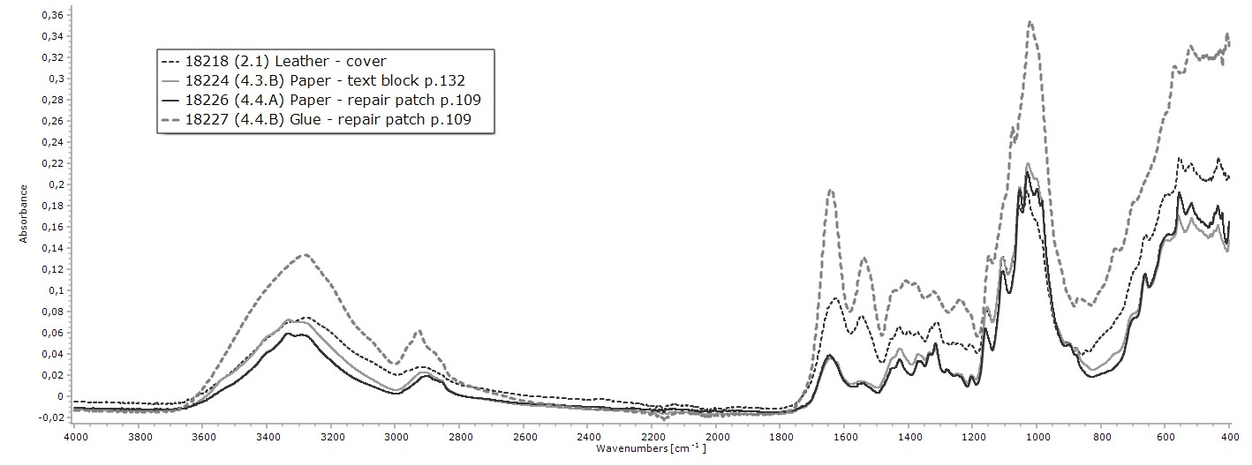
Supplemental figure 1: ATR-FTIR spectra of leather, paper and glue. All spectra shown in absorbance mode. Amide I (between 1600 and 1700 cm⁻¹) and amide II (between 1510 and 1580 cm⁻¹) bands are two major bands of the protein.

References
Panciera, W. 2006. The industries of Venice in the Seventeenth and Eighteenth centuries, in at the centre of the Old World. In: Lanaro P editor. Trade and Manufacturing in Venice and the venetian mainland, 1400-1800. p. 185-214.

