SUPPLEMENTAL MATERIAL

Supplemental Table 1 Objects associated with El Japón Burials
Reproduced from the original site excavation report Proyecto de Rescate Arqueológico San Gregorio Atlapulco (Ávila López 1995).
Burial Number | Burial Type | Sex¹ | Object | Count | Area of Body²
78 | Primary | M | Figurine fragment | 1 | Head
82 | Primary | I | Bead | 26 | Neck
160 | Primary | F* | Bead | 2 | Head
161 | Primary | M* | Bead | 8 | Arm
182 | Primary | F* | Bead | 1 | -
198 | Primary | I* | Copper bell | 1 | Torso
209 | Primary | F* | Spindle whorl | 1 | -
212 | Primary | I | Spindle whorl | 1 | -
233 | Primary | F* | Copper bell | 6 | Feet
234 | Primary | M* | Bead | 1 | -
290 | Primary | M | Bead | 1 | -
323 | Primary | M* | Bead | 3 | -
346 | Primary | M | Spindle whorl | 1 | Neck
381 | Primary | F | Spindle whorl | 1 | Feet
388 | Primary | M | Bead | 6 | -

1. M-male, F-females, I-indeterminate. *Age estimates on subadults (mean age-at-death <15) are not routinely assessed.
2. Omitted entries in the site report may indicate unclear association to the burial.

OXCAL MODEL CODES
Model 1 Human Bone Collagen ¹⁴C Dates, OxCal Code
Plot()
{
Sequence()
{
C_Date(1521);
Boundary(“Start Lower Burials ”);
Phase(“Lower Burials Collagen”)
{
R_Date(“Burial 50”, 399, 25)
{
Outlier();
};
R_Date(“Burial 180”, 330, 25);
R_Date(“Burial 145”, 360, 25);

R_Date(“Burial 87”, 360, 25);
R_Date(“Burial 90”, 299, 25);
};
Boundary(“End Lower burials”);
};
};
};

Model 1 Collagen ¹⁴C Dates, Results

 | Unmodelled |  |  |  | Modelled
 | 68.3% |  | 95.4% |  | 68.3% |  | 95.4%
 | From | To | From | To | From | To | From | To
Boundary, start |  |  |  |  | 1524 | 1578 | 1520 | 1617
Burial 50 | 1449 | 1491 | 1441 | 1622 | 1448 | 1492 | 1440 | 1623
Burial 180 | 1504 | 1635 | 1484 | 1639 | 1560 | 1631 | 1541 | 1639
Burial 145 | 1474 | 1623 | 1457 | 1634 | 1574 | 1622 | 1548 | 1635
Burial 87 | 1474 | 1622 | 1457 | 1634 | 1576 | 1623 | 1550 | 1634
Burial 90 | 1522 | 1644 | 1500 | 1655 | 1554 | 1640 | 1534 | 1647
Boundary, end |  |  |  |  | 1582 | 1653 | 1549 | 1730
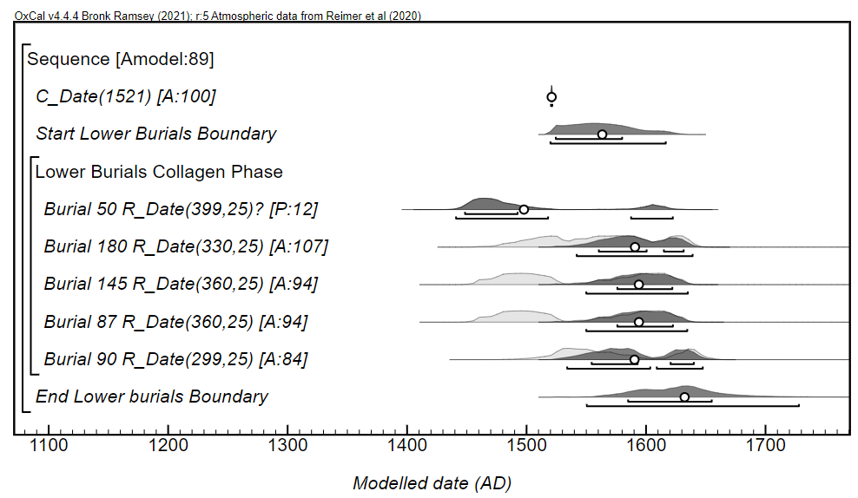
Model 2 Human Bone Bioapatite ¹⁴C Dates, OxCal Code
Plot()
{
Sequence()
{
C_Date(1521);
Boundary(“Start Lower Burials ”);
Phase(“Lower Burials Bioapatite”)
{
R_Date(“Burial 50”, 460, 30)
{
Outlier();
};
R_Date(“Burial 180”, 400, 35);
R_Date(“Burial 145”, 310, 25);
R_Date(“Burial 87”, 400, 35);
R_Date(“Burial 90”, 360, 40);
};
Boundary(“End Lower burials”);
};
};
};

Model 2 Bioapatite ¹⁴C Dates, Results

 | Unmodelled |  |  |  | Modelled
 | 68.3% |  | 95.4% |  | 68.3% |  | 95.4%
 | From | To | From | To | From | To | From | To
Boundary, start |  |  |  |  | 1548 | 1605 | 1523 | 1613
Burial 50 | 1427 | 1452 | 1412 | 1471 | 1427 | 1452 | 1412 | 1471
Burial 180 | 1446 | 1615 | 1435 | 1631 | 1589 | 1620 | 1562 | 1631
Burial 145 | 1521 | 1641 | 1495 | 1647 | 1569 | 1635 | 1544 | 1643
Burial 87 | 1446 | 1615 | 1435 | 1631 | 1590 | 1620 | 1562 | 1631
Burial 90 | 1468 | 1628 | 1455 | 1636 | 1580 | 1624 | 1554 | 1636
Boundary, end |  |  |  |  | 1598 | 1649 | 1564 | 1712

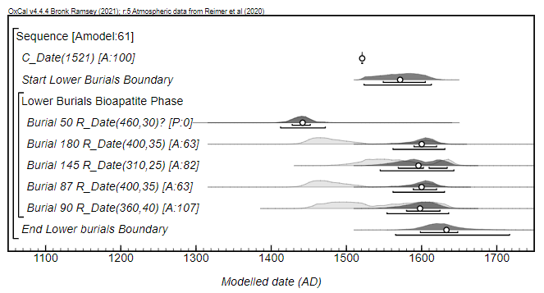
Model 3 Combined Collagen and Bioapatite ¹⁴C Dates, OxCal Code

Plot()
{
Sequence()
{
C_Date(1521);
Boundary(“Start Lower Burials ”);
Phase(“Lower Bur. Collagen Bioapatite Combined”)
{
R_Combine(“Bur. 50”)
{
R_Date(“Burial 50”, 399, 25);
R_Date(“Burial 50”, 460, 30);
};
Outlier();
};
R_Combine(“Bur. 180”)
{
R_Date(“Burial 180”, 330, 25);
R_Date(“Burial 180”, 400, 35);
};
R_Combine(“Bur. 145”)
{
R_Date(“Burial 145”, 360, 25);
R_Date(“Burial 145”, 310, 25);
};
R_Combine(“Bur. 87”)
{
R_Date(“Burial 87”, 360, 25);
R_Date(“Burial 87”, 400, 35);
};
R_Combine(“Bur. 90”)
{
R_Date(“Burial 90”, 299, 25);
R_Date(“Burial 90”, 360, 40);
};
Boundary(“End Lower Burials”);
};
};
};

Model 3 Combined Collagen and Bioapatite ¹⁴C Dates, Results

 | Unmodelled |  |  |  | Modelled
 | 68.3% |  | 95.4% |  | 68.3% |  | 95.4%
 | From | To | From | To | From | To | From | To
Boundary, start |  |  |  |  | 1540 | 1595 | 1522 | 1615
Burial 50 | 1442 | 1465 | 1434 | 1484 | 1443 | 1465 | 1434 | 1483
Burial 180 | 1480 | 1623 | 1462 | 1634 | 1583 | 1621 | 1560 | 1631
Burial 145 | 1503 | 1632 | 1487 | 1637 | 1571 | 1629 | 1554 | 1635
Burial 87 | 1460 | 1616 | 1453 | 1627 | 1588 | 1620 | 1563 | 1629
Burial 90 | 1521 | 1637 | 1495 | 1644 | 1564 | 1633 | 1545 | 1640
Boundary, end |  |  |  |  | 1593 | 1645 | 1564 | 1709

