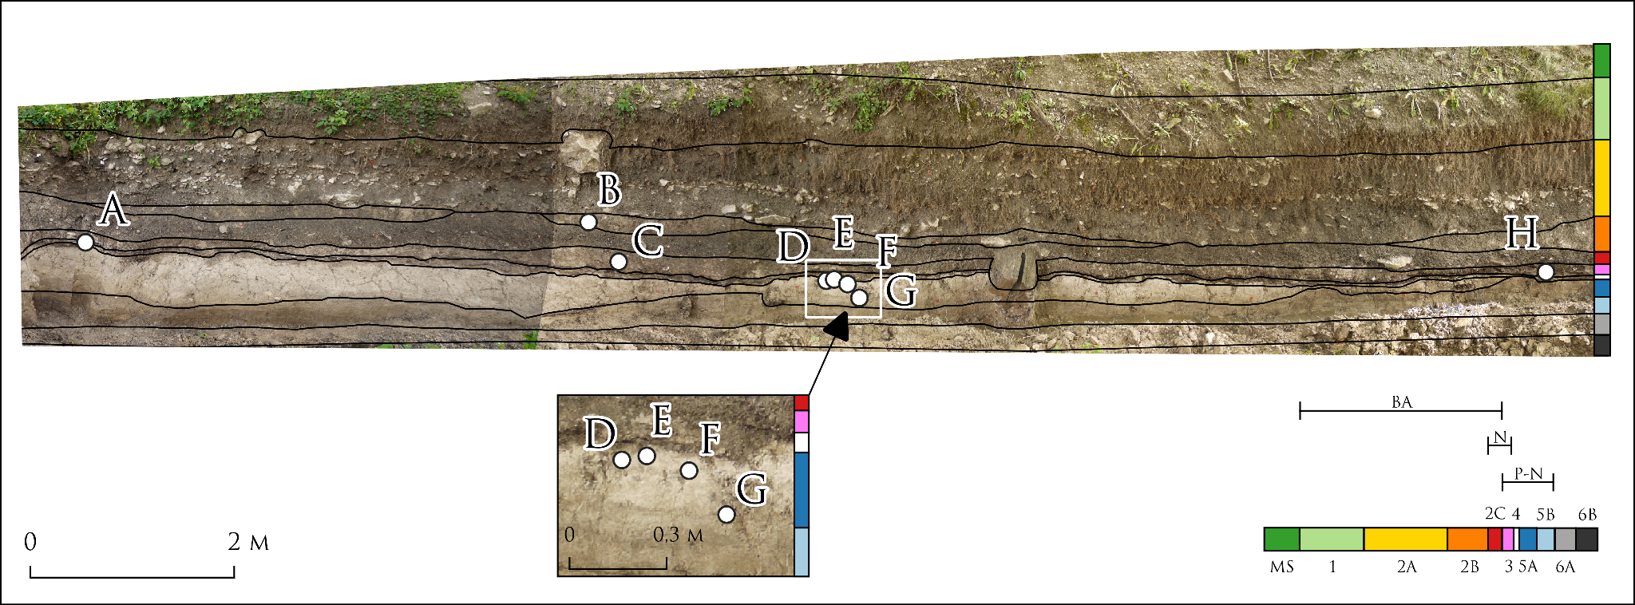
Supplement 1.1. Position of the radiocarbon dated pottery within the southern section of the Búr creek: A – GrA 56626; B – KB2; C – K11; D – K9, K9B; E – K10; F – K4; G – K8-2, K8-5; H – K23. The stratigraphic sequence of the section was divided into ten lithostratigraphic units (for their description, see table 1), which are colour-coded. The detail shows a part of the cross-section with lithostratigraphic unit 5a, that contained only grass-tempered pottery. Based on the archaeological material collected from the lithostratigraphic units it is possible to date the deposition and postdeposition processes. BA – Bronze Age; N - Neolithic; P-N – Pre-Neolithic; MS – modern surface.

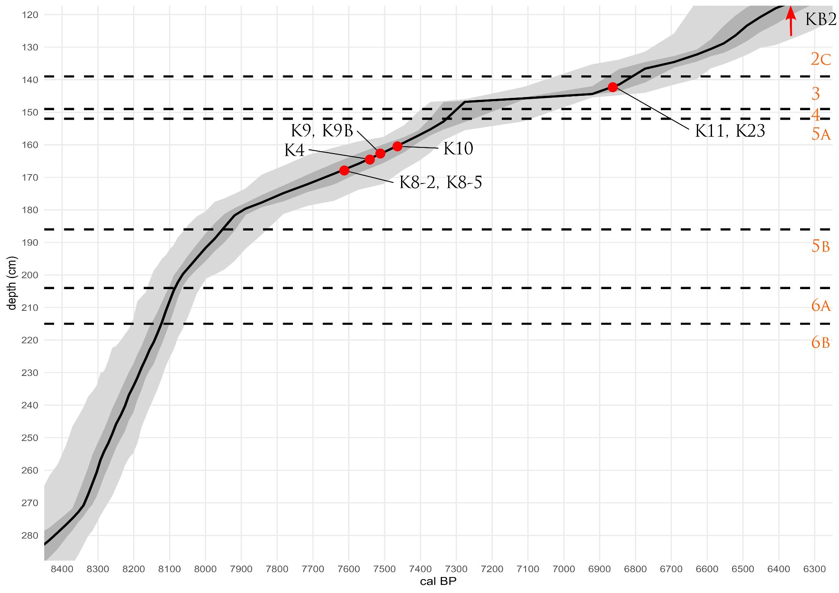

Supplement 1.2. Age-depth model (cal BP) of the section (based on Petřík et al. in prep.). Red – position of radiocarbon dated sherds; orange – lithostratigraphic units.

ID | Laboratory number | Description | Lithostratigraphy | Depth (cm) | Radiocarbon age | Literature
1 |  | ADM | border between 4 and 5a | 152 | 7309 ± 90 calBP | Petřík et al. in prep.
2 | GrA 56626 | OT | 4 | 153 | 6440 ± 140 BP | Šolcová et al. 2018
3 |  | ADM | border between 5a and 5b | 186 | 7940 ± 98 calBP | Petřík et al. in prep.
4 | UGAMS 10044 | BW | 5b | 215 | 7300 ± 30 BP | Šolcová et al. 2018
Supplement 1.3. Input data from site’s stratigraphic sequence used to calculate a chronostratigraphic Bayesian model. ADM – age-depth model; BW – bark and wood; OT – organic temper.

Plot()
{
Outlier_Model("General",T(5),U(0,4),"t");
Sequence("Chronostratigraphic model")
{
Boundary("Start unit 5b");
R_Date("UGAMS 10044",7300,30);
N("186 cm",1950-7940,58)
{
};
Boundary("End unit 5b");
Boundary("Start grass-tempered pottery (unit 5a)");
Phase("Grass-tempered pottery (unit 5a)")
{
KDE("Sum Grass-tempered pottery")
{
After("Unit 5a Bottom (age depth)")
{
N("186 cm",1950-7940,58)
{
};
};
R_Date("FTMC-YH59-6", 7201, 35)
{
Outlier(0.05);
};
R_Date("FTMC-YH59-7", 6959, 34)
{
Outlier(0.05);
};
R_Date("FTMC-YH59-9", 6874, 34)
{
Outlier(0.05);
};
R_Date("Beta-425294", 7060, 30)
{
Outlier(0.05);
};
R_Date("Beta-425293", 6850, 30)
{
Outlier(0.05);
};
R_Date("Beta-434617", 6670, 40)
{
Outlier(0.05);
};
R_Date("DeA-24372", 6668, 49)
{
Outlier(0.05);
};
R_Date("DeA-24373", 6612, 39)
{
Outlier(0.05);
};
R_Date("UGAMS 19701", 6470, 50)
{
Outlier(0.05);
};
R_Date("DeA-24370", 6449, 33)
{
Outlier(0.05);
};
color="#52854C";
R_Date("Beta-429295", 5810, 30)
{
Outlier(0.05);
};
R_Date("Beta-429296", 7310, 30)
{
Outlier(0.05);
};
R_Date("Beta-429297", 7760, 30)
{
Outlier(0.05);
};
Before("Unit 5a Top (age depth)")
{
N("152 cm",1950-7309,90)
{
};
};
};
};
color="#52854C";
Boundary("End grass-tempered pottery");
Boundary("Start unit 4");
N("152 cm",1950-7309,90)
{
};
R_Date("GrA 56626",6440,140);
};
};
Supplement 1.4. A chronostratigraphic model of the Santovka site (adapted after Petřík et al. 2022), based on data from sedimentary sequence (Supplement 1.1, 1.2) and radiocarbon dates from pottery (Table 3).

Name | Unmodelled (BC/AD) |  |  |  |  | Modelled (BC/AD) |  |  |  |  | Indices  A_{model} 13.7  A_{overall} 16.6
 | from | to | % | µ | σ | from | to | % | µ | σ | A_{comb} | A | L | P | C
Boundary End unit 4
Boundary End unit 4
R_Date GrA 56626 | -5634 | -5058 | 95.4 | -5384 | 141 | -5380 | -5002 | 95.4 | -5204 | 102 |  | 62.7 |  |  | 99.8
N 152 cm | -5541 | -5181 | 95.4 | -5361 | 90 | -5424 | -5184 | 95.4 | -5310 | 60 |  | 107.2 |  |  | 99.9
Boundary Start unit 4 |  |  |  |  |  | -5461 | -5252 | 95.4 | -5366 | 53 |  |  |  |  | 99.8
Boundary End grass-tempered pottery |  |  |  |  |  | -5476 | -5310 | 95.4 | -5410 | 42 |  |  |  |  | 99.7
N 152 cm | -5541 | -5181 | 95.4 | -5361 | 90 | -5541 | -5180 | 95.4 | -5360 | 90 |  | 100 |  |  | 99.9
Before Unit 5a Top (age depth) | ... | -5510.65 | 95.4
R_Date Beta-429297 | -6648 | -6498 | 95.4 | -6580 | 45 | -6087 | -5437 | 95.4 | -5778 | 185 |  | 5.4 |  |  | 92.9
R_Date Beta-429296 | -6228 | -6081 | 95.4 | -6155 | 45 | -6131 | -5442 | 95.4 | -5860 | 222 |  | 32.2 |  | 35.3 | 94.4
R_Date Beta-429295 | -4775 | -4549 | 95.4 | -4662 | 49 | -6034 | -5381 | 95.4 | -5665 | 184 |  | 5.5 |  |  | 97.6
R_Date DeA-24370 | -5479 | -5334 | 95.4 | -5416 | 36 | -5619 | -5358 | 95.4 | -5454 | 60 |  | 101.9 |  | 94.7 | 99.8
R_Date UGAMS 19701 | -5525 | -5321 | 95.4 | -5423 | 49 | -5609 | -5370 | 95.4 | -5467 | 73 |  | 96 |  | 96.2 | 99.8
R_Date DeA-24373 | -5621 | -5480 | 95.4 | -5552 | 42 | -5621 | -5480 | 95.4 | -5557 | 60 |  | 102.1 |  | 97.7 | 99.9
R_Date DeA-24372 | -5666 | -5481 | 95.4 | -5585 | 47 | -5668 | -5481 | 95.4 | -5587 | 52 |  | 103.2 |  | 98.5 | 99.9
R_Date Beta-434617 | -5661 | -5484 | 95.4 | -5587 | 40 | -5665 | -5483 | 95.4 | -5590 | 51 |  | 102.7 |  | 98.2 | 99.9
R_Date Beta-425293 | -5801 | -5661 | 95.4 | -5729 | 37 | -5829 | -5658 | 95.4 | -5728 | 45 |  | 102.7 |  | 98.1 | 99.9
R_Date Beta-425294 | -6012 | -5850 | 95.4 | -5940 | 37 | -6016 | -5840 | 95.4 | -5925 | 62 |  | 97.5 |  | 96.5 | 99.4
R_Date FTMC-YH59-9 | -5840 | -5669 | 95.4 | -5759 | 41 | -5841 | -5668 | 95.4 | -5758 | 47 |  | 103 |  | 98.2 | 99.9
R_Date FTMC-YH59-7 | -5971 | -5741 | 95.4 | -5838 | 55 | -5971 | -5738 | 95.4 | -5833 | 59 |  | 103.8 |  | 98.2 | 99.9
R_Date FTMC-YH59-6 | -6216 | -5988 | 95.4 | -6058 | 46 | -6091 | -5478 | 95.4 | -5950 | 164 |  | 77 |  | 76.2 | 94.6
N 186 cm | -6108 | -5876 | 95.4 | -5992 | 58 | -6108 | -5875 | 95.4 | -5991 | 58 |  | 99.9 |  |  | 99.8
After Unit 5a Bottom (age depth) | -5891.98 | ... | 95.4
U Sum Grass-tempered pottery_Scale | 9.97466e-18 | 1 | 95.4 | 0.5 | 0.285774 | 0.316 | 1 | 95.4 | 0.694495 | 0.202872 |  | 100 |  |  | 99.9
N Sum Grass-tempered pottery_Kernel | -2 | 2 | 95.4 | -3.64552e-9 | 1 | -2 | 2.01 | 95.4 | 0.0015709 | 1.00004 |  | 100 |  |  | 99.9
KDE_Model Sum Grass-tempered pottery |  |  |  |  |  |  |  |  | -5705 | 191 |  |  |  |  | 99.7
Phase Grass-tempered pottery (unit 5a)
Boundary Start grass tempered pottery (unit 5a) |  |  |  |  |  | -6152 | -5882 | 95.4 | -6039 | 73 |  |  |  |  | 92
Boundary End unit 5b |  |  |  |  |  | -6176 | -5946 | 95.4 | -6077 | 57 |  |  |  |  | 97.1
N 186 cm | -6108 | -5876 | 95.4 | -5992 | 58 | -6187 | -5993 | 95.4 | -6096 | 47 |  | 38.8 |  |  | 98.3
R_Date UGAMS 10044 | -6226 | -6078 | 95.4 | -6154 | 44 | -6215 | -6074 | 95.4 | -6137 | 39 |  | 98.6 |  |  | 99.3
Boundary Start unit 5b |  |  |  |  |  | -6408 | -6070 | 95.4 | -6192 | 108 |  |  |  |  | 99.3
Sequence Chronostratigraphic model of the site
U(0,4) | 3.98986e-17 | 4 | 95.4 | 2 | 1.1431 | 2.46 | 3.336 | 95.4 | 2.85947 | 0.21418 |  | 100 |  |  | 55.8
T(5) | -2.65 | 2.65 | 95.4 | -2.26696e-8 | 1.29081 |  |  |  | -0.054228 | 1.33637 |  |  |  |  | 69
Outlier_Model General |  |  |  |  |  | -1195 | 1409 | 95.4 | -43 | 779 |  |  |  |  | 88.5
Supplement 1.5. Results of a chronostratigraphic Bayesian model performed above (Supplement 1.3). Highlighted (red) are dates of grass-tempered pottery, which are below the agreement index of 60%.

