SUPPLEMENTARY ONLINE MATERIAL
Figure S1a Plan of High Mound East Phase 2 (LBA) with domestic architecture. Radiocarbon dated Locus 46 lies above architecture of Phase 2 and below architecture of Phase 1 in the northwest part of Trench 5155/3044.
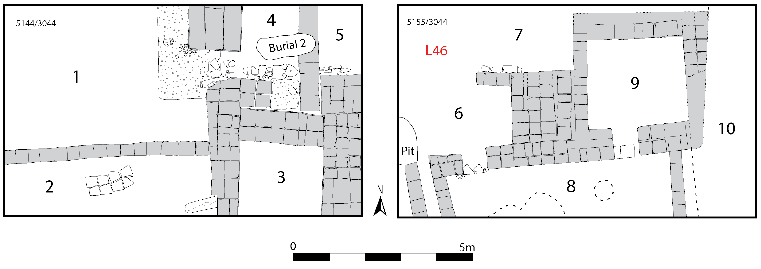
Figure S1b Plan of High Mound East Phase 1 (LBA) with burials and fragmentary architecture. Locations of radiocarbon dated loci (5 and 24) are marked. Locus 5 was a 2m × 6m north-south strip in the middle of Trench 5155/3044, above the Locus 24 pit.
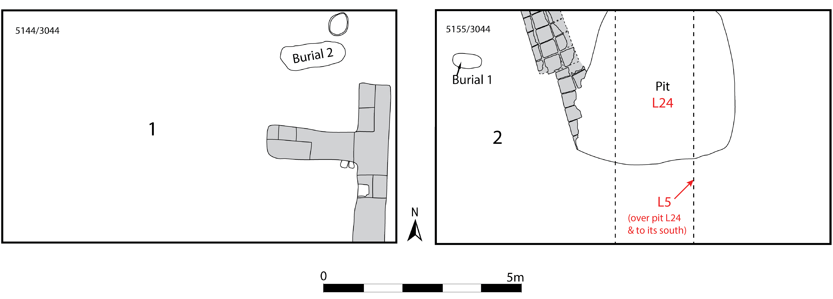

OxCal Code
Options()
{
Resolution=1;
};
Plot()
{
Outlier_Model("General",T(5),U(0,4),"t");
//Delta_R("Seasonal_Effect",19,5);
Sequence("KURD QABURSTAN")
{
Boundary("Start");
Phase("MBA settlement")
{
Label("LTNA Phase 2");
R_Date("GrM-19812 (4870/3217 L72)", 3517, 24)
{
Outlier("General",0.05);
};
Label("HMNS Phase 2");
R_Date("ETH-95763 (5072/3154 L21)", 3483, 24)
{
Outlier("General",0.05);
};
R_Date("ETH-95762 (5072/3164 L25)", 3469, 22)
{
Outlier("General",0.05);
};
R_Date("GrM-19811 (5072/3164 L25)", 3482, 24)
{
Outlier("General",0.05);
};
};
Boundary("End MBA settlement");
Phase("Occupation or data gap")
{
};
Boundary("Start LBA settlement");
Phase("HME Phase 3")
{
R_Date("GrM-19818 (5138/3051 L21)", 3379, 29)
{
Outlier();
};
R_Date("ETH-95767 (5144/3044 L144)", 3255, 24)
{
Outlier("General",0.05);
};
R_Date("GrM-19817 (5144/3044 L144)", 3220, 24)
{
Outlier("General",0.05);
};
R_Date("ETH-95768 (5144/3044 L140)", 3255, 23)
{
Outlier("General",0.05);
};
};
Boundary("Transition HME Phases 3 to 2");
Phase("HME Phase 2")
{
};
Boundary("End HME Phase 2");
Phase("Btwn HME btwn Phases 1 & 2")
{
R_Date("ETH-95764 (5155/3044 L46)", 3204, 23)
{
Outlier("General",0.05);
};
R_Date("GrM-19813 (5155/3044 L46)", 3146, 24)
{
Outlier("General",0.05);
};
};
Boundary("Start HME Phase 1");
Phase("HME Phase 1")
{
R_Date("ETH-95765 (5155/3044 L24)", 3222, 23)
{
Outlier("General",0.05);
};
R_Date("ETH-95766 (5155/3044 L5)", 3205, 24)
{
Outlier("General",0.05);
};
};
Boundary("End HME Phase 1");
};
Axis(-2400,-1300);
};

