Calibration of multiple tree-ring blocks and its implication on the debate of Minoan Eruption of Santorini around 17th-16th century BCE
Harsh Raj^{1*}, Lior Regev¹, Elisabetta Boaretto¹
¹D-REAMS Radiocarbon Laboratory, Scientific Archaeology Unit, Weizmann Institute of Science, Rehovot, Israel
*Email: harsh.raj@weizmann.ac.il

Supplementary Material:
Table S1: Details of the Moving Average (MA) curve used in this study
Sr. No. | Name of the MA curves | Number of years averaged
1. | 13_year_running_average | 13
2. | 16_year_running_average | 16
3. | 22_year_running_average | 22
4. | 24_year_running_average | 24
5. | 27_year_running_average | 27
6. | 30_year_running_average | 30

Table S2: OxCal script and output of two models used for benchmarking moving average calibration method
Moving average curve | Output
1. Ring count accurate  Plot()  {  D_Sequence()  {  Curve("", "13_year_running_average");  R_Date("Sample-A", 3383, 11);  Gap(24, 0);  Curve("", "24_year_running_average");  R_Date("Sample-B", 3381, 11);  Gap(22, 0);  Curve("", "22_year_running_average");  R_Date("Sample-C", 3370, 14);  Gap(13, 0);  Curve("", "13_year_running_average");  R_Date("Sample-D", 3320, 21);  };  }; | 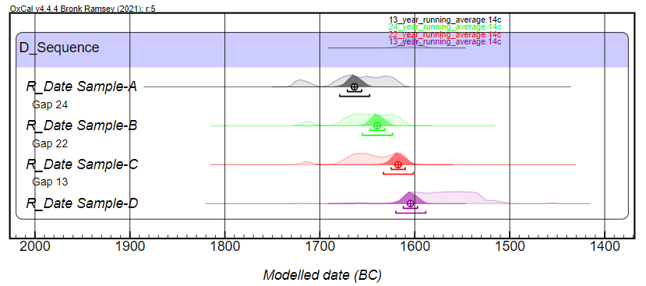
2. Considering only sequence  Plot()  {  Sequence()  {  Boundary("S");  Curve("", "13_year_running_average");  R_Date("Sample-A", 3383, 11);  Curve("", "24_year_running_average");  R_Date("Sample-B", 3381, 11);  Curve("", "22_year_running_average");  R_Date("Sample-C", 3370, 14);  Curve("", "13_year_running_average");  R_Date("Sample-D", 3320, 21);  Boundary("E");  };  }; | 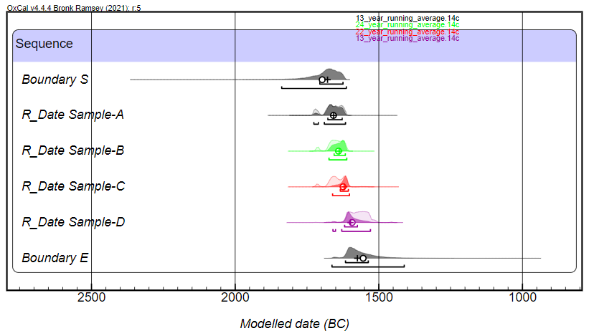

Table S3: OxCal script of four models described in Table 1 for calibration of olive branch radiocarbon ages (Friedrich et al., 2006)
IntCal13 | IntCal20 | Moving average curve
1. Ring count accurate  Plot()  {  Curve("IntCal13");  D_Sequence()  {  R_Date("Hd-23599-24426 1-13", 3383, 11);  Gap(18.5);  R_Date("Hd-23587 14-37", 3372, 12);  Gap(23);  R_Date("Hd-23589 38-59", 3349, 12);  Gap(17.5);  R_Date("Hd-23588-24402 60-72", 3331, 10);  Gap(6.5, 0);  Last("outermost ring");  };  }; | 1. Ring count accurate  Plot()  {  D_Sequence()  {  R_Date("Hd-23599-24426 1-13", 3383, 11);  Gap(18.5);  R_Date("Hd-23587 14-37", 3372, 12);  Gap(23);  R_Date("Hd-23589 38-59", 3349, 12);  Gap(17.5);  R_Date("Hd-23588-24402 60-72", 3331, 10);  Gap(6.5, 0);  Last("outermost ring");  };  }; | 1. Ring count accurate  Plot()  {  D_Sequence()  {  Curve("", "13_year_running_average");  R_Date("Hd-23599-24426", 3383, 11);  Gap(24, 0);  Curve("", "24_year_running_average");  R_Date("Hd-23587", 3372, 12);  Gap(22, 0);  Curve("", "22_year_running_average");  R_Date("Hd-23589", 3349, 12);  Gap(13, 0);  Curve("", "13_year_running_average");  R_Date("Hd-23588-24402", 3331, 10);  };  };
2. Ring count is increased by 25%, and gap uncertainty set to 25% of section count  Plot()  {  Curve("IntCal13");  V_Sequence()  {  R_Date("Hd-23599-24426 1-13", 3383, 11);  Gap(23,6);  R_Date("Hd-23587 14-37", 3372, 12);  Gap(29,7);  R_Date("Hd-23589 38-59", 3349, 12);  Gap(22,5);  R_Date("Hd-23588-24402 60-72", 3331, 10);  };  }; | 2. Ring count is increased by 25%, and gap uncertainty set to 25% of section count  Plot()  {  V_Sequence()  {  R_Date("Hd-23599-24426 1-13", 3383, 11);  Gap(23,6);  R_Date("Hd-23587 14-37", 3372, 12);  Gap(29,7);  R_Date("Hd-23589 38-59", 3349, 12);  Gap(22,5);  R_Date("Hd-23588-24402 60-72", 3331, 10);  };  }; | 2. Ring count is increased by 25%, and gap uncertainty set to 25% of section count  Options()  {  Resolution=4;  };  Plot()  {  V_Sequence()  {  Curve("", "16_year_running_average");  R_Date("Hd-23599-24426", 3383, 11);  Gap(30,7);  Curve("", "30_year_running_average");  R_Date("Hd-23587", 3372, 12);  Gap(27,7);  Curve("", "27_year_running_average");  R_Date("Hd-23589", 3349, 12);  Gap(16,4);  Curve("", "16_year_running_average");  R_Date("Hd-23588-24402", 3331, 10);  };  };
3. Considering only sequence  Plot()  {  Curve("IntCal13");  Sequence()  {  Boundary("S");  R_Date("innermost section",3383,11);  R_Date("second section",3372,12);  R_Date("third section",3349,12);  R_Date("outermost section",3331,10);  Boundary("E");  };  }; | 3. Considering only sequence  Plot()  {  Sequence()  {  Boundary("S");  R_Date("innermost section",3383,11);  R_Date("second section",3372,12);  R_Date("third section",3349,12);  R_Date("outermost section",3331,10);  Boundary("E");  };  }; | 3. Considering only sequence  Plot()  {  Sequence()  {  Boundary("S");  Curve("", "13_year_running_average");  R_Date("Hd-23599-24426", 3383, 11);  Curve("", "24_year_running_average");  R_Date("Hd-23587", 3372, 12);  Curve("", "22_year_running_average");  R_Date("Hd-23589", 3349, 12);  Curve("", "13_year_running_average");  R_Date("Hd-23588-24402", 3331, 10);  Boundary("E");  };  };
4. Considering only sequence (with 8 year offset as per Manning et al 2020)  Plot()  {  Curve("IntCal13");  Delta_R("8 14C year offset test",8,0);  Sequence("Friedrich et al. 2006 Olive as Sequence Only")  {  Boundary("Start");  Sequence()  {  R_Date( "Hd-23599-24426 'rings' 1-13", 3383, 11);  R_Date( "Hd-23587 'rings' 14-37", 3372, 12);  R_Date( "Hd-23589 'rings' 38-59", 3349, 12);  R_Date( "Hd-23588-24402 'rings' 60-72", 3331, 10);  };  Boundary("End");  };  }; | 4. Considering only sequence (with 8 year offset as per Manning et al 2020)  Plot( )  {  Delta_R("8 14C year offset test",8,0);  Sequence("Friedrich et al. 2006 Olive as Sequence Only")  {  Boundary("Start");  Sequence()  {  R_Date( "Hd-23599-24426 'rings' 1-13", 3383, 11);  R_Date( "Hd-23587 'rings' 14-37", 3372, 12);  R_Date( "Hd-23589 'rings' 38-59", 3349, 12);  R_Date( "Hd-23588-24402 'rings' 60-72", 3331, 10);  };  Boundary("End");  };  }; | 4. Considering only sequence (with 8 year offset as per Manning et al 2020)  Plot( )  {  Sequence()  {  Boundary("Start");  Curve("", "13_year_running_average");  Delta_R("a",8,0);  R_Date( "Hd-23599-24426 'rings' 1-13", 3383, 11);  Curve("", "24_year_running_average");  Delta_R("b",8,0);  R_Date( "Hd-23587 'rings' 14-37", 3372, 12);  Curve("", "22_year_running_average");  Delta_R("c",8,0);  R_Date( "Hd-23589 'rings' 38-59", 3349, 12);  Curve("", "13_year_running_average");  Delta_R("d",8,0);  R_Date( "Hd-23588-24402 'rings' 60-72", 3331, 10);  Boundary("End");  };  };
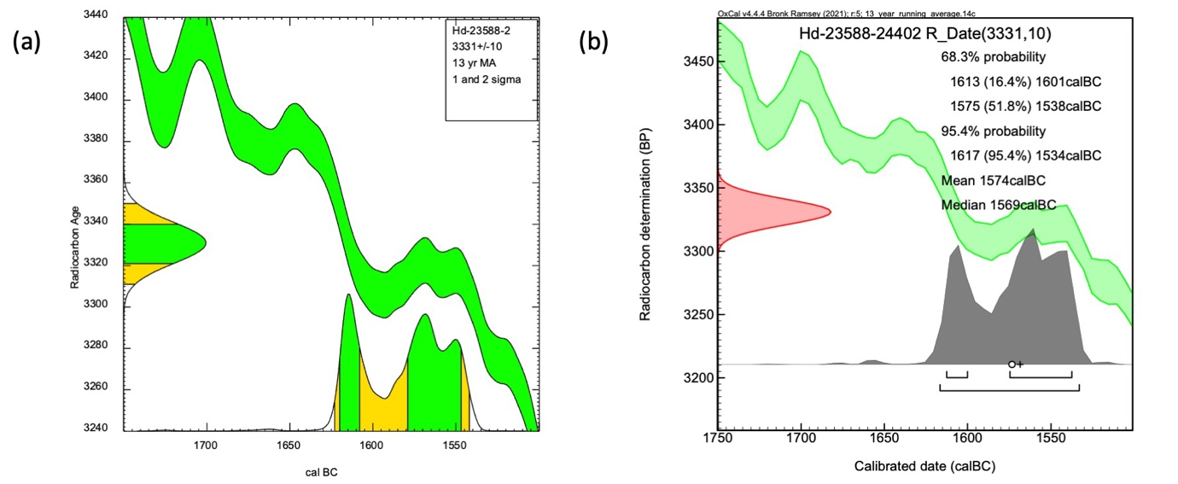
Figure S1: Calibration of radiocarbon age 3331 ± 10 yr BP using (a) smoothen IntCal20 curve with a 13 year moving average in CALIB and (b) 13 year moving average curve constructed in this study
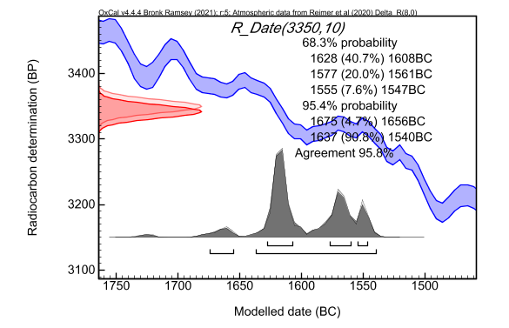
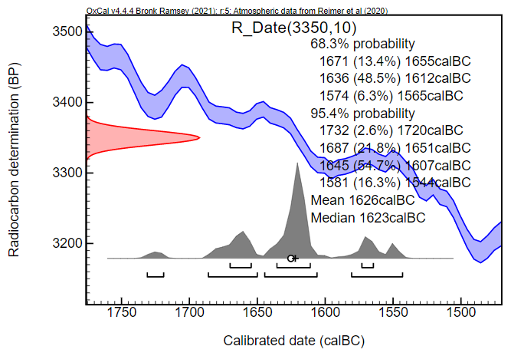
(a)
(b)

Figure S2: Calibration result of average radiocarbon age obtained from short-lived plant material from VDL in Santorini using IntCal20 curve (a) without any offset value, and (b) with an offset value of 8 years

