The Swan Point Site, Alaska: The Chronology of a Multi-component Archaeological Site in Eastern Beringia
– Supplemental Materials: Structures and Outputs for Sequential Phase Models

S1. Structure of Sequential Phase Model for Cultural Zones
S2. Chronological Query Language (CQL) for Sequential Phase Model for Cultural Zones
S3. Modelled Outputs for Sequential Phase Model for Cultural Zones
S4. Structure of Sequential Phase Model for Subzones of Cultural Zones
S5. Chronological Query Language (CQL) for Sequential Phase Model for Subzones of Cultural Zones
S6. Modelled Outputs for Sequential Phase Model for Subzones of Cultural Zones
S7. Structure of Sequential Phase Outlier Model for Cultural Zones
S8. Chronological Query Language (CQL) for Sequential Phase Outlier Model for Cultural Zones
S9. Modelled Outputs for Sequential Phase Outlier Model for Cultural Zones
S10. Structure of Sequential Phase Outlier Model for Subzones of Cultural Zones
S11. Chronological Query Language (CQL) for Sequential Phase Outlier Model for Subzones of Cultural Zones
S12. Modelled Outputs for Sequential Phase Outlier Model for Subzones of Cultural Zones

S1. Structure of Sequential Phase Model for Cultural Zones

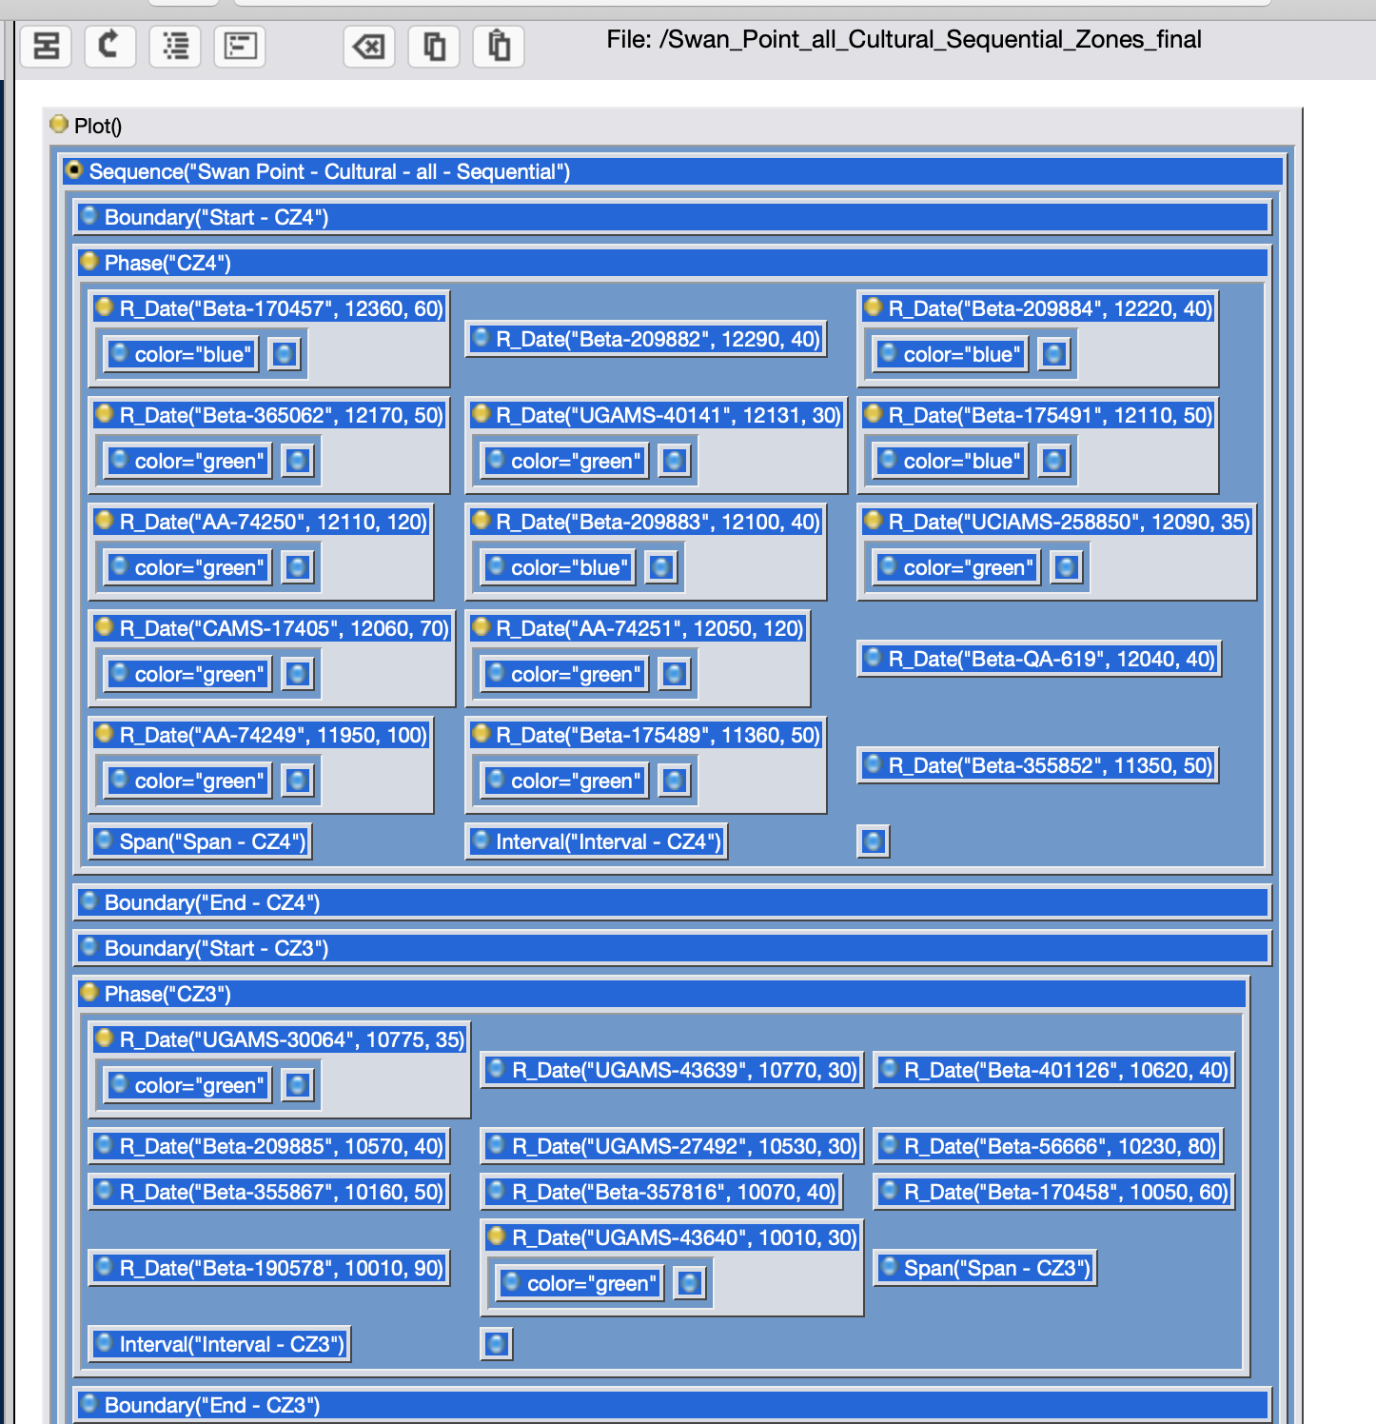
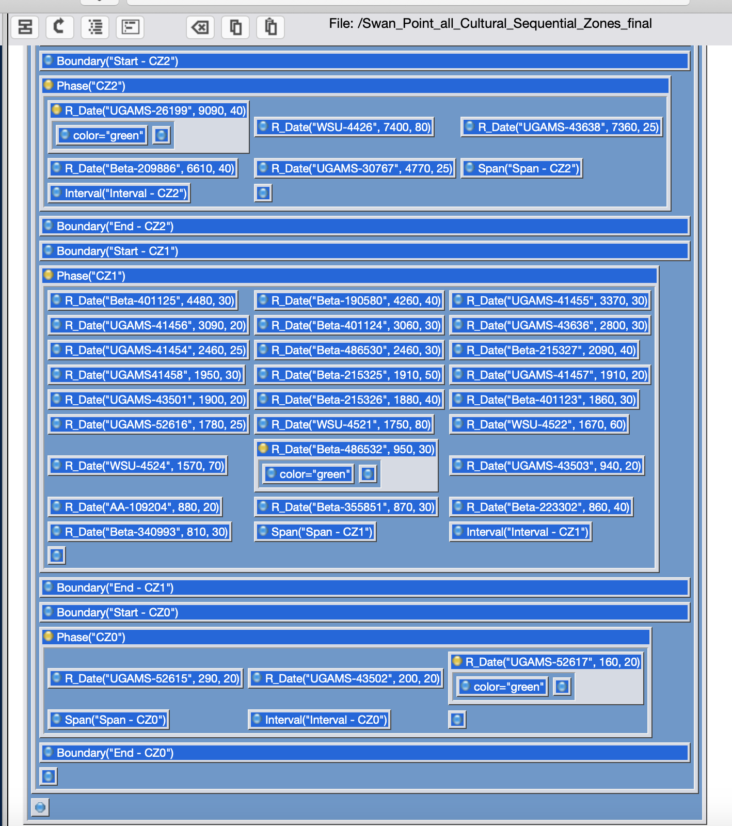

S2. Chronological Query Language (CQL) for Sequential Phase Model for Cultural Zones

Plot()
{
Sequence("Swan Point - Cultural - all - Sequential")
{
Boundary("Start - CZ4");
Phase("CZ4")
{
R_Date("Beta-170457", 12360, 60)
{
color="blue";
};
R_Date("Beta-209882", 12290, 40);
R_Date("Beta-209884", 12220, 40)
{
color="blue";
};
R_Date("Beta-365062", 12170, 50)
{
color="green";
};
R_Date("UGAMS-40141", 12131, 30)
{
color="green";
};
R_Date("Beta-175491", 12110, 50)
{
color="blue";
};
R_Date("AA-74250", 12110, 120)
{
color="green";
};
R_Date("Beta-209883", 12100, 40)
{
color="blue";
};
R_Date("UCIAMS-258850", 12090, 35)
{
color="green";
};
R_Date("CAMS-17405", 12060, 70)
{
color="green";
};
R_Date("AA-74251", 12050, 120)
{
color="green";
};
R_Date("Beta-QA-619", 12040, 40);
R_Date("AA-74249", 11950, 100)
{
color="green";
};
R_Date("Beta-175489", 11360, 50)
{
color="green";
};
R_Date("Beta-355852", 11350, 50);
Span("Span - CZ4");
Interval("Interval - CZ4");
};
Boundary("End - CZ4");
Boundary("Start - CZ3");
Phase("CZ3")
{
R_Date("UGAMS-30064", 10775, 35)
{
color="green";
};
R_Date("UGAMS-43639", 10770, 30);
R_Date("Beta-401126", 10620, 40);
R_Date("Beta-209885", 10570, 40);
R_Date("UGAMS-27492", 10530, 30);
R_Date("Beta-56666", 10230, 80);
R_Date("Beta-355867", 10160, 50);
R_Date("Beta-357816", 10070, 40);
R_Date("Beta-170458", 10050, 60);
R_Date("Beta-190578", 10010, 90);
R_Date("UGAMS-43640", 10010, 30)
{
color="green";
};
Span("Span - CZ3");
Interval("Interval - CZ3");
};
Boundary("End - CZ3");
Boundary("Start - CZ2");
Phase("CZ2")
{
R_Date("UGAMS-26199", 9090, 40)
{
color="green";
};
R_Date("WSU-4426", 7400, 80);
R_Date("UGAMS-43638", 7360, 25);
R_Date("Beta-209886", 6610, 40);
R_Date("UGAMS-30767", 4770, 25);
Span("Span - CZ2");
Interval("Interval - CZ2");
};
Boundary("End - CZ2");
Boundary("Start - CZ1");
Phase("CZ1")
{
R_Date("Beta-401125", 4480, 30);
R_Date("Beta-190580", 4260, 40);
R_Date("UGAMS-41455", 3370, 30);
R_Date("UGAMS-41456", 3090, 20);
R_Date("Beta-401124", 3060, 30);
R_Date("UGAMS-43636", 2800, 30);
R_Date("UGAMS-41454", 2460, 25);
R_Date("Beta-486530", 2460, 30);
R_Date("Beta-215327", 2090, 40);
R_Date("UGAMS41458", 1950, 30);
R_Date("Beta-215325", 1910, 50);
R_Date("UGAMS-41457", 1910, 20);
R_Date("UGAMS-43501", 1900, 20);
R_Date("Beta-215326", 1880, 40);
R_Date("Beta-401123", 1860, 30);
R_Date("UGAMS-52616", 1780, 25);
R_Date("WSU-4521", 1750, 80);
R_Date("WSU-4522", 1670, 60);
R_Date("WSU-4524", 1570, 70);
R_Date("Beta-486532", 950, 30)
{
color="green";
};
R_Date("UGAMS-43503", 940, 20);
R_Date("AA-109204", 880, 20);
R_Date("Beta-355851", 870, 30);
R_Date("Beta-223302", 860, 40);
R_Date("Beta-340993", 810, 30);
Span("Span - CZ1");
Interval("Interval - CZ1");
};
Boundary("End - CZ1");
Boundary("Start - CZ0");
Phase("CZ0")
{
R_Date("UGAMS-52615", 290, 20);
R_Date("UGAMS-43502", 200, 20);
R_Date("UGAMS-52617", 160, 20)
{
color="green";
};
Span("Span - CZ0");
Interval("Interval - CZ0");
};
Boundary("End - CZ0");
};
};

S3. Modelled Outputs for Sequential Phase Model for Cultural Zones

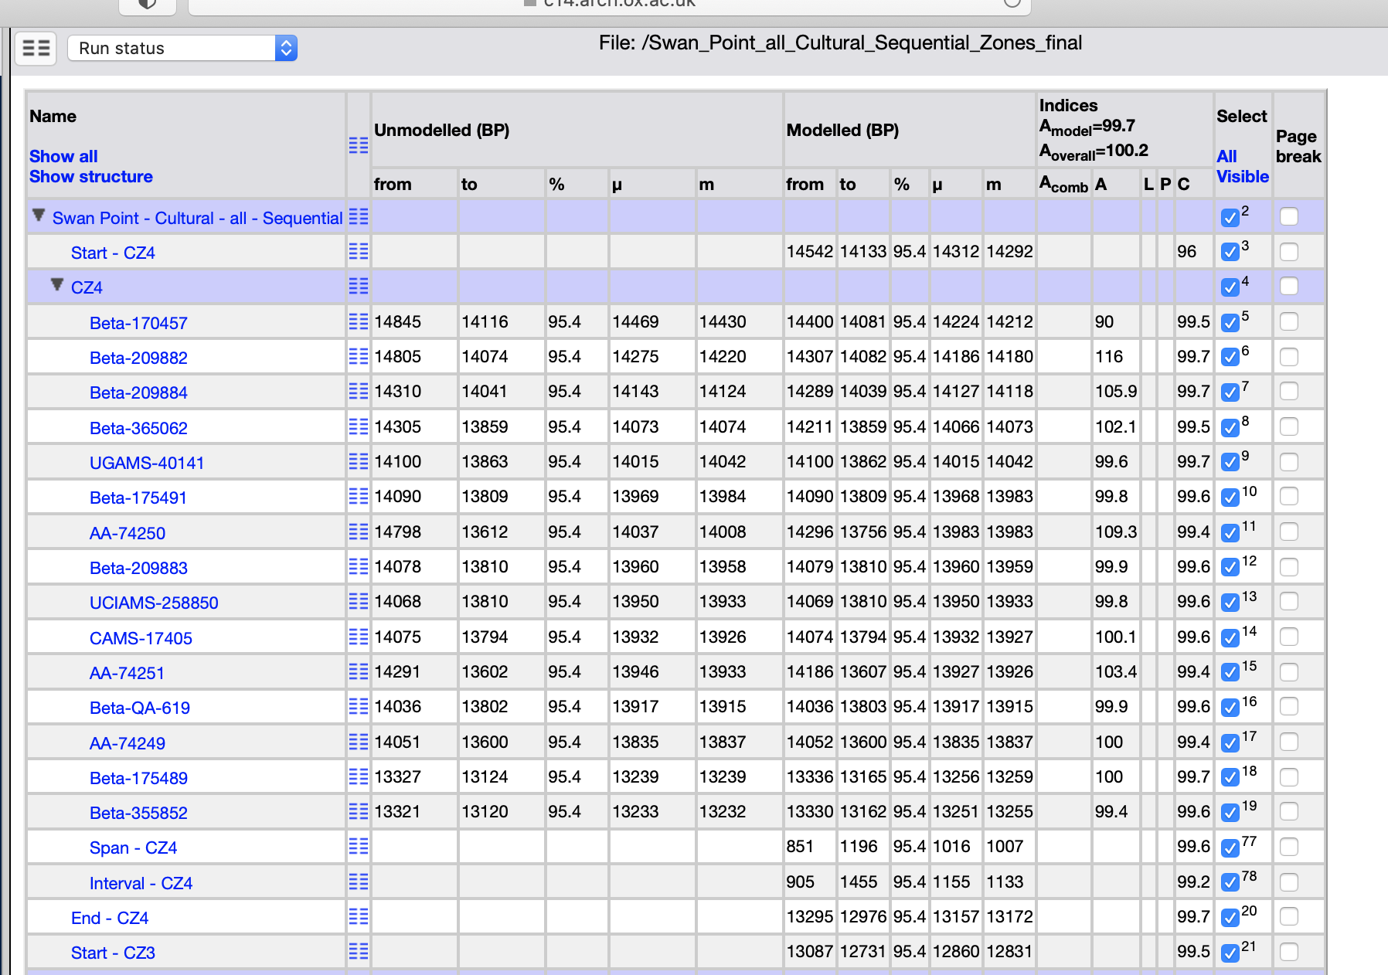
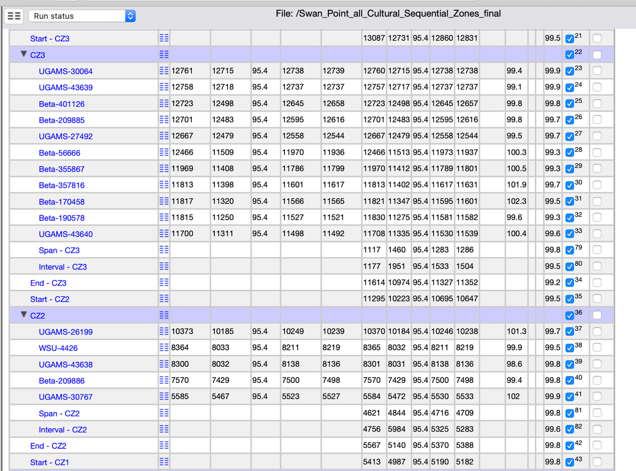
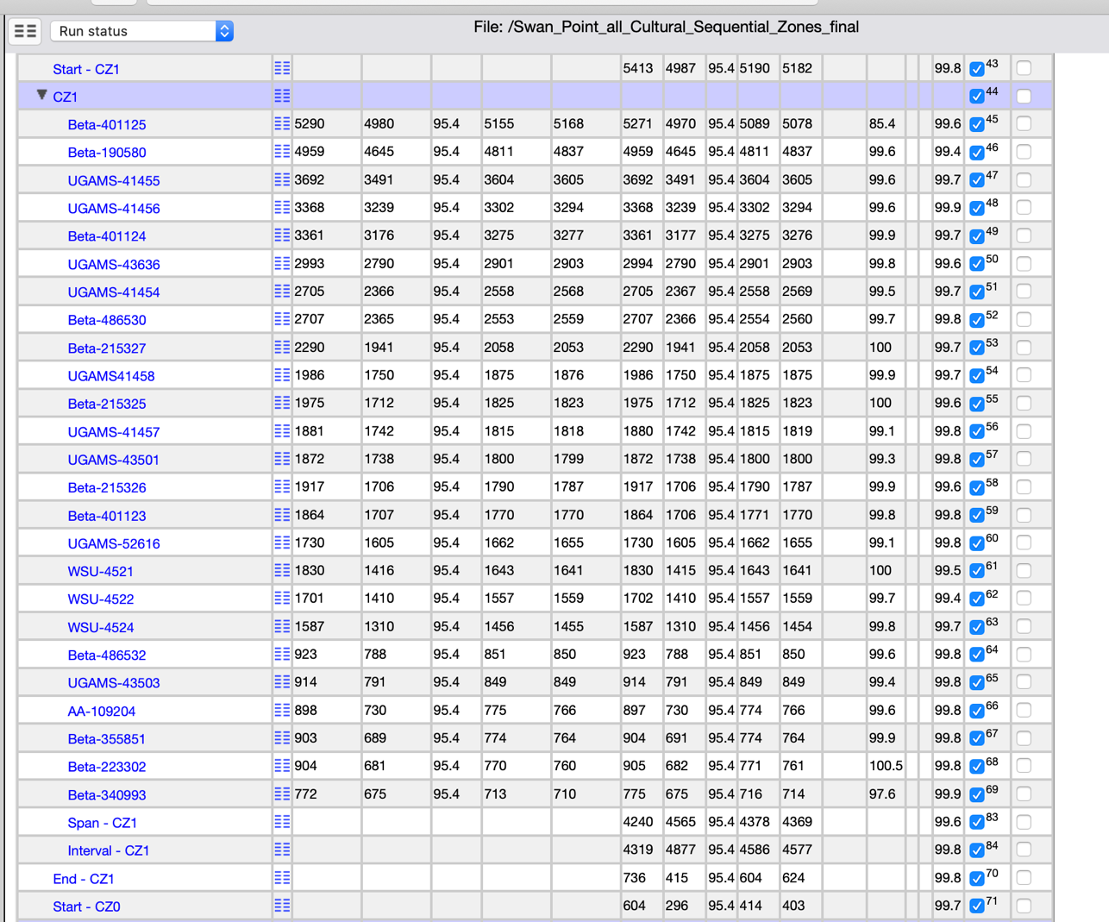
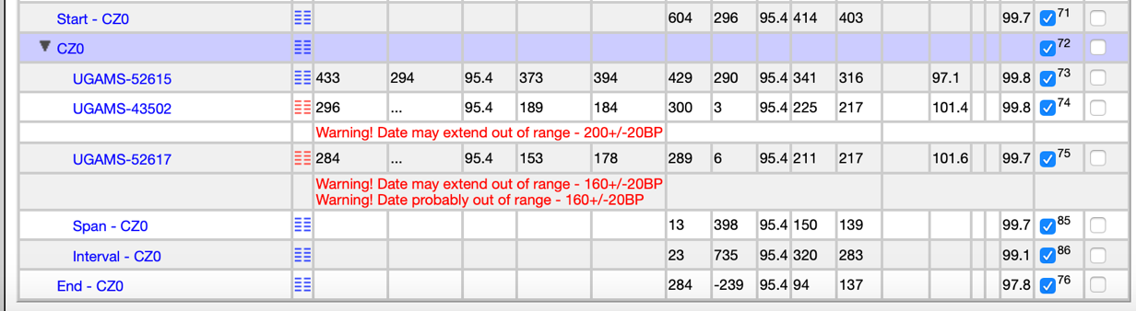

S4. Structure of Sequential Phase Model for Subzones of Cultural Zones

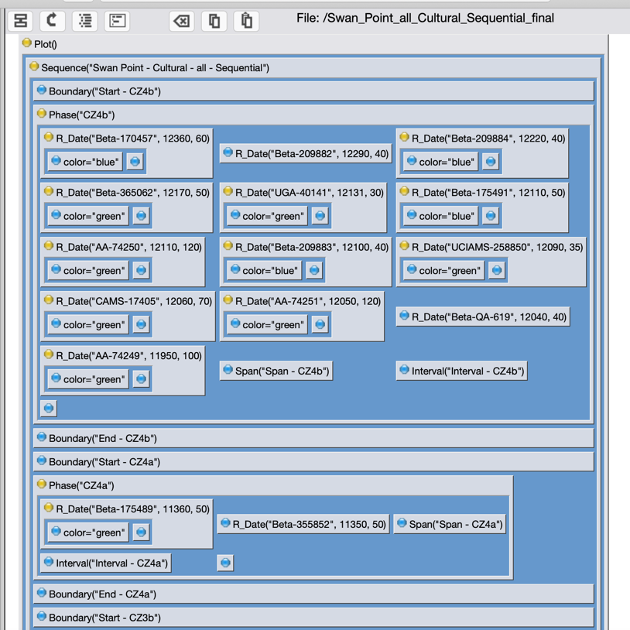
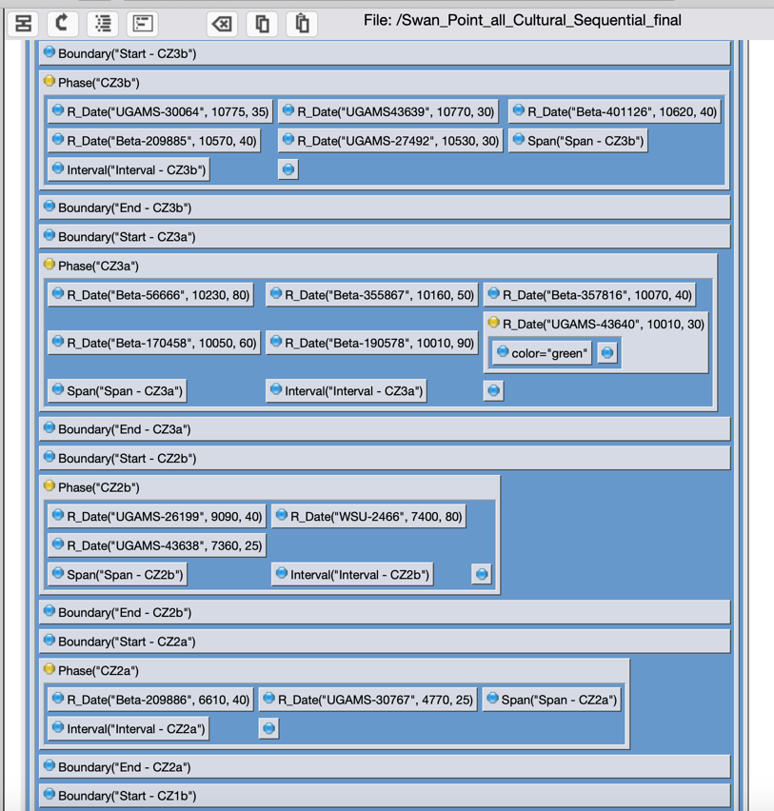
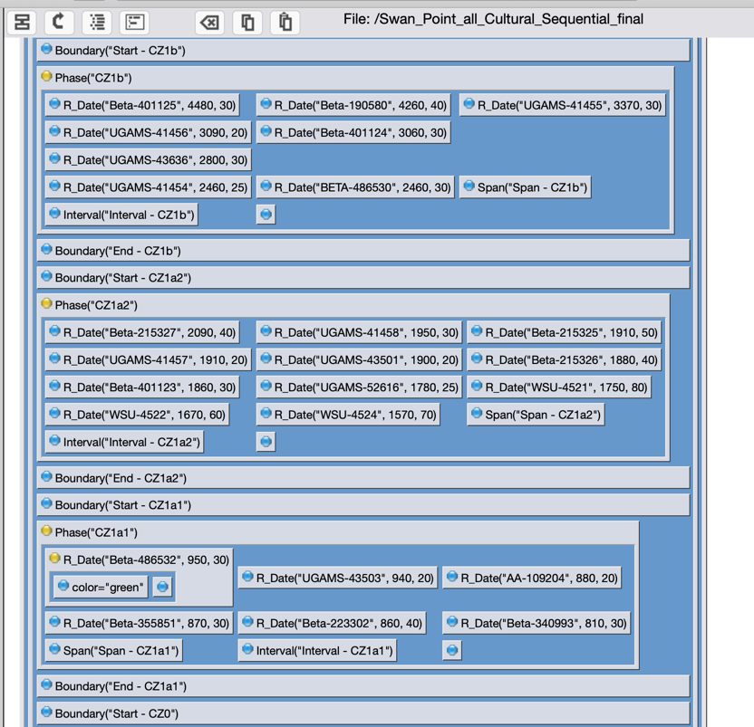
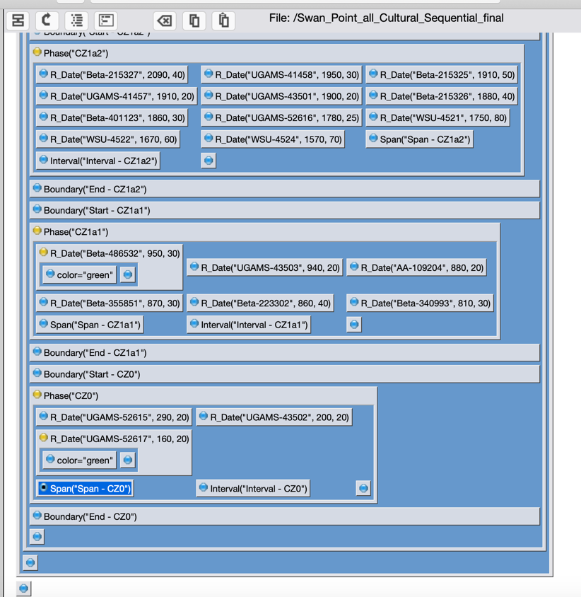

S5. Chronological Query Language (CQL) for Sequential Phase Model for Subzones of Cultural Zones

Plot()
{
Sequence("Swan Point - Cultural - all - Sequential")
{
Boundary("Start - CZ4b");
Phase("CZ4b")
{
R_Date("Beta-170457", 12360, 60)
{
color="blue";
};
R_Date("Beta-209882", 12290, 40);
R_Date("Beta-209884", 12220, 40)
{
color="blue";
};
R_Date("Beta-365062", 12170, 50)
{
color="green";
};
R_Date("UGA-40141", 12131, 30)
{
color="green";
};
R_Date("Beta-175491", 12110, 50)
{
color="blue";
};
R_Date("AA-74250", 12110, 120)
{
color="green";
};
R_Date("Beta-209883", 12100, 40)
{
color="blue";
};
R_Date("UCIAMS-258850", 12090, 35)
{
color="green";
};
R_Date("CAMS-17405", 12060, 70)
{
color="green";
};
R_Date("AA-74251", 12050, 120)
{
color="green";
};
R_Date("Beta-QA-619", 12040, 40);
R_Date("AA-74249", 11950, 100)
{
color="green";
};
Span("Span - CZ4b");
Interval("Interval - CZ4b");
};
Boundary("End - CZ4b");
Boundary("Start - CZ4a");
Phase("CZ4a")
{
R_Date("Beta-175489", 11360, 50)
{
color="green";
};
R_Date("Beta-355852", 11350, 50);
Span("Span - CZ4a");
Interval("Interval - CZ4a");
};
Boundary("End - CZ4a");
Boundary("Start - CZ3b");
Phase("CZ3b")
{
R_Date("UGAMS-30064", 10775, 35);
R_Date("UGAMS43639", 10770, 30);
R_Date("Beta-401126", 10620, 40);
R_Date("Beta-209885", 10570, 40);
R_Date("UGAMS-27492", 10530, 30);
Span("Span - CZ3b");
Interval("Interval - CZ3b");
};
Boundary("End - CZ3b");
Boundary("Start - CZ3a");
Phase("CZ3a")
{
R_Date("Beta-56666", 10230, 80);
R_Date("Beta-355867", 10160, 50);
R_Date("Beta-357816", 10070, 40);
R_Date("Beta-170458", 10050, 60);
R_Date("Beta-190578", 10010, 90);
R_Date("UGAMS-43640", 10010, 30)
{
color="green";
};
Span("Span - CZ3a");
Interval("Interval - CZ3a");
};
Boundary("End - CZ3a");
Boundary("Start - CZ2b");
Phase("CZ2b")
{
R_Date("UGAMS-26199", 9090, 40);
R_Date("WSU-2466", 7400, 80);
R_Date("UGAMS-43638", 7360, 25);
Span("Span - CZ2b");
Interval("Interval - CZ2b");
};
Boundary("End - CZ2b");
Boundary("Start - CZ2a");
Phase("CZ2a")
{
R_Date("Beta-209886", 6610, 40);
R_Date("UGAMS-30767", 4770, 25);
Span("Span - CZ2a");
Interval("Interval - CZ2a");
};
Boundary("End - CZ2a");
Boundary("Start - CZ1b");
Phase("CZ1b")
{
R_Date("Beta-401125", 4480, 30);
R_Date("Beta-190580", 4260, 40);
R_Date("UGAMS-41455", 3370, 30);
R_Date("UGAMS-41456", 3090, 20);
R_Date("Beta-401124", 3060, 30);
R_Date("UGAMS-43636", 2800, 30);
R_Date("UGAMS-41454", 2460, 25);
R_Date("BETA-486530", 2460, 30);
Span("Span - CZ1b");
Interval("Interval - CZ1b");
};
Boundary("End - CZ1b");
Boundary("Start - CZ1a2");
Phase("CZ1a2")
{
R_Date("Beta-215327", 2090, 40);
R_Date("UGAMS-41458", 1950, 30);
R_Date("Beta-215325", 1910, 50);
R_Date("UGAMS-41457", 1910, 20);
R_Date("UGAMS-43501", 1900, 20);
R_Date("Beta-215326", 1880, 40);
R_Date("Beta-401123", 1860, 30);
R_Date("UGAMS-52616", 1780, 25);
R_Date("WSU-4521", 1750, 80);
R_Date("WSU-4522", 1670, 60);
R_Date("WSU-4524", 1570, 70);
Span("Span - CZ1a2");
Interval("Interval - CZ1a2");
};
Boundary("End - CZ1a2");
Boundary("Start - CZ1a1");
Phase("CZ1a1")
{
R_Date("Beta-486532", 950, 30)
{
color="green";
};
R_Date("UGAMS-43503", 940, 20);
R_Date("AA-109204", 880, 20);
R_Date("Beta-355851", 870, 30);
R_Date("Beta-223302", 860, 40);
R_Date("Beta-340993", 810, 30);
Span("Span - CZ1a1");
Interval("Interval - CZ1a1");
};
Boundary("End - CZ1a1");
Boundary("Start - CZ0");
Phase("CZ0")
{
R_Date("UGAMS-52615", 290, 20);
R_Date("UGAMS-43502", 200, 20);
R_Date("UGAMS-52617", 160, 20)
{
color="green";
};
Span("Span - CZ0");
Interval("Interval - CZ0");
};
Boundary("End - CZ0");
};
};

S6. Modelled Outputs for Sequential Phase Model for Subzones of Cultural Zones

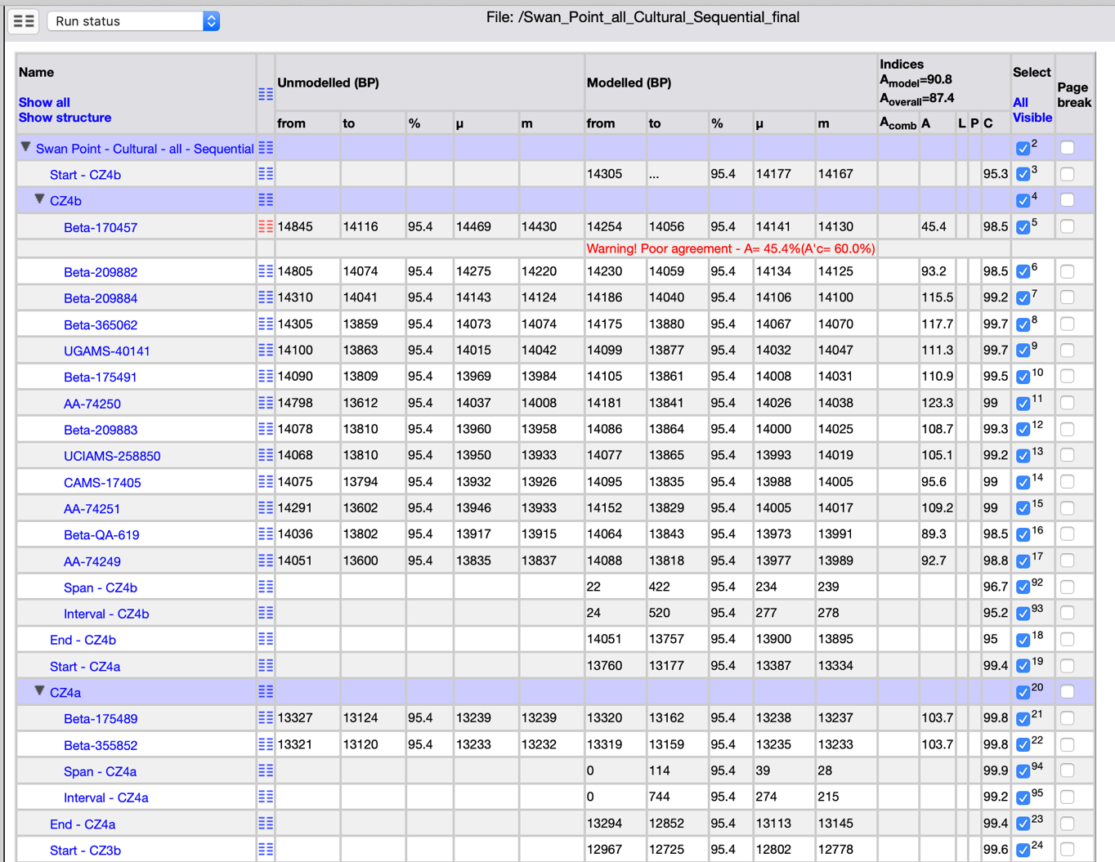
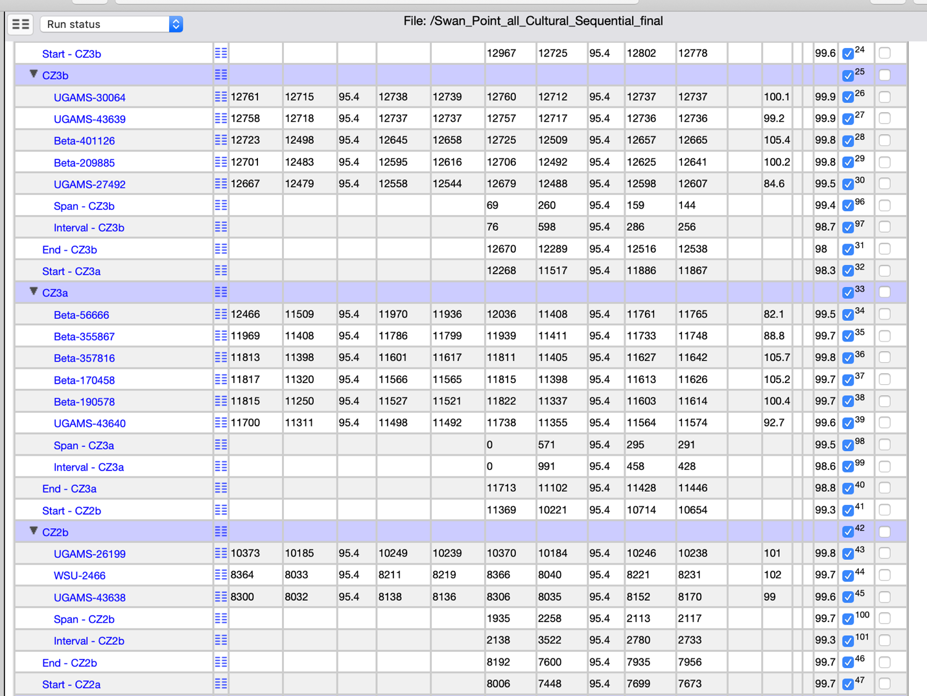
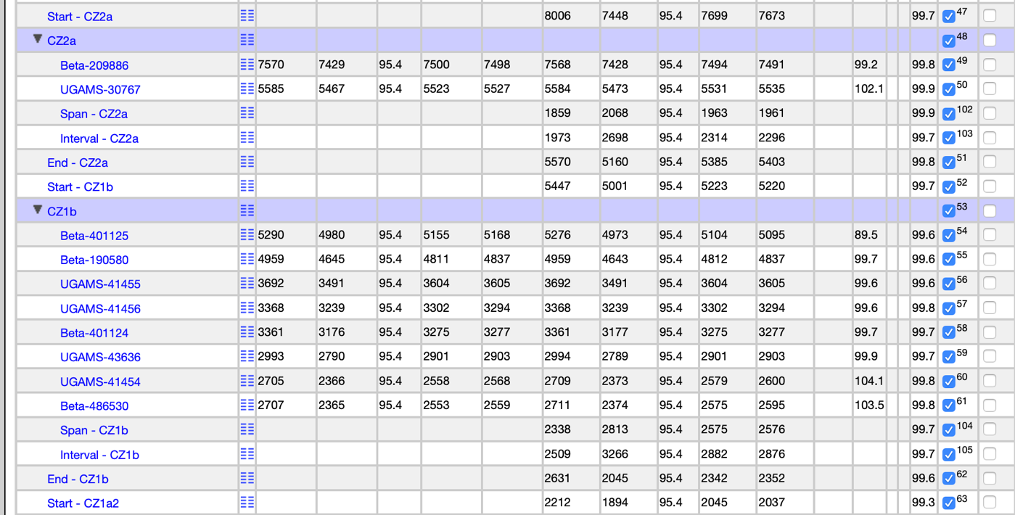
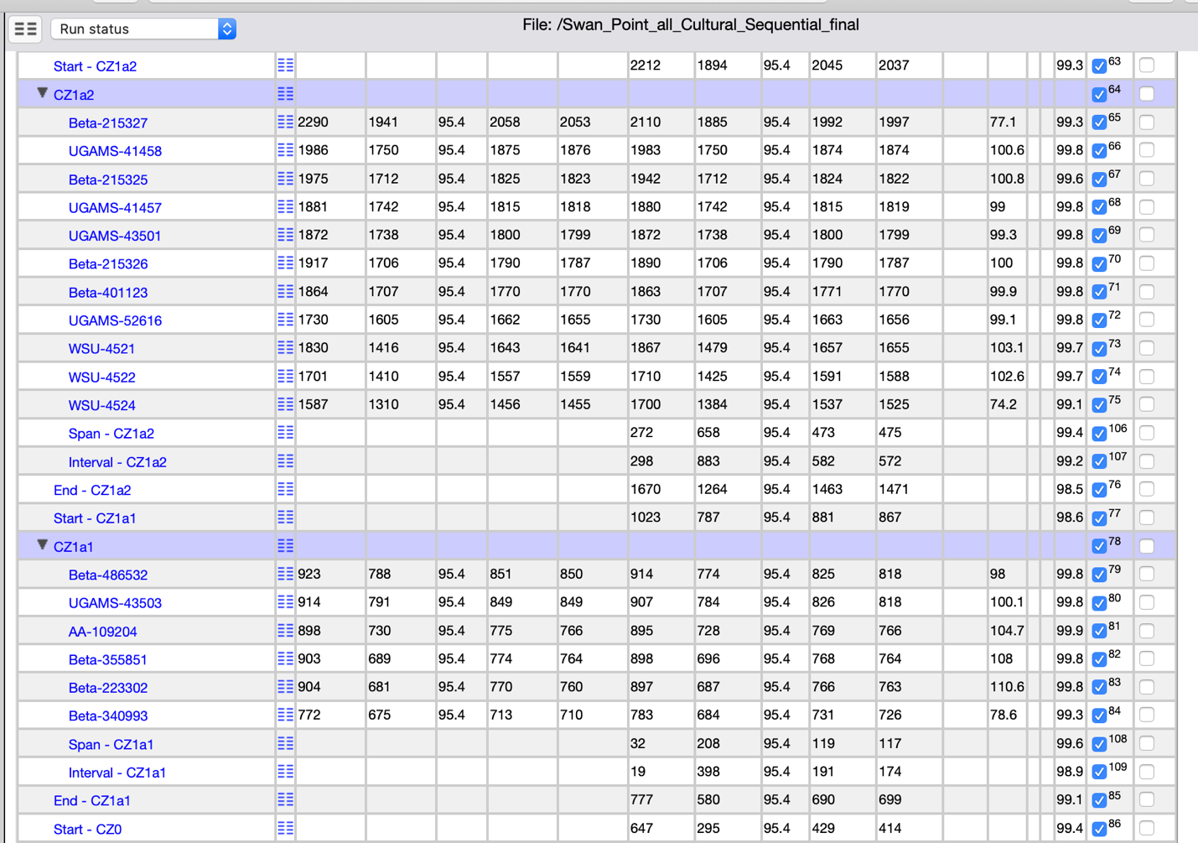
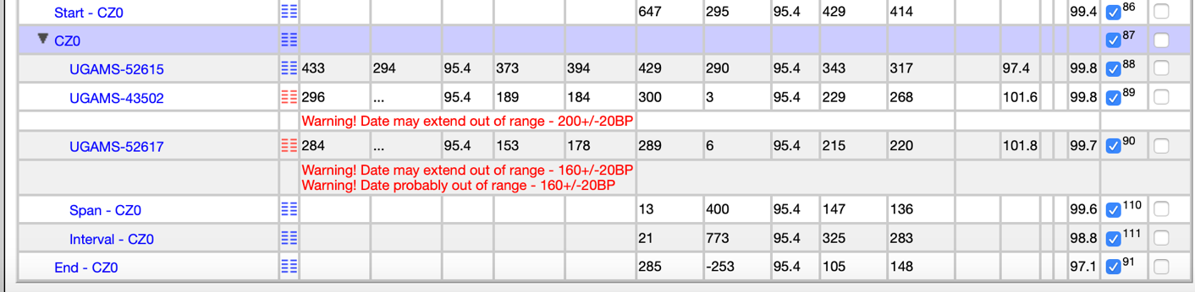

S7. Structure of Sequential Phase Outlier Model for Cultural Zones

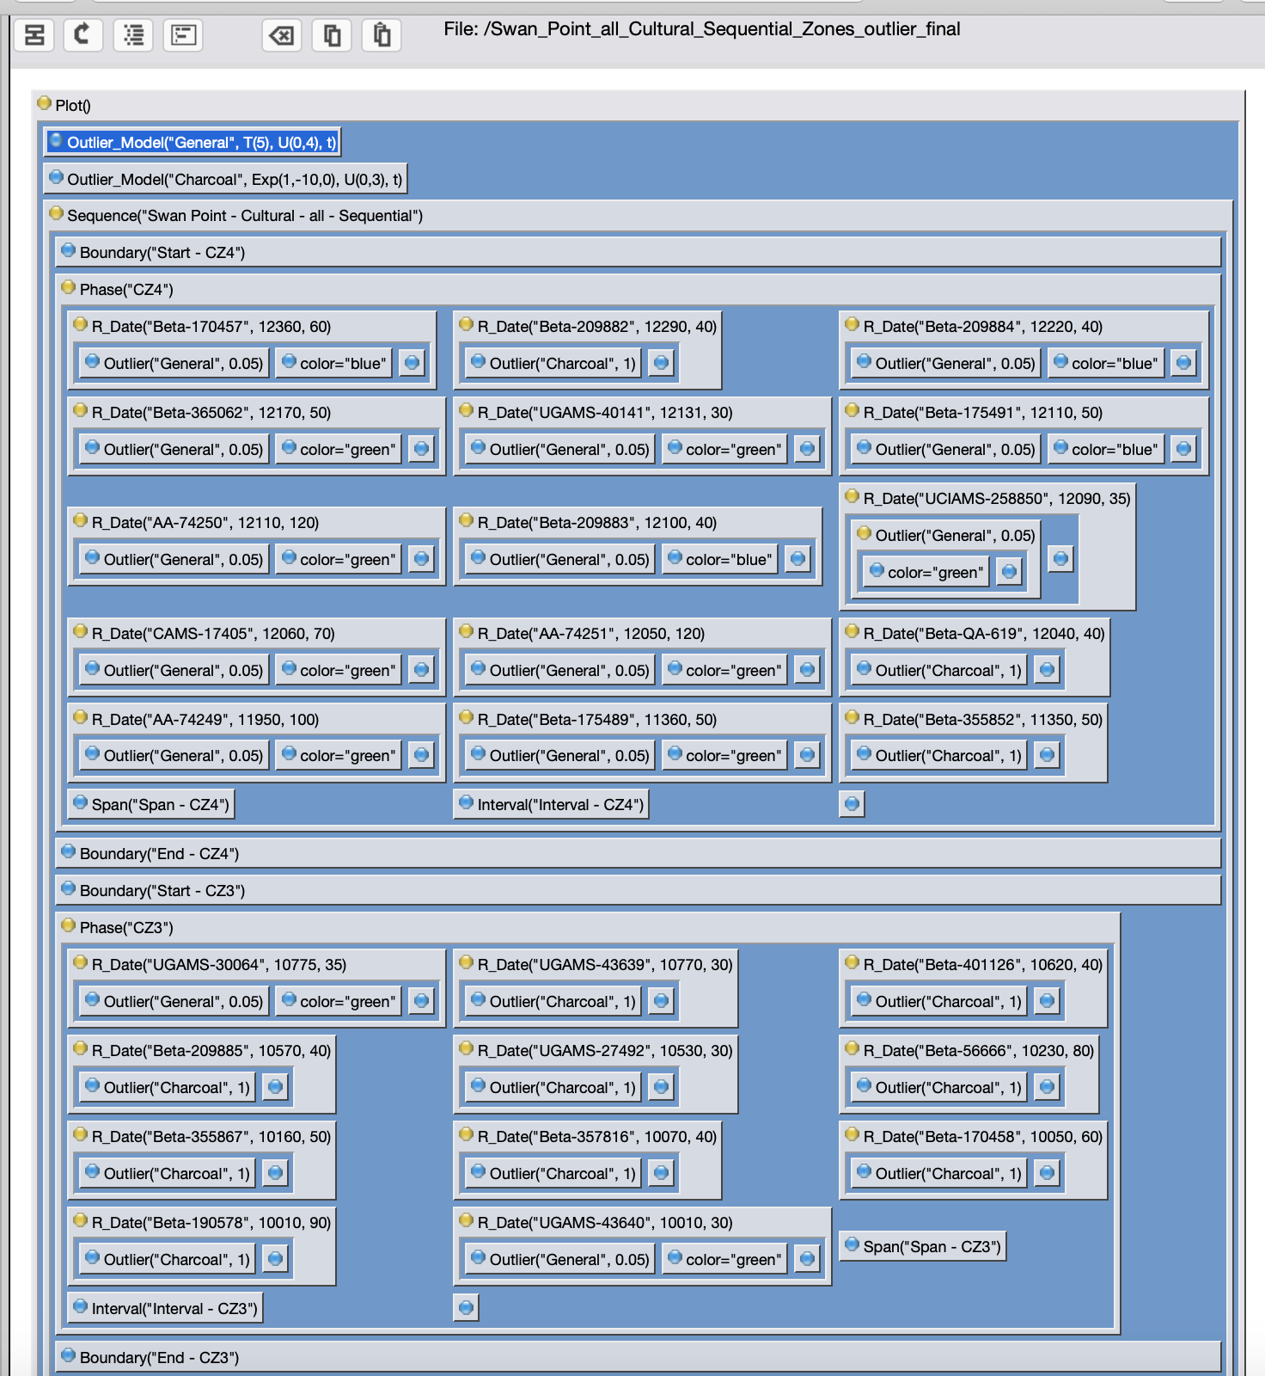
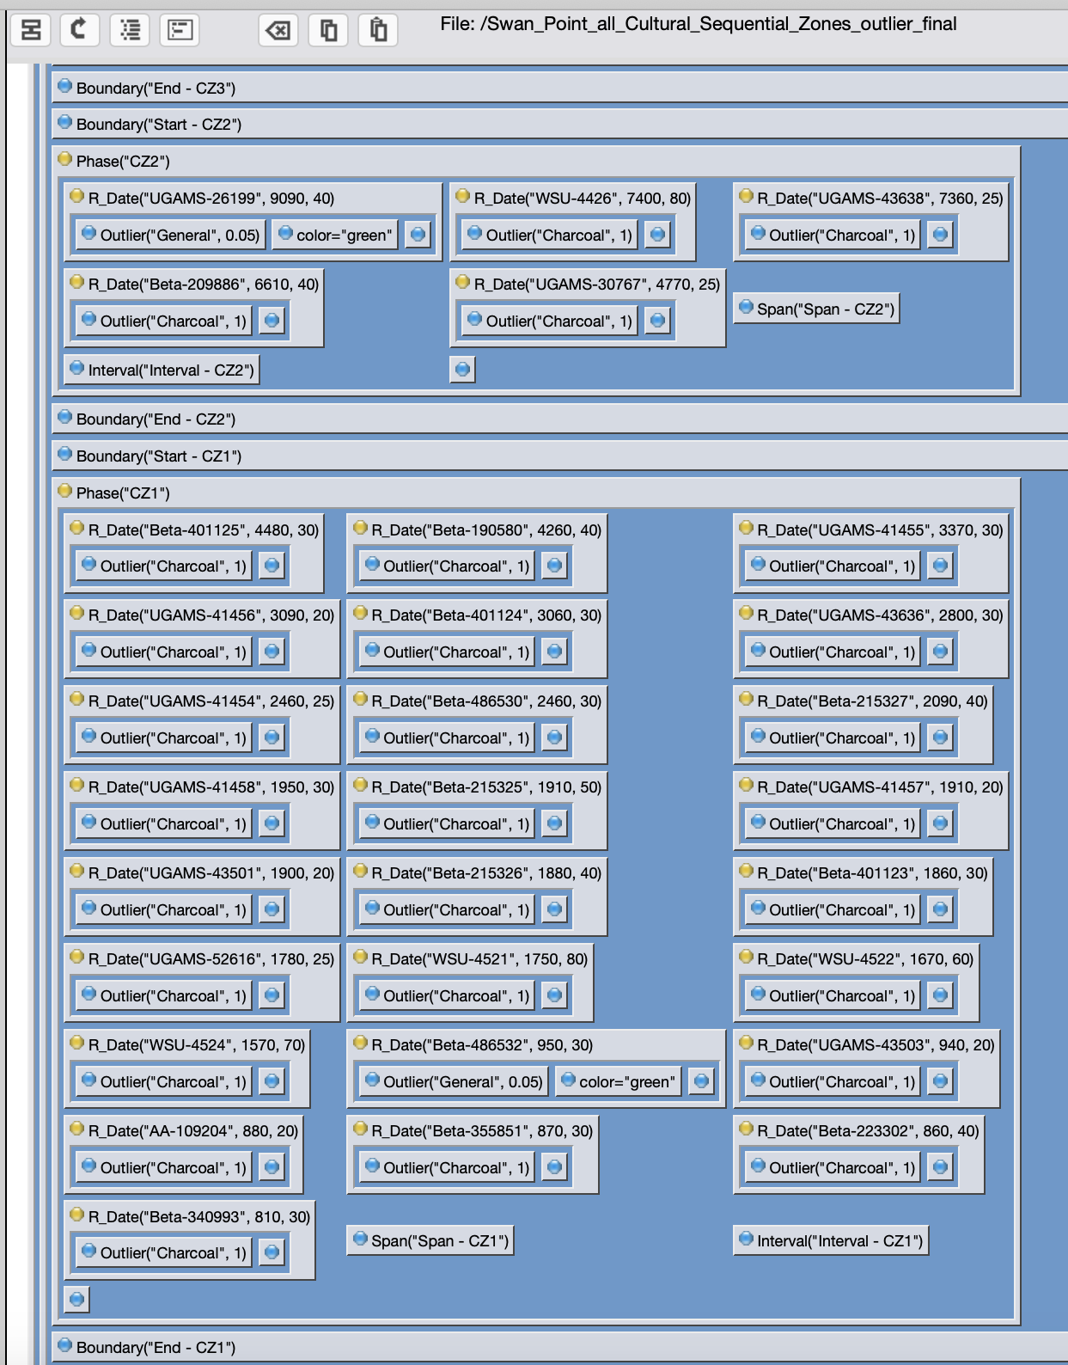
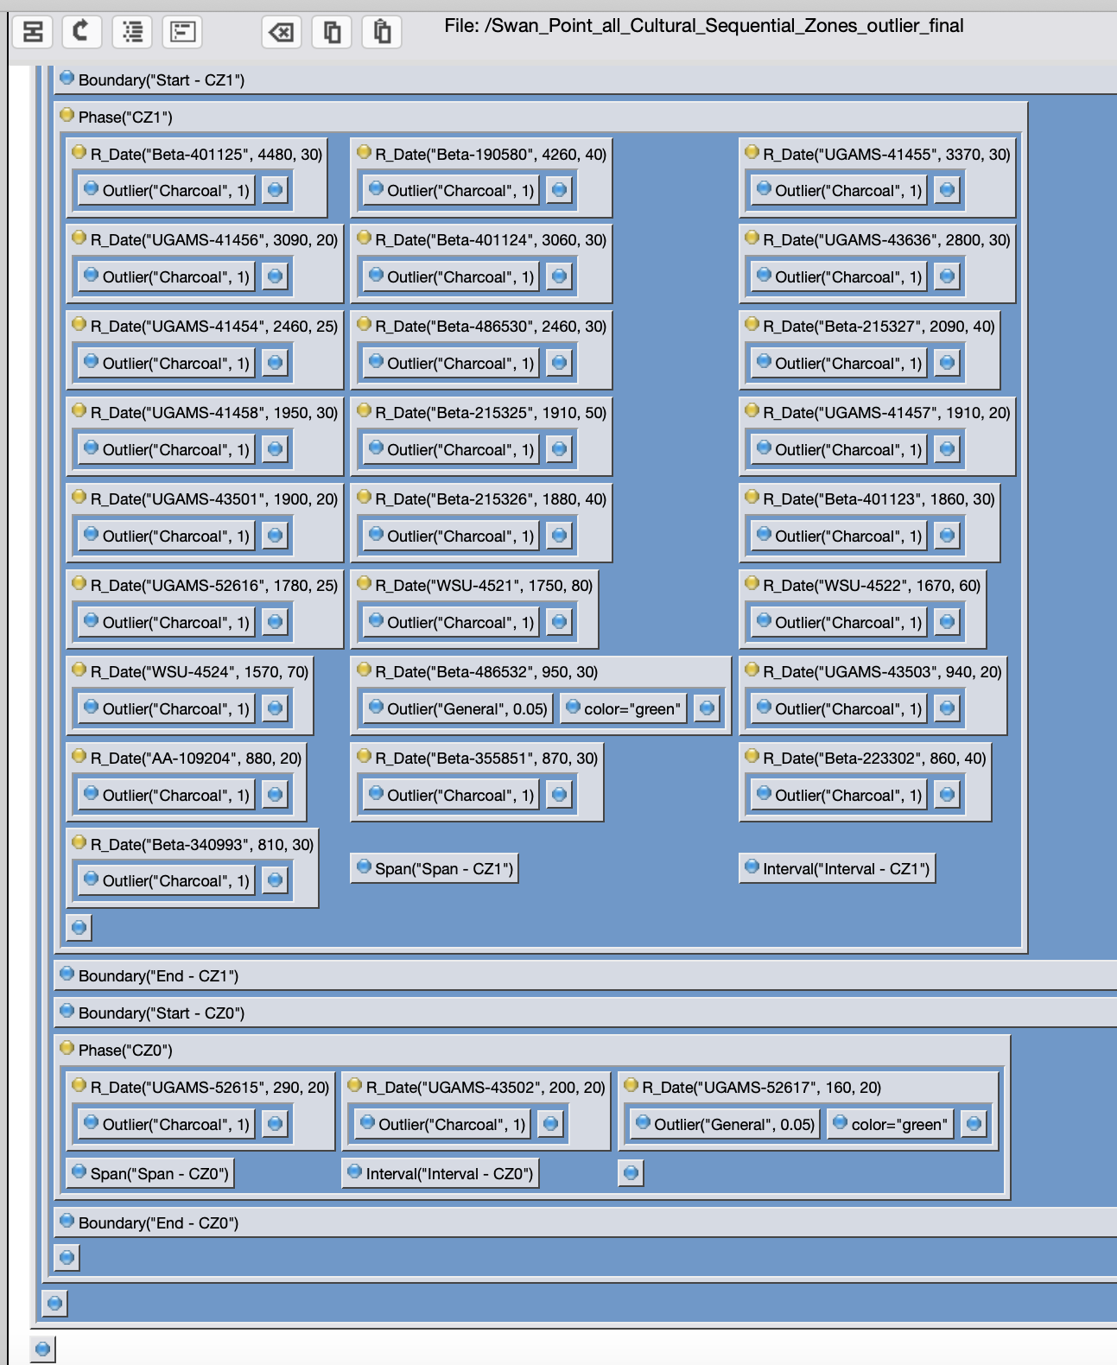

S8. Chronological Query Language (CQL) for Sequential Phase Outlier Model for Cultural Zones

Plot()
{
Outlier_Model("General", T(5), U(0,4), t);
Outlier_Model("Charcoal", Exp(1,-10,0), U(0,3), t);
Sequence("Swan Point - Cultural - all - Sequential")
{
Boundary("Start - CZ4");
Phase("CZ4")
{
R_Date("Beta-170457", 12360, 60)
{
Outlier("General", 0.05);
color="blue";
};
R_Date("Beta-209882", 12290, 40)
{
Outlier("Charcoal", 1);
};
R_Date("Beta-209884", 12220, 40)
{
Outlier("General", 0.05);
color="blue";
};
R_Date("Beta-365062", 12170, 50)
{
Outlier("General", 0.05);
color="green";
};
R_Date("UGAMS-40141", 12131, 30)
{
Outlier("General", 0.05);
color="green";
};
R_Date("Beta-175491", 12110, 50)
{
Outlier("General", 0.05);
color="blue";
};
R_Date("AA-74250", 12110, 120)
{
Outlier("General", 0.05);
color="green";
};
R_Date("Beta-209883", 12100, 40)
{
Outlier("General", 0.05);
color="blue";
};
R_Date("UCIAMS-258850", 12090, 35)
{
Outlier("General", 0.05)
{
color="green";
};
};
R_Date("CAMS-17405", 12060, 70)
{
Outlier("General", 0.05);
color="green";
};
R_Date("AA-74251", 12050, 120)
{
Outlier("General", 0.05);
color="green";
};
R_Date("Beta-QA-619", 12040, 40)
{
Outlier("Charcoal", 1);
};
R_Date("AA-74249", 11950, 100)
{
Outlier("General", 0.05);
color="green";
};
R_Date("Beta-175489", 11360, 50)
{
Outlier("General", 0.05);
color="green";
};
R_Date("Beta-355852", 11350, 50)
{
Outlier("Charcoal", 1);
};
Span("Span - CZ4");
Interval("Interval - CZ4");
};
Boundary("End - CZ4");
Boundary("Start - CZ3");
Phase("CZ3")
{
R_Date("UGAMS-30064", 10775, 35)
{
Outlier("General", 0.05);
color="green";
};
R_Date("UGAMS-43639", 10770, 30)
{
Outlier("Charcoal", 1);
};
R_Date("Beta-401126", 10620, 40)
{
Outlier("Charcoal", 1);
};
R_Date("Beta-209885", 10570, 40)
{
Outlier("Charcoal", 1);
};
R_Date("UGAMS-27492", 10530, 30)
{
Outlier("Charcoal", 1);
};
R_Date("Beta-56666", 10230, 80)
{
Outlier("Charcoal", 1);
};
R_Date("Beta-355867", 10160, 50)
{
Outlier("Charcoal", 1);
};
R_Date("Beta-357816", 10070, 40)
{
Outlier("Charcoal", 1);
};
R_Date("Beta-170458", 10050, 60)
{
Outlier("Charcoal", 1);
};
R_Date("Beta-190578", 10010, 90)
{
Outlier("Charcoal", 1);
};
R_Date("UGAMS-43640", 10010, 30)
{
Outlier("General", 0.05);
color="green";
};
Span("Span - CZ3");
Interval("Interval - CZ3");
};
Boundary("End - CZ3");
Boundary("Start - CZ2");
Phase("CZ2")
{
R_Date("UGAMS-26199", 9090, 40)
{
Outlier("General", 0.05);
color="green";
};
R_Date("WSU-4426", 7400, 80)
{
Outlier("Charcoal", 1);
};
R_Date("UGAMS-43638", 7360, 25)
{
Outlier("Charcoal", 1);
};
R_Date("Beta-209886", 6610, 40)
{
Outlier("Charcoal", 1);
};
R_Date("UGAMS-30767", 4770, 25)
{
Outlier("Charcoal", 1);
};
Span("Span - CZ2");
Interval("Interval - CZ2");
};
Boundary("End - CZ2");
Boundary("Start - CZ1");
Phase("CZ1")
{
R_Date("Beta-401125", 4480, 30)
{
Outlier("Charcoal", 1);
};
R_Date("Beta-190580", 4260, 40)
{
Outlier("Charcoal", 1);
};
R_Date("UGAMS-41455", 3370, 30)
{
Outlier("Charcoal", 1);
};
R_Date("UGAMS-41456", 3090, 20)
{
Outlier("Charcoal", 1);
};
R_Date("Beta-401124", 3060, 30)
{
Outlier("Charcoal", 1);
};
R_Date("UGAMS-43636", 2800, 30)
{
Outlier("Charcoal", 1);
};
R_Date("UGAMS-41454", 2460, 25)
{
Outlier("Charcoal", 1);
};
R_Date("Beta-486530", 2460, 30)
{
Outlier("Charcoal", 1);
};
R_Date("Beta-215327", 2090, 40)
{
Outlier("Charcoal", 1);
};
R_Date("UGAMS-41458", 1950, 30)
{
Outlier("Charcoal", 1);
};
R_Date("Beta-215325", 1910, 50)
{
Outlier("Charcoal", 1);
};
R_Date("UGAMS-41457", 1910, 20)
{
Outlier("Charcoal", 1);
};
R_Date("UGAMS-43501", 1900, 20)
{
Outlier("Charcoal", 1);
};
R_Date("Beta-215326", 1880, 40)
{
Outlier("Charcoal", 1);
};
R_Date("Beta-401123", 1860, 30)
{
Outlier("Charcoal", 1);
};
R_Date("UGAMS-52616", 1780, 25)
{
Outlier("Charcoal", 1);
};
R_Date("WSU-4521", 1750, 80)
{
Outlier("Charcoal", 1);
};
R_Date("WSU-4522", 1670, 60)
{
Outlier("Charcoal", 1);
};
R_Date("WSU-4524", 1570, 70)
{
Outlier("Charcoal", 1);
};
R_Date("Beta-486532", 950, 30)
{
Outlier("General", 0.05);
color="green";
};
R_Date("UGAMS-43503", 940, 20)
{
Outlier("Charcoal", 1);
};
R_Date("AA-109204", 880, 20)
{
Outlier("Charcoal", 1);
};
R_Date("Beta-355851", 870, 30)
{
Outlier("Charcoal", 1);
};
R_Date("Beta-223302", 860, 40)
{
Outlier("Charcoal", 1);
};
R_Date("Beta-340993", 810, 30)
{
Outlier("Charcoal", 1);
};
Span("Span - CZ1");
Interval("Interval - CZ1");
};
Boundary("End - CZ1");
Boundary("Start - CZ0");
Phase("CZ0")
{
R_Date("UGAMS-52615", 290, 20)
{
Outlier("Charcoal", 1);
};
R_Date("UGAMS-43502", 200, 20)
{
Outlier("Charcoal", 1);
};
R_Date("UGAMS-52617", 160, 20)
{
Outlier("General", 0.05);
color="green";
};
Span("Span - CZ0");
Interval("Interval - CZ0");
};
Boundary("End - CZ0");
};
};

S9. Modelled Outputs for Sequential Phase Outlier Model for Cultural Zones

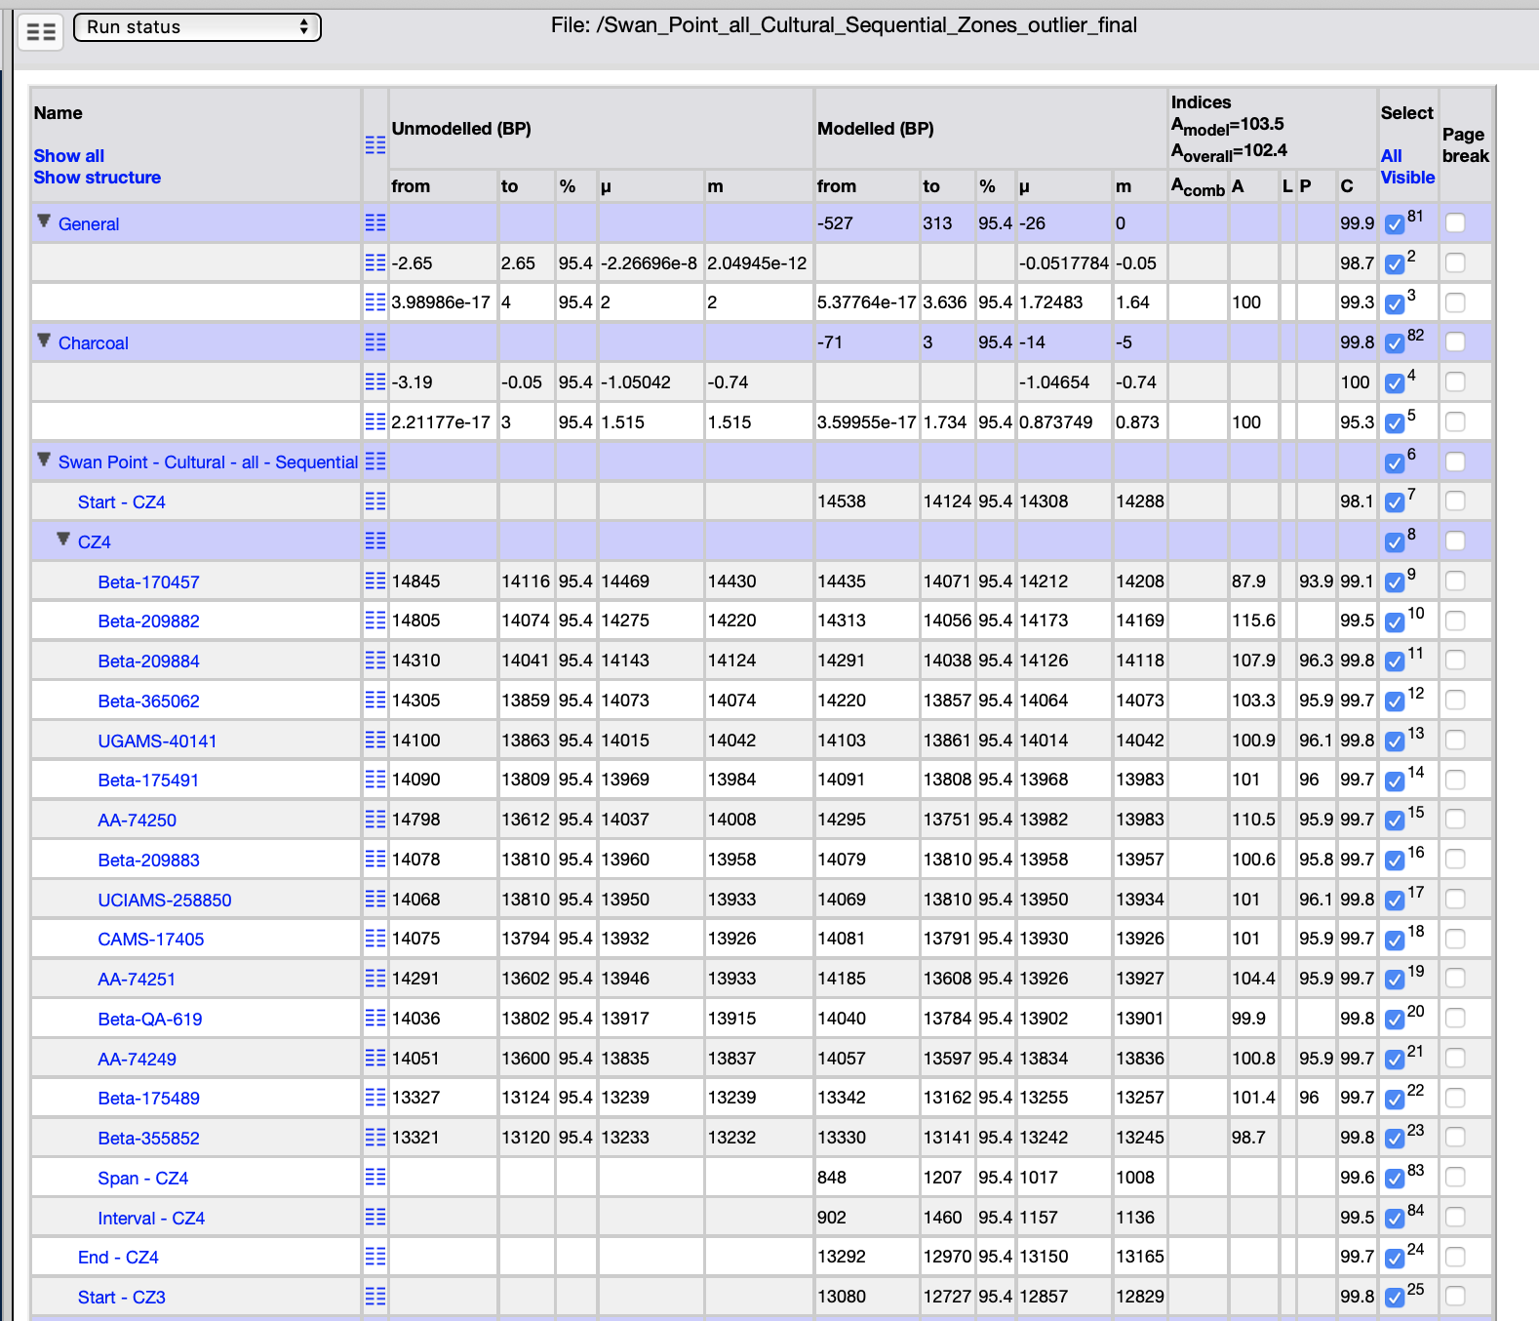
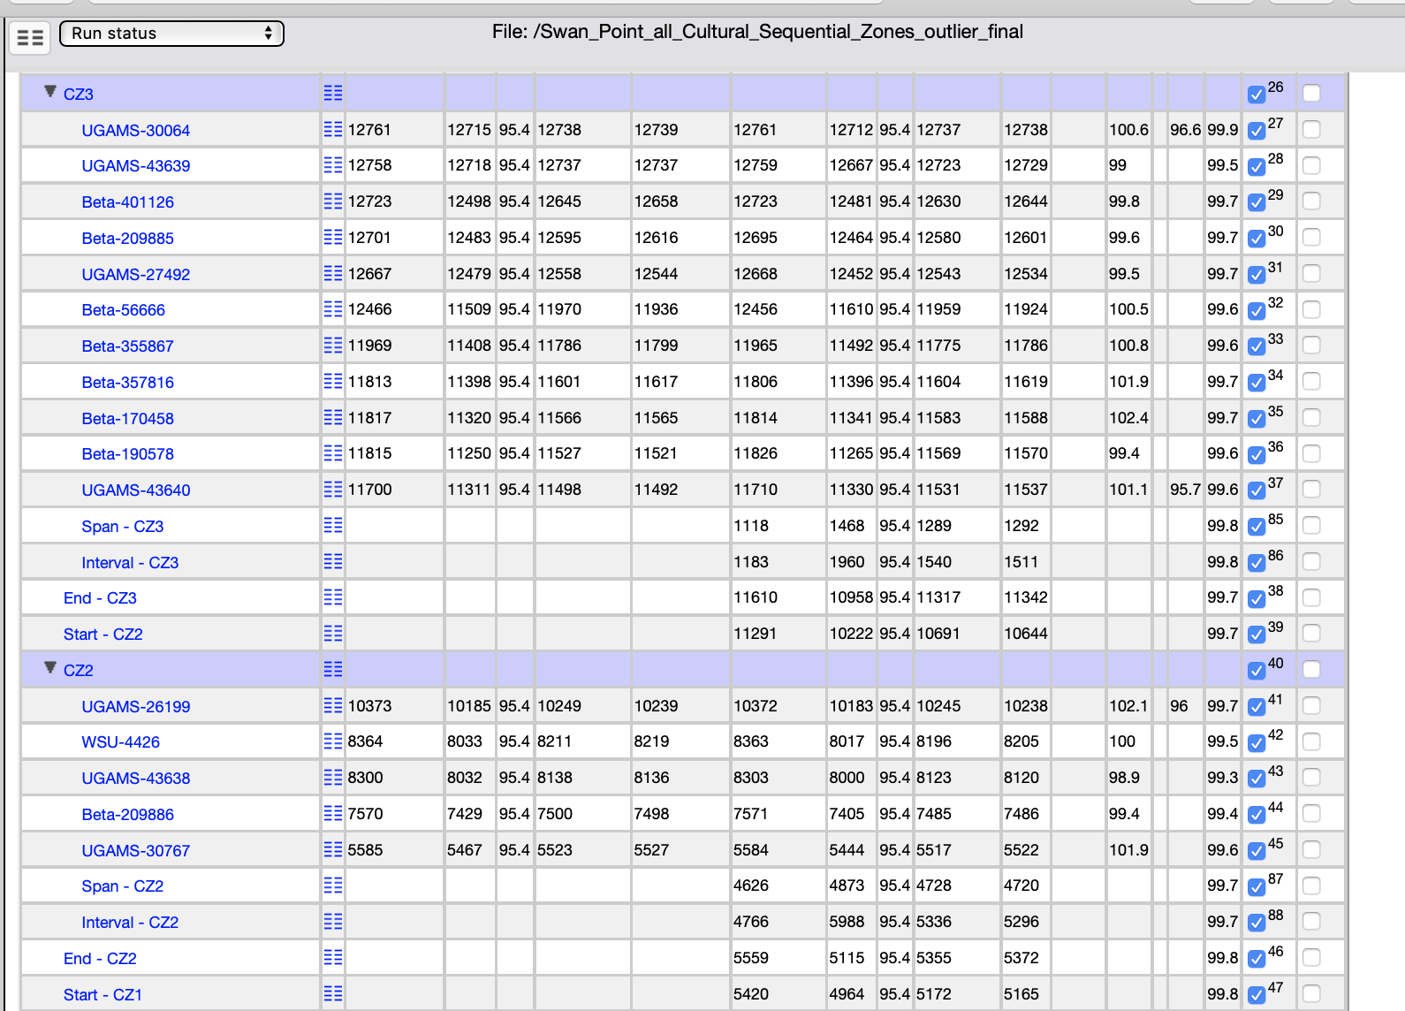
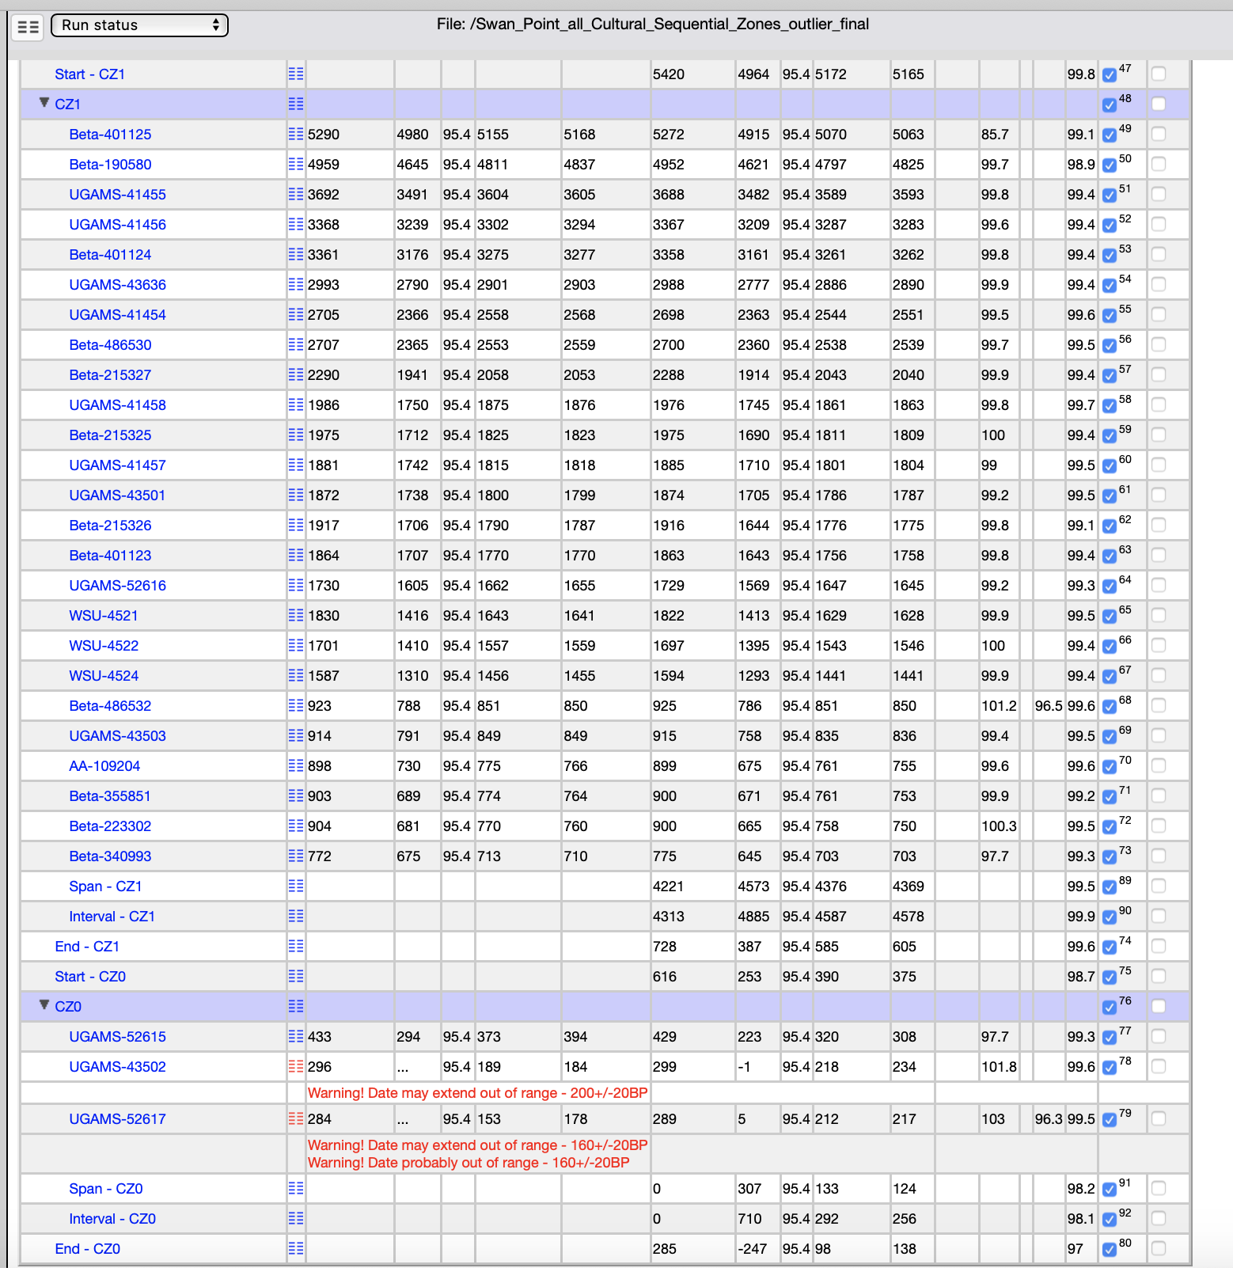

S10. Structure of Sequential Phase Outlier Model for Subzones of Cultural Zones

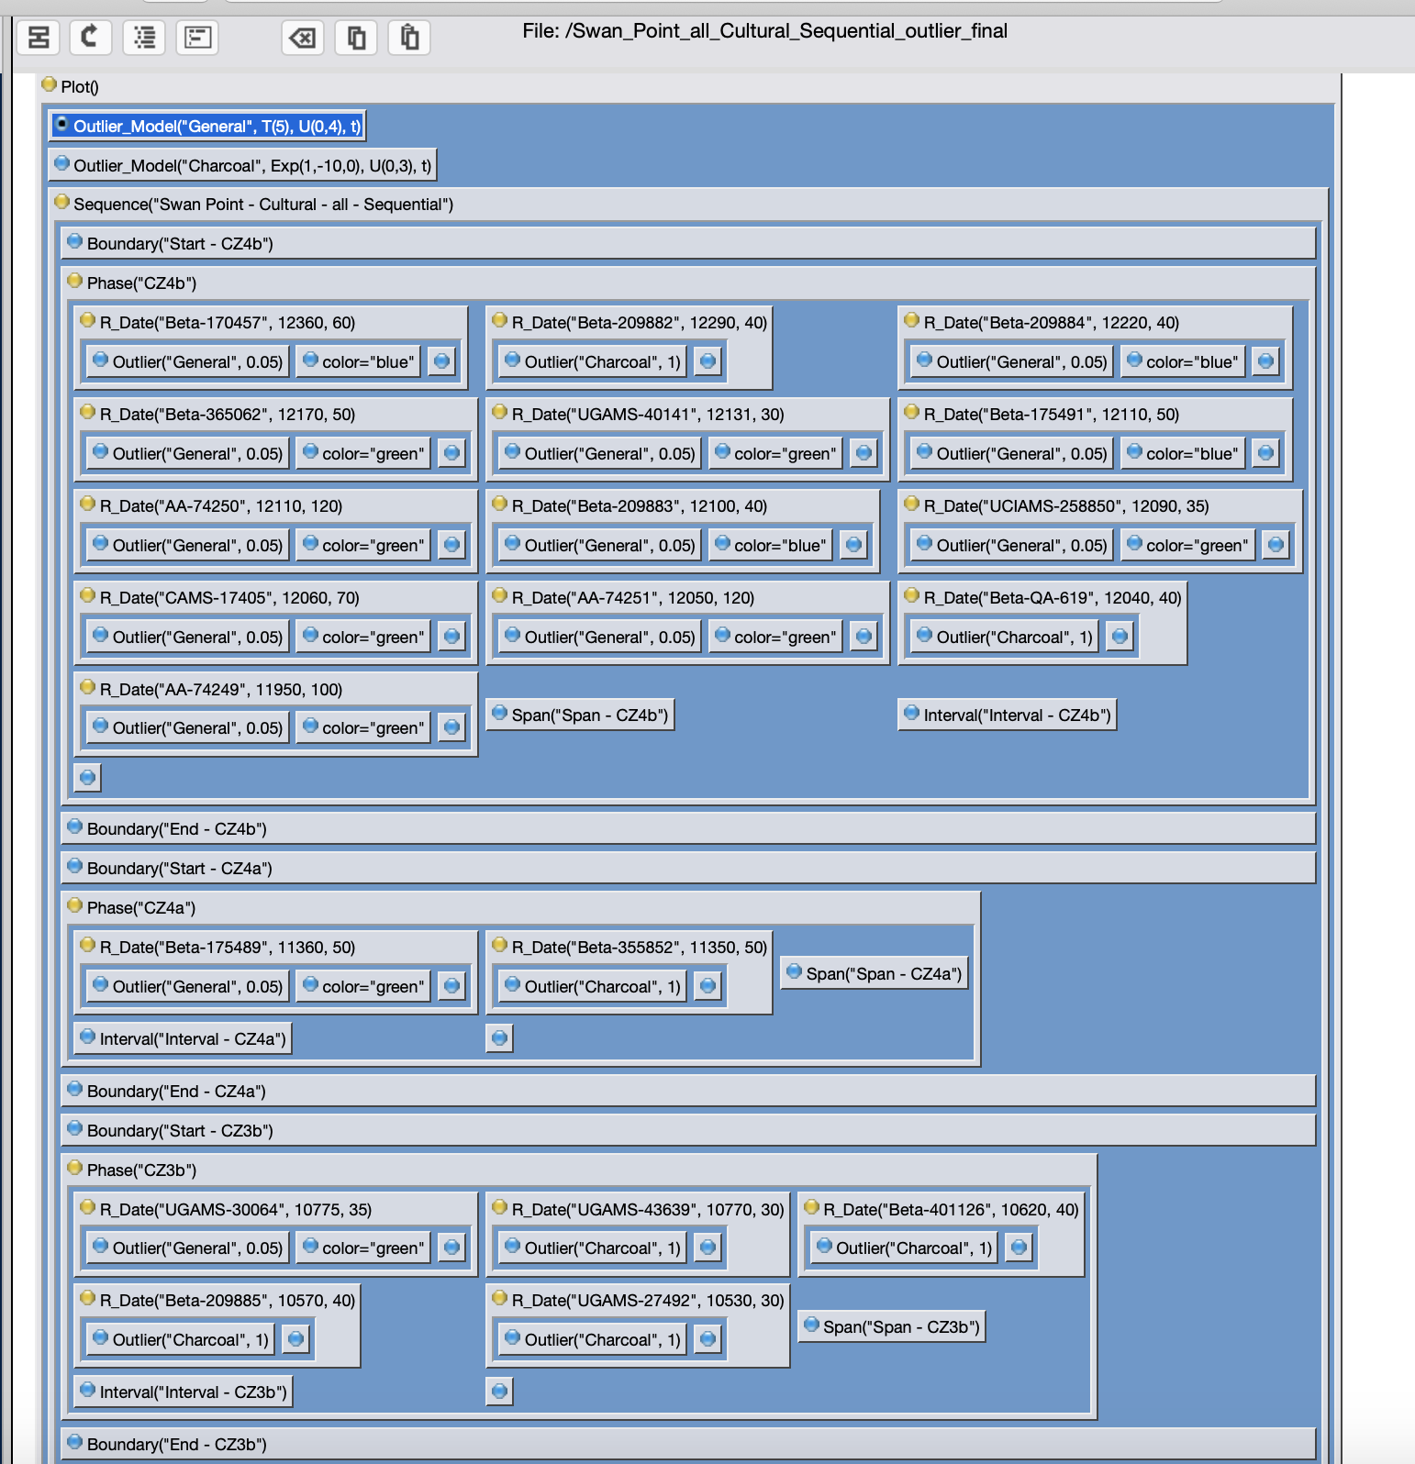
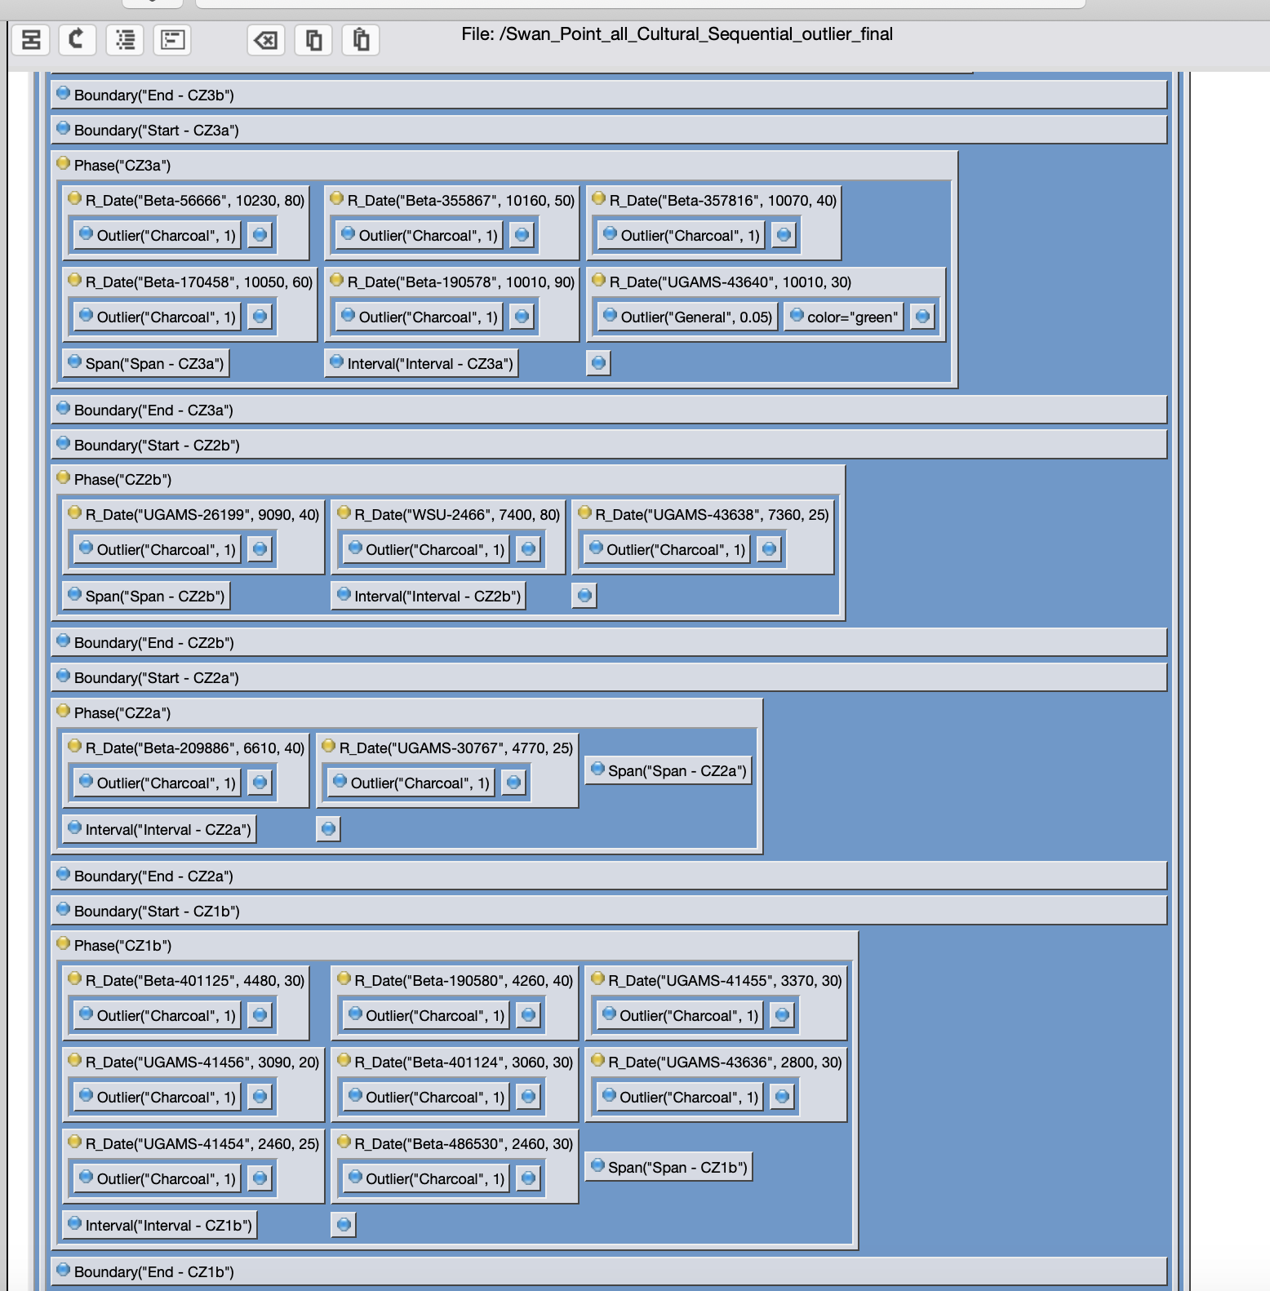
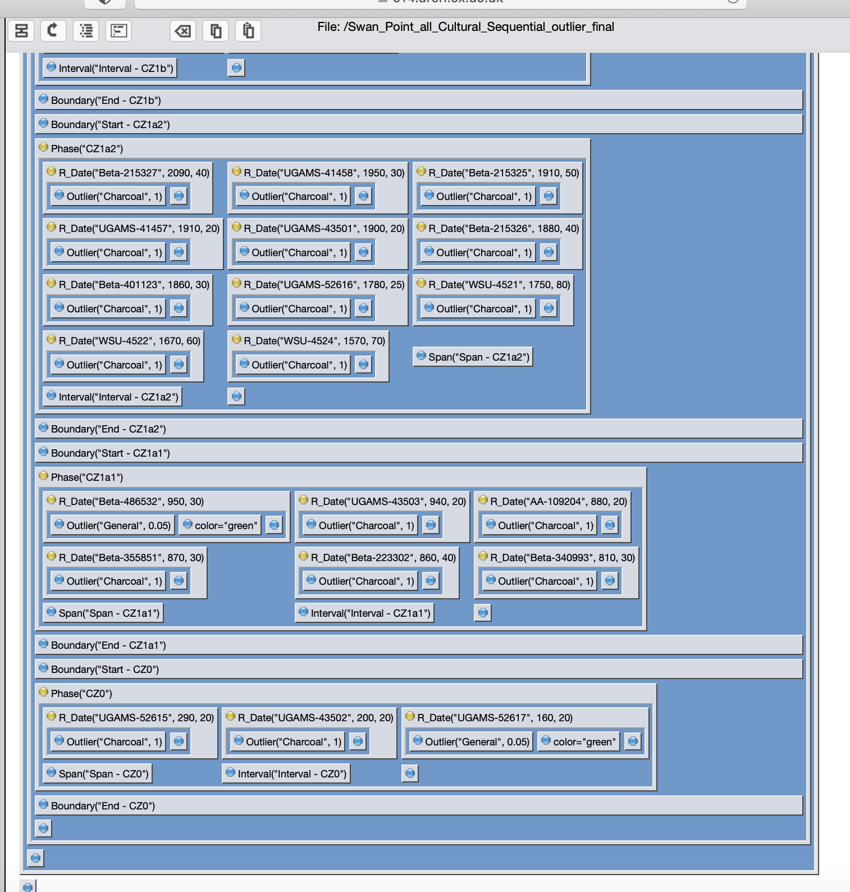

S11. Chronological Query Language (CQL) for Sequential Phase Outlier Model for Subzones of Cultural Zones

Plot()
{
Outlier_Model("General", T(5), U(0,4), t);
Outlier_Model("Charcoal", Exp(1,-10,0), U(0,3), t);
Sequence("Swan Point - Cultural - all - Sequential")
{
Boundary("Start - CZ4b");
Phase("CZ4b")
{
R_Date("Beta-170457", 12360, 60)
{
Outlier("General", 0.05);
color="blue";
};
R_Date("Beta-209882", 12290, 40)
{
Outlier("Charcoal", 1);
};
R_Date("Beta-209884", 12220, 40)
{
Outlier("General", 0.05);
color="blue";
};
R_Date("Beta-365062", 12170, 50)
{
Outlier("General", 0.05);
color="green";
};
R_Date("UGAMS-40141", 12131, 30)
{
Outlier("General", 0.05);
color="green";
};
R_Date("Beta-175491", 12110, 50)
{
Outlier("General", 0.05);
color="blue";
};
R_Date("AA-74250", 12110, 120)
{
Outlier("General", 0.05);
color="green";
};
R_Date("Beta-209883", 12100, 40)
{
Outlier("General", 0.05);
color="blue";
};
R_Date("UCIAMS-258850", 12090, 35)
{
Outlier("General", 0.05);
color="green";
};
R_Date("CAMS-17405", 12060, 70)
{
Outlier("General", 0.05);
color="green";
};
R_Date("AA-74251", 12050, 120)
{
Outlier("General", 0.05);
color="green";
};
R_Date("Beta-QA-619", 12040, 40)
{
Outlier("Charcoal", 1);
};
R_Date("AA-74249", 11950, 100)
{
Outlier("General", 0.05);
color="green";
};
Span("Span - CZ4b");
Interval("Interval - CZ4b");
};
Boundary("End - CZ4b");
Boundary("Start - CZ4a");
Phase("CZ4a")
{
R_Date("Beta-175489", 11360, 50)
{
Outlier("General", 0.05);
color="green";
};
R_Date("Beta-355852", 11350, 50)
{
Outlier("Charcoal", 1);
};
Span("Span - CZ4a");
Interval("Interval - CZ4a");
};
Boundary("End - CZ4a");
Boundary("Start - CZ3b");
Phase("CZ3b")
{
R_Date("UGAMS-30064", 10775, 35)
{
Outlier("General", 0.05);
color="green";
};
R_Date("UGAMS-43639", 10770, 30)
{
Outlier("Charcoal", 1);
};
R_Date("Beta-401126", 10620, 40)
{
Outlier("Charcoal", 1);
};
R_Date("Beta-209885", 10570, 40)
{
Outlier("Charcoal", 1);
};
R_Date("UGAMS-27492", 10530, 30)
{
Outlier("Charcoal", 1);
};
Span("Span - CZ3b");
Interval("Interval - CZ3b");
};
Boundary("End - CZ3b");
Boundary("Start - CZ3a");
Phase("CZ3a")
{
R_Date("Beta-56666", 10230, 80)
{
Outlier("Charcoal", 1);
};
R_Date("Beta-355867", 10160, 50)
{
Outlier("Charcoal", 1);
};
R_Date("Beta-357816", 10070, 40)
{
Outlier("Charcoal", 1);
};
R_Date("Beta-170458", 10050, 60)
{
Outlier("Charcoal", 1);
};
R_Date("Beta-190578", 10010, 90)
{
Outlier("Charcoal", 1);
};
R_Date("UGAMS-43640", 10010, 30)
{
Outlier("General", 0.05);
color="green";
};
Span("Span - CZ3a");
Interval("Interval - CZ3a");
};
Boundary("End - CZ3a");
Boundary("Start - CZ2b");
Phase("CZ2b")
{
R_Date("UGAMS-26199", 9090, 40)
{
Outlier("Charcoal", 1);
};
R_Date("WSU-2466", 7400, 80)
{
Outlier("Charcoal", 1);
};
R_Date("UGAMS-43638", 7360, 25)
{
Outlier("Charcoal", 1);
};
Span("Span - CZ2b");
Interval("Interval - CZ2b");
};
Boundary("End - CZ2b");
Boundary("Start - CZ2a");
Phase("CZ2a")
{
R_Date("Beta-209886", 6610, 40)
{
Outlier("Charcoal", 1);
};
R_Date("UGAMS-30767", 4770, 25)
{
Outlier("Charcoal", 1);
};
Span("Span - CZ2a");
Interval("Interval - CZ2a");
};
Boundary("End - CZ2a");
Boundary("Start - CZ1b");
Phase("CZ1b")
{
R_Date("Beta-401125", 4480, 30)
{
Outlier("Charcoal", 1);
};
R_Date("Beta-190580", 4260, 40)
{
Outlier("Charcoal", 1);
};
R_Date("UGAMS-41455", 3370, 30)
{
Outlier("Charcoal", 1);
};
R_Date("UGAMS-41456", 3090, 20)
{
Outlier("Charcoal", 1);
};
R_Date("Beta-401124", 3060, 30)
{
Outlier("Charcoal", 1);
};
R_Date("UGAMS-43636", 2800, 30)
{
Outlier("Charcoal", 1);
};
R_Date("UGAMS-41454", 2460, 25)
{
Outlier("Charcoal", 1);
};
R_Date("Beta-486530", 2460, 30)
{
Outlier("Charcoal", 1);
};
Span("Span - CZ1b");
Interval("Interval - CZ1b");
};
Boundary("End - CZ1b");
Boundary("Start - CZ1a2");
Phase("CZ1a2")
{
R_Date("Beta-215327", 2090, 40)
{
Outlier("Charcoal", 1);
};
R_Date("UGAMS-41458", 1950, 30)
{
Outlier("Charcoal", 1);
};
R_Date("Beta-215325", 1910, 50)
{
Outlier("Charcoal", 1);
};
R_Date("UGAMS-41457", 1910, 20)
{
Outlier("Charcoal", 1);
};
R_Date("UGAMS-43501", 1900, 20)
{
Outlier("Charcoal", 1);
};
R_Date("Beta-215326", 1880, 40)
{
Outlier("Charcoal", 1);
};
R_Date("Beta-401123", 1860, 30)
{
Outlier("Charcoal", 1);
};
R_Date("UGAMS-52616", 1780, 25)
{
Outlier("Charcoal", 1);
};
R_Date("WSU-4521", 1750, 80)
{
Outlier("Charcoal", 1);
};
R_Date("WSU-4522", 1670, 60)
{
Outlier("Charcoal", 1);
};
R_Date("WSU-4524", 1570, 70)
{
Outlier("Charcoal", 1);
};
Span("Span - CZ1a2");
Interval("Interval - CZ1a2");
};
Boundary("End - CZ1a2");
Boundary("Start - CZ1a1");
Phase("CZ1a1")
{
R_Date("Beta-486532", 950, 30)
{
Outlier("General", 0.05);
color="green";
};
R_Date("UGAMS-43503", 940, 20)
{
Outlier("Charcoal", 1);
};
R_Date("AA-109204", 880, 20)
{
Outlier("Charcoal", 1);
};
R_Date("Beta-355851", 870, 30)
{
Outlier("Charcoal", 1);
};
R_Date("Beta-223302", 860, 40)
{
Outlier("Charcoal", 1);
};
R_Date("Beta-340993", 810, 30)
{
Outlier("Charcoal", 1);
};
Span("Span - CZ1a1");
Interval("Interval - CZ1a1");
};
Boundary("End - CZ1a1");
Boundary("Start - CZ0");
Phase("CZ0")
{
R_Date("UGAMS-52615", 290, 20)
{
Outlier("Charcoal", 1);
};
R_Date("UGAMS-43502", 200, 20)
{
Outlier("Charcoal", 1);
};
R_Date("UGAMS-52617", 160, 20)
{
Outlier("General", 0.05);
color="green";
};
Span("Span - CZ0");
Interval("Interval - CZ0");
};
Boundary("End - CZ0");
};
};

S12. Modelled Outputs for Sequential Phase Outlier Model for Subzones of Cultural Zones

