Supplementary Information

Comparison of KIA- and GrM- results on the same tree-rings
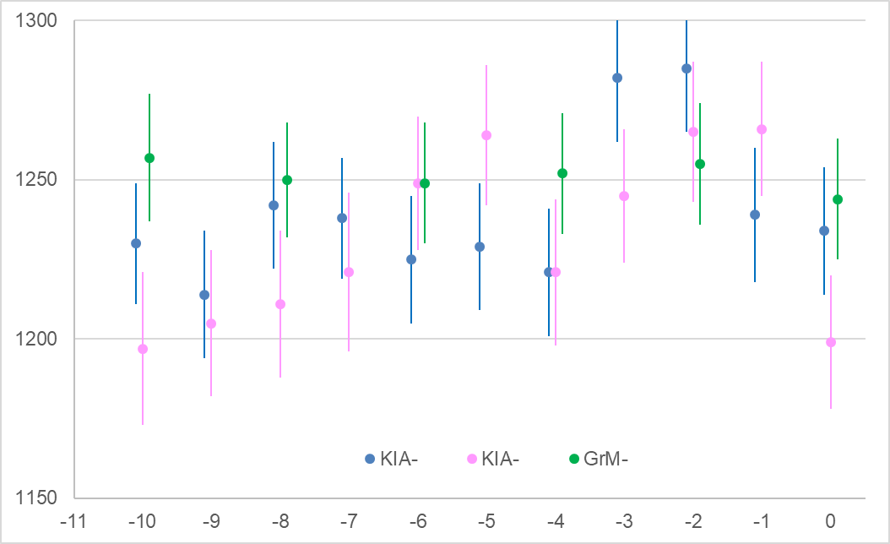
Supplementary Figure 1. Visual comparison of ¹⁴C measurements (± 1σ) on single-year α-cellulose samples by the Leibniz-Laboratory for AMS Dating and Stable Isotope Research, Kiel (KIA-) and Center for Isotope Research, Groningen University (GrM-) (Table 1). Horizontal scale: years before the final year of growth, year n. Vertical scale: ¹⁴C years BP.

Wiggle-matching of multi-annual samples (Meadows and Zunde 2014)
The code below will run in OxCal v.4 (https://c14.arch.ox.ac.uk/oxcal/OxCal.html).
- 2014 wiggle-match model, outliers removed manually using the Outlier() function. Remove the Curve command to apply IntCal20 instead of IntCal13

Options()
{
Resolution=1;
};
Plot()
{
Curve("IntCal13","intcal13.14c");
D_Sequence("2014 published model")
{
R_Combine("KIA-47645 -85 to -92 (88.5)")
{
R_Date("KIA-47645a", 1265, 25);
R_Date("KIA-47645b", 1320, 20);
};
Gap(8);
R_Combine("KIA-49360 -77 to -84 (80.5)")
{
Outlier();
R_Date("KIA-49360a", 1360, 25);
R_Date("KIA-49360b", 1375, 25);
};
Gap(9);
R_Combine("KIA-47644 -67 to -76 (71.5)")
{
R_Date("KIA-47644a", 1290, 25);
R_Date("KIA-47644b", 1305, 25);
};
Gap(10);
R_Combine("KIA-47643 -57 to -66 (61.5)")
{
R_Date("KIA-47643a", 1295, 25);
R_Date("KIA-47643b", 1280, 25);
};
Gap(10);
R_Combine("KIA-49359 -47 to -56 (51.5)")
{
R_Date("KIA-49359a", 1230, 25);
R_Date("KIA-49359b", 1220, 25);
};
Gap(10);
R_Combine("KIA-47642 -37 to -46 (41.5)")
{
R_Date("KIA-47642a", 1225, 25);
R_Date("KIA-47642b", 1230, 25);
};
Gap(10.5);
R_Combine("KIA-47641 -26 to -36 (31)")
{
Outlier();
R_Date("KIA-47641a", 1495, 25);
R_Date("KIA-47641b", 1190, 25);
};
Gap(10.5);
R_Combine("KIA-49358 -16 to -25 (20.5)")
{
R_Date("KIA-49358a", 1270, 25);
R_Date("KIA-49358b", 1285, 25);
};
Gap(10);
R_Combine("KIA-47640 -6 to -15 (10.5)")
{
R_Date("KIA-47640a", 1240, 20);
R_Date("KIA-47640b", 1235, 20);
};
Gap(8);
R_Combine("KIA-47639 n to n-5 (2.5)")
{
R_Date("KIA-47639a", 1265, 25);
R_Date("KIA-47639b", 1150, 20);
};
Gap(2.5);
Date("year n");
};
};

- Alternative wiggle-match model, all results treated as potential outliers using the Outlier_Model function, default R_Scaled settings applied (Bronk Ramsey 2009b) (i.e. large offsets in either direction are possible, but most offsets should be extremely small). Remove the Curve command to apply IntCal20 instead of IntCal13.

Options()
{
Resolution=1;
};
Plot()
{
Curve("IntCal13","intcal13.14c");
Outlier_Model("RScaled",T(5),U(0,3),"r");
D_Sequence("Araisi")
{
R_Combine("KIA47645 -85 to -92")
{
R_Date("KIA47645a", 1266, 24)
{
Outlier("RScaled", 1);
};
R_Date("KIA47645b", 1322, 21)
{
Outlier("RScaled", 1);
};
};
Gap(8);
R_Combine("KIA49360 -77 to -84")
{
R_Date("KIA49360a", 1360, 24)
{
Outlier("RScaled", 1);
};
R_Date("KIA49360b", 1373, 25)
{
Outlier("RScaled", 1);
};

};
Gap(9);
R_Combine("KIA47644 -67 to -76")
{
R_Date("KIA47644a", 1290, 25)
{
Outlier("RScaled", 1);
};
R_Date("KIA47644b", 1303, 24)
{
Outlier("RScaled", 1);
};
};
Gap(10);
R_Combine("KIA47643 -57 to -66")
{
R_Date("KIA47643a", 1293, 26)
{
Outlier("RScaled", 1);
};
R_Date("KIA47643b", 1278, 26)
{
Outlier("RScaled", 1);
};
};
Gap(10);
R_Combine("KIA49359 -47 to -56")
{
R_Date("KIA49359a", 1231, 23)
{
Outlier("RScaled", 1);
};
R_Date("KIA49359b", 1222, 23)
{
Outlier("RScaled", 1);
};
};
Gap(10);
R_Combine("KIA47642 -37 to -46")
{
R_Date("KIA47642a", 1226, 24)
{
Outlier("RScaled", 1);
};
R_Date("KIA47642b", 1230, 25)
{
Outlier("RScaled", 1);
};
};
Gap(10.5);
R_Combine("KIA47641 -27 to -36")
{
R_Date("KIA47641a", 1497, 23)
{
Outlier("RScaled", 1);
};
R_Date("KIA47641b", 1189, 23)
{
Outlier("RScaled", 1);
};
};
Gap(10.5);
R_Combine("KIA49358 -16 to -25")
{
R_Date("KIA49358a", 1270, 23)
{
Outlier("RScaled", 1);
};
R_Date("KIA49358b", 1281, 23)
{
Outlier("RScaled", 1);
};
};
Gap(10);
R_Combine("KIA47640 -6 to -15")
{
R_Date("KIA47640a", 1239, 22)
{
Outlier("RScaled", 1);
};
R_Date("KIA47640b", 1233, 20)
{
Outlier("RScaled", 1);
};
};
Gap(8);
R_Combine("KIA-47639 n to n-5")
{
R_Date("KIA47639a", 1266, 24)
{
Outlier("RScaled", 1);
};
R_Date("KIA47639b", 1152, 20)
{
Outlier("RScaled", 1);
};
};
Gap(2.5);
Date("year n");
};
};

