A glance to the Fragmenta membranea manuscript collection through FTIR and radiocarbon analyses: Supplementary Information

Authors: Kasso, T.¹, Kytökari, M.², Oinonen, M.³, Mizohata, K.⁴, Tahkokallio, J.⁵, Heikkilä, T.⁶
¹The Globe Institute, University of Copenhagen, Øster Farimagsgade 5, 1353 Copenhagen, Denmark
²Department of Chemistry, FIN-00560 University of Helsinki, Finland
³Laboratory of Chronology, Finnish Museum of Natural History, FIN-00014 University of Helsinki, Finland
⁴Accelerator Laboratory, Faculty of Sciences, FIN-00014 University of Helsinki, Finland
⁵National Library of Finland, 00014 University of Helsinki, Finland
⁶Faculty of Theology, University of Helsinki, 00014 University of Helsinki, Finland

Supplementary Information: AMS graphite target sizes
Since parchment samples are nearly solely collagen and the pretreatment process is designed to remove potential contaminants, the obtained carbon in an AMS graphite sample should primarily be resulting from collagen. Therefore, AMS graphite target masses of carbon and their ratio to the combusted sample mass are relevant. Carbon mass fraction of collagen is 0.42 (Guiry and Szpak, 2020) and thus we expect the mass ratio between graphitized and combusted samples (R_{graph/comb}) being roughly the same. In fact, the average R_{graph/comb} = 0.43(15) seems to be reasonable (Figure S1). Uncertainties in mass estimates are typically <10% and thus the broad scattering also carries relevant information on the quality of collagen and contamination. If the values are well below the assumed collagen value, one should possibly envision poorer collagen quality or contamination with a lower carbon content. Alternatively, if above, one should possibly envision contamination of material with higher carbon content. In Kasso et al. (2021) we estimated the safe limit for parchment radiocarbon dates of 0.3 – 0.4. mgC (Kasso et al., 2021). Concerning the AMS graphite target masses, two samples with also the lowest R_{graph/comb} have the lowest masses and below this safe limit: I.31 A2 0.1 mgC and II.44 H3 0.2 mgC.
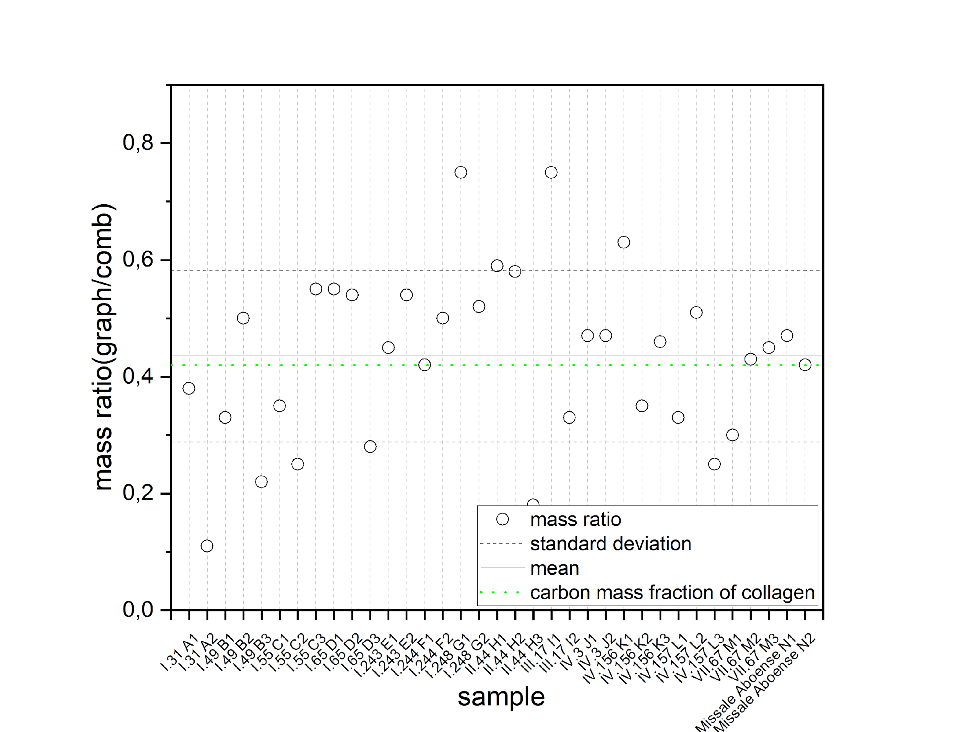
Figure S1.Ratios of graphitized sample masses to combusted sample masses.

Supplementary Information: FTIR data
FTIR data (Table S1) was calculated from the measured spectra using a custom-made python (version 3.8.3) script. The characteristic collagen peaks were observed in all of the samples approximately within 1700-1600 cm⁻¹, 1600-1500 cm⁻¹, 1300-1200 cm⁻¹ (amide I, amide II and amide III, respectively). In addition, carbonate peaks approximately within 1500-1400 cm⁻¹ and 900-700 cm⁻¹ were also observed. We also observed peaks indicative of CaSO₄ and starch approximately within the 1200-900 cm⁻¹ region in some of the samples (F005 and F017, respectively). In addition, indications of fire damage is observed through peak structures at ca. 2500-2000 cm⁻¹ (Bicchieri et al 2008) of which magnitudes are qualitatively given in Table S1 (small, medium, large).

Table S1. FTIR data.
Document | Labcode  (Hela-xxxx) | FTIR ID | A1 | A2 | A3 | ACO3 | A1/A2 | $$Δν$$ | 2500-2000 cm⁻¹ | Cluster
I.31 A1 | 4089 | F001 | 0.03 | 0.02 | 0.01 | 0.01 | 1.05 | 95.05 | medium | 1
I.31 A2 | 4090 | F002 | 0.06 | 0.06 | 0.03 | 0.01 | 1.08 | 93.18 | medium | 3
I.49 B1 | 4091 | F003 | 0.04 | 0.03 | 0.02 | 0.01 | 1.11 | 95.05 | medium | 1
I.49 B2 | 4092 | F004 | 0.01 | 0.01 | 0.01 | 0.00 | 0.97 | 95.05 | large | 1
I.49 B3 | 4093 | F005 | 0.03 | 0.02 | 0.01 | 0.01 | 1.56 | 82.00 | medium | 1
I.55 C1 | 4094 | F006 | 0.03 | 0.02 | 0.02 | 0.01 | 1.10 | 95.05 | medium | 1
I.55 C2 | 4095 | F007 | 0.17 | 0.15 | 0.09 | 0.02 | 1.11 | 95.05 | small | 2
I.55 C3 | 4096 | F008 | 0.04 | 0.03 | 0.02 | 0.01 | 1.11 | 95.05 | medium | 1
I.65 D1 | 4097 | F009 | 0.04 | 0.03 | 0.02 | 0.01 | 1.15 | 95.05 | medium | 1
I.65 D2 | 4098 | F010 | 0.04 | 0.04 | 0.02 | 0.01 | 1.07 | 96.91 | medium | 1
I.65 D3 | 4099 | F011 | 0.06 | 0.05 | 0.03 | 0.01 | 1.22 | 96.91 | medium | 3
I.243 E1 | 4100 | F012 | 0.04 | 0.04 | 0.02 | 0.01 | 1.14 | 95.05 | medium | 1
I.243 E2 | 4101 | F013 | 0.03 | 0.03 | 0.02 | 0.01 | 1.12 | 95.05 | medium | 1
I.244 F1 | 4102 | F014 | 0.04 | 0.03 | 0.03 | 0.03 | 1.23 | 152.82 | medium | 1
I.244 F2 | 4103 | F015 | 0.08 | 0.07 | 0.05 | 0.05 | 1.20 | 91.32 | small | 3
I.248 G1 | 4104 | F016 | 0.06 | 0.05 | 0.03 | 0.01 | 1.14 | 95.05 | medium | 1
I.248 G2 | 4105 | F017 | 0.04 | 0.02 | 0.01 | 0.01 | 1.51 | 95.05 | small | 1
II.44 H1 | 4106 | F018 | 0.04 | 0.03 | 0.02 | 0.01 | 1.21 | 95.05 | large | 1
II.44 H2 | 4107 | F019 | 0.02 | 0.01 | 0.01 | 0.01 | 1.26 | 95.05 | large | 1
II.44 H3 | 4108 | F020 | 0.04 | 0.04 | 0.02 | 0.01 | 1.16 | 95.05 | large | 1
III.17 I1 | 4109 | F021 | 0.03 | 0.02 | 0.01 | 0.00 | 1.17 | 95.05 | medium | 1
III.17 I2 | 4110 | F022 | 0.02 | 0.02 | 0.01 | 0.01 | 1.10 | 95.05 | large | 1
IV.3 J1 | 4111 | F023 | 0.13 | 0.12 | 0.07 | 0.05 | 1.15 | 93.18 | small | 2
IV.3 J2 | 4112 | F024 | 0.03 | 0.04 | 0.02 | 0.01 | 0.97 | 95.05 | medium | 1
IV.156 K1 | 4113 | F025 | 0.03 | 0.02 | 0.02 | 0.01 | 1.16 | 95.05 | medium | 1
IV.156 K2 | 4114 | F026 | 0.16 | 0.14 | 0.08 | 0.03 | 1.17 | 93.18 | small | 2
IV.156 K3 | 4115 | F027 | 0.02 | 0.02 | 0.01 | 0.01 | 1.15 | 102.50 | large | 1
IV.157 L1 | 4116 | F028 | 0.08 | 0.06 | 0.04 | 0.02 | 1.17 | 95.05 | medium | 3
IV.157 L2 | 4117 | F029 | 0.10 | 0.09 | 0.04 | 0.02 | 1.06 | 95.05 | medium | 3
IV.157 L3 | 4118 | F030 | 0.15 | 0.12 | 0.07 | 0.03 | 1.20 | 95.05 | small | 2
VII.67 M1 | 4119 | F031 | 0.05 | 0.05 | 0.03 | 0.01 | 1.02 | 89.46 | medium | 1
VII.67 M2 | 4120 | F032 | 0.03 | 0.03 | 0.02 | 0.01 | 0.95 | 95.05 | medium | 1
VII.67 M3 | 4121 | F033 | 0.06 | 0.06 | 0.05 | 0.07 | 0.97 | 95.05 | small | 3
Missale Aboense N1 | 4122 | F034 | 0.08 | 0.07 | 0.04 | 0.01 | 1.14 | 95.05 | medium | 3
Missale Aboense N2 | 4123 | F035 | 0.03 | 0.03 | 0.02 | 0.00 | 1.23 | 95.05 | medium | 1

Figure S2 shows the loadings of the first four principal components. PC1 accounts for 92.5% of the variance in the data, PC2 3.5%, PC3 2.9% and PC4 0.37%. The inclusion of additional principal components does not therefore increase the cumulative percent variance significantly, i.e, the first four principal components already account for 99% of the variance in the data. Figure S2 shows that PC1 captures more or less the entire spectrum of absorbances, with the absorbances from the amide I peak having the highest loadings. PC2 shows high negative loadings within the ~1200−900 cm⁻¹ region where most of the contaminants were observed, so it seems that PC2 captures information about contaminants. PC3 shows high positive loadings for the carbonate peaks, and PC4 does not add any more valuable information about the variance in the data.
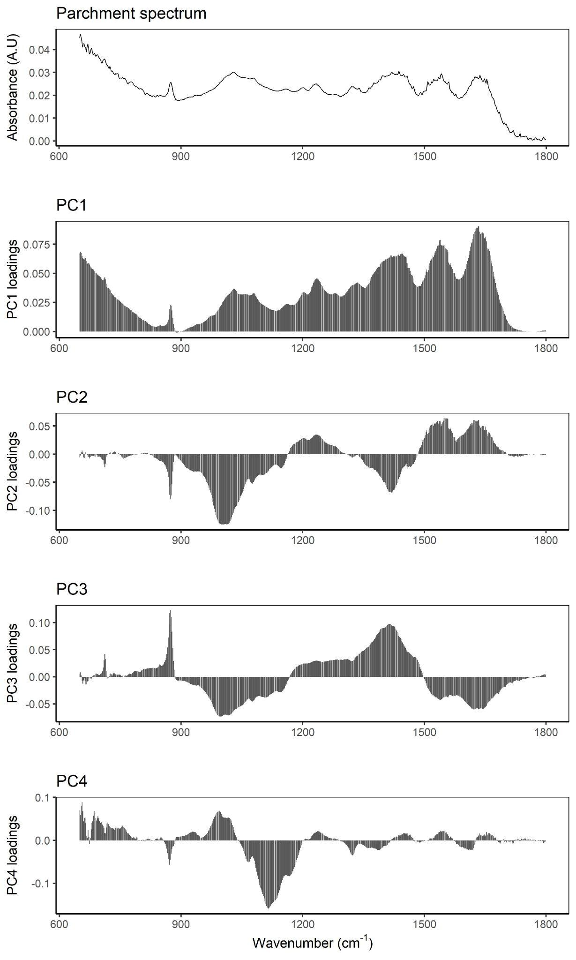
Figure S2. Loadings plot for the first 4 principal components of the FTIR data analysis. PC1 is consistent with the parchment FTIR spectrum and thus relates to the collagen content.
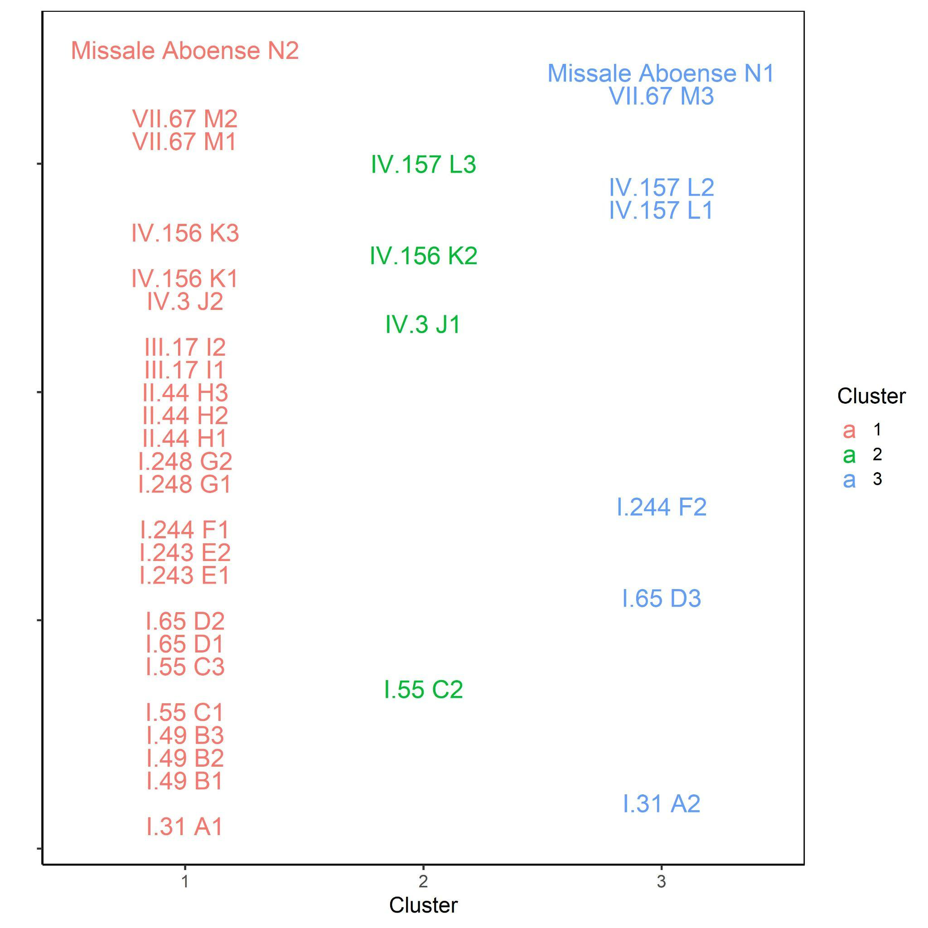
Figure S3. Clustering of the FTIR results of the samples. Clustering is mostly due to PC1 accounts 92.5% of the data variation and is related to the collagen content. Cluster 1: lowest amide I peak absorbance that is related to low collagen content. Cluster 2: highest amide I peak absorbance that is related to high collagen content. Cluster 3: amide I peak absorbance in between Cluster 1 and 2.
Supplementary Information: Radiocarbon dates
The estimated manufacturing years for the studied parchment fragments vary considerably. For Missale Aboense fragments these are assumed to be known within a 10-year time span (AD 1478-1488). Therefore, these are considered as suitable reference material to support our initial studies with Italian parchments with accurate manufacturing years of AD 1471 and 1506 (Kasso et al. 2021). However, for other studied fragments the assumed manufacturing time spans vary between 20 and 175 years. Actual manufacturing year can be only one of those within the time span. In addition, we assume that the own age of lamb/calf does not contribute significantly. So, instead of comparing the measured calendar year probability distributions (cpd) directly to the assumed uniform calendar year probability distribution of the time span, one should simulate radiocarbon ages of each assumed manufacturing year within the time span and compare their cpd’s to the measured age cpd’s. Differences between the cpd’s are evaluated with the Difference() command of Oxcal.
Table S2. Calendar-year calibrations of individual radiocarbon dates. Calendar-year probability distributions have been given as 68% and 95% confidence intervals (C.I.) in units of calendar years (calAD).
Document | Labcode  (Hela-xxxx) | Radiocarbon  age (BP) | σ | 68% C.I  (calAD) | 95% C.I.  (calAD)
I.31 A1 | 4089 | 955 | 50 | 1030-1160 | 995-1215
I.31 A2 | 4090 | 928 | 48 | 1040-1165 | 1025-1215
I.49 B1 | 4091 | 994 | 50 | 995-1155 | 900-1175
I.49 B2 | 4092 | 761 | 49 | 1225-1285 | 1175-1385
I.49 B3 | 4093 | 888 | 48 | 1045-1225 | 1035-1260
I.55 C1 | 4094 | 743 | 23 | 1265-1285 | 1225-1295
I.55 C2 | 4095 | 833 | 25 | 1180-1265 | 1170-1265
I.55 C3 | 4096 | 676 | 27 | 1280-1385 | 1275-1390
I.65 D1 | 4097 | 525 | 27 | 1400-1430 | 1325-1445
I.65 D2 | 4098 | 535 | 28 | 1395-1430 | 1325-1440
I.65 D3 | 4099 | 469 | 26 | 1425-1450 | 1410-1460
I.243 E1 | 4100 | 302 | 26 | 1520-1645 | 1495-1635
I.243 E2 | 4101 | 375 | 25 | 1455-1620 | 1450-1635
I.244 F1 | 4102 | 370 | 24 | 1460-1620 | 1450-1635
I.244 F2 | 4103 | 373 | 21 | 1460-1620 | 1450-1630
I.248 G1 | 4104 | 251 | 22 | 1640-1795 | 1525-1800
I.248 G2 | 4105 | 324 | 25 | 1510-1640 | 1490-1645
II.44 H1 | 4106 | 263 | 28 | 1525-1795 | 1515-1800
II.44 H2 | 4107 | 269 | 29 | 1525-1665 | 1515-1800
II.44 H3 | 4108 | 322 | 31 | 1510-1640 | 1480-1645
III.17 I1 | 4109 | 566 | 31 | 1320-1415 | 1305-1425
III.17 I2 | 4110 | 642 | 29 | 1295-1390 | 1285-1400
IV.3 J1 | 4111 | 693 | 28 | 1275-1380 | 1270-1390
IV.3 J2 | 4112 | 678 | 26 | 1280-1385 | 1275-1390
IV.156 K1 | 4113 | 135 | 22 | 1680-1930 | 1675-1945
IV.156 K2 | 4114 | 294 | 22 | 1520-1650 | 1510-1655
IV.156 K3 | 4115 | 130 | 26 | 1685-1930 | 1675-1945
IV.157 L1 | 4116 | 275 | 28 | 1525-1660 | 1510-1795
IV.157 L2 | 4117 | 216 | 30 | 1645-1800 | 1640-
IV.157 L3 | 4118 | 146 | 33 | 1675-1945 | 1665-
VII.67 M1 | 4119 | 378 | 31 | 1455-1620 | 1445-1635
VII.67 M2 | 4120 | 439 | 30 | 1430-1465 | 1420-1615
VII.67 M3 | 4121 | 498 | 28 | 1410-1440 | 1400-1450
Missale Aboense N1 | 4122 | 330 | 26 | 1500-1635 | 1480-1640
Missale Aboense N2 | 4123 | 397 | 23 | 1450-1495 | 1440-1625

Missale Aboensis, assumed AD1478-1488
The measured radiocarbon dates are 330(26) and 397(23) BP. At first glance these two seem to mismatch, but their cpd’s overlap and result in quantified difference of Figure S4. Figure S5 shows 10 simulated (AD1483) radiocarbon dates of Missale Aboense sample and their comparison to measured dates. Similarly to the measured dates, individual simulated radiocarbon dates range from 330 to 403 BP and their cpd’s are inevitably nearly 200 year wide. Particularly, they overlap nearly perfectly with the measured ones. This all illustrates the statistical nature of radiocarbon dates and the effect of temporal variation of atmospheric radiocarbon contents: one should not expect narrower calendar-year probability distributions for such samples.
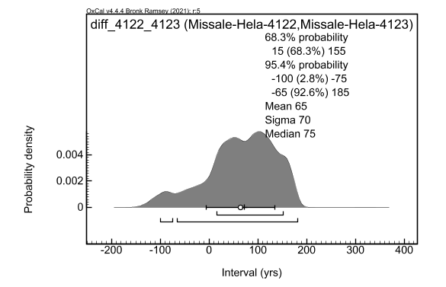
Figure S4. Difference between two measured radiocarbon dates of Missale Aboense parchment fragment.
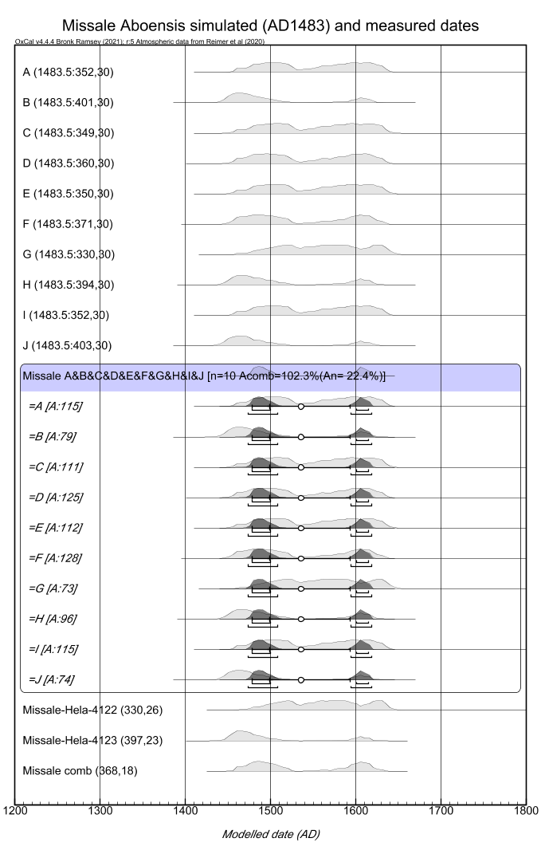
Figure S5. Comparison of simulated radiocarbon dates and their calendar-year probability distributions to the measured ones for the Missale Aboense sample.
Eventually, comparison of combined simulated and measured dates resulted in a difference peaking around 0 shown in Figure S6. Again, the broad distribution is due to the wide initial cpd’s. The combined measured radiocarbon date (Figure S6) is 368(18) BP that converts also to a wide cpd with double peaks at 1455 – 1525 calAD and 1570 – 1630 calAD (95% confidence interval i.e. C.I.). This agrees nearly perfectly with the cpd of the combined simulated dates of 1470 – 1525 calAD and 1575 – 1625 calAD (95% C.I.). It is likely that the first peak corresponds to the assumed manufacturing year of AD1478 – 1488 and the second is due to the unfortunate variation of the atmospheric radiocarbon content that allows it to be formed.
It is notable that Missale Aboensis samples are not among the ones that have the highest collagen content, but among the ones that have lowest collagen content (cluster 1: F034, Hela-4122) and average content (cluster 3: F035, Hela-4123). This indicates that the most obvious FTIR observations do not necessarily correlate with the quality of the measured radiocarbon dates. FTIR spectrum shows also indirect evidence of fire damage by medium-sized peak structures in all the samples at ca. 2500-2000 cm⁻¹.
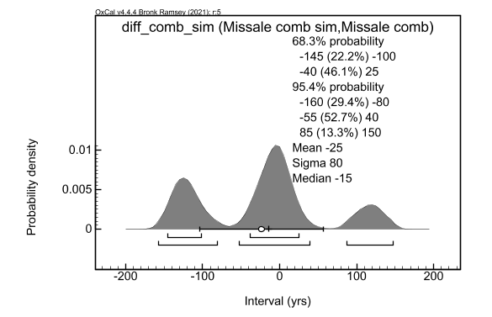
Figure S6. Difference between combined simulated and combined measured radiocarbon dates for Missale Aboense parchment fragment.
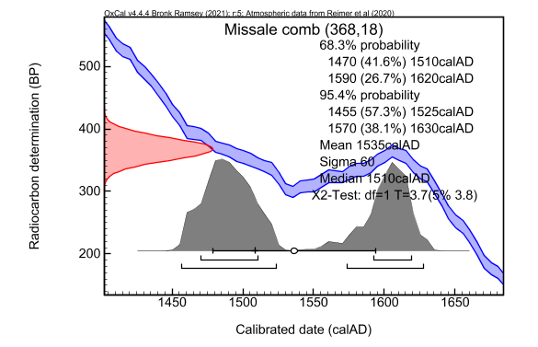
Figure S7. Combined measured radiocarbon date for Missale Aboense parchment fragment.
Overall, the Missale Aboense radiocarbon dates support the conclusions of Kasso et al. (2021) that our radiocarbon dating procedure performs as expected although the cpd’s inevitably suffer from the variation of the atmospheric radiocarbon content. Moreover, these provide examples of potential fire damage NOT affecting significantly to the radiocarbon ages. In the following, we discuss the other measured dates based on a similar approach of simulating radiocarbon dates of the assumed manufacturing years.
I.55, assumed AD1225-1400
I.55 provides an example of a case with a wide assumed range of manufacturing years of AD1225-1400. Similarly, the true manufacturing year can be only one within this wide temporal range. Figure S8 shows the difference of combined simulated and combined measured dates as a function of the assumed manufacturing year. The closest match i.e. 0 is obtained if the assumed manufacturing year is around AD1275. This assumption seems to be more or less consistent with the observed dates and their cpd’s (Figure S9). However, the scatter within the individual measurements seems to be slightly larger compared to the simulations. Particularly, there is a significant difference (cpd of Difference ≠ 0 within 95% confidence) between Hela-4095 and Hela-4096 dates. FTIR observes carbonate peaks in nearby regions within the parchment sample. However, in this work we demonstrate that our pretreatment is successful to remove carbonate contaminants. Moreover, fossil carbonates devoid of ¹⁴C cannot explain scattering towards younger ages (Hela-4096). FTIR spectrum shows also indirect evidence of fire damage by medium-, small- and medium-sized peak structures in C1, C2 and C3 samples, respectively, at ca. 2500-2000 cm⁻¹. Summarizing, it is possible to find an assumed manufacturing moment within the assumed age at ca. AD1275 that is more or less consistent to what is experimentally observed.
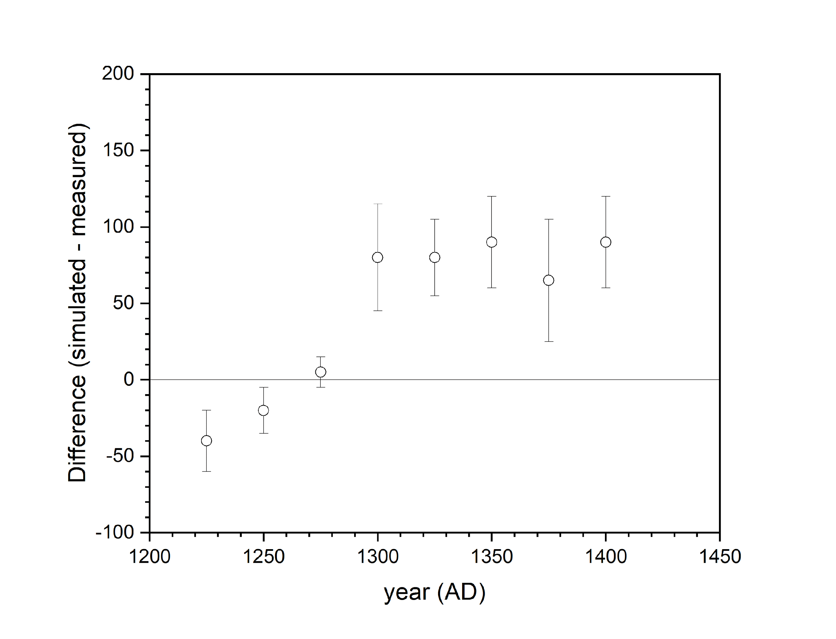
Figure S8. Difference between combined simulated and measured radiocarbon dates as a function of the assumed manufacturing year for I.55 parchment fragment.
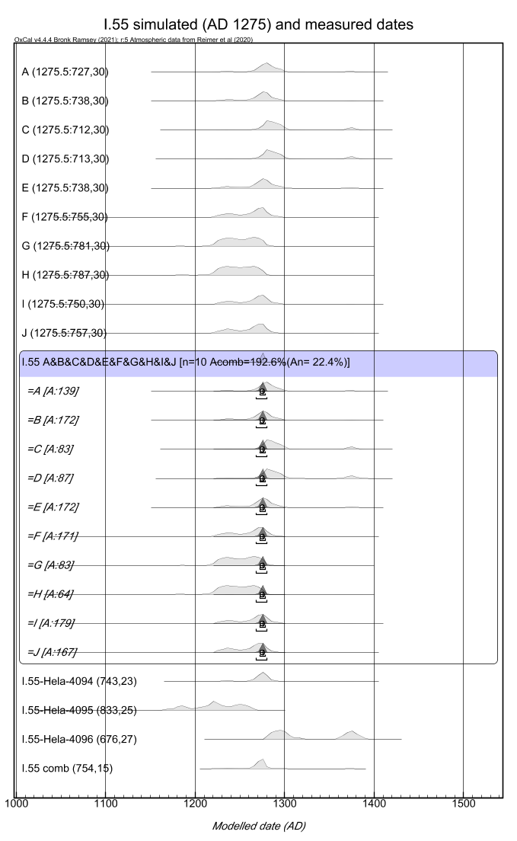
Figure S9. Comparison of simulated radiocarbon dates and their calendar-year probability distributions to the measured ones for I.55 parchment fragment.

I.31, assumed AD1180-1210
The measured radiocarbon dates of I.31 suffer from slightly larger statistical uncertainty due to AMS challenges during the measurements. Therefore, larger statistical uncertainty is also assumed in simulations. The measured data is consistent to each other and slightly older compared to the simulations of the assumed calendar year time span of AD1180-1210. However, simulations of AD1180 start to produce consistent cpd’s that overlap with the measurements. Particularly, note that ±50 ¹⁴C yr statistical uncertainty allows for 10 simulated radiocarbon dates spanning from 752 to 948 BP. This emphasizes the statistical variation of ¹⁴C ages (and their cpds) around the true calendar year age.
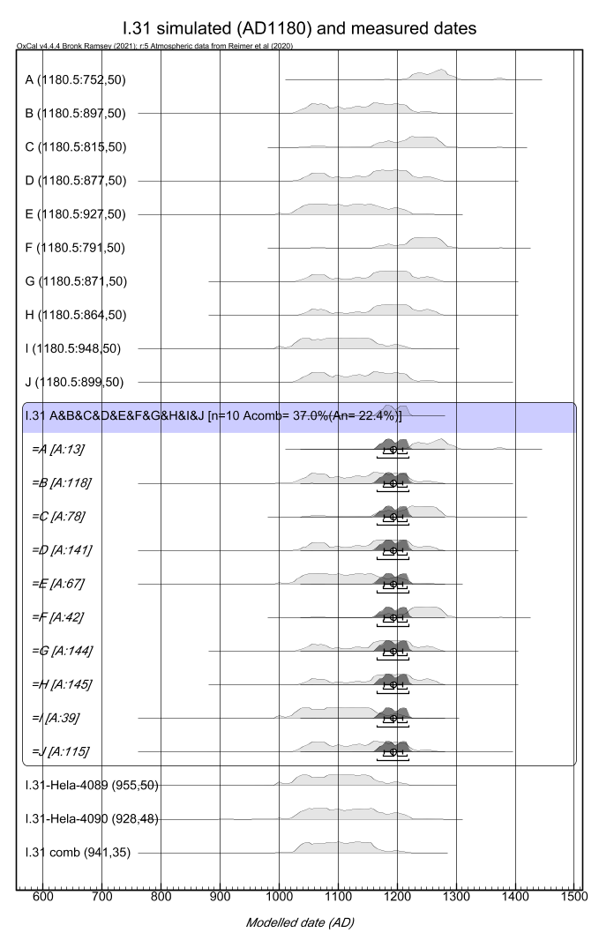

Figure S10. Comparison of simulated radiocarbon dates and their calendar-year probability distributions to the measured ones for I.31 parchment fragment.
FTIR data shows moderate inclusion of carbonates that our pretreatment provenly removes. It is interesting that for Hela-4090 the AMS graphite size was estimated to be the smallest within the measurement set (0.1 mg) and well below the safe estimate obtained by Kasso et al. (2021) of 0.3-0.4 mg. This small mass, however, is not in accord with the FTIR data, as all the collagen parameters A1 and A2 are not among the lowest ones. All in all, Hela-4090 overlaps the larger AMS graphite date of Hela-4089 (0.9 mg). This indicates that the cleanroom-based sample pretreatment process can successfully provide even smaller AMS graphite targets than estimated by Kasso et al. (2021). FTIR spectrum shows also indirect evidence of fire damage by medium-sized peak structures in all the samples at ca. 2500-2000 cm⁻¹.
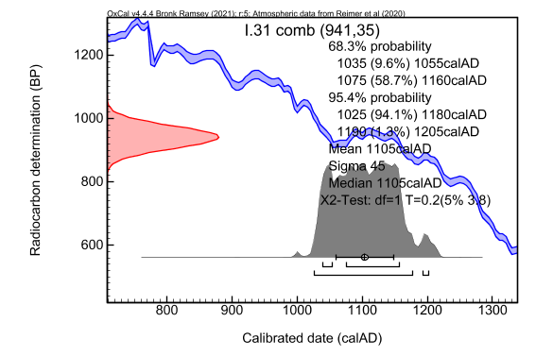
Figure S11. Combined radiocarbon date of I.31.

I.49, assumed AD1228-1300
The measured radiocarbon dates of I.49 suffer also from slightly larger statistical uncertainty due to AMS challenges during the measurements. Therefore, larger statistical uncertainty is also assumed in simulations. Scattering of the measurements is larger than in simulations and the combined measured data is older, even if the oldest assumed manufacturing year is assumed (AD1228). Only exception is Hela-4092 that possibly overlaps with the simulations. The tendency is thus similar to I.31 in that the measurements are concentrated in the older boundary of the assumed age. FTIR spectra reveal carbonate in the vicinity of all subsamples, signs of poor quality collagen for I.49 B2 and B3 that correspond to Hela-4092 and 4093, respectively. A strong doublet was observed in the FTIR spectrum of Hela-4093 between 1200—900 cm⁻¹, seemingly consistent with the presence of calcium sulphate. Sulphates could potentially originate from the gallic acid-based inks used in various parchments (Pronti et al., 2018). As the gallic acid contains carbon, the peaks should be considered as signs of potential contamination, if pretreatment is not capable of removing it. FTIR spectra shows also indirect evidence of fire damage by medium-, large- and medium-sized peak structures in B1, B2 and B3 samples, respectively, at ca. 2500-2000 cm⁻¹. Interestingly, the B2 sample with the most significant indication of damage also shows younger age compared to B1 and B3 samples. As both potential contaminative effects would possibly yield to younger ages, the reason for slightly older ¹⁴C dates compared to assumptions should be probably searched from somewhere else. This would also involve considerations whether the palaeographic estimate should be refined to be older (see Schniedewind 2005) and whether the estimated AMS uncertainty is realistic enough for these particular measurements. Summarizing, the scattering and leaning towards older boundaries may be induced as a convolution of all the above factors.
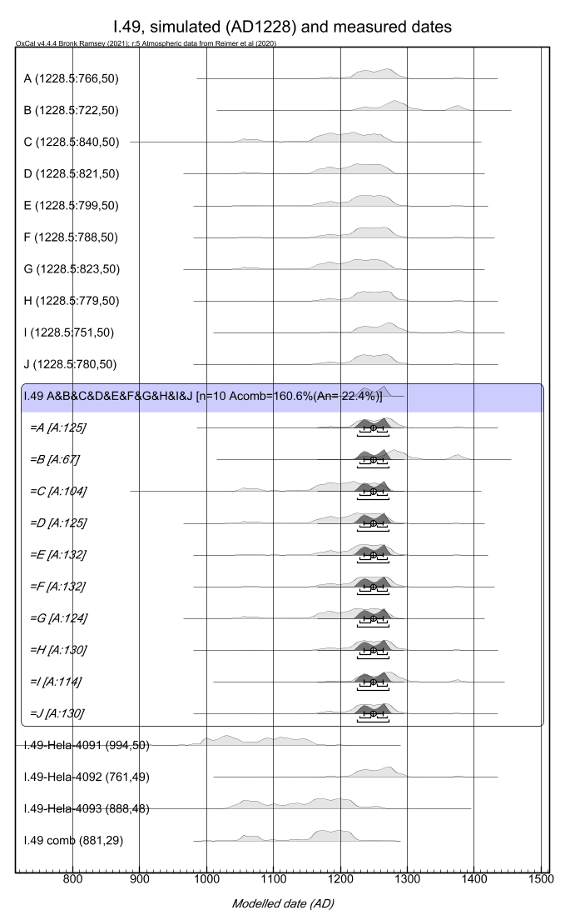
Figure S12. Comparison of simulated radiocarbon dates and their calendar-year probability distributions to the measured ones for I.49 parchment fragment.

I.65, assumed AD1250-1400
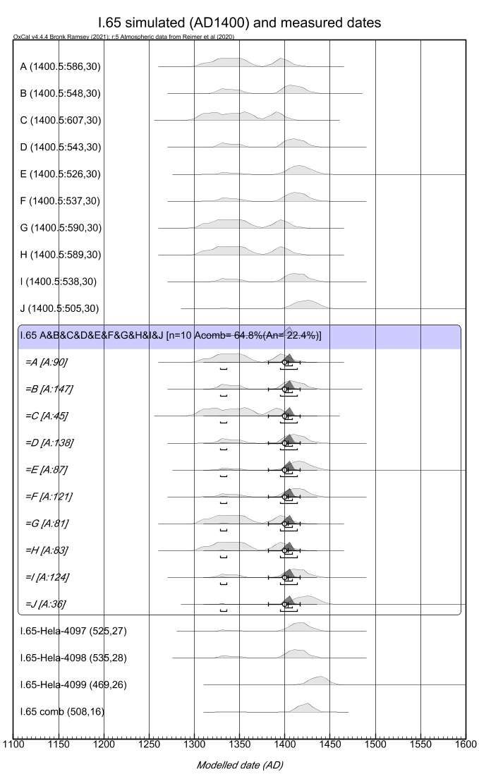
Figure S13. Comparison of simulated radiocarbon dates and their calendar-year probability distributions to the measured ones for I.65 parchment fragment.
All the measured radiocarbon dates overlap with each other (Difference = 0 within 95% C.I.) and thus they can be considered being consistent. Moreover, their cpd’s and scattering seems to be more or less reproduced by assuming the manufacturing year of around the younger boundary of the assumed time span (Figure S13). Particularly, based on simulations, the scattering of measurements can be due to statistics only. The FTIR results are interestingly clustered among different clusters of 1 (Hela-4097, 4098) with the lowest collagen content and 3 (Hela-4099) with moderately lower collagen content compared to cluster 2. So, impacts of the collagen quality issues seem to be modest and within the typical statistical scattering. The combined radiocarbon age is 508(16) BP that converts to a calendar date of 1405 – 1440 calAD (95% C.I.) that is slightly younger compared to the assumed age. FTIR spectrum shows also indirect evidence of fire damage by medium-sized peak structures in all the samples at ca. 2500-2000 cm⁻¹. It would be intriguing to link together the consistently slightly younger dates and consistent observations of these peaks.

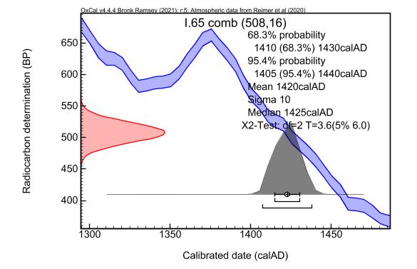

Figure S14. Combined radiocarbon date of I.65.

I.243, assumed AD1400-1500
Two measurements overlap and their combined date is 340(19) BP. Cpd of such a date is reproduced by simulations by assuming the manufacturing year of AD1500 that is at the younger boundary of the assumed date. FTIR data clusters within the group 1 with the lowest collagen content among the samples. On the other hand, sample treatment yields to large enough AMS graphite sizes with R_{graph/comb} values of close to the expected value. So, this indicates that quantitative FTIR and mass data do not necessarily agree. FTIR spectrum shows also indirect evidence of potential fire damage by medium-size peak structures in both E1 and E2 samples at ca. 2500-2000 cm⁻¹. As for I.65, it is interesting that both dates are slightly younger than expected and consistent with the similar peak magnitudes.
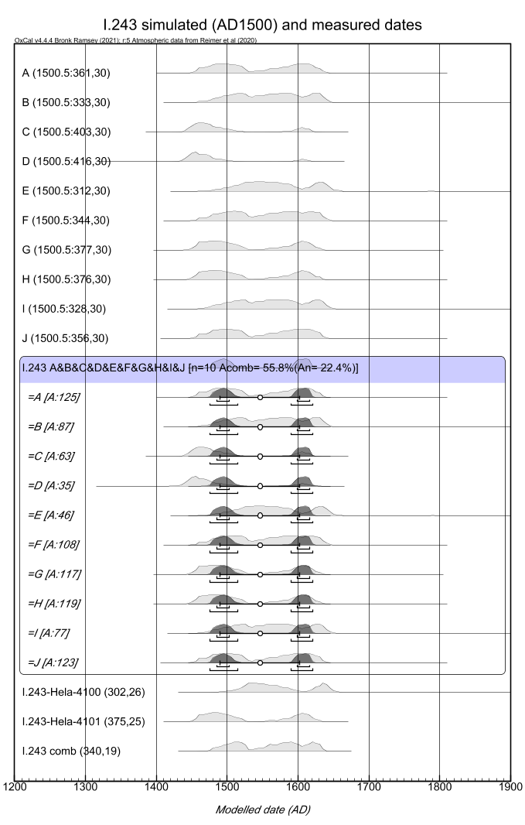
Figure S15. Comparison of simulated radiocarbon dates and their calendar-year probability distributions to the measured ones for I.243 parchment fragment.

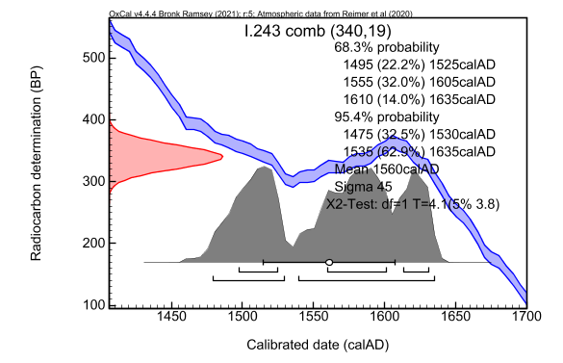
Figure S16. Combined radiocarbon date of I.243.

I.244, assumed AD1400-1500
FTIR data of I.244 F1 show outstandingly high $∆v$ value of 152. This indicates significant denaturation and oxidation of collagen compared to other samples with values lower than 95 - 100. In addition, FTIR shows significantly higher characteristic peak of carbonate within the sample and the collagen content parameters resemble to that of cluster 1 with the lowest collagen content. FTIR spectrum shows also indirect evidence of fire damage by medium and small peak structures in F1 and F2 samples, respectively, at ca. 2500-2000 cm⁻¹. Therefore, one should expect to see here a) low R_{graph/comb} value due to collagen loss and b) the most significant difference between the individual radiocarbon dates, if the degradation of collagen was a problem. On the contrary, one estimates R_{graph/comb} = 0.42 for I.244 F1 and see the smallest difference with the dates of 370(21) and 373(24) BP. These dates overlap with simulated dates of AD1500 i.e. the younger boundary of the assumed range. Carbonate contamination seems not to be a problem as the dates are not leaning to an older direction. This again indicates the high-quality pretreatment process in terms of carbonate removal. The worst-quality sample providing consistent radiocarbon date compared to the typical-quality sample also indicates that potentially all the extracted collagen samples have high-enough quality. This would also explain the poor general correlation between the FTIR results (that are made on untreated samples) and the observations on the treated samples – the efficient pretreatment process is able to extract high-quality collagen that do not carry signs of carbonate contamination or collagen of poor quality. However, in case the pretreatment process does not completely remove possible elemental carbon (ash) from fire damage, slightly younger age could probably be envisioned compared to the assumed age range. Eventually, the combined radiocarbon date provides two-peak cpd, of which the range 1455 – 1525 calAD may correspond to the expected manufacturing year of the parchment.

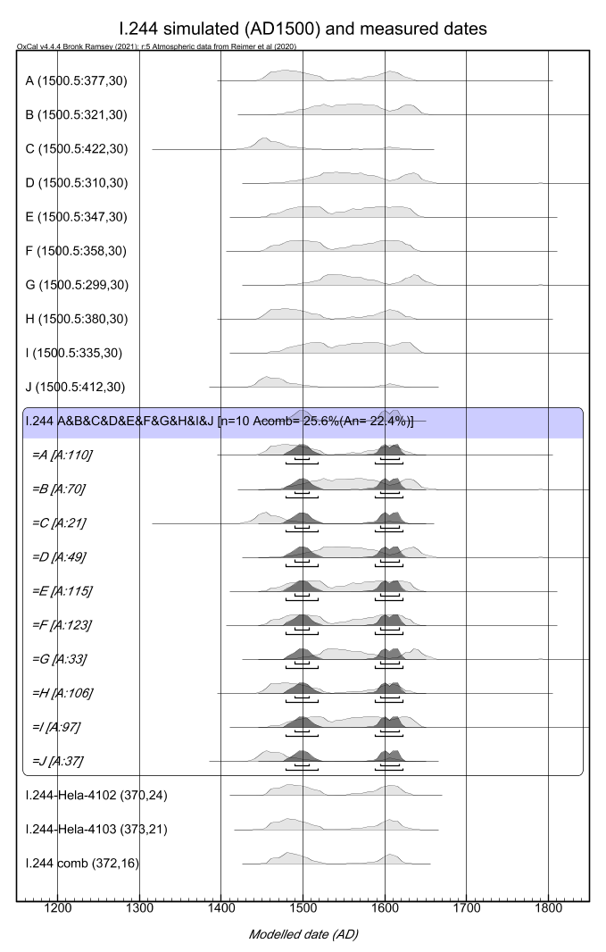
Figure S17. Comparison of simulated radiocarbon dates and their calendar-year probability distributions to the measured ones for I.244 parchment fragment.

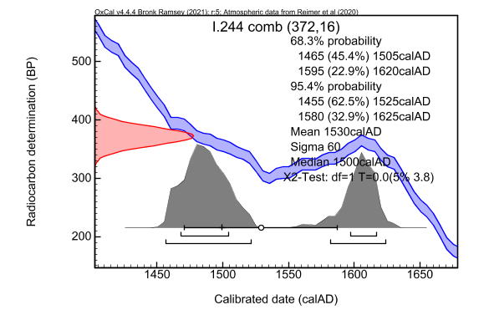
Figure S18. Combined radiocarbon date of I.244.

I.248, assumed AD1400-1500
Both samples are grouped to among the worst-quality samples (cluster 1) according to FTIR. In addition, for I.248 G2, peaks are observed within 1200-890 cm⁻¹ region which are consistent with the presence of starch (Pronti et al., 2018). In addition, I.248 G1 have R_{graph/comb} = 0.75 that is exceptionally high. These indicate some contamination additional to carbonate. As the presence of starch was observed in the FTIR spectrum, the potential contaminant of it should be considered. The corresponding radiocarbon date of G2 (Hela-4105) is, surprisingly though, closer to the assumed date – it overlaps the assumed date simulated with the younger boundary of AD1500. On the other hand, the other date of G1 (Hela-4104) is clearly younger. It would require simulations with AD1630 to be able to produce a similar kind of scattering of the radiocarbon dates, clearly beyond the assumed dates. The high R_{graph/comb} = 0.75 is not consistent with starch contamination as starch should have carbon content of 0.44. FTIR spectrum shows also indirect evidence of fire damage by medium and small peak structures in G1 and G2 samples, respectively, at ca. 2500-2000 cm⁻¹. Incorporation of elemental carbon would probably explain the high R_{graph/comb} observed for G1 that is also clearly younger (Hela-4104). Summarizing, although younger manufacturing year would probably explain the observed scattering, the sample pair has also indications of contamination at least in the untreated samples, signs of contamination of high carbon content and clear difference in the radiocarbon dates.
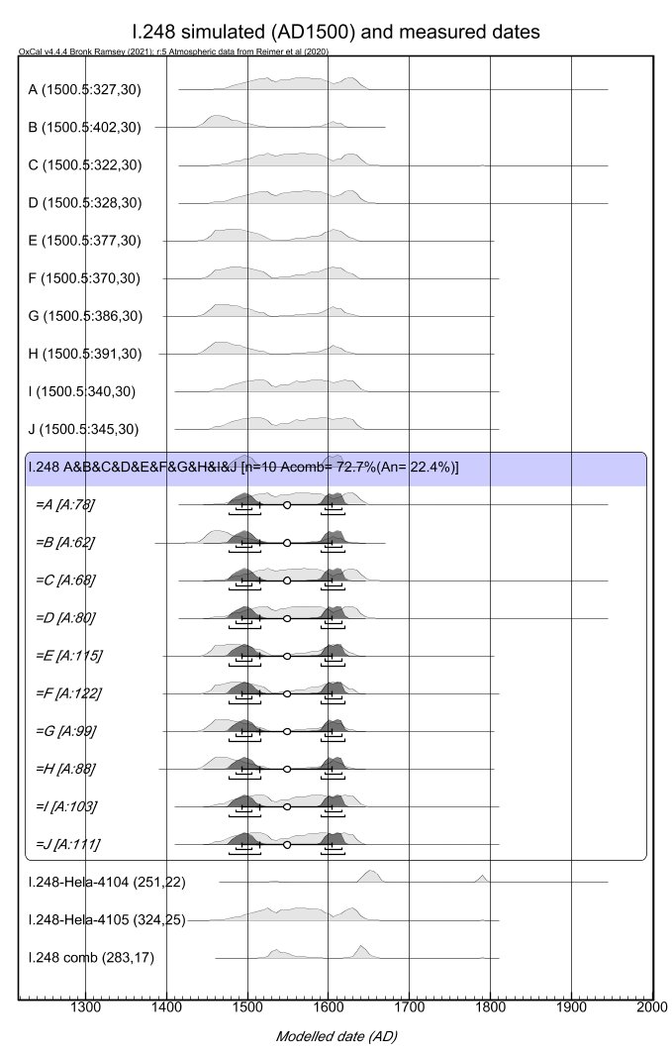
Figure S19. Comparison of simulated (AD1500) radiocarbon dates and their calendar-year probability distributions to the measured ones for I.248 parchment fragment.
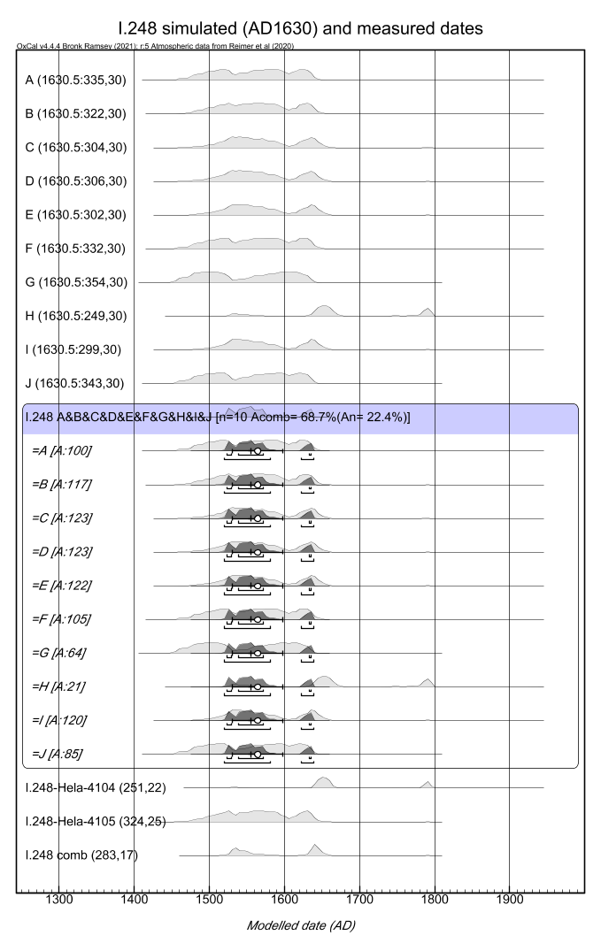
Figure S20. Comparison of simulated (AD1630) radiocarbon dates and their calendar-year probability distributions to the measured ones for I.248 parchment fragment.

II.44, assumed AD1390-1410
All three are grouped among the worst-quality samples (cluster 1) according to FTIR. In addition, all of them show carbonate peaks. FTIR spectra show also indirect evidence of fire damage by large peak structures in H1, H2 and H3 samples at ca. 2500-2000 cm⁻¹. This overall consistency between samples is possibly reflected within the dates as well: their cpd’s overlap. Combined radiocarbon date is 283(17) BP, which converts to cpd of 1520 – 1575 and 1625 – 1660 calAD (95% C.I.). This differs clearly from the assumed time range of simulated dates of ca. AD1400. Radiocarbon date simulations of ca. AD1600-1620 would lead to a better agreement, similarly as for I.248 samples.
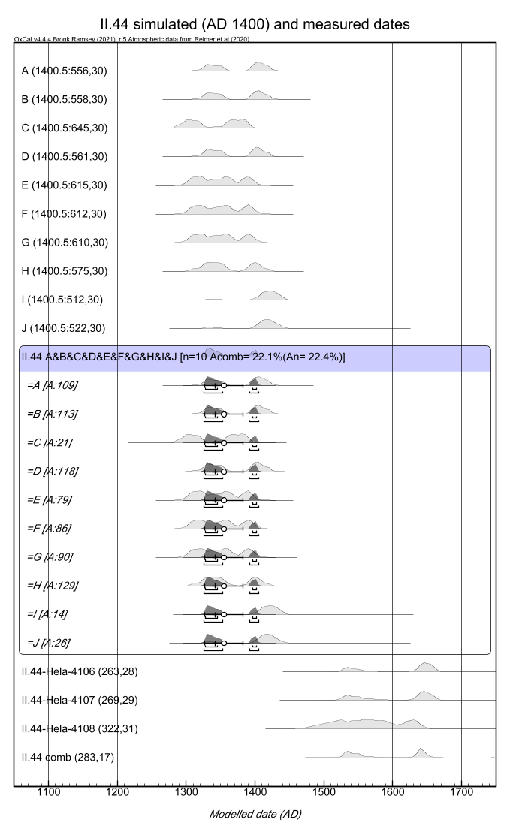
Figure S21. Comparison of simulated radiocarbon dates and their calendar-year probability distributions to the measured ones for II.44 parchment fragment.
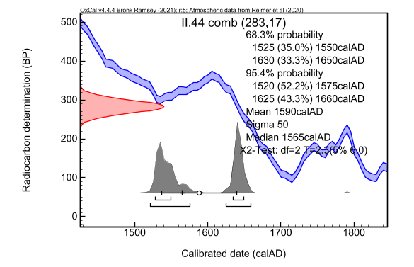
Figure S22. Combined radiocarbon date of II.44.

III.17, assumed AD1150-1300
Sample III.17 I1 (Hela-4106) shows outstandingly high R_{graph/comb} = 0.75 that may indicate contamination with material of larger carbon mass fraction. FTIR indicates both samples belonging to cluster 1 with worst-quality collagen and, particularly, III.17 I2 sample seems to be quality issues. FTIR spectra show also indirect evidence of fire damage by medium- and large-sized peak structures in I1 and I2 samples, respectively, at ca. 2500-2000 cm⁻¹. Nevertheless, two radiocarbon dates overlap and lead to a combined date of 607(22) BP. This leads to a cpd of 1300 – 1405 calAD (95% C.I.). that overlaps with the cpd of the simulated dates of AD1300: 1295 – 1390 calAD (95% C.I.). So, although there are indications of potential issues related to collagen quality and contamination of untreated sample, a) the measurement agree and b) it is possible to find calendar years within the younger boundary of the assumed time span that result in fully overlapping calendar year probability distributions.
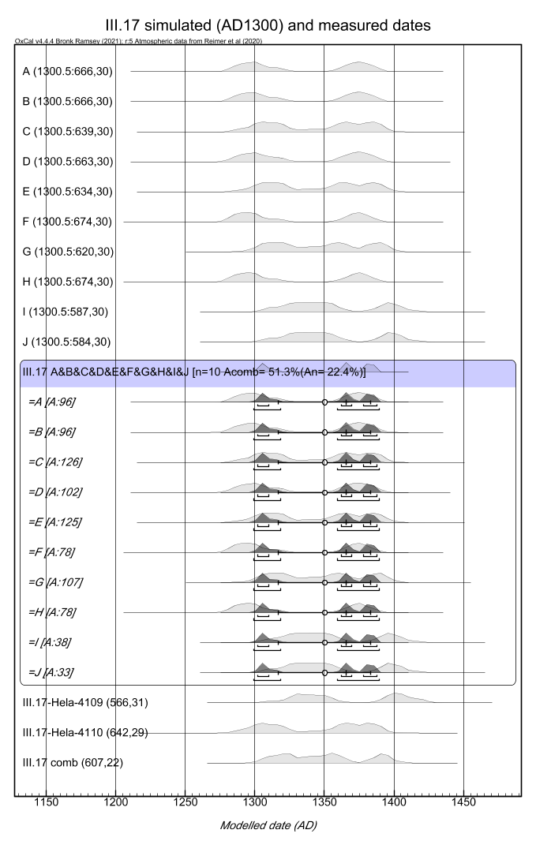

Figure S23. Comparison of simulated radiocarbon dates and their calendar-year probability distributions to the measured ones for III.17 parchment fragment.

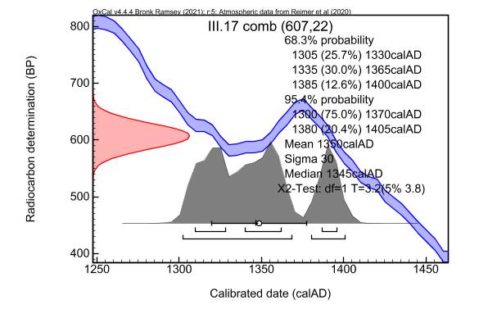
Figure S24. Combined radiocarbon date of III.17.

IV.3, assumed AD1125-1175
FTIR data indicates high-quality collagen for IV.3 J1 and worst quality for IV.3 J2. Moreover, the high-quality collagen sample is accompanied with a high intensity peak of carbonate. FTIR spectra show also indirect evidence of fire damage by small- and medium-sized peak structures in J1 and J2 samples, respectively, at ca. 2500-2000 cm⁻¹. So, this data pair acts as an additional test for the pretreatment process to deal with the potential collagen and contamination issues. The measurements have a nearly perfect overlap resulting in a combined date of 685(20) BP. So, initial difference between the collagen quality do not affect the measurement results. The combined date converts to calendar-year ranges of 1275 - 1310 calAD and 1360 – 1385 calAD (95% C.I.). These are clearly younger compared to the assumed ages of AD1125 - 1175. This cannot be explained by carbonate contamination, since it would make dates older, not younger. It is not possible to obtain overlap with the assumed ages even by radiocarbon-date simulations of the younger boundary of AD1175. Indication of fire damage may provide partial explanation of the observation. In addition, understanding the discrepancy should involve studies of assessing the accuracy (Schniedewind, 2005) of the paleographic estimate of the assumed age.
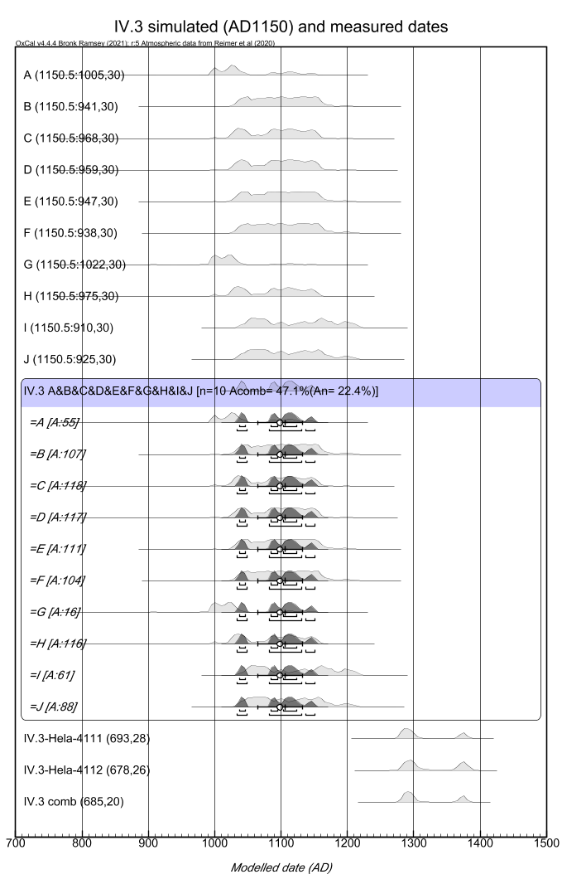
Figure S25. Comparison of simulated radiocarbon dates and their calendar-year probability distributions to the measured ones for IV.3 parchment fragment.

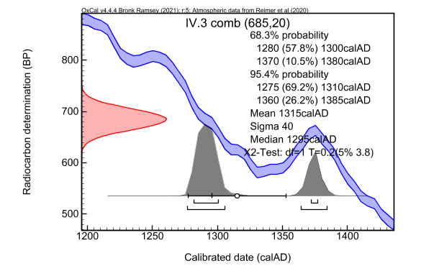
Figure S26. Combined radiocarbon date of IV.3.

IV.156, assumed AD1450-1500
Another example having both high-quality and less-optimal quality collagen initially among samples is IV.156: K1 and K3 samples belong to the cluster 1 and K2 to the cluster 2 according to FTIR data. The highest-quality samples result in youngest ages that are clearly separated from the assumed age of AD1450 – 1500. On the other hand, the lowest-quality sample provides a better agreement and somewhat overlaps with the cpd of the simulated radiocarbon dates, particularly of the younger boundary of the range. FTIR spectra of these samples shows a similar doublet (possibly calcium sulfate due to gallic acid used in ink) as was observed for I.49 B3 except with much smaller intensity and more symmetrical in shape. Moreover, we see the largest peaks in the sample IV.156 K2 that provide overlap in the age range compared to the assumptions and smallest peaks in IV.156 K1 and K3 that provide the youngest ages. FTIR spectra shows also indirect evidence of fire damage by medium, small and large peak structures in K1, K2 and K3, respectively, at ca. 2500-2000 cm⁻¹. So, whereas the potential contamination linked to the doublet may not explain the younger ages of Hela-4113 and 4115, these are coherent to the medium and large peak structures indicating fire damage. The measured and simulated cpd’s start to overlap if one assumes ca. AD1660 as the manufacturing year (Figure S28) even so that the large scattering can be understood. However, according to palaeographical analyses, such a young age is not possible since markings in the fragments show them being circulated from AD 1580 onwards. Thus, we tentatively link the younger ages at least partially to fire damage.
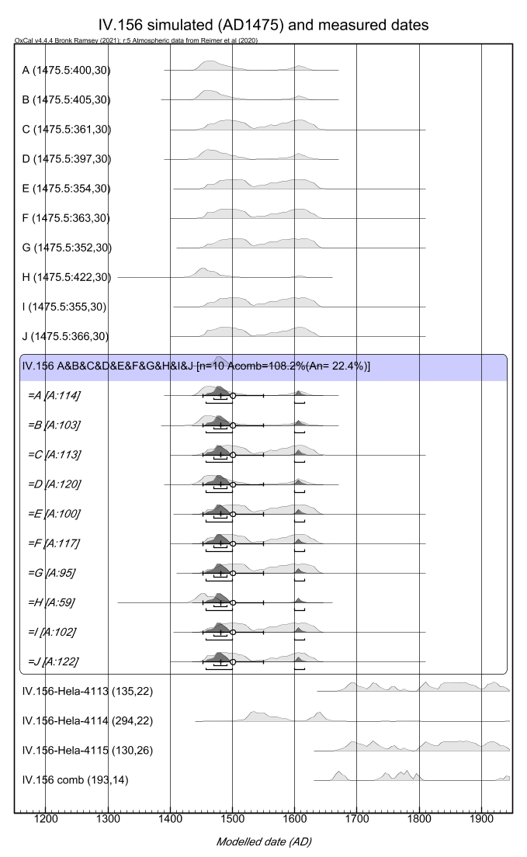
Figure S27. Comparison of simulated radiocarbon dates (AD1475) and their calendar-year probability distributions to the measured ones for IV.156 parchment fragment.

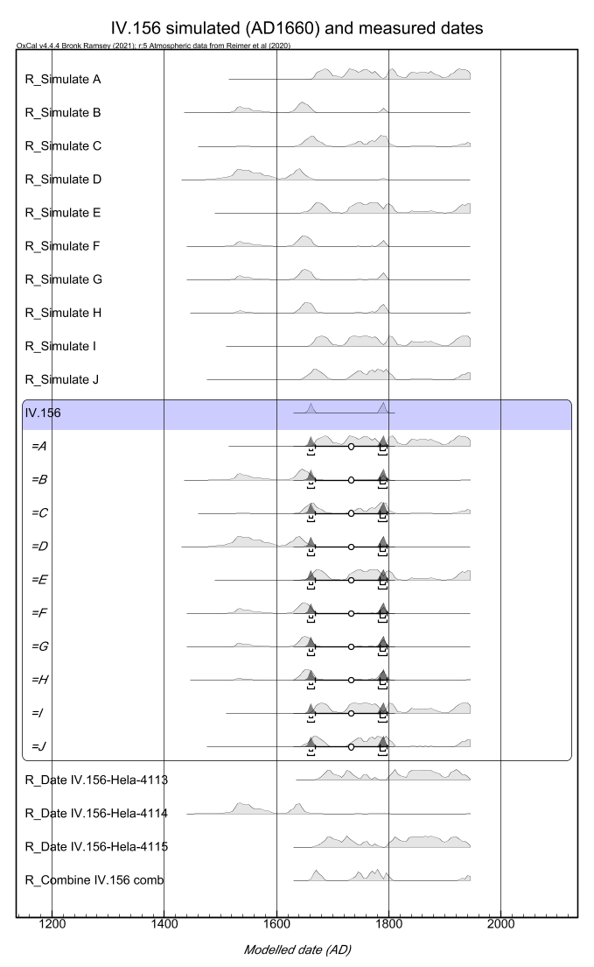
Figure S28. Comparison of simulated radiocarbon dates (AD1660) and their calendar-year probability distributions to the measured ones for IV.156 parchment fragment.

IV.157, assumed AD1450-1500
The IV.157 fragment samples show nearly the similar behaviour than IV.156, except FTIR indicates slightly better collagen quality particularly for L1 and L2 samples compared to K1 and K3, whereas L3 and K2 are equally better. A strong peak of 1035 cm⁻¹ is observed for the L2 sample corresponding to Hela-4117. Once again, this peak is similar in shape to the doublet that was observed in Hela-4093, so it should be considered as potential contamination (calcium sulfate/gallic acid), if chemical pretreatment process does not remove it. FTIR spectra shows indirect evidence of fire damage by medium, medium and small peak structures in L1, L2 and L3, respectively, at ca. 2500-2000 cm⁻¹. Eventually, the three radiocarbon dates partially overlap but Hela-4117 and 4118, in particular, do not reproduce the assumed age of AD 1450-1500. In fact, similarly to IV.156, both the cpds and their scatter is more or less reproduced if assuming the manufacturing year of ca. AD1660. However, according to palaeographical analyses, such a young age is not possible since markings in the fragments show them being circulated from AD 1580 onwards. Similarly, as for IV.156 samples, we tentatively link the younger ages at least partially to fire damage.

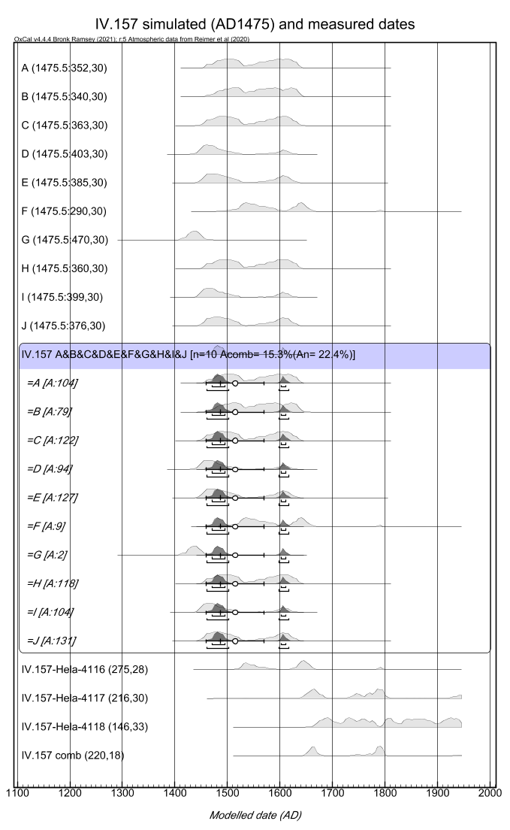
Figure S29. Comparison of simulated radiocarbon dates (AD1475) and their calendar-year probability distributions to the measured ones for IV.157 parchment fragment.

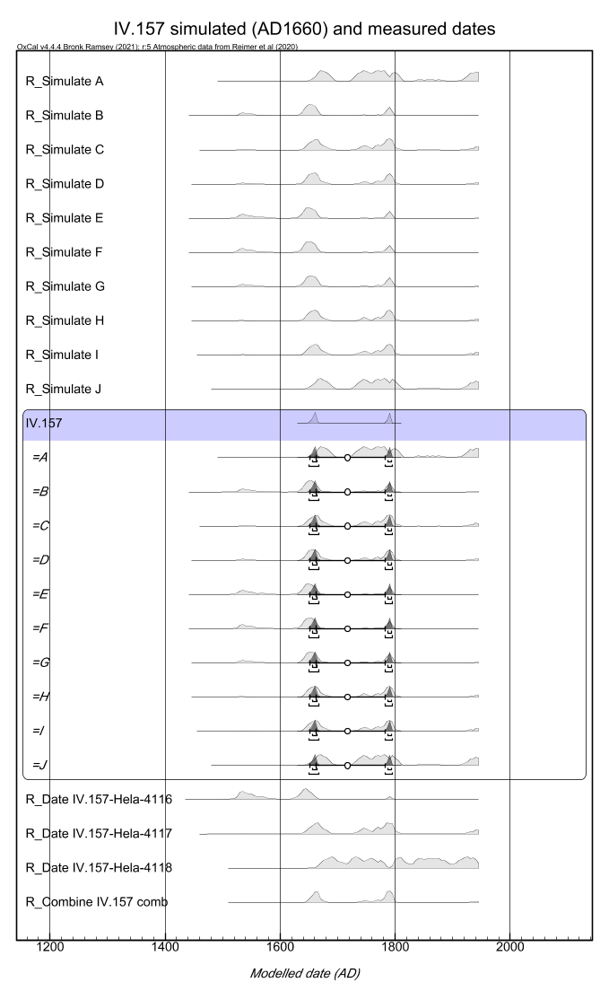
Figure S30. Comparison of simulated radiocarbon dates (AD1660) and their calendar-year probability distributions to the measured ones for IV.157 parchment fragment.

VII.67, assumed AD1300-1400
FTIR shows typical less-optimal quality of collagen (cluster 1 and 3) and also carbonate peaks, particularly for VII.67 M3. Actually, the radiocarbon date of M3 (Hela-4121) is slightly older, though not statistically separable from Hela-4120, than the others that would be consistent of carbonate contamination also within the pretreated sample. This is the only case within our data where large carbonate peaks may coincide with possibly an older date. Nevertheless, all the measurements are younger compared to the assumed time range. Their scattering can be explained by statistics and, in fact, simulated radiocarbon dates of AD1450 would produce more or less the observed date distribution. FTIR spectrum shows indirect evidence of fire damage by medium, medium and small peak structures in M1, M2 and M3, respectively, at ca. 2500-2000 cm⁻¹.
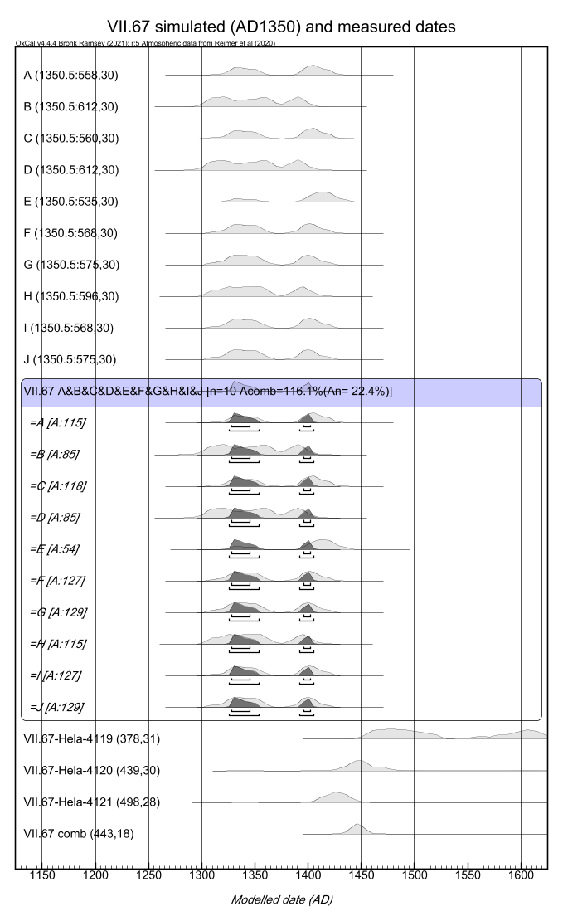
Figure S31. Comparison of simulated (AD1350) radiocarbon dates and their calendar-year probability distributions to the measured ones for VII.67 parchment fragment.
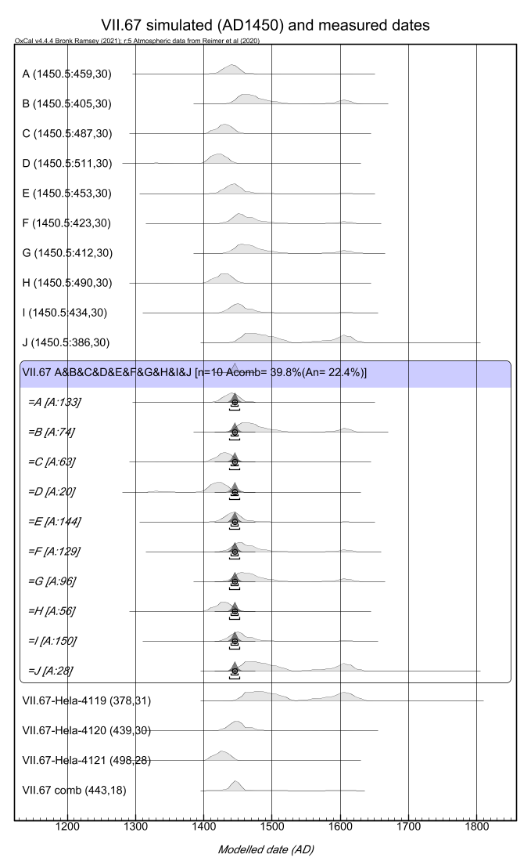
Figure S32. Comparison of simulated (AD1450) radiocarbon dates and their calendar-year probability distributions to the measured ones for VII.67 parchment fragment.

References
Bicchieri, M., Monti, M., Piantanida, G., Sodo, A., Tanasi, M.T. 2008. Inside the Parchment. Proceedings of the 9th International Conference on NDT or Art, Jerusalem, Israel, 25-30 May, 2008.
Guiry, E.J., Szpak, P., 2020. Quality control for modern bone collagen stable carbon and nitrogen isotope measurements. Methods Ecol. Evol. 11, 1049–1060. https://doi.org/10.1111/2041-210X.13433
Kasso, T.M., Oinonen, M.J., Mizohata, K., Tahkokallio, J.K., Heikkilä, T.M., 2021. VOLUMES OF WORTH—DELIMITING THE SAMPLE SIZE FOR RADIOCARBON DATING OF PARCHMENT. Radiocarbon 63, 105–120. https://doi.org/10.1017/RDC.2020.128
Pronti, L., Perino, M., Cursi, M., Santarelli, M.L., Felici, A.C., Bracciale, M.P., 2018. Characterization and Digital Restauration of XIV-XV Centuries Written Parchments by Means of Nondestructive Techniques: Three Case Studies. J. Spectrosc. 2018. https://doi.org/10.1155/2018/2081548
Schniedewind, W.M., 2005. Problems of Paleographic Dating of Inscriptions, in: Levy, T., Higham, T. (Eds.), The Bible and Radiocarbon Dating: Archaeology, Text and Science. Routledge.

