Age | Sample No. | Context | Material | Lab no. | Radiocarbon age (bp) | δ¹³C  (‰) | δ¹⁸O  (‰) | XRD |  | Description
2470-2160 BC | SA-285 | C.102 | Placuna placenta | Wk-41892 | 3033±20 | -4.56±0.3 | -4.59±0.25 | Calcite | 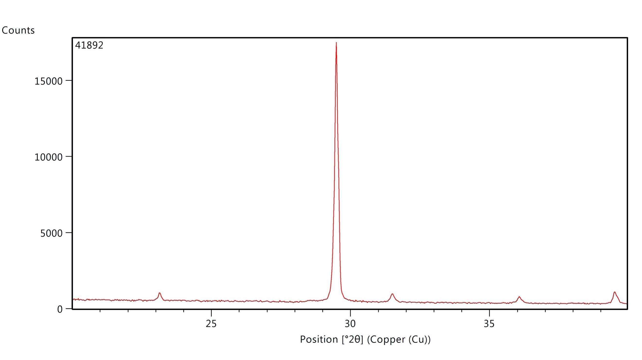 | Opaque with a pearly luster.
 | SA-4 | C.102/1 | Tegillarca granosa | Wk-42439 | 4101±15 | -4.84±0.3 | -4.11±0.25 | Calcite (burnt) | 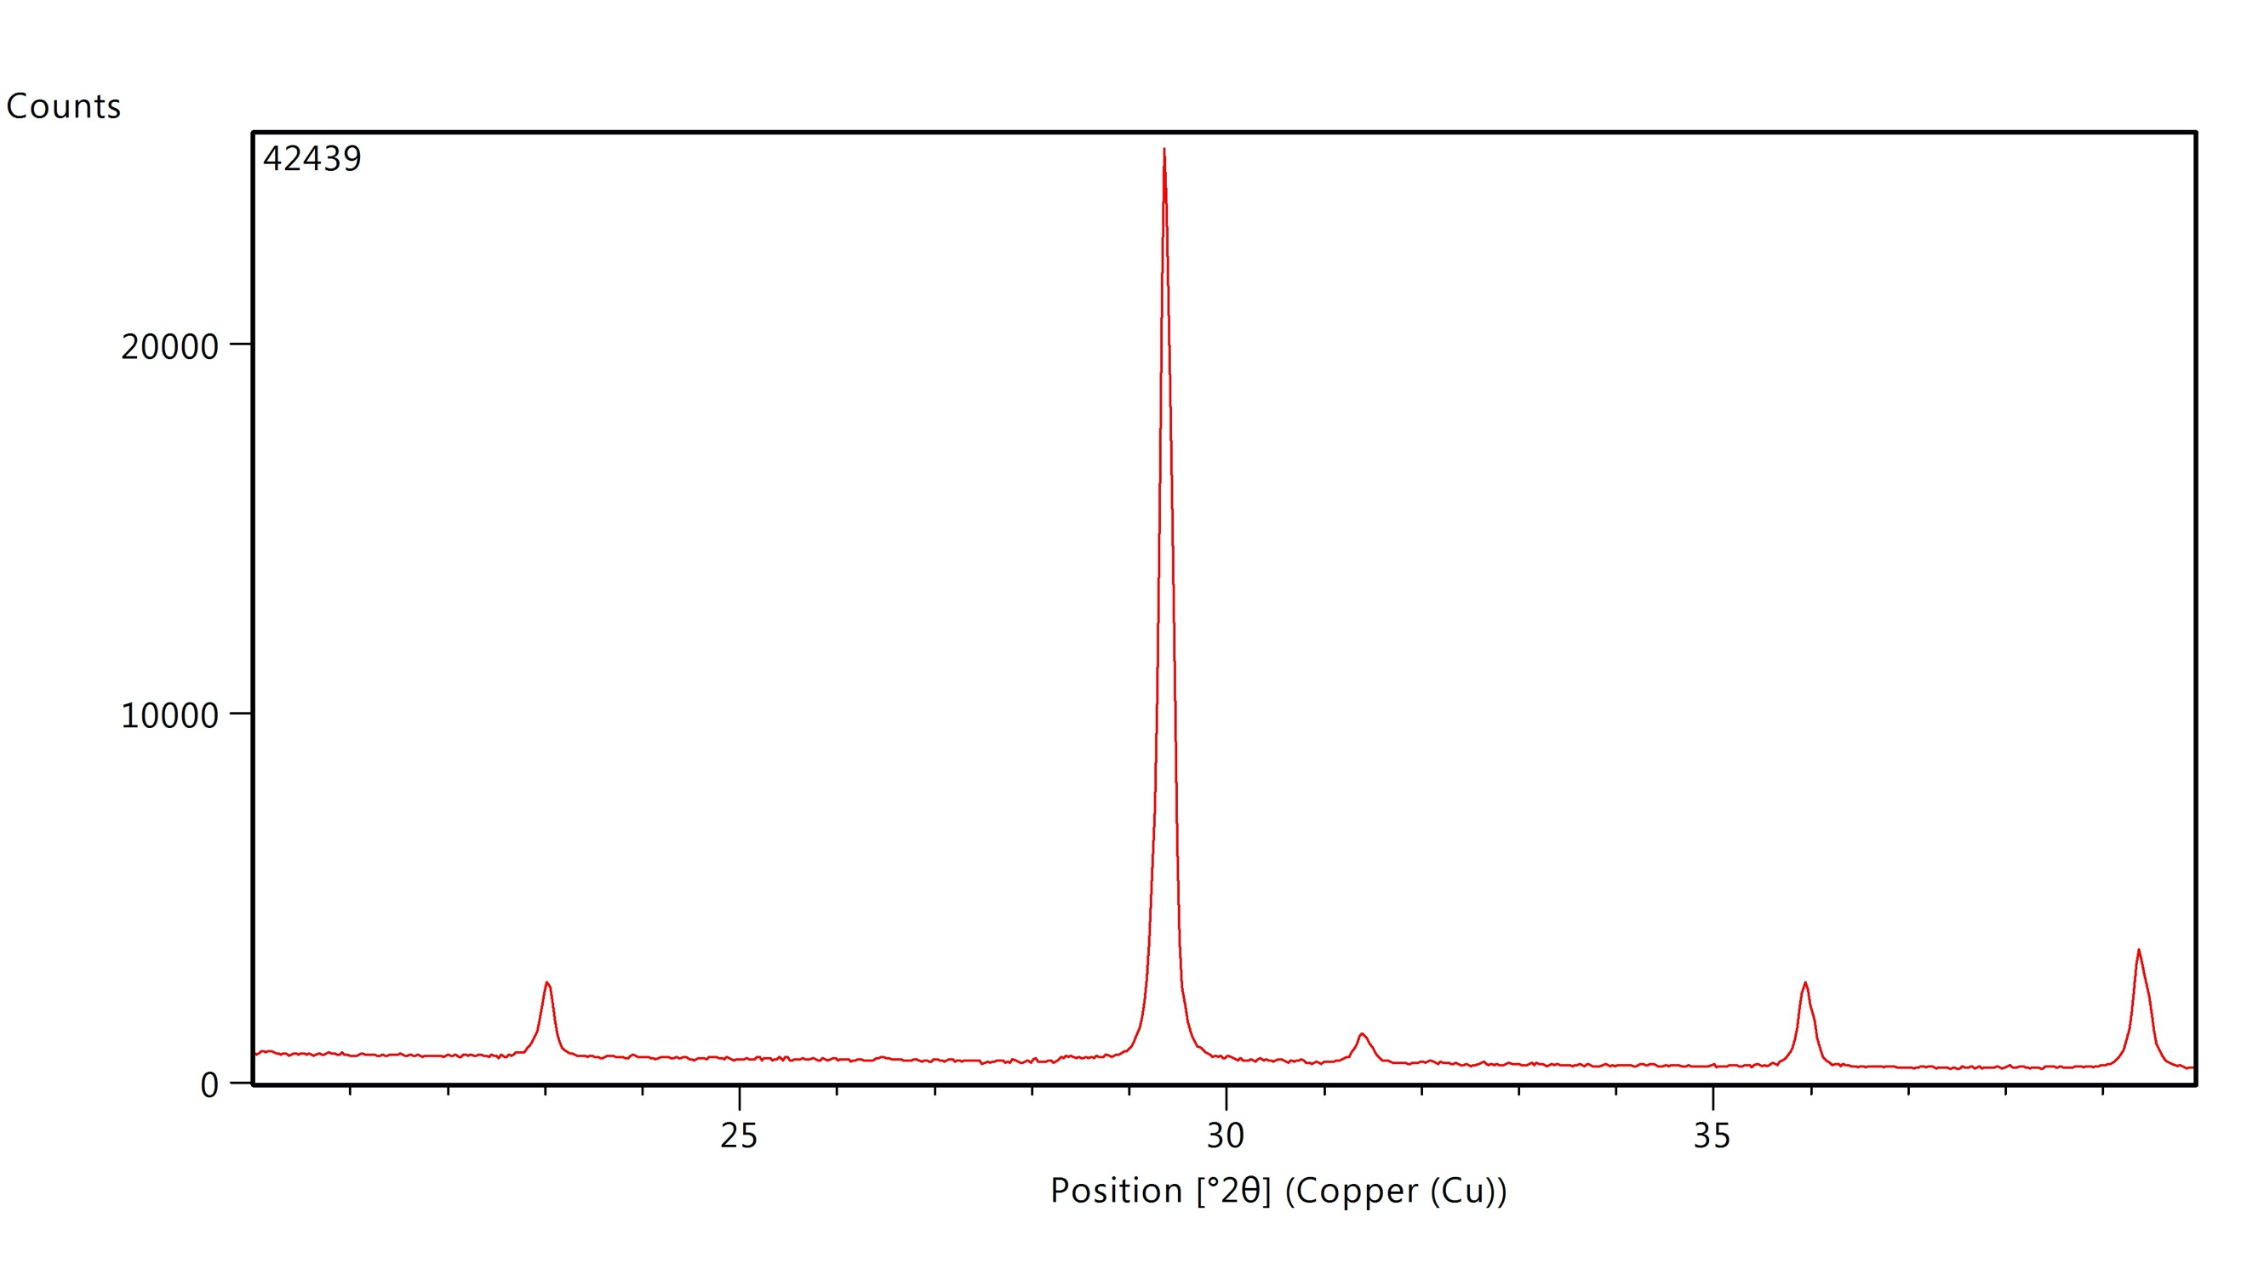 | White exterior but grey interior suggests possible burning. No obvious dissolution.
 |  |  |  |  |  | HIATUS
2940-2370 BC | SA-286 | C.104 | Placuna placenta | Wk-41896a | 3646±20 | -3.59±0.3 | -4.30±0.25 | Calcite | 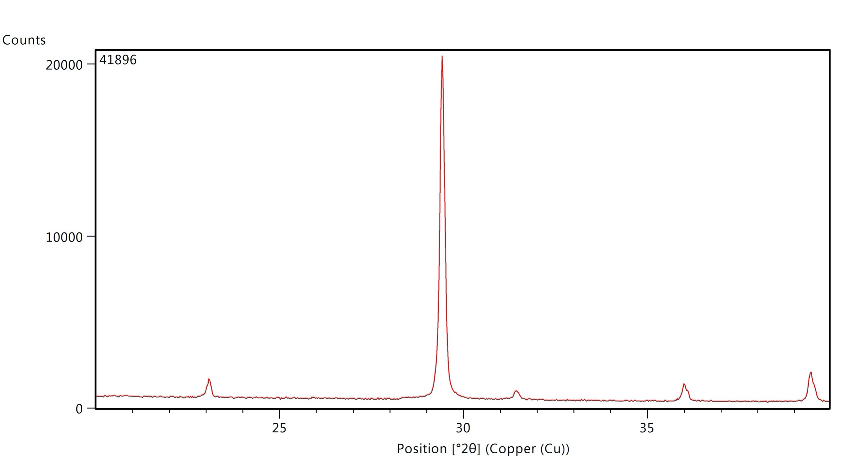 | Opaque with a minor pearly luster.
 |  |  |  | Wk-41896b | 3801±20
 | SA-297 | C.105 | Placuna placenta | Wk-41897 | 3889±20 | -5.80±0.3 | -4.42±0.25 | Calcite | 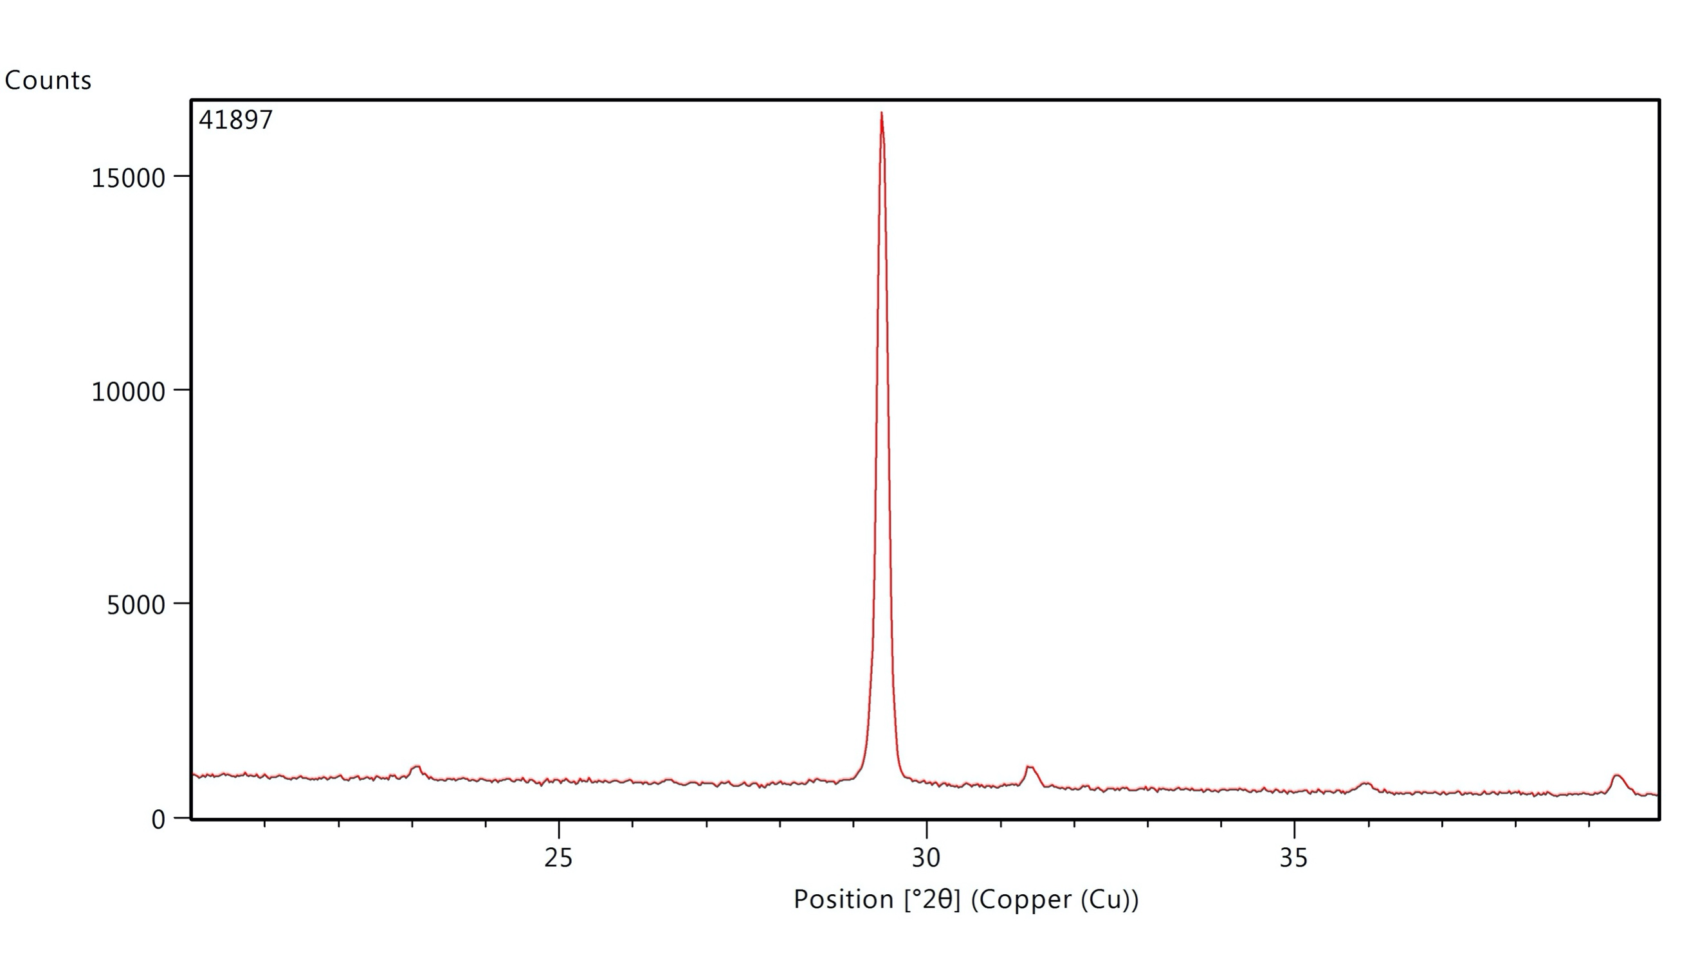 | Opaque.
 | SA-287 | C.106 | Placuna placenta | Wk-41900 | 3704±20 | -3.39±0.3 | -4.75±0.25 | Calcite | 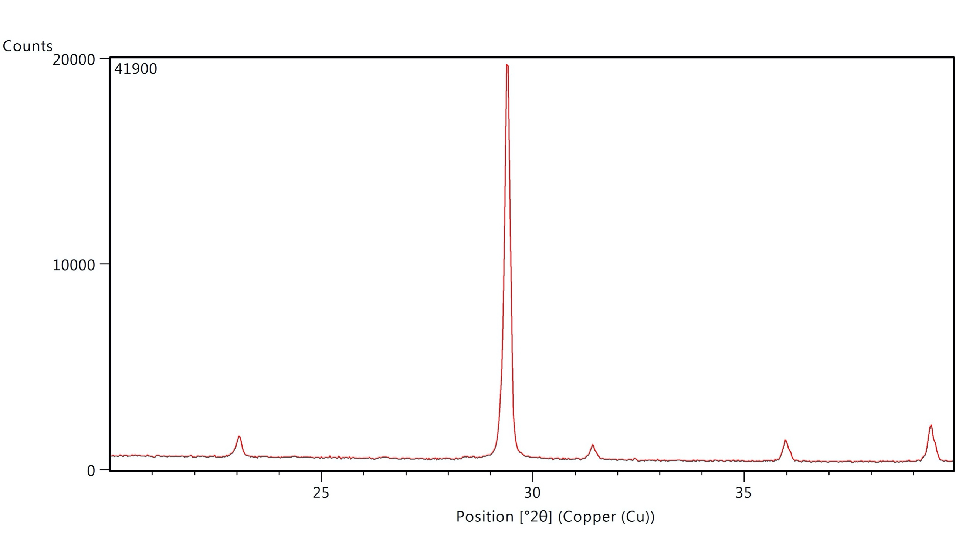 | Opaque with a slight pearly luster.
 | SA-288 | C.107 | Placuna placenta | Wk-41902 | 3577±20 | -6.05±0.3 | -3.80±0.25 | Calcite | 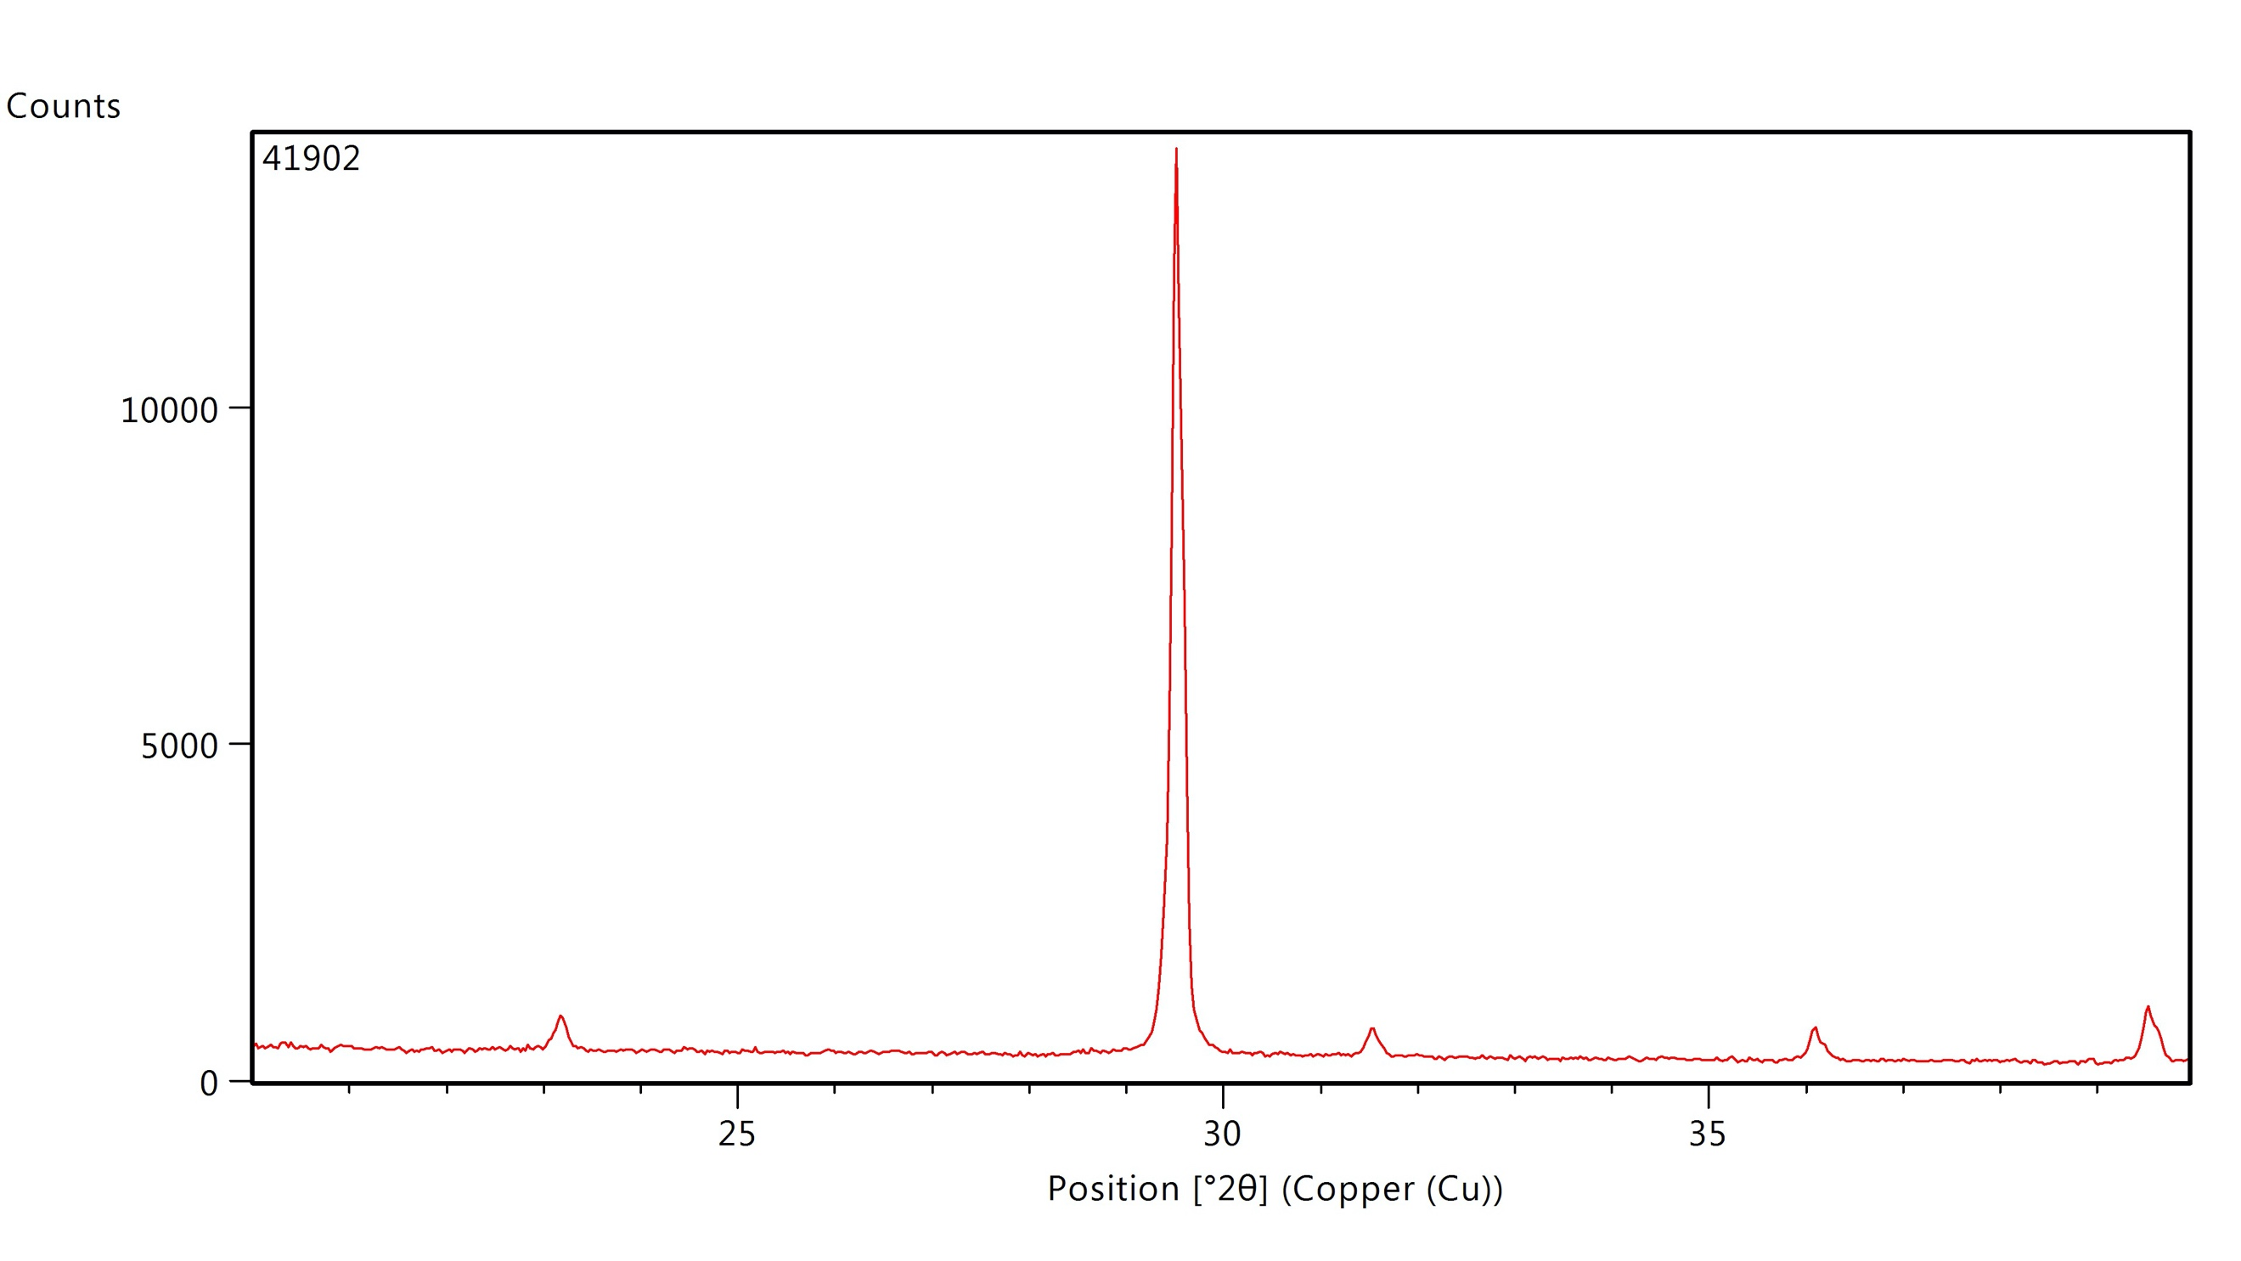 | Opaque with a slight pearly luster.
 | SA-289 | C.108 | Placuna placenta | Wk-41904a | 2398±20 | -5.84±0.3 | -3.42±0.25 | - | Too small for XRD analysis | Small fragmented pieces. Powdery, opaque.
 |  |  |  | Wk-41904b | 2297±20
 | SA-290 | C.109 | Placuna placenta | Wk-41906 | 3800±20 | -4.90±0.3 | -4.36±0.25 | Calcite | 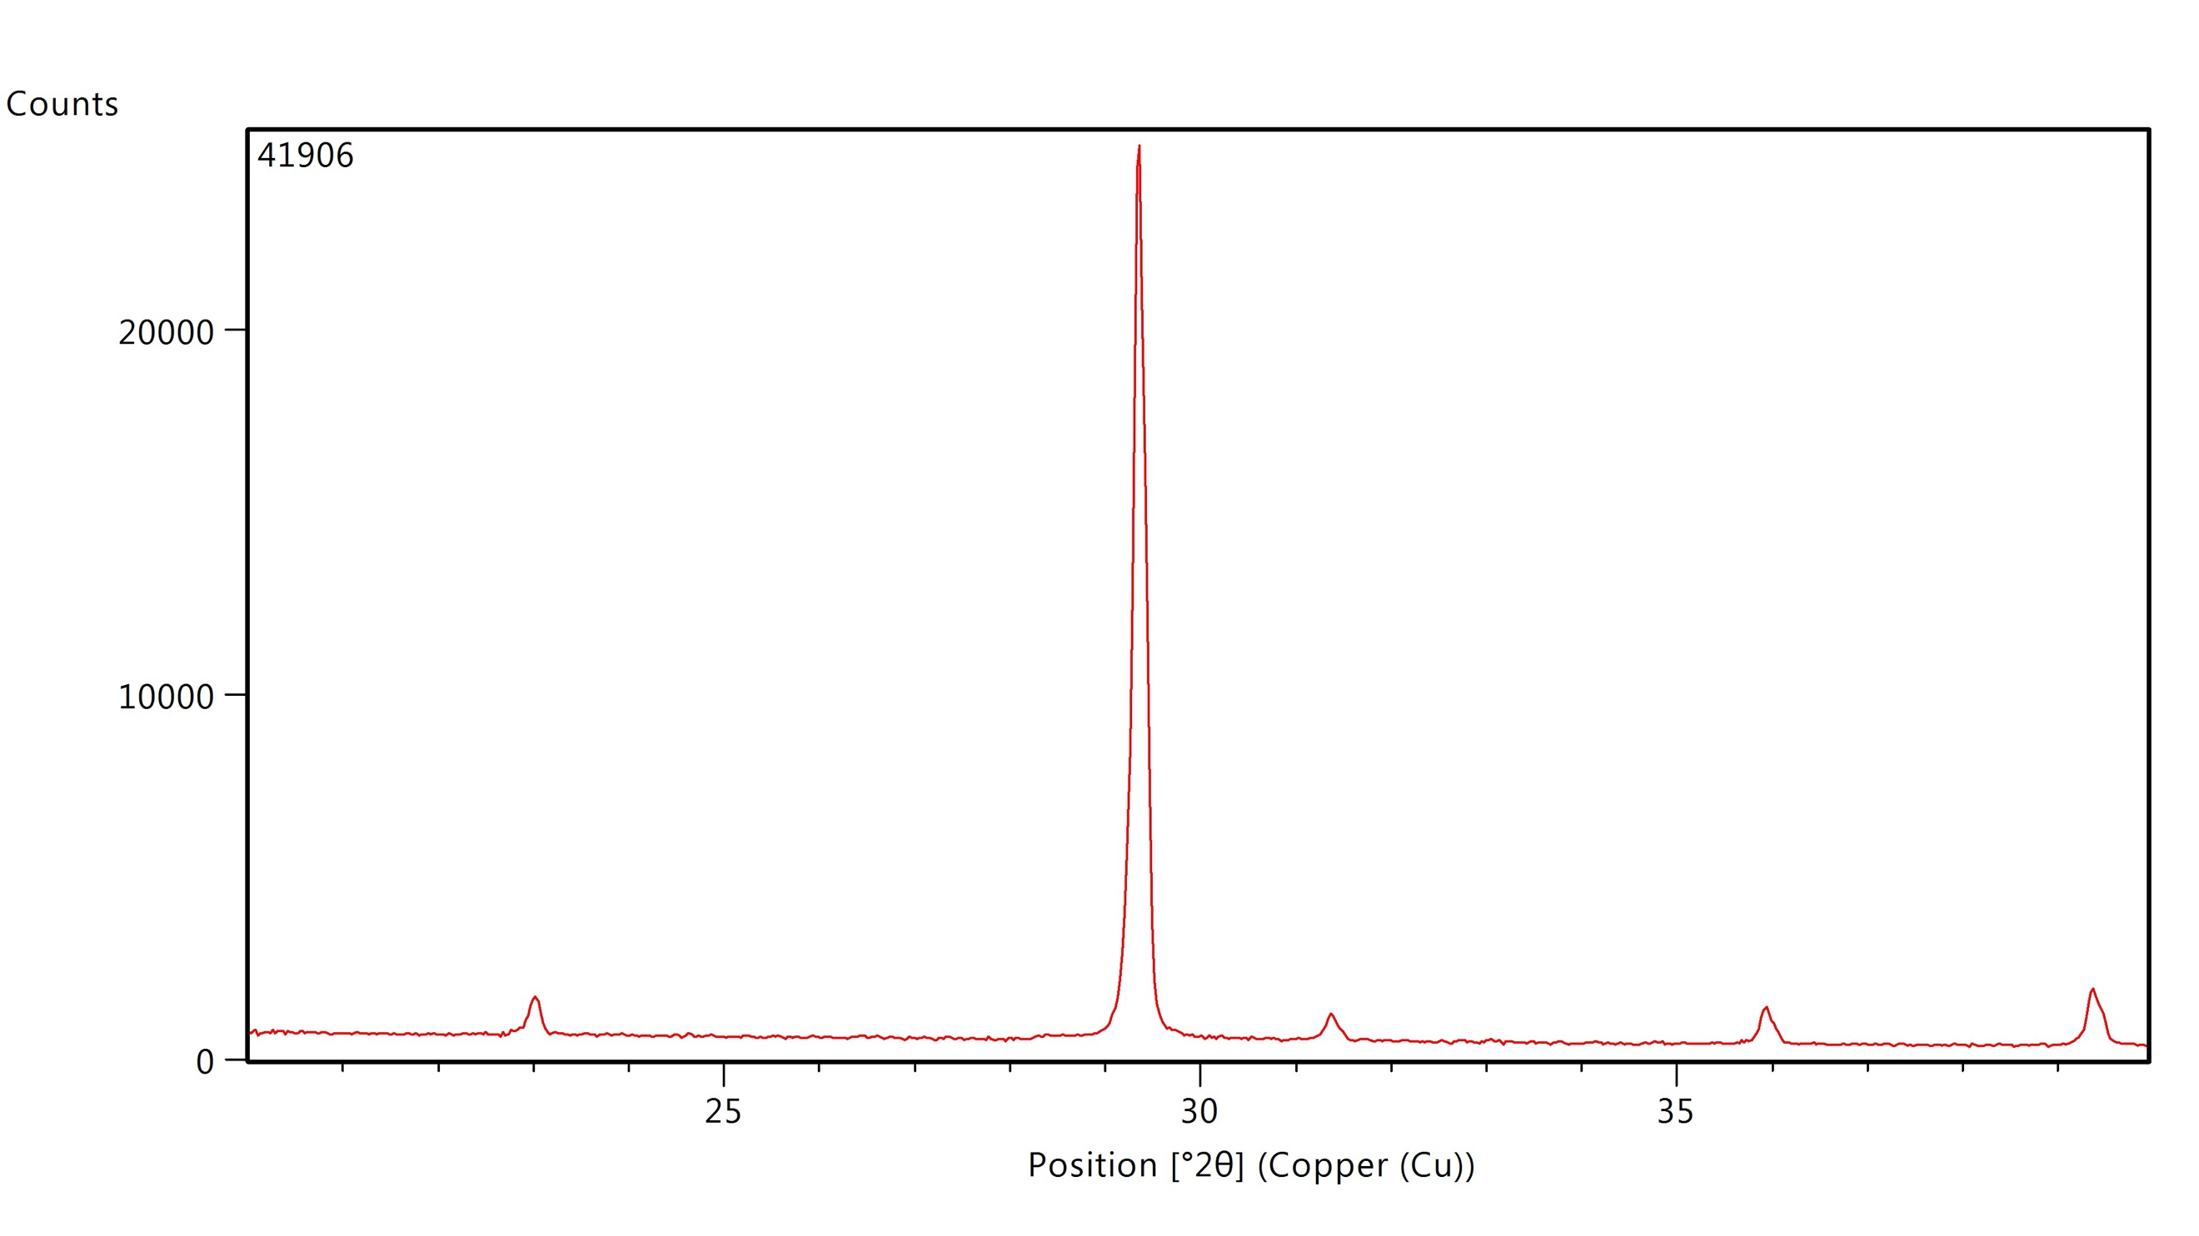 | Opaque with a slight pearly luster.
 | SA-291 | C.110 | Placuna placenta | Wk-41909 | 3880±20 | -2.33±0.3 | -3.05±0.25 | Calcite | 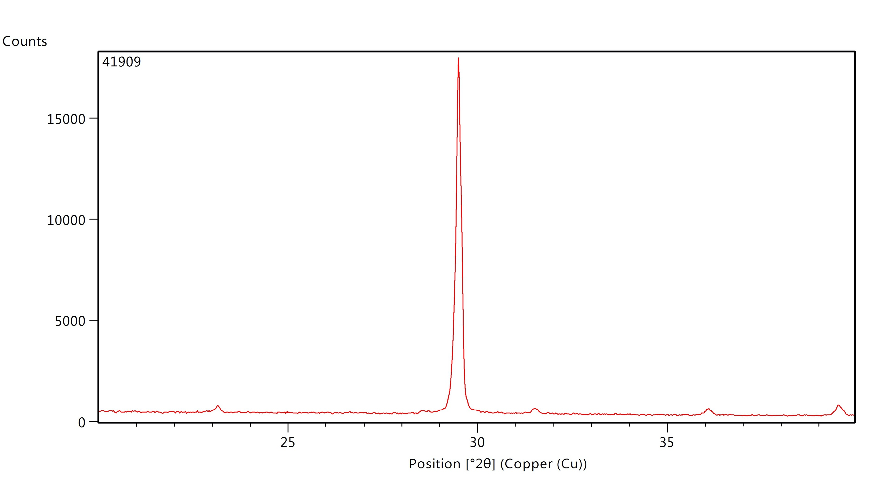 | Translucent with pearly luster. Brown imperfections within the shell are visible.
 | SA-292 | C.111 | Placuna placenta | Wk-41911a | 2109±20 | -4.76±0.3 | -4.54±0.25 | Calcite | 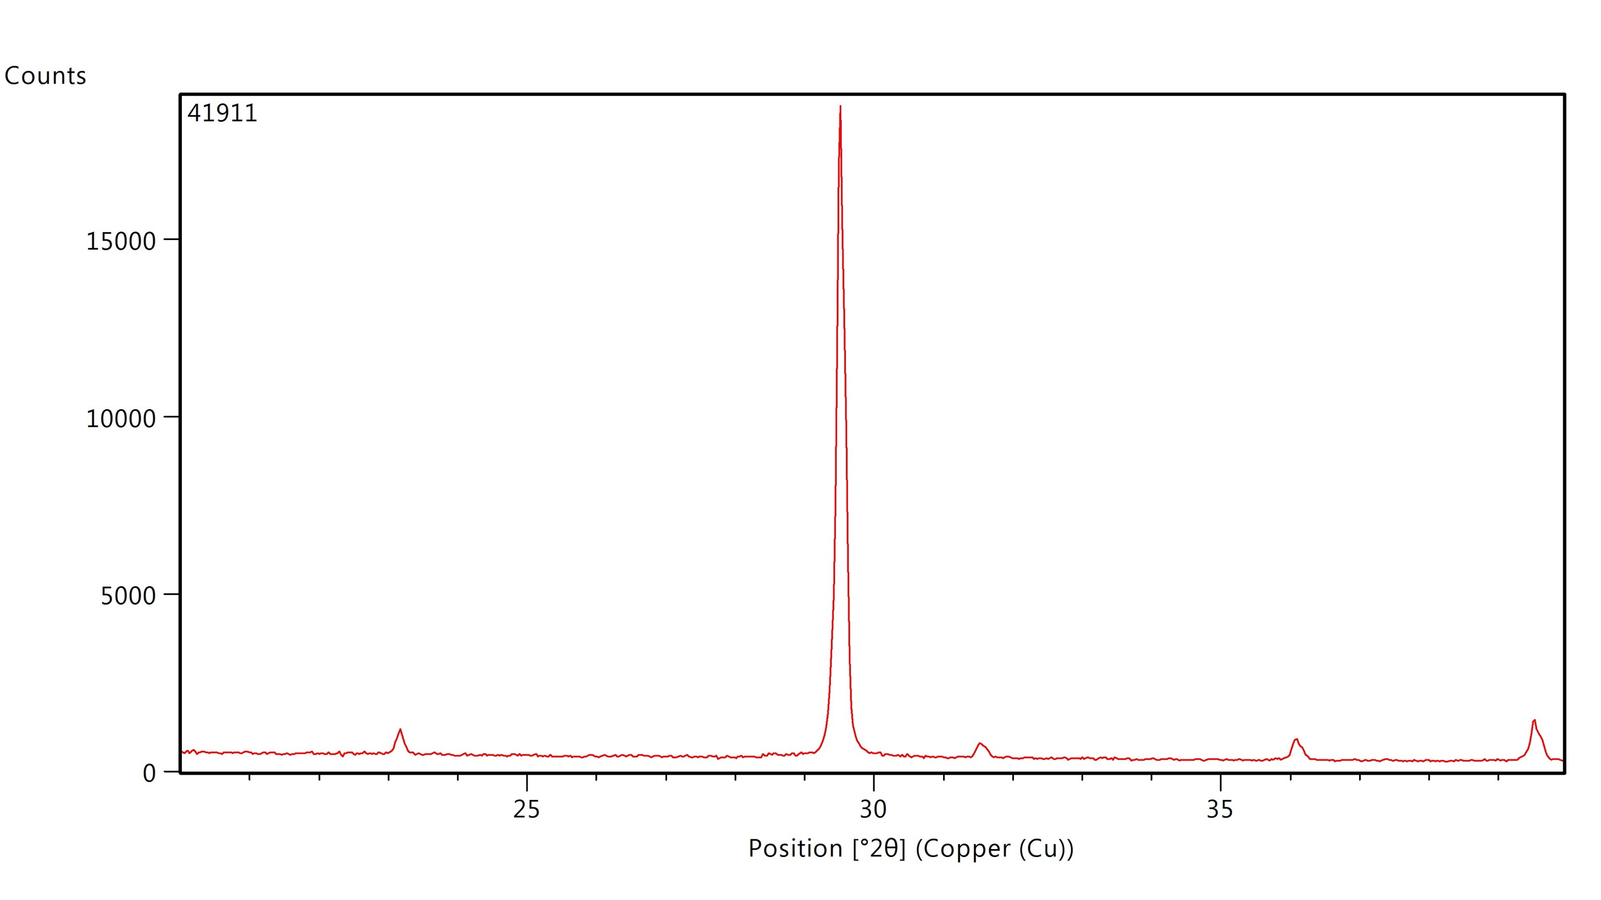 | Brownish grey. Opaque with a slight pearly luster.
 |  |  |  | Wk-41911b | 2670±20
 | SA-293 | C.112 | Placuna placenta | Wk-41913 | 3109±20 | -5.69±0.3 | -4.54±0.25 | Calcite | 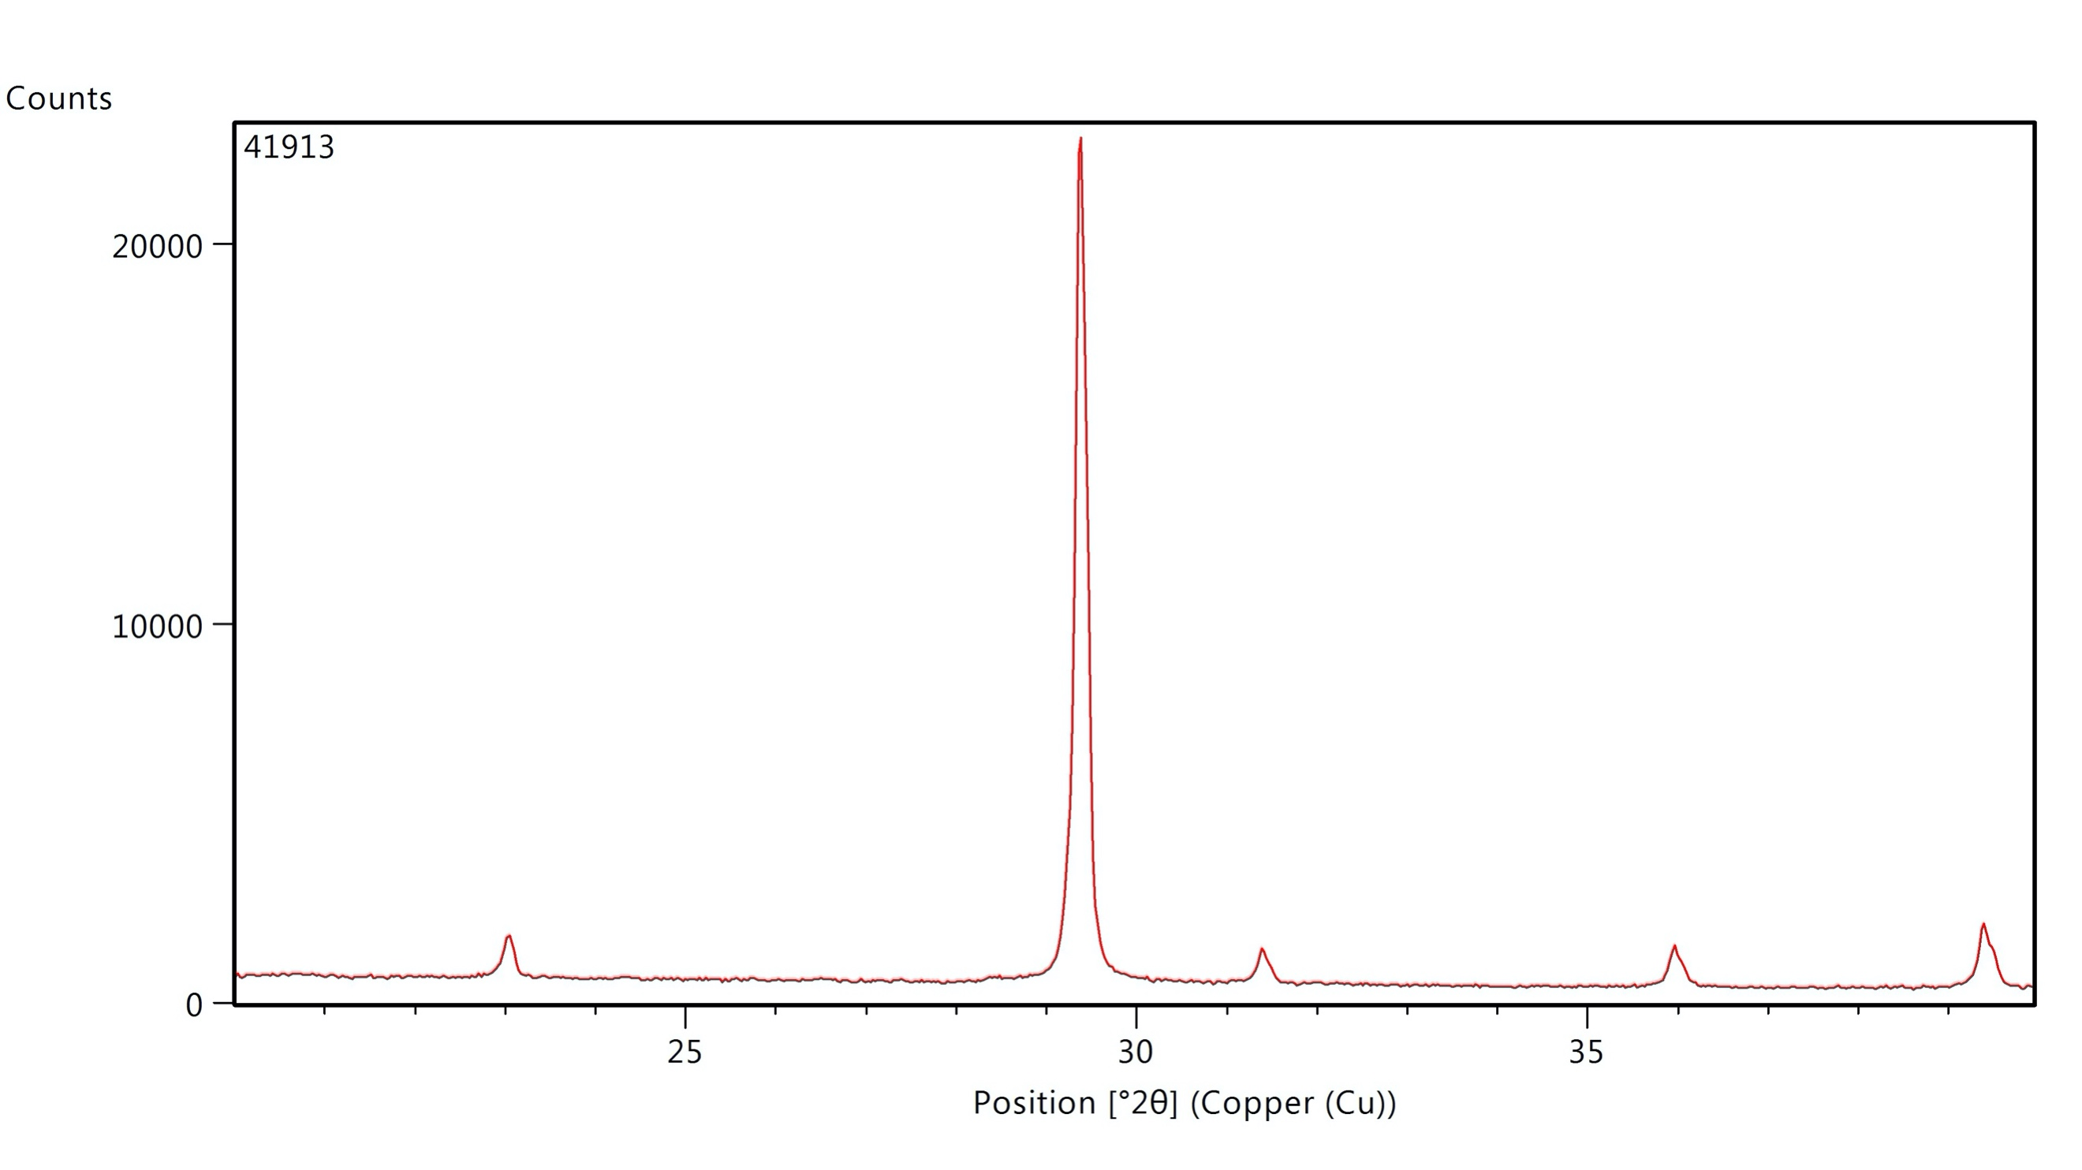 | Brownish grey. Opaque with a slight pearly luster.
 | SA-39 | C.104 | Tegillarca granosa | Wk-42440 | 4403±20 | -4.25±0.3 | -2.81±0.25 | Calcite (burnt) | 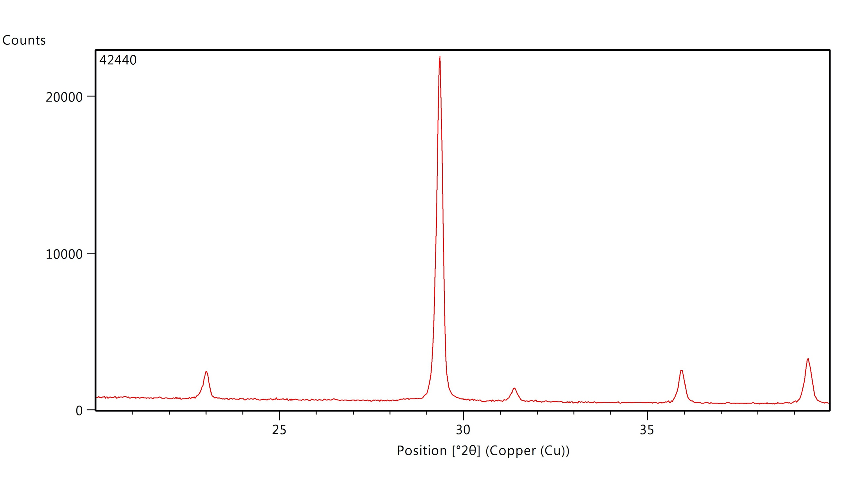 | Grey (burnt): cracks perpendicular to growth (mainly visible on the interior). Harder. Some dissolution of the exterior.
 | SA-55 | C.104/1 | Tegillarca granosa | Wk-42442a | 4030±15 | -4.26±0.3 | -2.5±0.25 | Aragonite | 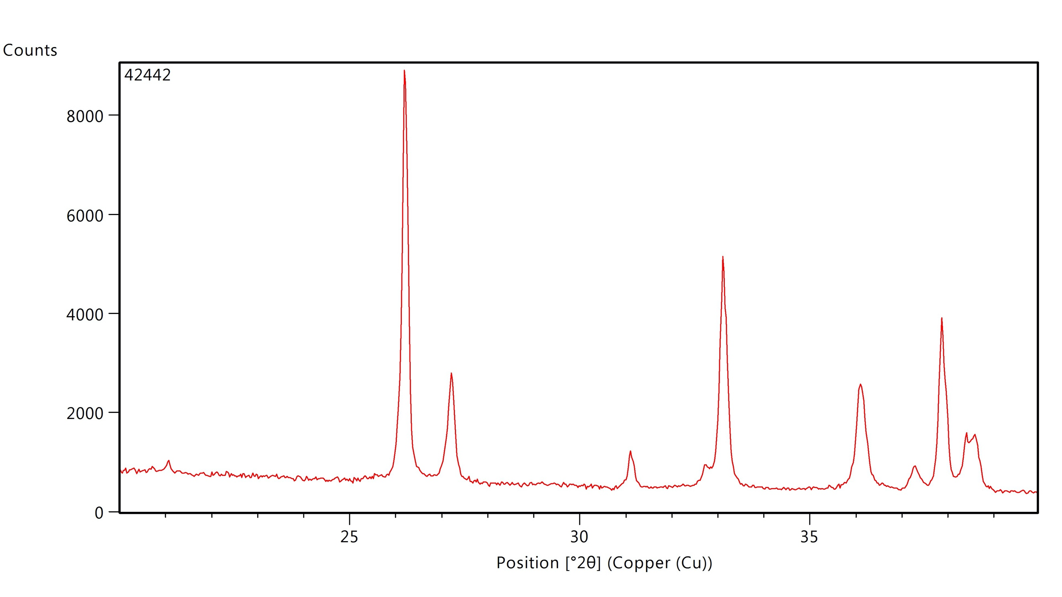 | Umbo and shell edge partly dissolved. Dissolution extends under the ribs. Powdery white appearance.
 |  |  |  | Wk-42442b | 4130±20
 | SA-154 | c.111/2 | Tegillarca granosa | Wk-42446 | 4492±18 | -3.73±0.3 | -3.34±0.25 | Calcite (burnt) | 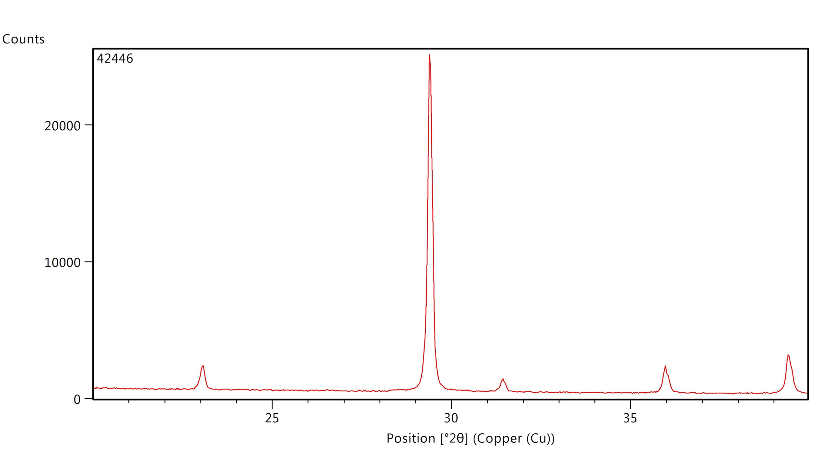 | Grey (burnt). Cracks perpendicular to growth. Hard.
 | SA-168 | C.112 | Tegillarca granosa | Wk-42436a | 4329±15 | -3.23±0.3 | -2.55±0.25 | Aragonite | 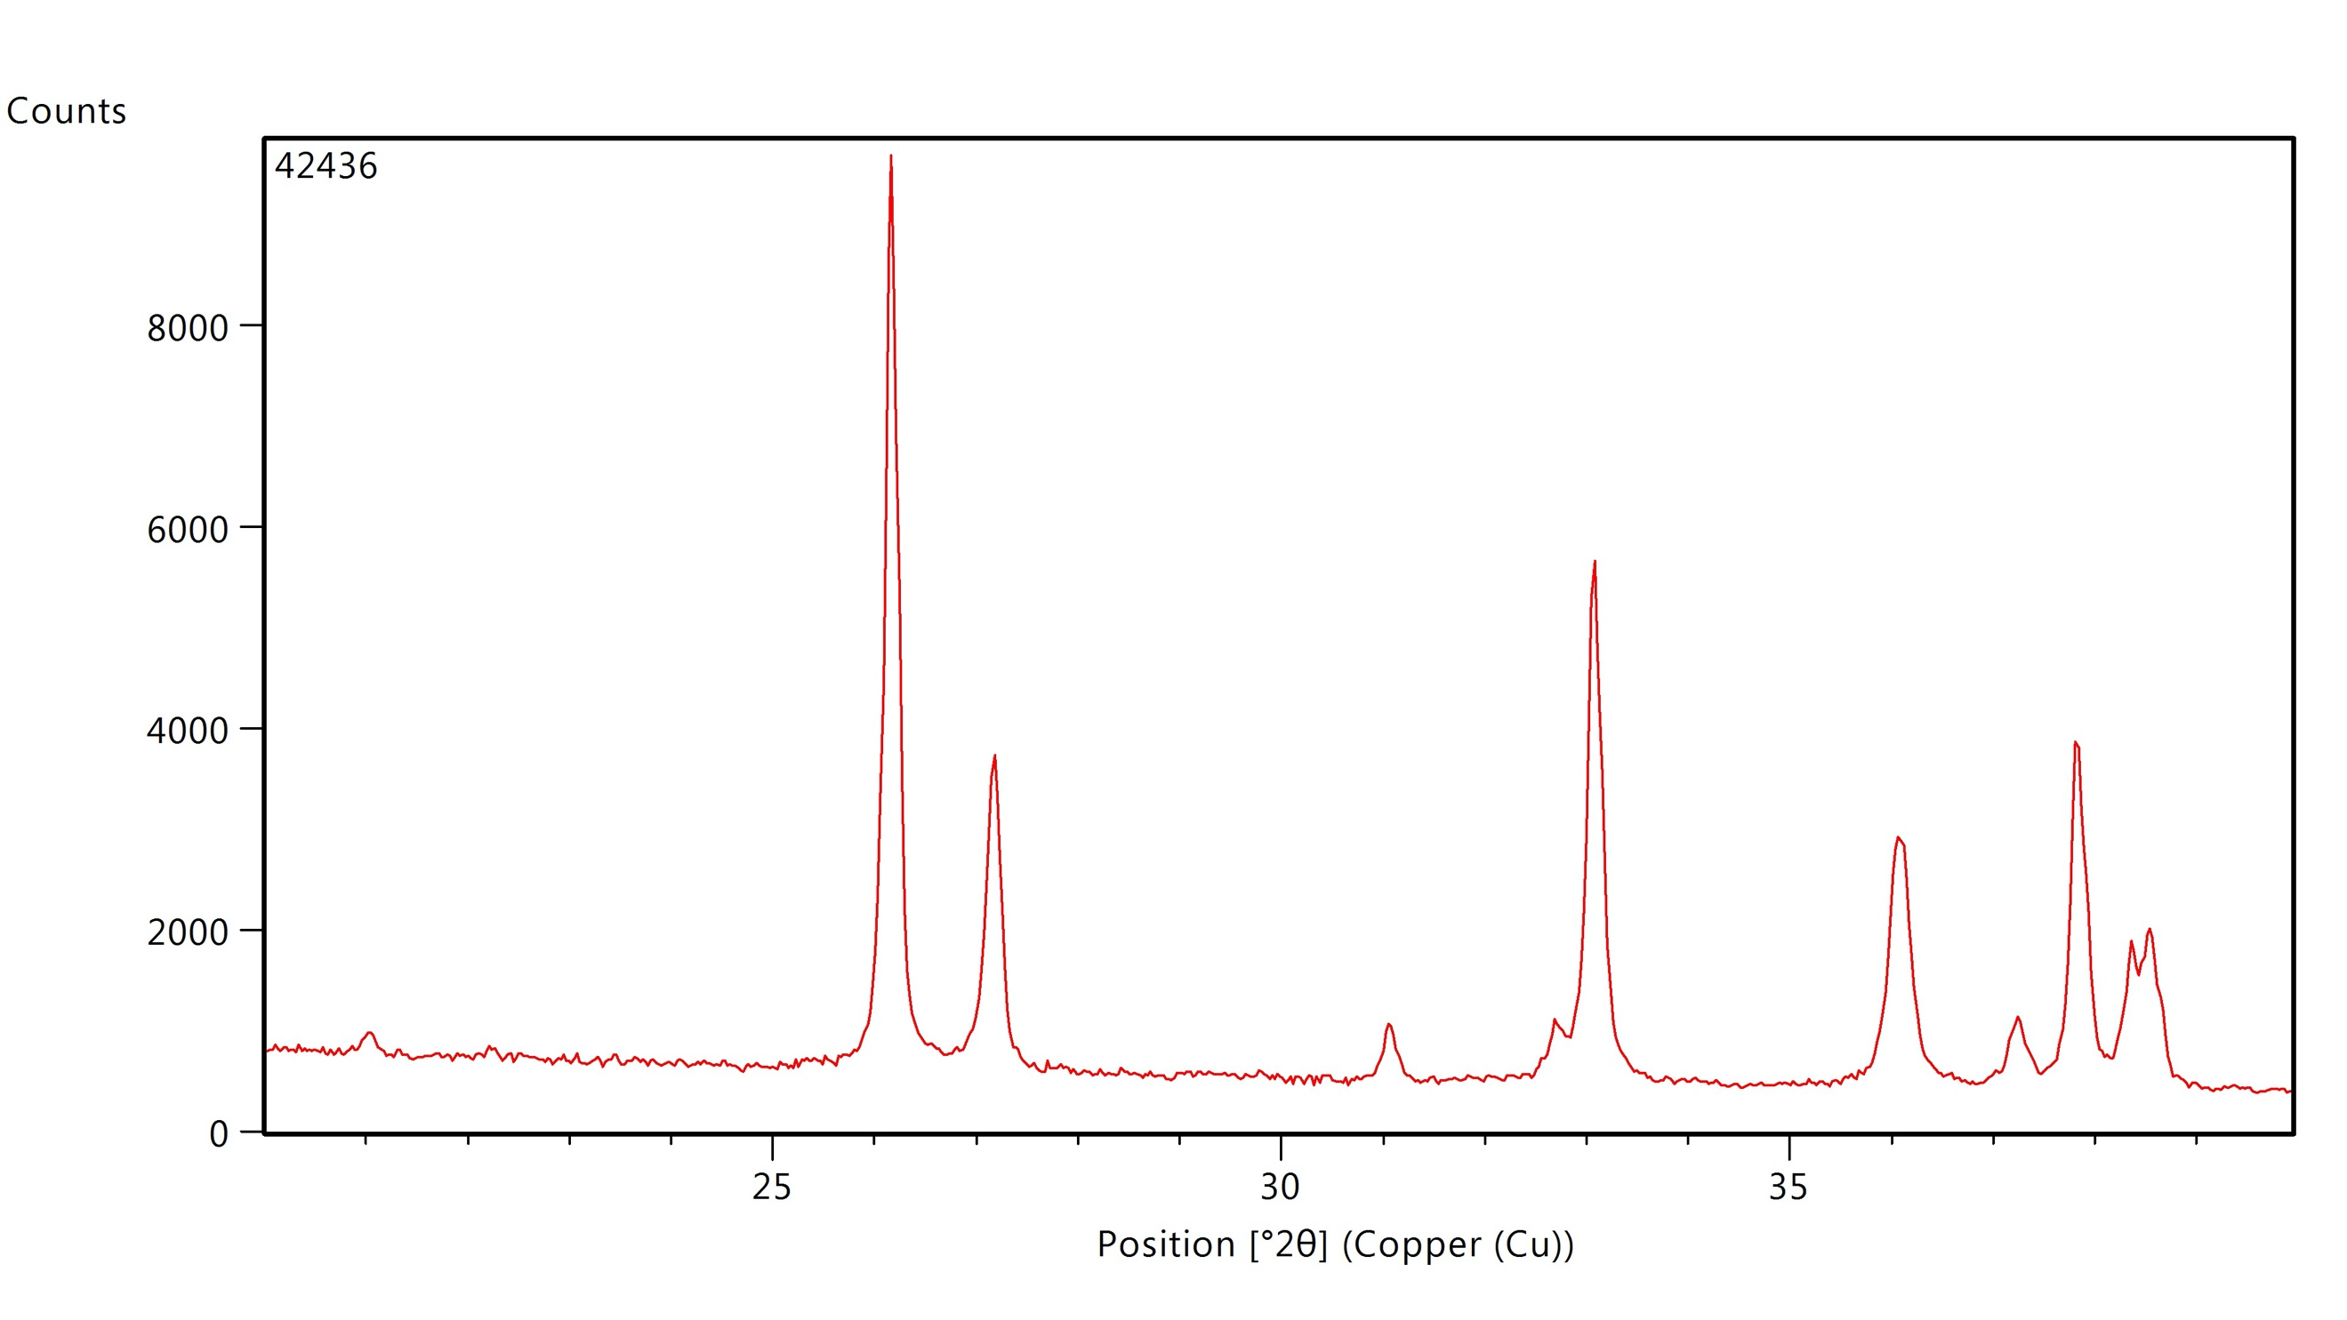 | Umbo and shell edge are mostly dissolved. Dissolution extends under the ribs. Powdery white appearance.
 |  |  |  | Wk-42436b | 4268±21
 |  |  |  | Wk-42436c | 4447±21
 | SA-274 | c112/2 | Tegillarca granosa | Wk-42437 | 4450±20 | -4.04±0.3 | -3.20±0.25 | Aragonite | 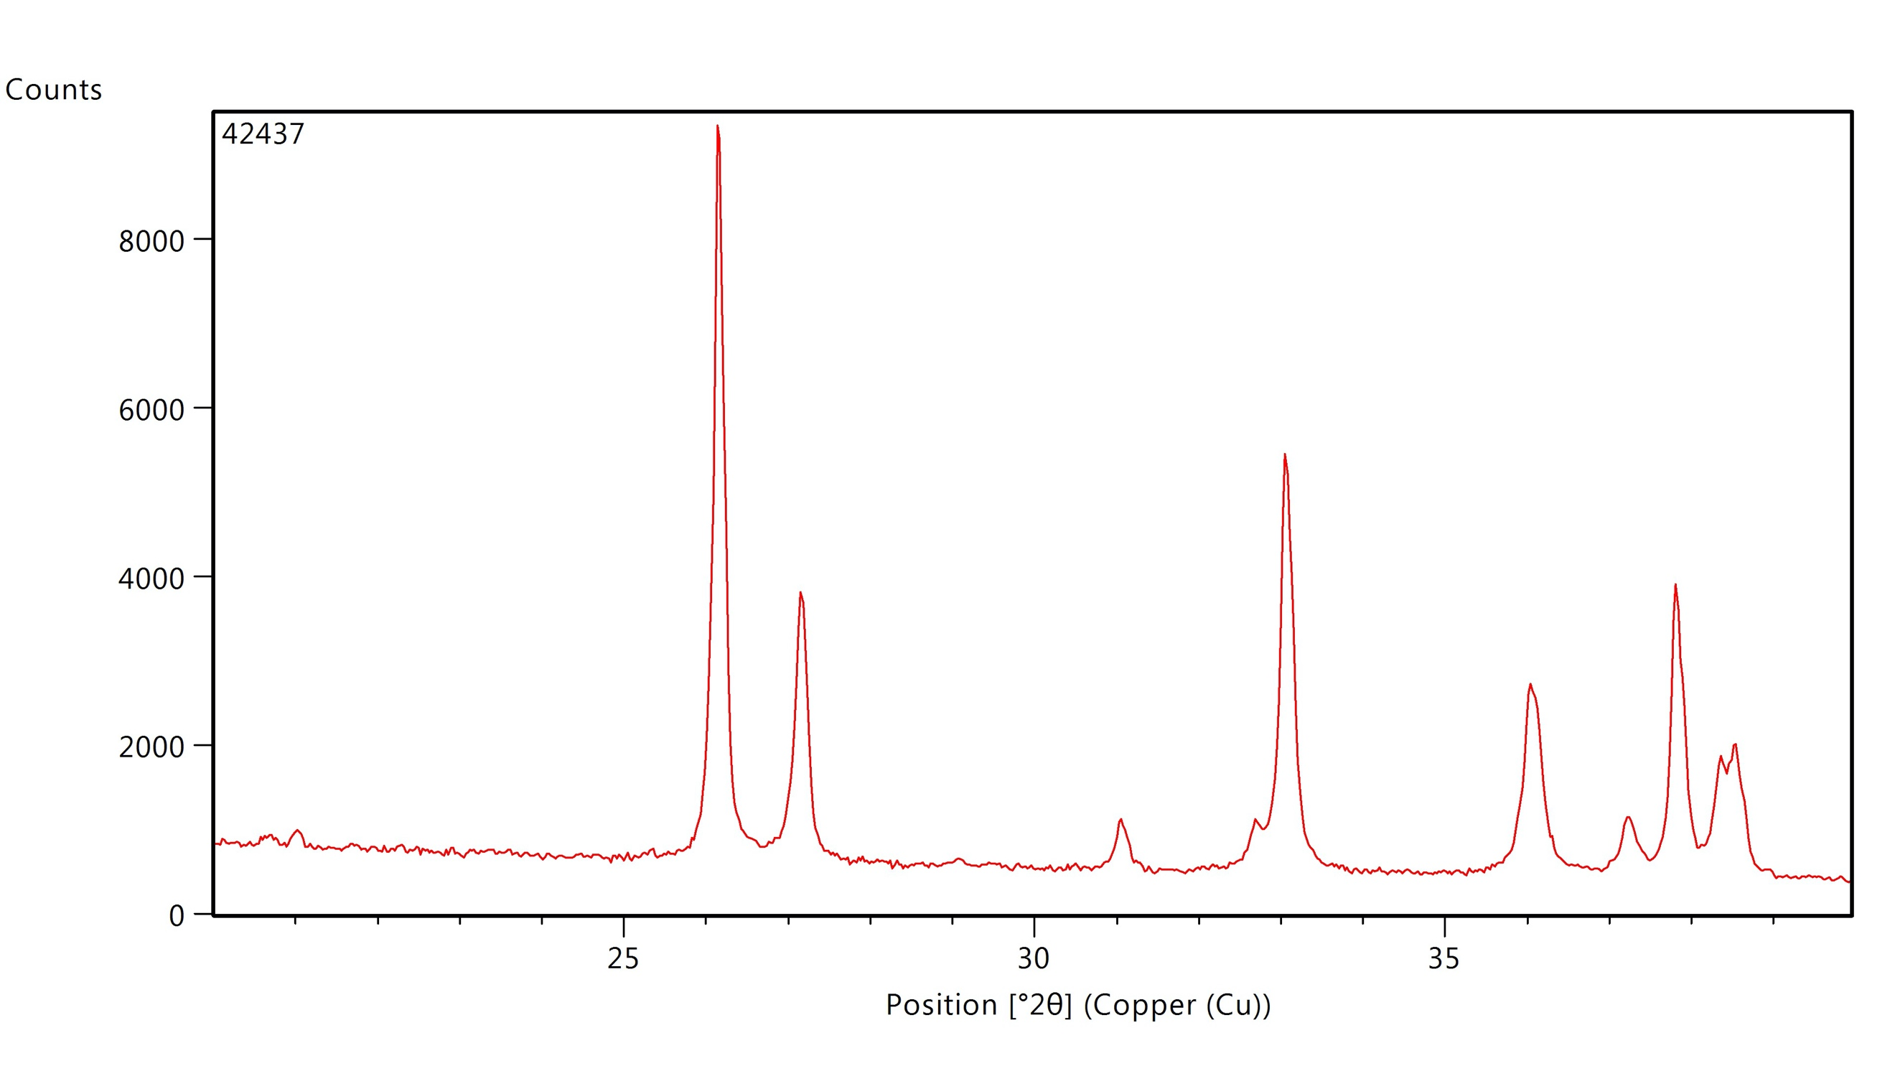 | Umbo and shell edge partly dissolved. Dissolution extends under the ribs. A mix of white and pearly appearance.
 |  |  |  |  |  | HIATUS
3090-2850 BC | SA-294 | C.113 | Placuna placenta | Wk-41915 | 4148±20 | -1.38±0.3 | -2.54±0.25 | Calcite | 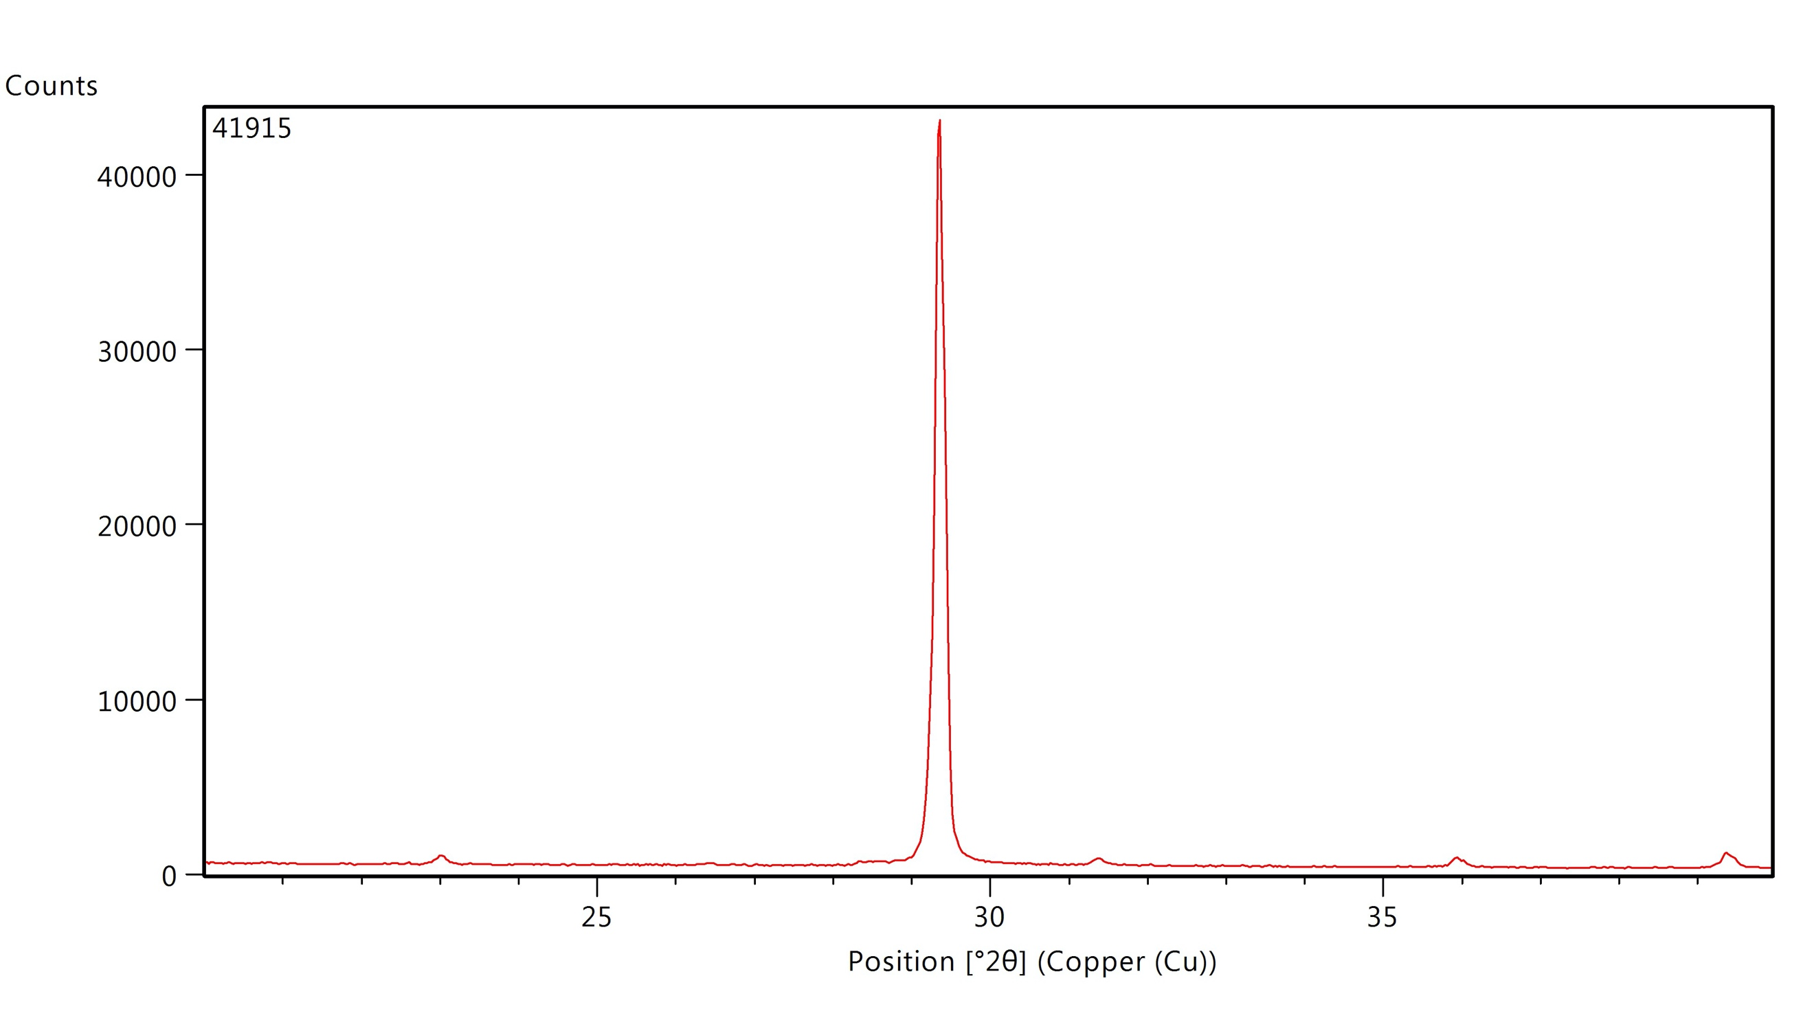 | Translucent with pearly luster. Brown imperfections within the shell are visible.
 | SA-295 | C.114 | Placuna placenta | Wk-41918a | 4185±20 | -2.08±0.3 | -2.32±0.25 | Calcite | 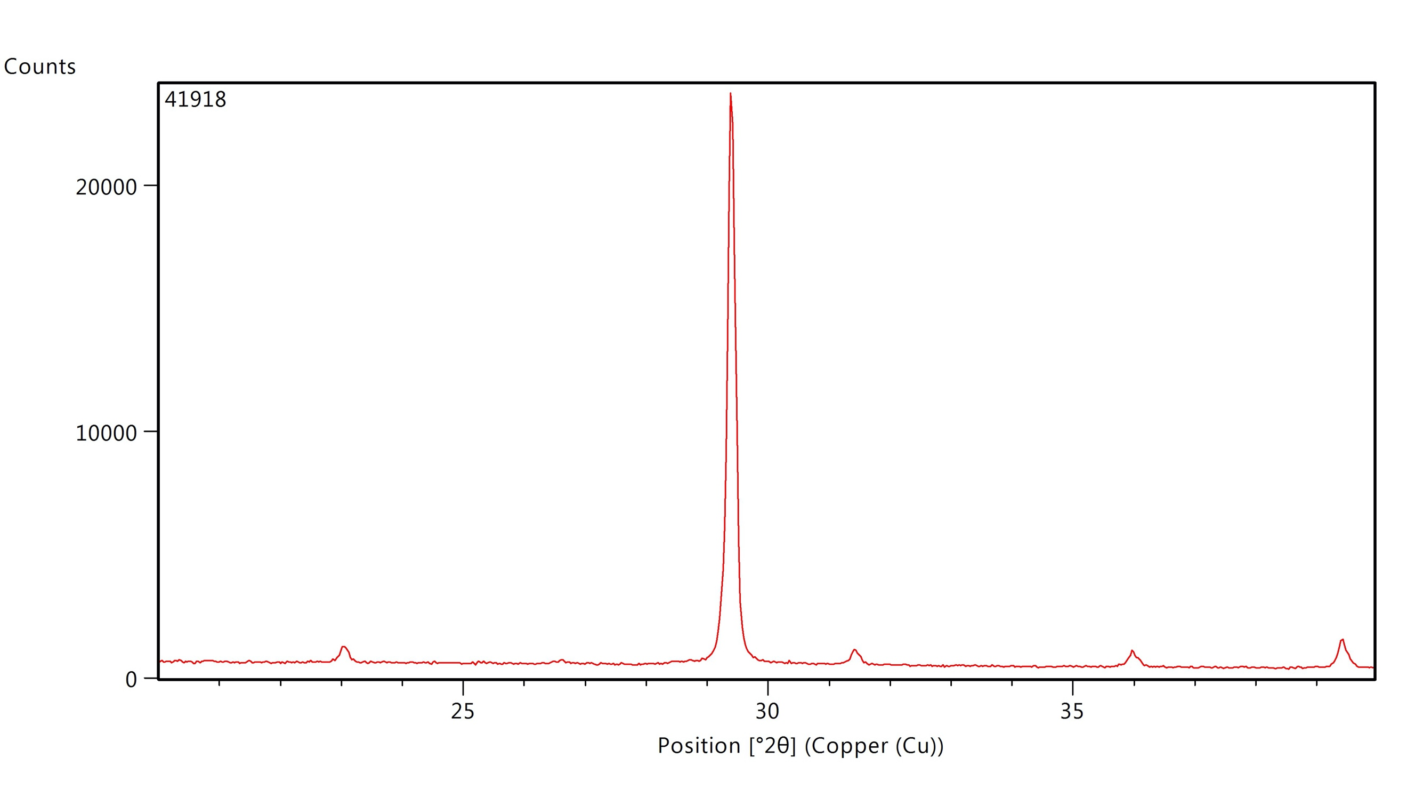 | Translucent with pearly luster.
 |  |  |  | Wk-41918b | 4234±20
 | SA-244 | c114/3 | Tegillarca granosa | Wk-42434 | 4635±20 | -4.53±0.3 | -4.35±0.25 | Calcite (burnt) | 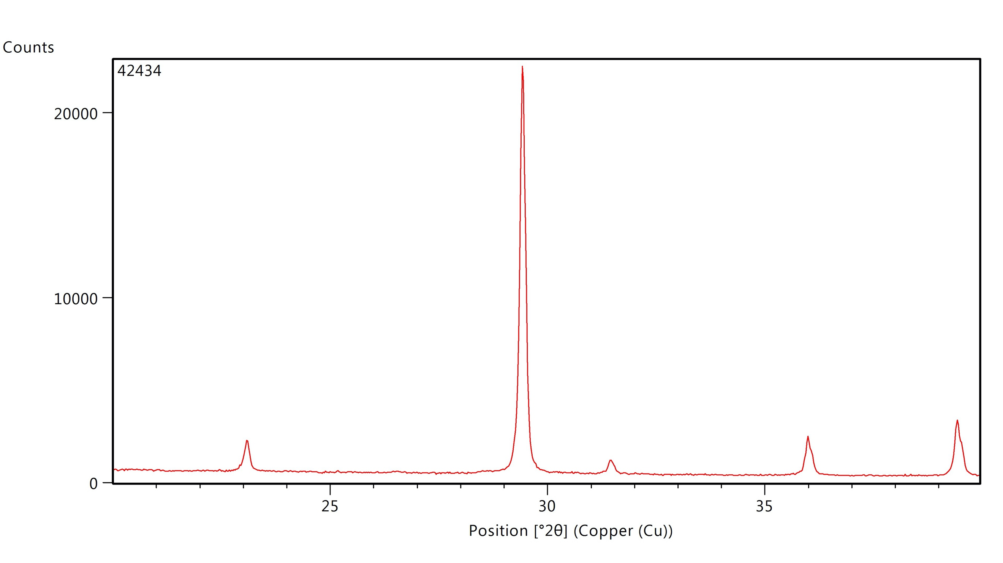 | Grey (burnt). Cracks perpendicular to growth. Hard.
Appendix 1: Archaeological, isotope, XRD, and descriptive information for shells from Thach Lac.

