SUPPLEMENTARY MATERIAL

S1: Thermoluminiscence dates from dolmens excluded of this study
Table S1. Thermo luminescence dates from ceramic fragments in dolmens of South Portugal. Adapted from Whittle and Arnaud (1975).

Site | Laboratoty code | Ceramic sample | Individual dates BC | Calibrated date (68% confidence) cal BC
Dolmen of Poço da Gateria 1 | OxTL169a | b1  b2  b3 | 4640±430  4305±400  4615±450 | 4510±360  (4870-4150)
Dolmen of Gorginos | OxTL169b | c1  c2  c3 | 3860±360  4805±400  4595±420 | 4440±360  (4800-4080)
Dolmen Grande da Comenda da Igreja | OxTL169f | f1  f2  f3  f4 | 3380±340  3340±350  3255±330  3015±340 | 3235±310  (3545-2925)
Dolmen of Farisoa 1 | OxTL169i | i1  i2 | 2745±380  2185±260 | 2405±260  (2665-2145)

S2. Dates excluded: previous occupation levels

Table S2. Radiocarbon dating (n: 9) excluded for the sum of probablities. Dates from sites with previous occupation levels: Tremedal, Cabeçuda 1, Castelhanas, Figueira Branca, Azután, Joaniña, Alberite and Casas de Don Pedro (Calibrated dating by OxCal v.4.4 Bronk Ramsey (2020); r: 5 IntCal20 Atmospheric data from Reimer et al. 2020).

Site | Laboratory  Code | Architecture | Context | Sample | ¹⁴C (BP) | Calibrated date (68% confidence) cal BC | Calibrated date (95% confidence) cal BC | Reference
Tremedal | Gra-15938 | Passage grave | Monument base level. Previous occupation | Charcoal | 7960±60 | 7040-6700 | 7050-6650 | Ruiz-Gálvez 2000
Cabeçuda 1 | ICEN-978 | Passage grave | Monument base level. Previous occupation | Charcoal | 7660±60 | 6570-6440 | 6640-6420 | Oliveira 1997a
Castelhanas | ICEN-1264 | Passage grave | Monument base level. Previous occupation | Charcoal | 6360±110 | 5480-5210 | 5540-5040 | Rocha 2020
Figueira  Branca | ICEN-823 | Passage grave | Hearth, Monument base level. Previous occupation | Charcoal | 6250±50 | 5310-5080 | 5330-5050 | Oliveira 1997b
Azután | Ly-4578 | Passage grave | Chamber base level. Previous occupation | Charcoal | 5840±130 | 4880-4530 | 5030-4360 | Bueno Ramírez et al. 1999
Joaniña | Sac-1380 | Simple chamber dolmen | Chamber base level. Previous occupation | Charcoal | 5400±210 | 4450-3980 | 4720-3770 | Oliveira 1997a
Alberite | Beta-80602 | ‘Covered gallery’ | Chamber, hearth on the ochre paving | Charcoal | 5320±90 | 4320-4040 | 4340-3970 | Ramos Muñoz and Giles Pacheco 1996
Azután | Beta-132917 | Passage grave | Hut under the mound | Charcoal | 5250±40 | 4230-3980 | 4240-3970 | Bueno Ramírez et al. 2002, 2005
Casas de Don Pedro | Beta-471735 | Elongated chamber dolmen | Hearth associated with two previous standing-stones | Charcoal | 5040±30 | 3950-3780 | 3960-3710 | Gavilán Ceballos and Mas Cornellá 2021

S3. El Pozuelo 1. Contemporaneity test (x²-Test) of phase 5 radiocarbon dating.

S3.1
Table S3.1. Phase 5 dating of the dolmen of El Pozuelo 1. Probabilistic estimates of the contemporaneity test (x²-Test) (OxCal v.4.4 Bronk Ramsey (2020); r: 5 IntCal20 Atmospheric data from Reimer et al. 2020).

CALIBRATED DATES |  |  | MODELLED DATES
Laboratory code | Calibrated  date (68% confidence  cal BC) | Calibrated  date (95% confidence  cal BC) | Posterior density estimated (68%  probability  cal BC) | Posterior density estimated (95%  probability  cal BC) | A_{comb}  Index | A  Index | x² -Test  Index
Combine Phase 5 | 2870-2660 | 2880-2630 |  |  | 117 |  | df=2 T=0.091(5% 5.991)
CNA-3268.1.1 | 2880-2660 | 2880-2620 | 2870-2660 | 2880-2630 |  | 108.2
CNA-3261.1.1 | 2870-2630 | 2880-2580 | 2870-2660 | 2880-2630 |  | 110.3
CNA-3269.1.1 | 2870-2630 | 2880-2580 | 2870-2660 | 2880-2630 |  | 110

S3.2
Figure S3.2. Phase 5 of El Pozuelo 1, Los Llanetes cluster. Probabilistic estimates of the contemporaneity test (x²-Test) (OxCal v.4.4 Bronk Ramsey (2020); r: 5 IntCal20 Atmospheric data from Reimer et al. 2020).
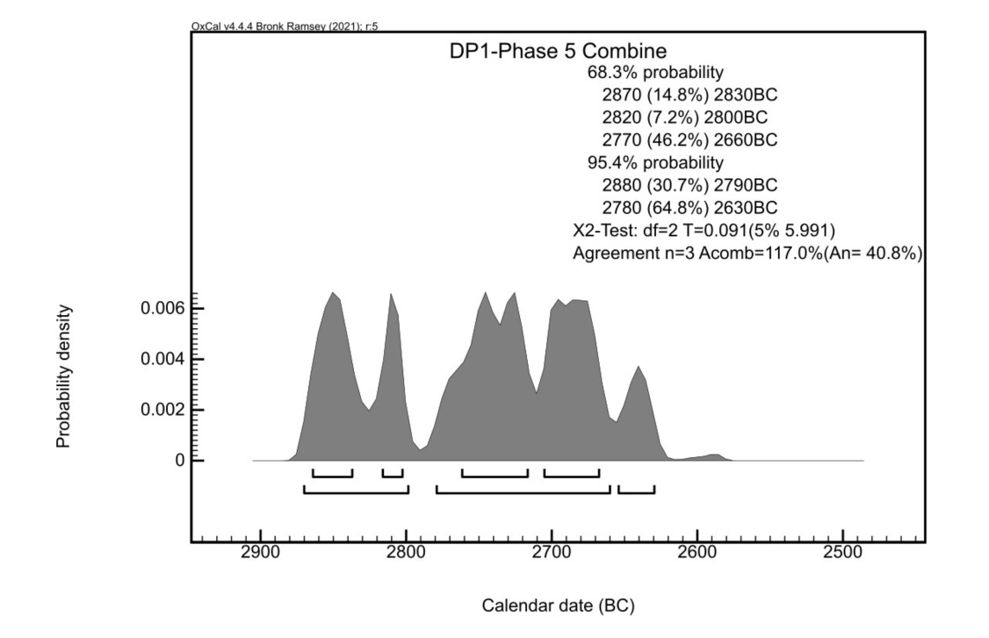

S4. Calibrated radiocarbon dating of the Chinflón mines

S4.1.
Table S4.1. Calibrated radiocarbon dating of the Chinflón mines (from Rothenberg and Blanco, 1980; Burleigh et al. 1982) (OxCal v.4.4 Bronk Ramsey (2021); r:5 IntCal20 Atmospheric data from Reimer et al., 2020).

Laboratory code | Context | Sample | ¹⁴C (BP) | Calibrated date 68% confidence) cal BC | Calibrated date (95% confidence) cal BC
Chinflón (BM-1529) | Mining camp. Settlement: level 3 | Charcoal | 3320 ± 130 | 1750-1440 | 1950-1290
Chinflón (BM-1600) | Mining camp. Settlement: level 4 | Charcoal | 2890 ± 50 | 1200-1000 | 1220-920
Chinflón (BM-1599) | Mining camp.  Mine 3: level 9, shaft base 3B3 | Charcoal. Branch of Quercus sp. | 2830 ± 50 | 1060-910 | 1190-830
Chinflón (BM-1528) | Mining camp. Settlement: level 2.  Habitation level | Charcoal | 2650 ± 60 | 900-770 | 980-570

S4.2.
Figure S4.2. Calibrated radiocarbon dating of the Chinflón mines (OxCal v.4.4 Bronk Ramsey (2021); r:5 IntCal20 Atmospheric data from Reimer et al., 2020).

