**SUPPLEMENTARY MATERIAL**

**RECENT PROGRESS IN ATMOSPHERIC FOSSIL FUEL CO2 TRENDS TRACED BY RADIOCARBON IN CHINA**

Weijian Zhou1,2,3,4,*, Zhenchuan Niu1,2,3,5, Shugang Wu1,3, Xiaohu Xiong1,3, Peng Wang1,3, Peng Cheng1,3, Yaoyao Hou1,3, Hua Du1,3, Ning Chen1,3, Xuefeng Lu1,3

1State Key Laboratory of Loess and Quaternary Geology, CAS Center for Excellence in Quaternary Science and Global Change, Institute of Earth Environment, Chinese Academy of Sciences, Xi'an, China

2Open Studio for Oceanic-Continental Climate and Environment Changes, Pilot National Laboratory for Marine Science and Technology (Qingdao), Qingdao, China

3Shaanxi Provincial Key Laboratory of Accelerator Mass Spectrometry Technology and Application, Joint Xi'an AMS Center between IEECAS and Xi'an Jiaotong University, Xi'an, China

4Xi'an Institute for Innovative Earth Environment Research, Xi'an, China

5Shaanxi Guanzhong Plain Ecological Environment Change and Comprehensive Treatment National Observation and Research Station

*Corresponding author. *E-mail addresses*: weijian@loess.llqg.ac.cn

**Brief description of Method**

The methods used in this study are briefly described in the Supplementary Material. Details of the methods were shown in Zhou et al. (2014, 2020), Niu et al. (2016), Cheng et al. (2017) and Hou et al. (2020).

1. **Sample collection**

We used different sampling methods to trace different spatio-temporal resolution of CO2*ff*.

Air bags were used in short-term (minutes to hours) sampling. Air samples were collected in aluminum foil sampling bags (Delin Gas Packing Co., Ltd, Dalian, China) using a pump for approximately 10 min. The operator held his/her breath when turning on and off the switch and maintained a distance from the apparatus during sampling. The bags were flushed with ambient air three times before sampling.

The flasks used in instantaneous sampling have a volume of 4.2 L, and were evacuated before sampling. To verify whether the foxtail leaves can record the air Δ14C values during the growth period from March to August, the ambient air samples were collected by flasks at the same place of foxtail growth during the same period.

Displacement of phosphoric acid solution was used for long-term (days to weeks) sampling. A 4-liter flask was filled with phosphoric acid solution (pH=2) to prevent the dissolution of CO2. While the acid solution flowed out of the flask drop by drop, the air was compressed into the flask because of the pressure gradient between inside and outside of the flask. The flow rate was controlled by a regulator to give the desired sampling time.

Molecular sieves were used for sampling times of minutes to days. The molecular sieve device included a molecular sieve cartridge (MSC) and pressure gradient apparatus. The MSC was made in a quartz tube. The center of cartridge was filled with 5 g of 13X molecular sieve. The apparatus was designed to actively absorb CO2 from the atmosphere. The MSC should be activated completely before sampling to ensure that there was no contamination. After sampling, the MSC was inserted into a tube furnace and attached to a vacuum with a quick coupling and evacuated to less than 10–2 Torr. The connections leading up to the cartridge were then evacuated.

Green foxtail was used to study the spatial distribution of CO2*ff* because of its wide distribution. Green foxtail is an annual herbaceous plant with a growth period of the summer half year. Three individual green foxtails were collected at each site, put into plastic, self-sealing bags and transported to the laboratory.

1. **δ13C measurements**

The δ13C values of air samples were analyzed by a G2131-i CO2 gas analyzer (Picarro Inc., USA). This equipment employs cavity ring-down spectroscopy (CRDS) technology. Briefly, the sample air was filtered, dried in an ethanol-liquid nitrogen cold trap (–90 ºC), and then introduced into a high-finesse optical cavity. Each sample was measured for 6 minutes. Because of the dead volumes when switching to a new sample, only the data in the last 4 minutes was averaged for a sample. δ13C was determined using a 30-second moving average. The precision of δ13C measurement was < 0.2‰. The 13C data of samples were expressed as δ notation, relative to Vienna Pee Dee Belemnite (VPDB) on a scale defined by adopting a δ13C value of +1.95‰ for NBS19-limestone (RM 8544) relative to VPDB (Coplen, 1995).

1. **Δ14C sample preparation**

The air in the bag was first passed through a liquid nitrogen trap (–196 ºC) in a vacuum system at a flow rate of about 200 mL min–1 to trap CO2 and water, and then the trapped water was removed with an ethanol-liquid nitrogen trap (–90 ºC).A zinc-iron method was used for the graphitization of CO2, with zinc particles and iron powder as reductant and catalyst, respectively. The obtained graphite (1.0–1.2 mg) from ambient air samples was pressed into aluminum target holders for 14C measurement.

The tree cores were separated into annual rings with a scalpel under a binocular microscope. The sample (20–25 mg) was placed into a 1 mol/L HCl solution at 70 °C overnight, and then 6–8 mg NaClO2 was added at 70 °C until the cellulose was pure white. After bleaching, the sample was rinsed with deionized water and heated in 0.1 mol/L NaOH at 70 °C for 2 h, and then re-rinsed, heated in 0.5 mol/L HCl at 70 °C for 2 h. After those processes, the sample was rinsed with deionized water until neutral and dried at 60 °C. Pretreated samples (about 4 mg) and cupric oxide (600–650 mg) were placed into 6 mm quartz tubes and evacuated. The quartz tubes were sealed and then heated at 850 °C for 4 h in a muffle furnace. The purified and graphitized CO2 were then processed to determine Δ14C as described below.

**d. Δ14C measurements**

The 14C levels in the air samples were measured using a 3 MV accelerator mass spectrometer (AMS) in Xi’an, China. The precision of a typical 14C measurement was 3‰. The 14C levels determined here are expressed as Δ14C values, i.e., the per mil (‰) deviation from the absolute radiocarbon reference standard, corrected for fractionation and decay (Stuiver and Polach, 1977).

where (14C/12C)*SN* is the 14C/12C ratio of the sample normalized to a common *δ*13C value of –25‰ and (14C/12C)*ABS* is the absolute radiocarbon reference standard after the fractionation and decay corrections.

**References**

Zhou WJ, Wu SG, Huo WW, Xiong XH, Cheng P, Lu XF, Niu ZC. 2014. Tracing fossil fuel CO2 using Δ14C in Xi’an City, China. Atmospheric Environment 94: 538–545.

Zhou WJ, Niu ZC, Wu SG, Xiong XH, Hou YY, Wang P, Feng T, Cheng T, Du H, Lu XF, et al. 2020. Fossil fuel CO2 traced by radiocarbon in fifteen Chinese cities. Science of the Total Environment 729: 138639.

Niu ZC, Zhou WJ, Cheng P, Wu SG, Lu XF, Xiong XH, Du H, Fu YC. 2016. Observations of atmospheric Δ14CO2 at the global and regional background sites in China: implication for fossil fuel CO2 inputs. Environmental Science & Technology 50(22): 12122–12128.

Cheng P, Wu SG, Fu YC, Xiong XH, Niu ZC, Fan YK, 2017. Low-Flow Pressure Gradient Pumping for Active Absorption of CO2 on a Molecular Sieve. Radiocarbon 59(2): 281–291.

Hou YY, Zhou WJ, Cheng P, Xiong XH, Du H, Niu ZC, Yu Xia, Fu YC, Lu XF. 2020. 14C-AMS Measurements in Modern Tree Rings to Trace Local Fossil Fuel-Derived CO2 in the Greater Xi'an Area, China. Science of the Total Environment 715:136669.

Coplen T B, 1995. Discontinuance of SMOW and PDB. Nature 375: 285.

Stuiver M, Polach H A, 1977. Discussion: Reporting of 14C data. Radiocarbon 19, 355–363.

**Table S1** The δ13C value of different fossil fuels sources

|  |  |  |
| --- | --- | --- |
| Fossil fuels type | δ13C values (‰) | References |
| Chinese coal | -23.5 | Tang 2001 |
| Natural gas | -39.5 | Pang et al. 2016 |
| Vehicle exhaust | -31.2 | Zhou et al. 2020 |

References

Tang G, 2001. δ13C Characteristics of carboniferous coal in North China and its paleo geographic implications, (Political Scholars Anthology of Peking University). Beijing: Peking University.

Pang J, Wen X, Sun X, 2016. Mixing ratio and carbon isotopic composition investigation of atmospheric CO2 in Beijing, China. Science of the Total Environment 539: 322–330.

Zhou WJ, Niu ZC, Wu SG, Xiong XH, Hou YY, Wang P, Feng T, Cheng T, Du H, Lu XF, et al. 2020. Fossil fuel CO2 traced by radiocarbon in fifteen Chinese cities. Science of the Total Environment 729: 138639.

**Table S2** Correlations between PM2.5 and CO2*ff* in some Chinese metropolises (Zhou et al. 2020).

|  |  |  |  |
| --- | --- | --- | --- |
| City | Correlation coefficient (R) | Significance | Slope (μg/m3·ppm-1) |
| Harbin | 0.33 | <0.01 | 3.23 |
| Urumqi | 0.83 | <0.01 | 3.17 |
| Shenyang | 0.54 | <0.01 | 2.21 |
| Hohhot | 0.41 | <0.01 | 1.35 |
| Beijing | 0.83 | <0.01 | 1.45 |
| Xining | 0.66 | <0.01 | 0.51 |
| Qingdao | 0.72 | <0.01 | 2.66 |
| Lanzhou | 0.74 | <0.01 | 0.46 |
| Xi’an | 0.74 | <0.01 | 2.23 |
| Shanghai | 0.77 | <0.01 | 2.12 |
| Wuhan | 0.82 | <0.01 | 2.68 |
| Chongqing | 0.84 | <0.01 | 3.98 |
| Guiyang | 0.64 | <0.01 | 0.75 |



**Figure S1**.Comparisons of Δ14C for different sampling approaches, which show the Δ14C consistency between the approaches of air bag and molecular sieve (a), displacement of H3PO4 solution and molecular sieve (b), and flask sample and foxtail plant parts (c). Details of these sampling approaches are shown in the Method Section in the Supplementary Material. The flask samples in (c) were collected near the foxtail samples from March to August, the same period of foxtail growth. Among different parts of foxtail plants, the Δ14C values of leaves are the most representative of the atmospheric Δ14C values during the growth period.

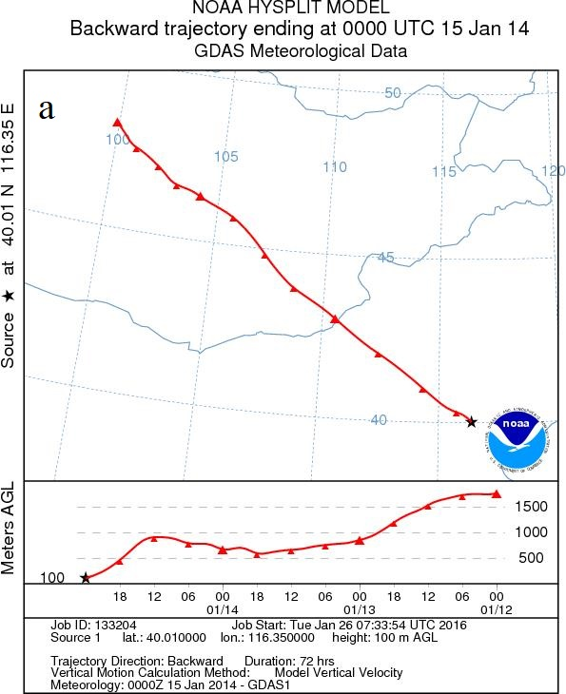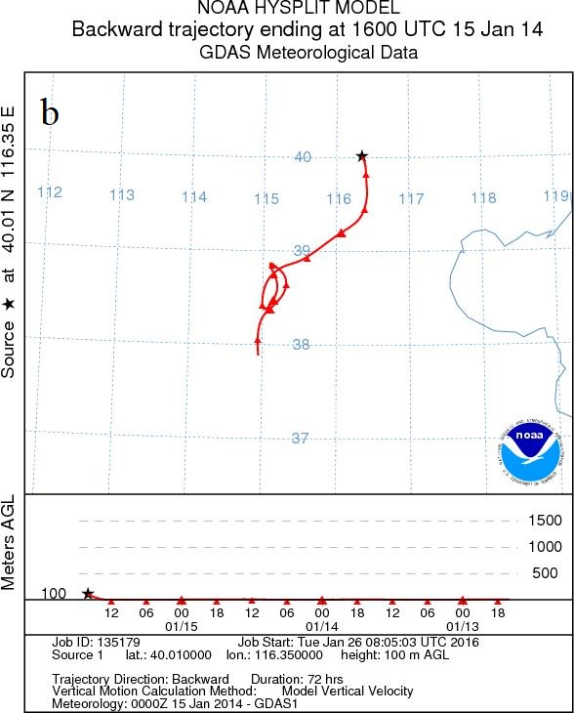

**Figure S2.** Back-trajectories of air masses at the urban site in Beijing in the daytime (a) and at night (b) in January. The hour is local time.

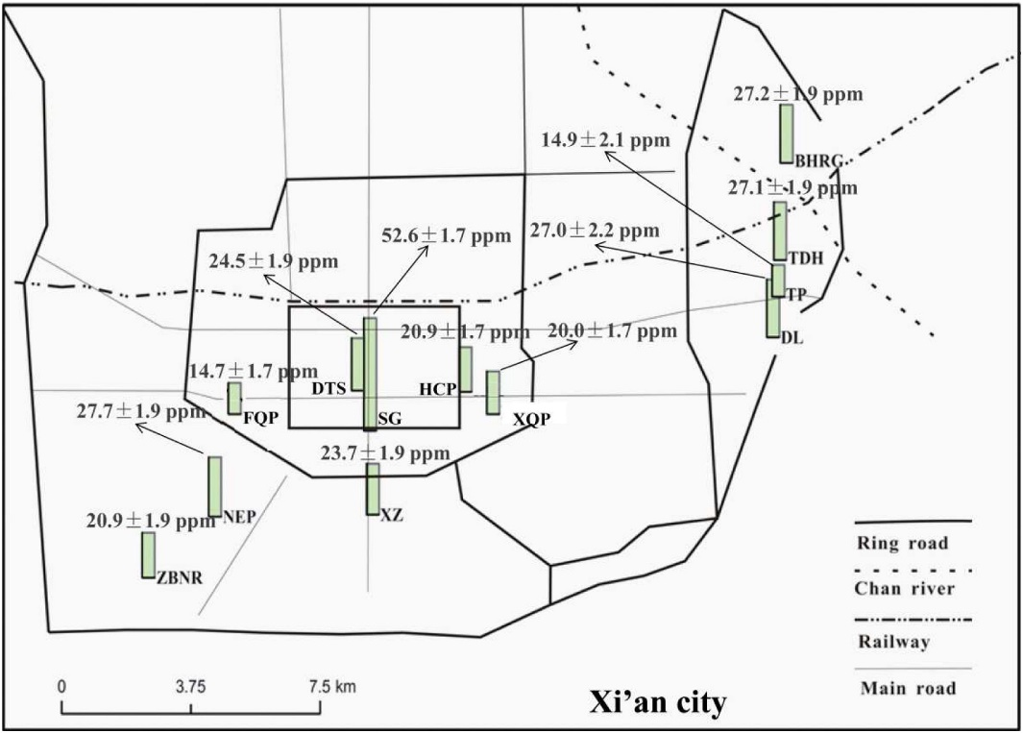

**Figure S3.** Spatial distribution of CO2ff indicated by the leaves of green foxtail. The length of the green bars indicates the mixing ratio of CO2ff. Source: Zhou et al. (2014)

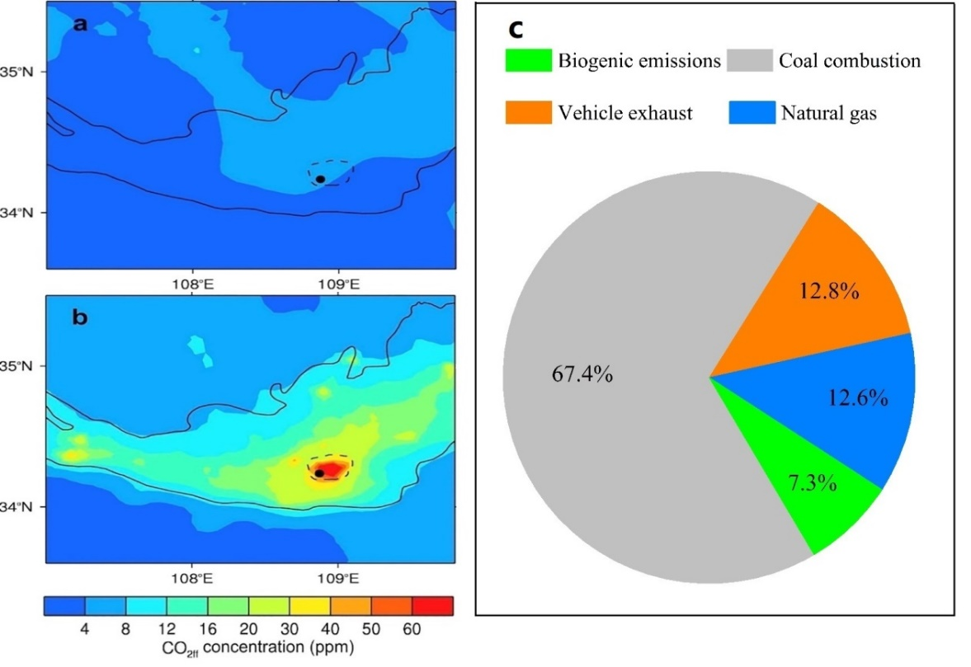

**Figure S4.** The spatial distributions of simulated CO2*ff* concentrations in the Guanzhong basin in January 2014 without (a) and with (b) local CO2*ff* emissions, and the contributions of different sources to atmospheric CO2 offset over background CO2 concentration during wintertime 2014 in Xi’an (c). Source: modified from Zhou et al. (2020).

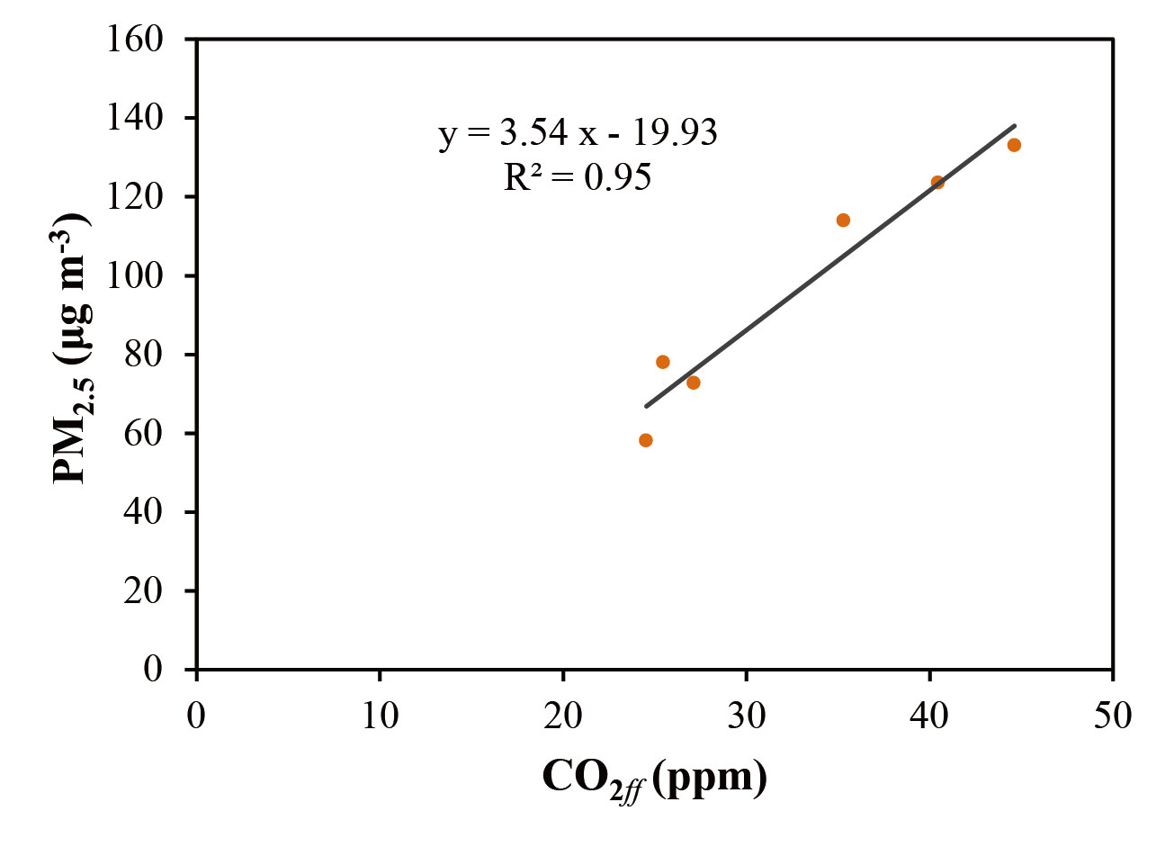

**Figure S5**. The correlation of annual averages of PM2.5 and CO2*ff* during 2011-2016 in Xi’an.