Appendix 1

Recent ice level fluctuations
The five caves presented in the main body of text were each visited in turn during the period 2018-2020.
Bertijeva Jama was explored and mapped only recently, but the entrance was known to a local resident for several decades. The presence of a snow plug at a depth of -15 m inside the cave entrance likely prevented any exploration of the deeper cave. Access to the deeper part of the cave, below the main snow/ice plug, was achieved for the first time on 07/08/2020 by abseiling through a narrow gap between the limestone bedrock and the snow plug.
The cave called ‘Planika’ was accessed first in 2008 (ICCC and JSPDT 2019), by abseiling about 70 m off the western cliffs of the Migovec Plateau (Figure 1b). The comparison of the photographs and surveys completed at that time with the data from a more recent visit in 2019 suggests that the height of the ice body of the entrance pitch decreased by about 5 m on average, reaching a maximum of 7 m under the main entrance pit, exposing the underlying cobble floor. The description of original exploration mentions the necessity to climb up into a small ice-floored side passage and abseil 5 m on the other side in order to reach the southernmost part of the cave (Figure 2). The summer 2019 visit showed that this detour is no longer required. The retreat of the ice body uncovered an alternative way into the deep part of the cave, which had been hitherto impassable.
M-10 is a pit with near cylindrical shape located in the middle of the Migovec Plateau. The snow in that cave has been a key water supply for speleological expeditions, therefore M-10 was visited on an annual basis. The 1994 Slovenian cave cadaster entry quoted the maximum depth in M-10 as -33 m (ICCC and JSPDT 2007). A summer 2020 re-survey of M-10 increased its recorded depth to -45 m, ending in a cobble-floored and ice-free chamber (Figure 2). This strongly suggests that snow or ice prevented the original explorers and surveyors from accessing the deeper part of the cave. Further, the geometry of snow deposits in sag-type caves is often comprised of a peak in the center of the pit and a more or less pronounced peripheral trench, which can measure anywhere from 1 to ~10 m. A maximum surveyed depth of -33 m in 1994 therefore suggests that the actual average snow-surface was closer to the surface. During the 2015 summer expedition, the snow level in M-10 was also noted to be at the same depth as a prominent ledge at a depth of -25 m (Figure 2, ICCC and JSPDT 2019). Using this reference point, a retreat of 5 m was measured between 2015 and 2020 (Figure 2).
M-15 was first explored in 1976 and surveyed a year later (Kataster jam [Cave Cadaster] 2020). The top of the snow cone was at a depth of -40 m then, and a 2020 resurvey found no substantial difference in the snow height.
M-17 snow levels are somewhat better documented by photographs, largely due to the attractive nature of its ice speleothems and consequently there is a record of annual visits starting August 2017. In the 1994 survey, a hanging block of ice is clearly depicted in the middle of the a/b doline. Since the exploration report and its companion map paint M-17 a single-entrance cave (ICCC and JSPDT 2007), we can assume that the connection between doline c/d and the main ice chamber was blocked at the time. The ice block hanging in the middle of the historical entrance pit had already disappeared by summer 2017, when M-17 was further visited by members of ICCC. A cone of modern snow from doline c/d is evident in the background of suppl. Figure 2a, suggesting that some space between rock and ice must have existed at least seasonally for the snow to be deposited in such a way. The snow cone geometry did not change substantially between visits in 2017 and August 2018, at which time the first temperature loggers were installed. The first direct evidence of a passable connection between a/b and c/d open shafts comes from a visit in late October 2018 (suppl. Figure 2b). Upon a return visit in June 2019, the snow level in doline c/d had risen again by several meters, closing off this connection. In July 2020, the connection to doline c/d was open again (suppl. Figure 2a).
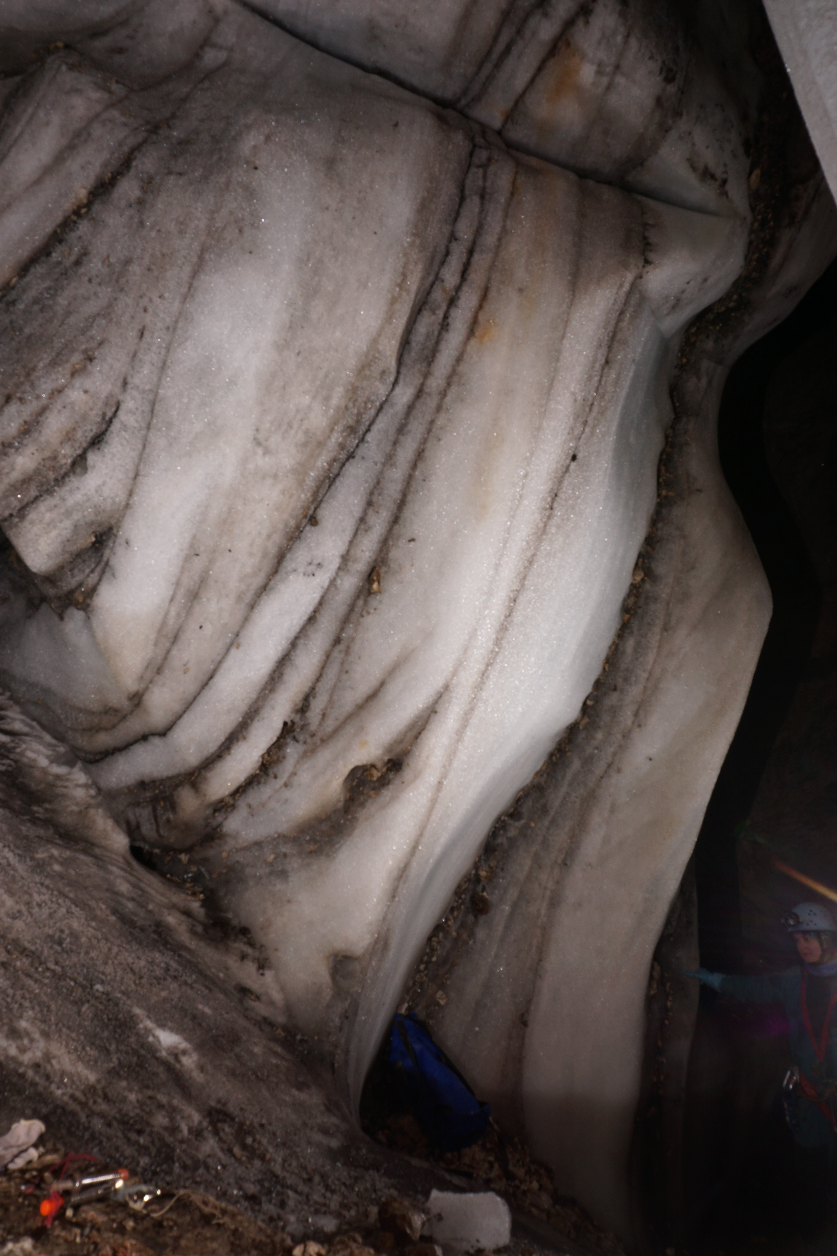
Supplementary Figure 1 View of the well exposed ice stratigraphy in the ice pit of M-17 cave. Photo: C. Spötl (2020).
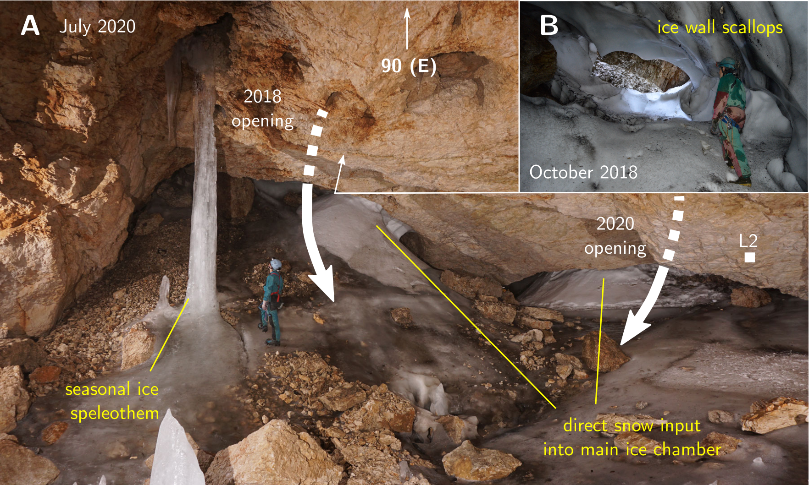
Supplementary Figure 2 View of the main ice chamber in M-17 cave, on July 2020 visit, highlighting the open snow tunnel allowing snow to be deposited directly over the ice floor. Photo: C. Spötl.

Temperature systematics in M-17 over the 2018-2021 MONITORING PERIOD

Record of Vogel meteorological station
At the Vogel meteorological station, precipitation maxima were recorded in spring (AM) and autumn (SON) between 2010-2019 (suppl. Figure 3, Reliable Prognosis 2021), denoting the strong influence of Mediterranean cyclogenesis in autumn.
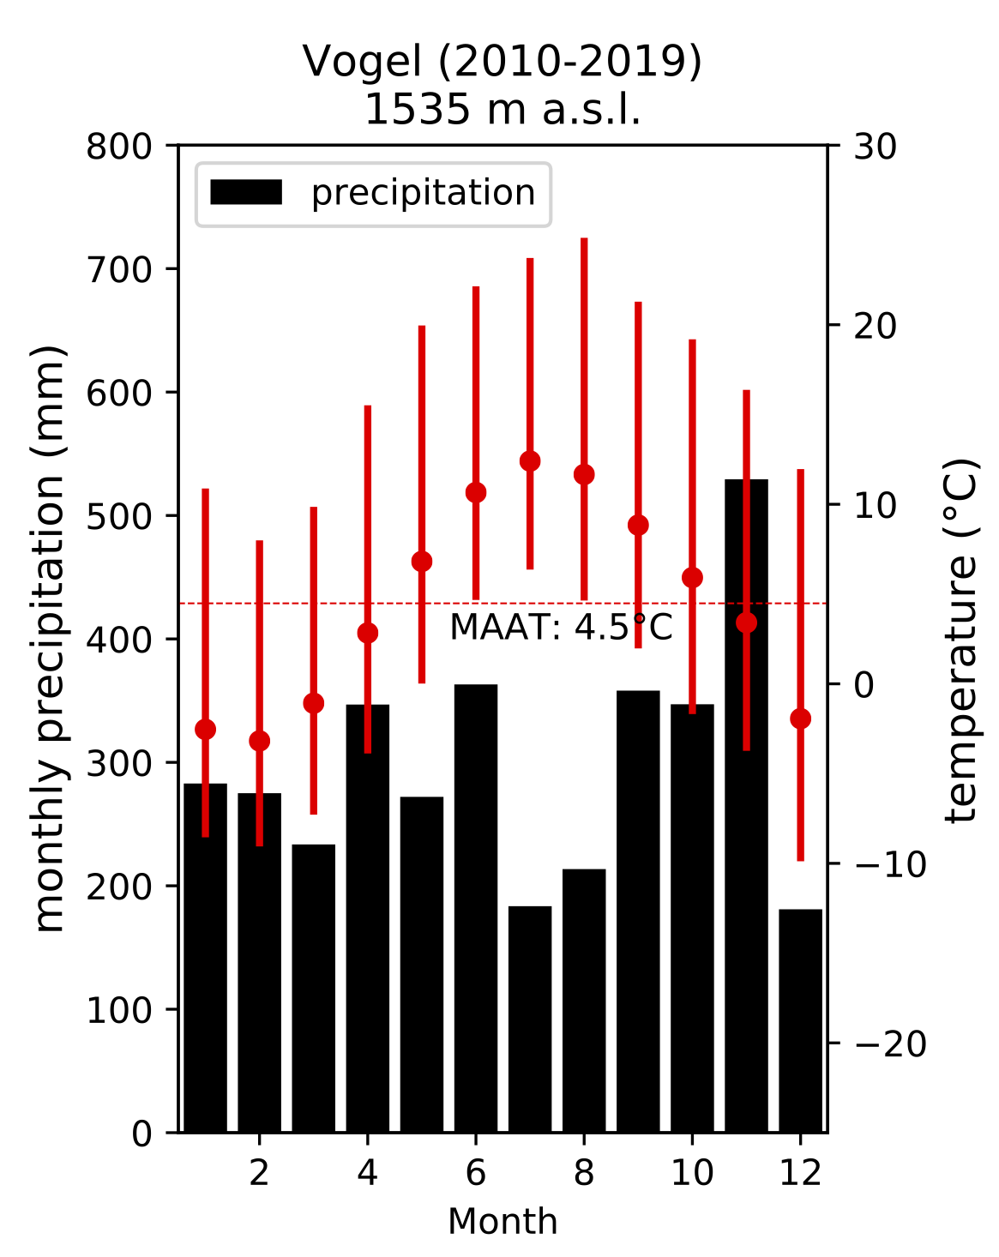
Supplementary Figure 3 Mean monthly temperature and precipitation at the Vogel meteorological station 2010-2019 (Reliable Prognosis 2021).
The hourly temperature measurements from Vogel meteorological stations were corrected to account for the elevation difference to the Migovec Plateau. Using a selection of stations from northwest Slovenia (Nova Gorica, Bovec,Krn, Vogel and Kredarica), the local environmental lapse rate could be estimated. Using a value of 0.55°C 100 m$​^{−1}$, this yielded a temperature correction $Δ_{t_{vogel−migovec}}=−1.9$°C. The corrected Vogel temperature record is used in all further plots.
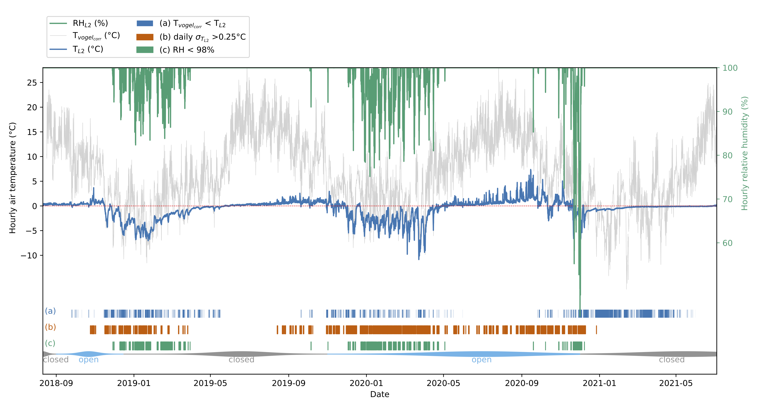
Supplementary Figure 4 Temperature and relative humidity recorded at logger L2 and at the Vogel meteorological station. The red line denotes the 0°C isotherm. A detailed description of the colored fields is given below. Open (closed) state of the snow tunnel is given by the blue (gray) bar at the bottom. The bar is widest around actual observations of an open snow tunnel or lack thereof.

M-17 as a cold air trap
The temperature series recorded at M-17 between 08/2018 and 07/2020 (Figure 6) reveal the systematics of a cold air trap, i.e., stable air temperatures close to 0°C next to the ice body during the summer half year, and negative excursions of one to several days, followed by gradual warming during the cold season. Such excursions take place in lockstep with outside air temperature variations. Between 08/2018 and 07/2019, there were 4529 hours (189 days) when the cave air temperature was below 0°C, with a minimum at $−7.04±0.25$°C on the 23rd of January. Between 08/2019 and 07/2020 3862 freezing hours (161 days) were recorded, with a minimum at $−10.86±0.05$°C on March 23rd. Freezing hours occur almost exclusively during the winter half-year, in one nearly continuous period, highlighting the cooling phase of the cave. The 2018/2019 winter pattern is characterized by prolonged negative excursions of intermediate amplitude, whereas the following winter shows increased temperature variability, with rapid temperature drops and marginally slower subsequent warming. The 2019/2020 winter season also exhibits more pronounced and frequent negative local minima (Figure 6). The maximum daily air temperature range was recorded between 22nd/23rd March 2020, when cave air temperature at L2 dropped by 7.6°C over the course of c. 22 hours.
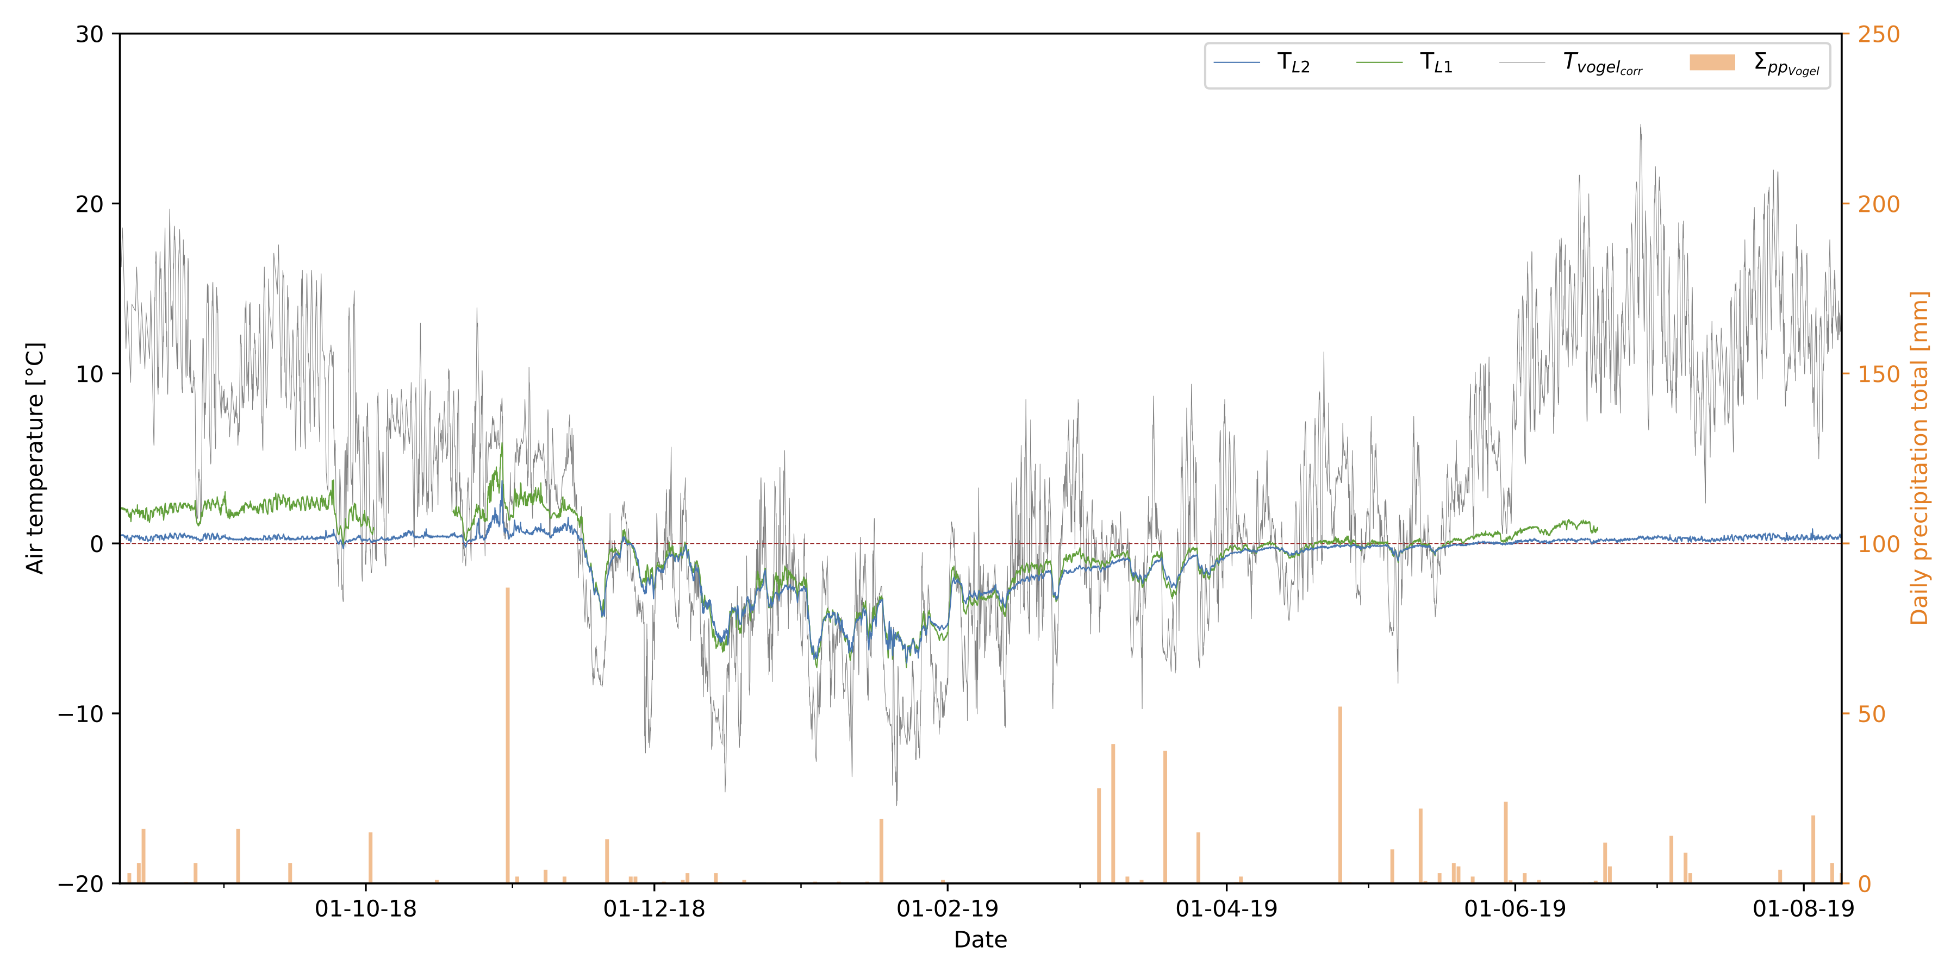
Supplementary Figure 5 Temperature time series of loggers L1, L2 and Vogel station between 10/08/2018 and 09/08/2019. The daily precipitation totals recorded at Vogel station are also given (Reliable Prognosis 2021).
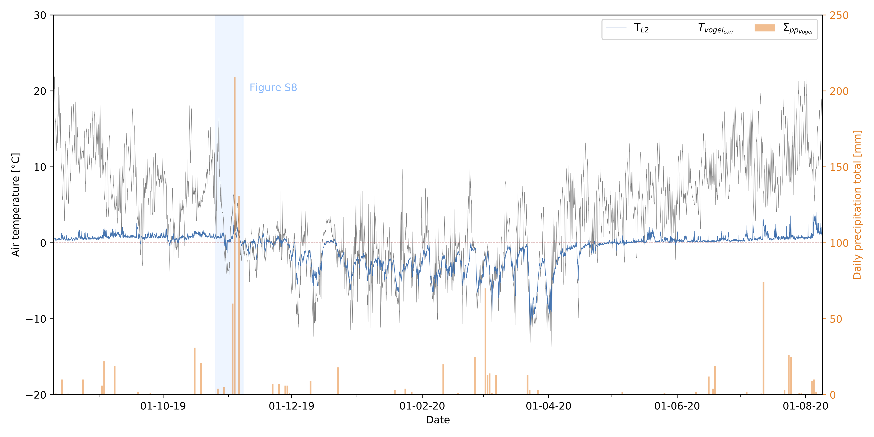
Supplementary Figure 6 Temperature time series of logger L2 and Vogel station between 10/08/2019 and 04/07/2020. The daily precipitation totals recorded at Vogel station are also given (Reliable Prognosis 2021).
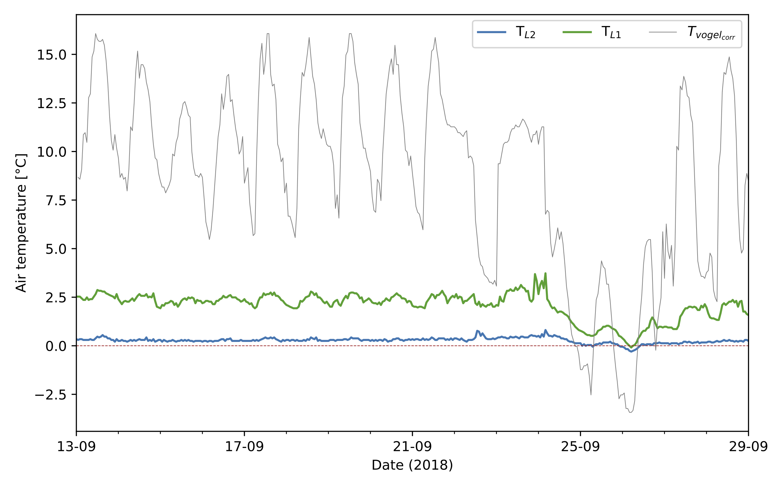
Supplementary Figure 7 Detailed hourly temperature time series of loggers 75, 73 and Vogel station for the period 13/09/2018 to 29/09/2018, highlighting the response of in-cave loggers to diurnal variations in outside air temperature, as well as a short-lived cold air incursion on 25-26th September, which perturbed the air stratification in the cave.
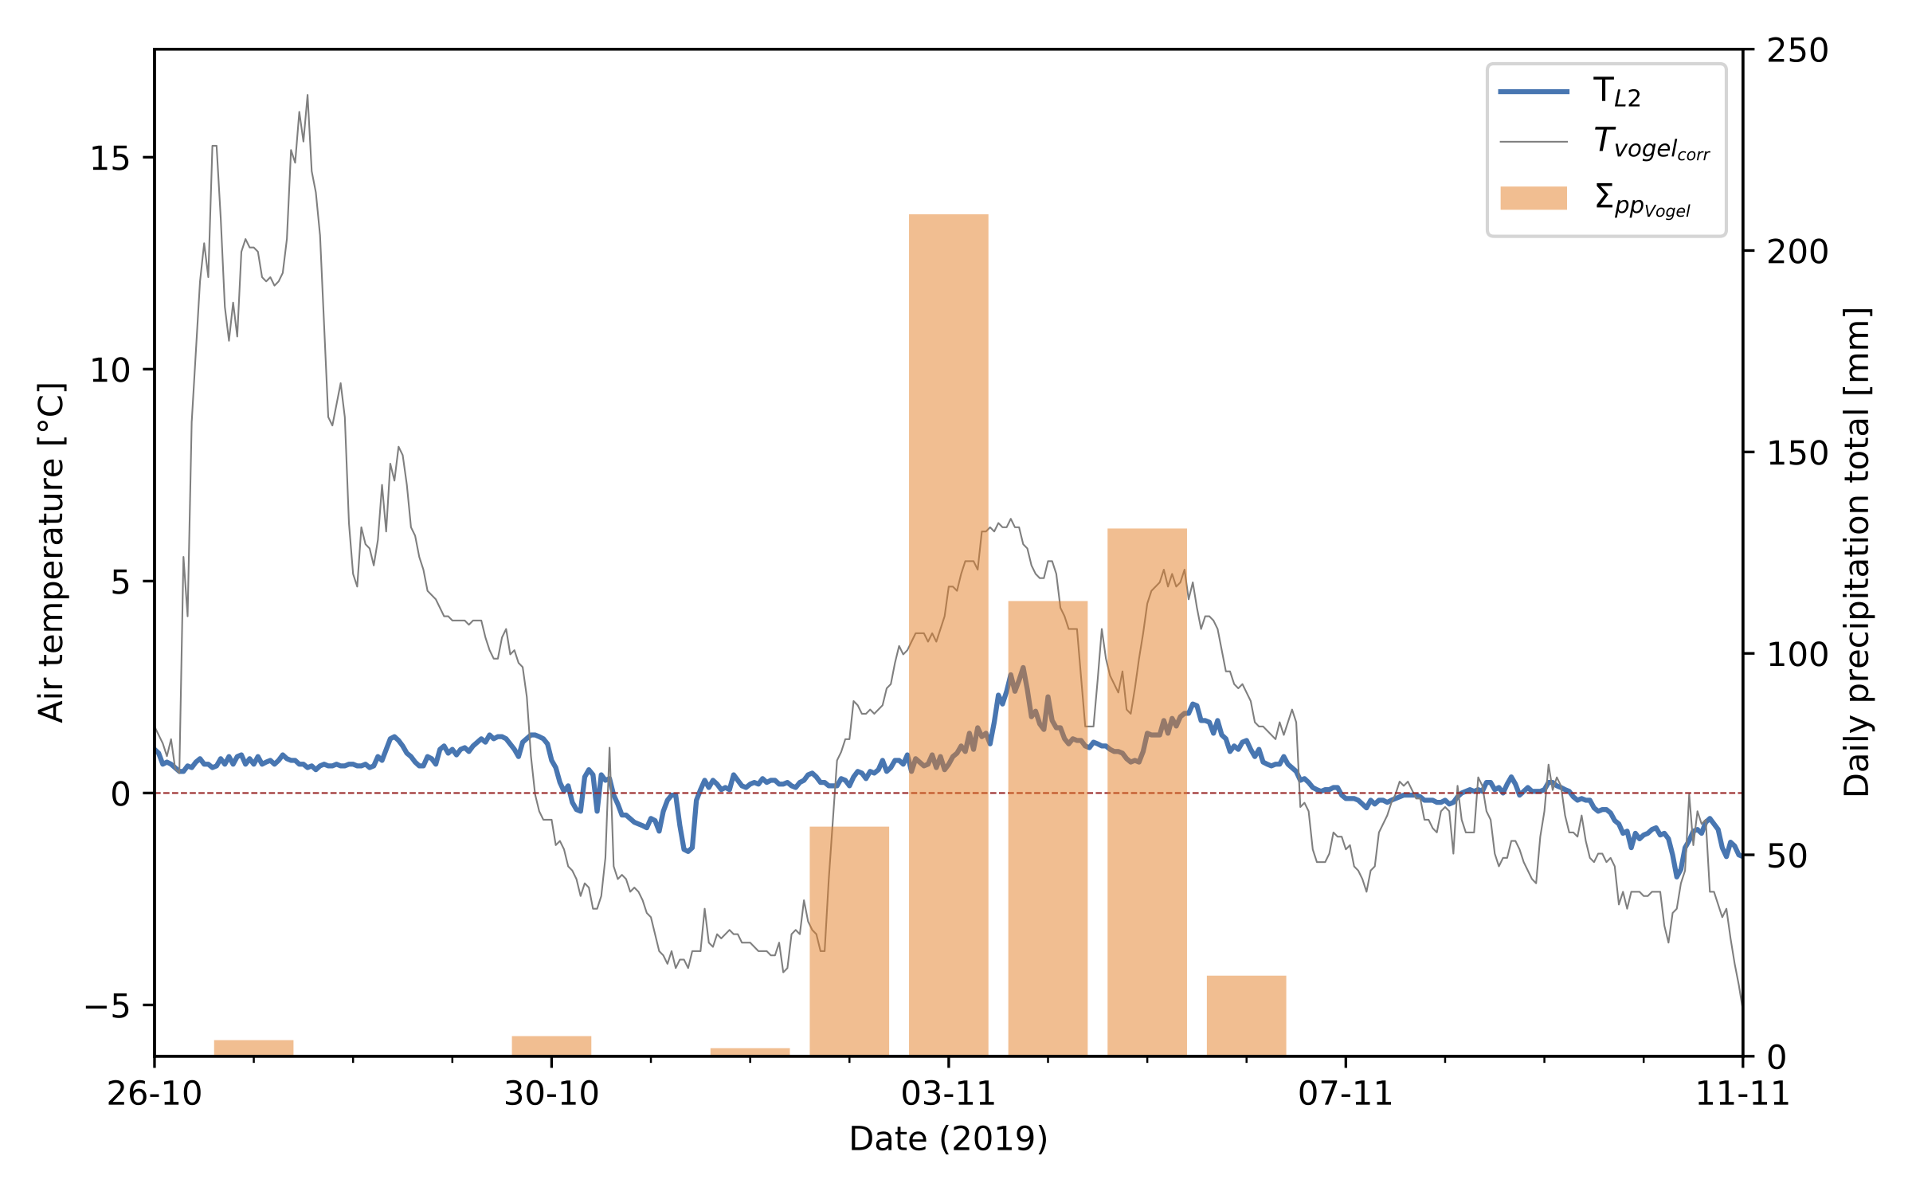
Supplementary Figure 8 Detailed hourly temperature time series of loggers 75 and Vogel station, and daily precipitation for the period 26/11/2019 to 09/11/2019, highlighting the response of in-cave logger 75 to a exceptional rainfall event between 1st-7th November. Note the sharp temperature rises on 3rd and 5th November, which occurred in lockstep with the peak precipitation

Variable response of loggers L1 and L2
During the first eleven months of monitoring, L1 and L2 measured T/RH concurrently, with L1 located closer to the permanent a/b entrance. The summer signals at L1 and L2 differ by their mean values and amplitude (suppl. Figure 5&7). This behavior is well illustrated during the period spanning 9th to 23rd September 2018 (suppl. Figure 7). Daily fluctuations of c. 1°C around 2.0°C were recorded at L1 every day of that period. In contrast, L2 captured a diurnal signal with an amplitude never exceeding 0.5°C, around a mean of 0.5°C, indicative of stable air stratification in the cave, with temperatures decreasing with depth. This situation came to an end on the 23rd of September, when a cold air incursion depressed the temperature at both loggers so that they recorded virtually the same temperature for several hours, indicating a well-mixed cave atmosphere due to ventilation. A new thermal stratification was established soon after the outside air temperature rose above that of the cave interior. The muting of the signal amplitude with depth is expected in a sag-type cave. It also noteworthy that the entrance c/d was open at that time, allowing forced convection between the two entrances. One result of such a convection is the development of c. 1 m-wide scallops in the ice walls of the tunnel (suppl. Figure 2b).

Relative Humidity
Relative humidity records in M-17 provide additional insight into the exchange between the cave air saturated with water vapor (RH = 100%) and the outside atmosphere. Both these records show excursions towards lower relative humidity in winter, with minima of c. 80% in January and February 2019; lower and more numerous minima of c. 75% were recorded from January to April 2020. Each of the negative RH excursions were synchronous with the ‘cold events’ of the temperature record at L2, indicating a substantial exchange between the cave and the atmosphere during winter, i.e., ventilation.
The presence of ice, whose melting provides a massive heat buffer leads to a negative thermal anomaly of 4.2°C relative to the mean annual air temperature (MAAT) predicted from the lapse rate at the cave elevation (2.7°C at 1870 m a.s.l.).

T/RH criteria for an open/closed cave
The different colored fields in suppl. Figure 4 depict the Boolean value of three independent criteria for the definition of a ‘closed’ vs. ‘open’ ventilation system. Firstly, we highlight time periods when the synthetic $T_{vogel_{corr}}$ Vogel temperature is lower that recorded at L2 ($T_{vogel_{corr}}<T_{L2}$, criterion a). The value of this Boolean was true (false) for 2379 (5830) hours between 08/18 and 07/19, and 1840 (6048) hours between 08/19 and 07/20.
The second criterion (b) corresponds to periods when the standard deviation over 24 hours exceeds 0.25°C at L2. This range is unlikely to be exceeded whenever a stable air stratification occurs, e.g., during the reference period of 09/18 (suppl. Figure 7). This criterion identifies rapid temperature oscillations, as well as sharp departures from a stable temperature, both of which are indicative of the advection and mixing of cave and surface air. The value of this Boolean was true (false) for 840 (7704) hours between 08/18 and 07/19, and 3504 (4585) hours between 08/19 and 07/20.
The final criterion (c) pertains to relative humidity. The cave atmosphere during the closed season is characterized by saturation with respect to water vapor reflecting the low air temperatures that prevail near the ice body. Water films developing on temperate ice provide a large surface in contact with air, allowing efficient vapor exchange, which leads to a rapid saturation of cave air with respect to water vapor (Wigley and Brown 1976). Mixing this saturated air mass with a less humid component advected into the cave results in a drop in relative humidity. The value of this Boolean was true (false) for 742 (7602) hours between 08/18 and 07/19, and for 1360 (6729) hours between 08/19 and 07/20.
Cold air advection is the key process for cooling the sag-type cave atmosphere below 0°C during the winter season, with prolonged negative air temperature excursions leading to more vigorous ventilation. Luetscher et al. (2008) showed for instance that wind speed at the cave entrance scaled with the square root of the $ΔT_{in/out}$ at Monlési ice cave (Jura Mountains). According to the $ΔT_{in/out}>=0$ criterion, there are both more ventilated hours and freezing hours during the 2018/2019 winter than during the 2019/2020 winter. However, the relative humidity and daily temperature variation criteria each suggest that during the 2018/2019 winter season, the cave was less ventilated and warmer than the 2019/2020 season. This apparent disagreement between criteria is robust with respect to changes in the chosen relative humidity threshold (98% or lower) or daily variation amount ($ΔT$= 1°C or higher). Criteria b and c, solely derived from L2 are internally consistent, whereas criterion a relies on a synthetic temperature series, reconstructed from observations at station (Vogel) located both at a lower elevation station, and on the leeward side of Bohinj Ridge. The influence of local topographical effects is thus non-negligible and may explain the apparent disagreement between criterion a and criteria b/c.

Effect of liquid precipitation
Liquid precipitation has several effects on ice build-up and loss. First, sensible heat is advected into the cave when relatively warm water enters the cave environment and cools down in contact with the cave atmosphere, the rock walls and ice. Additionally latent heat is released upon freezing, for instance when seasonal speleothems are formed. Precipitation enters the cave by falling in either doline a/b or doline c/d, but it is also transmitted rapidly through the thin and heavily fractured limestone overburden to the main chamber. Thus, extreme rainfall events are quasi-immediately experienced by the cave environment. Extreme events were indeed recorded during the monitoring period, namely between 2nd-7th November 2019 (suppl. Figure 6&8). Starting 07.00 GMT+1 on 02/11, the recorded total for the previous 24h was 2 mm. This increased to 57 mm on the 3rd, 209 mm on the 4th, 113 mm on the 5th, 131 mm on the 6th and finally, 20 mm on the 7th of November. In total, 522 mm of rain fell within less than a week (suppl. Figure 8). This is one of the very few times that L2 registered a double ‘peak’ in temperature over 2°C; the latter were correlated with the precipitation maxima (on 04/11/19 and 06/11/19) (suppl. Figure 8). This extreme event also contributed to forming the snow tunnel anew, in the vicinity of L2. One immediate result of the tunnel opening early on in winter was the direct inflow of winter snow over the congelation ice surface of the main chamber (cf. suppl. Figure 2a).

Appendix 2

Appendix 2: OXCAL MODEL DEFINITIONS

KDE MODELS OF M17
Plot()
{
KDE_Model("Positive")
{
Sequence("A")
{
Boundary(Start_A);
Phase("M17_Positive")
{
R_Date("MIG-9",1044,26);
R_Date("MIG-8",951,26);
R_Date("MIG-7",905,31);
R_Date("MIG-C1",762,35);
R_Date("MIG-C2",1172,23);
R_Date("MIG-C4",1068,34);
R_Date("MIG-C6",759,23);
R_Date("MIG-1",1060,22);
R_Date("MIG-2",1119,36);
R_Date("MIG-6", 843,25);
R_Date("MIG-18",981,24);
R_Date("MIG-19",568,22);
R_Date("MIG-11",85,23);
};
Boundary(End_A);
};
};
KDE_Model("Negative")
{
Sequence("B")
{
Boundary(Start_B);
Phase("B")
{
R_Date("MIG-10",695,24);
R_Date("MIG-3",682,30);
R_Date("MIG-4",912,32);
R_Date("MIG-5", 595,23);
};
Boundary(End_B);
};
};
};

KDE ModelS OF ALPINE CAVES
Plot()
{
KDE_Model("Hundalm_KDE")
{
Sequence()
{
Boundary('start');
Phase("Hundalm I")
{
R_Date("H14", 2664, 32);
};
Boundary('I/II');
Phase("Hundalm II")
{
R_Date("H19", 1378, 33);
R_Date("H20", 1419, 30);
R_Date("H21", 1452, 30);
R_Date("H-I", 1380, 30);
};
Boundary('II/III');
Phase("Hundalm III")
{
R_Date("H1", 326, 25);
R_Date("H2", 334, 25);
R_Date("H3", 38, 29);
R_Date("H12", 250, 24);
R_Date("H13", 800, 25);
R_Date("H16", 786, 31);
R_Date("H17", 790, 27);
R_Date("H18", 402, 29);
R_Date("H22", 361, 19);
R_Date("H23", 806, 32);
R_Date("H25", 152, 29);
R_Date("H26", 688, 22);
R_Date("H27", 647, 32);
R_Date("H28", 172, 29);
};
Boundary('end');
};
};
};
KDE_Model("Kugina_KDE")
{
Sequence()
{
Boundary('start');
Phase("Kugina")
{
R_Date("KG1", 915, 25);
R_Date("KG2", 935, 25);
R_Date("KG3", 735, 25);
R_Date("KG4", 705, 30);
};
Boundary('end');
};
};
KDE_Model("Vukusic_KDE")
{
Sequence()
{
Boundary('start');
Phase("Vukusic")
{
R_Date("VUK11", 3245,30);
R_Date("VUK12", 330, 30);
};
Boundary('end');
};
};
KDE_Model("Z_KDE")
{
Sum("Z_sum")
{
Sequence()
{
Boundary('start');
Phase("Z")
{
R_Date("Z-4329", 197, 50);
R_Date("Z-2562", 150, 100);
R_Date("Z-2583", 140, 90);
};
Boundary('end');
};
};
};

References
ARSO. 2021. Atlas okolja. http://gis.arso.gov.si/atlasokolja.
Bronk Ramsey C. 2009. Bayesian analysis of radiocarbon dates. Radiocarbon. 51(1):337–360.
Froehlich K, Kralik M, Papesch W, Rank D, Scheifinger H, Stichler W. 2008. Deuterium excess in precipitation of Alpine regions–moisture recycling. Isotopes in Environmental and Health Studies. 44(1):61–70.
ICCC, JSPDT. 2007. The Hollow Mountain (1994-2006). Frost JM; Hooper J, editors. Imperial College Caving Club.
ICCC, JSPDT. 2019. The Hollow Mountain III (2013-2017). Racine TMF; Čarga J, editors. Imperial College Caving Club.
Kataster jam [Cave Cadaster]. 2020. https://www.katasterjam.si.
Kern Z, Bočić N, Sipos G. 2018. Radiocarbon-dated vegetal remains from the cave ice deposits of Velebit mountain, Croatia. Radiocarbon. 60(5):1391–1402.
Luetscher M, Lismonde B, Jeannin P-Y. 2008. Heat exchanges in the heterothermic zone of a karst system: Monlesi cave, Swiss Jura Mountains. Journal of Geophysical Research: Earth Surface. 113(F02025). doi:10.1029/2007JF000892.
Reliable Prognosis. 2021. Weather Station Vogel, Slovenia.
Spötl C, Reimer PJ, Luetscher M. 2014. Long-term mass balance of perennial firn and ice in an Alpine cave (Austria): Constraints from radiocarbon-dated wood fragments. The Holocene. 24(2):165–175. doi:10.1177/0959683613515729.
Wigley T, Brown M. 1976. Cave meteorology. The Science of Speleology, Academic Press, New York.:329–344.

