APPENDIX
Supplementary Material 1: Relationships between Am/P peak ratios, IRSFs, and collagen extracted from pigeon bone samples. Circular symbols show the percentage of collagen extracted after full procedure for radiocarbon dating, crosses are percentage of organic materials according to:
Weight % organic = 11.06 ln(Am/P) + 32.43 (Trueman et al. 2004),
and triangles are IRSFs calculated from FTIR spectra.
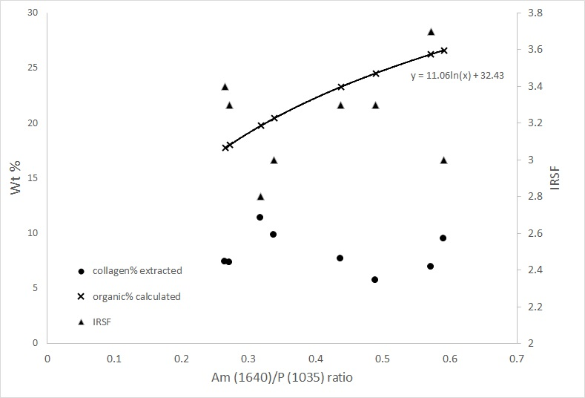
SM Fig 1: plot of the collagen in wt% extracted after full procedure, and IRSF and Am (1640)/P91035) ratio. The calculated organic% according to the measured Am (1640)/P91035) ratio of the pigeon bones in this study according to Trueman et al 2004 is plotted.
The plot in SM fig 1 shows a negative correlation between IRSF (triangles) and extracted collagen (circle). Moreover, the organic percentage calculated from Am/P ratios seems less correlated with either IRSF or percentage of extracted collagen.

Supplementary Material 2 Code for comparison between Combine() vs R_Combine(), and applications of Difference() and Order() functions, with comments after “//”.

Plot()
{
R_Date("Shivta 2 RTD-8978", 1437, 24); //Radiocarbon date of Shivta Building 2
R_Combine("R_combine Shivta 6 ")
{
R_Date("RTD-8963", 1475, 35);
R_Date("RTD-8964", 1480, 34);
}; // R_Combine() for Shivta Building 6
Combine("Combine Shivta 6")
{
R_Date("RTD-8963", 1475, 35);
R_Date("RTD-8964", 1480, 34);
}; // Combine() for Shivta Building 6
R_Date("ZG RTD-8973", 1520, 22); //Radiocarbon date of Zoological Garden
R_Date("RN RTD-8977", 1512, 24); //Radiocarbon date of Rova Noy
R_Combine("R_combine Saadon B ")
{
R_Date("RTD-8976", 1511, 30);
R_Date("RTD-8971", 1537, 33);
R_Date("RTD-8972", 1547, 23);
}; // R_Combine() for Sa’adon Building B
Combine("Combine Saadon B")
{
R_Date("RTD-8976", 1511, 30);
R_Date("RTD-8971", 1537, 33);
R_Date("RTD-8972", 1547, 23);
}; // Combine() for Sa’adon Building B
R_Date("Elusa RTD-9091", 1539, 26); // Radiocarbon date for the latest garbage outside the city of Elusa
Difference("Shivta2-6 Difference", "Shivta 2 RTD-8978", "Combine Shivta 6"); // difference between Shivta Building 2 and combined date of Shivta Building 6
Difference("Shivta6-RN Difference", "Combine Shivta 6", "RN RTD-8977"); // difference between combined date of Shivta Building 6 and Rova Noy
Difference("RN-ZG Difference", "RN RTD-8977", "ZG RTD-8973"); // difference between Rova Noy and Zoological Garden
Difference("ZG-SD Difference", "ZG RTD-8973", "Combine Saadon B"); // difference between Zoological Garden and combined date of Sa’adon Building B
Difference("SD-Elusa Difference", "Combine Saadon B", "Elusa RTD-9091"); // difference between combined date of Sa’adon Building B and latest garbage of Elusa
Order("order of Combine")
{
Date("=Shivta 2 RTD-8978");
Date("=Combine Shivta 6");
Date("=ZG RTD-8973");
Date("=RN RTD-8977");
Date("=Combine Saadon B");
Date("=Elusa RTD-9091");
}; // Order of pigeon towers and Elusa garbage
};

Supplementary Material 3 Multiple plot of the code, showing the comparison between results of R_Combine() and Combine().
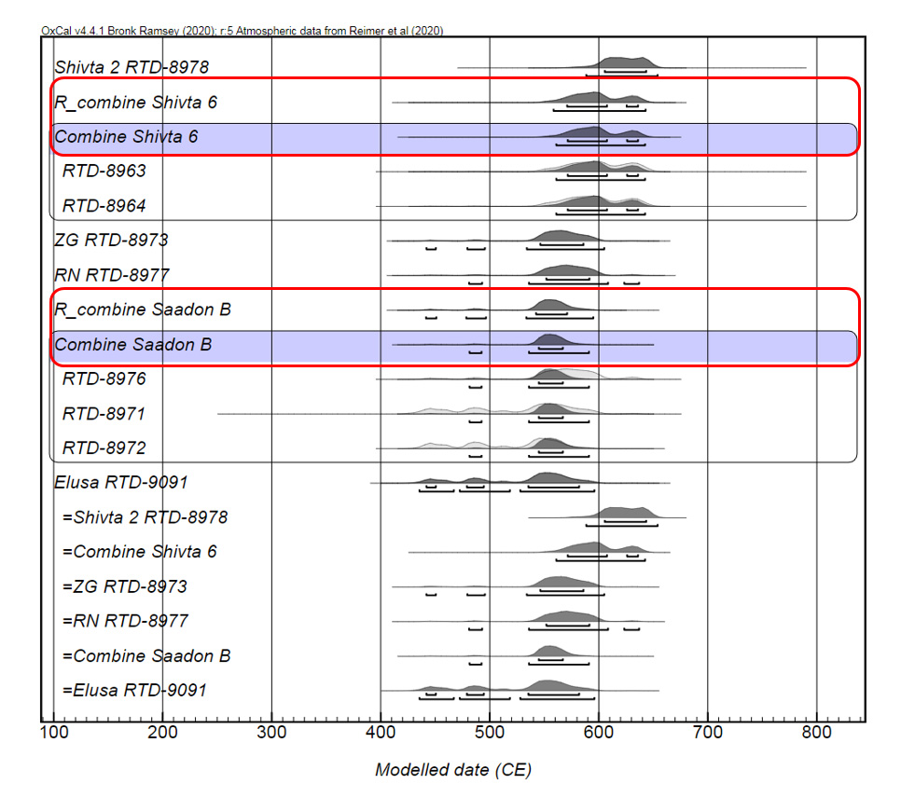

Supplementary Material 4 Results of Difference() functions.
