Wheat seed (Triticum aestivum L.) radiocarbon concentration over the last 75 years: Supplements

Table S1. Measured radiocarbon concentration in annual Gatersleben wheat harvest between 1946-2020. Final errors are the larger of either error of the weighted mean (${σ1}_{\overline{x}}^{2}=\frac{1}{\sum_{i=1}^{n}{\frac{1}{σ_{i}^{2}}}}$) or the standard error (${σ2}_{\overline{x}}^{2}=\frac{\sum_{i=1}^{n}{\frac{{{(x}_{i}-x_{mean})}^{2}}{σ_{i}^{2}}}}{(n-1)\sum_{i=1}^{n}{\frac{1}{σ_{i}^{2}}}}$) (see main text). Date is the last day of the periods April-June (winter type) or May-July (spring type).
Lab. ID | Sample ID | crop type | Date | F¹⁴C | 1 σ | ∆¹⁴C (‰) | 1 σ
55167 | TRI 261 / 1946 | winter type | 15.5.46 | 0.9542 | 0.0019 | -45.4 | 1.9
55168 | TRI 1291 / 1947 | winter type | 15.5.47 | 0.9697 | 0.0021 | -30.0 | 2.1
55169 | TRI 653 / 1948 | spring type | 15.6.48 | 0.9683 | 0.0033 | -31.5 | 3.9
55170 | TRI 2060 / 1949 | spring type | 15.6.49 | 0.9689 | 0.0019 | -31.0 | 1.9
55171 | TRI 4102 / 1950 | spring type | 15.6.50 | 0.9633 | 0.0019 | -36.7 | 1.9
55172 | TRI 4244 /1951 | winter type | 15.5.51 | 0.9660 | 0.0023 | -34.2 | 2.3
55173 | TRI 4131 / 1952 | spring type | 15.6.52 | 0.9636 | 0.0023 | -36.6 | 2.7
55174 | TRI 4272 / 1953 | winter type | 15.5.53 | 0.9620 | 0.0026 | -38.4 | 2.6
55175 | TRI 4166 / 1954 | spring type | 15.6.54 | 0.9724 | 0.0023 | -28.1 | 2.3
55176 | TRI 2680 / 1955 | spring type | 15.6.55 | 0.9998 | 0.0021 | -0.8 | 2.1
55177 | TRI 4399 / 1956 | spring type | 15.6.56 | 1.0366 | 0.0036 | 35.9 | 3.6
55178 | TRI 6307 / 1957 | spring type | 15.6.57 | 1.0729 | 0.0049 | 72.0 | 4.9
55179 | TRI 4420 / 1958 | spring type | 15.6.58 | 1.1461 | 0.0026 | 145.0 | 2.6
55180 | TRI 4896 / 1959 | spring type | 15.6.59 | 1.2866 | 0.0037 | 285.6 | 3.7
55181 | TRI 4925 / 1960 | spring type | 15.6.60 | 1.2292 | 0.0027 | 227.8 | 2.7
55182 | TRI 6451 / 1961 | winter type | 15.5.61 | 1.2196 | 0.0028 | 218.0 | 2.8
55183 | TRI 6315 / 1962 | spring type | 15.6.62 | 1.3935 | 0.0029 | 391.5 | 2.9
55184 | TRI 6886 / 1963 | winter type | 15.5.63 | 1.8617 | 0.0030 | 858.9 | 3.0
55104 | TRI 7309 / 1964 | spring type | 15.6.64 | 1.9115 | 0.0031 | 908.3 | 3.1
55105 | TRI 7461 / 1965 | winter type | 15.5.65 | 1.7815 | 0.0024 | 778.3 | 2.4
55106 | TRI 7504 / 1966 | spring type | 15.6.66 | 1.6956 | 0.0026 | 692.3 | 2.6
55107 | TRI 8306 / 1967 | spring type | 15.6.67 | 1.6171 | 0.0023 | 613.8 | 2.3
55108 | TRI 8473 / 1968 | winter type | 15.5.68 | 1.5538 | 0.0024 | 550.4 | 2.4
55109 | TRI 9364 / 1969 | winter type | 15.5.69 | 1.5544 | 0.0022 | 550.8 | 2.2
55110 | TRI 9757 / 1970 | spring type | 15.6.70 | 1.5371 | 0.0041 | 533.4 | 4.1
55111 | TRI 9821 / 1971 | winter type | 15.5.71 | 1.5104 | 0.0022 | 506.6 | 2.2
55112 | TRI 9951 / 1972 | spring type | 15.6.72 | 1.4612 | 0.0022 | 457.3 | 2.2
55113 | TRI 10331 / 1973 | spring type | 15.6.73 | 1.4267 | 0.0023 | 422.7 | 2.3
55114 | TRI 10839 / 1974 | winter type | 15.5.74 | 1.4166 | 0.0036 | 412.5 | 3.6
55115 | TRI 11280 / 1975 | winter type | 15.5.75 | 1.3799 | 0.0022 | 375.7 | 2.2
55116 | TRI 11405 / 1976 | spring type | 15.6.76 | 1.3450 | 0.0035 | 340.8 | 3.5
55117 | TRI 11802 / 1977 | winter type | 15.5.77 | 1.3377 | 0.0027 | 333.3 | 2.7
55118 | TRI 11935 / 1978 | winter type | 15.5.78 | 1.3225 | 0.0020 | 318.0 | 2.0
55119 | TRI 12816 / 1979 | winter type | 15.5.79 | 1.2975 | 0.0028 | 292.9 | 2.79
55120 | TRI 12913 / 1980 | winter type | 15.5.80 | 1.2811 | 0.0023 | 276.5 | 2.3
55121 | TRI 12950 / 1981 | winter type | 15.5.81 | 1.2638 | 0.0033 | 259.1 | 3.3
55122 | TRI 13179 / 1982 | spring type | 15.6.82 | 1.2416 | 0.0022 | 236.8 | 2.2
55123 | TRI 13243 / 1983 | winter type | 15.5.83 | 1.2291 | 0.0022 | 224.2 | 2.2
55124 | TRI 13410 / 1984 | spring type | 15.6.84 | 1.2167 | 0.0032 | 211.7 | 3.2
55125 | TRI 15001 / 1985 | spring type | 15.6.85 | 1.2037 | 0.0023 | 198.6 | 2.3
55126 | TRI 14398 / 1986 | spring type | 15.6.86 | 1.1924 | 0.0022 | 187.2 | 2.2
55127 | TRI 15170 / 1987 | winter type | 15.5.87 | 1.1799 | 0.0033 | 174.6 | 3.3
55128 | TRI 16094 / 1988 | winter type | 15.5.88 | 1.1697 | 0.0022 | 164.4 | 2.2
55129 | TRI 16153 / 1989 | spring type | 15.6.89 | 1.1622 | 0.0024 | 156.7 | 2.4
55130 | TRI 16569 / 1990 | winter type | 15.5.90 | 1.1466 | 0.0021 | 141.0 | 2.1
55131 | TRI 16697 / 1991 | winter type | 15.5.91 | 1.1443 | 0.0022 | 138.6 | 2.3
55132 | TRI 16567 / 1992 | winter type | 15.5.92 | 1.1324 | 0.0034 | 126.7 | 3.4
55133 | TRI 16753 / 1993 | winter type | 15.5.93 | 1.1266 | 0.0023 | 120.7 | 2.3
55134 | TRI 16750 / 1994 | winter type | 15.5.94 | 1.1296 | 0.0026 | 123.6 | 2.6
55135 | TRI 17653 / 1995 | spring type | 15.6.95 | 1.1142 | 0.0021 | 108.2 | 2.2
55136 | TRI 17731 / 1996 | spring type | 15.6.96 | 1.1134 | 0.0022 | 107.2 | 2.2
55137 | TRI 17859 / 1997 | spring type | 15.6.97 | 1.1076 | 0.0044 | 101.3 | 4.4
55138 | TRI 17893 / 1998 | intermediate (winter) | 15.5.98 | 1.1038 | 0.0040 | 97.5 | 4.0
55139 | TRI 17733 / 1999 | winter type | 15.5.99 | 1.0942 | 0.0023 | 87.7 | 2.3
54966 | TRI 18292 / 2000 | spring type | 15.6.00 | 1.0888 | 0.0025 | 82.2 | 2.5
54967 | TRI 18810 /2001 | spring type | 15.6.01 | 1.0842 | 0.0036 | 77.5 | 3.6
54968 | TRI 18884 / 2002 | spring type | 15.6.02 | 1.0780 | 0.0022 | 71.2 | 2.2
54969 | TRI 19297 / 2003 | spring type | 15.6.03 | 1.0722 | 0.0021 | 65.4 | 2.1
54970 | TRI  19328 /  2004 | spring type | 15.6.04 | 1.0664 | 0.0035 | 59.5 | 3.5
54971 | TRI 217 / 2005 | winter type | 15.5.05 | 1.0607 | 0.0021 | 53.7 | 2.1
54972 | TRI 19454 / 2006 | winter type | 15.5.06 | 1.0567 | 0.0018 | 49.6 | 1.8
54973 | TRI 21371 / 2007 | winter type | 15.5.07 | 1.0543 | 0.0018 | 47.1 | 1.8
54974 | TRI 10191 / 2008 | winter type | 15.5.08 | 1.0492 | 0.0035 | 41.9 | 3.5
54975 | TRI 21554 / 2009 | spring type | 15.6.09 | 1.0508 | 0.0020 | 43.4 | 2.0
54976 | TRI 4549 / 2010 | spring type | 15.6.10 | 1.0363 | 0.0020 | 28.8 | 2.0
54977 | TRI 29527 / 2011 | winter type | 15.5.11 | 1.0363 | 0.0020 | 28.7 | 2.0
54978 | TRI 29837 / 2012 | winter type | 15.5.12 | 1.0315 | 0.0021 | 23.8 | 2.1
54979 | TRI 29772 / 2013 | spring type | 15.6.13 | 1.0299 | 0.0019 | 22.1 | 1.9
54980 | TRI 30040 / 2014 | winter type | 15.5.14 | 1.0230 | 0.0021 | 15.1 | 2.1
54981 | TRI 29570 / 2015 | winter type | 15.5.15 | 1.0223 | 0.0023 | 14.3 | 2.3
54982 | TRI 29840 / 2016 | winter type | 15.5.16 | 1.0204 | 0.0021 | 12.3 | 2.1
54983 | TRI 29985 / 2017 | winter type | 15.5.17 | 1.0138 | 0.0023 | 5.6 | 2.3
54984 | TRI 1003 / 2018 | winter type | 15.5.18 | 1.0068 | 0.0021 | -1.4 | 2.1
54985 | TRI 5603 / 2019 | spring type | 15.6.19 | 1.0073 | 0.0021 | -1.1 | 2.1
55357 | TRI 4551 / 2020 | spring type | 15.6.20 | 1.0098 | 0.0017 | 1.3 | 1.7

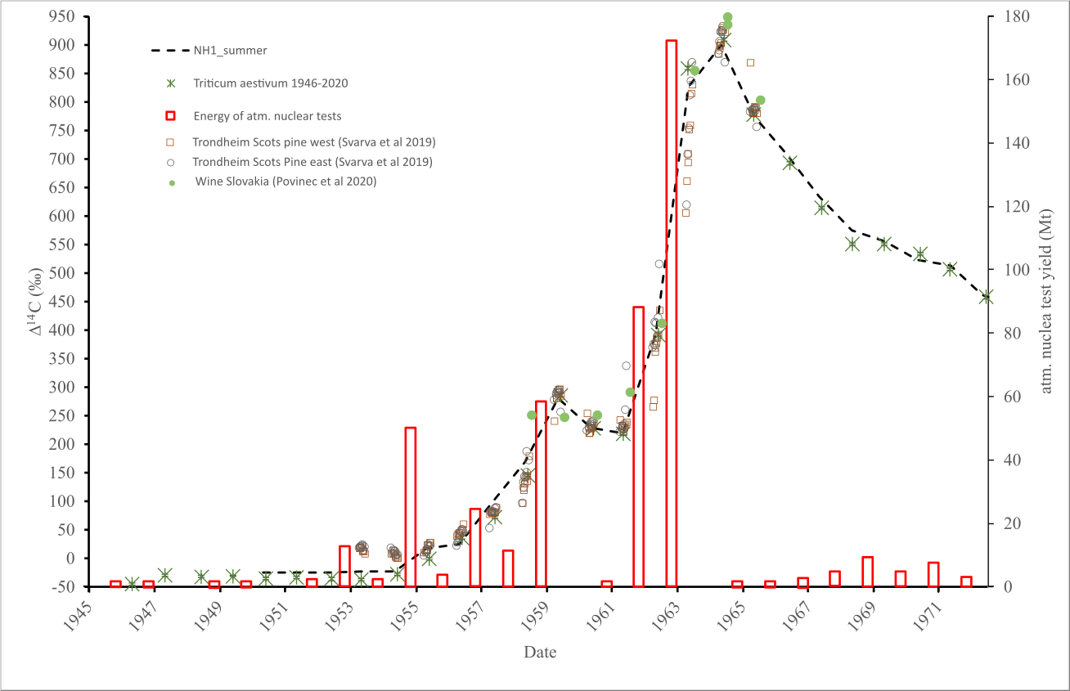

Supplement Figure S1 : 14C concentration of Gatersleben-wheat-tissue between 1945 – 1970. Red circles give annual detonation yield of atmospheric nuclear tests ( Bergkvist and Ferm 2000).

Figure S 1. ¹⁴C concentration of Gatersleben-wheat-tissue ((green asterisks)) between 1945 – 1971 and the NH1 dataset (Hua et al. 2013). Red bars give annual detonation yield of atmospheric nuclear tests (data from: Bergkvist and Ferm 2000; UNSCEAR_AnnexC 2000). In addition, radiocarbon data from tree-rings (Norway) and wine (Slovakia), discussed in the main text, are shown (Svarva et al 2019, Povinec et al 2020).

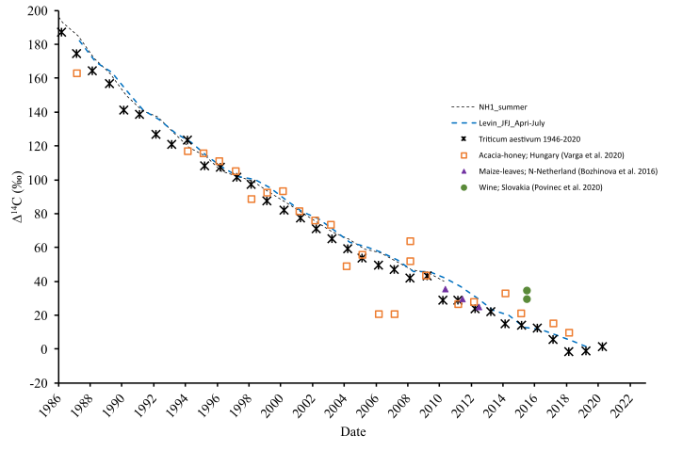
Figure S 2. ¹⁴C concentration of Gatersleben-wheat-tissue (black asterisks) between 1986 – 2020 in comparison to the NH1 dataset (Hua et al. 2013), Jungfraujoch (Emmenegger et al. 2020; Hammer and Levin 2017; Levin et al. 2008; Levin and Kromer 2004), honey from Hungary (Varga et al 2020), maize-leaves from northern Netherlands (Bozhinova et al. 2016), and wine from Slovakia (Povinec et al. 2020).

References:
Bergkvist N-O, Ferm R. 2000. “Nuclear Explosions 1945 -1998.” Stockholm.
Emmenegger L, Leuenberger M, Steinbacher M, RI I. 2020. ICOS ATC, CAL 14C Release, Jungfraujoch (10.0 m). Retrieved from https://hdl.handle.net/11676/X-lXPKZlO4DWX7wncsLQ7akY
Hammer S, Levin I. 2017. Monthly mean atmospheric D14CO2 at Jungfraujoch and Schauinsland from 1986 to 2016. https://doi.org/doi/10.11588/data/10100

Hua Q, Barbetti M, Rakowski A Z. 2013. “ATMOSPHERIC RADIOCARBON FOR THE PERIOD 1950–2010.” Radiocarbon 55 (4): 2059–72.
Levin I, Hammer S, Kromer B, Meinhardt F. 2008. Radiocarbon observations in atmospheric CO2: Determining fossil fuel CO2 over Europe using Jungfraujoch observations as background. Science of the Total Environment, 391(391), 211–216.
Levin I, Kromer B. 2004. The tropospheric 14CO2 level in mid-latidudes of the northern hemisphere (1959-2003). Radiocarbon, 46(3), 1261-1272.

Povinec P P, Kontuľ I, Lee S H, Sýkora I, Kaizer J, Richtáriková M. 2020. Radiocarbon and 137Cs dating of wines. Journal of Environmental Radioactivity, 217(November 2019).
Svarva H, Grootes P, Seiler M, Stene S, Thun T, Vaernes E, Nadeau M-J. 2019. The 1953-1965 rise in atmospheric bomb 14C in central Norway. Radiocarbon, 61(6), 1765–1774.
UNSCEAR_AnnexC. 2000. “Report to the General Assembly; Annex C: Exposures to the Public from Man-Made Sources of Radiation.” New York. https://www.unscear.org/unscear/en/publications/2000_1.html.

