**Supporting Information**

**Flexible soil microbial carbon metabolism across an Asian elevation gradient**

Yishan Jiang1,6, Dayi Zhang 2, Nicholas J.Ostle3, Chunling Luo1,4*,Yan Wang5, Ping Ding6, Zhineng Cheng1, Chengde Shen7, Gan Zhang1*

1State Key Laboratory of Geochemistry, Guangzhou Institute of Geochemistry, Chinese Academy of Sciences, Guangzhou, 510640, China

2School of Environment, Tsinghua University, Beijing, 100084, China

3Lancaster Environment Centre, Lancaster University, Lancashire, LA14YQ, UK

4College of Natural Resources and Environment, South China Agricultural University, Guangzhou, 510642, China

5School of Environmental Science & Technology, Dalian University of Technology, Dalian, 116024, China

6State Key Laboratory of Isotope Geochemistry, Guangzhou Institute of Geochemistry, Chinese Academy of Sciences, Guangzhou, 510640, China

7University of Chinese Academy of Sciences, Beijing 100049, China

*Corresponding author E-mail address: [clluo@gig.ac.cn](mailto:clluo@gig.ac.cn), [zhanggan@gig.ac.cn](mailto:zhanggan@gig.ac.cn)

**Catalogue**

1. Soil physical and chemical analysis

2. PLFAs’ extraction for Compound-specific 14C analysis

3. Optimization of preparative capillary gas chromatography system

3.1 Chemicals and instruments

3.2 Orthogonal experiment design

3.3 Results and discussion

3.4 Conclusion

**Tables and figures**

**Tables**

Table_1_Supp. Pearson correlations of environmental, soil properties and soil microbial parameters

Table_2_Supp. Representative PLFAs of microbes

Table_3_Supp. Retention times and yield calculated C (μg) of singe FAME under optimum conditions.

Table_4_Supp. Sample size (μg C) of analyzed PLFAs samples

**Figures**

Figure_1_Supp. Recoveries of FAMEs in PFC U-tubes using different washing solvents.

Figure_2_Supp. Relative area counts for five C chain categories in GRS617 as a function of inlet initial temperature.

Figure_3_Supp. Ratio of area counts for five C chain categories in GRS617 as a function of inlet final temperature.

Figure_4_Supp. Relative area counts for five C chain categories in GRS617 observed of increasing solvent venting time.

Figure_5_Supp. Ratio of area counts for five C chain categories in GRS617 as a function of increasing CIS heating rate.

Figure_6_Supp. Relative area counts for five C chain categories of FAMEs in GRS617 (a) and forest soil sample (b) observed in different CIS injection mode.

Figure_7_Supp. Trapping recoveries of FAMEs from GRS617 (a) and forest soil sample (b) as a function of trapping temperature of the PFC. The recoveries have been corrected against the amount of the FAMEs directed to the FID.

Figure_8_Supp. GC-FID spectrograms under different injection volumes of forest soil sample.

Figure_9_Supp. PCGC separation of the target compounds from forest soil sample.

Figure_10_Supp. 13C values of PLFAs on Gongga Mountaion

**1 Soil preparation and soil physical and chemical analysis**

Superficial litter, large roots, and any nonorganic material were removed to avoid interference. The soil samples were taken back to the laboratory in a cool box and kept frozen at -20 °C until extraction and analysis within 10 days.

A representative portion (about 20 g) of each soil sample was dried at 30 °C to a constant weight. The soils were ball-milled in order to homogenize the sample material before analysis. Carbonates were removed from the bulk soil with 0.1M HCl solution. Following this procedure the sample was neutralized with NaOH solution and distilled water, dried at 30 °C and ball-milled again. The soil samples were used to do the physicochemical analyses including soil density, soil organic carbon (SOC) content, total nitrogen (TN) content and soil pH. Soil density was collected with the bulk density ring while soil sampling. Soil pH was measured by the pH measurement (Rex Electric Chemical, Type PHSJ-4F), with soil dissolved in 1 mol/L KCL solution in proportion of 1:2.5. SOC content, TN were analyzed by Elementar (Vario EL Ⅲ).

**2 extraction of soil PLFAs for Compound-specific 14C analysis**

Approximately 450 g soil (wet) was placed in two precombusted glass jars with Teflon-lined caps. The soil was spiked with 864 ml fresh citrate buffer, firstly extracted with chloroform, methanol, and Bligh and Dyer solution (2:1:0.8 mixture of methanol/chloroform/citrate buffer) in the proportion of 1:2:0.8. After vortex for 1 min and ultrasonic for 15 min to make them mixed adequately, the sample was left to extract and separate for another 12 h. Then, the supernatant was transferred to the separating funnel, and the rest mixture was centrifuged at 2500 r/min for 10 min with the supernatant transferred to the same funnel. The extraction procedure was repeated again with 300 ml Bligh and Dyer solution, split the phases by 372 ml chloroform and 372 ml citrate buffer and left to separate overnight.

The bottom phase in the separating funnel was transferred and rotary-evaporated until dry to yield lipid extract. The dry lipid extract was then transferred to a 150 g of fully activated silica gel (baked at 450 °C for 12 h) column and eluted with 1 L of chloroform, 1.5 L of acetone and 1 L methanol, respectively. This column chromatography procedure separated different classes with increasing polarity, which were neutral lipids (including hydrocarbons, free fatty acids, and sterols), glycolipids and polar lipids (phospholipids), respectively. The methanol phase (phospholipids contained) was collected and evaporated under nitrogen stream till dry. To test the recoveries of PLFAs during the column chromatography, the silica gel column was further eluted with another 0.5 L methanol. This eluent only contained less than 7±1% of the total PLFAs.

The retrieved PLFAs need trans-methylated in mild alkaline methanol to yield the homologous fatty acid methyl esters (FAMEs) for GC separation. Briefly, the dried phospholipids fraction were first dissolve in 1 ml MeOH: toluene (v/v 1:1 ), followed by the addition of 60 ml 0.2 mol/L KOH in methanol (freshly prepared), and incubated in a water bath at 37 °C for 15 min. Then, the liquid phase was split by adding 100 ml hexane/chloroform (4:1) solution, 18 ml acetic acid, and 100 ml milli Q water. The upper organic phase was transferred to a flask. The bottom phase was extracted again by 100 ml hexane/chloroform (4:1) solution. The supernatant was combined, and evaporated under nitrogen stream till dry.

A second column chromatograph was done using 6 g fully activated silica gel to further purify the yielded FAMEs. The column was firstly eluted with 60 ml hexane (discarded), and then with 60 ml DCM/hexane (v/v 1:1) for collecting purified FAMEs. The purified FAMEs fraction was dried under nitrogen stream.

[Qualitative](app:ds:qualitative) [analysis](app:ds:analysis) of resulting PLFA-fatty acid methyl ester fractions (FAMEs) was mainly performed by a GLC reference standard GRS617 prepared by Brian Nutter (NU-CHEK, INC., USA) with a combination of pure fatty acid standards (Sigma 37 component FAME mix and 26 component bacterial acid methyl esters (BAME) mix 47080-U, Germany). In addition, a pure C19:0 FAME purchased from Dr. Ehrenstorfer (Germany) was dissolved in hexane and used as an internal standard for the quantification of FAMEs.

The final sample size of analyzed PLFAs samples was listed in **Table_2_Supp.**

**3. Optimization of preparative capillary gas chromatography system**

3.1 Chemicals and instruments

The PCGC optimization was mainly performed with a GLC reference standard GRS617 prepared by Brian Nutter (NU-CHEK, INC., USA). This standard reference material is a mixture of 40 fatty acid methyl esters (methyl butyrate, methyl hexanoate, methyl octanoate, methyl decanoate, methyl undecanoate, methyl laurate, methyl tridecanoate, methyl myristate, methyl myristoleate, methyl pentadecanoate, methyl 10-pentadecenoate, methyl palmitate, methyl palmitoleate, methyl heptadecanoate, methyl 10-heptadecenoate, methyl stearate, methyl elaidate, methyl oleate, methyl linoelaidate, methyl linoleate, methyl arachidate, methyl gamma linolenate, methyl 11-eicosenoate, methyl heneicosanoate, methyl 11-14 eicosadienoate, methyl behenate, methyl homogammalinolenate, methyl erucate, methyl 11-14-17 eicosatrienoate, methyl arachidonate, methyl tricosanoate, methyl docosadienoate, methyl lignocerate, methyleicosapentaenoate, methyl nervonate, three methyl docosahexaenoatehomologous series). The GRS617 standard was dissolved in hexane forming a nominal concentration of 40 mg/L.

The Agilent 7890A GC is equipped with an Agilent 7693 autosampler and a flame ionization detector (FID), integrated with a Gerstel CIS 1. In the CIS inlet, the carrier gas is connected through a septumless sampling head and enters the liner at the top, which can be heated or cooled rapidly. About 1% of the effluent is diverted to FID and the remaining is directed to the PFC. The preparative device consists of an eight-port zero-dead volume valve connected to the transfer line from GC and a set of seven 100 μl glass U-tube traps (one for waste and six for target samples).

After addition of C19:0 as the internal standard, the collection efficiency of CIS was calculated according to relative peak areas of analytes on GC-FID under different conditions, where C19:0 peak areas are assumed as 100%. The PFC recoveries obtained in this study were calculated according to peak areas of GC-FID before and after trapping by the PCGC and always corrected against the amount of the FAMEs directed to the FID. The U-tubes containing the FAMEs were each rinsed 10 times with 10 μl acetone, [dichloromethane](app:ds:dichloromethane) (DCM), and hexane, respectively, to test the recoveries **(Figure_1_Supp.)**. The test was repeated three times for each solvent, and the result revealed that the best recovery for all FAMEs (C14‒C18) was the U-tube washed by DCM. In addition, [DCM](app:ds:dichloromethane) is also the ideal solvent to deliver the sample to further preparation of graphite target for AMS 14C measurement. Therefore, the trapped compounds were washed 10 times by 10 μl [DCM](app:ds:dichloromethane) to transfer to the injection vial.

**3.2 Orthogonal experiment design**

The following seven instrument parameters were investigated in the order of their relative importance: CIS initial temperature, CIS end temperature, CIS solvent venting time, CIS heating rate, CIS injection mode, PFC trapping temperature, and injection volume. For each parameter, a series of injection of the GRS617 standard or the forest soil extract was carried out, and the signal intensity of each FAME group was investigated by varying each parameter at a time. During the experiment, the value of each investigated instrument parameter was gradually increased, and the peak area of each FAME group was integrated and normalized by the maximum area among the parallel experiments.

**3.3 Results and discussion**

3.3.1 CIS inlet temperature

CIS injection mode is normally used in PCGC to harvest (semi-) volatile compounds from large sample volume, and also to eliminate solvent prior to transferring the sample to the GC column. It is crucial to ensure the most evaporation of solvent (hexane) to prevent its impact on the target compounds volatilization and to obtain higher recoveries. Besides, a higher inlet initial temperature is also beneficial for transferring less volatile analytes to the GC column. In this study, five inlet initial temperatures and two end temperatures were set to evaluate the effect on the injection efficiency for harvesting different FAMEs from the GRS617.

A temperature of 30 °C below the boiling point of the solvent has been suggested by the manufacturer for the solvent venting period. Since the boiling point of n-hexane is 69 °C, we chose a period from 30 °C to 60 °C (10 °C as an interval) to calculate the peak areas of solvents and FAMEs **(Figure_2_Supp.)**. The peak areas of FAMEs measured from each injection were normalized against the maximum peak area observed during the corresponding series of injections. Similar C chain variation and microbial-representative FAMEs were grouped together. With the initial inlet temperature increasing from 30 °C to 60 °C, target compounds exhibited a slight decreasing, while the solvent residual showed a sharp decreasing. Considering the relative low solvent residual and high compound contents, 40 °C was chosen as the inlet initial temperature. This temperature is almost identical to the recommended temperature by the manufacture (39 °C for n-hexane).

Two CIS inlet end temperatures (280 °C and 300 °C) were used to evaluate the effect on the injection efficiency **(Figure_3_Supp.)**. Under the same inlet final temperature, the vapor pressures/boiling points of analytes are the most important factors controlling the injection efficiency. However, the contents of different temperatures did not demonstrate a significant variation. Therefore, 300 °C was chosen as the inlet final temperature for further optimization.

3.3.2 CIS solvent venting time

Besides inlet temperature, the solvent venting time may also significantly affect the performance of the CIS. This time should be long enough to allow all the solvent to evaporate and also should limit, as much as possible, the loss of volatile target analytes. Preliminary experiments showed that the injected solvent can be removed in about 5 s (0.083 min) when the inlet temperature is 40 °C for n-hexane. Therefore, we made a series of injection of the GRS617 solution, for which the venting time changed from 0.07 to 0.11 min (increased at 0.01 min step). The optimal values for inlet temperature were used (initial 40 °C and final 300 °C). **Figure_4_Supp.** showed that the decreasing of FAMEs over venting time did not exhibit a significant trend even for the venting time of 0.11 min. Consequently, solvent venting time should be set at 0.1 min when the solvent is barely existed during the harvesting of FAMEs.

3.3.3 CIS heating rate

The CIS heating rate should also be set considering the boiling points of target compounds. An appropriately heating rate can not only reduce the amount of solvent that can enter the column, but also improve the separation efficiency of specific compounds. Three injections of the GRS617 standard were repeated for three venting rates (4 ml/min, 8 ml/min, and 12 ml/min, **Figure_5_Supp.**). The optimal value for solvent venting time (0.1 min) and inlet temperature (initial 40 °C and final 300 °C) were used. The peak areas of FAMEs showed a steady increase with the rise of heating rate, while the solvent peak displayed less disparity **(Figure_5_Supp.)**. Hence, a heating rate of 12 °C /min was chosen for harvesting FAMEs.

3.3.4 CIS injection mode

The injection rate can significantly affect the chromatography. Previous studies showed that lower injection rate caused obvious compound discrimination and resulted in a reduction of the relative peak areas of the less volatile compounds. The reason may be that the failure in liquid film formation inside the liner would hamper the evaporation of solvent and analytes. To detect the effect of the injection mode on the peak areas of FAMEs in both the GRS617 and the forest soil FAMEs sample, fast (6000 μl/min), medium (3000 μl/min), and slow (300 μl/min) injection modes were used **(Figure_6_Supp.)**. Areas were higher for compounds and lower for solvents using the fast injection mode than the other two modes both for the standard and the forest soil sample, i.e. the fast injection mode favored the analysis of C14 ‒ C18 FAMEs.

3.3.5 Optimization of PFC trapping temperature

The optimum trapping temperature for different compounds may be different. Most of the previous studies used the liquid nitrogen-cooled units to support the glass traps of PFC, which could achieve a temperature of –20 °C during the collection of individual *n*-alkanes, fatty acids, or polycyclic aromatic hydrocarbons (PAHs). It was proposed that a low cooling temperature would prevent the breakthrough of target compounds. However, a recent study used a relatively high trapping temperature (60 °C) to avert condensation of high boiling point compounds, such as long chain alkanes (≥*n*-C24) and FAMEs, at the end of distribution lines. Since liquid nitrogen-cooled units is considerable expensive and inconvenient during auto-sampling for large volume trapping, it is crucial to explore a proper trapping temperature close to room temperature (about 30 °C) for the PFC trapping of short-chained FAMEs.

Four PFC trapping temperatures (‒20 °C, 0 °C, 20 °C, and room temperature 30 °C) were tested for the FAMEs recoveries of GRS617 and forest soil sample **(Figure_7a _Supp. and Figure_7b _Supp.)**. Categories of C18 (C18:1, trans-9; C18:1, cis-9; C18:2, trans-9, 12; C18:2 cis-9, 12; C18:3, cis-6, 9, 12; C18:3, cis-9, 12, 15) FAMEs provided similar variation were grouped together. In general, high recoveries of 90 ‒ 100% were acquired for most of FAMEs. The trapping of FAMEs based on different temperatures did not present a significant trend, and was efficient even at ambient temperatures. Thus, it suggested that harvesting of C14 ‒ C18 FAMEs by PCGC system can also be actually possible when the liquid nitrogen-cooled unit is absent.

3.3.6 Optimized injection volume for forest soil sample

Traditionally, the PCGC injection volume is 3 ‒ 5 μl. For the sake of obtaining sufficient amounts of target compounds for CSRA, over one hundred injections are needed. For saving time, a large injection volume is recommended. However, overlarge injection volume may overload the capillary column and result in overlapped peak areas. In order to find an adequate injection volume that both ensure the purity of target compounds and save the trapping time while collecting FAMEs from samples with high concentrations (≥100 µg/ml), we increased the injection volume from 0.5 μl to 5 μl by applying the PTV inlet solvent vent mode **(Figure_8_Supp.)**. The figure indicated that for collecting those less heterogeneous FAMEs (i.e. C14, C15, C16, and C17), the injection volume can be promoted to 5 μl；while for more heterogeneous FAMEs (i.e. C18) the injection can only be 3 μl at most.

**3.4 Conclusion**

Operation parameters of a PCGC system were optimized on an attempt to trap short-chain (C14 ‒ C18) FAMEs from forest soil matrix. Five groups of reference FAMEs were used to evaluate the performance of the PCGC system under different CIS and PFC operating parameters. The optimum PCGC conditions were: CIS initial temperature (40 °C), CIS end temperature (300 °C), CIS solvent venting time (0.1 min), CIS heating rate (12 °C/min), CIS injection mode (fast mode), PFC trapping temperature (room temperature 30 °C), and injection volume (3 μl). Under our optimum PCGC conditions, the recoveries of target compounds were generally higher than 90 % based on GC-FID (Fig. S7b), and c.a.100 μg C **(Table_3_Supp.)** of a single FAME can be harvested within 450 g forest soil. Furthermore, the average purity of the FAMEs under investigation was generally higher than 90% based on GC-MS analysis **(Figure_9_Supp.)**. In conclusion, our optimal operational parameters for PCGC system is efficient and applicable to separate and harvest individual PLFA or PLFA groups from forest soil for following compound specific radiocarbon analysis on AMS.

**Table_1_Supp. Pearson correlations of environmental, soil properties and soil microbial parameters**

|  | Lati.2 | Elev.3 | MAT4 | MAP5 | SD.6 | SOC7 | TN8 | C/N9 | pH | δ13C10 | Bac.11 | Fun.12 | GN13 | GP14 | GP/GN15 | F/B16 | Biom.17 |
| --- | --- | --- | --- | --- | --- | --- | --- | --- | --- | --- | --- | --- | --- | --- | --- | --- | --- |
| Lon.1 | .428 | -.130 | .117 | -.357 | .237 | .182 | .253 | -.396 | .367 | -.378 | .166 | -.314 | .015 | .201 | .354 | -.302 | -.010 |
| Lati.2 | 1 | **-.922\*\*** | **.921\*\*** | -.609 | .415 | .244 | .489 | **-.638\*** | .588 | **-.951\*\*** | .219 | .215 | .175 | .215 | **.658\*** | **-.648\*** | .289 |
| Elev.3 |  | 1 | **-.996\*\*** | .527 | -.482 | -.263 | -.488 | .437 | -.584 | **.928\*\*** | -.232 | -.362 | -.216 | -.216 | **-.657\*** | .620 | -.347 |
| MAT4 |  |  | 1 | -.514 | .439 | .255 | .473 | -.422 | .581 | **-.935\*\*** | .239 | .389 | .229 | .223 | **.655\*** | -.621 | .367 |
| MAP5 |  |  |  | 1 | -.304 | .250 | .069 | .531 | -.302 | **-.653\*** | -.101 | -.133 | -.071 | -.096 | -.465 | .336 | -.146 |
| SD.6 |  |  |  |  | 1 | .727* | **.784\*\*** | .034 | .477 | -.491 | .743* | .529 | .685* | .740* | **.807\*\*** | **-.754\*** | **.674\*** |
| SOC7 |  |  |  |  |  | 1 | **.956\*\*** | .257 | .233 | -.276 | **.826\*\*** | .554 | **.793\*\*** | **.835\*\*** | .598 | **-.663\*** | **.713\*** |
| TN8 |  |  |  |  |  |  | 1 | -.003 | .345 | -.488 | **.764\*** | .523 | **.727\*** | **.771\*\*** | **.686\*** | **-.741\*** | **.679\*** |
| C/N9 |  |  |  |  |  |  |  | 1 | -.146 | -.519 | .259 | .261 | .279 | .255 | -.109 | .054 | .228 |
| pH |  |  |  |  |  |  |  |  | 1 | -.615 | .232 | .210 | .139 | .203 | **.750\*** | **-.749\*** | .375 |
| δ13C10 |  |  |  |  |  |  |  |  |  | 1 | -.376 | -.401 | -.333 | -.366 | **-.774\*** | **.689\*** | **-.458\*** |
| Bac.11 |  |  |  |  |  |  |  |  |  |  | 1 | **.818\*\*** | **.985\*\*** | **.998\*\*** | **.763\*** | **-.727\*** | **.940\*\*** |
| Fun.12 |  |  |  |  |  |  |  |  |  |  |  | 1 | **.885\*\*** | **.788\*\*** | **.667\*** | **-.639\*** | **.935\*\*** |
| GN13 |  |  |  |  |  |  |  |  |  |  |  |  | 1 | **.978\*\*** | **.702\*** | **-.678\*** | **.952\*\*** |
| GP14 |  |  |  |  |  |  |  |  |  |  |  |  |  | 1 | **.744\*** | **-.706\*** | **.918\*\*** |
| GP/GN15 |  |  |  |  |  |  |  |  |  |  |  |  |  |  | 1 | **-.944\*\*** | **.823\*\*** |
| F/B16 |  |  |  |  |  |  |  |  |  |  |  |  |  |  |  | 1 | **-.805\*\*** |

**Correlation is significant at the 0.01 level (2-tailed); * Correlation is significant at the 0.05 level (2-tailed).

1Lon.: Longtitude. 2Lati.: Latitude. 3Elev.: Elevation. 4MAT: mean annual temperature. 5MAP: mean annual precipitation. SD.6: Soil density. 7SOC:soil organic carbon inventory. 8TN: total nitrogen inventory.  9C/N: ratio of soil carbon to nitrogen. 10δ13C: δ13C of soil organic C 11Bac.: Bacteria. 12Fun.: Fungi. 13GN: Gram negative bacteria. 14GP: Gram positive bacteria. 15GP/GN: ratio of Gram positive bacteria to Gram negative bacteria. 16F/B: ratio of fungi to bacteria. 17Biom.: total microbial biomass.

**Table_2_Supp.** Representative PLFAs of microbes

|  |  |
| --- | --- |
| Microorganism | Unique fatty acid |
| Common bacterial signatures | iC15:0， aC15:0， C15:0， iC16:0， C16:1ω9， C16:1ω7t， iC17:0， C18ω7 and cycC19:0 |
| Fungi | C18:1ω9，C18:2ω6、18:3ω6、C18:3ω3 |
| Gram-positive bacteria | Multiple branched chains PLFAs |
| Gram-negative bacteria | PLFAs containing multiple hydroxyl groups |
| Aerobes | C16:1ω7，C18ω7t |
| Anaerobes | cycC17:0，cycC19:0 |
| Sulfate-reducing bacteria | 10melC16:0，iC17:1ω7，C17:1ω6 |
| Methane-oxidizing bacteria | C16:1ω8，C16:1ω5c，C18:1ω8c，C18:1ω6c |
| Barophilic/psychrophilic bacteria | C20:5，C22:6 |
| Cyanobateria | polyunsaturated PLFAs，C18:2ω6 |
| Protozoa | C20:3ω6，C20:4ω6 |
| Actinomycetes | 10melC16:0，10melC17:0，10melC18:0 |
| Microalgae | C16:3ω3 |
| Flavobacterium balustinum | iC17:1ω7，br2OH-C15:0 |
| Bacillus spp. | branched chain PLFAs |
| Desulfobacteria | cycC18:0（ω7，8） |
| Sulfobacteria | iC17:1ω5，10melC18:1ω6，11mel18:1ω6 |
| Desulfovibrio | iC17:1ω7c，i15:1ω7c，iC19:1ω7c |
| Desulfobulbus | C17:1ω6，C15:1 |

(Frostegård and Bååth, 1996; Hill et al., 2000; Joergensen and Potthoff, 2005; Sakamoto et al., 2004; Tunlid and White, 1992; Vestal and White, 1989)

**Table_3_Supp.** Retention times and yield calculated C (μg) of singe FAME under optimum conditions.

|  |  |  |
| --- | --- | --- |
| Target compounds (FAME) | Retention time/min | Yield C of target FAME/μg |
| C14:0 | 18.05 | 219 |
| C15:0 | 20.09 | 119 |
| C16:1 | 24.05 | 134 |
| C16:0 | 24.60 | 1200 |
| C17:0 | 27.84 | 81.9 |
| C18:0 | 32.90 | 218 |

**Table_4_Supp.** Sample size (μg C) of analyzed PLFAs samples

|  |  |  |
| --- | --- | --- |
| NO. | Component | Estimating C (ug) |
| GG2000-1 | iC15:0+aC15:0 | 139.2 |
| GG2000-2 | C16:1 | 381 |
| GG2000-3 | C16:0 | 453 |
| GG2000-4 | brC17 | 199.8 |
| GG2000-5 | cyC17 | 56.1 |
| GG2000-6 | cyC19 | 181.2 |
| GG2500-1 | iC15:0+aC15:0 | 139.2 |
| GG2500-2 | C16:1 | 381 |
| GG2500-3 | C16:0 | 453 |
| GG2500-4 | brC17 | 199.8 |
| GG2500-5 | cyC17 | 56.1 |
| GG2500-6 | cyC19 | 181.2 |
| GG2900-1 | iC15:0+aC15:0 | 139.2 |
| GG2900-2 | C16:1 | 381 |
| GG2900-3 | C16:0 | 453 |
| GG2900-4 | brC17 | 199.8 |
| GG2900-5 | cyC17 | 56.1 |
| GG2900-6 | cyC19 | 181.2 |
| MeOH | MeOH | - |

**Figure_1_Supp.** Recoveries of FAMEs in PFC U-tubes using different washing solvents. The error bars correspond to ±1 standard deviation (n= 3).

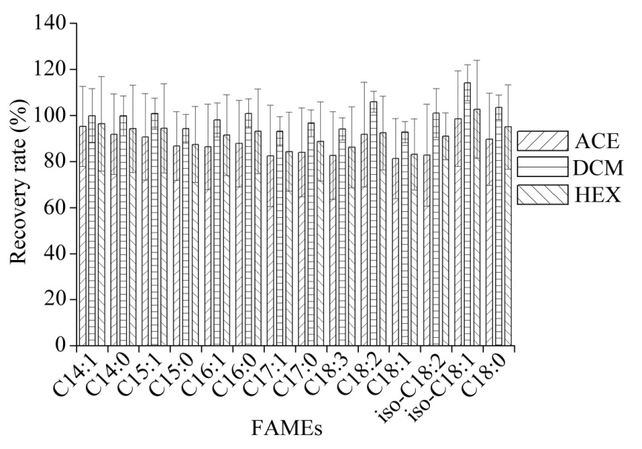

**Figure_2_Supp.** Relative area counts for five C chain categories in GRS617 as a function of inlet initial temperature. The error bars correspond to ±1 standard deviation (n= 3).



**Figure_3_Supp.** Ratio of area counts for five C chain categories in GRS617 as a function of inlet final temperature. The error bars correspond to ±1 standard deviation (n= 3).

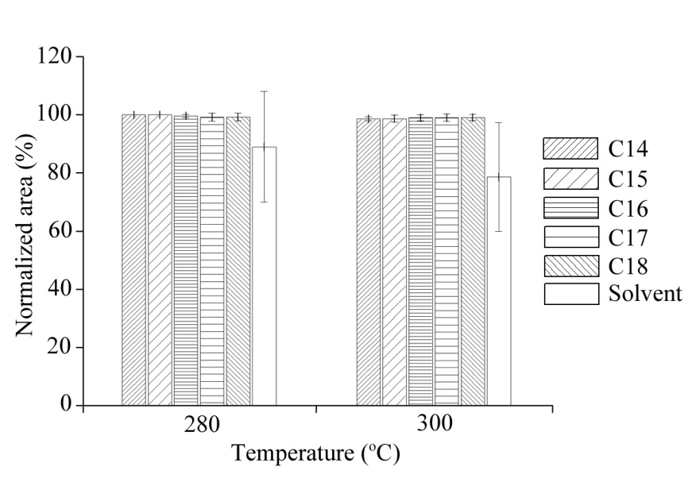

**Figure_4_Supp.** Relative area counts for five C chain categories in GRS617 observed of increasing solvent venting time. The error bars correspond to ±1 standard deviation (*n*= 3).



**Figure_5_Supp.** Ratio of area counts for five C chain categories in GRS617 as a function of increasing CIS heating rate. The error bars correspond to ±1 standard deviation (*n*= 3).



**Figure_6_Supp.** Relative area counts for five C chain categories of FAMEs in GRS617 (a) and forest soil sample (b) observed in different CIS injection mode. The error bars correspond to ±1 standard deviation (n= 3).



**a GRS617**



**b Forest soil sample**

**Figure_7_Supp.** Trapping recoveries of FAMEs from GRS617 (a) and forest soil sample (b) as a function of trapping temperature of the PFC. The recoveries have been corrected against the amount of the FAMEs directed to the FID. The error bars correspond to ±1 standard deviation (n= 3).

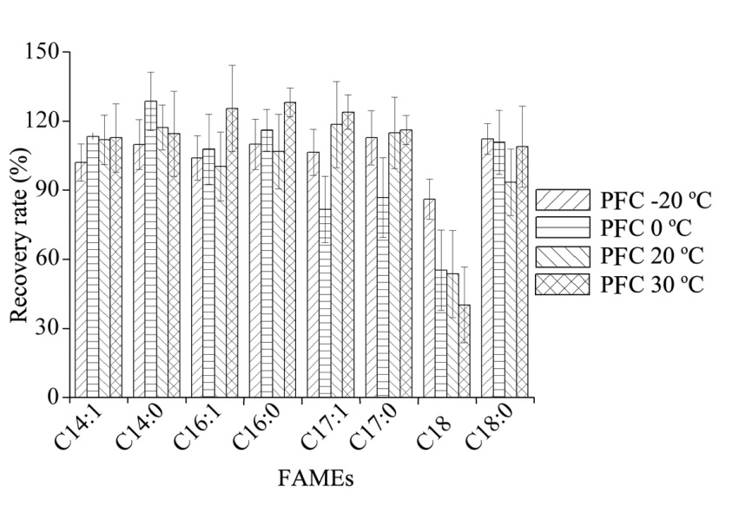

**a GRS617**

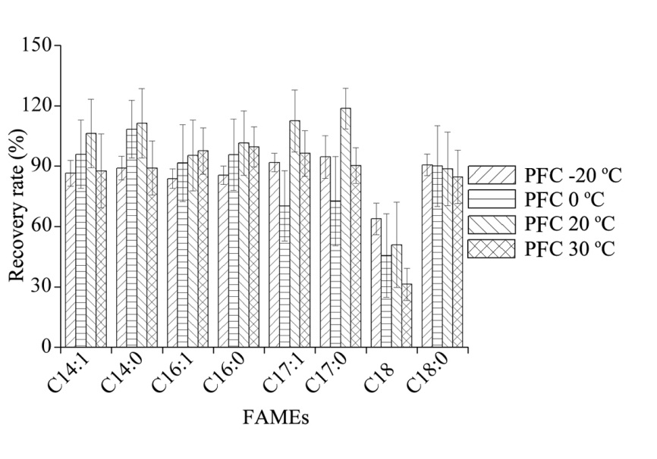

**b Forest soil sample**

**Figure_8_Supp.** GC-FID spectrograms under different injection volumes of forest soil sample.

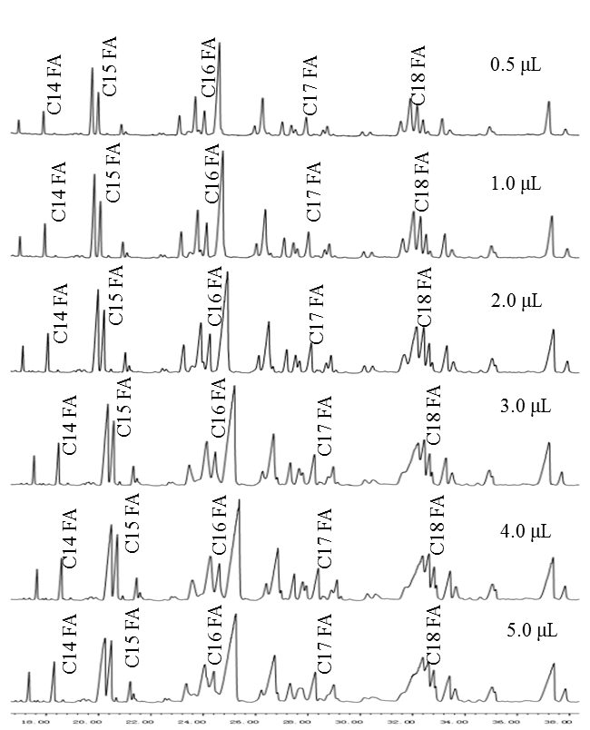

**Figure_9_Supp.** PCGC separation of the target compounds from forest soil sample.



**Figure_10_Supp.** 13C values of PLFAs on Gongga Mountaion

