Mini kit CO₂ sampling equipment
1. List of components
Component | Details | Number required | Operating temperature (deg C)*
CO₂ sensor | SprintIR®-W, 0-5% with flow through adaptor. Gas Sensing Solutions, Cumbernauld, UK | 1 | 0 to 50
Air pump | D220 BL, TCS micropumps Ltd, Faversham, UK | 1 | -20 to 100
Microcontroller | Arduino Nano | 1
Rocker switch | On/off | 2
Momentary Pushbutton switch |  | 1
Electrical connector | Wago cable connector (222-515; 5 channel) | 3
OLED display | 128X64 0.96" OLED I2C | 1
Zener Diode | 1N4953B | 1
Resistor | 10k-ohm | 1
Dupont cables
Electrical hook-up wire
Battery | 9v PP9 | 1 | -5 to 55
Tubing | Isoversinic, Saint Gobain, France |  | -20 to 200
Coupling | PMCD42-02, Colder Products Company, USA | 1
Coupling | PMCD16-02, Colder Products Company, USA | 1
*Based on manufacturer’s specifications

2. Electrical connections schematic
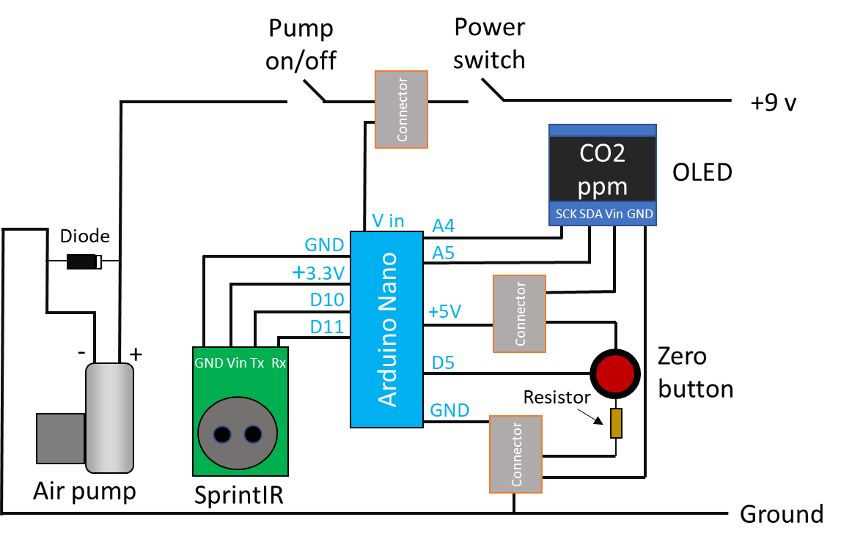
3. Tubing connections schematic
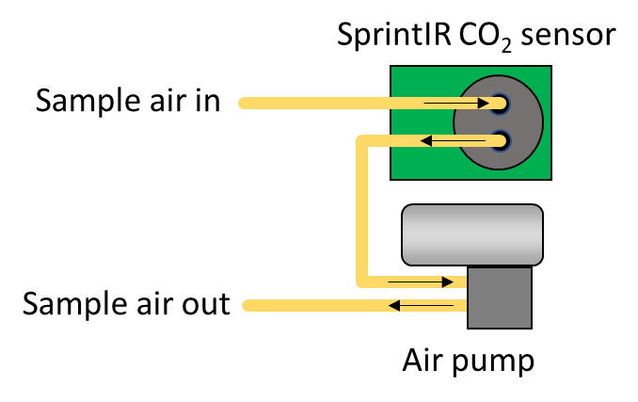
4. Arduino code

#include <SoftwareSerial.h>
SoftwareSerial portOne(10, 11); //TX = digital pin 10, RX = digital pin 11
#include <SPI.h>
#include <Wire.h>

/*
Universal 8bit Graphics Library, https://github.com/olikraus/u8glib/
Copyright (c) 2012, olikraus@gmail.com
All rights reserved.
Redistribution and use in source and binary forms, with or without modification,
are permitted provided that the following conditions are met:
* Redistributions of source code must retain the above copyright notice, this list
of conditions and the following disclaimer.
* Redistributions in binary form must reproduce the above copyright notice, this
list of conditions and the following disclaimer in the documentation and/or other
materials provided with the distribution.
THIS SOFTWARE IS PROVIDED BY THE COPYRIGHT HOLDERS AND
CONTRIBUTORS "AS IS" AND ANY EXPRESS OR IMPLIED WARRANTIES,
INCLUDING, BUT NOT LIMITED TO, THE IMPLIED WARRANTIES OF
MERCHANTABILITY AND FITNESS FOR A PARTICULAR PURPOSE ARE
DISCLAIMED. IN NO EVENT SHALL THE COPYRIGHT HOLDER OR
CONTRIBUTORS BE LIABLE FOR ANY DIRECT, INDIRECT, INCIDENTAL,
SPECIAL, EXEMPLARY, OR CONSEQUENTIAL DAMAGES (INCLUDING, BUT
NOT LIMITED TO, PROCUREMENT OF SUBSTITUTE GOODS OR SERVICES;
LOSS OF USE, DATA, OR PROFITS; OR BUSINESS INTERRUPTION) HOWEVER
CAUSED AND ON ANY THEORY OF LIABILITY, WHETHER IN CONTRACT,
STRICT LIABILITY, OR TORT (INCLUDING NEGLIGENCE OR OTHERWISE)
ARISING IN ANY WAY OUT OF THE USE OF THIS SOFTWARE, EVEN IF
ADVISED OF THE POSSIBILITY OF SUCH DAMAGE.
*/

#include "U8glib.h"
U8GLIB_SSD1306_128X64 u8g(U8G_I2C_OPT_NONE|U8G_I2C_OPT_DEV_0);
long timer = 0;
char string[6];
char inData[60];
int index;
int zeroPin = 5;
float CO2ppm = 0;
String sCO2ppm = "";
int zerotext = 0;

void setup()
{
Serial.begin(9600);
portOne.begin(9600);
portOne.flush();
pinMode(zeroPin, INPUT);
String setFilter = "A 16\r\n"; //set the digital filter on the SPRINT. Number: 1 is no filtering, 32 when factory-supplied.
portOne.println(setFilter);
timer = millis();
}

void loop()
{
if (millis() - timer > 500) {
zerotext = 0;
portOne.listen();
while (portOne.available() > 0) {
char inByte = portOne.read();
if (inByte == 'Z') {
index = 0;
sCO2ppm = "";
}
inData[index] = inByte;
index++;
}
sCO2ppm = " " + sCO2ppm + inData[2] + inData[3] + inData[4] + inData[5] + inData[6];
CO2ppm = sCO2ppm.toFloat();
CO2ppm = CO2ppm * 10;

Serial.println(CO2ppm, 0);
if (digitalRead(zeroPin) == HIGH) {
String sendcalib = "U\r\n";
portOne.println(sendcalib);
zerotext = 1;
}
u8g.firstPage();
do {
draw();
} while ( u8g.nextPage() );
timer = millis();
}
}

void draw(void) {
u8g.setFont(u8g_font_fur11);
u8g.setPrintPos(0, 12);
u8g.print("CO2 ppm: ");
if (zerotext == 1) {
u8g.setPrintPos(64, 60);
u8g.print("zeroing");
}
u8g.setFont(u8g_font_fur20);
u8g.setPrintPos(20, 44);
u8g.print(CO2ppm, 0);
}

5. Sampling procedures
Atmospheric CO₂ sampling: Sample air is first pumped through the Mini-kit and out to atmosphere via the soda lime trap to remove traces of the previous sample. Clips (red bars) are then removed from the molecular sieve cartridge and placed on the soda lime cartridge (as shown below) to force the air flow through the molecular sieve. Sampling is performed until 3 to 10 ml of CO₂ has been trapped on the molecular sieve (the sieve will trap 100 % of the CO₂ until a volume of ca. 10 ml has been collected, and therefore the sampling time is determined from the flow rate (450 ml/min) and CO₂ concentration of the air being sampled). An air filter at the gas inlet can be used to prevent particles entering the magnesium perchlorate cartridge.
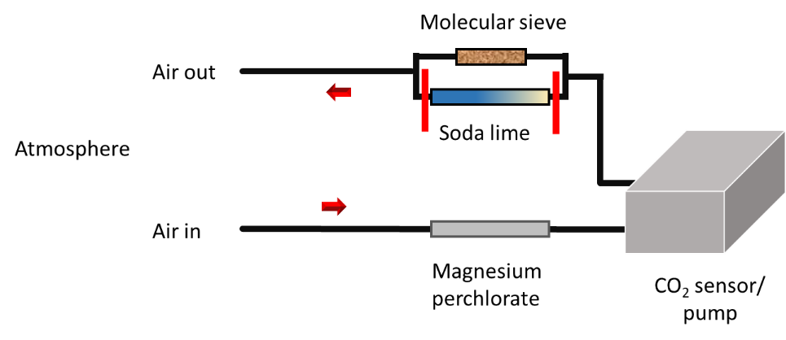
Closed chamber sampling: First, atmospheric CO₂ is removed from the chamber to prevent it from contaminating the sample. This is done using the setup below by pumping the chamber air through the soda lime cartridge and back to the chamber in a closed loop until the CO₂ sensor indicates no CO₂ remains. Clips are retained on the molecular sieve cartridge and no clips are present on the soda lime cartridge.

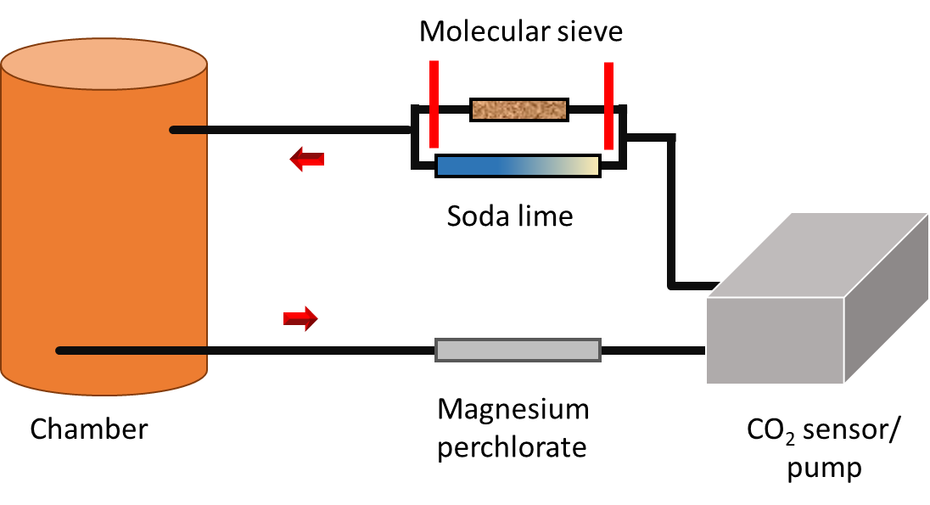

The chamber is then left to accumulate CO₂ (the Mini kit can be disconnected and used on another chamber if required). When sufficient (> 3 ml) CO₂ has accumulated, the chamber air is pumped through a molecular sieve cartridge. The closed loop is used again, but this time the clips on the molecular sieve trap are removed and placed on the soda lime cartridge before starting the pump. The amount of CO₂ trapped on the molecular sieve can be estimated from the volume of the chamber and the decrease in CO₂ concentration during sampling (i.e. the difference represents the amount of CO₂ trapped).

