Do weak or strong acids remove carbonate contamination from ancient tooth enamel more effectively? The effect of acid pretreatment on radiocarbon and δ¹³C analyses

Supplementary Online Material

Rachel Wood^{1, 2}, Andre Barros Fleury^{2, 3}, Stewart Fallon¹, Nguyen Thi Mai Huong⁴, Nguyen Anh Tuan⁴

^{1.} Research School of Earth Sciences, Australian National University, Acton, 2603, Australia
^{2.} School of Archaeology and Anthropology, Australian National University, Acton, 2603, Australia
^{3.} Curio Projects Pty Ltd, 17 Thurlow Street, Redfern, 2016, Australia
^{4.} Anthropological and Palaeoenvironmental Department, The Institute of Archaeology of Vietnam, Hanoi, Vietnam

- Samples

Table SOM 1; Contextual information for pig teeth from Lo Gach used in this study (Piper personal communication 2019). Within trench 1, samples are ordered from deepest to shallowest. LGa786 from trench 2 is probably of a similar age to LGa921 and 923.

Sample name | Context
LGa786 | 14LGa: c.203/1 (trench 2). Dark yellowish brown sandy loam consisting of a mixture of sediment, charcoal and cultural remains (pottery and animal bone).
LGa921 | 14LGa: c.105 (trench 1). Dark brown sand deposit that underlay all other cultural deposits in Trench 1. This is effectively a natural deposit into which settlement debris had been dumped, prior to development of cultural deposits over the top. This deposit was partially underwater when the river adjacent river was high.
LGa923 | 14LGa: F1-140 (trench 1). A deliberately laid surface probably constructed using sand and shell lime mortar.
LGa932 | 14LGa: F1-126 (trench 1). Very dark greyish brown loamy sand containing huge quantities of silicified rice husks.
LGa935 | 14LGa: F1-17 (trench 1). Loose brown sandy loam was restricted to the northwest corner of Trench 1. This appears to represent a layer of detritus that had built up on an underlying, deliberately laid floor surface.

2. Radiocarbon dating

2.1 Radiocarbon background correction

An additional combustion step was introduced to remove gases evolved from enamel during reaction with phosphoric acid, as the iron catalyst was often poisoned during graphitization. To measure the method radiocarbon background, 12 samples of IAEA-C1 (Carrara Marble), leached in 0.1 M HCl to remove 10% of the starting weight, was acidified and combusted between June 2017 and February 2019 as described in section 2.3.

F¹⁴C against inverse carbon yield is positively correlated (r = 0.8, n = 12, t = 4.2, p < 0.05), and so a sample size dependent background is made for all samples combusted in this way using a least squares regression line (Equation SOM 1, Figure SOM 1). The standard deviation of the population of the residuals (0.000724 at 1 σ) is used as the uncertainty term.

$y= 0.000529 × \left(\frac{1}{ C (mg)}\right)+0.00223$ (Equation 1)

Figure SOM 1; Radiocarbon dates on IAEA-C1 after reaction with phosphoric acid and heating over CuO wire and Ag foil. The least squares regression (solid line) and 1 σ uncertainty (dashed line) is marked on the plot. Uncertainty on each measurement is also plotted at 1 σ.
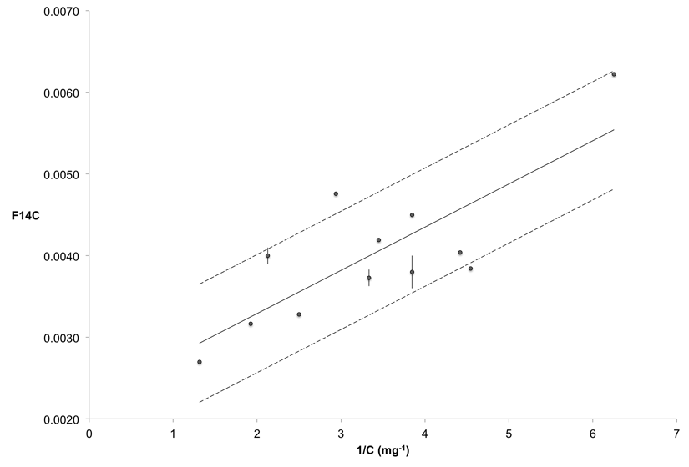

2. 2 Adsorption of atmospheric carbon dioxide to small particles

To test whether a significant amount of atmospheric CO₂ was adsorbed after acid cleaning of enamel, the hand ground and micronized fractions of sample DU798, treated after 20 hours reaction with acetic acid (pretreatment protocol 3), were dated in the following ways:
- No exposure: The cleaned enamel was not exposed to atmosphere. After cleaning, a fraction of sample was removed as a slurry, placed into a VacutainerTM, immediately frozen in a dry ice – ethanol slurry, and evacuated to less than 3x10⁻³ Torr before reaction with phosphoric acid according to the normal protocol.
- Routine exposure: The freeze-dried cleaned enamel was exposed to air for 1 hour whilst weighing before the Vacutainer was evacuated to less than 3x10⁻³ Torr, as typical in the laboratory.
- Long exposure: The freeze-dried cleaned enamel was left in a test tube loosely covered with aluminum foil for 21 days.

As previously found (Wood et al. 2016), the hand ground samples produced younger ages than the micronized samples because contaminants from the burial environment were not removed as efficiently as from the micronized samples (Table SOM 2). However, there was no significant change with increased exposure to atmosphere within each grain size (micronized samples Χ², df 2, T=4.2, 5%=6.0; hand ground samples df 2, T= 2.0, 5%=6.0). Whilst unlikely to affect dates of <30 kBP, atmospheric adsorption could still be a problem when older dates are considered due to increased sensitivity to smaller amounts of modern carbon. Therefore, all cleaned samples were exposed to air for less than one hour.

Table SOM 2; Effect of exposure to atmospheric CO₂ on tooth enamel from DU798 after an acetic acid leach
Grinding | Atmospheric exposure | % yield | S-ANU# | F¹⁴C | ¹⁴C age (BP)
Handground | A. None | NA | 54306 | 0.0860 ± 0.0013 | 19710 ± 130
Handground | B. Routine (1 hour) | 74.6 | 54307 | 0.0842 ± 0.0012 | 19879 ± 123
Handground | C. Long (21 days) | 74.4 | 54309 | 0.0832 ± 0.0014 | 19978 ± 143
Micronised | A. None | NA | 54310 | 0.0362 ± 0.0011 | 26657 ± 245
Micronised | B. Routine (1 hour) | 68.4 | 54311 | 0.0359 ± 0.0011 | 26725 ± 246
Micronised | C. Long (21 days) | 68.0 | 54312 | 0.0390 ± 0.0012 | 26068 ± 248

3. FTIR

3.1 FTIR Methods

1-1.5 mg of sample was mixed with 200-300 mg dry KBr and pressed into pellets under vacuum. The average of 100 transmission spectra were recorded on a Bruker Tensor 27 at the Research School of Earth Sciences at the ANU between -400 – -4000 cm⁻¹, at a resolution of 4 cm⁻¹, and a concave rubber band correction with 64 baseline points was applied in the OPUS software. Indexes of bioapatite were calculated according to Table SOM 3.

To reduce the uncertainty introduced by variable grinding during sample preparation, a ‘grinding curve’ can be plotted for the untreated handground samples (Asscher et al. 2011b). To construct a grinding curve, the KBr pellet was reground and the spectra recorded at least 5 times. Each index is then plotted against the full width at half maximum (FWHM) of the 1035 cm⁻¹ peak. To compare between teeth, the index value at a FWHM of 110 cm⁻¹ has been calculated by regression. Whilst IRSF and API are related to grain size and a grinding curve has been constructed, BPI is not related to FWHM and an average has been calculated. The method could not be applied to the micronized samples as grain sizes were too small.

Table SOM 3: FTIR indexes of bioapatite used in this study. “B” refers to height of the band, and “V” the valley. Numbers provide approximate wavenumbers (cm⁻¹) of the band.

Index | Formula | Reference
IRSF (InfraRed Splitting Factor). Also known as PCI (Phosphate Crystallinity Index) or CI_{IR} (Crystallinity Index, Infra Red) | $$\frac{B\left(605\right)+ B(565)}{V(590)}$$ | (Termine and Posner 1966; Weiner and Bar-Yosef 1990)
BPI (B-carbonate on Phosphate Index) | $$\frac{B(1415)}{B(605)}$$ | (LeGeros 1991)
API (A-carbonate on Phosphate Index) | $$\frac{B(1545)}{B(605)}$$ | (Sponheimer and Lee-Thorp 1999)

3.2 FTIR Results

Figure SOM 2: The effect of the type of acid used in pretreatment on the FTIR indices a - c) IRSF, d - f) BPI, g - i) API and j - l) API/BPI with different leaching protocols for teeth from Duoi U’Oi (a, d, g, j), Lo Gach (b, e, h, k) and modern teeth (c, f, i, l). 0 represents no treatment, 1. Hydrochloric acid, 2. Lactic acid, 3. Acetic acid, 4. Propionic acid and 5. Acetic acid and EDTA.
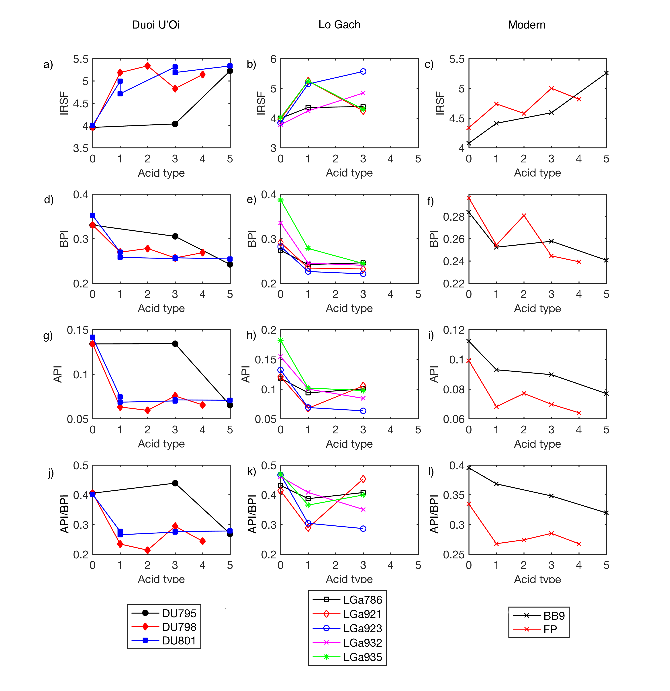

Figure SOM 3; Comparison of the FTIR indicies a - b) IRSF, c - d) BPI, e - f) API and g - h) API/BPI with F¹⁴C for teeth from Duoi U’Oi (a, c, e, g) and Lo Gach (b, d, f, h). Please refer to Figure SOM 2 for a legend.

