SUPPLEMENTAL MATERIALS

BERING STRAIT LOCATIONS AND CONTEXTS OF SAMPLES

This section provides information on the archaeological sites and context of the samples that were radiocarbon dated in the study. In addition, we provide a summary of the modern seal skulls used in the study. An excel file in the Supplemental Materials provides data in each radiocarbon sample and assay.

Cape Krusenstern
Cape Krusenstern is a large beach ridge site complex located on the northwest shore of Kotzebue Sound. The beach ridge complex is within the larger Cape Krusenstern National Historic Landmark and Archaeological District (NOA-00042), which encompasses the entire Cape Krusenstern National Monument. The beach ridge complex itself (NOA-00002) consists of hundreds of sites. We collected paired samples from six sites and 11 features. Detailed site and project descriptions can be found in Freeburg and Anderson (2012; See also Anderson and Freeburg 2013, 2014; Anderson et al. 2018; Giddings and Anderson 1986). Below is a summary of the sites and features sampled for the current project.

NOA-00463
This is a large, multi-component site located in the southeast area of the beach ridge complex, on a recent beach ridge. The site consists of 17 house features, 34 cultural features (e.g., activity areas, possible houses), 51 cache pits, and several surface features and artifacts. We excavated shovel tests and test units across the site, and obtained eight radiocarbon dates from five features within the site including paired samples from House 4A. Dates for the site range from modern to approximately 900 radiocarbon years.

HOUSE 4A OF 2XH071608A
House 4A is located approximately 17 m west of House 3A, on the same beach ridge formation. House 4A is a small single room house; the main room measures approximately 4 x 4.5 m, and the tunnel is approximately 6 m long. We excavated Test Unit 1723B, a 1 by 1 m test, near the exterior entrance to the tunnel (Figure S1). Cultural materials recovered during testing included faunal remains (including fish bone), worked wooden objects, structural wood, three blue glass beads, and a metal object. The paired samples were collected several levels above the probable floor, or occupation surface, of the feature (in Level 7). Beta-13536 was collected in Level 3, in the same level that we also identified structural wood and a large whale rib that may have been used in house construction. We collected Beta-13535 in Level 6, approximately 30 cm below Beta-13536; we also recovered fauna, worked wood, and a possible lithic in the same level.

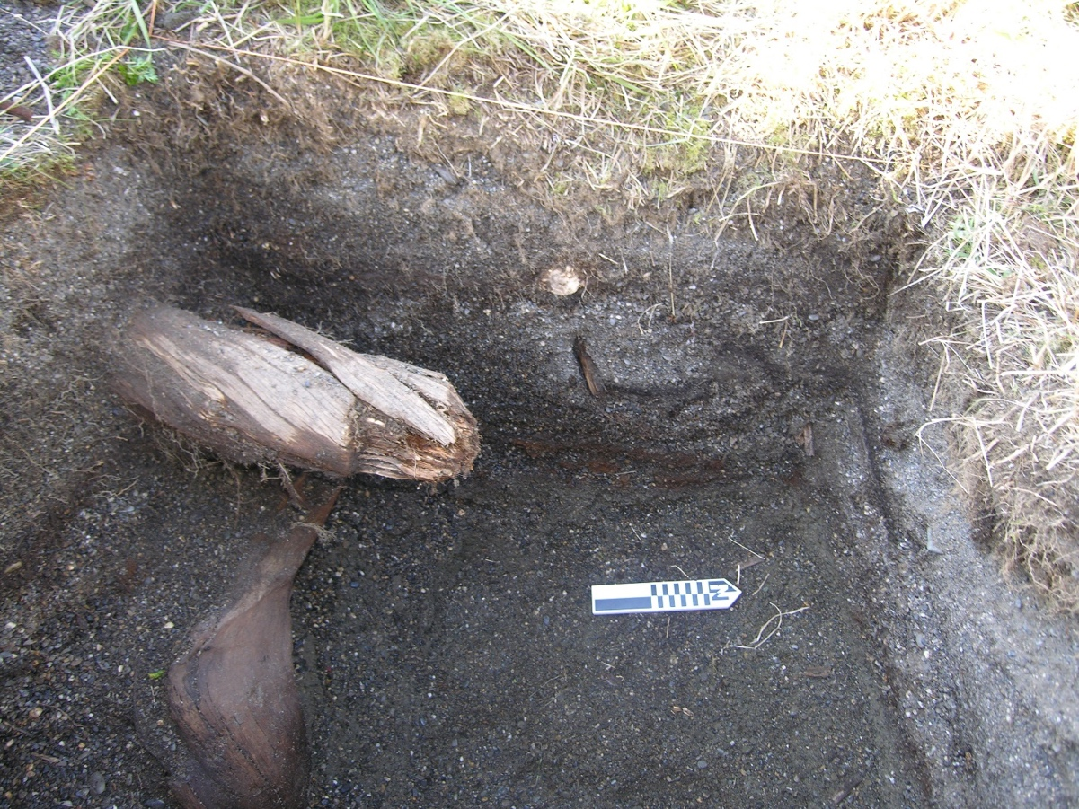
Figure S1. West wall profile of Test Unit 1723B (Photo by Nick Radko).

NOA-00473 (Early Western Thule Type Site)
The Early Western Thule Site (NOA-00473) was originally recorded and excavated by Giddings and Anderson (1986). We resurveyed and tested the site between 2008 and 2011, documenting seven houses, 52 associated cache pits, and nine other cultural features that may be associated activity areas (Figure S4). The site was originally interpreted on the basis of artifact styles and radiocarbon dates as dating to around AD 1000 (~870 cal BP); investigators later concluded that houses labeled 4,5, and 6 by Giddings and Anderson (1986) are more recent, dating to the late 13th century (Freeburg and Anderson 2012:101; Giddings and Anderson 1986:71). Additional dating of features from the site yielded a range of ages from approximately 1230 BP (1080–1240 cal BP, or cal AD 710–870) to the late pre-contact era, indicating that the location was occupied continuously for hundreds of years (Freeburg and Anderson 2012:101-102). Paired radiocarbon samples were collected from a 1 x 1 m test unit excavated in a cache pit (CACHE PIT 1A, Test ID 458A) located on the same ridge as Houses 4 and 5 (Figures S2, S3, and S4). OS-81578 was collected from Level 3, approximately 30-40 cm bs (below surface), in a layer of alternating loose and compact sandy beach gravels; minimal faunal material, a flake, and wood were noted in this layer, which is likely a post-use fill. Beta-326113 was collected from Level 4, approximately 40-50 cm bs, and was found in association with several wooden structural elements that may have formed the sides near the bottom of the cache pit. Faunal material and wood were recovered from Level 4.

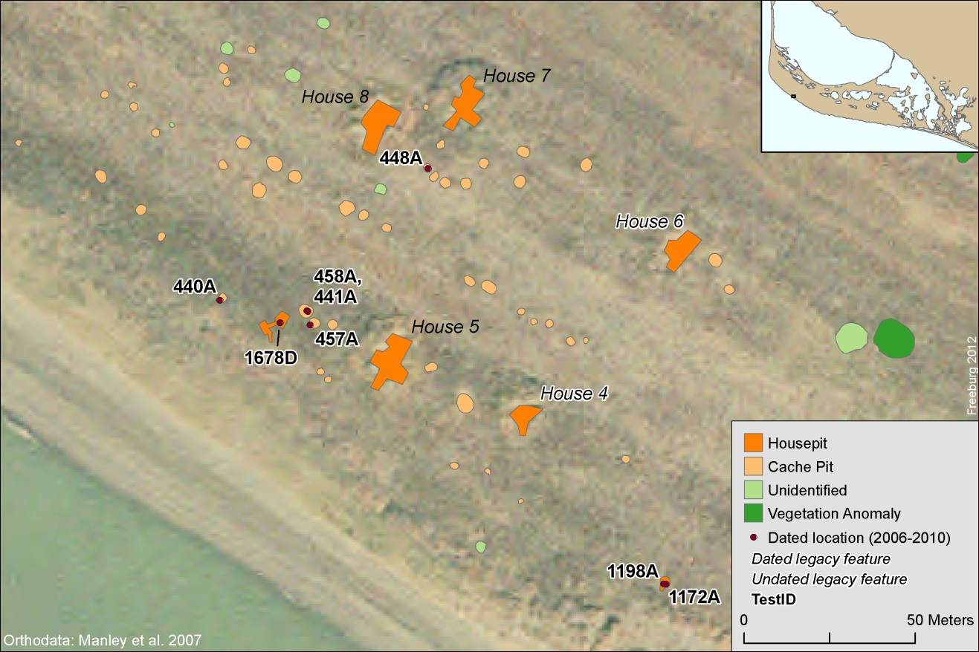
Figure S2. Newly dated features in the Early Western Thule settlement (Freeburg and Anderson 2012); paired samples are from Cache Pit labeled 458A.

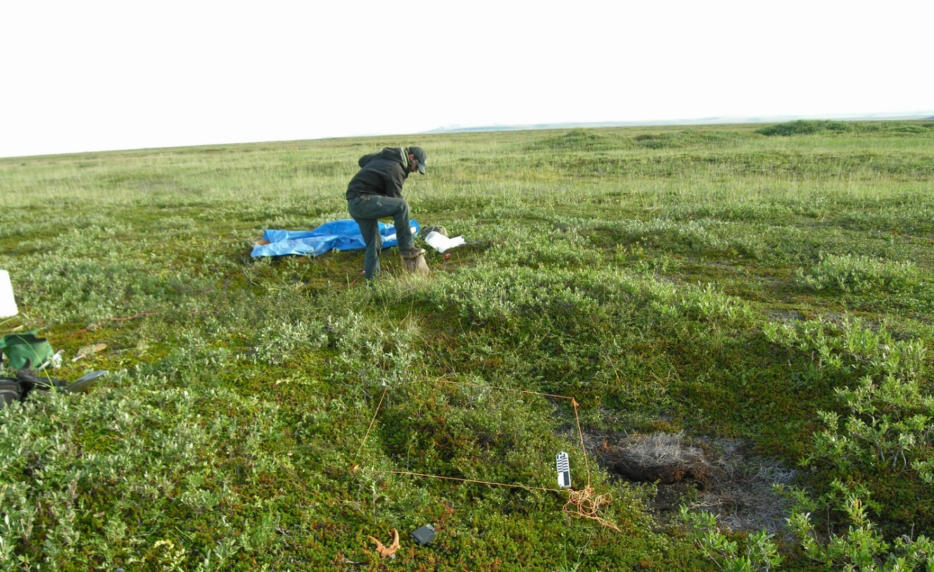
Figure S3. Test Unit 458A in background (during excavation). Note associated cache pit in foreground. View to the north (Photo by Shelby Anderson).

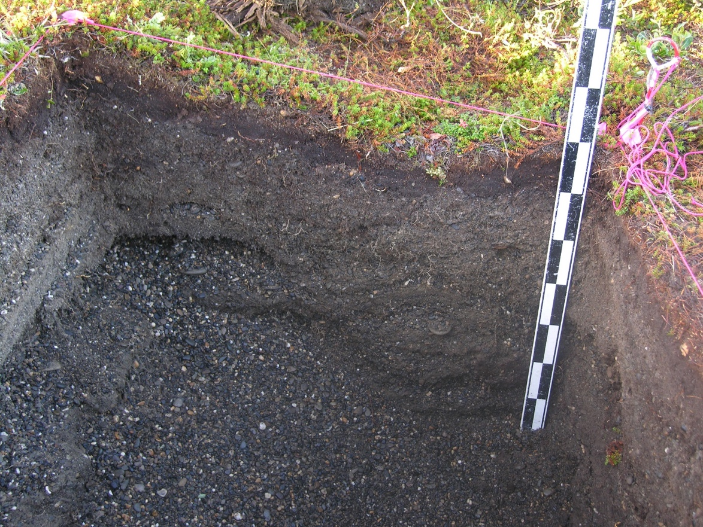
Figure S4. Test ID 458A south wall profile (Photo by Adam Freeburg).

NOA-00474
NOA-00474 consists of one single-roomed semi-subterranean house, two associated cache pits, and an additional feature (Unidentified 1B of 10PROXH062509A) that could be a small house or an activity area associated with occupation of a nearby house (Figure S5). Both paired samples, Beta-326114 and Beta-326119, were collected at 16-42 cm bs during shovel test excavation within Unidentified Feature 1B (10PROXH062509A). Shovel testing identified fractured limestone under the sod layer, and a bone deposit from 16-32 cm bs.

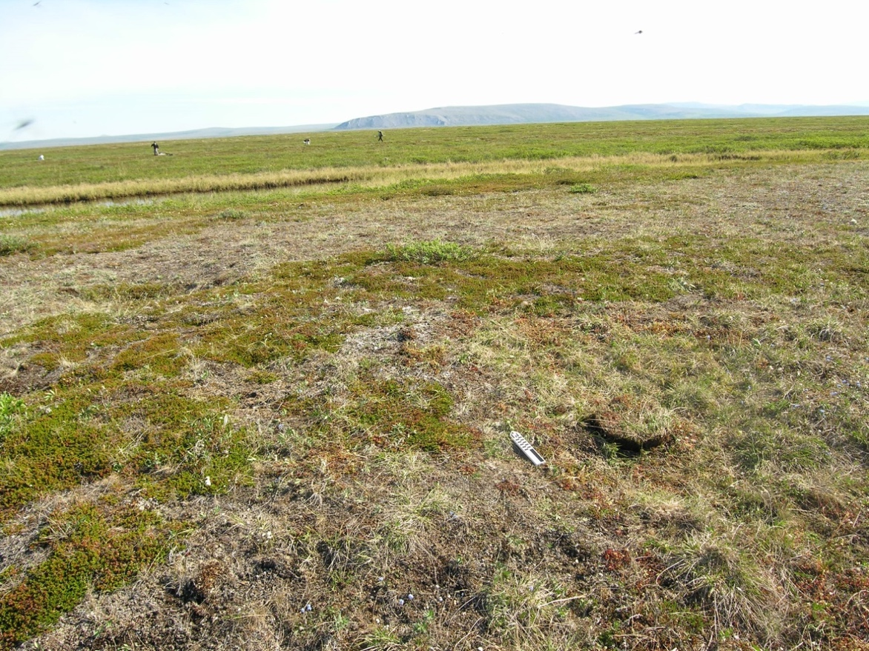
Figure S5. Unidentified 1B with capped shovel test in foreground. Cache pits 1B and 2B are beyond the tested feature. View to the northeast (Photo by Josh Dinwiddie).

NOA-00513
Site NOA-00513 is an extensive site, containing 45 house features, 100 cache pits, 11 surface scatters, and one feature of unknown origins. The site crosses multiple beach ridges and occupation of the site area spanned over 1000 years. Paired samples were recovered from four different features within the site, an activity area (Activity Area 361XH070108A) and three houses (House 2 31XH070508A, House 4 111XH070508A, and House 10 41XH062708A).

Activity Area 361XH070108A
Paired samples Beta-326105 and Beta-223220 were collected during shovel testing of an apparent activity area. Both samples were collected 15 cm bs; a flaked stone uniface and two flakes were also identified during testing.

House 2 of 1XH070508A
Paired samples Beta-326106 and Beta-226149 were collected during shovel testing of House Feature 2 (1XH070508A). The house was a single rectangular room with a short tunnel. Fire cracked rock, wood, charcoal, and bone were all noted during shovel testing.

HOUSE 4 111XH070508A
Paired samples Beta-326107 and Beta-226151 were collected during shovel testing of a single, rectangular, roomed house with a tunnel. Wood, charcoal, and bone were noted during testing.

HOUSE 10 41XH062708A
Paired samples Beta-326109 and Beta-223219 were collected during shovel testing of a single roomed house with a tunnel, originally recorded by Giddings (Giddings and Anderson 1986) as House 81. The shovel test was placed at the center of the house.

NOA-00538
NOA-00538 is another large site, containing eight house features, seven cache pits, 35 unidentified features, four hearths, three surface artifact scatters, 21 individual surface artifacts, and four surface faunal specimens. We excavated 26 shovel test pits across the site, identifying subsurface material at various locales. Occupation of the site dates to approximately the last 2000 years. Paired samples Beta-326108 and Beta-226154 were collected from a house feature within the site, House 2 of 24PROXH1070808A. The house was one room, with no tunnel, and was thought originally to be an Ipiutak house based on the house appearance and location within the beach ridge complex. Shovel testing yielded seal bone and charcoal.

NOA-00558
NOA-00558 is a large site, extending approximately 800 m along a series of WNW-ESE- trending beach ridges. The site consists of six house pits, 26 cache pits, 126 unidentified features, four isolated surface artifacts, and six surface faunal specimens (AHRS site form). We excavated 72 shovel test pits across the site area, which identified subsurface cultural materials in some locales. Paired samples were obtained from three features within the site, a house (HOUSE 1A OF 10GEOXH063008A) and two indeterminate feature (UNIDENTIFIED 7B OF 10PROXH070308A, 1177A and UNIDENTIFIED 3B of 10PROXH070509A, 1195A) (Figures S6, S7, and S8). Occupation of the site spans 1500 years.

Samples from House 1A (10GEOXH063008A) were collected during excavation of a 1 x 1 m test unit (5437B). Paired samples Beta-326115 and Beta-326116 were collected from Level 5 of the feature, in midden or fill deposits. Ground slate, bone, ceramic, and charcoal materials were recovered from the same level.

Samples from Unidentified 7B (10PROXH070308A) were also collection of a 1 x 1 m test unit (1177A). Paired samples Beta-326117 and Beta-326120 were collected from Level 4 of the feature, which consisted of midden or fill deposits. Wood, bone, ceramic, and lithic materials were recovered from the same level.

Samples from Unidentified 3B (10PROXH070509A) were collected during excavation of a 1 x 1 m test unit (1195A). Sample OS-93940 was collected from Level 2, 28 cm below datum (bd); level two cultural material included charcoal, decomposing wood, and fauna (including calcined bone). This was most likely fill material that would not, necessarily, date to the occupation or use of the feature. Samples Beta-326118 and OS-96756 were collected from Level 4, at 47 cm bd from a midden deposit that contained calcined bone, charcoal, seal oil soaked sediment, fire cracked rock, and several lithic flakes.

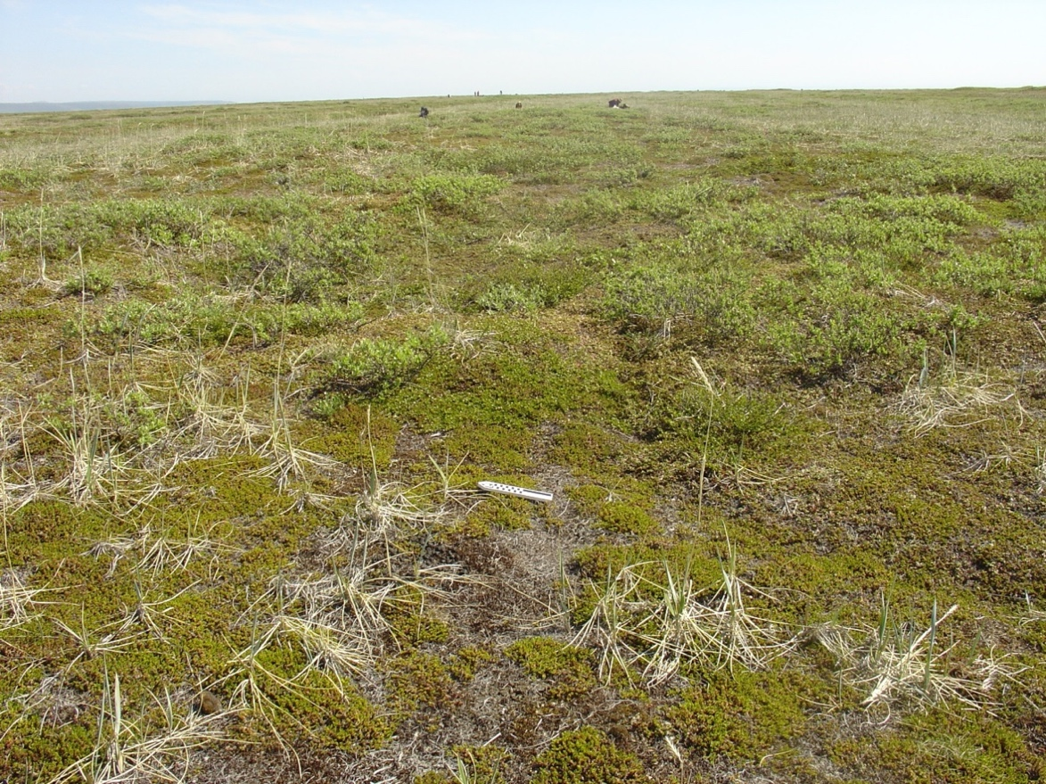
Figure S6. House 1A of 10GEOXH063008A overview to the east (Photo by Amy Thompson).

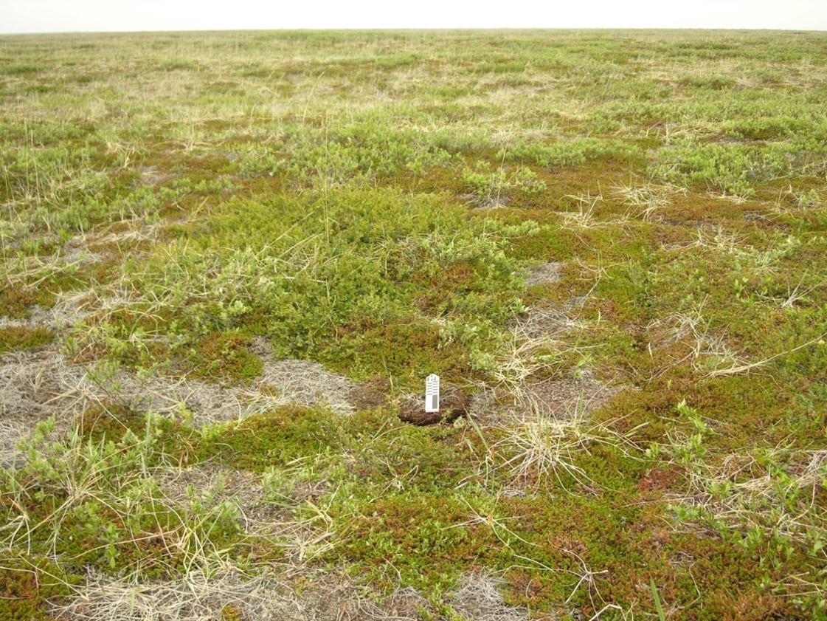
Figure S7. Unidentified 7B of 10PROXH070308A feature, view to the north. Shovel test location under north arrow, near center of depression (Photo by Josh Diles).

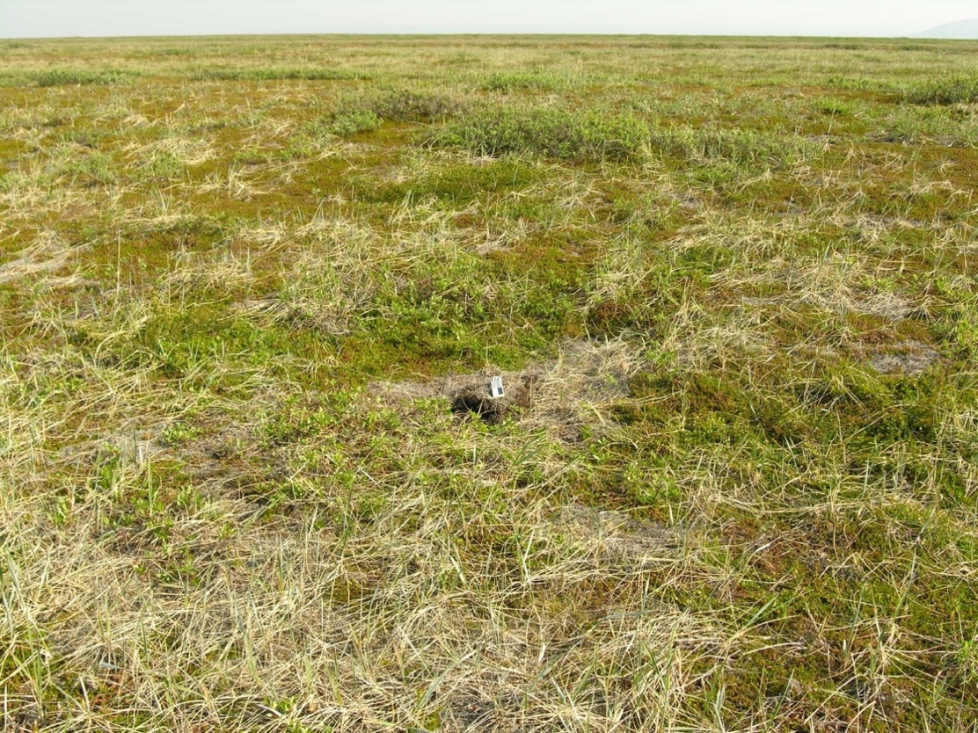
Figure S8. Unidentified 3B of 10PROXH070509A feature, view to the north. Shovel test location visible under north arrow, near center of depression (Photo by Josh Diles).

Cape Espenberg
Cape Espenberg comprises a shore-parallel series of over 20 low sand dunes atop a prograding mainland attached spit at the northern limit of the Seward Peninsula, at the southern entrance to Kotzebue Sound (Figure S9). Cape Espenberg lies within the Bering Land Bridge National Park and Preserve. The dune complex includes hundreds of archaeological sites, including surface scatters over 4,000 to 2,000 years old and concentrations of house depressions and cache pits that preserve collapsed driftwood houses generally less than 1,000 years old. Cape Espenberg was briefly surveyed by J. Louis Giddings in 1960, as described in Giddings and Anderson (1986) and in the late–1980s by the National Park Service (NPS), directed by Schaaf et al. (1988). The geomorphic history of the dune field was the subject of a Ph.D. by Mason (1990), with supplemental research reported in various publications (Mason et al. 1995, 1997; Mason and Jordan 1993, 1997; Mason et al. 2019). The Espenberg spit was constructed during four depositional regimes, two dominated by progradation, I and III, two by erosion, II and IV. Excavations for preliminary assessment were conducted by Harritt (1994) for the NPS. More extensive excavations were completed at six houses in three sites by Hoffecker and Mason (2009–2011) and Alix and Mason (2017, 2018) under the auspices of the National Science Foundation. A database of over 150 radiocarbon samples constrains both archaeological and geological chronologies.

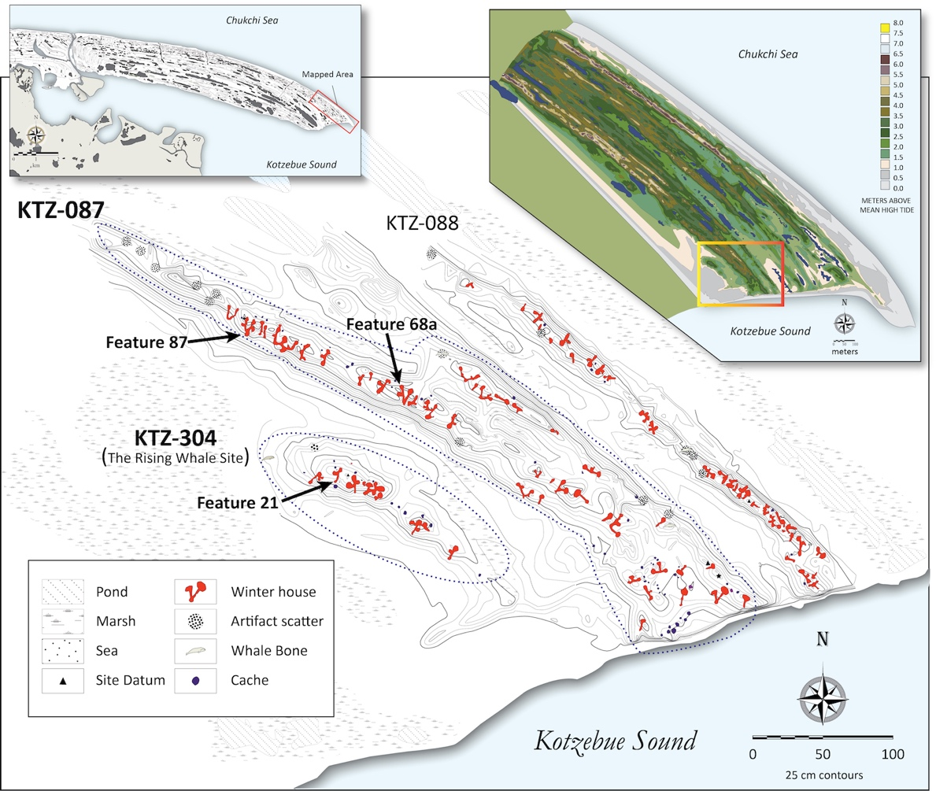
Figure S9. The Cape Espenberg spit; the tip of the spit mapped in 2010 showing the beach ridge topography; and the excavated house features where radiocarbon samples were selected: KTZ-087, features 87 and 68A; KTZ-304, Feature 21 (figure by John Darwent, modified from Darwent et al. 2013).

KTZ-00087
KTZ-00087 is one of the largest sites on the Cape Espenberg spit, extending northwest to southeast across 500 m of the E-5a and b dune ridges (Figure S9). The geomorphic history of the E-5a, 5b dune ridges is established from cut bank exposures at the eastern margin of the ridge, constrained by a dozen samples on a variety of materials including driftwood, shell and plant macrofossils. Previous National Park Service research (Schaaf 1988:255ff; Harritt 1994:84) mapped only a small portion of the site (<10%), only 50 m from its eroding southeast margin. The site extends “across hundreds of meters” on two dune ridges, not the single ridge described in Schaaf (1988b:255). Based on surface topography, KTZ-00087 includes thirty-nine, likely, multi-room house depressions, nine ceramic, bone and/or lithic scatters, and, at a minimum, 48 features defined as cache pits (Hoffecker and Mason 2010: Appendix A, Table 2). The features occur within several spatially discrete areas, which may reflect prehistoric settlement patterns or demographic history (Darwent et al. 2013). Cache pits occur mostly in two of the blocks, at both ends of the site.

FEATURE 87
Feature 87 [=Feature 30 of Harritt 1994] was selected for excavation in 2009 by the NSF funded Human Response to Cultural Change at Cape Espenberg project headed by John F. Hoffecker and Owen K. Mason, based on its inferred large size and the presence of whale bones (two mandibles and a scapula) on the surface, limited testing in 1988 and a radiocarbon assay produced a mid to late 13th century age assignment (Beta-28011, 730±90 BP, 540–900 cal BP, or cal AD 1050–1410), a date incorrectly reported by Harritt (1994:105-109) in his Table A-1.1, from “Feature 61,” from KTZ-087, and referenced in his appendix (Harritt 1994:300) as Feature 30 within KTZ-087 but in the text as on KTZ-088 (Harritt 1994: 105ff). Mapping in 2007 (see Darwent et al. 2013) established the correct location for Feature 87, correcting the mis-location as Feature 30 in Harritt (1994:96, 105ff), associated with the nearby site KTZ-088 on the E-4 dune, that followed Schaaf’s original error (1988b:261). The house was originally considered a possible “Birnirk” house by Schaaf (1988b:261), based on curvilinear decorated potsherds from the surface, and referred to as the “looted house” due to several small pits adjacent the house depression. Two whale mandibles served as likely monumental uprights in the rear room, which after excavation was found to be related with an upper occupation not associated with the principal occupation at depth. Feature 87 was 350 m northwest of site datum, about half the distance inferred by Harritt (1994:96), who possibly employed the datum of KTZ-088 on the E-4 dune ridge. The extent of looting proved insignificant, established in the large scale excavation in 2009 and 2011; the latter directed by Max Friesen, the subject of a Ph.D. dissertation at the University of Toronto (Norman 2015) and several articles on site structure, taphonomy and archaeofauna (Norman 2018a, 2018b; Norman et al. 2017).

Feature 87 consists of a well-preserved driftwood house with vertical walls and both back and side benches within a large room in its north end (Figure S10). An eight-meter long entry extends to the south and terminates in an extensive midden. A charred area at the southeast was most likely connected to the entrance tunnel but a lack of clear architectural evidence is due to the location of a 2 x 1 m test trench placed by Harritt in the 1980s at a possible connection between the kitchen and the tunnel. However, the kitchen may connect directly with the rear room (Norman et al. 2017). A large inventory, including 154,000 bones and over 4000 artifacts of ceramic, stone, bone and wood was recovered mostly in 2011. Diagnostic harpoon heads place the occupation in Early Thule (not Birnirk) and includes the Sicco, Nunagiak and Kilimatavik types (following Ford 1959) and related multi-barbed types. The extensive archaeofauna was dominated by ringed seal. Slat armor was recovered within the structure, as well as a polar bear bone dagger in the midden (Brown et al. 2013).

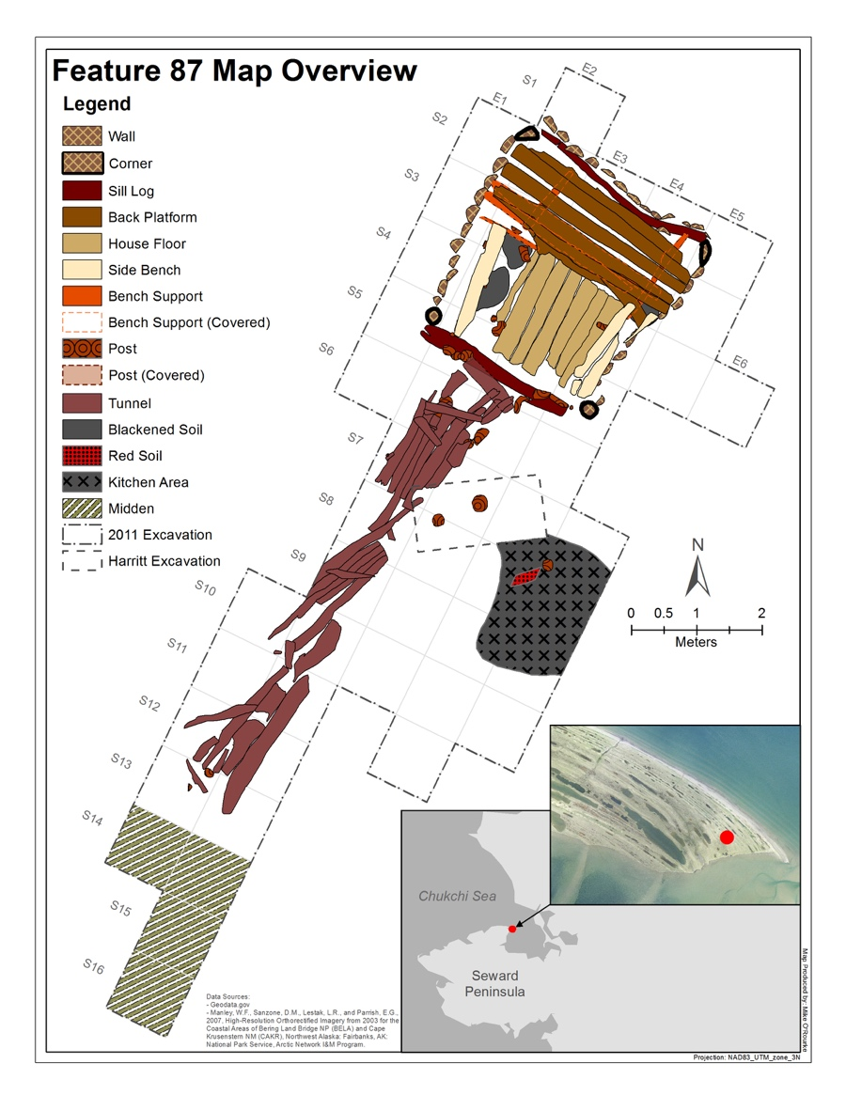
Figure S10. Planview map of KTZ-087, Feature 87 (figure by Lauren Norman, modified from Norman et al. 2017).

Ten radiocarbon ages, 9 terrestrial and one marine-derived materials, were obtained from Feature 87. Six ages were run on caribou bones, two on structural pieces of wood (Picea spp.), one on charcoal, and one on a seal bone. The context of the dates within the house and midden, and other associated features and fill, is equivocal since as Norman (2018a) concluded: “the fill is a palimpsest of multiple occupations, some possibly related to the house occupation.” The terrestrial ages range over a century and a half among the mean calibrated values, even though their age ranges overlap at 2-standard deviations when calibrated (Norman et al. 2017). In general, the midden ages and one structural wood age were the oldest, although a second structural wood member yielded the youngest of all of the Feature 87 ages. The paired seal and caribou samples (AA97492, AA97492, respectively) used in this study were from bulk samples of post-depositional fill in the same excavation unit (4S 1E) between 50 and 60 cm bd, above the occupation floor (Table S1). One was from an end-ring sample (OS-96130) from wood forming the rear platform, from a nearby square (2S 3E) where the paired caribou and seal samples were recovered, was also used in this study. AA97492 and OS-96130 are statistically similar and were combined into an average age for a terrestrial age for Feature 87 to compare to the age on the paired radiocarbon age on a seal bone (Table S2).

FEATURE 68A
Feature 68A was located ca. 30 m east of Feature 87 and excavated under the direction of C (Figure S11). Darwent in 2010. Feature 68A, the remains of a driftwood frame structure (Figure S13), is comprised of a partially excavated small room 9 m² with a 5.5 m long south-facing entry; floor boards preserved in the room and rear platform boards were at right angle to each other, with rear platform and back wall not fully excavated (see Darwent et al. 2013:Supplemental Figure 12). The long entrance tunnel wall was made of regularly spaced uprights posts maintained at their base by cross pieces and buttressing stacked horizontal wall logs. Slat armor and a fletched arrow shaft were recovered in the entryway to the back room. Of further interest, social interaction was revealed by the find of a native copper needle (Cooper et al. 2016), and amber beads.

Within Feature 68A, excavations within a 26 m² block produced 1890 artifacts, the overwhelming majority were chert flaking (n=986) or wood artifacts (n=145) or ceramic sherds, with 14,000 specimens of archaeofauna, of which only remains from the floor levels were identified (N=5288). These are mostly of ringed seal (93%) followed distantly by caribou (3.5%). Dog bone from this feature was sampled for ancient DNA analysis (Brown et al. 2013). Diagnostic harpoon heads were few, one of Nunagiak type, one of the close socketed Kilimatavik type, most considered western Thule.
The dating of Feature 68A relies on ten assays: four on chitin from beetle exoskeletons, three on caribou bones, one on a seal bone, one on the outer rings of a piece of structural wood (Picea spp.), and one on a crowberry (Empetrum nigrum) seed. Three ¹⁴C assays on caribou bone were obtained from bulk faunal samples, one from levels, 59 to 76 cm bd within an activity area separated from the house structure and two from the lowest levels atop the small rear room, between 139 and ca. 146 to 157 cm bd. Two out of the three ages on caribou are statistically similar and overlap at 2-standard deviations when calibrated, including the ages from the house feature and the activity area outside of the house (Tables S1 and S2). The crowberry seed was recovered from the floor of the entry way and the wooden structural cross piece was in the tunnel. The age on the wood was from the outer ring of the wood. A ringed seal bone was extracted from the same level bag, as was a caribou bone from the side activity area within 6N 3E (Table S1). The caribou, wood and crowberry seed ages range over two centuries in median calibrated age values with 3 out of the 5 ages being statistically similar and overlapping at 2-standard deviations when calibrated (see Tables S1 and S2). These three statistically similar ages were combined into an average age for the terrestrial ages for Feature 68A and compared to the seal ages (Table S2).

Four radiocarbon assays on insect (beetles) chitin were obtained from screened bulk samples collected by Scott Elias from the house floor: 215±15 BP (NRSL-21689), 230±15 (NRSL-21688), 435±15 BP (NRSL-21690), and 540±15 BP (NRSL-21691) (ages from McIntosh 2011) (the chitin ages are not used this study or quoted in Table S1). The radiocarbon ages on beetle chitin fall within the range of ages obtained on caribou bones, structural wood, and the crowberry seed from the Feature 68A house floor and outside activity area.

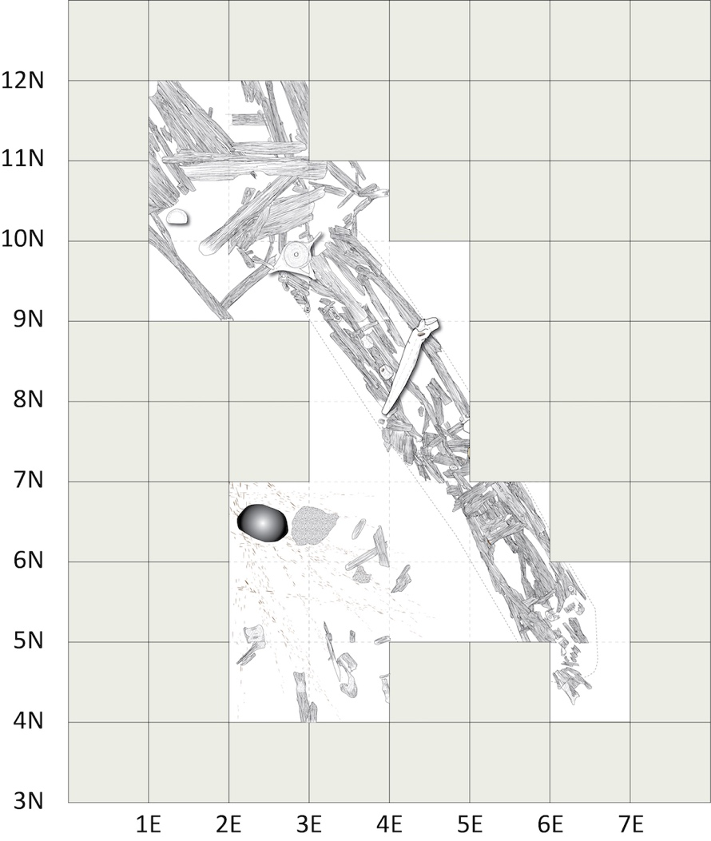
Figure S11. Planview map of KTZ-087, Feature 68A, showing the main room, long entrance tunnel, and external kitchen and/or pottery-production area (figure by John Darwent, modified from Darwent et al. 2013).

KTZ-00304, Rising Whale Site
The Rising Whale site, KTZ-304, is situated atop a low dune, E-6, and describes a multi-component site within a lengthy progradational cycle termed Unit III (Mason 1990; Mason and Jordan 1993; Mason et al. 1997) that formed between 200 BC and AD 1000. Observed on aerial photographs and a brief field visit in 1988, the site was reported in 2006 by Mason (Hoffecker and Mason 2010), having escaped the attention of earlier surveys. Excavation within KTZ-304 was undertaken in 2010, 2011, and again in 2016 and 2017. The site includes eight single or multi-room house depressions within two groupings (Features 2, 4, 5 and Features 11, 12, 20, 21 and 24) and 14 cache pits and five artifact scatters within blowout basins. A whale vertebra (Feature 28) marks the northwest limit of the site. The houses vary in design; the most complex, Feature 21, contains at least three, possibly four rooms, connected by short passage ways (Alix et al. 2018), while two houses are marked by long entries, a main room and a side room.

FEATURE 21
Feature 21 includes a main driftwood framed room (ca. 9 m²) with a back bench, a wood floor and a short planked passage way leading to small side structure at the left, partly framed with logs and containing clinker burnt bones and charcoals, likely impregnated with sea mammal oil, most likely a kitchen. A lengthy entry extends to the southeast, and contained a large inventory of hunting and fishing objects, esp. several fishing lures, as well as ceramic sherds. Several engraved bone objects revealed an emergent aesthetic; one in particular is an engraving of a caribou. The cultural inventory within Feature 21 obtained from excavations in 2010 and 2016 includes 1360 artifacts and >15,000 animal bones, with a sizable representation of caribou (ca. 20%) as well as the preeminence of ringed seal. Partial, possibly disturbed, human remains were encountered beneath the rear bench, the circumstances of death uncertain.

Twelve radiocarbon ages were produced on seal and caribou bones from Feature 21: two on seal bones and 10 on caribou bones. Four caribou and two seal samples, two sets of paired samples, were extracted from bulk faunal samples collected from Level 1E, interpreted as roof fill collapse above the occupation surface of the driftwood house. The stratigraphic thickness of Level 1E varied across the feature, lying generally between 72 and 95 cm bd. The most precise elevational data, consists of a 10 cm increment (72-82 cm bd) within 6N 5E, in the southern block where two caribou samples came from, interpreted in 2011 as “fill just above the floor,” but determined to lie at least 50 cm higher than the floor upon the full excavation of the structure. Two additional assays on caribou were from an adjacent square, unit 5N 4E, possibly 10 cm lower, from the small diagonal side room considered a kitchen room. The six remaining radiocarbon ages were run on caribou samples from lower depths. Feature 21 caribou ages range over two decades in their calibrated age mean values with 8 out of the 9 of them being statistically similar and overlapping at 2-standard deviations (see Tables S1 and S2). We consider these 8 caribou ages statistically similar enough to combine into an average age for the terrestrial ages and compare to the seal ages.

Deering
Deering is a northwestern Native Alaskan community situated on a spit within Kotzebue Sound on the northern coast of the Seward Peninsula. Several archaeological sites are located along the Deering spit that compose the Deering Archaeological District (Alaska Heritage Resources Survey number KTZ-000169; Figure S12). Paired seal and caribou samples came from three houses at three different sites at Deering: Ipiutak House 1 (KTZ-00299), Western Thule House 1 (KTZ-00300), and Western Thule House 2 (KTZ-00301). These sites were excavated between 1998 and 1999 by UIC and NLUR. Bowers (2009) provides detailed information on the excavations, stratigraphy and research at Deering. Below is a summary of the features sampled for this study.

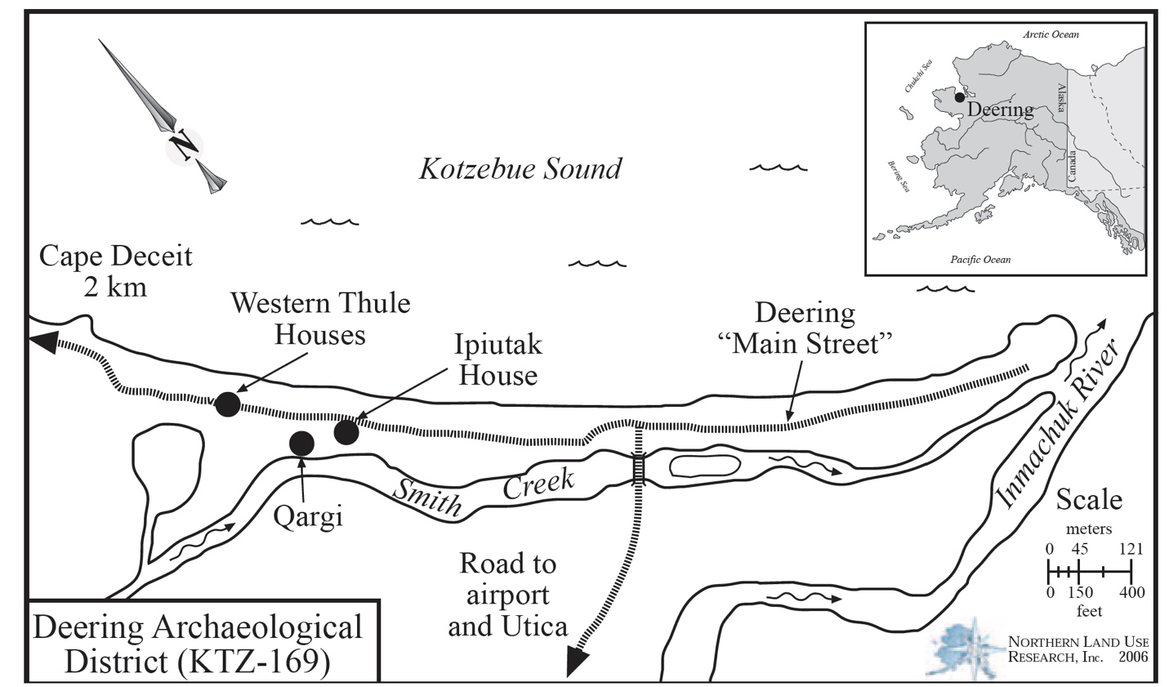
Figure S12. Map of Deering Archaeological District showing the general locations of the Ipiutak House (KTZ-299) and Western Thule Houses (House 1 – KTZ-300 and House 2- KTZ-301).

Western Thule House 1 (KTZ-00300)
The Western Thule House 1 (KTZ-00300) is a semi-subterranean house constructed of driftwood, whalebone and sod (Figure S13). Approximately 1790 artifacts were recovered from the Western Thule House 1 with most of the cultural materials coming from fill in the house (Figure S14). Approximately 45,000 faunal remains were excavated from the house feature with most being recovered from the house floor and fill directly overlying the floor. Six radiocarbon dates on caribou bone and charcoal associated with the Western Thule House 1 floor and fill: 830±40 BP (Beta-224229), 850±40 BP (Beta-224231), 870±40 BP (Beta-224232), 870±40 BP (Beta-138568), 900±40 BP (Beta-224230), and 920±40 BP (Beta-138565). These ages give an average age of 873±17 BP (730–890 cal BP, or AD 1220–1060) for the deposits and the floor and overlying fill. Seal and caribou paired samples for this come from the floor and fill directly above the floor.

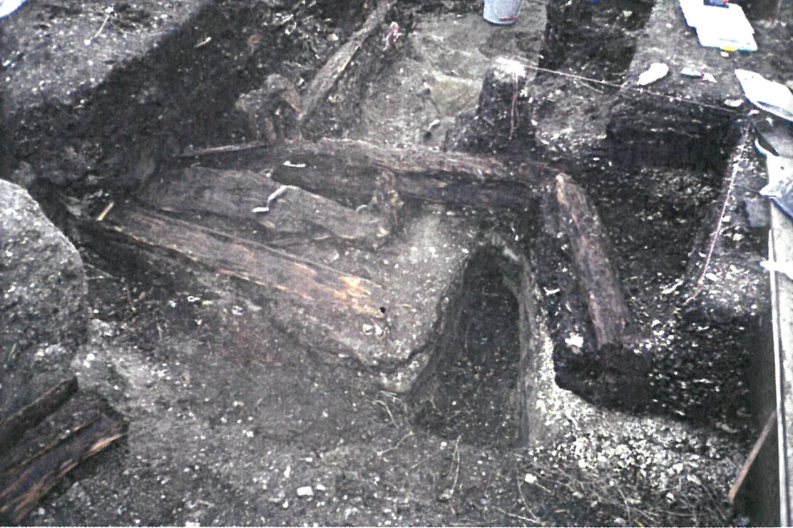
Figure S13. Western Thule House 1, 1999 (Photo from Bowers et al. 2009).

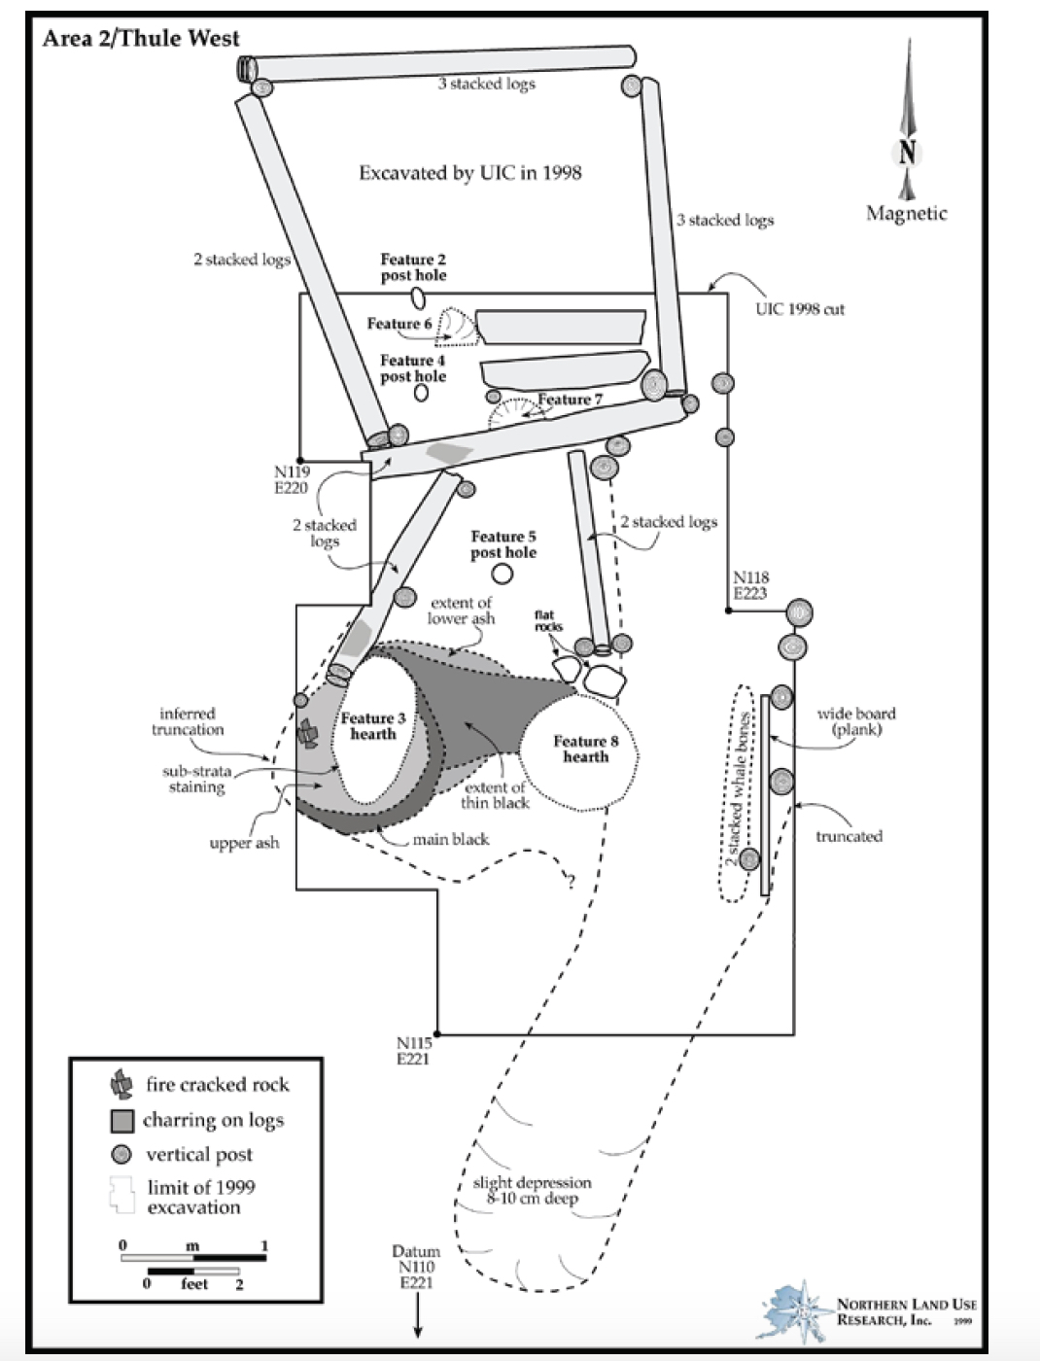
Figure S14. Western Thule House 1 stratigraphy and stratigraphic diagram (Map from Bowers et al. 2009).

Western Thule House 2 (KTZ-00301)
The Western Thule House 2 (KTZ-00301) consists of a semi-subterranean house feature constructed of driftwood, whalebone, and sod (Figure S15). Artifacts and faunal remains were recovered from the floor of the house, as well as midden fill directly overlying the floor (Figure S16). Approximately 1860 artifacts and 50,000 faunal remains were recovered from the Western Thule House 2 excavation. Three radiocarbon dates were run on wood and caribou remains from the feature’s floor: 790±40 BP (Beta-189091), 817±43 BP (AA97481), and 827±42 BP (AA97480). These dates give an average date of 811±25 BP (680–770 cal BP, or AD 1270–1180) for the deposits on the Deering Thule House 2 floor and overlying fill. The paired seal and caribou samples were recovered from this house floor.

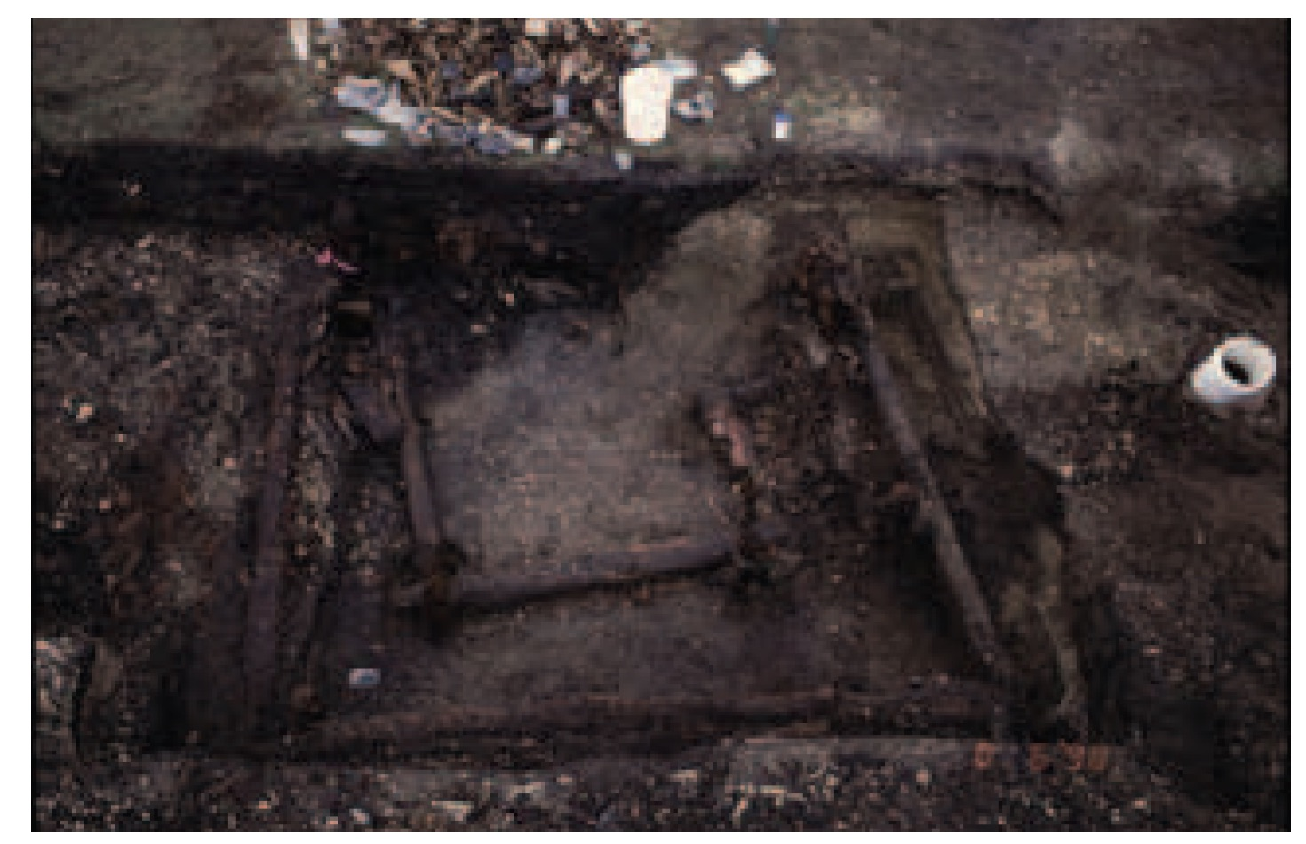
Figure S15. Western Thule House 2, 1999 (Photo from Bowers et al. 2009).

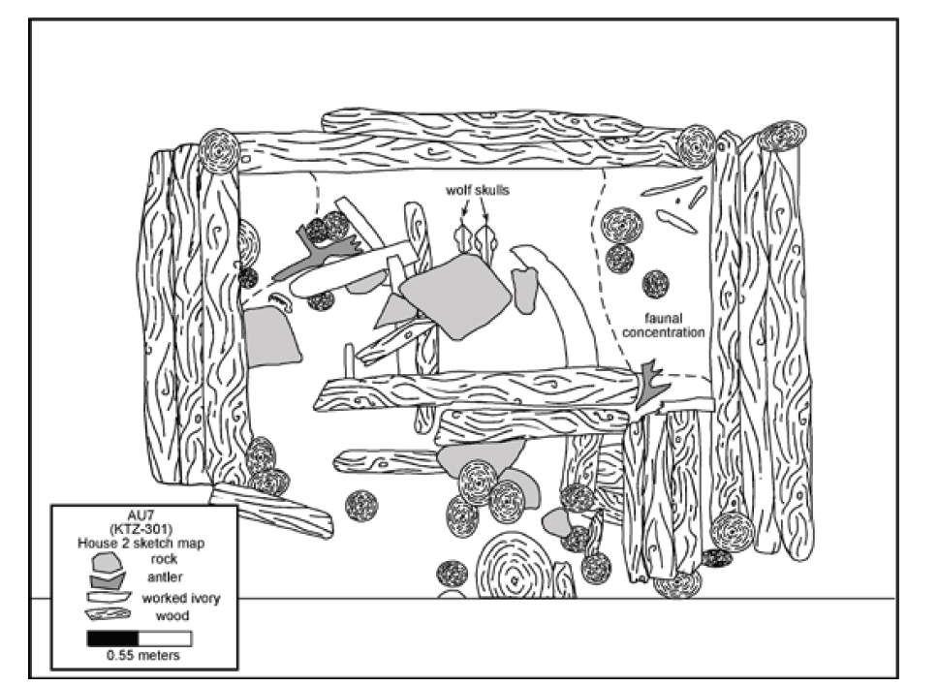
Figure S16. Western Thule House 2 stratigraphy and stratigraphic diagram (Map from Bowers et al. 2009).

Deering Ipiutak House (KTZ-00299)
The KTZ-00299 Ipiutak House is a semi-subterranean house that has an organic-rich substrate for a floor, likely decayed wood (Figures S17 and S18). Intact structural elements such as driftwood and sod were not found; however, these structural elements were likely scavenged for reuse after the abandonment of the house. Three radiocarbon dates on caribou and charcoal samples were recovered a hearth in the house and from the floor: 1220±40 BP (Beta-231493), 1250±40 BP (Beta-138562), and 1310±45 (AA97486). These three dates average to 1256±24 BP (1090–1280 cal BP, or AD 860–670).

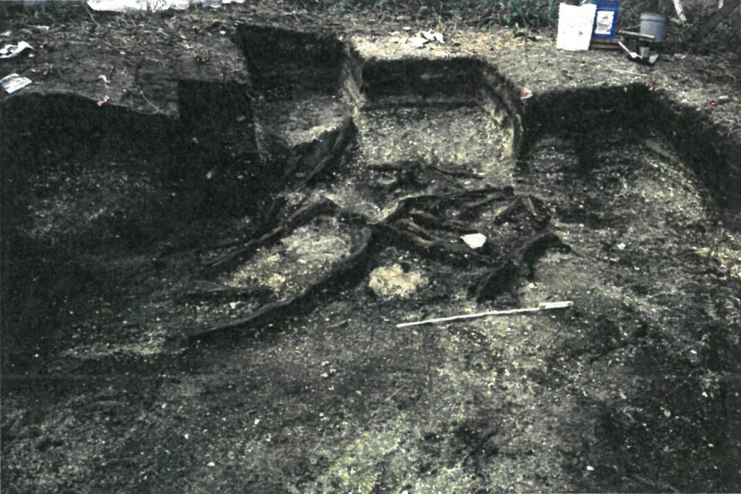
Figure S17. Ipiutak house after excavation, 1999 (Photo from Bowers et al. 2009).

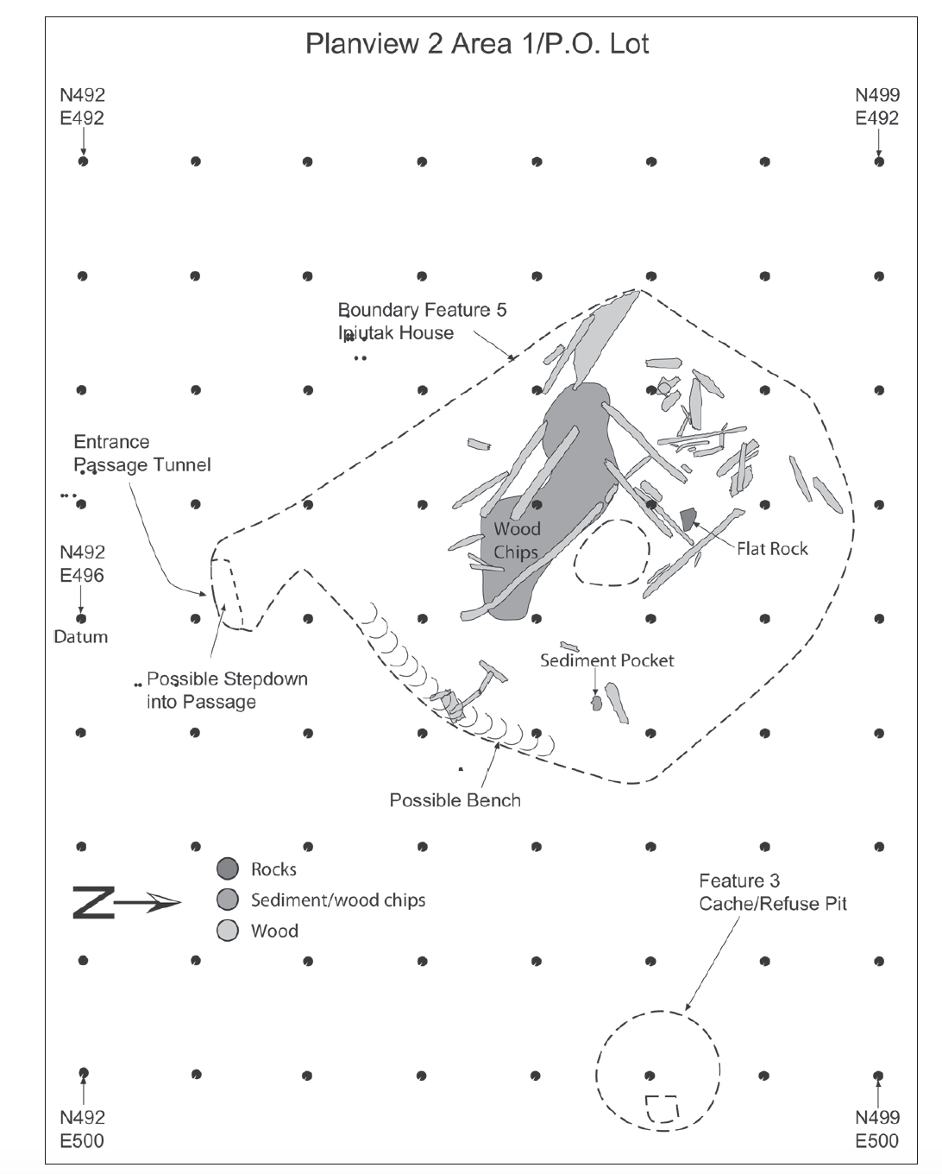
Figure S18. Deering Ipiutak House stratigraphy and stratigraphic diagram (Map from Bowers et al. 2009).

Kivalina
Ipiutak – Wood Feature (NOA-00362)
The city and village of Kivalina is located on a barrier island that is bounded by the Chukchi Sea and Kivalina Lagoon. The Ipiutak wood feature at the NOA-00362 site at Kivalina was excavated in 2009 by Northern Land Use Research Inc. archaeologists Richard O. Stern and Michael Wendt, as part of a cultural resources monitoring for the construction of a water treatment plant (Stern et al. 2010). The Ipiutak wood feature at NOA362 is composed of large wood logs or planks arranged in a linear fashion, laid side by side and oriented southeast to northwest to form a flat surface (Figures S19, S20, and S21). Shorter and thinner planks were laid perpendicular, at right angles, to the larger planks. The species of one of the planks was identified as Picea sp./Larix sp. (Claire Alix, Alaska Quaternary Center, University of Alaska Fairbanks, report to Northern Land Use Research Inc., 8/30/2012), which is most likely was driftwood gathered near a shore given that trees did not grow in this region during the Ipiutak time period, nor do they grow at Kivalina today. Artifacts recovered from the excavation included a gray chert arrow point typical of Ipiutak Type 2 styles defined by Larsen and Rainey (1948:66, Plate 2), a grey chert flake core, and grey chert side scraper, and several chert flake tools (Stern et al. 2010). Numerous faunal remains were collected from the top of the wood feature with the most abundant species represented being phocid (seal) and cervids (caribou and moose), mostly caribou. Other faunal remains present were from Odobenidae (walrus) and Aves (bird). One radiocarbon date from the wooden feature at NOA-00362 was produced on a caribou mandible: 1470±40 BP (Beta-266435) (1300–1510 cal BP, or AD 440–660). The wood feature and other buried cultural remains within the excavation area are associated with a prominent buried soil (Figure S23).

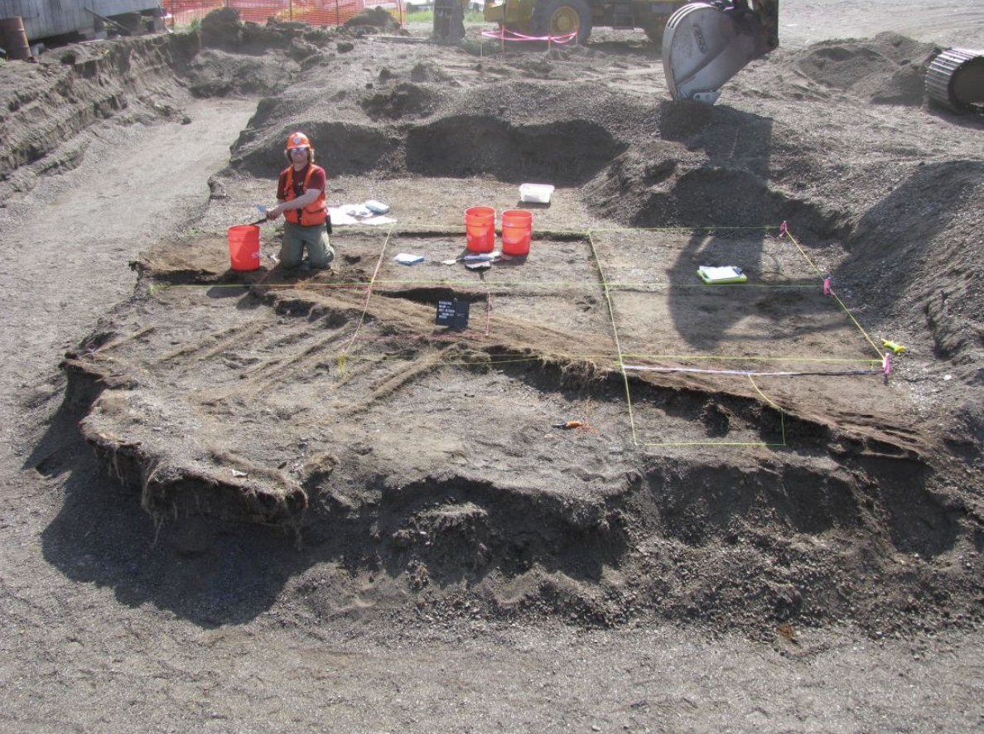
Figure S19. Wood feature in excavation grid, looking south (Photo from Stern et al. 2010).

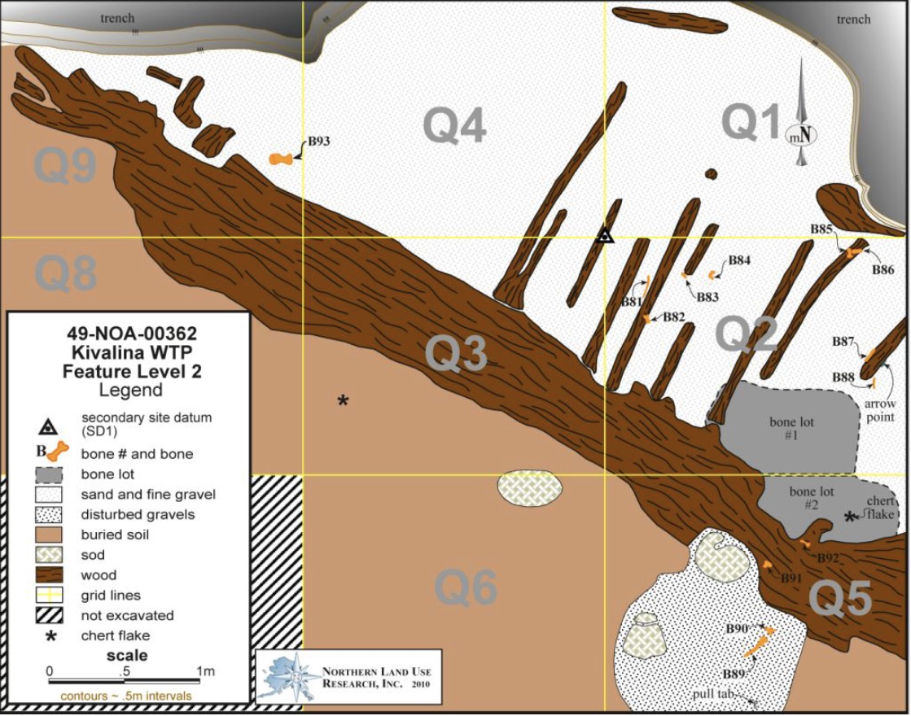
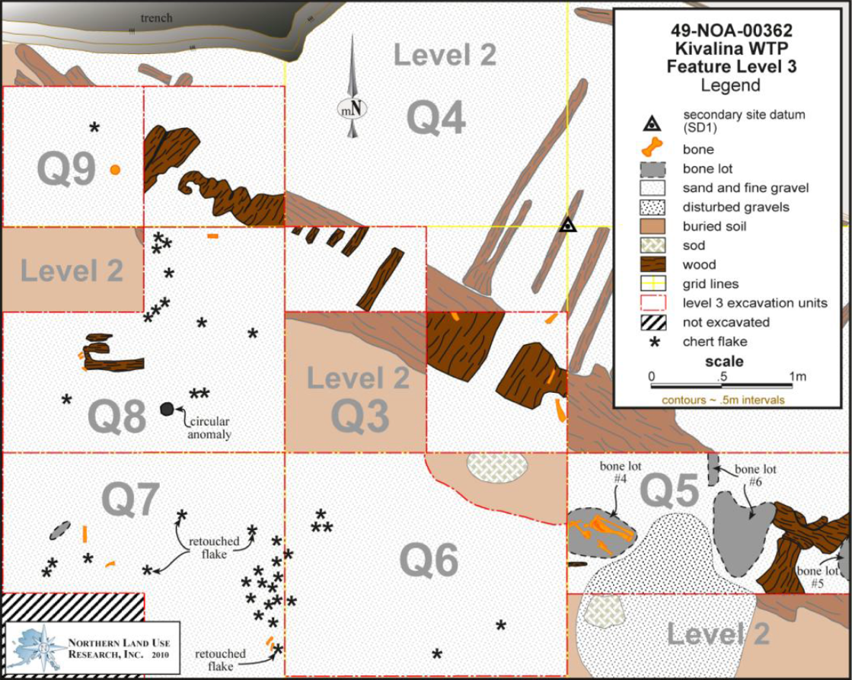
Figure S20. NOA-00362, Kivalina WTP, Feature Level 2 (above) and Level 3 (below) (Map from Stern et al. 2010).

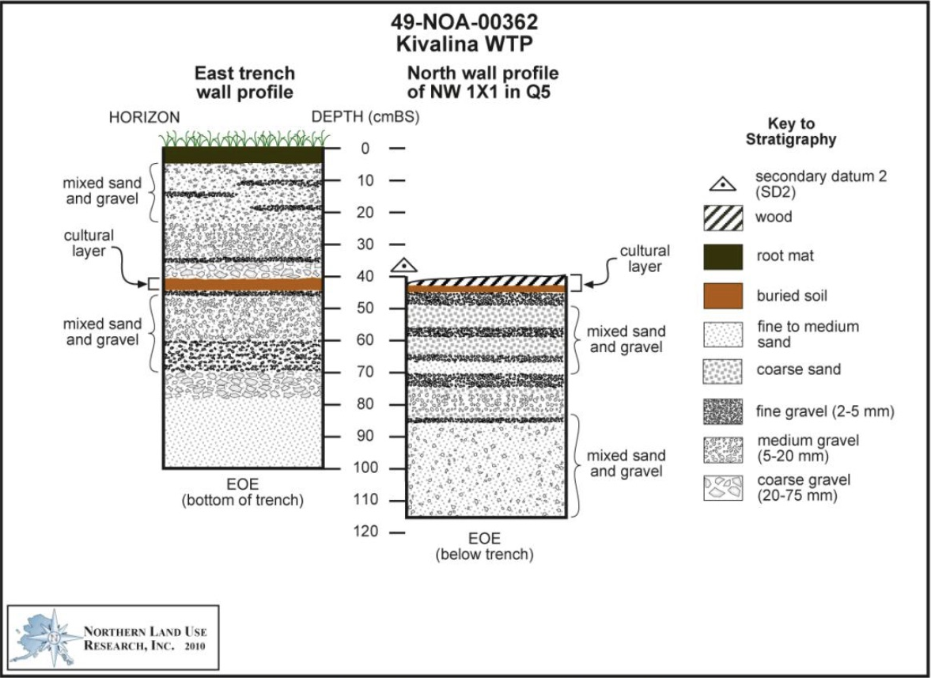
Figure S21. East trench wall profile and North wall profile in NW 1 x 1 in Q5 (Profile from Stern et al. 2010).

Kotzebue
Kotzebue Archaeological District (KTZ-00036)
The Kotzebue Archaeological District (KTZ-00036) is located within the city of Kotzebue, or Qikiqtaġruk, on Baldwin Peninsula that juts in to the Kotzebue Sound. The district consists of at least 53 sites, 47 historic and 16 prehistoric, including the large villages of Old Kotzebue (KTZ-00031) and Intermediate Kotzebue (KTZ-00030) sites. The paired caribou and seal samples from KTZ-00036 were recovered from three buried semi-subterranean house features, Housepits 3, 6, and 8 investigated by Northern Land Use Research Inc. in 2010 (Carlson et al. 2013). All three housepits were recorded and partially excavated during a cultural resources monitoring project as part of the reconstruction of Shore Avenue. Artifact styles and types are indicative of Kotzebue Period, or Late Prehistoric Iñupiat, assemblages from coastal northwestern Alaska. Each housepit and the recovered artifacts and fauna are detailed in Carlson et al. (2013).

HOUSEPIT 3
Housepit 3 consists of a semi-subterranean house with multiple floors. The house is composed of logs on the outer edges of the floors; several were vertical supports for the roof beams. There were at least distinct 3 floors superimposed one and other being separated by collapsed roof beams and lenses of small gravels (Figures S22, S23 and S24). Each of the floors yielded faunal remains and artifacts. Artifact styles and types are indicative of Late Prehistoric Iñupiat assemblages from coastal northern Alaska. Three caribou samples from the highest of the floors, Floor 3, were radiocarbon dated: 313±42 BP (AA97475) and 660±47 BP (AA100198). If the dates are averaged, the result is 613±23 BP (550–650 cal BP, or AD 1400–1300).

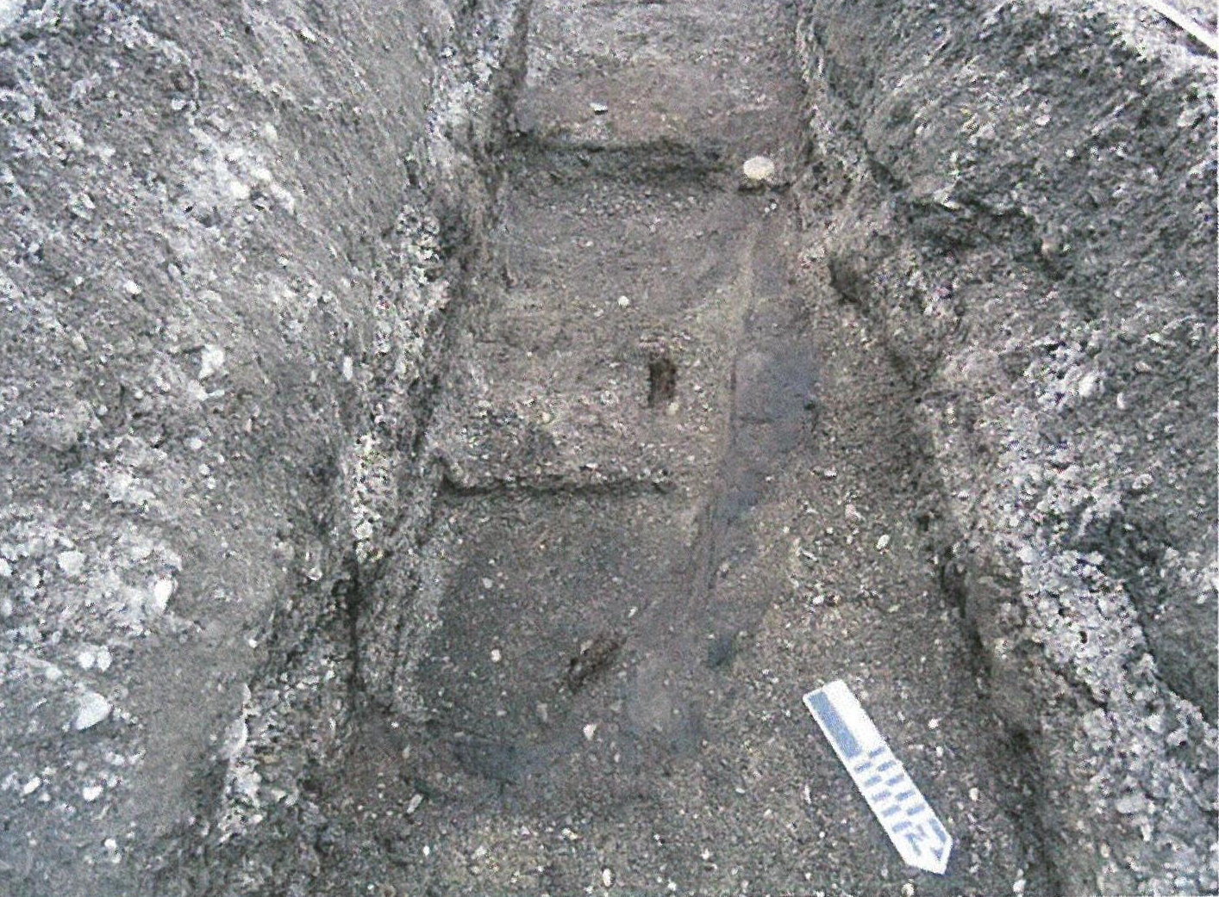
Figure S22. Housepit 3 plan view showing three discrete living surfaces (Photo from Carlson et al. 2013).

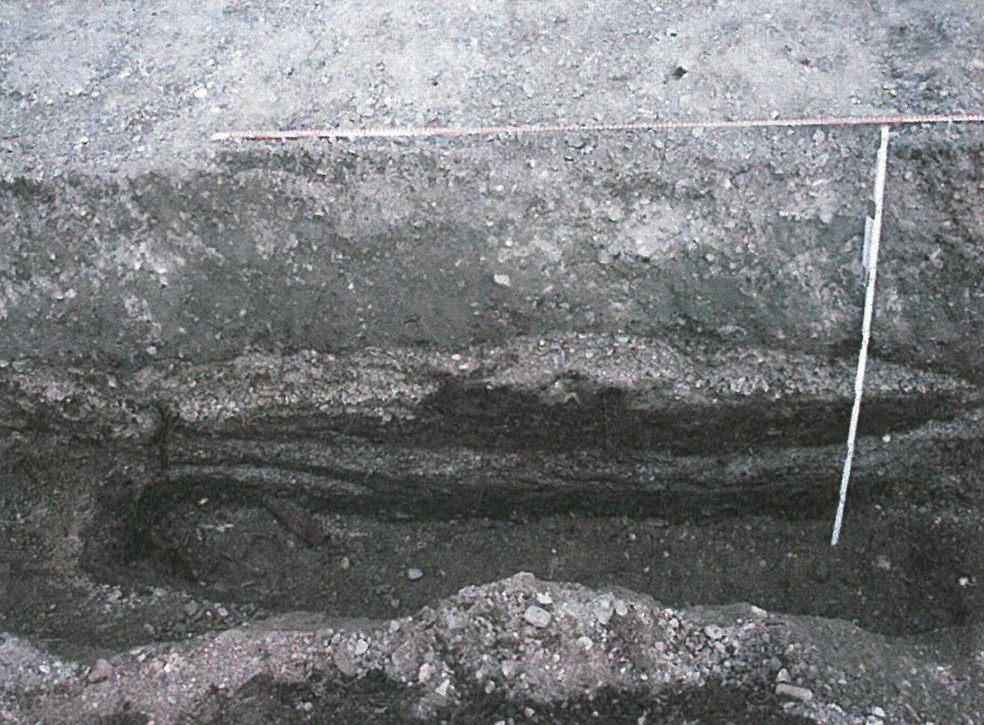
Figure S23. Housepit 3 east wall profile (Photo from Carlson et al. 2013).

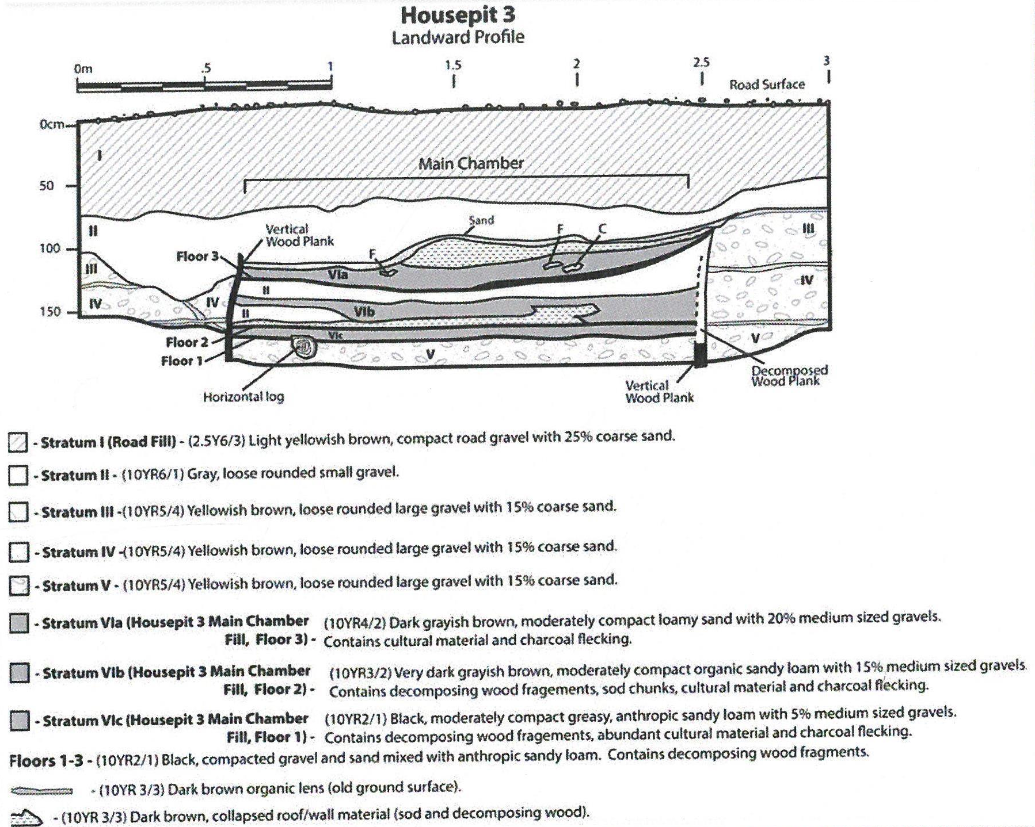
Figure S24. Housepit 3 profile illustration (Profile from Carlson et al. 2013).

HOUSEPIT 8
Housepit 8 is a buried semi-subterranean house with cultural fill, including roof fall, capping a single house floor made of thin wood planks. The section of the house that was revealed during construction activity was undisturbed and subsequently excavated by Carlson et al. (2013) (Figures S25 and S26). Numerous artifacts and faunal remains were recovered including many that were collected in-situ from the intact house floor. A worked caribou metapodial identified as an awl (UA2010-270-109) and a seal canine tooth (UA2010-270-105) were selected from the collection for sampling and radiocarbon dating. The caribou returned a date of 230±20 (UGAMS41354) which calibrates to 306–1 cal BP (cal AD 1640–1950). The seal returned a date of 1150±20 BP (UGAMS41355) which calibrates to 980–1170 cal BP (cal AD 780–970).

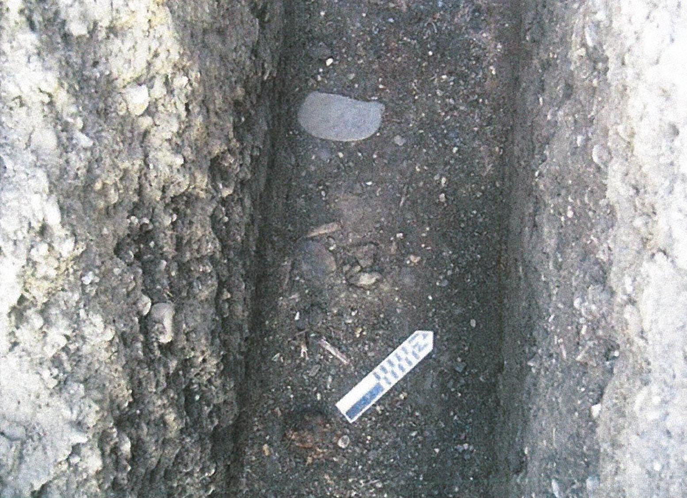
Figure S25. Housepit 8 in situ artifacts of floor surface (Photo from Carlson et al. 2013).

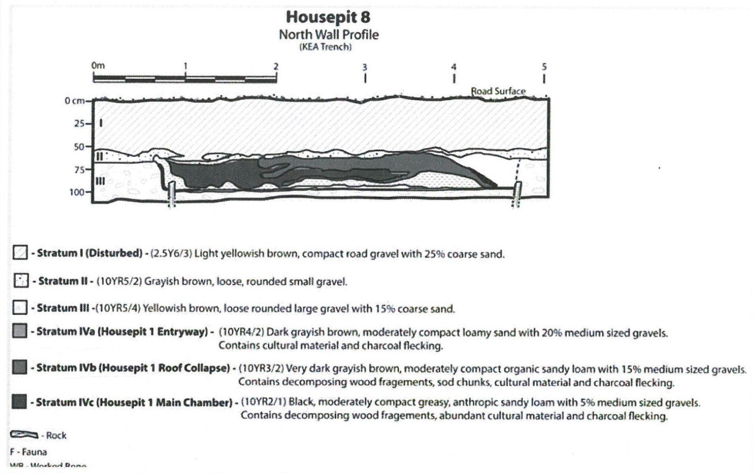
Figure S26. Housepit 8 north wall profile illustration (Profile from Carlson et al. 2013).

Housepit 3, KTZ-00030, Intermediate Kotzebue
The site of Intermediate Kotzebue, which is a significant contributing element to the Kotzebue Archaeological District, was first recorded and tested by James Louis Giddings (1952) late in the 1941 field season and then again in 1947. Giddings (1952:19-20) describes the site as consisting of approximately thirty closely grouped house pits situated on three beach ridges “between the sea shore and a half-mile-long lake,” two miles west of Kotzebue. Nearly 80 years later the Intermediate Kotzebue site now exists within an area that is used extensively by local residents, small aircraft pilots, and the Kotzebue Airport. The lake Giddings described in his monograph is now referred to as Isaac Lake, and additional work was completed here in 2014 to clear the area for use as a material site for improvement projects at the Kotzebue Airport (Odell et al. 2015). In 1941, Giddings (1952) excavated houses 1 and 3 at Intermediate Kotzebue and in 1947 excavated houses 7, 8, and 12 (Figure S27). Several hundred artifacts were recovered between the five houses including harpoon parts, line sinkers, hook shanks, gorges, leister prongs, net-making tools, bird blunts, arrowheads, scrapers, knives, knife handles, ulus, adzes, drills, armor plates, pottery, pendants, labrets, combs, spoons, sled parts, and many other bone, antler, ivory, and stone implements and tools. Giddings (1952:108) also recovered sixty-two combined structural wood samples that were well-preserved enough for tree-ring dating. Based on these dates, which range between AD 1426 and 1559, Giddings’ suggests an average occupation date of AD 1550 for the site. Radiocarbon dates run on samples collected during the 2014 work for the material site fall between AD 1300 and 1500 (Odell et al. 2014:167-170). For this study, two artifacts within the University of Alaska Museum of the North collection from Giddings’ House 3 were sampled for radiocarbon dating. An ice pick made from caribou antler (1-1941-1038) returned a date of 340±20 BP (UGAMS20319) which calibrates to 315–475 cal BP (cal AD 1470–1635). A net sinker made from a seal tibia (1-1941-1032) returned a date of 1150±20 BP (UGAMS20318) which calibrates to 980–1170 cal BP (cal AD 780–970).

Figure S27. Plan view and profile for House 3 at Intermediate Kotzebue (Giddings 1952:21).

Noatak River
XBM-00131, Maiyumerak Creek
The Maiyumerak Creek site (XBM-00131) is located along the middle portion of the Noatak River near its confluence with Maiyumerak Creek in Noatak National Preserve. The site is situated on a low terrace three meters above the creek and consists of at least seven buried semi-subterranean housepit features and associated midden deposits (Figure S28). This site was first recorded by National Park Service (NPS) archaeologists in 1994. In 2006 NPS archaeologists returned to the site to excavate the remainder of House Pit 8, which was eroding and falling into the creek (Shirar 2007, 2009) (Figures S29 and S30).

HOUSE PIT 8
During the House Pit 8 excavation a total of nineteen complete 1 x 1m test units and several partial units were excavated in four natural levels: (1) the modern organic root mat, (2) house roof and wall fall material, (3) house fill and floor, and (4) culturally sterile alluvial deposit. Over 100,000 bones and bone fragments and several thousand artifacts were collected during the House Pit 8 excavation. Seven radiocarbon dates have been run on samples collected from House Pit 8 and include four on caribou bone, two on charcoal, and one on seal bone (see radiocarbon tables in Supplemental Materials). Taken as a whole these dates indicate that this house was occupied at some point between cal AD 1500 and 1700 (Shirar 2007, 2009, 2011). The dated caribou and seal bone specimens were all collected from within the house fill and floor level of House Pit 8. All of the other housepit features and the extensive midden in the southwest portion of the site were also tested in 2006 and each is radiocarbon dated, but it remains unknown whether seal bone exist from any those contexts.

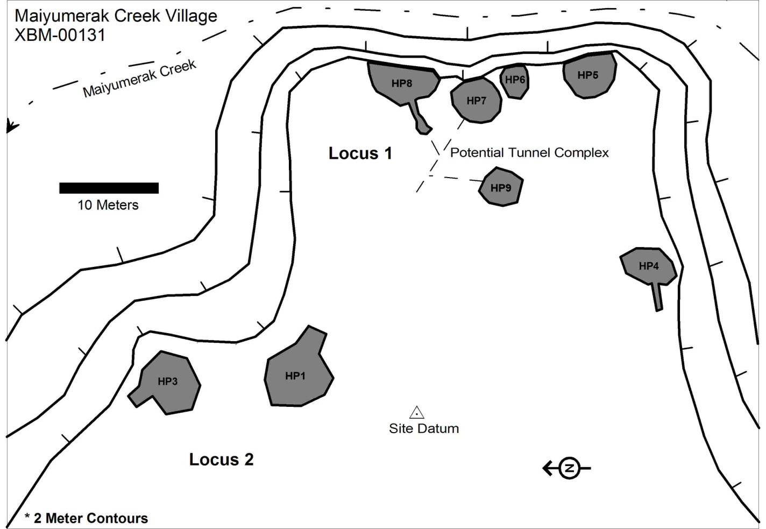
Figure S28. Map of house depressions at the Maiyumerak Creek site showing House Pit 8 (HP8) (Map from Shirar 2007).

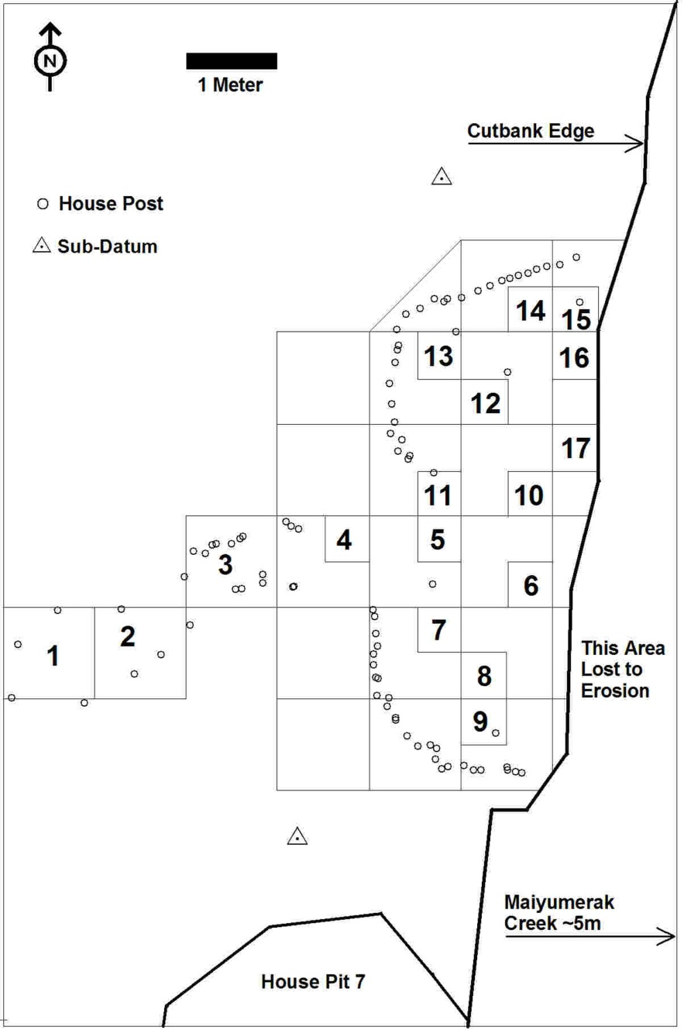
Figure S29. Map with HP8 wall posts, erosional cut, test units, and faunal analysis sample units (Map from Shirar 2007).

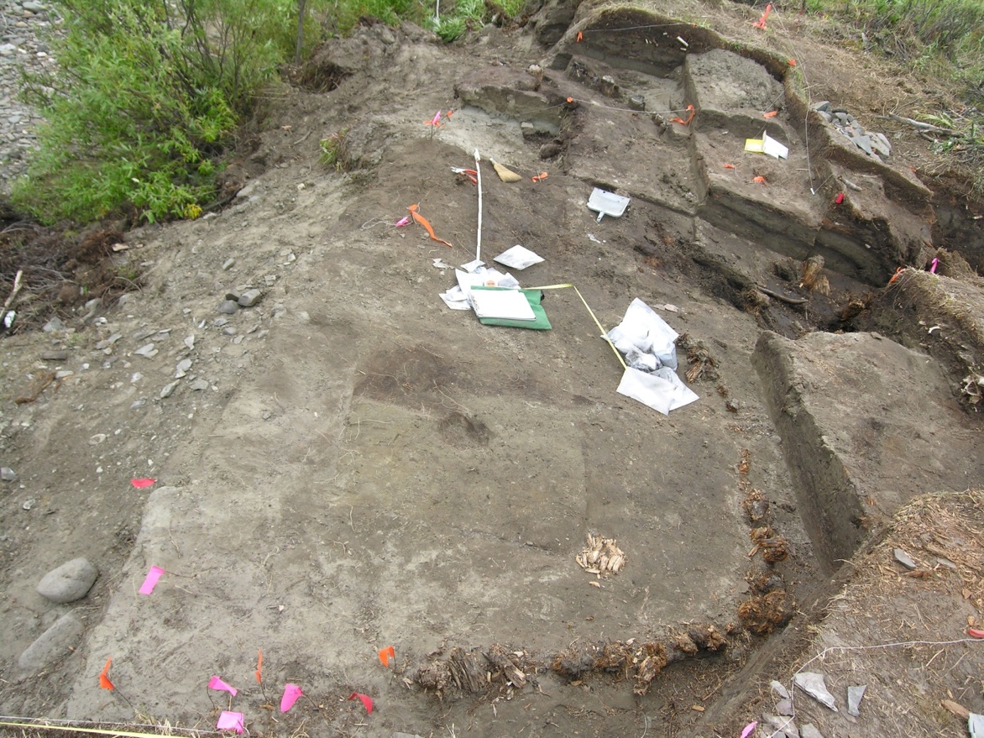
Figure 30. Map showing base of HP8 excavation and wall posts (Photo from Shirar 2007).

Modern Specimens
Cape Nome
Specimen UAM:MAMM:7137 is a Erignathus barbatus skull collected by Otto William Geist near Cape Nome, Alaska, in 1946. This specimen is housed in the Mammalogy collection at the University of Alaska Museum of the North (Figure S31).

St. Lawrence Island
Specimen UAM:MAMM:2091 is a Pusa hispida skull collected by Otto William Geist in the St. Lawrence Island region, Alaska, on March 28, 1932 (Figure S31).

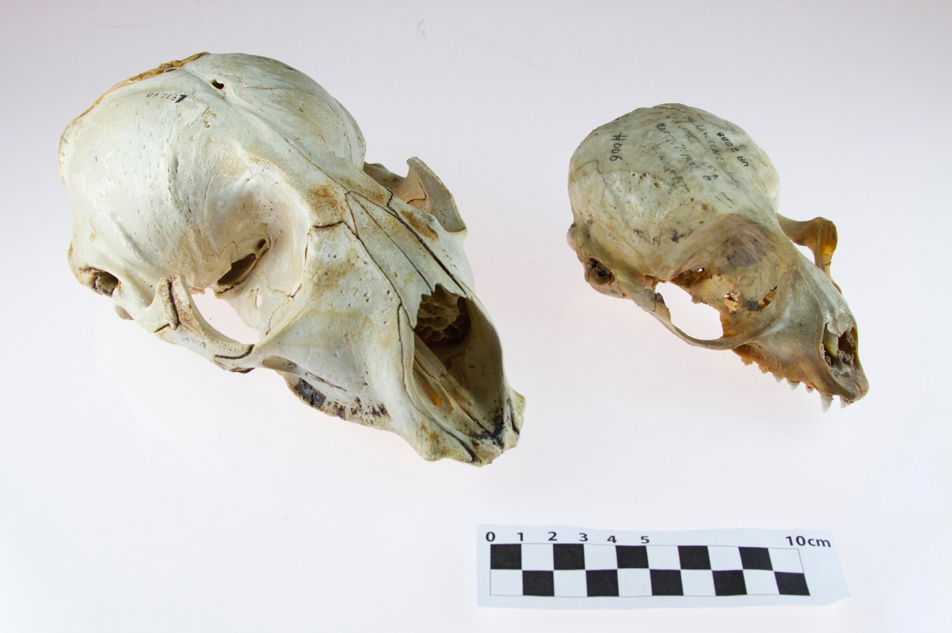
Figure S31. Photograph of modern seal specimens from the UAMN mammalogy collection.

RADIOCARBON AND STABLE ISOTOPES LABORATORY PROTOCOLS

Archaeological Center Research Facility for Stable Isotope Chemistry at the University of Utah

A whole bone or tooth sample weighing ~500 mg is demineralized in 0.6N HCl at 4ºC. The supernatant is decanted and replaced daily until a calcium phosphate density gradient is no longer visible. Type 2 H₂O is used throughout in glassware that had been baked out at 550º C for 3 hours. Demineralizing whole rather than crushed material produces a acid insoluble, chemical fraction known as a collagen or dentin pseudomorph. This process allows preservation to be closely monitored and is complete when the supernatant is free of calcium phosphate, visible as a density gradient, and the sample is "spongy" when probed.

The pseudomorph is then rinsed to neutrality and soaked in 5% KOH replaced daily until the supernatant is clear. This procedure removes base-soluble organic contaminants such as humic and fulvic acids. After acid and base extraction, the protein pseudomorph is rinsed to neutrality and gelatinized in 5 ml of water (pH 3) for 24 hours at 90ºC. Water-soluble and -insoluble phases are separated by filtration with a 0.45 micron, Luerlock syringe filter and the water-soluble phase is lyophilized and weighed to obtain a final collagen yield.

δ¹³C and δ¹⁵N values are determined relative to PDB on acid and base extracted protein (bone collagen or tooth dentin) by flash combustion to produce CO₂ and N₂ and measured against the appropriate reference gas on a Finnigan Delta Plus mass spectrometer with Carlo Erba EA118 CHN interface at the Stable Isotope Ratio Facility for Environmental Research (SIRFER) on the University of Utah campus. Stable carbon and nitrogen isotope measurements and weight percent C:N values are obtained from a single sample combustion. (Analytical precision is ± 0.1 ‰ for carbon and ± 0.2 ‰ for nitrogen.

Beta Analytic, Inc.
Bone, antler, wood and wood charcoal samples were sent to Beta Analytic Inc. for AMS radiocarbon dating. Their general pretreatment protocols can be found at https://www.radiocarbon.com/pretreatment-carbon-dating.htm. The current collagen extraction procedures at Beta are found at http://www.radiocarbon.com/carbon-dating-bones.htm. Beta’s general collagen extraction preparations can be summarized as follows. The exterior of the sample is removed and the remaining is then crushed and placed in diluted, cold HCl. The sample is subjected to the cold, diluted acid wash until demineralized leaving an acid insoluble (collagenous) solution. Any rootlets remaining in the extract are removed through the acid washes. An alkali wash (NaOH) was applied to all of the bone samples to remove any base-soluble organic acids from the extract.

Beta’s general protocols for wood and wood charcoal samples can be found at https://www.radiocarbon.com/charcoal-wood.htm#Chemical. They are summarized as follows. Rootlets were removed by hand using tweezers and by scraping off the surface of a sample with a scalpel. The samples were subsequently crushed then dispersed in deionized (DI) water.

The samples were washed with hot HCl then neutralized, then washed by an NaOH and again neutralized, and lastly, by a final HCl rinse to neutralize the remainder of the samples before drying. Any contaminants (sediments and rootlets) that are visible throughout this process are removed. As stated on Beta’s website “Chemical concentrations, temperatures, exposure times, and number of repetitions depend on the sample submitted.” For wood, after the pretreatment of acid-alkali-acid washes, a sample soaked in sodium chlorite (NaClO₂) in a bath at a pH of 3 and temperature of 70°C, which ensures all remaining components are solely wood cellulose. Laboratory numbers are given with the prefix “Beta-“.

Center for Accelerator Spectrometry at Lawrence Livermore National Laboratory –
One bone sample was sent to the Center for Accelerator Mass Spectrometry (CAMS) at Lawrence Livermore National Laboratory. The CAMS procedure for collagen extraction and purification follows the modified Longin method as described in Brown et al. (1988:171-177). Following cryogenic purification the CO² is reduced in the presence of iron catalyst and a stoichiometric excess of hydrogen as described in Vogel et al. (1984:289-293).

Center for Applied Isotope Studies at the University of Georgia
Bone samples were treated with 1N HCl to dissolve the mineral component, rinsed with Milli-Q water, and subsequently treated with a 0.1M NaOH solution to remove potential humic acid contaminants. The samples were rinsed with Milli-Q water, and then treated with 1N HCl. The residues were filtered and rinsed with deionized water, and heated at 80ºC for 6 hours under slightly acid conditions (pH=3) to dissolve the collagen into a solution. This collagenous solution was filtered to isolate pure collagen and then freeze-dried. The collagen was combusted in sealed and evacuated ampules in the presence of CuO at a temperature of 575ºC.

The carbon dioxide was cryogenically purified from other reaction products and catalytically converted to graphite using the method of Vogel et al. (1984). Graphite ¹⁴C/¹³C ratios were measured using a CAIS 0.5 MeV accelerator mass spectrometer. The sample ratios were compared to the ratio measured from the Oxalic Acid I (NBS SRM 4990). All radiocarbon ages are quoted as uncalibrated dates with an error of one standard deviation (1σ), and expressed as radiocarbon years before 1950 (BP) using the ¹⁴C half-life of 5,568 years. The sample ¹³C/¹²C ratios were measured (with an error of less than 0.1‰) separately using a stable isotope ratio mass spectrometer and expressed as δ¹³C with respect to the PDB, and all ages have been corrected for isotope fractionation. Laboratory numbers are given with the prefix “UGAMS”.

National Ocean Sciences AMS Facility
Charcoal, wood, and several bone samples were sent to the National Ocean Sciences AMS Facility (NOSAMS). NOSAMS pretreats plant/wood and charcoal samples through a series of heated acid-base-acid leaches. This process is designed to remove inorganic carbon and mobile organic acid phases, and may be repeated up to twenty times prior to AMS measurement (NOSAMS 2019a). Collagen was extracted from bone specimens at the Archaeological Center Research Facility for Stable Isotope Chemistry at the University of Utah. NOSAMS then combusted the collagen samples at high temperatures to produce CO² for AMS measurement. NOSAMS 2019c describes the lab 14C procedures.

W.M. Keck Carbon Cycle Accelerator Mass Spectrometer Facility at the University of California Irvine
Bone samples were sent to the Keck-CCAMS Facility at UC Irvine for AMS radiocarbon dating. The KCCAMS procedures for collagen purification by ultrafiltraton from bone follow the modified Longin method (Brown et al. 1988) and are described in Beaumont et al. (2010). Graphitization and measurements were conducted at the Keck-CCAMS Facility following Santos et al. (2007) and Southon et al. (2004). Laboratory numbers are given the prefix “UCIAMS-”

Radiocarbon Laboratory at the Department of Earth System Science at the University of California Irvine
Caribou bone samples, and a deciduous charcoal sample, were submitted to the University of California, Irvine, Keck-Carbon Cycle AMS facility. Bone samples were processed following lab protocols established by KCCAMS personnel (https://sites.uci.edu/keckams/protocols/). Bone collagen extraction uses a modified Longin (1971) collagen extraction method followed by ultrafiltration (Brown et al. 1988). Bones were cleaned of by use of a Dremel tool to grind off the entire exterior surface of the bone to remove all contaminates then crushed to reduce bone fragments to between 0.5 and 2 mm. These fragments were then decalcified with 0.5N HCL, rinsed with Milli-Q water, and then processed through a Centriprep YM-30 ultrafilter, which involves the use of MQ water and 0.01N HCL in a sonicator. Alkali treatment (0.1N NaOH) was used to remove base-soluble contaminants if necessary. Samples were then rinsed with 0.1N HCL and MQ water. Water was removed and 0.01N concentration of HCL added; samples were heated at 60 ºC for 8 to 10 hours, followed by ultrafiltration to isolate the collagen and freeze drying. CO2 is obtained from these purified organic samples by combusting them in sealed quartz tubes with CuO and Ag wire at 900ºC. The CO2 is reduced to graphite following KCCAMS protocols (Lloyd et al. 1991; Santos et al. 2004; Vogel et al. 1984). Laboratory numbers are given with the prefix “UCIAMS-“.

University of Arizona Accelerator Mass Spectrometry Laboratory
Caribou and seals bones were sent to the University of Arizona Accelerator Mass Spectrometry Lab for radiocarbon dating. Collagen pretreatments at NSF-Arizona AMS were conducted using a semiautomated acid-base-acid extraction system (Hodgins et al. n.d.; Law and Hedges 1989). The semi-automated system consists of a reservoir system that drains water, acid, and base reagents into flow cells at specific quantities and times within the pretreatment process. Bones were cleaned of sediments and other exogenous materials adhering to the surface by removal of a sample’s exterior with a Dremel milling bit and sonication thereafter. After surface removal and sonication, the sample was crushed into a powder (~500 mg) and then placed into one of 12 flow cells. Four glass reservoirs hold ultrapure water, 0.5 M HCl, 0.1 M NaOH, and 0.010 M HCl that are directed into the flow cells that hold pulverized bone samples. A pump system controls the reagent flow through a software interface (Hodgins et al. n.d.). The “collagen” fraction is washed into test tubes, heated at 70º C for 24 hrs to gelatinize, freeze dried, and combusted. Laboratory numbers are given with the prefix “AA”.

REFERENCES
Alix C, Mason O, Norman L, Bigelow N, Maio C, Anderson S, Grieve-Rawson S, Lincoln A, O’Rourke D, Poupon L, Vanlandeghem M. 2017. Birnirk prehistory and the emergence of the Inupiaq culture in northwestern Alaska. Archaeological and anthropological perspectives. Field investigations at Cape Espenberg, 2016. Annual Report to the National Park Service, U.S. Department of the Interior, and the University of Alaska Fairbanks.

Alix C, Mason O, Anderson S, Bogardus R, Bigelow N, Lincoln A, Norman L, Maio C, Vanlandeghem M, O’Rourke D, Rasic J, Lorain M, Prentiss A. 2018. Birnirk prehistory and the emergence of the Inupiaq culture in northwestern Alaska. Archaeological and anthropological perspectives. Field investigations at Cape Espenberg, 2017. Annual Report to the National Park Service, U.S. Department of the Interior, and the University of Alaska Fairbanks.

Anderson SL, Freeburg A. 2014. High latitude coastal settlement patterns: Cape Krusenstern, Alaska. Journal of Island and Coastal Archaeology 9(3):295–318.

Anderson SL, Freeburg A. 2013. A high resolution chronology for the Cape Krusenstern site Complex, northwest Alaska. Arctic Anthropology 50(1):49–71.

Anderson SL, Jordan JW, Freeburg A. 2018. Human settlement and mid-late Holocene coastal environmental change at Cape Krusenstern, northwest Alaska. Quaternary International https://doi.org/10.1016/j.quaint.2018.10.028.

Beaumont W, Beverly R, Southon J, Taylor RE. 2010. Bone preparation at the KCCAMS laboratory. Nuclear Instruments and Methods in Physics Research B 268:906–909.

Bowers PM. (editor). 2009. The archaeology of Deering, Alaska: Final report on the Deering Village Safe Water Archaeological Program. Report prepared by Northern Land Use Research Inc., Fairbanks, Alaska, for the Native Village of Deering and the City of Deering, Alaska, the Department of Environmental Conservation-Village Safe Water Office and the Alaska State Historic Preservation Office, Anchorage, Alaska.

Brown TA, Nelson DE, Vogel JS, Southon JR. 1988. Improved collagen extraction by modified Longin method. Radiocarbon 30(2):171–177.

Brown SK, Friesen TM, Mason OK, Darwent CM. 2012. Ancient DNA identification of a polar bear bone dagger from Cape Espenberg, Alaska. Alaska Journal of Anthropology 10(1–2):173‒175.

Brown SK, Darwent CM, Sacks, BN. 2013. Ancient DNA evidence for genetic continuity in arctic dogs. Journal of Archaeological Science 40(2):1279–1288.

Brown TA, Nelson DE, Vogel JS, Southon JR. 1988. Improved collagen extraction by modified Longin method. Radiocarbon 30(2):171–177.

Carlson ES, Smith HL, Bowers PM, McGowan S, McKinney HJ. 2013. Kotzebue Shore Avenue Reconstruction Project: construction monitoring cultural resource project. Report prepared by Northern Land Use Research Inc., Fairbanks, Alaska, for the Alaska Interstate Construction LLC, Anchorage, Alaska.

Cooper, HK, Mason O, Mair V, Hoffecker JF, Speakman RJ. 2016. Evidence of Eurasian metal alloys on the Alaskan coast in prehistory. Journal of Archaeological Science 74:176-183.

Darwent J, Mason OK, Hoffecker JF, Darwent CM. 2013. 1,000 years of house change at Cape Espenberg, Alaska: a case study in horizontal stratigraphy. American Antiquity 78(3):433–455.

Freeburg A, Anderson SL. 2012. Human-environmental dynamics at Cape Krusenstern, two hundred generations: on the beach of their time, final report. Report prepared by the University of Washington, Seattle, Washington, for the National Park Service. Submitted as partial fulfillment of UW – NPS PNW CESU Cooperative Agreement # J8W07070032, September 14, 2012. Manuscript on file, NPS WEAR, Anchorage.

Giddings JL. 1952. The Arctic Woodland Culture of the Kobuk River. Philadelphia, PA: Museum Monographs, The University of Pennsylvania Museum.

Giddings JL, Anderson DD. 1986. Beach ridge archeology of Cape Krusenstern: Eskimo and pre-Eskimo settlements around Kotzebue Sound, Alaska. Washington, D.C.: National Park Service.

Harritt RK. 1994. Eskimo prehistory on the Seward Peninsula. Research Report AR 21, National Park Service, Alaska Regional Office, Anchorage.

Hodgins GWL, Gann JP, Vonarx AJ, Jull AJT. n.d. A new semiautomated acid-base-acid extraction system for radiocarbon samples. Unpublished manuscript on file with the University of Arizona AMS Laboratory, Tucson.

Hoffecker, JF, Mason, OK. 2010. Human Response to Climate Change at Cape Espenberg: AD 800 – 1400 Field Investigations at Cape Espenberg, 2010. Preliminary Report to the National Park Service. U. S. Department of the Interior. INSTAAR, University of Colorado, Boulder.

Hoffecker JF, Mason OK. 2011. Human Response to Climate Change at Cape Espenberg: AD 800 – 1400 Field Investigations at Cape Espenberg, 2011. Annual Report to the National Park Service. U.S. Department of the Interior. INSTAAR, University of Colorado, Boulder.

Law IA, Hedges REM. 1989. A Semi-Automated Bone Pretreatment System and the Pretreatment of Older and Contaminated Samples. Radiocarbon 31(3):247-253.

Lloyd DH, Vogel JS, Trumbore S. 1991. Lithium contamination in AMS measurement of 14C. Radiocarbon 33(3):297–301.

Longin R. 1971. New method of collagen extraction for radiocarbon dating. Nature 230:241–242.

Mason, OK. 1990. Beach Ridge Geomorphology of Kotzebue Sound: Implications for Archaeology and Paleoclimatology. Unpublished Ph.D. dissertation, Quaternary Science, University of Alaska Fairbanks.

Mason OK, Jensen AM, Rinck B, Alix CM, Bowers PM, Hoffecker JF. 2019. Heightened early medieval storminess across the Chukchi Sea, AD 400–1100: a proxy of the Late Antique Little Ice Age. Quaternary International, https://doi.org/10.1016/j.quaint.2019.01.042.

Mason OK, Hopkins DM, Plug LJ. 1997. Chronology and paleoclimate of storm-induced erosion and episodic dune growth across Cape Espenberg spit, Alaska. Journal of Coastal Research 13(3):770–797.

Mason OK, Jordan JW, Plug LJ. 1995. Late Holocene storm and sea-level history in
the Chukchi Sea. Journal of Coastal Research 17:173–180.

Mason OK, Jordan JW. 1993. Heightened North Pacific storminess and synchronous late
Holocene erosion of northwest Alaska Beach Ridge complexes. Quaternary Research 40(1):55–
69.

Mason OK, Jordan JW. 1997. Sea level and storm history of northern Seward Peninsula final
report to the Shared Beringian Heritage Project, Bering Land Bridge National Park and
Preserve, Alaska Regional Office, Anchorage.

McIntosh, N. 2011. Late Holocene insect fossil assemblages from natural and archaeological
settings at Cape Espenberg, Alaska. Unpublished M.Sc. thesis, Quaternary Science, Royal
Holloway, University of London.

Norman L. 2015. Ethnography, analogy, and arctic archaeofaunas: assessing the limits of zooarchaeological interpretation. Unpublished Ph.D. dissertation, Department of Anthropology, University of Toronto, Toronto.

Norman L. 2018. Comparing fill and floor: a taphonomic framework for understanding
depositional histories in a semi‐subterranean house in Northwest Alaska. International
Journal of Osteoarchaeology 28(6):1–11.

Norman L. 2018. Ethnohistoric documents as analogical tools: a case study from Northwest
Alaska. Journal of Anthropological Archaeology 51:1-15.

Norman L, Friesen TM, Alix CM, O’Rourke M, Mason OK. 2017. An early Inupiaq occupation: observations on a Thule house from Cape Espenberg, Alaska. Open Archaeology 3:17–48.

Odell M, Smith R, Rinck B, Carrilho Y, Heppner A, Undem C, Slobodina N, Mason O, Kopperl R. 2015. Cultural resource management report for the Isaac Lake Materials Site, Kotzebue, Alaska. Report prepared by SWCA Environmental Consultants, Anchorage, Alaska, for Brice, Inc.

Santos, GM, Moore, RB, Southon, JR, Griffin, S, Hinger, E, Zhang, D. 2007. AMS 14C sample preparation at the KCCAMS/UC Irvine Facility: status report and performance of small samples. Radiocarbon 9(2):255–269.

Schaaf J. (editor). 1988. The Bering Land Bridge: an archaeological survey. Resources
Management Report 14, 2 vols. Anchorage: National Park Service, Alaska Region.

Shirar S. 2007. Maiyumerak Creek: late prehistoric subsistence and seasonality in northwest Alaska. Unpublished Master’s thesis, Department of Anthropology, University of Alaska, Fairbanks.

Shirar S. 2009. Subsistence and seasonality at a late prehistoric house pit in northwest Alaska. Journal of Ecological Anthropology 13(1):6–25.

Shirar S. 2011. Late Holocene chronology of the Noatak and Kobuk Rivers. Alaska Journal of Anthropology 9(2):1–16.

Southon J, Santos G, Druffel-Rodriguez K, Druffel E, Trumbore S, Xu XM, Griffin S, Ali S, Mazon M. 2004. The Keck Carbon Cycle AMS laboratory, University of California, Irvine: initial operation and a background surprise. Radiocarbon 46:41–49.

Stern RO, Reuther JD, Bowers PM, Gelvin-Reymiller C, Hayes JM. 2010. Cultural resources monitoring of water treatment plant construction (2009) in Kivalina, Alaska. Report prepared by Northern Land Use Research Inc., Fairbanks, Alaska, for the Alaska Native Tribal Health Consortium, Anchorage, Alaska.

