THE CASTLE OF ACHANDUIN, LISMORE – A POINT OF REFERENCE FOR THE RADIOCARBON ANALYSIS OF MORTAR-ENTRAPPED RELICT LIMEKILN FUELS
ELECTRONIC SUPPLEMENTARY MATERIAL
Mark Thacker; 27 Upper Carloway, Isle of Lewis, Scotland; mark.thacker@stir.ac.uk

- Achanduin Castle Model 1a
1.1 - Model 1a Script
Options()
{
Resolution=1 year;
kIterations=20000;
};
Plot()
{
Outlier_Model("General 1a",T(5),U(0,4),"t");
Sequence("Achanduin Castle Standalone Sequence 1a")
{
Tau_Boundary("Achanduin Castle Woodland Growth 1a");
Phase("Achanduin Castle MERLF Assemblage 1a")
{
R_Date("SUERC-62545", 701, 34)
{
Outlier("General 1a", 0.05);
};
R_Date("SUERC-62546", 698, 34)
{
Outlier("General 1a", 0.05);
};
R_Date("SUERC-62547", 785, 34)
{
Outlier("General 1a", 0.05);
};
Span("Achanduin Castle Assemblage Growth 1a");
};
Boundary("Achanduin Castle Construction Completed 1a");
};
};

1.2 – Model 1a Table of Distributions
 | Unmodelled Distributions 1a (cal AD) |  | Modelled Distributions 1a (cal AD) |  | A Indices
 | 68.2% prob. | 95.4% prob | 68.2% prob. | 95.4% prob.
R-Date Codes
SUERC-62545 | 1265-1380 | 1255-1390 | 1270-1295 | 1255-1385 | 119.3
SUERC-62546 | 1270-1380 | 1255-1390 | 1270-1295 | 1255-1385 | 119.1
SUERC-62547 | 1220-1270 | 1185-1285 | 1235-1280 | 1205-1290 | 101.3
Generated
End Boundary |  |  | 1270-1335 | 1260-1525
Span |  |  | 0-55 | 0-140
Model |  |  |  |  | 121
Overall |  |  |  |  | 119.9
Table S1 – Probability Distributions associated with Model 1a. All distributions rounded out to 5 years. See 1.3 below for model specification.
1.3 – Model 1a Multiple Plot
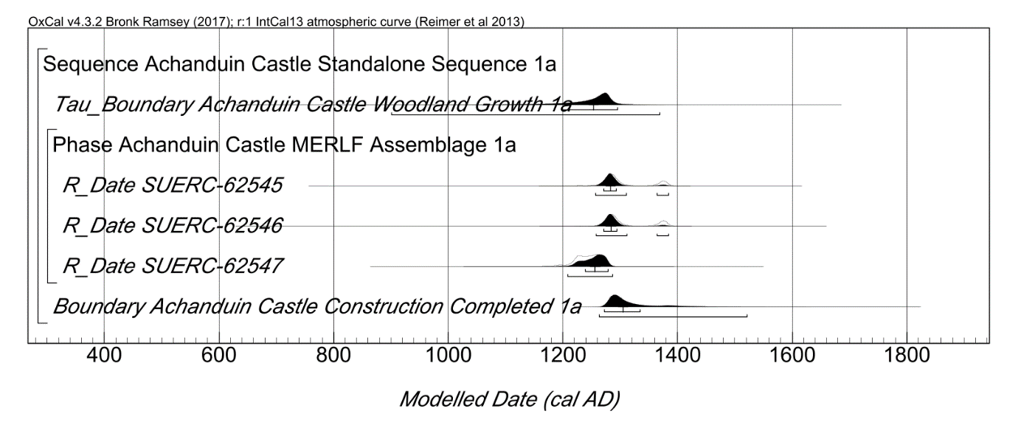
Fig. S1 (above). Probability distributions of dates from Achanduin Castle Model 1a, including phasing interpretations and radiocarbon data. Plotted in OxCal v4.3.2 (Bronk Ramsey 2017), calibrated using IntCal13 atmospheric curve (Reimer et al 2013), this model was set at 1 year resolution and run with 20000 kIterations. All three radiocarbon dates have been situated within a single phase and all five tagged with a 5% outlier probability within the ‘General’ outlier model (Bronk Ramsey 2009). Each distribution represents the relative probability than an event occurs at a particular time and for each of the radiocarbon dates two distributions have been plotted: one in outline, which is the result of simple radiocarbon calibration; and a solid one, which is based on the chronological model. The Boundary distribution ‘Achanduin Castle Construction Completed 1a’ situated at the end of this phase is an estimate of the date when construction of Achanduin Castle was completed. Squared brackets beneath each distribution represent the highest probability distributions at 68.2% and 95.4% probability. A Span distribution was also generated by this model but is not included in these plots (see table S1)
1.4 - Model 1a End Boundary
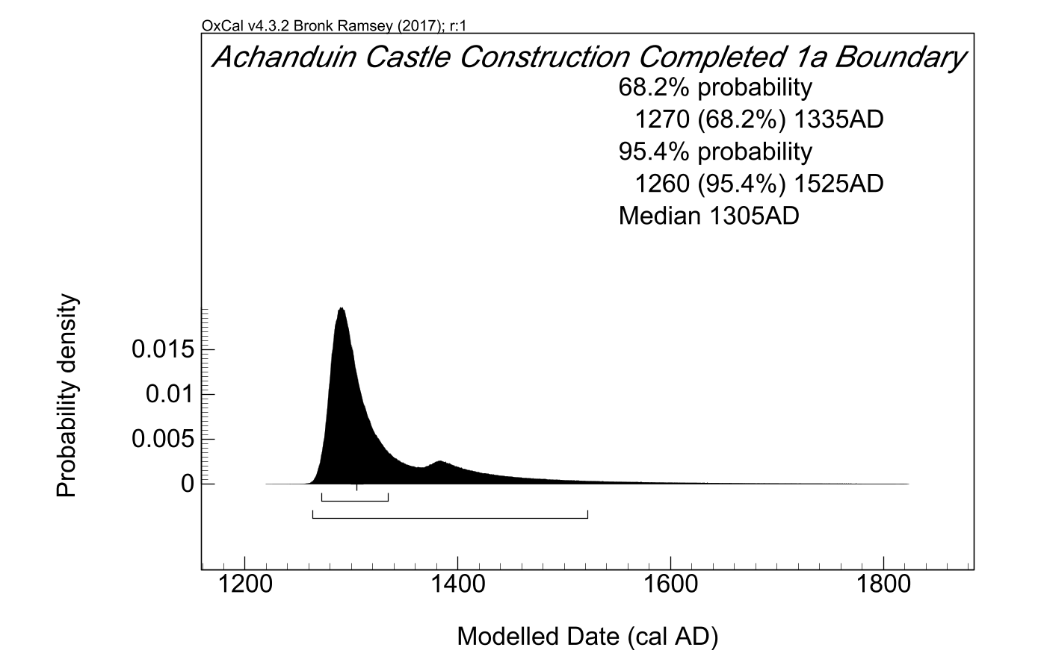
Fig. S2 (above). End Boundary probability distribution for Achanduin Castle generated by Model 1a (from ESM fig. S1 above). All probability distributions have been rounded out to 5 years.
- Achanduin Castle Model 1b
2.1 – Model 1b Script
Options()
{
Resolution=1 year;
kIterations=20000;
};
Plot()
{
Outlier_Model("General 1b",T(5),U(0,4),"t");
Sequence("Achanduin Castle Standalone Sequence 1b")
{
Tau_Boundary("Achanduin Castle Woodland Growth 1b");
Phase("Achanduin Castle MERLF Assemblage 1b")
{
R_Date("SUERC-62545", 701, 34)
{
Outlier("General 1b", 0.05);
};
R_Date("SUERC-62546", 698, 34)
{
Outlier("General 1b", 0.05);
};
R_Date("SUERC-62547", 785, 34)
{
Outlier("General 1b", 0.05);
};
Span("Achanduin Castle Assemblage Growth 1b");
};
Boundary("Achanduin Castle Construction Completed 1b");
};
Sequence("Achanduin Castle Multidisciplinary Sequence 1b")
{
Date("=Achanduin Castle Construction Completed 1b");
C_Date("Charter Reference", 1310, 0.05);
};
};

2.2 - Model 1b Table of Distributions
 | Unmodelled Distributions 1b (cal AD) |  | Modelled Distributions 1b (cal AD) |  | A Indices
 | 68.2% prob. | 95.4% prob | 68.2% prob. | 95.4% prob.
R-Date Codes
SUERC-62545 | 1265-1380 | 1255-1390 | 1270-1290 | 1260-1300 | 129.6
SUERC-62546 | 1270-1380 | 1255-1390 | 1270-1290 | 1265-1300 | 128.9
SUERC-62547 | 1220-1270 | 1185-1285 | 1245-1280 | 1215-1290 | 99.2
C-Dates
Charter Reference |  | 1305-1310 |  |  | 70.7
Generated
End Boundary |  |  | 1280-1305 | 1270-1310
Span |  |  | 0-40 | 0-70
Model |  |  |  |  | 108
Overall |  |  |  |  | 107.4
Table S2 – Probability Distributions associated with Model 1b. All distributions rounded out to 5 years. See 2.3 below for model specification.

2.3 – Model 1b Multiple Plot
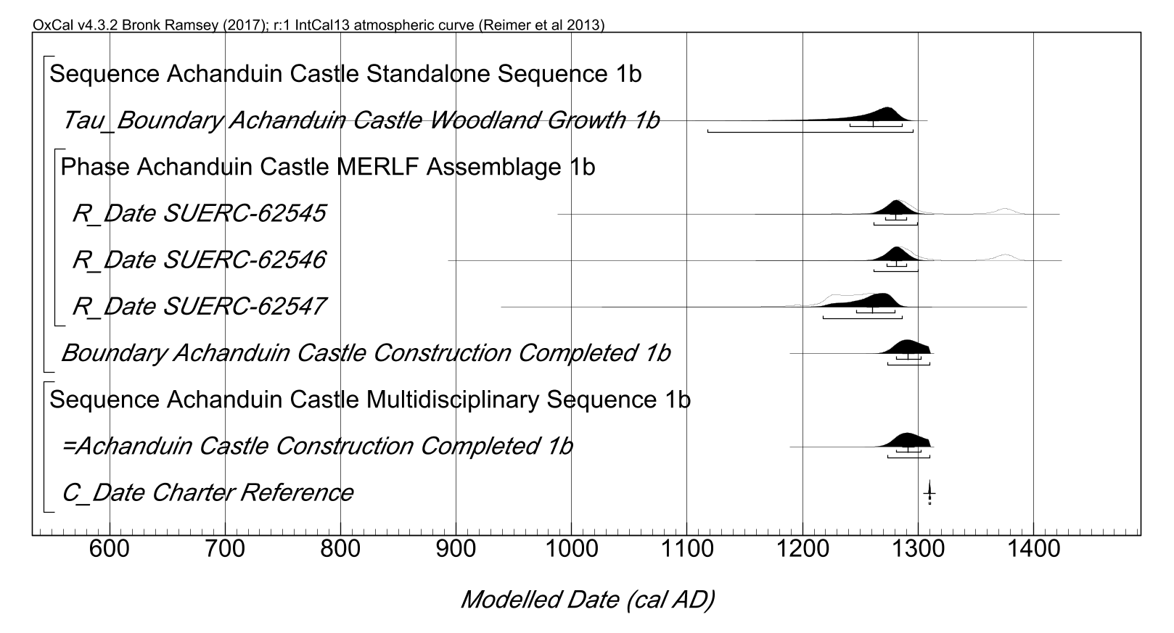
Fig. S3 (above). Probability distributions of dates from Achanduin Castle Model 1b, including phasing interpretations, radiocarbon data and 1304 charter reference. Plotted in OxCal v4.3.2 (Bronk Ramsey 2017), calibrated using IntCal13 atmospheric curve (Reimer et al 2013), this model was set at 1 year resolution and run with 20000 kIterations. The general methodology is the same as described for Fig. S1 (above), but a separate ‘multidisciplinary’ sequence has been added, constraining the Boundary distribution ‘Achanduin Castle Construction Completed 1b’ to a period before 1310 AD.
2.4 – Model 1b End Boundary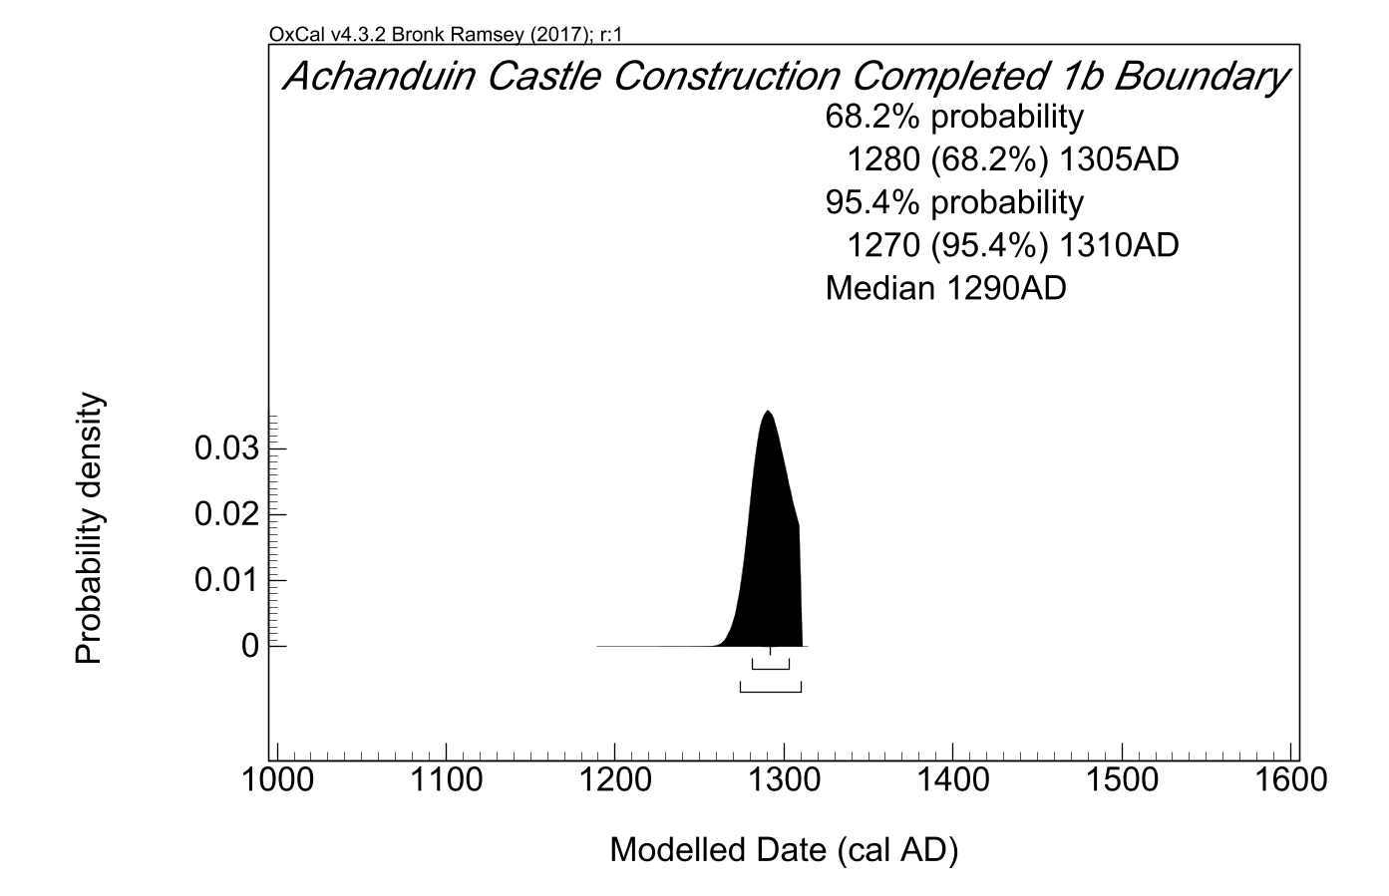
Fig. S4 (above). End Boundary probability distribution for Achanduin Castle generated by Model 1b (from model illustrated in fig. S3 above). All probability distributions have been rounded out to 5 years.
- – Achanduin Castle Model 1c
3.1 – Model 1c Script
Options()
{
Resolution=1 year;
kIterations=20000;
};
Plot()
{
Outlier_Model("General 1c",T(5),U(0,4),"t");
Sequence("Achanduin Castle Standalone Sequence 1c")
{
Tau_Boundary("Achanduin Castle Woodland Growth 1c");
Phase("Achanduin Castle MERLF Assemblage 1c")
{
R_Date("SUERC-62545", 701, 34)
{
Outlier("General 1c", 0.05);
};
R_Date("SUERC-62546", 698, 34)
{
Outlier("General 1c", 0.05);
};
R_Date("SUERC-62547", 785, 34)
{
Outlier("General 1c", 0.05);
};
Span("Achanduin Castle Assemblage Growth 1c");
};
Boundary("Achanduin Castle Construction Completed 1c");
};
Sequence("Achanduin Castle Multidisciplinary Sequence 1c")
{
C_Date("Balliol Coin", 1292, 0.05);
Date("=Achanduin Castle Construction Completed 1c");
C_Date("Charter Reference", 1310, 0.05);
};
};

3,2 – Model 1c Table of distributions
 | Unmodelled Distributions 1c (cal AD) |  | Modelled Distributions 1c (cal AD) |  | A Indices
 | 68.2% prob. | 95.4% prob | 68.2% prob. | 95.4% prob.
R-Date Codes
SUERC-62545 | 1265-1380 | 1255-1390 | 1275-1295 | 1260-1305 | 131.3
SUERC-62546 | 1270-1380 | 1255-1390 | 1275-1295 | 1260-1305 | 133
SUERC-62547 | 1220-1270 | 1185-1285 | 1235-1280 | 1210-1290 | 102.9
C-Dates
Charter Reference |  | 1305-1310 |  |  | 70.7
Balliol Coin |  | 1290-1295 |  |  | 70.7
Generated
End Boundary |  |  | 1290-1305 | 1290-1310
Span |  |  | 10-55 | 0-80
Model |  |  |  |  | 95.9
Overall |  |  |  |  | 95.7
Table S3 – Probability Distributions associated with Model 1c. All distributions rounded out to 5 years. See 3.3 below for model specification.

3.3 – Model 1c Multiple Plot
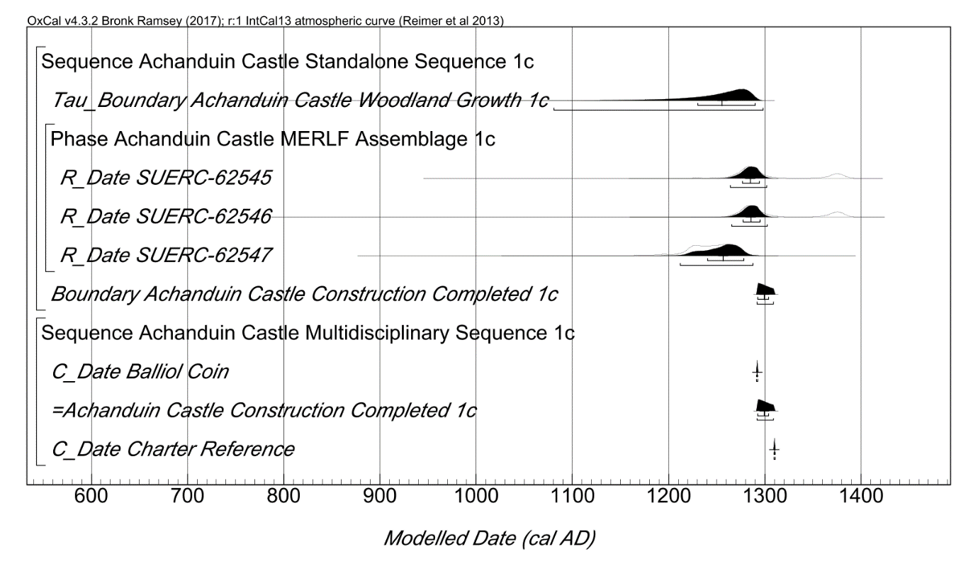
Fig. S5 (above). Probability distributions of dates from Achanduin Castle Model 1c, including phasing interpretations, radiocarbon data, 1304 charter reference and 1292 x 1296 coin. Plotted in OxCal v4.3.2 (Bronk Ramsey 2017), calibrated using IntCal13 atmospheric curve (Reimer et al 2013), this model was set at 1 year resolution and run with 20000 kIterations. The general methodology is the same as described for Fig. S1 (above), but a separate ‘multidisciplinary’ sequence has been added in which the Boundary distribution ‘Achanduin Castle Construction Completed 1c’ is constrained toa period after the 1292 and before 1310.
3.4 – Model 1c End Boundary
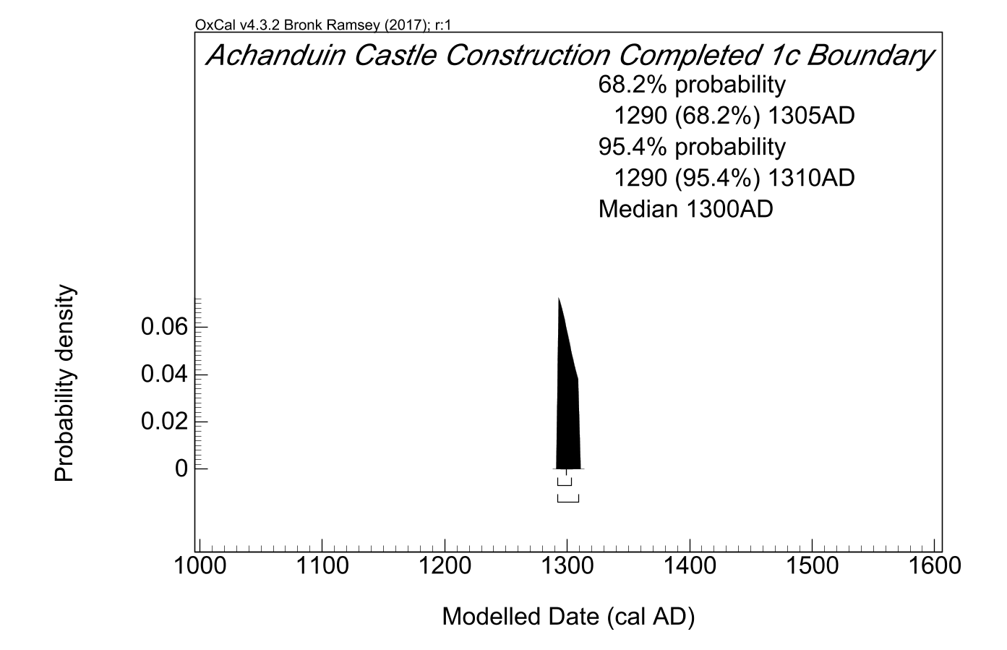
Fig. S6 (above). End Boundary probability distribution for Achanduin Castle generated by Model 1c (from model illustrated in fig. S5 above). All probability distributions have been rounded out to 5 years.
4.0 - Achanduin Castle Model 2a
4.1 - Model 2a Script
Options()
{
Resolution=1 year;
kIterations=20000;
};
Plot()
{
Outlier_Model("Charcoal 2a",Exp(1,-10,0),U(0,2),"t");
Sequence("Achanduin Castle Standalone Sequence 2a")
{
Boundary("Achanduin Castle Woodland Growth 2a");
Phase("Achanduin MERLF Assemblage 2a")
{
R_Date("SUERC-62545", 701, 34)
{
Outlier("Charcoal 2a", 1);
};
R_Date("SUERC-62546", 698, 34)
{
Outlier("Charcoal 2a", 1);
};
R_Date("SUERC-62547", 785, 34)
{
Outlier("Charcoal 2a", 1);
};
Span("Achanduin Castle Assemblage Growth 2a");
};
Boundary("Achanduin Castle Construction Completed 2a");
};
};

4.2 - Model 2a Table of Distributions
 | Unmodelled Distributions 2a (cal AD) |  | Modelled Distributions 2a (cal AD) |  | A Indices
 | 68.2% prob. | 95.4% prob | 68.2% prob. | 95.4% prob.
R-Date Codes
SUERC-62545 | 1265-1380 | 1255-1390 | 1270-1310 | 1255-1400 | 113.4
SUERC-62546 | 1270-1380 | 1255-1390 | 1270-1310 | 1260-1400 | 113.3
SUERC-62547 | 1220-1270 | 1185-1285 | 1240-1295 | 1205-1350 | 101.1
Generated
End Boundary |  |  | 1275-1400 | 1265-1825
Span |  |  | 0-55 | 0-145
Model |  |  |  |  | 114.2
Overall |  |  |  |  | 114
Table S4 – Probability Distributions associated with Model 2a. All distributions rounded out to 5 years. See 4.3 below for model specification.

4.3 - Model 2a Multiple Plot
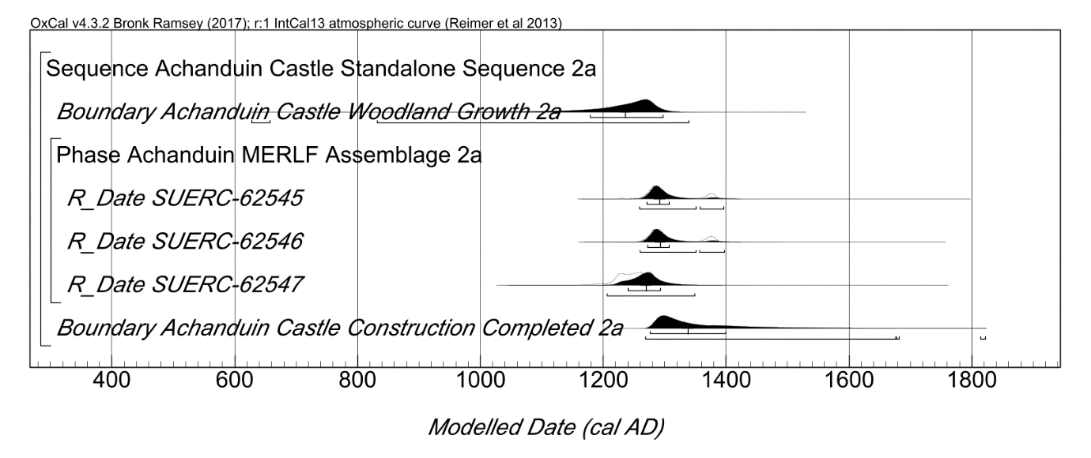
Fig. S7 (above). Probability distributions of dates from Achanduin Castle Model 2a, including phasing interpretations and radiocarbon data. Plotted in OxCal v4.3.2 (Bronk Ramsey 2017), calibrated using IntCal13 atmospheric curve (Reimer et al 2013), this model was set at 1 year resolution and run with 20000 kIterations. All three radiocarbon dates have been situated within a single phase and all five tagged with a 100% outlier probability within a ‘Charcoal’ outlier model (Bronk Ramsey 2009) modified to a time-constant of 100 years. Each distribution represents the relative probability than an event occurs at a particular time. The Boundary distribution ‘Achanduin Castle Construction Completed’ situated at the end of this phase is an estimate of the date when construction of Achanduin Castle was completed. Squared brackets beneath each distribution represent the highest probability distributions at 68.2% and 95.4% probability. A Span distribution was also generated by this model but is not included in these plots (see table S4).
4.4 - Model 2a End Boundary
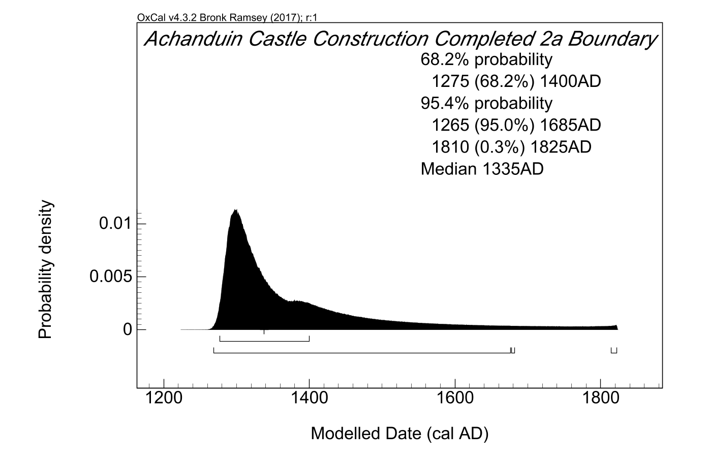
Fig. S8 (above). End Boundary probability distribution for Achanduin Castle generated by Model 2a (from model illustrated in fig. S7 above). All probability distributions have been rounded out to 5 years.
5.0 - Achanduin Castle Model 2b
5.1 - Model 2b Script
Options()
{
Resolution=1 year;
kIterations=20000;
};
Plot()
{
Outlier_Model("Charcoal 2b",Exp(1,-10,0),U(0,2),"t");
Sequence("Achanduin Castle Standalone Sequence 2b")
{
Boundary("Achanduin Castle Woodland Growth 2b");
Phase("Achanduin MERLF Assemblage 2b")
{
R_Date("SUERC-62545", 701, 34)
{
Outlier("Charcoal 2b", 1);
};
R_Date("SUERC-62546", 698, 34)
{
Outlier("Charcoal 2b", 1);
};
R_Date("SUERC-62547", 785, 34)
{
Outlier("Charcoal 2b", 1);
};
Span("Achanduin Castle Assemblage Growth 2b");
};
Boundary("Achanduin Castle Construction Completed 2b");
};
Sequence("Achanduin Castle Multidisciplinary Sequence 2b")
{
Date("=Achanduin Castle Construction Completed 2b");
C_Date("Charter Reference", 1310, 0.05);
};
};

5.2 - Model 2b Table of Distributions
 | Unmodelled Distributions 2b (cal AD) |  | Modelled Distributions 2b (cal AD) |  | A Indices
 | 68.2% prob. | 95.4% prob | 68.2% prob. | 95.4% prob.
R-Date Codes
SUERC-62545 | 1265-1380 | 1255-1390 | 1270-1295 | 1260-1305 | 123.5
SUERC-62546 | 1270-1380 | 1255-1390 | 1270-1295 | 1265-1305 | 122.9
SUERC-62547 | 1220-1270 | 1185-1285 | 1255-1290 | 1225-1305 | 97.5
C-Dates
Charter Reference |  | 1305-1310 |  |  | 70.6
Generated
End Boundary |  |  | 1285-1310 | 1275-1310
Span |  |  | 0-30 | 0-60
Model |  |  |  |  | 101.9
Overall |  |  |  |  | 102
Table S5 – Probability Distributions associated with Model 2b. All distributions rounded out to 5 years. See 5.3 below for model specification.
5.3 - Model 2b Multiple Plot
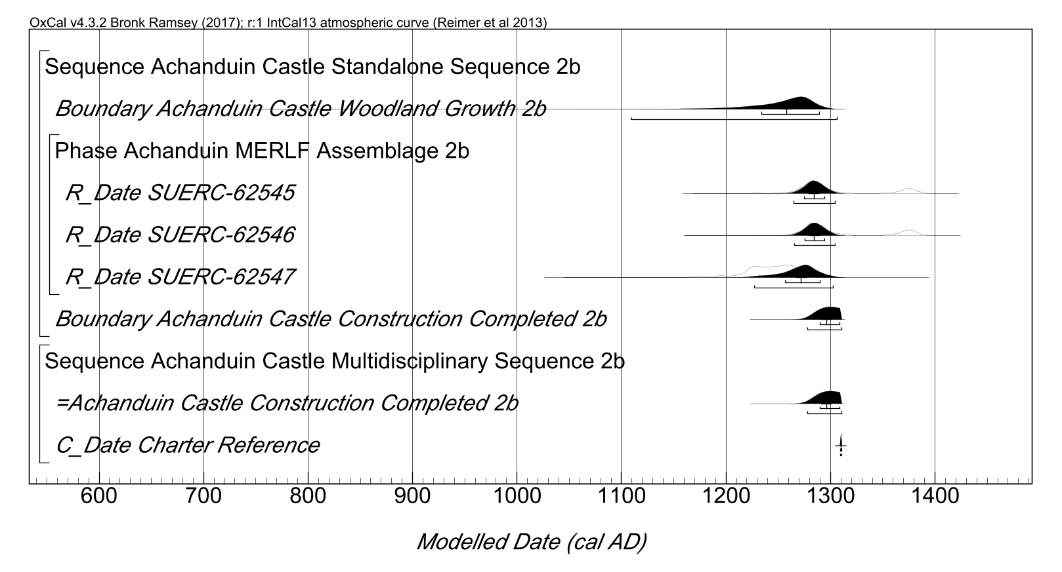
Fig. S9 (above). Probability distributions of dates from Achanduin Castle Model 2b, including phasing interpretations, radiocarbon data and 1304 charter reference. Plotted in OxCal v4.3.2 (Bronk Ramsey 2017), calibrated using IntCal13 atmospheric curve (Reimer et al 2013), this model was set at 1 year resolution and run with 20000 kIterations. The general methodology is the same as described for fig. S7 (above), but a separate ‘multidisciplinary’ sequence has been added in which the Boundary distribution ‘Achanduin Castle Construction Completed 2b’ is constrained to a period before 1310 AD.
5.4 - Model 2b End boundary
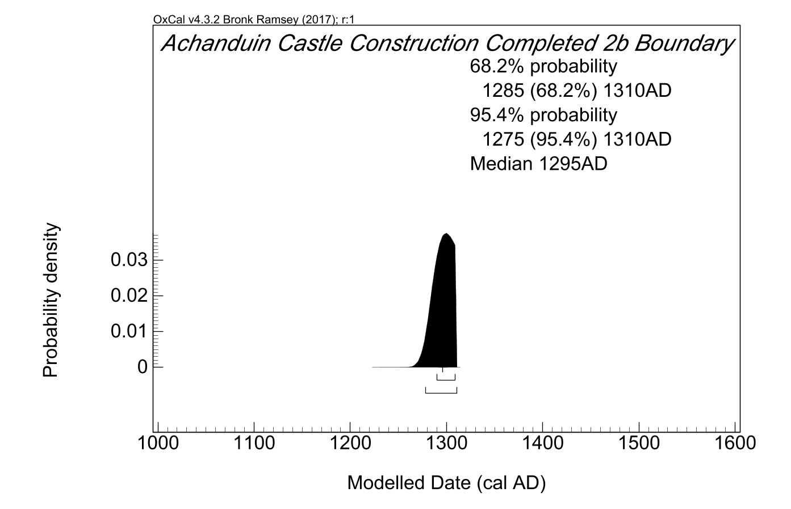
Fig. S10 (above). End Boundary probability distribution for Achanduin Castle generated by Model 2b (from model illustrated in fig. S9 above). All probability distributions have been rounded out to 5 years.

6.0 - Achanduin Castle Model 2c
6.1 – Model 2c Script
Options()
{
Resolution=1 year;
kIterations=20000;
};
Plot()
{
Outlier_Model("Charcoal 2c",Exp(1,-10,0),U(0,2),"t");
Sequence("Achanduin Castle Standalone Sequence 2c")
{
Boundary("Achanduin Castle Woodland Growth 2c");
Phase("Achanduin MERLF Assemblage 2c")
{
R_Date("SUERC-62545", 701, 34)
{
Outlier("Charcoal 2c", 1);
};
R_Date("SUERC-62546", 698, 34)
{
Outlier("Charcoal 2c", 1);
};
R_Date("SUERC-62547", 785, 34)
{
Outlier("Charcoal 2c", 1);
};
Span("Achanduin Castle Assemblage Growth 2c");
};
Boundary("Achanduin Castle Construction Completed 2c");
};
Sequence("Achanduin Castle Multidisciplinary Sequence 2c")
{
C_Date("Balliol Coin", 1292, 0.05);
Date("=Achanduin Castle Construction Completed 2c");
C_Date("Charter Reference", 1310, 0.05);
};
};

6.2 – Model 2c Table of Distributions
 | Unmodelled Distributions 2c (cal AD) |  | Modelled Distributions 2c (cal AD) |  | A Indices
 | 68.2% prob. | 95.4% prob | 68.2% prob. | 95.4% prob.
R-Date Codes
SUERC-62545 | 1265-1380 | 1255-1390 | 1275-1300 | 1265-1310 | 128.8
SUERC-62546 | 1270-1380 | 1255-1390 | 1275-1300 | 1265-1310 | 129.7
SUERC-62547 | 1220-1270 | 1185-1285 | 1255-1295 | 1225-1305 | 99.3
C-Dates
Charter Reference |  | 1305-1310 |  |  | 70.7
Balliol Coin |  | 1290-1295 |  |  | 70.7
Generated
End Boundary |  |  | 1290-1310 | 1290-1310
Span |  |  | 0-30 | 0-65
Model |  |  |  |  | 92.2
Overall |  |  |  |  | 92.6
Table S6 – Probability Distributions associated with Model 2c. All distributions rounded out to 5 years.
6.3 – Model 2c Multiple Plot
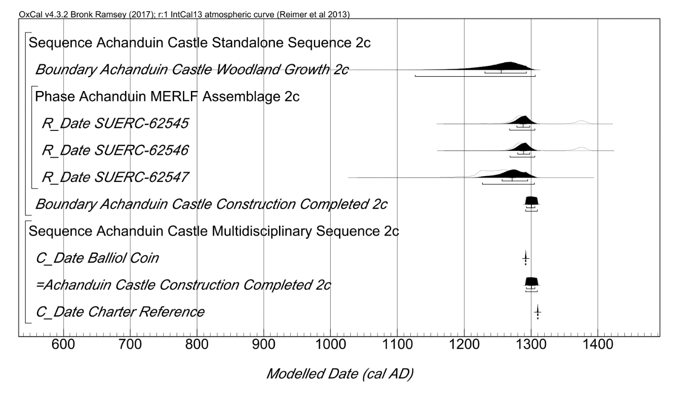
Fig. S11 (above). Probability distributions of dates from Achanduin Castle Model 2c, including phasing interpretations, radiocarbon data, 1304 charter reference and 1292 x 1296 coin. Plotted in OxCal v4.3.2 (Bronk Ramsey 2017), calibrated using IntCal13 atmospheric curve (Reimer et al 2013), this model was set at 1 year resolution and run with 20000 kIterations. The general methodology is the same as described for Fig. S7 (above), but a separate ‘multidisciplinary’ sequence has been added in which the Boundary distribution ‘Achanduin Castle Construction Completed 2c’ is constrained to a period after 1292 and before 1310 AD.
6.4 – Model 2c End Boundary
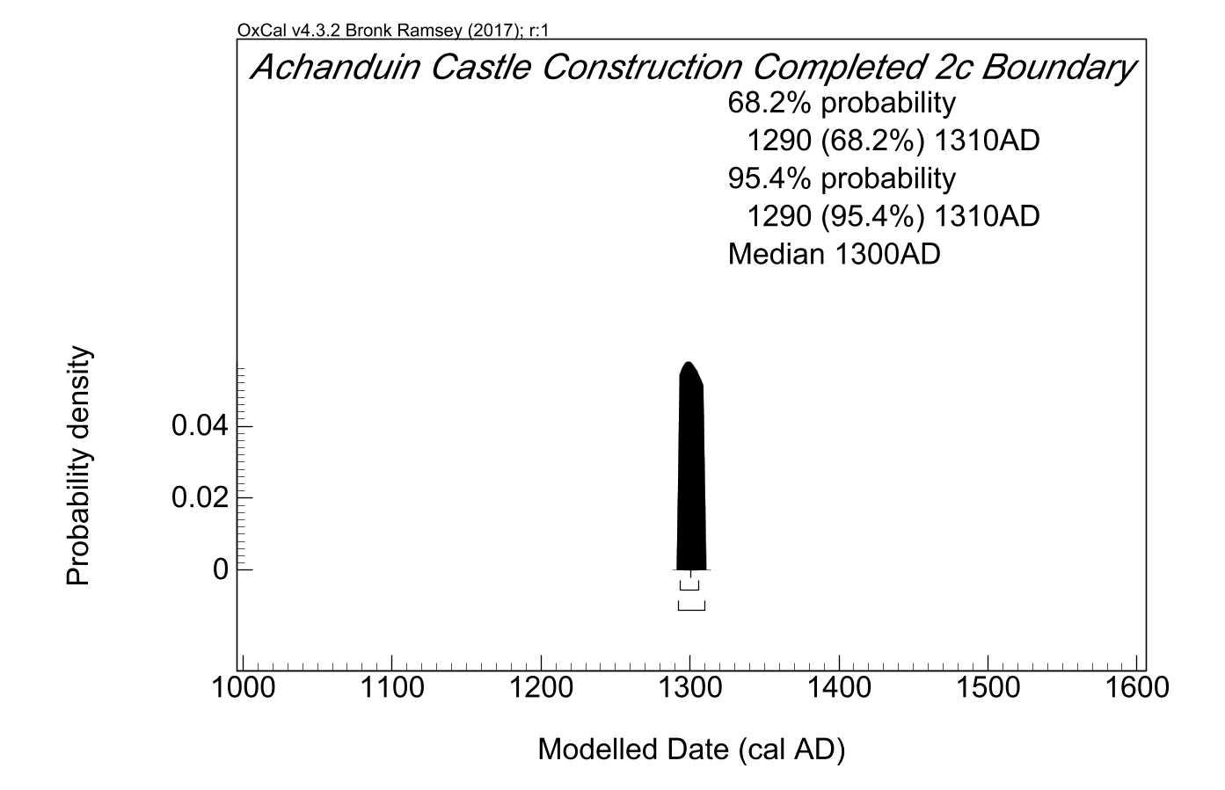
Fig. S12 (above). End Boundary probability distribution for Achanduin Castle generated by Model 2c (from model illustrated in fig. S11 above). All probability distributions have been rounded out to 5 years.
7.0 - Achanduin Castle Model 3a
7.1 – Model 3a Script
Options()
{
Resolution=1 year;
kIterations=20000;
};
Plot()
{
Outlier_Model("Charcoal 3a",Exp(1,-10,0),U(0,3),"t");
Sequence("Achanduin Castle Standalone Sequence 3a")
{
Boundary("Achanduin Castle Woodland Growth 3a");
Phase("Achanduin Assemblage 3a")
{
R_Date("SUERC-62545", 701, 34)
{
Outlier("Charcoal 3a", 1);
};
R_Date("SUERC-62546", 698, 34)
{
Outlier("Charcoal 3a", 1);
};
R_Date("SUERC-62547", 785, 34)
{
Outlier("Charcoal 3a", 1);
};
Span("Achanduin Castle Assemblage Growth 3a");
};
Boundary("Achanduin Castle Construction Completed 3a");
};
};

7.2 - Model 3a Table of Distributions
 | Unmodelled Distributions 3a (cal AD) |  | Modelled Distributions 3a (cal AD) |  | A Indices
 | 68.2% prob. | 95.4% prob | 68.2% prob. | 95.4% prob.
R-Date Codes
SUERC-62545 | 1265-1380 | 1255-1390 | 1265-1315 | 1255-1435 | 111.8
SUERC-62546 | 1270-1380 | 1255-1390 | 1265-1315 | 1255-1435 | 111.7
SUERC-62547 | 1220-1270 | 1185-1285 | 1230-1295 | 1190-1400 | 101.3
Generated
End Boundary |  |  | 1275-1435 | 1265-1825
Span |  |  | 0-30 | 0-65
Model |  |  |  |  | 112.8
Overall |  |  |  |  | 112.5
Table S7 – Probability Distributions associated with Model 3a. All distributions rounded out to 5 years. See 7.3 below for model specification.

7.3 – Model 3a Multiple Plot
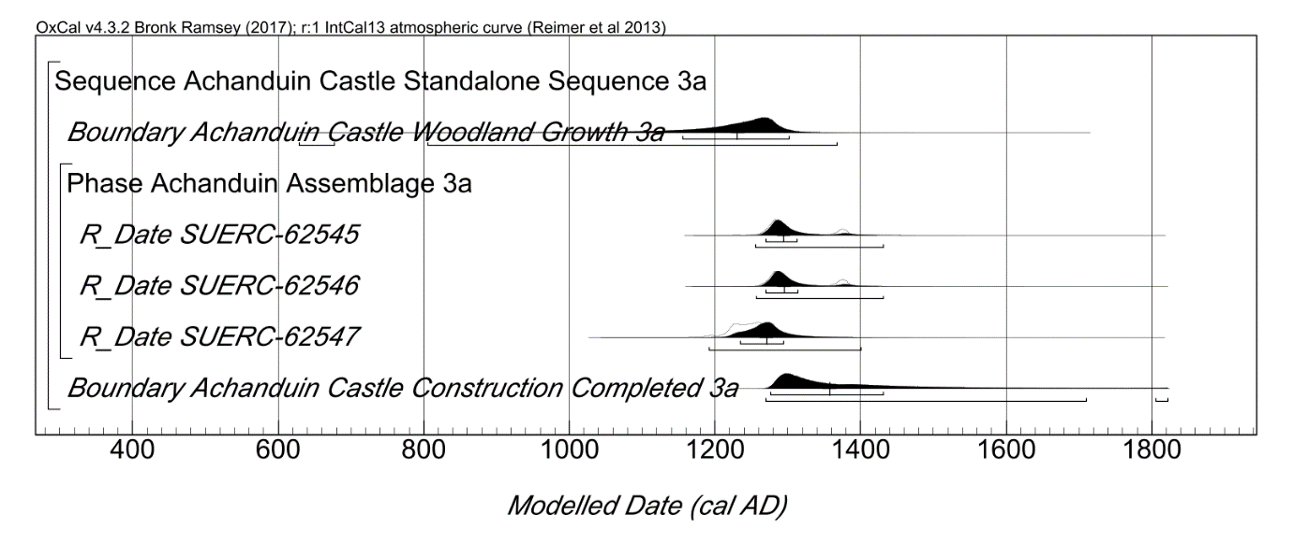
Fig. S13 (above). Probability distributions of dates from Achanduin Castle Model 3a, including phasing interpretations and radiocarbon data. Plotted in OxCal v4.3.2 (Bronk Ramsey 2017), calibrated using IntCal13 atmospheric curve (Reimer et al 2013), this model was set at 1 year resolution and run with 20000 kIterations. All three radiocarbon dates have been situated within a single phase and all five tagged with a 100% outlier probability within the default ‘Charcoal’ outlier model (Bronk Ramsey 2009) with a time-constant of 1,000 years. Each distribution represents the relative probability than an event occurs at a particular time. The Boundary distribution ‘Achanduin Castle Construction Completed 3a’ situated at the end of this phase is an estimate of the date when construction of Achanduin Castle was completed. Squared brackets beneath each distribution represent the highest probability distributions at 68.2% and 95.4% probability. A Span distribution was also generated by this model but is not included in these plots (see table S7).

7.4 – Model 3a End Boundary
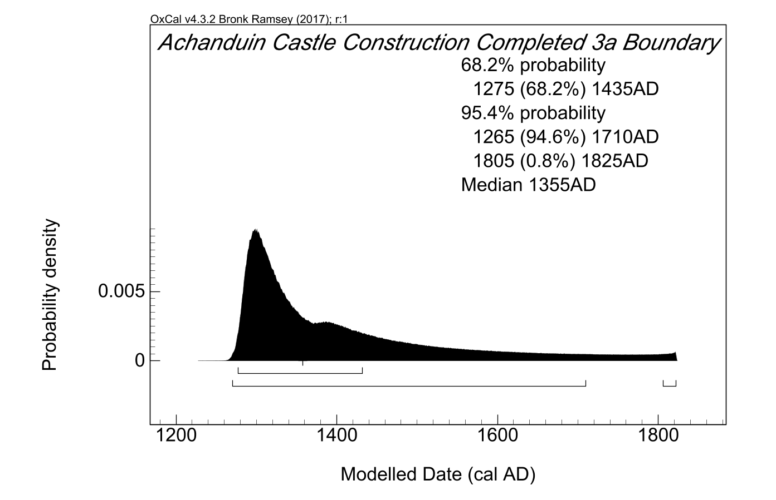
Fig. S14 (above). End Boundary probability distribution for Achanduin Castle generated by Model 3a (from model illustrated in fig. S13 above). All probability distributions have been rounded out to 5 years.
8.0 - Achanduin Castle Model 3b
8.1 – Model 3b Script
Options()
{
Resolution=1 year;
kIterations=20000;
};
Plot()
{
Outlier_Model("Charcoal 3b",Exp(1,-10,0),U(0,3),"t");
Sequence("Achanduin Castle Standalone Sequence 3b")
{
Boundary("Achanduin Castle Woodland Growth 3b");
Phase("Achanduin MERLF Assemblage 3b")
{
R_Date("SUERC-62545", 701, 34)
{
Outlier("Charcoal 3b", 1);
};
R_Date("SUERC-62546", 698, 34)
{
Outlier("Charcoal 3b", 1);
};
R_Date("SUERC-62547", 785, 34)
{
Outlier("Charcoal 3b", 1);
};
Span("Achanduin Castle Assemblage Growth 3b");
};
Boundary("Achanduin Castle Construction Completed 3b");
};
Sequence("Achanduin Castle Multidisciplinary Sequence 3b")
{
Date("=Achanduin Castle Construction Completed 3b");
C_Date("Charter Reference", 1310, 0.05);
};
};

8.2 – Model 3b Table of Distributions
 | Unmodelled Distributions 3b (cal AD) |  | Modelled Distributions 3b (cal AD) |  | A Indices
 | 68.2% prob. | 95.4% prob | 68.2% prob. | 95.4% prob.
R-Date Codes
SUERC-62545 | 1265-1380 | 1255-1390 | 1270-1295 | 1260-1305 | 123.4
SUERC-62546 | 1270-1380 | 1255-1390 | 1270-1295 | 1265-1305 | 122.8
SUERC-62547 | 1220-1270 | 1185-1285 | 1255-1290 | 1225-1305 | 97.6
C-Dates
Charter Reference |  | 1305-1310 |  |  | 70.8
Generated
End Boundary |  |  | 1285-1310 | 1275-1310
Span |  |  | 0-30 | 0-60
Model |  |  |  |  | 101.9
Overall |  |  |  |  | 102
Table S8 – Probability Distributions associated with Model 3b. All distributions rounded out to 5 years. See 8.3 below for model specification.
8.3 – Model 3b Multiple Plot
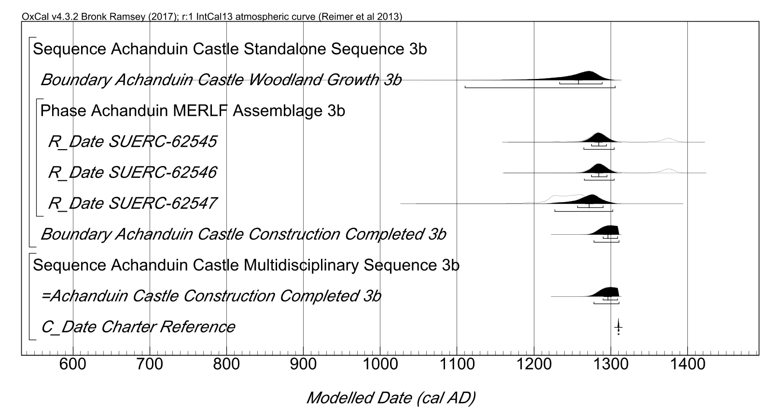
Fig. S15 (above). Probability distributions of dates from Achanduin Castle Model 3b, including phasing interpretations, radiocarbon data and 1304 charter reference. Plotted in OxCal v4.3.2 (Bronk Ramsey 2017), calibrated using IntCal13 atmospheric curve (Reimer et al 2013), this model was set at 1 year resolution and run with 20000 kIterations. The general methodology is the same as described for fig. S13 (above), but a separate ‘multidisciplinary’ sequence has been added which constrains the Boundary distribution ‘Achanduin Castle Construction Completed 3b’ to a period before 1310 AD.
8.4 – Model 3b End Boundary
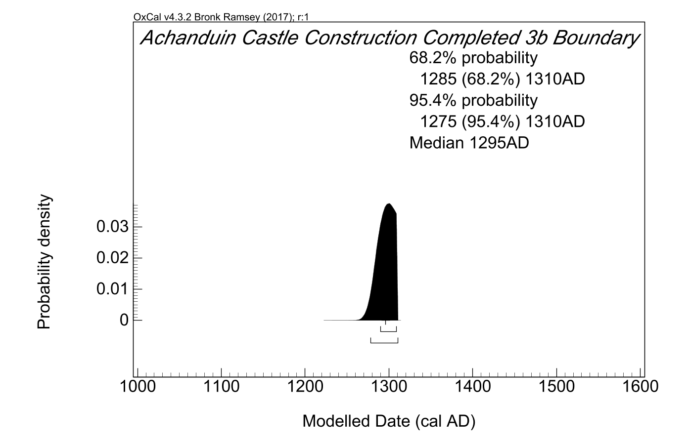
Fig. S16 (above). End Boundary probability distribution for Achanduin Castle generated by Model 3b (from model illustrated in fig. S15 above). All probability distributions have been rounded out to 5 years.
9.0 - Achanduin Castle Model 3c
9.1 – Model 3c Script
Options()
{
Resolution=1 year;
kIterations=20000;
};
Plot()
{
Outlier_Model("Charcoal 3c",Exp(1,-10,0),U(0,3),"t");
Sequence("Achanduin Castle Standalone Sequence 3c")
{
Boundary("Achanduin Castle Woodland Growth 3c");
Phase("Achanduin MERLF Assemblage 3c")
{
R_Date("SUERC-62545", 701, 34)
{
Outlier("Charcoal 3c", 1);
};
R_Date("SUERC-62546", 698, 34)
{
Outlier("Charcoal 3c", 1);
};
R_Date("SUERC-62547", 785, 34)
{
Outlier("Charcoal 3c", 1);
};
Span("Achanduin Castle Assemblage Growth 3c");
};
Boundary("Achanduin Castle Construction Completed 3c");
};
Sequence("Achanduin Castle Multidisciplinary Sequence 3c")
{
C_Date("Balliol Coin", 1292, 0.05);
Date("=Achanduin Castle Construction Completed 3c");
C_Date("Charter Reference", 1310, 0.05);
};
};

9.2 Model 3c Table of Distributions
 | Unmodelled Distributions 3c (cal AD/AD) |  | Modelled Distributions 3c (cal AD) |  | A Indices
 | 68.2% prob. | 95.4% prob | 68.2% prob. | 95.4% prob.
R-Date Codes
SUERC-62545 | 1265-1380 | 1255-1390 | 1275-1300 | 1265-1310 | 128.7
SUERC-62546 | 1270-1380 | 1255-1390 | 1275-1300 | 1265-1310 | 129.7
SUERC-62547 | 1220-1270 | 1185-1285 | 1255-1295 | 1225-1305 | 99.3
C-Dates
Charter Reference |  | 1305-1310 |  |  | 70.8
Balliol Coin |  | 1290-1295 |  |  | 70.8
Generated
End Boundary |  |  | 1290-1310 | 1290-1310
Span |  |  | 0-30 | 0-65
Model |  |  |  |  | 92.3
Overall |  |  |  |  | 92.7
Table S9 – Probability Distributions associated with Model 3c. All distributions rounded out to 5 years.
9.3 - 3c Multiple Plot
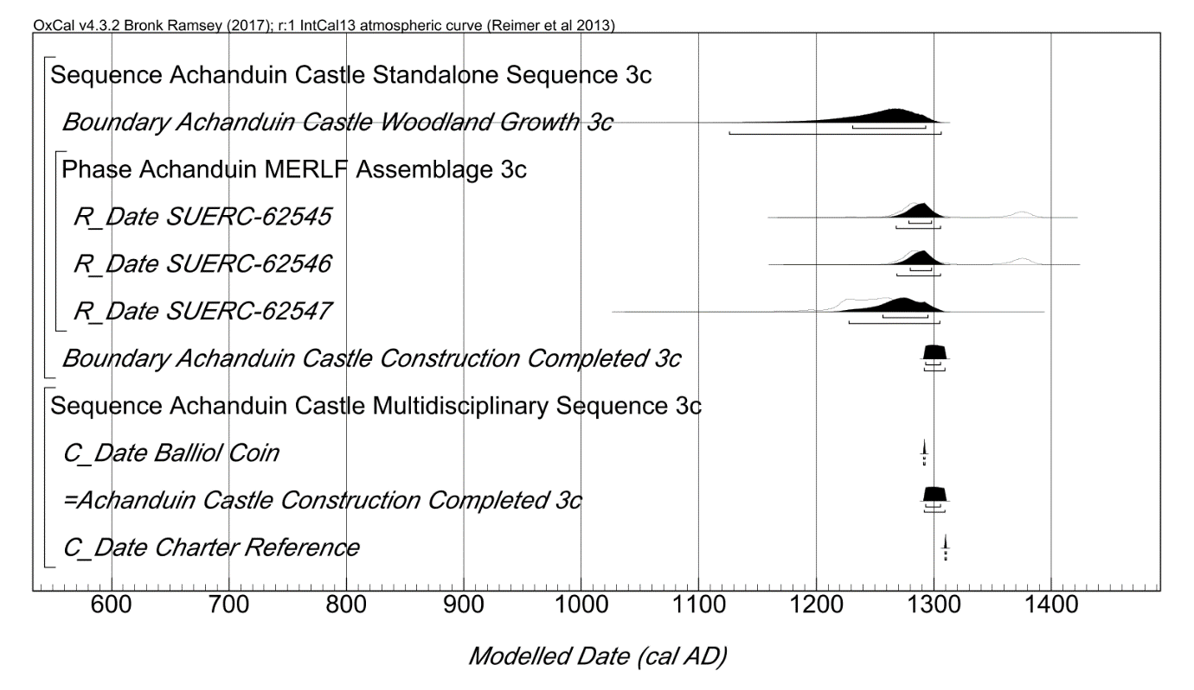
Fig. S17 (above). Probability distributions of dates from Achanduin Castle Model 3c, including phasing interpretations, radiocarbon data, 1304 charter reference and 1292 x 1296 coin. Plotted in OxCal v4.3.2 (Bronk Ramsey 2017), calibrated using IntCal13 atmospheric curve (Reimer et al 2013), this model was set at 1 year resolution and run with 20000 kIterations. The general methodology is the same as described for fig. S13 (above), but a separate ‘multidisciplinary’ sequence has been added in which the Boundary distribution ‘Achanduin Castle Construction Completed 3c’ is constrained to a period before 1310 and after 1292 AD..
9.4 – Model 3c End Boundary
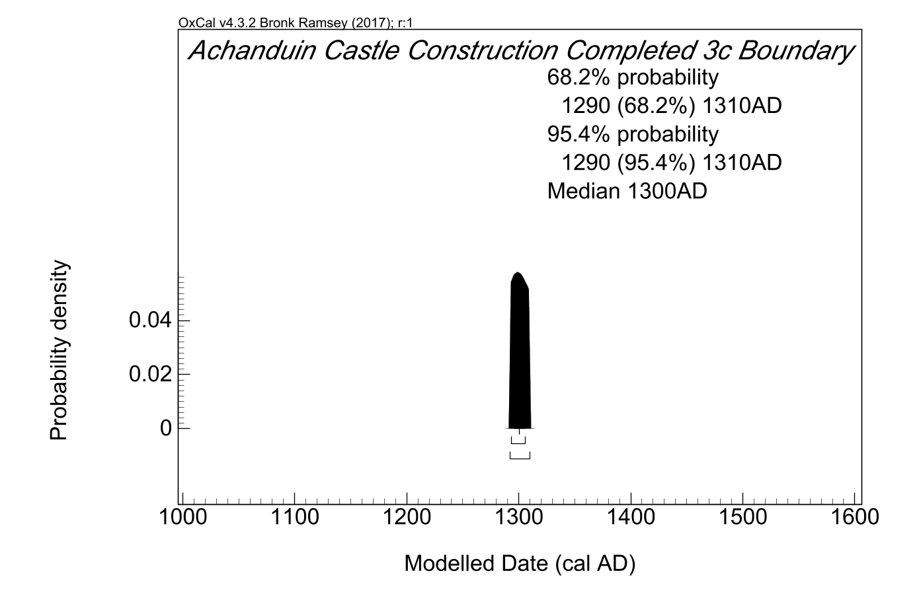
Fig. S18 (above). End Boundary probability distribution for Achanduin Castle generated by Model 3c (from model illustrated in fig. S17 above). All probability distributions have been rounded out to 5 years.
10.0 - Achanduin Castle Model 4a
10.1 – Model 4a Script
Options()
{
Resolution=1 year;
kIterations=20000;
};
Plot()
{
Sequence("Achanduin Castle Standalone Sequence 4a")
{
Boundary("Achanduin Castle Woodland Growth 4a");
Phase("Achanduin Castle MERLF Assemblage 4a")
{
R_Date("SUERC-62545", 701, 34)
{
};
R_Date("SUERC-62546", 698, 34)
{
};
R_Date("SUERC-62547", 785, 34)
{
};
Span("Achanduin Castle Assemblage Growth 4a");
};
Boundary("Achanduin Castle Construction Completed 4a");
};
};

10.2 – Model 4a Table of Distributions

 | Unmodelled Distributions 4a (cal AD) |  | Modelled Distributions 4a (cal AD) |  | A Indices
 | 68.2% prob. | 95.4% prob | 68.2% prob. | 95.4% prob.
R-Date Codes
SUERC-62545 | 1265-1380 | 1255-1390 | 1270-1295 | 1255-1385 | 116.6
SUERC-62546 | 1270-1380 | 1255-1390 | 1270-1295 | 1255-1385 | 116
SUERC-62547 | 1220-1270 | 1185-1285 | 1245-1280 | 1215-1285 | 96.5
Generated
End Boundary |  |  | 1270-1340 | 1260-1565
Span |  |  | 0-45 | 0-135
Model |  |  |  |  | 115.6
Overall |  |  |  |  | 116.6
Table S10 – Probability Distributions associated with Model 4a. All distributions rounded out to 5 years. See 10.3 below for model specification.

10.3 – Model 4a Multiple Plot
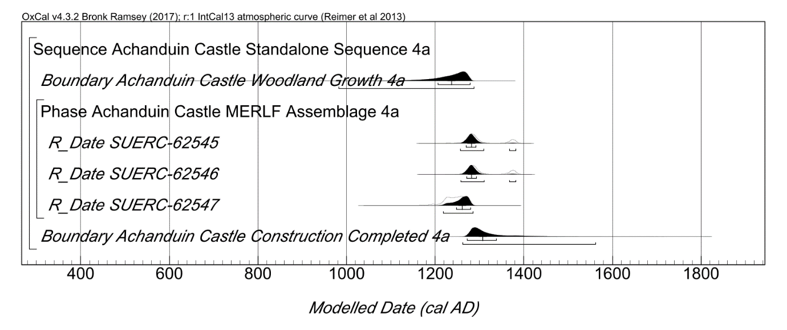
Fig. S19 (above). Probability distributions of dates from Achanduin Castle Model 3a, including phasing interpretations and radiocarbon data. Plotted in OxCal v4.3.2 (Bronk Ramsey 2017), calibrated using IntCal13 atmospheric curve (Reimer et al 2013), this model was set at 1 year resolution and run with 20000 kIterations. All three radiocarbon dates have been situated within a single phase and the Boundary distribution ‘Achanduin Castle Construction Completed 4a’ situated at the end of this phase is an estimate of the date when construction of Achanduin Castle was completed. Squared brackets beneath each distribution represent the highest probability distributions at 68.2% and 95.4% probability. A Span distribution was also generated by this model but is not included in these plots (see table S10).

10.4 – Model 4a End Boundary
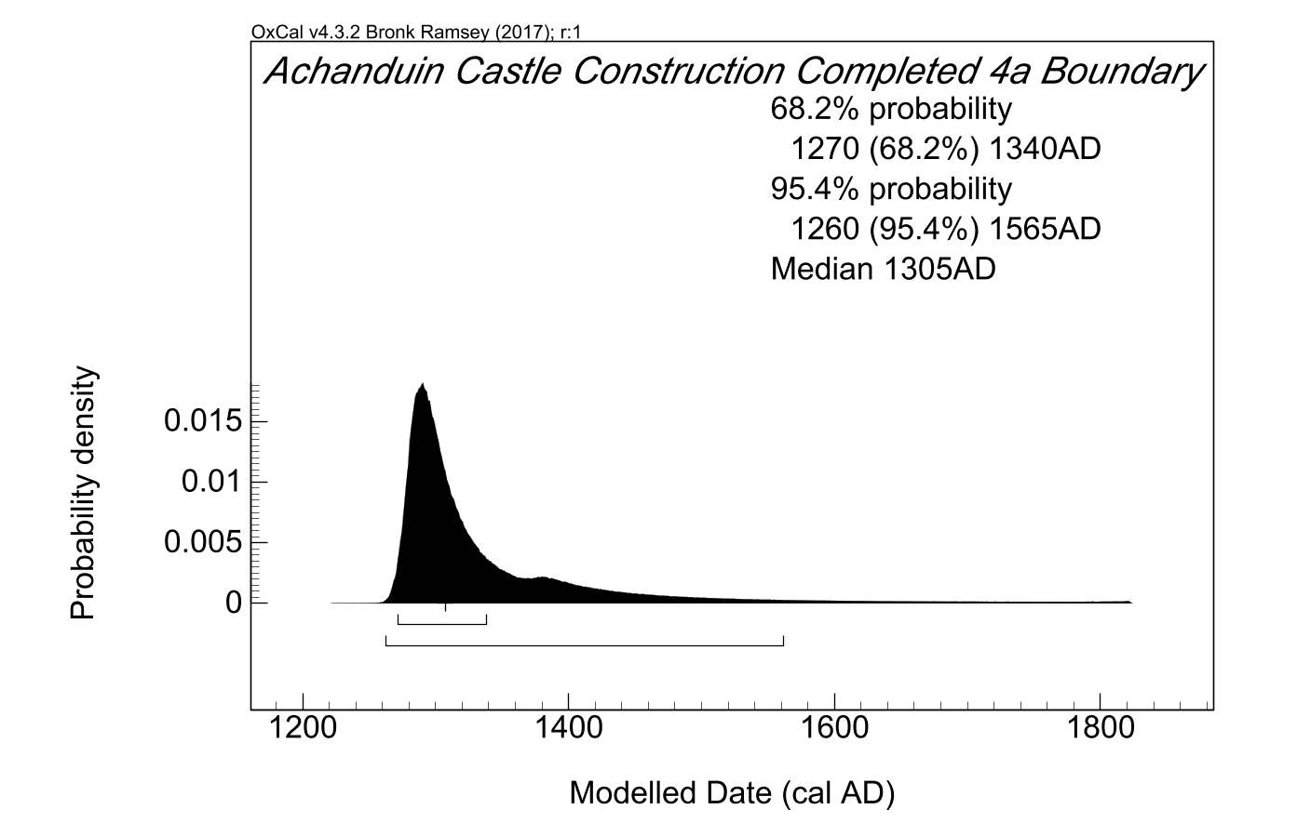
Fig. S20 (above). End Boundary probability distribution for Achanduin Castle generated by Model 4a (from model illustrated in fig. S19 above). All probability distributions have been rounded out to 5 years.

11.0 - Achanduin Castle Model 4b
11.1 – Model 4b Script
Options()
{
Resolution=1 year;
kIterations=20000;
};
Plot()
{
Sequence("Achanduin Castle Standalone Sequence 4b")
{
Boundary("Achanduin Castle Woodland Growth 4b");
Phase("Achanduin Castle MERLF Assemblage 4b")
{
R_Date("SUERC-62545", 701, 34)
{
};
R_Date("SUERC-62546", 698, 34)
{
};
R_Date("SUERC-62547", 785, 34)
{
};
Span("Achanduin Castle Assemblage Growth 4b");
};
Boundary("Achanduin Castle Construction Completed 4b");
};
Sequence("Achanduin Castle Multidisciplinary Sequence 4b")
{
Date("=Achanduin Castle Construction Completed 4b");
C_Date("Charter Reference", 1310, 0.05);
};
};

11,2 – Model 4b Table of Distributions

 | Unmodelled Distributions 4b (cal AD) |  | Modelled Distributions 4b (cal AD) |  | A Indices
 | 68.2% prob. | 95.4% prob | 68.2% prob. | 95.4% prob.
R-Date Codes
SUERC-62545 | 1265-1380 | 1255-1390 | 1270-1290 | 1260-1300 | 122.8
SUERC-62546 | 1270-1380 | 1255-1390 | 1270-1290 | 1265-1300 | 121.9
SUERC-62547 | 1220-1270 | 1185-1285 | 1250-1280 | 1220-1285 | 93.2
C-Dates
Charter Reference |  | 1305-1310 |  |  | 70.8
Generated
End Boundary |  |  | 1280-1305 | 1270-1310
Span |  |  | 0-30 | 0-65
Model |  |  |  |  | 98.6
Overall |  |  |  |  | 99.3
Table S11 – Probability Distributions associated with Model 4b. All distributions rounded out to 5 years. See 10.4 below for model specification.

11.3 – Model 4b Multiple Plot
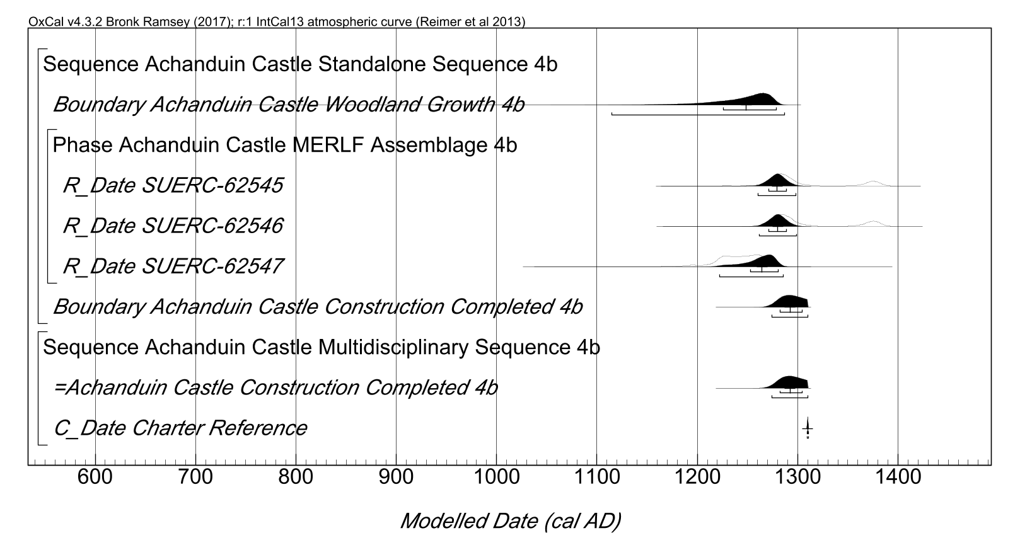
Fig. S21 (above). Probability distributions of dates from Achanduin Castle Model 4b, including phasing interpretations, radiocarbon data and 1304 charter reference. Plotted in OxCal v4.3.2 (Bronk Ramsey 2017), calibrated using IntCal13 atmospheric curve (Reimer et al 2013), this model was set at 1 year resolution and run with 20000 kIterations. The general methodology is the same as described for fig. S19 (above), but with an additional ‘multidisciplinary’ sequence constraining the Boundary distribution ‘Achanduin Castle Construction Completed 4b’ to a period before 1310 AD. A span distribution was also included in the phase (see table S11).

11.4 – Model 4b End Boundary
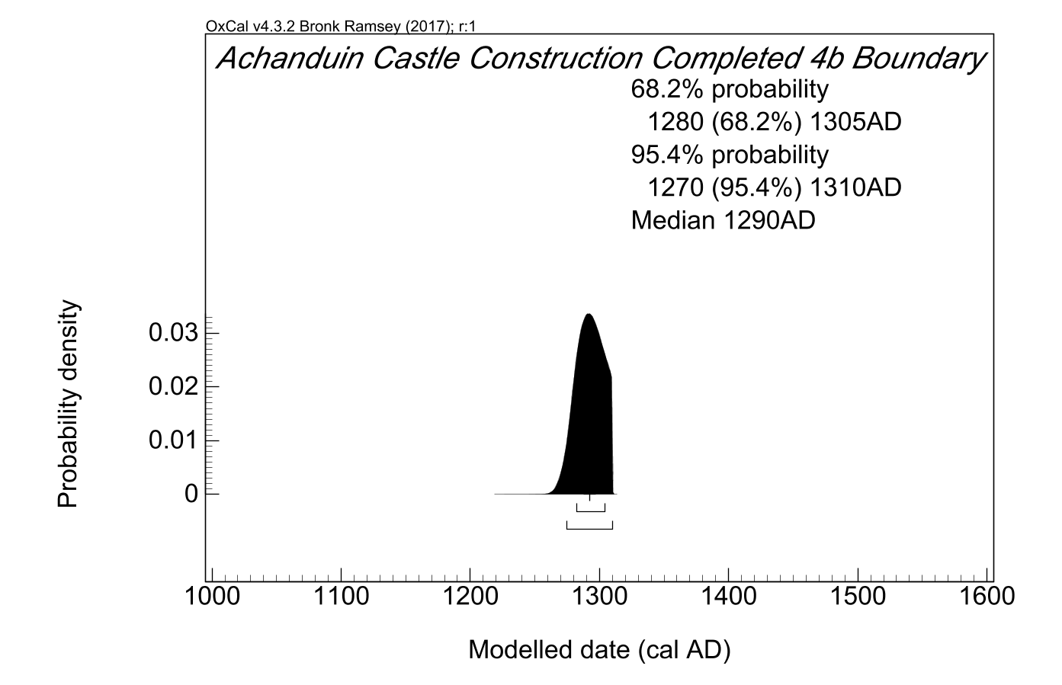
Fig. S22 (above). End Boundary probability distribution for Achanduin Castle generated by Model 4b (from model illustrated in fig. S21 above). All probability distributions have been rounded out to 5 years.
12.0 - Achanduin Castle Model 4c
12.1 – Model 4c Script
Options()
{
Resolution=1 year;
kIterations=20000;
};
Plot()
{
Sequence("Achanduin Castle Standalone Sequence 4c")
{
Boundary("Achanduin Castle Woodland Growth 4c");
Phase("Achanduin Castle MERLF Assemblage 4c")
{
R_Date("SUERC-62545", 701, 34)
{
};
R_Date("SUERC-62546", 698, 34)
{
};
R_Date("SUERC-62547", 785, 34)
{
};
Span("Achanduin Castle Assemblage Growth 4c");
};
Boundary("Achanduin Castle Construction Completed 4c");
};
Sequence("Achanduin Castle Multidisciplinary Sequence 4c")
{
C_Date("Balliol Coin", 1292, 0.05);
Date("=Achanduin Castle Construction Completed 4c");
C_Date("Charter Reference", 1310, 0.05);
};
};

12,2 – Model 4c Table of Distributions
 | Unmodelled Distributions 4c (cal AD/AD) |  | Modelled Distributions 4c (cal AD) |  | A Indices
 | 68.2% prob. | 95.4% prob | 68.2% prob. | 95.4% prob.
R-Date Codes
SUERC-62545 | 1265-1380 | 1255-1390 | 1270-1295 | 1260-1305 | 126.9
SUERC-62546 | 1270-1380 | 1255-1390 | 1270-1295 | 1260-1305 | 128.1
SUERC-62547 | 1220-1270 | 1185-1285 | 1245-1280 | 1215-1385 | 97.8
C-Dates
Charter Reference |  | 1305-1310 |  |  | 70.7
Balliol Coin |  | 1290-1295 |  |  | 70.7
Generated
End Boundary |  |  | 1290-1305 | 1290-1310
Span |  |  | 0-45 | 0-70
Model |  |  |  |  | 89.6
Overall |  |  |  |  | 90.2
Table S12 – Probability Distributions associated with Model 4c. All distributions rounded out to 5 years. See 12.3 below for model specification.

12.3 – Model 4c Multiple Plot
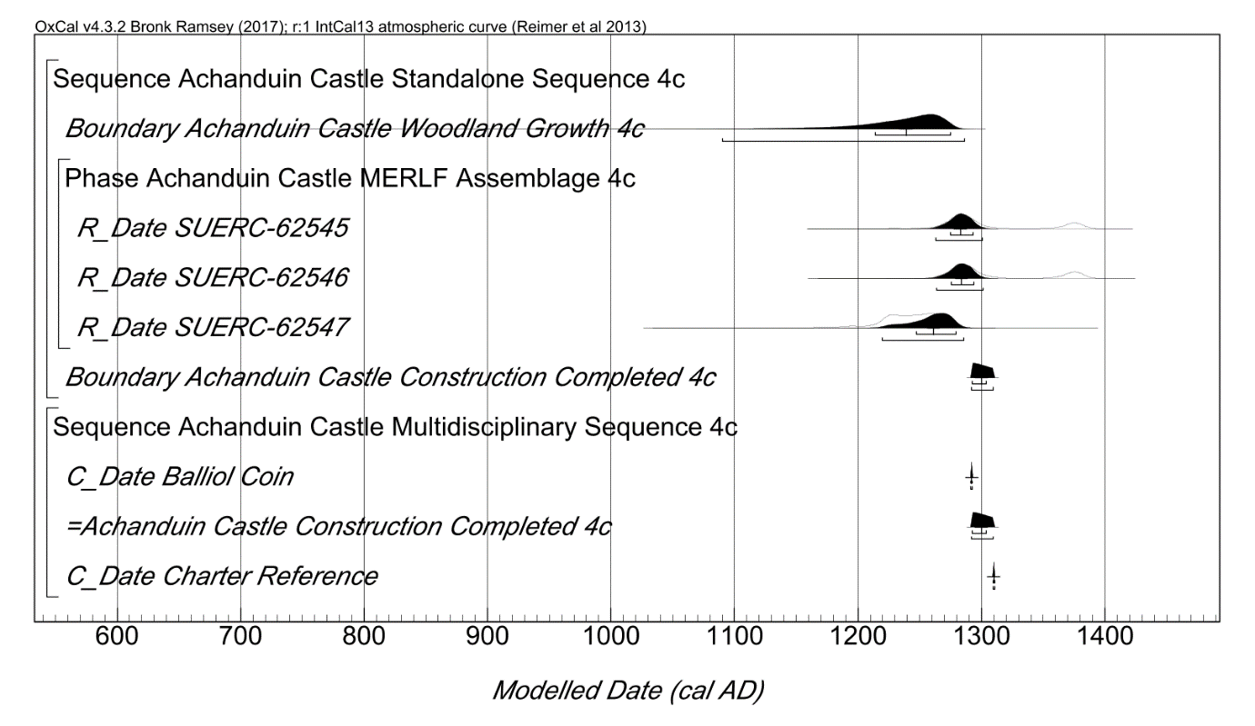
Fig. S23 (above). Probability distributions of dates from Achanduin Castle Model 4c, including phasing interpretations, radiocarbon data, 1304 charter reference and 1292 x 1296 coin. Plotted in OxCal v4.3.2 (Bronk Ramsey 2017), calibrated using IntCal13 atmospheric curve (Reimer et al 2013), this model was set at 1 year resolution and run with 20000 kIterations. The general methodology is the same as described for Fig. S19 (above), but a separate ‘multidisciplinary’ sequence has been added in which the Boundary distribution ‘Achanduin Castle Construction Completed 4c’ is constrained to a period after 1292 and before 1310 AD.
12.4 – Model 4c End Boundary
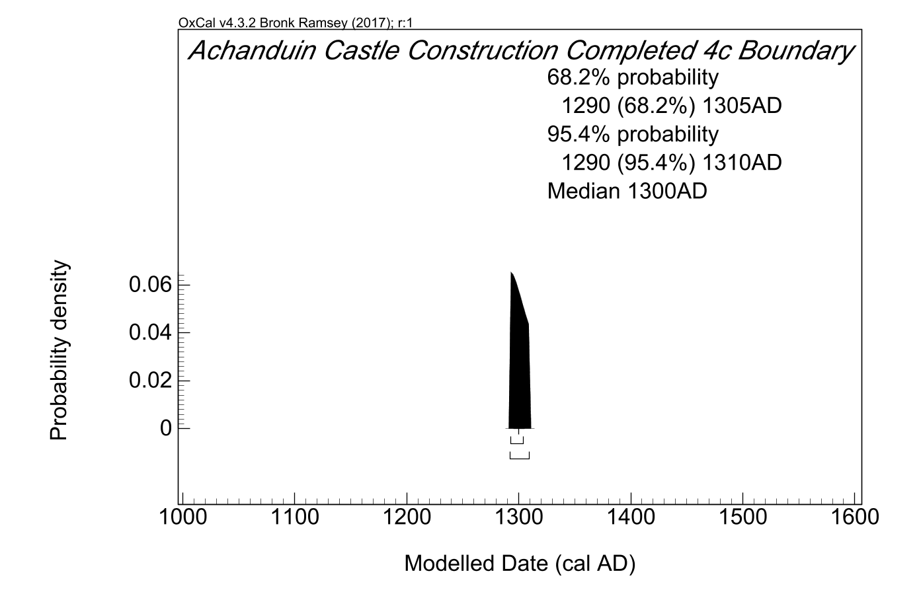
Fig. S24 (above). End Boundary probability distribution for Achanduin Castle generated by Model 4c (from model illustrated in fig. S23 above). All probability distributions have been rounded out to 5 years.

