Radiation defects in lime mortars and plasters studied by EPR spectroscopy
Zuzanna Kabacińska^{1*}, Danuta Michalska², Bernadeta Dobosz³
¹Institute of Chemistry and Technical Electrochemistry, Poznań University of Technology, Berdychowo 4, 60-965 Poznań, Poland

²Institute of Geology, Faculty of Geographical and Geological Sciences, Adam Mickiewicz University, Krygowskiego 12, 61-680 Poznań, Poland
³Medical Physics and Radiospectroscopy Division, Faculty of Physics, Adam Mickiewicz University, Uniwersytetu Poznańskiego 2, 61-614 Poznań, Poland
*Corresponding author: zuziakab@amu.edu.pl
Supplementary Information
Fig. S1 EPR spectra of UV- and γ-irradiated samples Hip10 (a, b), Hip8 (c, d) and 61H (e, f), and simulated signals present in those spectra (g). γ dose for samples Hip10 and Hip8 was 1 kGy, and 2.21 kGy for sample 61H. Spectra were normalized using Mn²⁺ signal as a reference.
Fig S2. Experimental and simulated spectra of sample Hip 10 after 6 hours of UV irradiation.

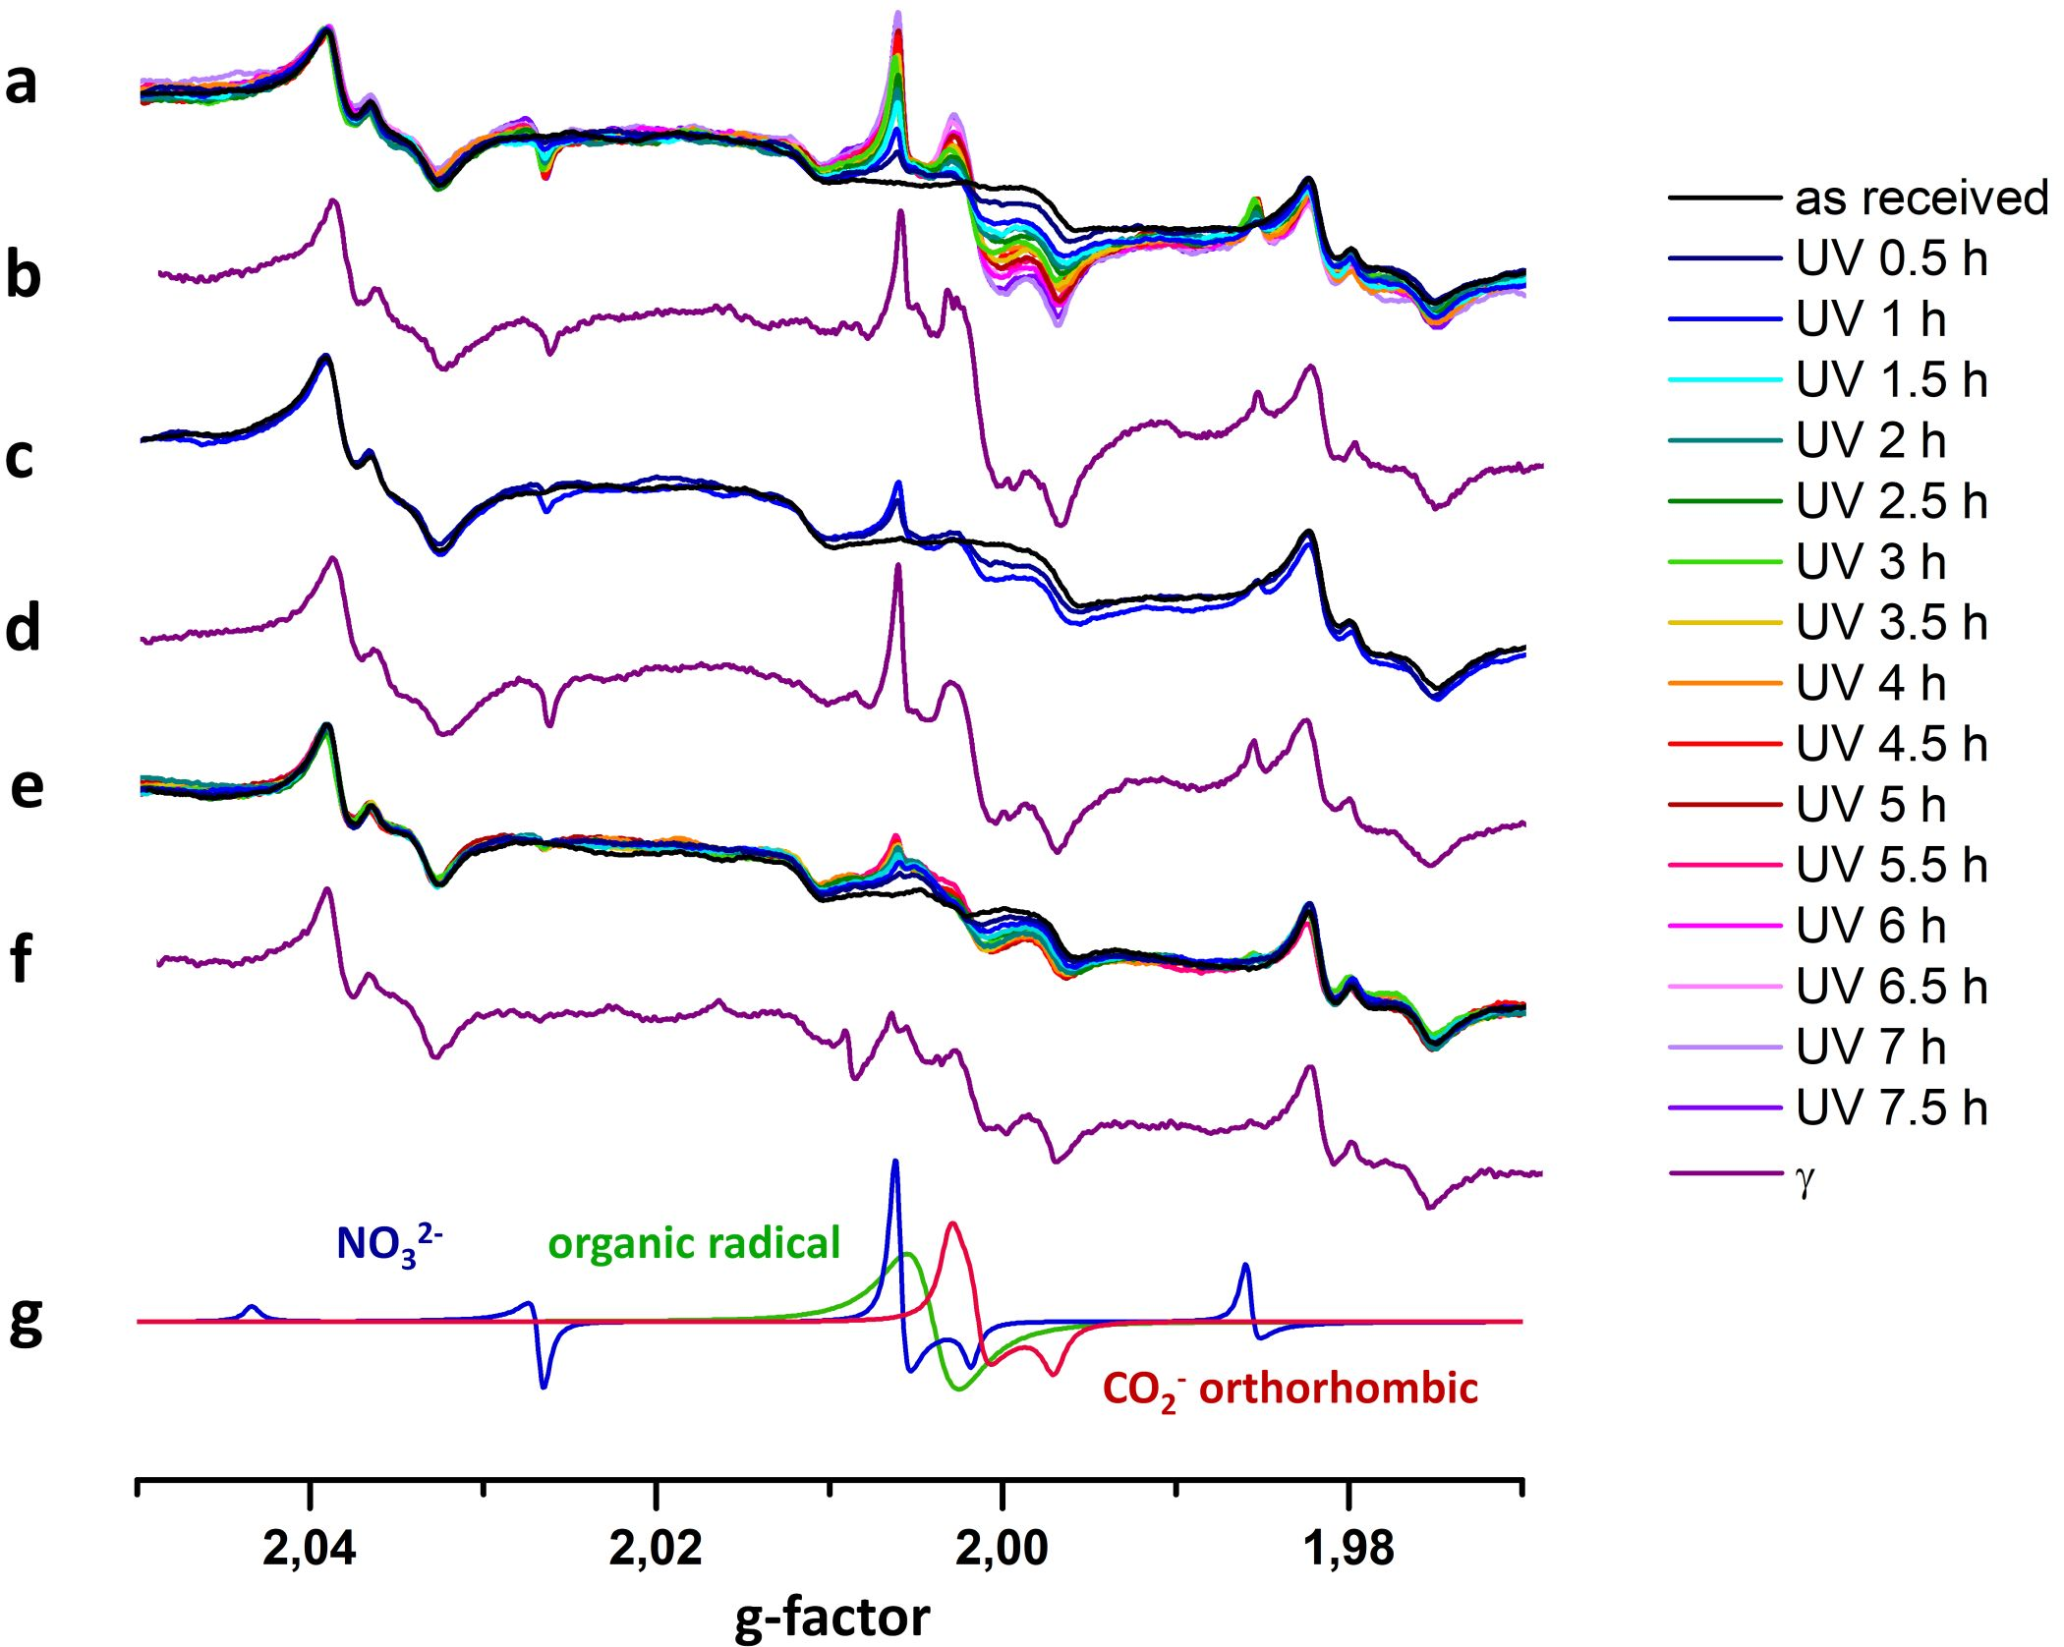
Fig. S1 EPR spectra of UV- and γ-irradiated samples Hip10 (a, b), Hip8 (c, d) and 61H (e, f), and simulated signals present in those spectra (g). γ dose for samples Hip10 and Hip8 was 1 kGy, and 2.21 kGy for sample 61H. Spectra were normalized using Mn²⁺ signal as a reference.

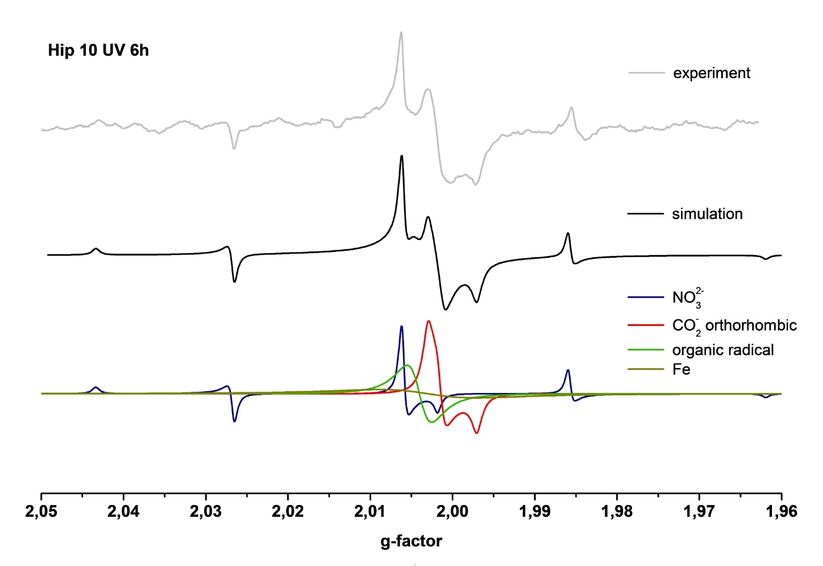
Fig S2. Experimental and simulated spectra of sample Hip 10 after 6 hours of UV irradiation.

