Table S1 ¹⁴C dates of the studied sites from the published research.
Site | Burial context | Material | 14C date (BP) | Calibrated (2σ; cal yr BP) | References
Tianshanbeilu | T35M4 | Bone collagen | 3230±30 | 3381-3557 | (Wang et al. 2007)
Tianshanbeilu | M315 | Bone collagen | 3190±30 | 3361-3463 | (Wang et al. 2007)
Tianshanbeilu | M354 | Bone collagen | 3040±30 | 3165-3346 | (Wang et al. 2007)
Tianshanbeilu | M599 | Bone collagen | 3530±30 | 3712-3892 | (Wang et al. 2007)
Dongheigou | 07BSDM013-2 | Bone collagen | 2555±25 | 2506-2752 | (Ling et al. 2013)
Dongheigou | 07BSDF004② | Bone collagen | 2195±20 | 2146-2309 | (Ling et al. 2013)
Dongheigou | 06BSDM009 | Bone collagen | 2000±25 | 1891-1989 | (Ling et al. 2013)
Dongheigou | 06BSDM010 | Bone collagen | 2290±25 | 2184-2353 | (Ling et al. 2013)
Dongheigou | 06BSDM011 | Bone collagen | 2140±25 | 2010-2300 | (Ling et al. 2013)
Dongheigou | 06BSDM003 | Bone collagen | 2115±25 | 2002-2150 | (Ling et al. 2013)
Dongheigou | 06BSDM008RI | Bone collagen | 2230±25 | 2154-2331 | (Ling et al. 2013)
Dongheigou | 06BSDM004 | Bone collagen | 2215±25 | 2152-2315 | (Ling et al. 2013)
Yanghai | ⅠM5(B） |  | 2690±40 | 2748-2861 | (Li et al. 2011)
Yanghai | ⅢM76（D） |  | 2190±40 | 2069-2329 | (Li et al. 2011)
Yanghai | ⅡM213 | Seed | 2620±35 | 2715-2840 | (Jiang et al. 2007a)
Yanghai | ⅡM2069 | wood | 2245±35 | 2153-2344 | (Jiang et al. 2009)
Yanbulake | 一类C型 | Wood | 3051±54 | 3078-3380 | (Zhang et al., 1989)
Yanbulake | 一类C型 | Wood | 2979±54 | 2980-3339 | (Zhang et al., 1989)
Yanbulake | 一类C型 | Wood | 2974±54 | 2970-3335 | (Zhang et al., 1989)
Yanbulake | 二类A型 | Wood | 2580±54 | 2487-2788 | (Zhang et al., 1989)
Yanbulake | 三类A型 | 芦苇 | 2405±78 | 2324-2725 | (Zhang et al., 1989)
Qiongkeke | M11 | Rotten wood |  | 2984-2830 | (Liu et al., 2002)
Qiongkeke | M52 | Rotten wood |  | 3040-2906 | (Liu et al., 2002)
Duogang | M216-2 | 人骨 | 2619±24 | 2732-2774 | (Zhang et al., 2014)
Goukou |  | Animal bone | 3285±30 | 3449-3578 | (Wang et al., 2018)
Goukou |  | Animal bone | 3195±35 | 3356-3544 | (Wang et al., 2018)
Goukou |  | Human bone | 2950±25 | 3004-3180 | (Wang et al., 2018)
Goukou |  | Human bone | 2935±20 | 3005-3160 | (Wang et al., 2018)
Goukou |  | Animal bone | 2850±25 | 2877-3058 | (Wang et al., 2018)
Goukou |  | Animal bone | 2775±35 | 2785-2954 | (Wang et al., 2018)
Goukou |  | Human bone | 2400±30 | 2348-2680 | (Wang et al., 2018)
Goukou |  | Wood | 2380±35 | 2340-2679 | (Wang et al., 2018)
Goukou |  | Human bone | 2285±25 | 2183-2351 | (Wang et al., 2018)
Goukou |  | Human bone | 2240±25 | 2155-2337 | (Wang et al., 2018)
Goukou |  | Ovicaprid bone | 2170±20 | 2116-2305 | (Wang et al., 2018)
Goukou |  | Ovicaprid bone | 2140±35 | 2003-2304 | (Wang et al., 2018)
Goukou |  | Animal bone | 1920±25 | 1820-1926 | (Wang et al., 2018)
Goukou |  | Ovicaprid bone | 1405±20 | 1290-1343 | (Wang et al., 2018)
Goukou | F2 |  | 3195±35 | 3356-3544 | (Ruan et al., 2017)
Goukou | F2 |  | 3285±30 | 3449-3578 | (Ruan et al., 2017)
Goukou | F3 |  | 3275±30 | 3411-3575 | (Ruan et al., 2017)
Goukou | F6 |  | 3250±30 | 3400-3562 | (Ruan et al., 2017)
Goukou | F2 |  | 3300±30 | 3453-3592 | (Ruan et al., 2017)
Goukou | M49 |  | 2935±20 | 3005-3160 | (Ruan et al., 2017)
Goukou | M75 |  | 2950±25 | 3004-3180 | (Ruan et al., 2017)
Goukou | F5 |  | 2860±30 | 2878-3067 | (Ruan et al., 2017)
Note:
a. Calibrated ¹⁴C age were published without original data in Qiongkeke;
b. Published ¹⁴C age from Yanbulake were calculated with Libby half-life of 5730 years, we recalculated them with Libby half of 5568 years in this study.

Table S2 Summary of the isotopic results of animals from other sites in Tianshan region.
Sites | Samples | Species | Skeletal element | δ¹³C | δ¹⁵N | C: N | References
Tianshanbeilu | T33 | sheep/goat | Femur | -17.8 | 8.7 | 3.1 | (Wang et al. 2017)
Goukou | M48 | Sheep/goat | Metatasal | -18.5 | 3.3 | 3.2 | (Wang et al. 2018)
Goukou | M48 | Horse | Long bone | -19.9 | 3.2 | 3.1 | (Wang et al. 2018)
Goukou | T2 | Sheep/goat |  | -18.5 | 5.2 | 3.2 | (Wang et al. 2018)
Goukou | T2 | Sheep/goat | Radius | -17.2 | 7.4 | 3.2 | (Wang et al. 2018)
Goukou | T2 | Cattle | Tooth | -17.5 | 8.6 | 3.2 | (Wang et al. 2018)
Goukou | M5 | Sheep/goat | Talus | -19.5 | 5.8 | 3.1 | (Wang et al. 2018)
Goukou | M22 | Sheep/goat | Sacrum | -17.5 | 7.4 | 3.2 | (Wang et al. 2018)
Goukou | M25 | sheep/goat | Pelvis | -16.9 | 7.6 | 3.2 | (Wang et al. 2018)
Goukou | M27 | sheep/goat | Lumbar | -14.7 | 9.9 | 3.2 | (Wang et al. 2018)
Heigouliang | H28 | Sheep |  | -18.3 | 7.9 | 3.2 | (Wang et al. 2015)
Heigouliang | H29 | Sheep |  | -19 | 7.5 | 3.3 | (Wang et al. 2015)
Dongheigou | BLK1 | Horse | Humerus | -20 | 5.77 | 3.27 | (Ling et al. 2016)
Dongheigou | BLK2 | Horse | Metacarpale | -20 | 6.16 | 3.26 | (Ling et al. 2016)
Dongheigou | BLK3 | Horse | Femur | -19.9 | 6.11 | 3.48 | (Ling et al. 2016)
Dongheigou | BLK4 | Horse | Metatarsal | -20.1 | 6.22 | 3.22 | (Ling et al. 2016)
Dongheigou | BLK5 | Horse | Phalanx | -20.2 | 6.13 | 3.26 | (Ling et al. 2016)
Dongheigou | BLK6 | Horse | Rib | -20.5 | 6.97 | 3.30 | (Ling et al. 2016)
Dongheigou | BLK7 | Horse | Humerus | -20.4 | 6.74 | 3.27 | (Ling et al. 2016)
Dongheigou | BLK8 | Horse | Metacarpale | -19.9 | 7.13 | 3.29 | (Ling et al. 2016)
Dongheigou | BLK9 | Horse | Femur | -20.4 | 6.74 | 3.31 | (Ling et al. 2016)
Dongheigou | BLK10 | Horse | Phalanx | -20.4 | 7.22 | 3.32 | (Ling et al. 2016)
Dongheigou | BLK11 | Horse | Phalanx | -20.5 | 7.01 | 3.28 | (Ling et al. 2016)
Dongheigou | BLK12 | Horse | Rib | -20.5 | 6.93 | 3.30 | (Ling et al. 2016)
Dongheigou | BLK13 | Sheep | Humerus | -18.9 | 6.43 | 3.27 | (Ling et al. 2016)
Dongheigou | BLK14 | Sheep | Femur | -19.1 | 6.78 | 3.29 | (Ling et al. 2016)
Dongheigou | BLK15 | Sheep | Metacarpale | -19.1 | 6.66 | 3.18 | (Ling et al. 2016)
Dongheigou | BLK16 | Sheep | Metatarsus | -19 | 6.69 | 3.25 | (Ling et al. 2016)
Dongheigou | BLK17 | Sheep | Phalanx | -19 | 7.19 | 3.29 | (Ling et al. 2016)
Dongheigou | BLK18 | Sheep | Rib | -18.9 | 7.03 | 3.26 | (Ling et al. 2016)
Dongheigou | BLK19 | Sheep | Rib | -19.4 | 8.27 | 3.25 | (Ling et al. 2016)
Dongheigou | BLK20 | Sheep | Humerus | -19.2 | 7.98 | 3.3 | (Ling et al. 2016)
Dongheigou | BLK21 | Sheep | Femur | -19.2 | 7.99 | 3.28 | (Ling et al. 2016)
Dongheigou | BLK22 | Sheep | Metacarpale | -19.3 | 8.09 | 3.18 | (Ling et al. 2016)
Dongheigou | BLK23 | Sheep | Metatarsus | -19.2 | 8.29 | 3.28 | (Ling et al. 2016)
Dongheigou | BLK24 | Sheep | Phalanx | -19.5 | 8.37 | 3.26 | (Ling et al. 2016)
Dongheigou | BLK25 | Horse | Femur | -20.8 | 6.75 | 3.27 | (Ling et al. 2016)
Dongheigou | BLK26 | Horse | Femur | -20.1 | 6.38 | 3.31 | (Ling et al. 2016)
Dongheigou | BLK27 | Horse | Femur | -19.3 | 7.45 | 3.27 | (Ling et al. 2016)
Dongheigou | BLK28 | Sheep | Femur | -18.8 | 6.93 | 3.31 | (Ling et al. 2016)
Dongheigou | BLK29 | Sheep | Femur | -18.7 | 8.31 | 3.01 | (Ling et al. 2016)
Dongheigou | BLK30 | Sheep | Femur | -19 | 7.33 | 3.27 | (Ling et al. 2016)
Dongheigou | BLK31 | Sheep | Femur | -19.3 | 6.4 | 3.24 | (Ling et al. 2016)
Dongheigou | BLK32 | Sheep | Femur | -19.3 | 6.2 | 3.09 | (Ling et al. 2016)
Dongheigou | BLK33 | Sheep | Femur | -19.2 | 6.55 | 3.27 | (Ling et al. 2016)
Dongheigou | BLK34 | Sheep | Femur | -19.5 | 5.48 | 3.26 | (Ling et al. 2016)
Dongheigou | BLK35 | Sheep | Femur | -19.4 | 6.21 | 3.23 | (Ling et al. 2016)
Dongheigou | BLK36 | Sheep | Femur | -19.2 | 6.21 | 3.25 | (Ling et al. 2016)
Dongheigou | BLK37 | Sheep | Femur | -19 | 7.34 | 1.87 | (Ling et al. 2016)
Dongheigou | BLK38 | Sheep | Femur | -18.8 | 7.13 | 3.26 | (Ling et al. 2016)
Dongheigou | BLK45 | Cattle | Metatarsus | -20.1 | 6.6 | 3.23 | (Ling et al. 2016)
Dongheigou | BLK46 | Cattle | Metacarpale | -19.6 | 7.68 | 3.39 | (Ling et al. 2016)
Dongheigou | BLK47 | Cattle | Metacarpale | -19.6 | 8.66 | 3.25 | (Ling et al. 2016)
Dongheigou | BLK52 | Goat | Metatarsus | -19.3 | 8.34 | 3.26 | (Ling et al. 2016)
Dongheigou | BLK53 | Goat | Metatarsus | -19 | 7.5 | 3.29 | (Ling et al. 2016)

Bayesian chronological model results:
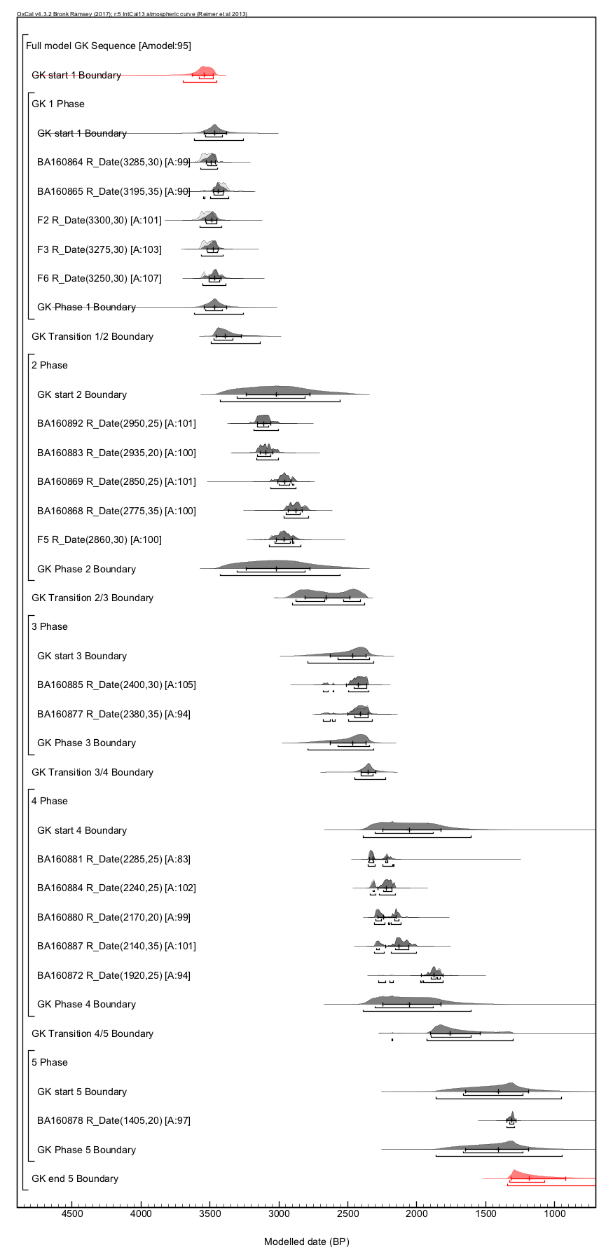
Figure s1: Bayesian chronological model for Goukou. There are five stage in Goukou: Bronze Age Ⅰ, Bronze Age Ⅱ, Iron Age, Warring States–Han Dynasty and Jin–Tang Dynasties. In this study, we discuss the data from Iron Age which modelled median age is about 2470Cal yr BP
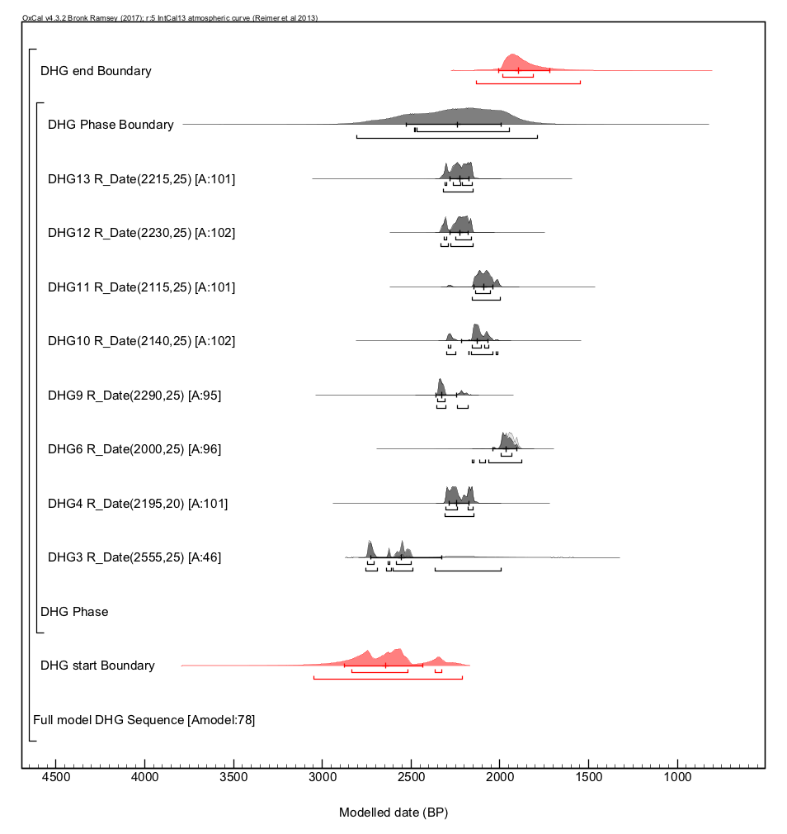
Figure s2: Bayesian chronological model for Dongheigou. The modelled age is 2240Cal yr BP.

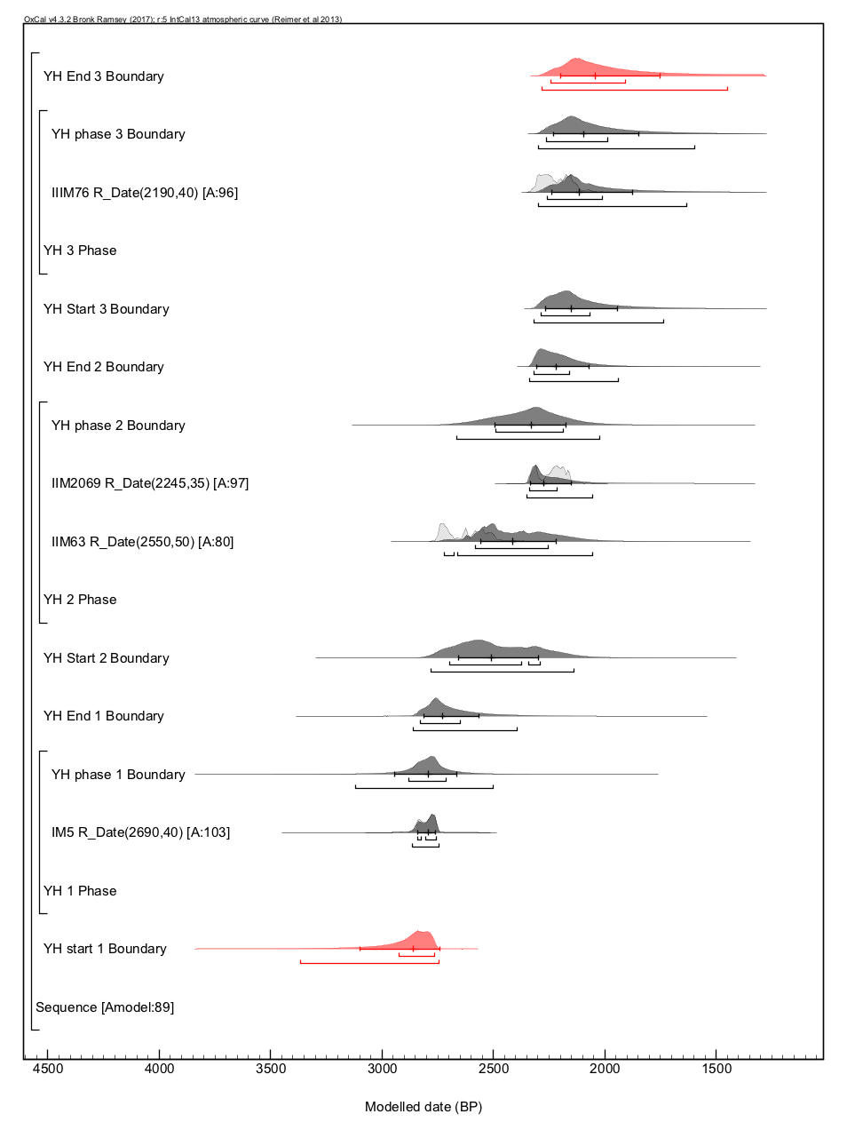
Figure s3: Bayesian chronological model for Yanghai. Yanghai cemetery is divided into three phases: late Bronze, Iron Age and Han Dynasty. We discussed the data from late Bronze and Iron Age which the modelled median age is about 2800 and 2330Cal yr BP, respectively.
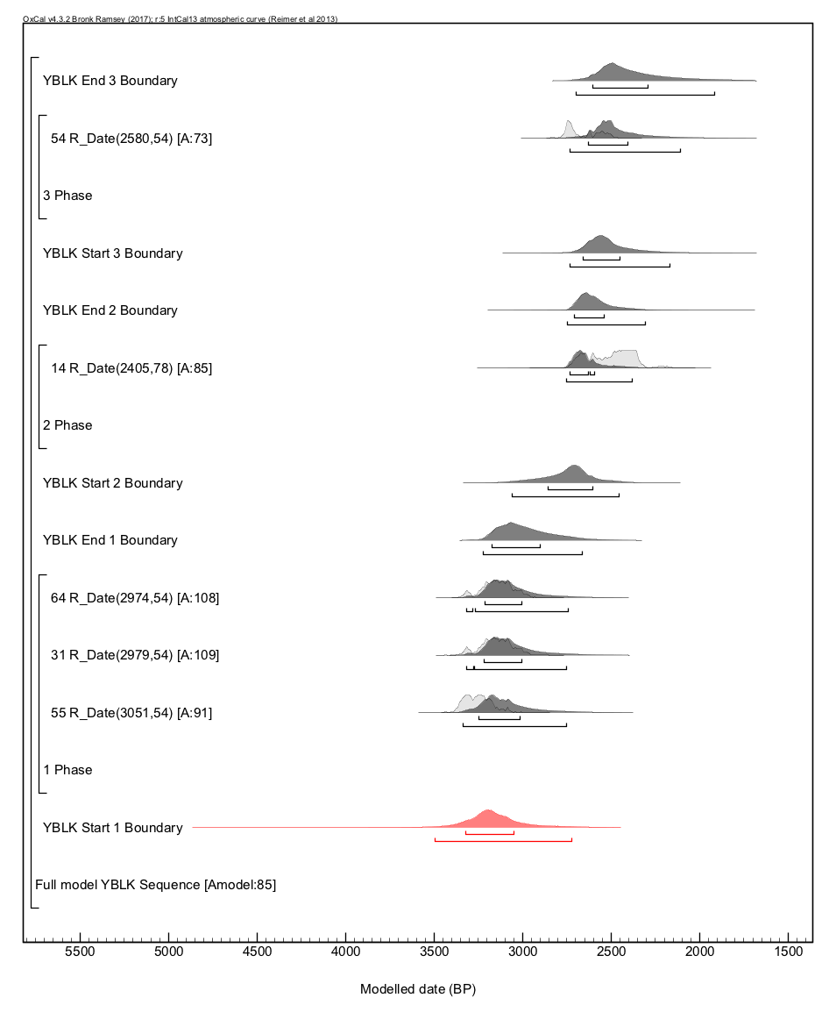
Figure s4: Bayesian chronological model for Yanbulake. There are three period in Yanbulake site, including late Bronze, Iron Age and late Iron Age. In this study, isotopic data come from Iron Age which modelled median age is 2710Cal yr BP.
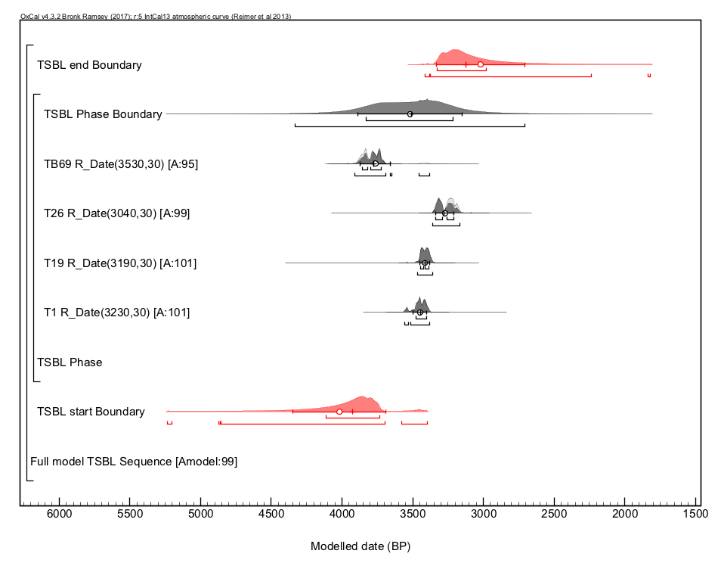
Figure S5: Bayesian chronological model for Tianshanbeilu. The modelled age is 3510Cal yr BP.

