**Dating adoption and intensification of food-crops: insights from 4MSR (Binjor), an Indus (Harappan) site in north-western India**

**Shalini Sharma1, 4, Sanjay Kumar Manjul2, Arvin Manjul3, Puran Chand Pande4, Anil K. Pokharia1#**

1 Birbal Sahni Institute of Palaeosciences, 53 University Road, Lucknow-226007, Uttar Pradesh, India

2 Institute of Archaeology, Archaeological Survey of India, Red Fort, Delhi-110006, India

3 Excavation Branch- II, Archaeological Survey of India, Purana Quila, Delhi-110003, India

4 Kumaun University, D.S.B. Campus, Nainital-263001, Uttarakhand, India

# Corresponding author: pokharia.anil@gmail.com

#Phone no. +91-9839569376

**Supplemental Material**

Table S1 List of charred crop remains and weed & wild taxa recovered from Harappan phases (Early phase, Transitional phase, Mature phase) at 4MSR, NW India.

Table S2 Absolute counts, Ubiquity and Diversity index of crops, weeds and wild taxa from different cultural phases at 4MSR, NW India.

Table S3 Density of crops taxa per ten litre of soil sediment from different cultural phases at 4MSR, NW India.

Figure S1 Layout of trench N60E10 at 4MSR showing relative location of some of the sample collected (in red) and analyzed.

Figure S2 Stratigraphy of trenches E10, E20, N10W10, N10E10 and S10E10 at 4MSR showing relative location of some of the sample collected (in red) and analyzed.

Figure S3 Layout of trenches N00, S20E10, N10E10 and W30 at 4MSR showing relative location of some of the sample collected (in red) and analyzed.

Table S1 List of charred crop remains and weed & wild taxa recovered from Harappan phases (Early phase, Transitional phase, Mature phase) at 4MSR, NW India.



















Table S2 Absolute counts, Ubiquity and Diversity index of crops, weeds and wild taxa from different cultural phases at 4MSR, NW India.





Table S3 Density of crops taxa per ten litre of soil sediment from different cultural phases at 4MSR, NW India.



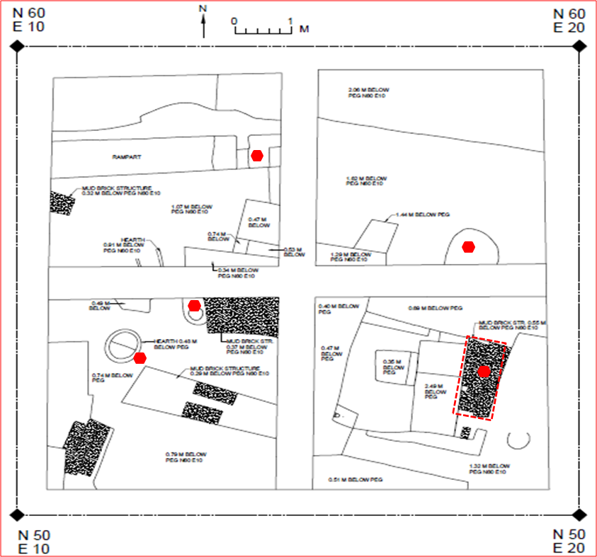

Figure S1 Layout of trench N60E10 at 4MSR showing relative location of some of the sample collected (in red) and analyzed.

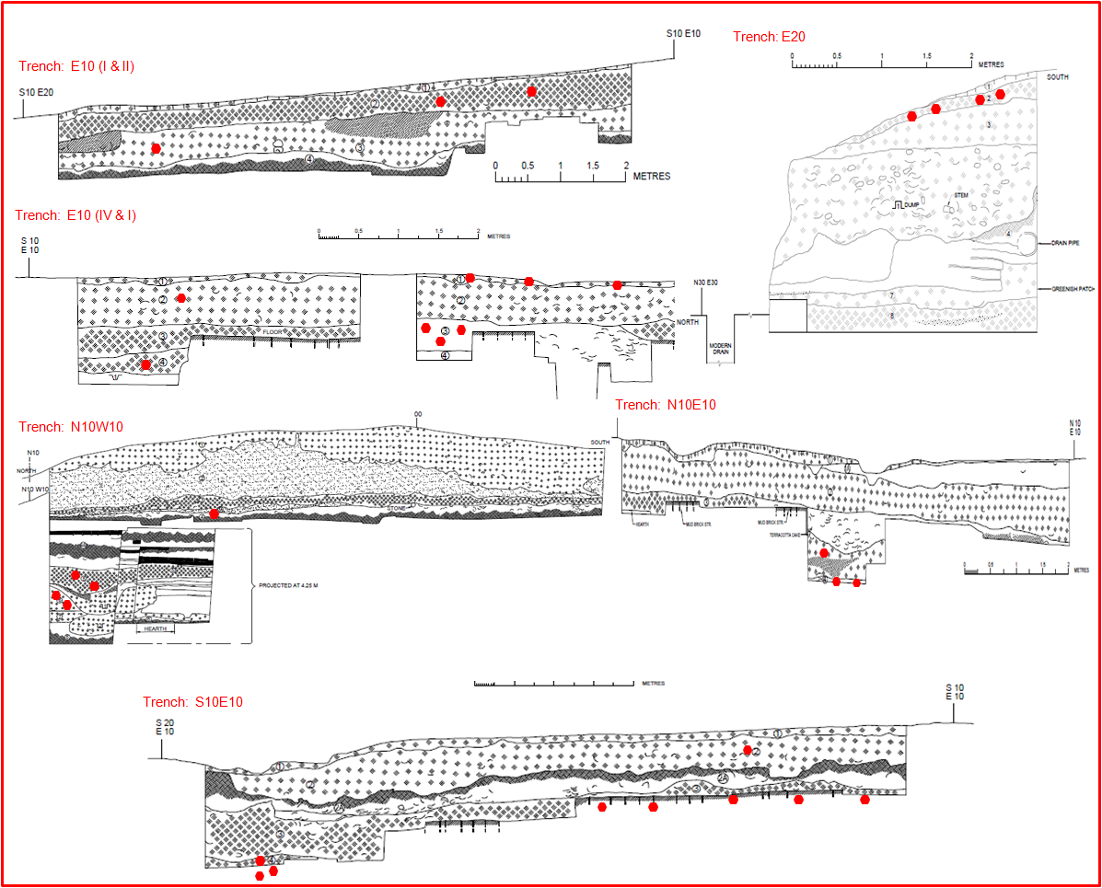

Figure S2 Stratigraphy of trenches E10, E20, N10W10, N10E10 and S10E10 at 4MSR showing relative location of some of the sample collected (in red) and analyzed.

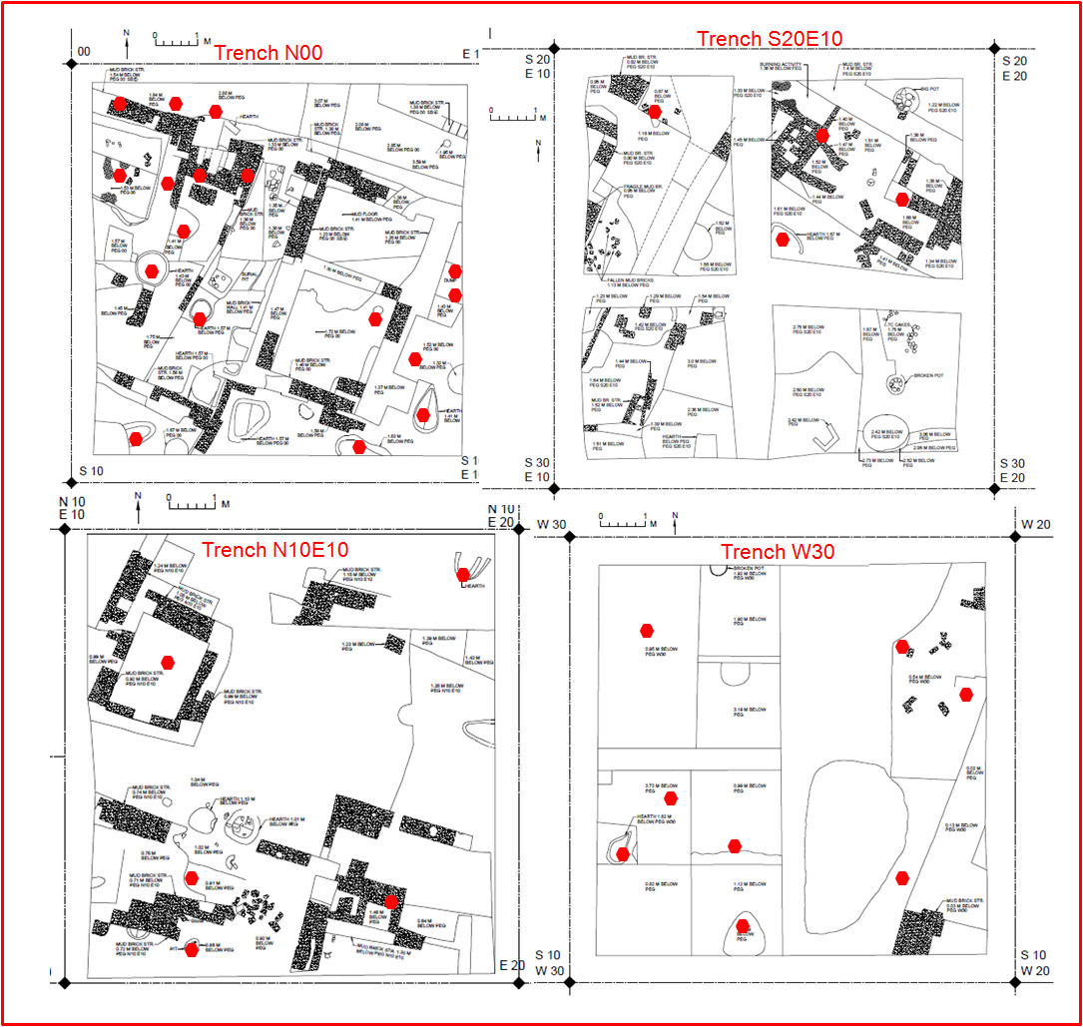

Figure S3 Layout of trenches N00, S20E10, N10E10 and W30 at 4MSR showing relative location of some of the sample collected (in red) and analyzed.