**Supplementary Information**

Figure S1. FTIR raw data of the hydraulic plasters and mortars in this study.

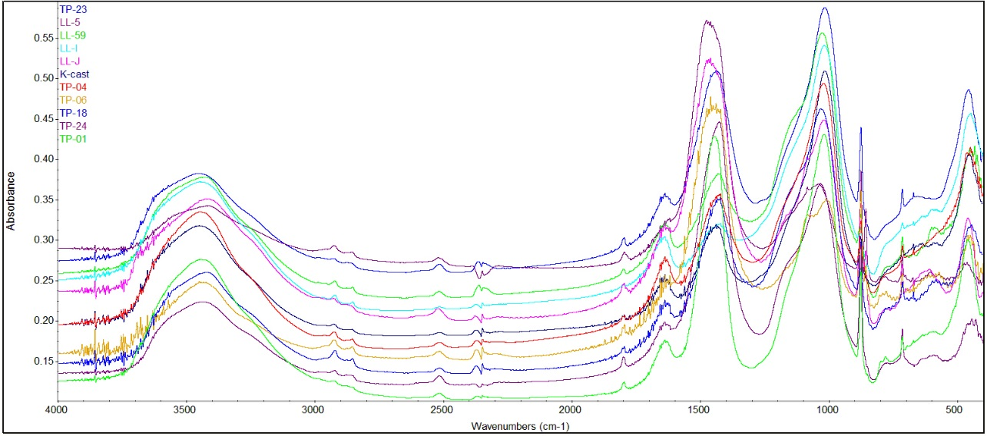

Figure S2. FTIR raw data of selected standards of clays, feldspars, glass, quartz family, volcanic materials and igneous materials in this study.

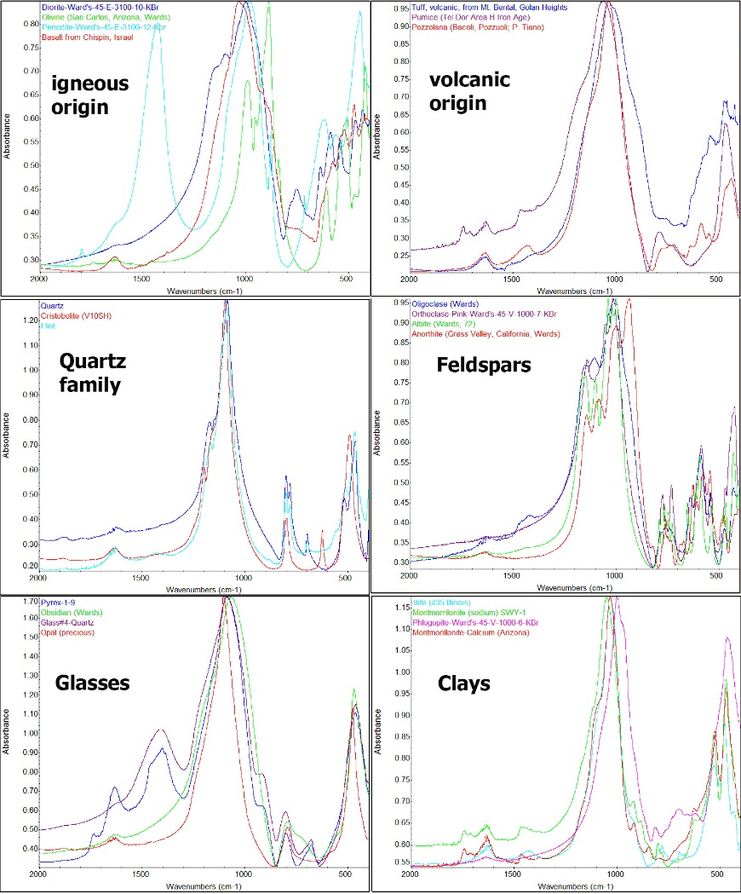

Figure S3. FTIR spectroscopic indicators of the (A) calcite ν2 and ν4 vibrational modes peak heights (normalized to ν3), (B) silicates main peak FWHM and asymmetry of mortars bulk and wet separated fraction, and C) XRD examinations of the samples from Cannero, Italy (Ricci et al. *this issue*).

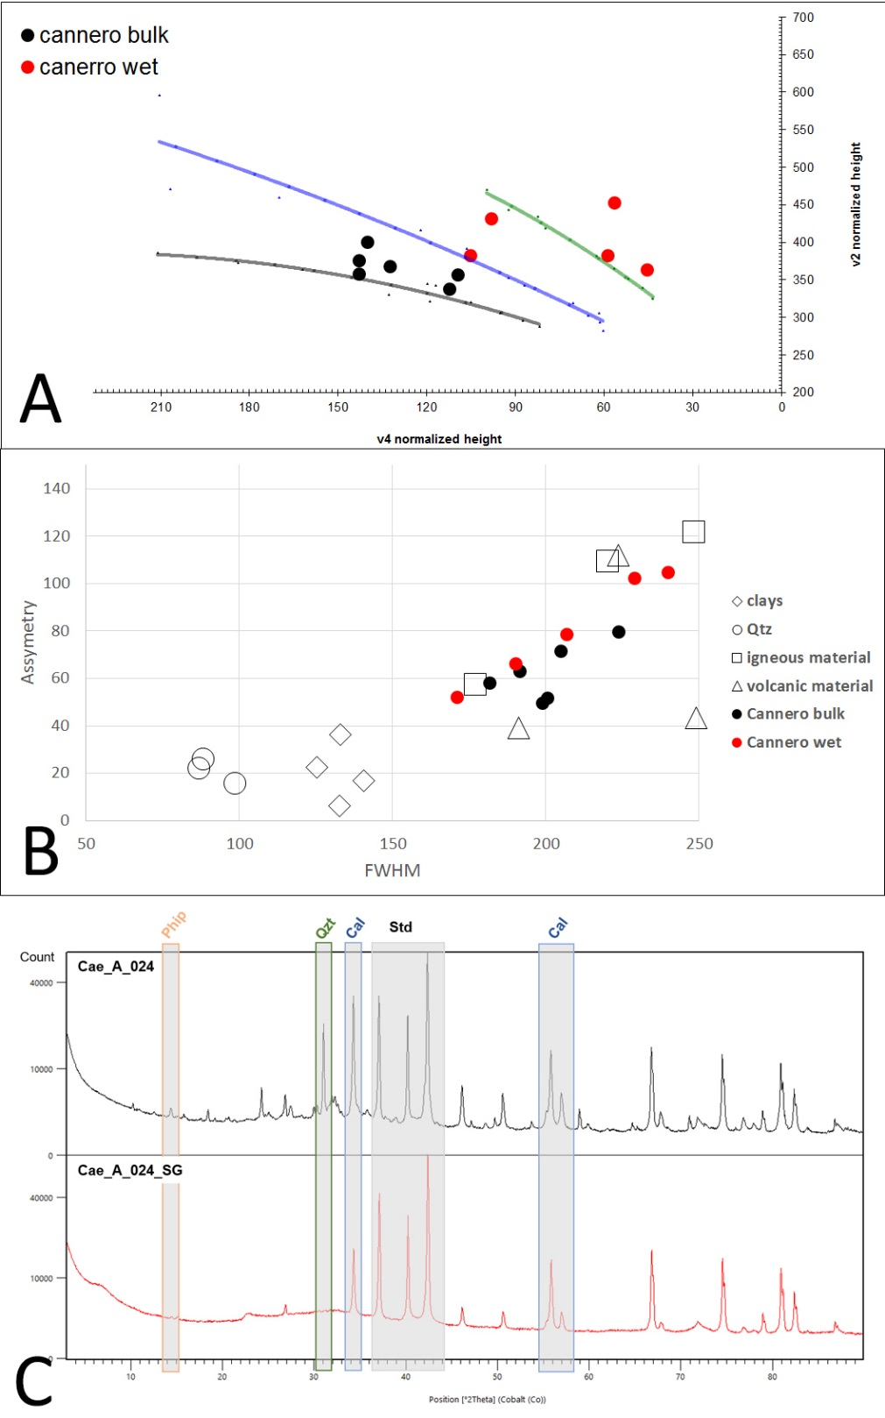

Figure S4. XRF raw data of the studied plasters and mortars (summarized in table S1).

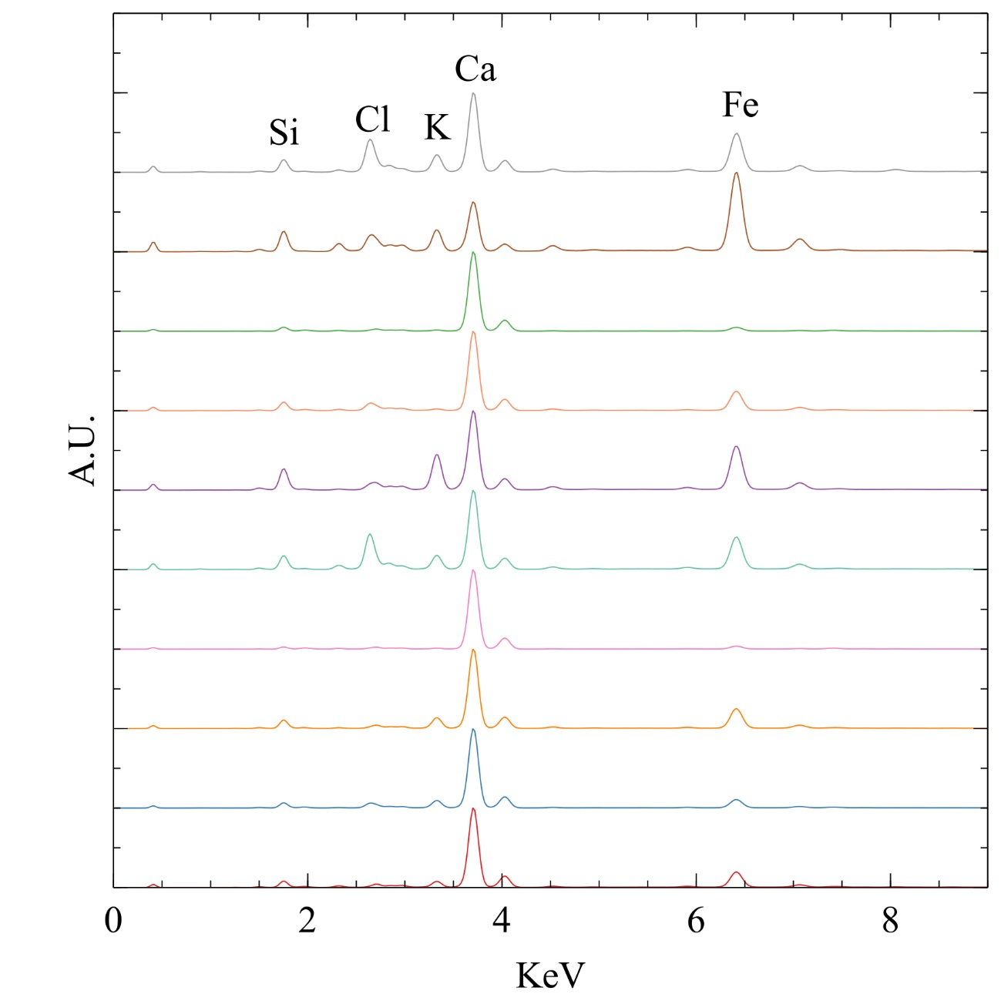

Figure S5. Mineralogical quantitative phase analysis of the analyzed plasters K-cast, TP-06, TP-18, TP-24, obtained by full profile fitting of the experimental XRD patterns according to the Rietveld method (summarized in table S2).

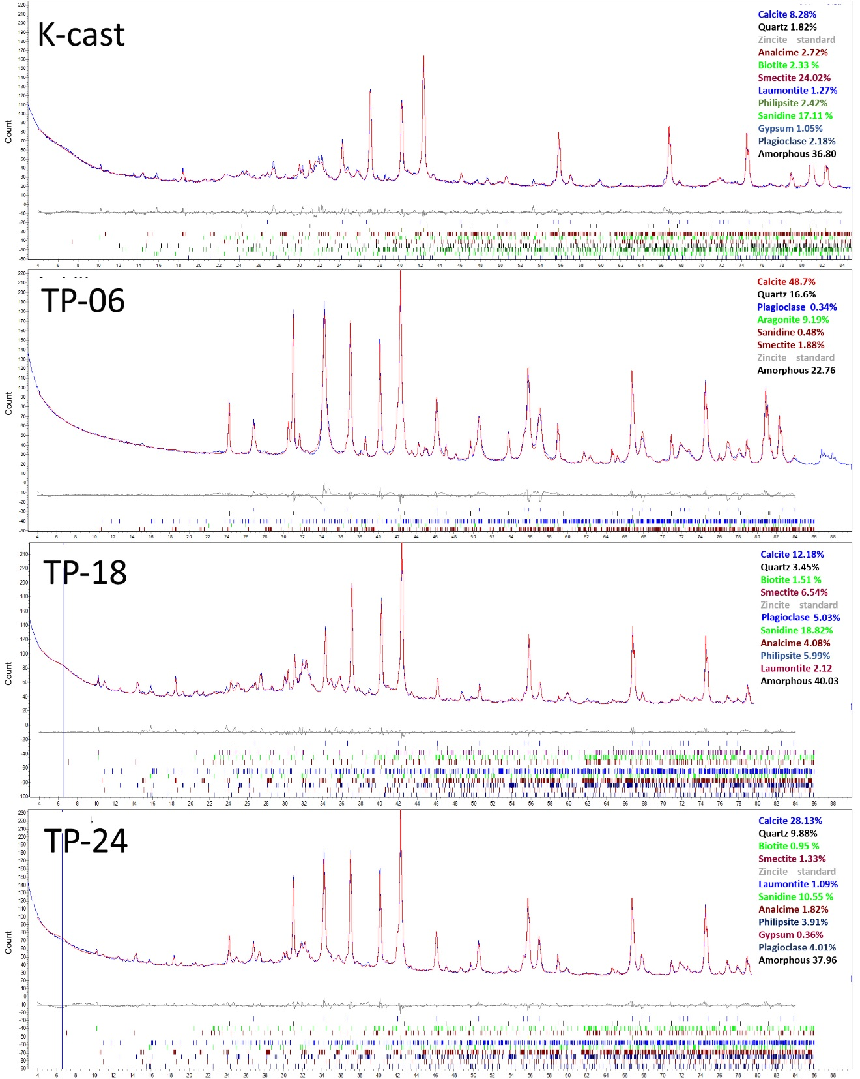

Table S1. XRF raw data elemental composition of the studied plasters and mortars. Calibration of elements net counts intensity to concentration percentage is following an internal calibration published by Rowe et al. (2012). The concentrations are presented as oxides after conversion from Elements to Oxides via James Cook University of Australia. The HI index is calculated following Vola et al. (2011).

|  |  |  |  |  |  |  |  |  |  |  |  |
| --- | --- | --- | --- | --- | --- | --- | --- | --- | --- | --- | --- |
|  | TP-01 | TP-04 | TP-06 | TP-18 | TP-23 | TP-24 | LL-5 | LL-59 | LL-I | LL-J | K-cast |
| CaO | 16.04 | 22.45 | 26.82 | 08.41 | 16.52 | 07.69 | 31.59 | 06.15 | 09.98 | 14.20 | 03.14 |
| MgO | 05.68 | 01.00 | 06.56 | 02.57 | 05.61 | - | 02.93 | 02.10 | 4.98 | 08.47 | 05.11 |
| SiO2 | 15.27 | 17.38 | 15.23 | 27.55 | 21.13 | 19.23 | 08.57 | 15.61 | 08.88 | 17.95 | 15.76 |
| Al2O3 | 03.36 | 04.12 | 00.49 | 06.57 | 05.12 | - | 00.62 | 03.38 | - | 02.26 | 03.75 |
| Fe2O3 | 02.27 | 01.72 | 00.98 | 02.91 | 02.81 | 01.57 | 00.92 | 02.00 | 01.47 | 02.44 | 03.47 |
| SO3 | 01.33 | - | 00.67 | 00.32 | 00.42 | 05.49 | 00.82 | 00.92 | 00.67 | 00.77 | 02.76 |
| K2O | 01.02 | 02.09 | 00.12 | 04.07 | 02.28 | 02.77 | - | 01.30 | - | 00.04 | 01.27 |
| MnO | - | 00.05 | - | - | 00.09 | - | - | - | 00.01 | - | 00.08 |
| P2O5 | 00.25 | 00.35 | 00.48 | - | - | - | 01.28 | - | 00.16 | 00.48 | - |
| Hydraulic Index (HI) | 00.96 | 00.99 | 00.94 | 03.37 | 01.03 | 02.70 | 00.16 | 02.25 | 00.69 | 00.99 | 02.78 |

Table S2. Mineralogical quantitative phase analysis of the analyzed plasters K-cast, TP-06, TP-18, TP-24, obtained by full profile fitting of the experimental XRD patterns according to the Rietveld method. We note that the wet separated fraction QPA analysis (Table S2), a water-based heavy particle separation (Addis et al 2019), shows slightly different mineralogical compositing, perhaps because it is only collecting the particles below 2µm in size that relate mostly with the binder.

