Supplements

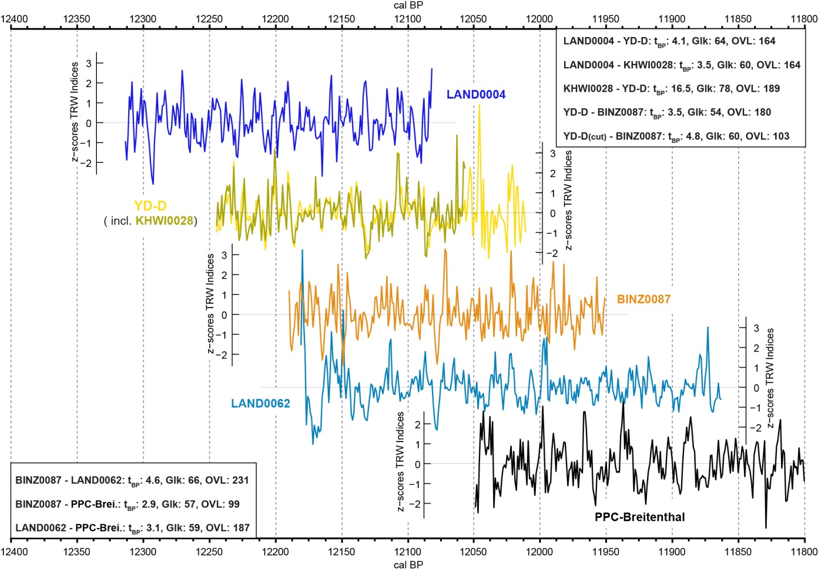
SM 1: Cross-dating of the tentative linked YD Swiss trees to the PPC-Breitenthal (Friedrich et al. in prep.). Single z-scored TRW curves show good visual agreement and are supported by the cross-dating results obtained in this study (t_{BP} and Glk).

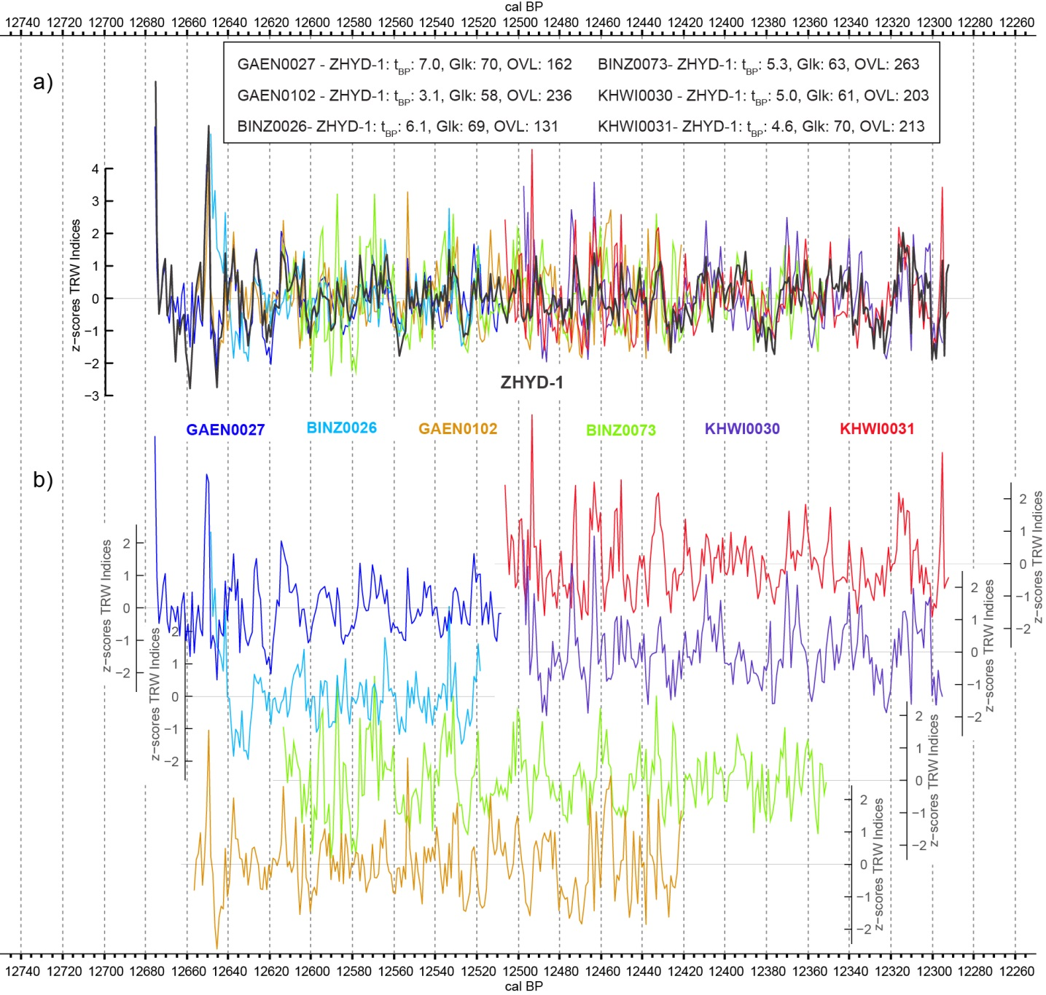
SM 2: Cross-dating results (t_{BP} and Glk) and z-scored single TRW curves of the ¹⁴C dated trees in the ZHYD-1 chronology plotted against its mean curve (a) indicating good overall agreement. Individual visual comparison of the z-scored growth curves of each ¹⁴C dated trees outlining their temporal placement, overlap and TRW synchrony (b).

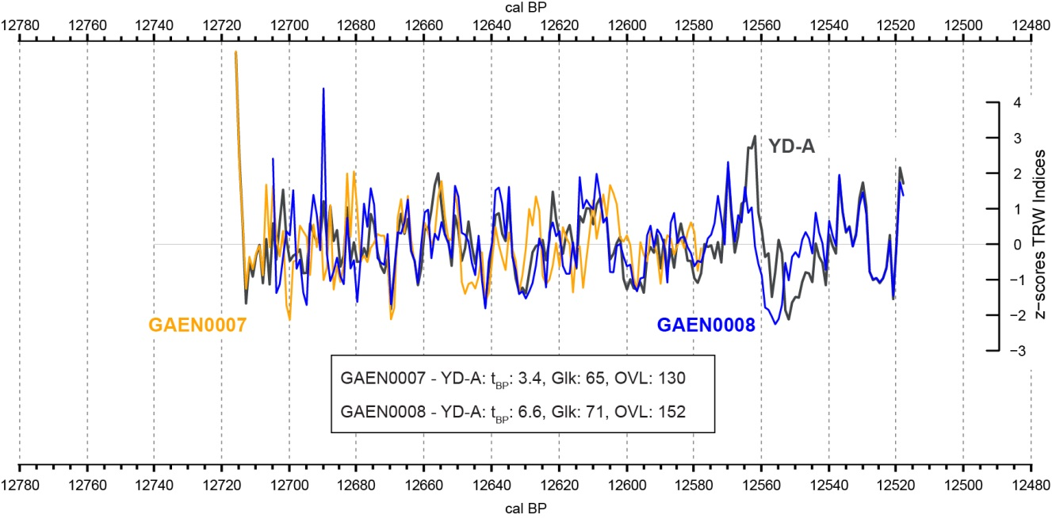
SM 3: Cross-dating results (t_{BP} and Glk) and visual comparison of ¹⁴C dated trees in the YD-A mean curve (YD-A).

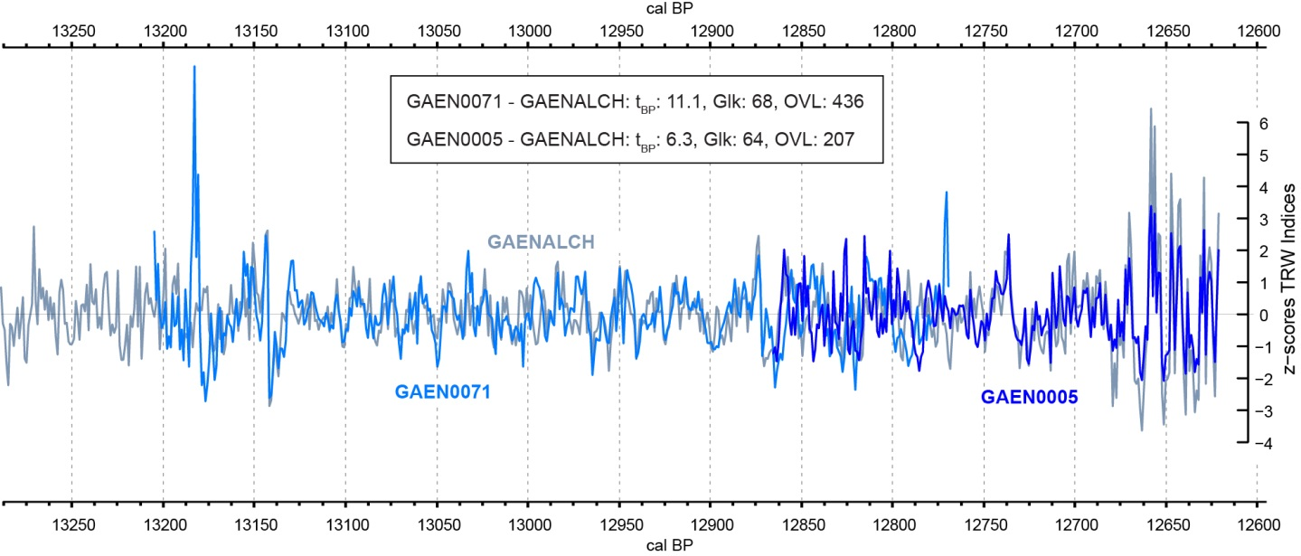
SM 4: Visual comparison of GAEN0005 and GAE0071 to the Zurich Geanziloo chronology (GAENALCH) and corresponding cross-dating results (T_{BP} and Glk) in the YD transition.

SM 5: Characteristics of the three described Younger Dryas periods in this study (MSL = mean segment length; AGR = average growth rate).

Period | Chronology | Nr. of trees | Length of period/chronology (years) | Start approx. BP | End approx. BP | MSL (years) | AGR (mm) | Nr. of high-resolution ¹⁴C measured trees
Tentative linked to PPC | - | 6 | 451 | 12314 | 11863 | 232 | 0.80 | 4
Floating YD chronologies | ZHYD-1 | 15 | 383 | 12675 | 12292 | 199 | 1.02 | 6
Floating YD chronologies | YD-A | 8 | 198 | 12716 | 12518 | 135 | 0.79 | 2
YD Transition | GAENALCH | 55 | 1464 | 14085 | 12621 | 265 | 0.80 | 2

