**Supporting Materials**

**Compound-specific radiocarbon, stable carbon isotope and biomarker analysis of mixed marine/terrestrial lipids preserved in archaeological pottery vessels**

Emmanuelle Casanova1, Timothy D.J. Knowles1,2, Candice Ford1,*, Lucy J.E. Cramp4, Niall Sharples5 and Richard P. Evershed1,2

1Organic Geochemistry Unit, School of Chemistry, University of Bristol, Cantock’s Close BS8 1TS, UK

2Bristol Accelerator Mass Spectrometry Facility, University of Bristol, 43 Woodland Road, BS8 1UU, UK

3Department of Anthropology and Archaeology, 43 Woodland Road, University of Bristol, BS8 1UU, UK

4School of History, Archaeology and Religion, Cardiff University, Humanities Building, Colum Drive, Cardiff CF10 3EU, UK

*Present address: The University of Nottingham, School of Chemistry, University Park, Nottingham NG7 2RD,

14 UK.

**S1- Site location and stratigraphic information of Mound 2**

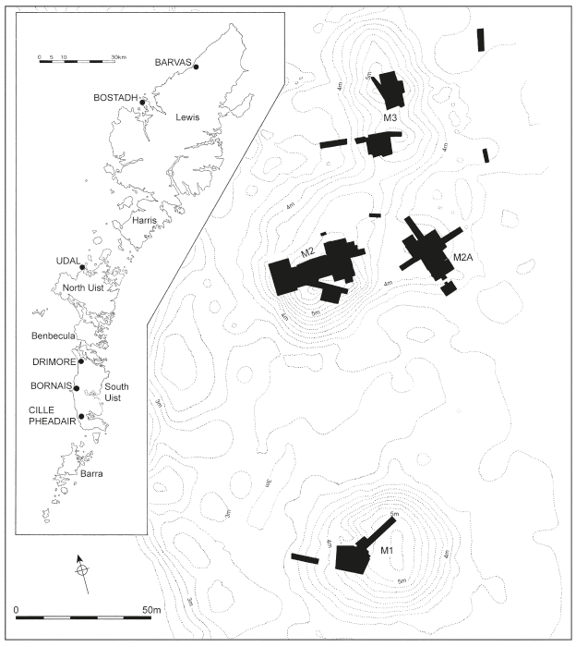

Figure S1: Location of the site of Bornais and the 4 mounds excavated. From Sharples *et al.* (2016), Fig.17.1.



Figure S2: Schematic diagram showing the stratigraphic information for the Mound 2. Green contexts correspond to the ones studied in this paper.

**S2- Detailed method for lipid residue analyses**

To remove surface contaminants, a small part of the potsherd (*~* 2 - 7 g) was cleaned with a modelling drill then sampled using hammer and chisel and ground to fine powder using mortar and pestle. Approximately 1 to 2 g of ground potsherd were weighed into a clean culture tube (I) with stopper and 20 µL of internal standard (IS; *n*‑tetratriacontane) at 1 mg.ml-1 was added. The lipids were extracted using a solution of H2SO4/MeOH (4% *v/v*, 5 mL, ­70 oC, 1 h,). The supernatant of culture tube I was then centrifuged (2500 rpm, 10 min) and transferred to a clean culture tube (II) before adding double distilled water (2 mL). *N-*hexane was added (2 x 3 mL) to culture tube I and the supernatant transferred to culture tube II. Following this, 2 x 2 ml *n-*hexane was added directly to the H2SO4/MeOH solution in culture tube II and whirlimixed to extract the remaining residues, then transferred to the 3.5 mL vials and blown down until a full vial of *n-*hexane remained. A procedural blank was prepared and analysed alongside every batch of archaeological materials to assess whether contamination was introduced during the protocol. Before analysis, an aliquot of the total lipid extract (TLE; 1/4) was derivatised by the addition of BSTFA (*N,O*‑bis(trimethylsilyl)trifluoroacetamide; 20 µL, 70 ºC, 1 h). Excess BSTFA was blown down at 40 ºC under a gentle stream of nitrogen, and an appropriate amount of *n-*hexane was added, prior to analysis with GC, GC-MS and GC‑C-IRMS (Correa-Ascencio and Evershed 2014).

GC analysis of TLEs (Section 2.3.2.1) for quantification was performed on a Hewelett Packard 5890 series II gas chromatograph or an Agilent Technologies 7890A GC. Helium was used as carrier gas at constant flow (2 mL.min-1), and a flame ionisation detector (FID) used to monitor column effluent. Lipids extracts (1 µL) were injected into a non‑polar fused silica capillary column (50 m x 0.32 mm i.d., DB1 stationary phase (100 % dimethylpolysiloxane), 0.17 µm film thickness, Agilent technologies). The oven temperature program started with an isothermal hold at 50 ºC for 2 min, then the temperature was increased at 10 ºC.min-1 to 300 ºC and held for 10 min (Evershed *et al.* 1990).

GC-MS analysis of TLEs for molecular identification was performed on a Finnigan Trace MS quadrupole instrument coupled to a Trace GC, or on a Thermo Scientific ISQ LT single quadrupole GC-MS coupled to a Trace 1300, with manual or auto-sampling injections. The lipid extracts (1 µL) were introduced into a non‑polar fused silica capillary column (50 m x 0.32 mm i.d., DB1 stationary phase, 0.17 µm film thickness, Agilent Technologies). For TLEs analysis the oven temperature program started with an isothermal hold at 50 ºC during 2 min, then the temperature increased at 10 ºC.min-1 to 300 ºC and held for 10 min. The MS used electron ionization (EI) mode operating at 70 eV with a GC interface temperature of 300 ºC and a source temperature of 200 ºC. Acquisition used the total ion current (TIC) mode over the range *m/z*50-650 Daltons at 8.3 scans.s-1 (Evershed *et al.* 1990). Screening for di-hydroxy fatty acid methyl esters (DHYAs, aquatic biomarkers) used selected ion monitoring (SIM) mode, monitoring *m/z* 159, 187, 215, 243, 259, 287, 315, 443, 459, 471, 487, 499 and 515 (for -COOMe derivatives instead of -COOTMS as published; Cramp and Evershed 2014).

In order to determine the presence of other aquatic biomarkers (APAAs and isoprenoid acids), TLEs were run on a polar column (60 m x 0.32 mm i.d., VF-23ms stationary phase (polydimethylsiloxane highly substituted with cyanopropyl groups), 0.15 µm film thickness,Agilent Technologies). The temperature program started with an isothermal hold at 70 ºC for 2 min, followed by a ramp at 10 ºC.min-1 to 220 ºC, then a ramp at 4 ºC.min-1 to 300 ºC and finally an isothermal hold for 10 min. Full scan mode *m/z* 50-650 and SIM mode, screening for the masses *m/z* 105, 262, 290, 318 and 346, were performed for the detection of APAAs (Cramp and Evershed 2014).

The GC-C-IRMS analyses on C16:0 and C18:0 FAs (for identification of the source of animal fats) was performed on an Agilent Technologies 7890A, coupled via an IsoPrime GC5 combustion interface (CuO and silver reactor, 850 ºC) to an IsoPrime 100 mass spectrometer. The FAME extracts (1 µL) were injected into a non-polar column (50 m x 0.32 mm i.d., DB1 stationary phase, 0.17 µm film thickness, Agilent technologies). The GC oven temperature was held for 2 min at 40 ºC and increased to 300 ºC at 10 ºC.min-1 and held for 10 min. The MS used EI at 70 eV and had three Faraday cups collecting for the masses *m/z* 44, 45 and 46. Data were acquired and processed by the IonVantage software (Copley *et al.* 2003).

**S3- Results of lipid residue analysis**

Table S1: Results of lipid residue analysis of potsherds from the site of Bornais Mound 2, House 2. P corresponds to the Phytanic acid and TMDT to the 4,8,12-trimethyltridecanoic acid. Compounds in brackets corresponds to trace amounts (not clearly identified).

| Sherd # | Block | Code | C  (µg.g-1) | FAs | DHYAs | APAAs | IFAs | δ13C16:0  (‰) | δ13C18:0  (‰) | Δ13C  (‰) | Assignment (before CSRA dating) |
| --- | --- | --- | --- | --- | --- | --- | --- | --- | --- | --- | --- |
| BN-132 | BCA | 1259/3790 | 849 | C14-C18 | - | - | (TMTD), P | -25.8 | -31.0 | -5.2 | Mixture dairy, non-ruminant fats |
| BN-133 | BCA | 1280/9448/3/3887 | 137 | C14-C18 | C18 | - | - | - | - | - | *nd* |
| BN-134 | BCB | 6/8656 | 190 | C14-C22 | - | C18, C20, C22 | TMTD, P | - | - | - | *nd* |
| BN-135 | BCB | 1089/8654 | 1444 | C14-C22 | C18, C20, C22 | - | (TMTD), P | -26.3 | -26.6 | -0.2 | Mixture ruminant adipose, marine fats |
| BN-136 | BCB/C | 1074/2/3529 | 207 | C14-C22 | C18, C20, C22 | C18 | - | -26.7 | -32.9 | -6.2 | Mixture dairy, marine fats |
| BN-137 | BCC | 182/1/8659 | 676 | C14-C22 | - | C18, C20, C22 | TMTD, P | -24.9 | -28.4 | -3.5 | Mixture dairy, marine fats |
| BN-138 | BCC | 528/2199 | 19 | C14-C22 | - | - | - | - | - | - | *nd* |
| BN-139 | BCC | 549/2264 | 3135 | C14-C20 | C18, C22 | C18 | - | -26.6 | -29.3 | -2.7 | Ruminant adipose fats |
| BN-140 | BCC | 550/5/2458 | 216 | C14-C22 | C18, C20, C22 | C18, C20, C22 | TMTD, P | -22.1 | -25.2 | -3.1 | Marine fats |
| BN-141 | BCC | 550/5/2458 | 28 | C16-C22 | (C18) | - | - | -26.6 | -32.5 | -5.9 | Mixture dairy, non-ruminant fats |
| BN-142 | BCC | 557/5/2341 | 2220 | C14-C22 | C18, C20, C22 | C18, (C20) | (TMTD), P | -24.9 | -27.9 | -3.0 | - |
| BN-143 | BCC | 557/5/8660 | 5630 | C14-C20 | C18 | C18 | P | -25.8 | -27.9 | -2.2 | Mixture ruminant adipose, marine fats |
| BN-144 | BCC | 558/5/8670 | 2483 | C14-C22 | C18, C20, C22 | C18 | (TMTD), P | -25.6 | -28.9 | -3.3 | Mixture dairy, marine fats |
| BN-145 | BCC | 565/8655 | 1425 | C14-C22 | C18 | - | P | -27.0 | -31.3 | -4.3 | Mixture dairy, non-ruminant fats |
| BN-146 | BCC | 921/2992 | 1349 | C14-C22 | C18 | C18 | P | -25.6 | -30.2 | -4.6 | Mixture dairy, non-ruminant fats |
| BN-147 | BCC | 1008/3063 | 56 | C16-C22 | (C18) | - | - | - | - | - | *nd* |
| BN-148 | BCC | 1008/9452/8657 | 60 | C14-C22 | C18, C20, C22 | C18, (C20, C22) | TMTD, P | -25.3 | -29.2 | -4.0 | Mixture dairy, marine fats |
| BN-149 | BCC | 1010/9685/2/3279 | 3984 | C14-C22 | C18, C20, C22 | C18 | (TMTD), P | -26.3 | -30.4 | -4.1 | Mixture dairy, marine fats |
| BN-150 | BCC | 1010/2/3266 | 1460 | C14-C22 | C18, (C20, C22) | C18, C20, C22 | TMTD, P | -25.2 | -29.0 | -3.8 | Mixture dairy, marine fats |
| BN-151 | BCC | 1049/9809/8661 | 2141 | C14-C22 | C18, (C20, C22) | C18 | P | -26.9 | -29.6 | -2.7 | Mixture ruminant, non-ruminant adipose fats |
| BN-152 | BCC | 1057/9895/8656 | 0 | - | - | - | - | - | - | - | - |
| BN-153 | BCC | 1057/9894/3522 | 1409 | C14-C22 | (C18) | C18 | - | -26.5 | -29.8 | -3.3 | Mixture dairy, non-ruminant fats |
| BN-154 | BCC | 1057/9893/3461 | 1153 | C14-C20 | C18, C20, C22 | C18, (C20, C22) | TMTD, P | -27.0 | -30.1 | -3.0 | Mixture ruminant adipose, marine fats |
| BN-155 | BCC | 1057/9894/3535 | 4198 | C14-C22 | - | - | - | -26.5 | -28.6 | -2.2 | Mixture ruminant, non-ruminant adipose fats |
| BN-156 | BCC | 1057/9894/8666 | 276 | C14-C18 | - | - | - | -25.3 | -28.9 | -3.6 | Mixture dairy, non-ruminant fats |
| BN-157 | BCC | 1079/2/8671 | 11 | C16-C22 | C18 | - | TMTD, P | - | - | - | *nd* |
| BN-158 | BCC | 1220/9991/3662 | 12 | - | (C18) | - |  | - | - | - | *nd* |
| BN-159 | BCC | 1220/9991/8664 | 1178 | C14-C20 | C18 | C18 | P | -26.4 | -32.0 | -5.6 | Mixture dairy, non-ruminant fats |
| BN-160 | BCC | 1234/9492/8665 | 4559 | C14-C22 | C18 | C18 | (TMTD), P | -26.4 | -31.0 | -4.6 | Mixture dairy, non-ruminant fats |
| BN-161 | BCC | 1260/9467/3779 | 546 | C14-C18 | (C18, C20, C22) | - | - | -25.7 | -31.2 | -5.5 | Mixture dairy, non-ruminant fats |
| BN-162 | BCC | 1260/9465/8672 | 1574 | C16, C18 | (C18) | - | - | -26.7 | -29.3 | -2.6 | Mixture ruminant, non-ruminant adipose fats |
| BN-163 | BCC | 2192/11902/10/2192 | 452 | C14-C18 | C18 | C18 | - | -27.3 | -31.5 | -4.2 | Mixture dairy, non-ruminant fats |
| BN-164 | BCC | 2225/11943/6230 | 129 | C16-C22 | C18, C20, C22 | C18 | TMTD, P | -25.8 | -31.6 | -5.8 | Mixture dairy, marine fats |
| BN-165 | BCC | 2231/11968/14/6214 | 1823 | C14-C18 | (C18) | - | - | -26.3 | -30.1 | -3.7 | Mixture dairy, non-ruminant fats |
| BN-166 | BCC | 2258/11287/15/8663 | 246 | C16, C18 | C18 | C18, C20 | TMTD, P | -25.8 | -31.7 | -5.9 | Mixture dairy, marine fats |
| BN-167 | BCC | 2264/6314 | 946 | C14-C22 | (C18, C20, C22) | C18, C20, C22 | TMTD, P | -23.5 | -26.6 | -3.1 | Marine fats |
| BN-168 | BCC | 2264/14/6312 | 1105 | C16, C18 | C18 | C18 | - | -29.2 | -31.5 | -2.3 | Ruminant adipose fats |
| BN-169 | BCC | 2264/14/8667 | 2 | C18, C22 | - | - | - | - | - | - | - |
| BN-170 | BCC | 2285/11278/19/8662 | 4231 | C14-C22 | - | C18, C20, C22 | TMTD, P | nd | nd | nd | Marine fats |
| BN-171 | BCC | 2297/11318/19/8658 | 872 | C14-C22 | C18 | C18 | P | -26.2 | -32.2 | -6.0 | Mixture dairy, non-ruminant fats |
| BN-172 | BCC | 2613/9/6398 | 834 | C16-C20 | (C18, C20) | C18 | P | -26.1 | -28.5 | -2.4 | Mixture ruminant, non-ruminant adipose fats |
| BN-173 | BCC | 2637/11398/6500 | 2376 | C14-C22 | C18, C20, C22 | C18, C20, C22 | TMTD, P | -26.0 | -30.5 | -4.5 | Mixture dairy, marine fats |
| BN-174 | BCC | 2657/11464/16/6523 | 1176 | C14-C22 | C18, C20, C22 | C18, (C20, C22) | (TMTD), P | -25.9 | -28.5 | -2.6 | Mixture ruminant adipose, marine fats |
| BN-175 | BCC | 2673/11489/13/8669 | 41 | C16-C22 | C18, (C22) | C18, C20, C22 | (TMTD), P | -25.6 | -29.8 | -4.2 | Mixture dairy, marine fats |
| BN-176 | BCC | 2692/12041/7300 | 924 | C16-C20 | C18, (C20, C22) | C18, (C20, C22) | P | -26.4 | -29.0 | -2.6 | Mixture ruminant adipose, marine fats |
| BN-177 | BCC | 2700/12057/6631 | 497 | C16-C22 | C18, C20, C22 | C18, (C20) | TMTD, P | -25.1 | -30.3 | -5.2 | Mixture dairy, marine fats |
| BN-178 | BCC | 2715/12090/20/6637 | 280 | C16-C22 | C18, C20, C22 | C18, C20, (C22) | TMTD, P | - | - | - | - |
| BN-179 | BCC | 2731/1204/20/6686 | 1083 | C14-C20 | (C18) | C18 | P | -26.5 | -29.8 | -3.2 | Mixture dairy, non-ruminant fats |
| BN-180 | BCC | 545+39/2501 | 536 | C16-C20 | (C18) | C18, C20, C22 | P | -24.4 | -28.1 | -3.7 | Mixture dairy, marine fats |

**S4- Summary of published Δ determinations in the Hebrides Islands**

Table S2: Summary of ΔR values published for the Hebridian Islands

|  |  |  |  |  |
| --- | --- | --- | --- | --- |
| Location | Site | ΔR ± 1σ | Time period | Reference |
| Outer Hebrides  Lewis and Harris | Guinnerso | -130 ± 36 | 1,460 - 1,630 AD | Ascough *et al.* 2017 |
| Bostadh | -56 ± 14 | 893 - 984 AD | Ascough *et al.* 2009 |
| Garenin | -85 ± 17 | 887 - 995 AD | Ascough *et al.* 2009 |
| Traigh na Beirigh | -126 ± 39 | 4,540 - 4,240 BC | Ascough *et al.* 2017 |
| Northton | 64 ± 41 | 6,390 - 6,290 BC | Ascough *et al.* 2017 |
| 79 ± 32 | 6,390 - 6,230 BC | Ascough *et al.* 2007 |
| Outer Hebrides  North Uist | Baleshare | -79 ± 17 | 252 BC - 149 AD | Ascough *et al.* 2004 |
| 68 ± 95 | 77 BC - 111 AD | Reimer *et al.* 2002 |
| Outer Hebrides  South Uist | Hornish point | -79 ± 17 | 252 BC - 149 AD | Ascough *et al.* 2004 |
| -184 ± 122  -146 ± 71 | 394 BC - 24 AD | Reimer *et al.* 2002 |
| Inner Hebrides  (& Mainland) | Carding Mill Bay | 150 ± 28 | 3,641 - 3,521 BC | Russell *et al.* 2015 |
| 86 ± 67 | 3,942 - 3,653 BC | Reimer *et al.* 2002 |
| -44 ± 91 | 3,965 – 3,714 BC | Reimer *et al.* 2002 |
| Sand | 64 ± 41 | 6,480 - 6,420 BC | Ascough *et al.* 2017 |
| 64 ± 19 | 6,480 - 6,420 BC | Ascough *et al.* 2007 |

**S5- Details on CSRA dates**

Table S3: Details of CSRA dates on pottery vessels and aquatic biomarker detection

|  |  |  |  |  |  |  |  |
| --- | --- | --- | --- | --- | --- | --- | --- |
| Sample | Phase | Layer | BRAMS # | mCO2 (µg) | Age ± 1σ (BP) | σ range | Comments |
| BN89-C16:0 | LIA 2 | BAC | 1549.1.1 | 199 | 1396 ± 29 | •• | No aquatic biomarkers |
| BN89-C18:0 | LIA 2 | BAC | 1549.1.2 | 312 | 1336 ± 27 |
| BN89-C16:0 | LIA 2 | BAC | 1549.2.1 | 230 | 1404 ± 30 | •• |
| BN89-C18:0 | LIA 2 | BAC | 1549.2.2 | 373 | 1322 ± 29 |
| BN74-C16:0 | LIA 2 | BAC | 1551.1.1 | 388 | 1394 ± 27 | •• | APAAs |
| BN74-C18:0 | LIA 2 | BAC | 1551.1.2 | 534 | 1369 ± 26 |
| BN74-C16:0 | LIA 2 | BAC | 1551.2.1 | 379 | 1299 ± 29 | • |
| BN74-C18:0 | LIA 2 | BAC | 1551.2.2 | 448 | 1273 ± 29 |
| BN77-C16:0 | LIA 2 | BAF | 1605.1.1 | 234 | 1364 ± 29 | • | No aquatic biomarkers |
| BN77-C18:0 | LIA 2 | BAF | 1605.1.2 | 293 | 1375 ± 28 |
| BN87-C16:0 | LIA 2 | BAF | 1604.1.1 | 175 | 1292 ± 29 | • | APAAs |
| BN87-C18:0 | LIA 2 | BAF | 1604.1.2 | 246 | 1315 ± 28 |
| BN88-C16:0 | LIA 2 | BAG | 1548.1.1 | 216 | 1720 ± 28 | • | APAAs, DHYAs |
| BN88-C18:0 | LIA 2 | BAG | 1548.1.2 | 141 | 1729 ± 30 |
| BN88-C16:0 | LIA 2 | BAG | 1548.2.1 | 228 | 1726 ± 30 | • |
| BN88-C18:0 | LIA 2 | BAG | 1548.2.2 | 165 | 1728 ± 32 |
| BN35-C16:0 | EN | BBD | 1552.1.1 | 112 | 1389 ± 33 | X | APAAs, DHYAs |
| BN35-C18:0 | EN | BBD | 1552.1.2 | 142 | 1255 ± 30 |
| BN35-C16:0 | EN | BBD | 1552.2.1 | 136 | 1151 ± 33 | • |
| BN35-C18:0 | EN | BBD | 1552.2.2 | 125 | 1161 ± 34 |
| BN91-C16:0 | EN | BBD | 1603.1.1 | 207 | 1372 ± 29 | - | APAAs, DHYAs - No internal control |
| BN91-C18:0 | EN | BBD | 1603.1.2 | *79* | - |  |  |
| BN101-C16:0 | EN | BBD | 1550.1.1 | 110 | 1033 ± 27 | X | No aquatic biomarkers |
| BN101-C18:0 | EN | BBD | 1550.1.2 | 105 | 1420 ± 31 |
| BN101-C16:0 | EN | BBD | 1550.2.1 | 110 | 1469 ± 33 | - | No internal control |
| BN101-C18:0 | EN | BBD | 1550.2.2 | *70* | - | Small size, exclude |
| BN105-C16:0 | EN | BBD | 1547.1.1 | 164 | 1288 ± 30 | • | No aquatic biomarkers |
| BN105-C18:0 | EN | BBD | 1547.1.2 | 128 | 1247 ± 31 |
| BN105-C16:0 | EN | BBD | 1547.2.1 | 120 | 1370 ± 34 | •• |
| BN105-C18:0 | EN | BBD | 1547.2.2 | 117 | 1280 ± 34 |
| BN110-C16:0 | EN | BBA | 1608.1.1 | 184 | 1360 ± 29 | •• | APAAs |
| BN110-C18:0 | EN | BBA | 1608.1.2 | 153 | 1288 ± 30 |
| BN115-C16:0 | MN | BCA | 1609.1.1 | 219 | 989 ± 28 | • | No aquatic biomarkers |
| BN115-C18:0 | MN | BCA | 1609.1.2 | 214 | 984 ± 29 |
| BN142-C16:0C18:0 | MN | BCC | 2069.1.1 | 238 | 1007 ± 29 | - | DHYAs - No internal control |
| BN149-C16:0C18:0 | MN | BCC | 2064.1.1 | 145 | 1768 ± 34 | - | DHYAs - No internal control |
| BN160-C16:0 | MN | BCC | 2066.1.1 | - | 1230 ± 29 | • | No aquatic biomarkers |
| BN160-C18:0 | MN | BCC | 2066.1.2 | 216 | 1165 ± 31 |
| BN165-C16:0 | MN | BCC | 2063.1.1 | 311 | 1080 ± 29 | • | No aquatic biomarkers |
| BN165-C18:0 | MN | BCC | 2063.1.2 | 285 | 1040 ± 29 |
| BN167-C16:0C18:0 | MN | BCC | 2068.1.1 | 225 | 1295 ± 31 | - | APAAs, TMTD - No internal control |
| BN168-C16:0 | MN | BCC | 2061.1.1 | 123 | 1211 ± 34 | X | No aquatic biomarkers |
| BN168-C18:0 | MN | BCC | 2061.1.2 | 253 | 1062 ± 34 |
| BN173-C16:0C18:0 | MN | BCC | 2067.1.1 | 167 | 1234 ± 32 | - | APAAs, DHYAs, TMTD - No internal control |
| BN174-C16:0 | MN | BCC | 2062.1.1 | 219 | 1152 ± 31 | •• | APAAs |
| BN174-C18:0 | MN | BCC | 2062.1.2 | 296 | 1065 ± 33 |
| BN38-C16:0 | MN | AD | 1606.1.1 | 121 | 871 ± 31 | - | No aquatic biomarkers - No internal control |
| BN36-C16:0 | LN | AG | 1607.1.1 | 201 | 767 ± 29 | •• | APAAs, DHYAs |
| BN36-C18:0 | LN | AG | 1607.1.2 | 115 | 816 ± 31 |

**S6- Quantification of marine derived-C using FRUITS (v2.1)**

Table S4: Determination of the percentage marine products in pottery vessels CSRA dated using FRUITS.

|  |  |  |  |  |  |  |
| --- | --- | --- | --- | --- | --- | --- |
| Target/  Consumer | Source/Food | Mean | sd | 2.5pc | median | 97.5pc |
| BN89 | ruminant adipose | 0.646 | 0.1001 | 0.4117 | 0.6601 | 0.8014 |
| marine | 0.354 | 0.1001 | 0.1986 | 0.3399 | 0.5884 |
| BN74 | ruminant adipose | 0.6361 | 0.09734 | 0.4126 | 0.6486 | 0.7901 |
| marine | 0.3639 | 0.09734 | 0.21 | 0.3514 | 0.5875 |
| BN174 | ruminant adipose | 0.537 | 0.1158 | 0.2521 | 0.5545 | 0.7138 |
| marine | 0.463 | 0.1158 | 0.2862 | 0.4455 | 0.7491 |
| BN160 | milk | 0.7067 | 0.09375 | 0.5054 | 0.7157 | 0.8641 |
| marine | 0.2933 | 0.09375 | 0.136 | 0.2843 | 0.4951 |
| BN165 | milk | 0.6372 | 0.1027 | 0.389 | 0.6489 | 0.7997 |
| marine | 0.3628 | 0.1027 | 0.2004 | 0.3511 | 0.6111 |
| BN77 | ruminant adipose | 0.6823 | 0.09332 | 0.4724 | 0.6928 | 0.8323 |
| marine | 0.3177 | 0.09332 | 0.1678 | 0.3072 | 0.5276 |
| BN88 | ruminant adipose | 0.2925 | 0.1237 | 0.03621 | 0.3041 | 0.505 |
| marine | 0.7075 | 0.1237 | 0.4951 | 0.696 | 0.9638 |
| BN110 | ruminant adipose | 0.3656 | 0.1253 | 0.08533 | 0.3807 | 0.5757 |
| marine | 0.6344 | 0.1253 | 0.4243 | 0.6193 | 0.9148 |
| BN87 | milk | 0.6823 | 0.08895 | 0.4844 | 0.6914 | 0.8288 |
| marine | 0.3177 | 0.08895 | 0.1713 | 0.3086 | 0.5156 |
| BN35 | milk | 0.6692 | 0.1059 | 0.4316 | 0.681 | 0.8465 |
| marine | 0.3308 | 0.1059 | 0.1536 | 0.319 | 0.5685 |
| BN105 | milk | 0.7343 | 0.094 | 0.5228 | 0.7439 | 0.8934 |
| marine | 0.2657 | 0.094 | 0.1067 | 0.2561 | 0.4774 |
| BN115 | milk | 0.4731 | 0.1099 | 0.2199 | 0.4864 | 0.6534 |
| marine | 0.5269 | 0.1099 | 0.3468 | 0.5136 | 0.7803 |
| BN36 | milk | 0.4835 | 0.1136 | 0.2177 | 0.4982 | 0.6682 |
| marine | 0.5165 | 0.1136 | 0.3323 | 0.5018 | 0.7824 |

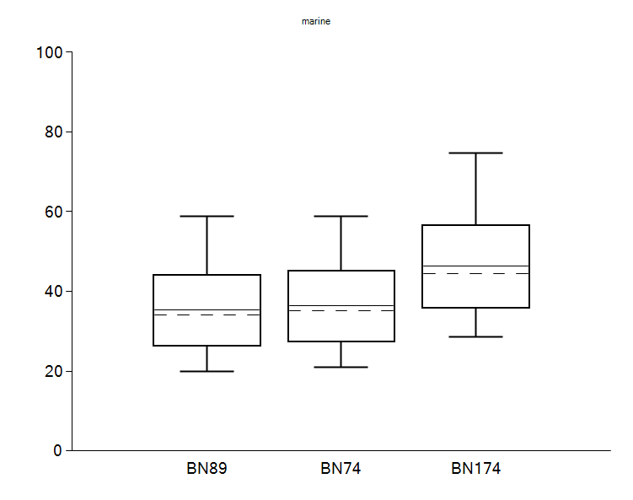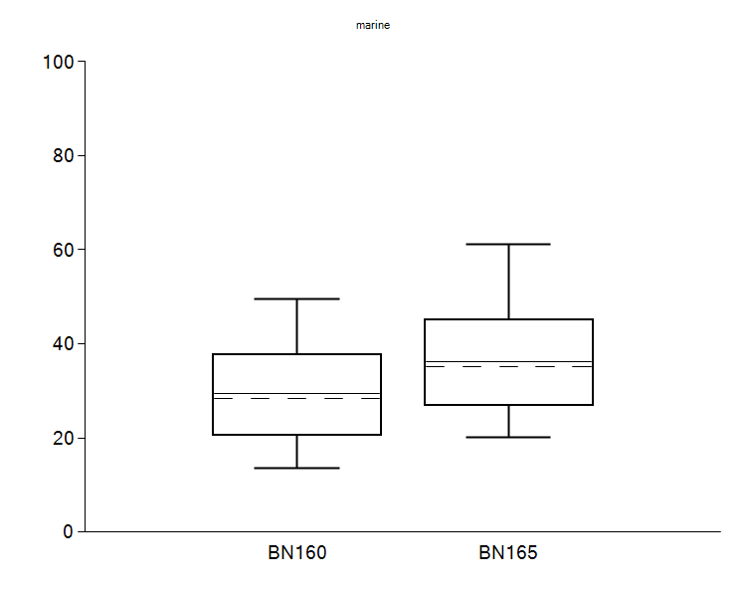

Figure S3: Box and whisker plot for the marine contribution in potsherds dominated by (a) ruminant adipose fats and (b) dairy fats for the potsherds CSRA dated and corrected in the main paper (from FRUITS v2.1).

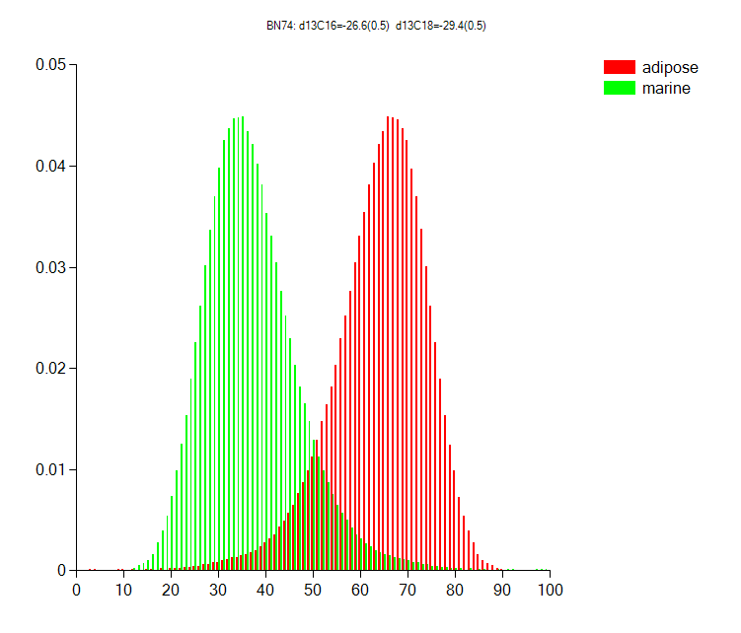 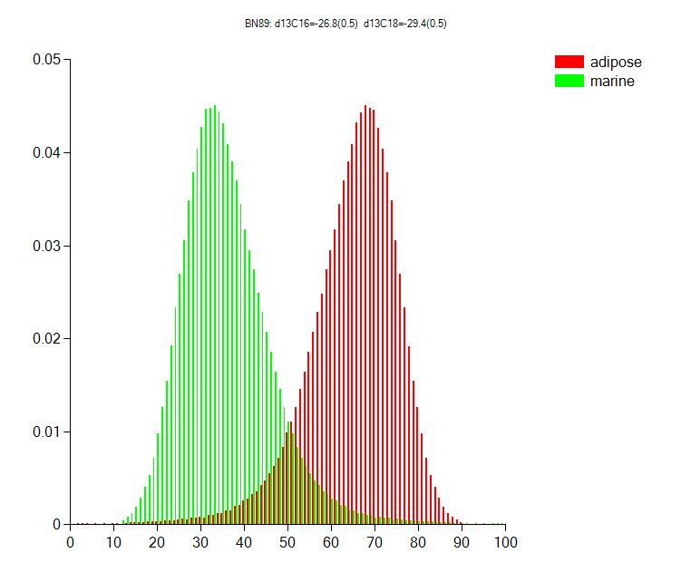 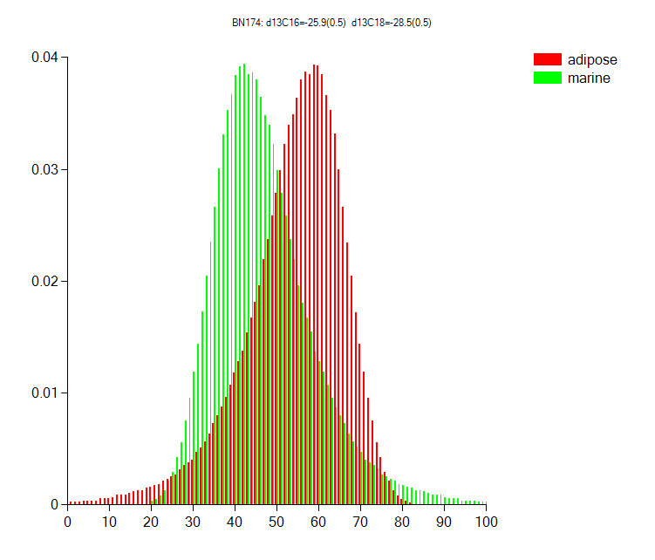 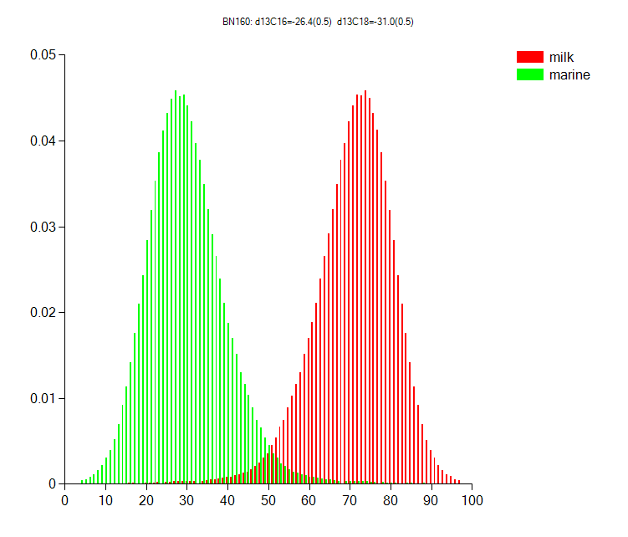 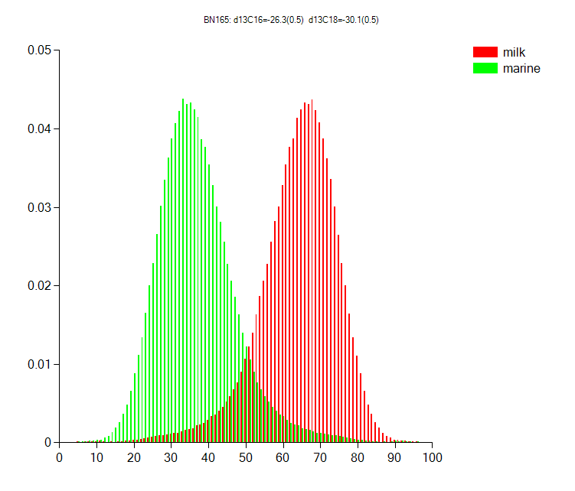

Figure S4: Probability distribution for the proportion of marine (green) and terrestrial (red) resources for the potsherds CSRA dated and corrected in the main paper (from FRUITS v2.1)

R

**References**

Ascough, P., Cook, G. and Dugmore, A. 2005. Methodological approaches to determining the marine radiocarbon reservoir effect. *Progress in Physical Geography* 29 (4): 532-547

Ascough, P. L., Dugmore, A. J., Cook, G. T., Higney, E., Barber, J. and Scott, E. M. 2004. Holocene variations in the Scottish marine radiocarbon reservoir effect. *Radiocarbon* 46 (2): 611-620

Ascough, P. L., Cook, G. T., Church, M. J., Dugmore, A. J., Arge, S. V. and McGovern, T. H. 2006. Variability in North Atlantic marine radiocarbon reservoir effects at c. AD 1000. *The Holocene* 16 (1): 131-136

Ascough, P. L., Cook, G. T., Dugmore, A. J. and Scott, E. M. 2007. The North Atlantic marine reservoir effect in the Early Holocene: Implications for defining and understanding MRE values. *Nuclear Instruments and Methods in Physics Research Section B: Beam Interactions with Materials and Atoms* 259 (1): 438-447

Ascough, P. L., Cook, G. T. and Dugmore, A. J. 2009. North Atlantic marine 14C reservoir effects: implications for late-Holocene chronological studies. *Quaternary Geochronology* 4 (3): 171-180

Ascough, P. L., Church, M. J. and Cook, G. T. 2017. Marine radiocarbon reservoir effects for the Mesolithic and Medieval periods in the Western Isles of Scotland. *Radiocarbon* 59 (1): 17-31

Casanova, E., Knowles, T. D. J., Williams, C., Crump, M. P. and Evershed, R. P. 2017. Use of a 700 MHz NMR microcryoprobe for the identification and quantification of exogenous carbon in compounds purified by preparative capillary gas chromatography for radiocarbon determinations. *Analytical Chemistry* 89 (13): 7090-7098

Casanova, E., Knowles, T. D. J., Williams, C., Crump, M. P. and Evershed, R. P. 2018. Practical considerations in high precision compound-specific radiocarbon dating: Eliminating the effects of solvent and sample cross-contamination on accuracy and precision. *Analytical Chemistry* 90 (18): 11025-11032

Casanova, E., T. D. J. Knowles, A. Bayliss, J. Dunne, M. Z. Barański, A. Denaire, P. Lefranc, S. di Lernia, M. Roffet-Salque, J. Smyth, T. Gillard, E. Claßen, B. J. Coles, M. Illet, C. Jeunesse, M. Krueger, A. Marciniak, S. Minnitt, R. Rotunno, P. Van De Velde, I. van Wijk, MOLA and R. P. Evershed. In revisions). Accurate compound-specific radiocarbon dating of archaeological pottery vessels. *Nature.*

Copley, M. S., Berstan, R., Dudd, S. N., Docherty, G., Mukherjee, A. J., Straker, V., Payne, S. and Evershed, R. P. 2003. Direct chemical evidence for widespread dairying in prehistoric Britain. *Proceedings of the National Academy of Sciences* 100 (4): 1524-1529

Correa-Ascencio, M. and Evershed, R. P. 2014. High throughput screening of organic residues in archaeological potsherds using direct acidified methanol extraction. *Analytical Methods* 6 (5): 1330-1340

Cramp, L. J. E. and Evershed, R. P. 2014. Reconstructing aquatic resource exploitation in human prehistory using lipid biomarkers and stable isotope. In *Treatise on Geochemistry: Archaeology and Anthropology Amsterdam*: Elsevier Oxford 12: 319-339

Evershed, R. P., Heron, C. and Goad, L. J. 1990. Analysis of organic residues of archaeological origin by high-temperature gas chromatography and gas chromatography-mass spectrometry. *Analyst* 115 (10): 1339-1342

Reimer, P. J., McCormac, F. G., Moore, J., McCormick, F. and Murray, E. V. 2002. Marine radiocarbon reservoir corrections for the mid to late Holocene in the eastern subpolar North Atlantic. *The Holocene* 12 (2): 129-135

Russell, N., Cook, G. T., Ascough, P. L. and Dugmore, A. J. 2010. Spatial variation in the marine radiocarbon reservoir effect throughout the Scottish post-Roman to late Medieval period: North Sea values (500-1350 BP). *Radiocarbon* 52 (3): 1166-1181

Russell, N., Cook, G. T., Ascough, P. L. and Scott, E. M. 2015. A period of calm in Scottish seas: A comprehensive study of ΔR values for the northern British Isles coast and the consequent implications for archaeology and oceanography. *Quaternary Geochronology* 30: 34-41

Sharples, N., Ingrem, C., Marshall, P., Mulville, J., Powell, A. and Reed, K. 2016. “The Viking occupation of the Herbides: evidence from the excavations at Bornais, South Uist”. In *Maritime societies of the Viking and medieval world* (James Barrett and Sara-Jane Gibbon) Chapter 17, pp. 247-268, Monograph 37, Maney, Leeds.