Online Supplementary Information 1

Bayesian modelling of wood-age offsets in cremated bone
Helene Agerskov Rose, John Meadows, Mogens Bo Henriksen

OxCal model code
Radiocarbon dates are calibrated using the IntCal13 Northern Hemisphere atmospheric radiocarbon data set (Reimer et al. 2013). Post bomb dates are calibrated using the Bomb13NH1 (AD1650-2010) radiocarbon data set (Hua et al. 2013) with additional data points from the Hammer and Levin datasets of atmospheric ¹⁴C activity from the Alps (dataset provided in Online Supplementary Information 2) (Levin et al. 2013; Hammer and Levin 2017).
The following CQL code will run in OxCal v4 (Bronk Ramsey 2009), which is available online at https://c14.arch.ox.ac.uk/. Full details of how the program works and what individual functions are designed to do is given at http://c14.arch.ox.ac.uk/oxcalhelp/hlp_contents.html. A full bibliography is also provided. Please contact the corresponding author if you experience difficulties using the models.

Part 1 Modelling legacy dates from Olsen et al. (2008; 2013) and Minami et al. (2019)
Options ()
{
BCAD=FALSE;
Plot ()
{
Phase("likelihoods")
{
Phase("offsets Olsen et al. 2008_2013", )
{
R_Date("AAR-9576 CB", 2714, 34); //Gl.Brydegaard
R_Date ("AAR-9570 pitch", 2706, 35); //Gl.Brydegaard
//R_Date ("AAR-9571 CB", 2486, 25); //Lerbjerg I
//R_Date ("AAR-9568 pitch", 2826, 34); //Lerbjerg I
R_Date ("AAR-9569 pitch", 2459, 41) ;//Lerbjerg II
R_Date ("AAR-9573 CB", 2502, 39); //Lerbjerg II
R_Date ("AAR-8110 CB", 2882, 47); //Rom D2
R_Date ("AAR-4681 pitch", 2790, 45); //Rom D2
R_Date ("AAR-8111 CB", 2805, 45); //Rom D1
R_Date ("AAR-4682 pitch", 2815, 40); //Rom D1
R_Date ("AAR-8112 CB", 2829, 39); //Virkelyst
R_Date ("AAR-6097 pitch", 2815, 40); //Virkelyst
R_Date ("CB comb", 3127, 20); //Egtved
C_Date ("dendro", 3320, 1); //Egtved
};
Combine("Minami et al. 2019")
{
R_Date ("Jsi-2-B2W", 877, 30);
R_Date ("Jsi-4-B3W", 875, 30);
R_Date ("Jsi-4-B4W", 890, 30);
};
C_Date ("Jsi death date", 737,1);
Phase("offsets")
{
Difference ("Gl.Brydegaard", "AAR-9570 pitch", "AAR-9576 CB");
Difference ("Lerbjerg II", "AAR-9569 pitch", "AAR-9573 CB");
Difference ("Rom D2", "AAR-4681 pitch", "AAR-8110 CB");
Difference ("Rom D1", "AAR-4682 pitch", "AAR-8111 CB");
Difference ("Virkelyst", "AAR-6097 pitch", "AAR-8112 CB");
Difference ("Egtved","dendro", "CB comb");
Difference ("Jsi","Jsi death date", "Minami et al. 2019");
};
};
Sequence ()
{
Boundary ("start offsets",0);
Phase("offsets")
{
Date ("=Gl.Brydegaard");
Date ("=Lerbjerg II");
Date ("=Rom D2");
Date ("=Rom D1");
Date ("=Virkelyst");
Date ("=Egtved");
Date ("=Jsi");
KDE_Plot ("constrained offsets",);
};
Tau_Boundary ("end offsets");
};
};
};
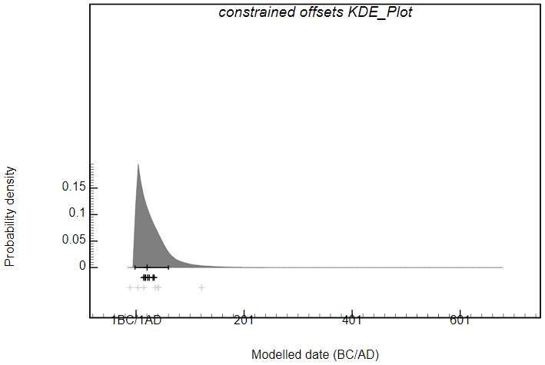
Constrained wood-age offset from Olsen et al. (2008; 2013) and Minami et al. (2019) summarized in a KDE_Plot. Posterior offsets are estimated to -10yrs to 52yrs (68% probability range), with a median of 21yrs. The black bar indicates the 1σ range and crosses the mean values of individual differences.

Part 2 Archaeological dataset, calculating differences between radiocarbon dates on cremated bone and associated material.
Plot ()
{
Phase("likelihoods")
{
Phase("Aarre")
{
R_Date ("A86 CB", 2382, 19);
R_Date ("A86 KIA-53941", 2463, 25); //Acer trunk
R_Date ("A95 CB", 2428, 27);
R_Date ("A95 KIA-53984", 2370, 25); //twig
R_Date ("A95 KIA-53985", 2430, 26); //twig
R_Combine ("A95 twigs comb")
{
R_Date ("A95 KIA-53984_1", 2370, 25);
R_Date ("A95 KIA-53985_1", 2430, 26);
};
R_Date ("A99 CB", 2255, 20);
R_Date ("A99 RICH-25071", 2269, 29); //Alnus trunk (pit)
R_Date ("A99 RICH-25069", 2085, 29); //twig
R_Date ("A99 RICH-25066", 2251, 30); //Alnus trunk
R_Date ("A99 RICH-25067", 3115, 31); //Quercus trunk
R_Date ("A117 CB", 2431, 15);
R_Date ("A117 KIA-53943", 2449, 25); //Quercus trunk
R_Date ("A117 KIA-53944", 2495, 24); //Quercus trunk
R_Date ("A130 CB", 2253, 18);
R_Date ("A130 KIA-53945", 2585, 25); //grass
R_Date ("A130 KIA-53946", 2156, 24); //cereal
R_Date ("A155 CB", 2367, 18);
R_Date ("A155 KIA-53948", 2494, 24); //cereal
R_Date ("A155 KIA-53949", 2466, 24); //grass
R_Date ("A198 CB", 2325, 21);
R_Date ("A198 KIA-53951", 2967,24); //Alnus trunk
R_Date ("A278 CB", 2463, 19);
R_Date ("A278 KIA-53953", 2400, 25); //grass
R_Date ("A278 KIA-53954", 2445, 25); //grass
R_Combine ("A278 grass comb")
{
R_Date ("A278 KIA-53953_1", 2400, 25);
R_Date ("A278 KIA-53954_1", 2445, 25);
};
R_Date ("A393 CB", 2480, 27);
R_Date ("A393 RICH-25068", 2901,32); //cereal from pit
R_Date ("A393 RICH-25070", 2914, 32); //cereal from pit
R_Date ("A393 KIA-52411", 3134, 25); //cereal from urn
R_Date ("A393 KIA-52412", 3150, 27); //cereal from urn
R_Date ("A393 KIA-52413", 2611, 27); //Quercus trunk
R_Date ("A394 CB", 2446, 14); //A394
R_Date ("A394 KIA-52414", 2778, 27); //Alnus branch sapwood
R_Date ("A394 KIA-52415", 2843, 26); //cereal
R_Date ("A394 KIA-52416", 2772, 26); //Alnus heartwood
R_Date ("A394 KIA-52417", 2719, 27); // Quercus trunk
R_Date ("A394 KIA-53983", 3029, 24); //Acer trunk
};
Phase("offsets")
{
Difference ("A86 CB-Acer sp.trunk", "A86 CB", "A86 KIA-53941")
{
color="grey";
};
Difference ("A95 CB-twig_1", "A95 CB", "A95 KIA-53984")
{
color="black";
};
Difference ("A95 CB-twig_2", "A95 CB", "A95 KIA-53985")
{
color="black";
};
Difference ("A95 CB-twigs comb", "A95 CB", "A95 twigs comb");
Difference ("A99 CB-Alnus trunk(pit)", "A99 CB","A99 RICH-25071")
{
color="grey";
};
Difference ("A99 CB-twig", "A99 CB", "A99 RICH-25069")
{
color="black";
};
Difference ("A99 CB-Alnus trunk","A99 CB", "A99 RICH-25066")
{
color="grey";
};
Difference ("A99 CB-Quercus trunk", "A99 CB", "A99 RICH-25067")
{
color="grey";
};
Difference ("A117 CB-Quercus trunk_1","A117 CB", "A117 KIA-53943")
{
color="grey";
};
Difference ("A117 CB-Quercus trunk_2", "A117 CB", "A117 KIA-53944")
{
color="grey";
};
Difference ("A130 CB-grass","A130 CB", "A130 KIA-53945")
{
color="black";
};
Difference ("A130 CB-cereal","A130 CB", "A130 KIA-53946")
{
color="black";
};
Difference ("A155 CB-cereal", "A155 CB", "A155 KIA-53948")
{
color="black";
};
Difference ("A155 CB-grass", "A155 CB", "A155 KIA-53949")
{
color="black";
};
Difference ("A198 CB-Alnus trunk", "A198 CB", "A198 KIA-53951")
{
color="grey";
};
Difference ("A278 CB- grass_1", "A278 CB", "A278 KIA-53953")
{
color="black";
};
Difference ("A278 CB- grass_2", "A278 CB", "A278 KIA-53954")
{
color="black";
};
Difference ("A278 CB-grass comb", "A278 CB", "A278 grass comb");
Difference ("A393 CB-cereal_1(pit)", "A393 CB", "A393 RICH-25068")
{
color="black";
};
Difference ("A393 CB-cereal_2(pit)", "A393 CB", "A393 RICH-25070")
{
color="black";
};
Difference ("A393 CB-cereal_1(urn)-CB","A393 CB", "A393 KIA-52411")
{
color="black";
};
Difference ("A393 CB-cereal_2(urn)-CB", "A393 CB", "A393 KIA-52412")
{
color="black";
};
Difference ("A393 CB-Quercus trunk-CB", "A393 CB""A393 KIA-52413")
{
color="grey";
};
Difference ("A394 CB-Alnus branch", "A394 CB", "A394 KIA-52414")
{
color="black";
};
Difference ("A394 CB-cereal", "A394 CB", "A394 KIA-52415")
{
color="black";
};
Difference ("A394 CB-Alnus heartwood","A394 CB", "A394 KIA-52416")
{
color="grey";
};
Difference ("A394 CB-Quercus trunk", "A394 CB", "A394 KIA-52417")
{
color="grey";
};
Difference ("A394 CB-Acer trunk", "A394 CB", "A394 KIA-53983")
{
color="grey";
};
};
};
Sequence ()
{
Boundary ("Start offsets",0);
Phase ("modelled offsets")
{
Date ("=A95 twigs comb-CB");
Date ("=A99 Twig_CB");
Date ("=A130 Cereal-CB");
Date ("=A278 grass comb_CB");
KDE_Plot ("constrained offsets",);
};
Tau_Boundary ("End offsets");
};
};

Part 3 Testing outlier models on archaeological results

Model 1 with Charcoal OM
Options ()
{
Resolution=1;
};
Plot ()
{
Outlier_Model ("charcoal", Exp(1,-10,0), U(0,3),"t");
Sequence ("Aarre")
{
Boundary("Start");
Phase ("Aarre urnfield cemetery")
{
Sequence ("A86")
{
After ("older CC from A86")
{
R_Date ("A86 KIA-53941", 2463, 25);
//Acer sp. trunk
};
Phase("A86")
{
R_Date ("A86 CB KIA-53942", 2382, 19)
{
Outlier ("charcoal", 1);
};
};
};
Combine("A95")
{
R_Date ("RICH-25342 CB", 2428, 27)
{
Outlier ("charcoal", 1);
};
R_Date ("A95 twigs comb", 2399, 19);
//2xtwig
};
Sequence ("A99")
{
After ("older CC from A99")
{
R_Date ("A99 RICH-25071", 2269, 29);
//Alnus trunk (pit)
R_Date ("A99 RICH-25066", 2251, 30);
//Alnus sp. trunk
R_Date ("A99 RICH-25067", 3115, 31);
//Quercus trunk
};
Combine("A99")
{
R_Date ("GrM-16774 CB", 2255, 20)
{
Outlier ("charcoal", 1);
};
R_Date ("RICH-25069", 2085, 29);
//twig
};
};
Sequence ("A117")
{
After ("older CC from A117")
{
R_Date ("A117 KIA-53943", 2449, 25);
//Quercus trunk
R_Date ("A117 KIA-53944", 2495, 24);
//Quercus trunk
};
Phase("A117")
{
R_Date ("A117 CB (mean)", 2431, 15)
{
Outlier ("charcoal", 1);
};
};
};
Sequence ("A130")
{
After ("older CC from A130")
{
R_Date ("A130 KIA-53945", 2585, 25);
//grass
};
Combine("A130")
{
R_Date ("A130 KIA-53947 CB", 2253, 18)
{
Outlier ("charcoal", 1);
};
R_Date ("A130 KIA-53946", 2156, 24);
//cereal
};
};
Sequence ("A155")
{
After ("older CC from A155")
{
R_Date ("A155 KIA-53948", 2494, 24);
//cereal
R_Date ("A155 KIA-53949", 2466, 24);
//grass
};
Phase("A155")
{
R_Date ("A155 CB KIA-53950", 2367, 18)
{
Outlier ("charcoal", 1);
};
};
};
Sequence ("A198")
{
After ("older CC from A155")
{
R_Date ("A198 KIA-53951", 2967,24);
//Alnus trunk
};
Phase("A198")
{
R_Date ("A198 CB KIA-53952", 2325, 21)
{
Outlier ("charcoal", 1);
};
};
};
Combine("A278")
{
R_Date ("KIA-53955 CB", 2463, 19)
{
Outlier ("charcoal", 1);
};
R_Date ("A278 grass comb", 2423, 18);
//2xgrass
};
Sequence ("A393")
{
After ("older CC from A393")
{
R_Date ("A393 RICH-25068", 2901,32);
//cereal from pit
R_Date ("A393 RICH-25070", 2914, 32);
//cereal from pit
R_Date ("A393 KIA-52411", 3134, 25);
//cereal from urn
R_Date ("A393 KIA-52412", 3150, 27);
//cereal from urn
R_Date ("A393 KIA-52413", 2611, 27);
//Quercus trunk
};
Phase("A393")
{
R_Date ("A393 CB RICH-25341", 2480, 27)
{
Outlier ("charcoal", 1);
};
};
};
Sequence ("A394")
{
After ("older CC from A394")
{
R_Date ("A394 KIA-52414", 2778, 27);
//Alnus branch sapwood
R_Date ("A394 KIA-52415", 2843, 26);
//cereal
R_Date ("A394 KIA-52416", 2772, 26);
//Alnus heartwood
R_Date ("A394 KIA-52417", 2719, 27);
//Quercus trunk
R_Date ("A394 KIA-53983", 3029, 24);
//Acer trunk
};
Phase("A394")
{
R_Date ("A394 CB (mean)", 2446,14)
{
Outlier ("charcoal", 1);
};
};
};
Span ("Aarre urnfield cemetery");
};
Boundary("End");
};
};
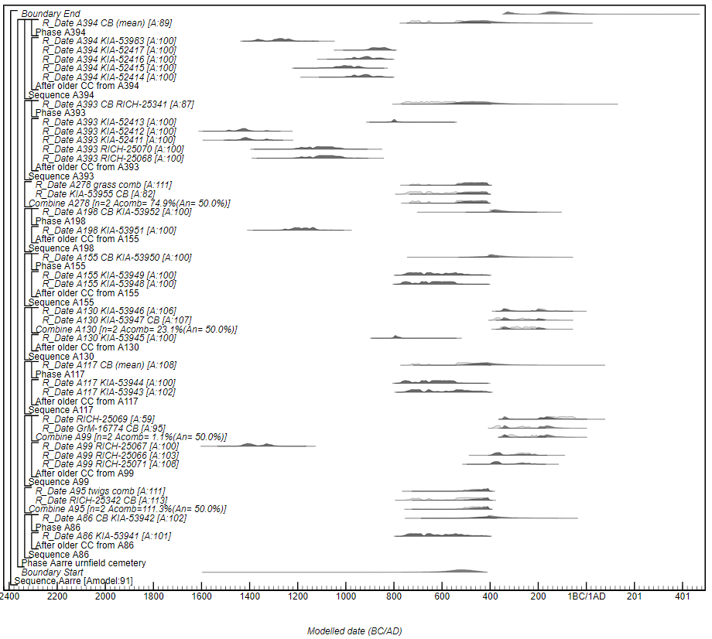

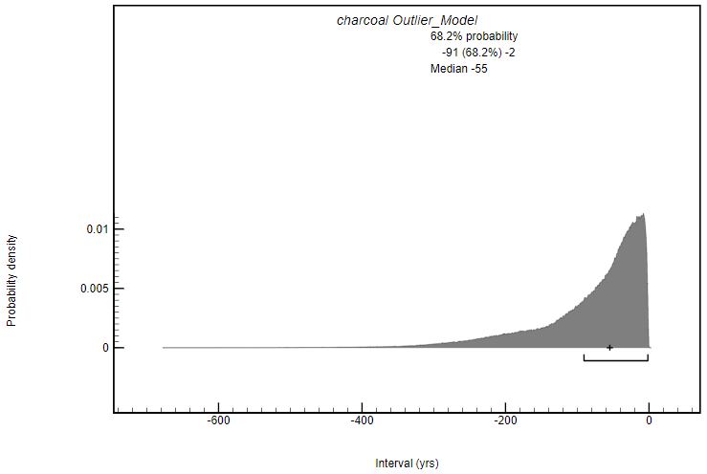
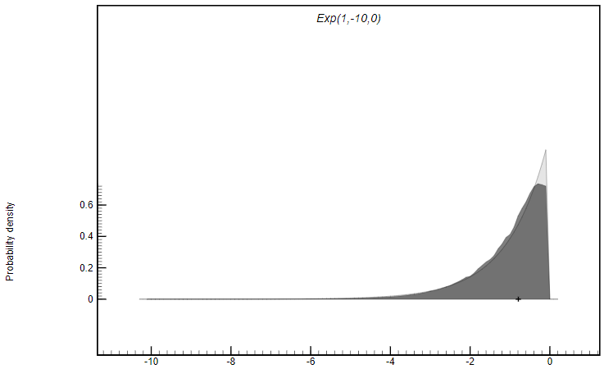
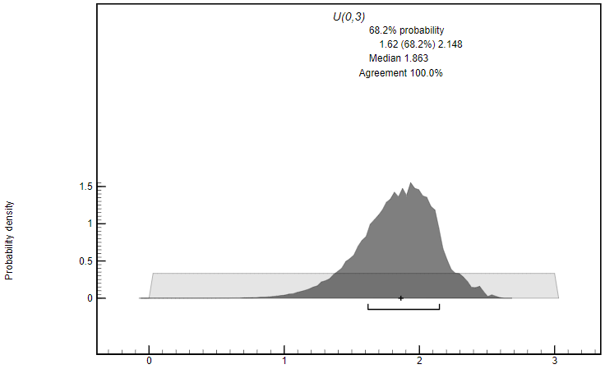

Model 2 with Cremation OM
Options ()
{
Resolution=1;
};
Plot ()
{
Outlier_Model ("cremation", Exp(0.9,-10,-0.1), U(1,3),"t");
Sequence ("Aarre")
{
Boundary("Start");
Phase ("Aarre urnfield cemetery")
{
Sequence ("A86")
{
After ("older CC from A86")
{
R_Date ("A86 KIA-53941", 2463, 25);
//Acer sp. trunk
};
Phase("A86")
{
R_Date ("A86 CB KIA-53942", 2382, 19)
{
Outlier ("cremation", 1);
};
};
};
Combine("A95")
{
R_Date ("RICH-25342 CB", 2428, 27)
{
Outlier ("cremation", 1);
};
R_Date ("A95 twigs comb", 2399, 19);
//2xtwig
};
Sequence ("A99")
{
After ("older CC from A99")
{
R_Date ("A99 RICH-25071", 2269, 29);
//Alnus trunk (pit)
R_Date ("A99 RICH-25066", 2251, 30);
//Alnus sp. trunk
R_Date ("A99 RICH-25067", 3115, 31);
//Quercus trunk
};
Combine("A99")
{
R_Date ("GrM-16774 CB", 2255, 20)
{
Outlier ("cremation", 1);
};
R_Date ("RICH-25069", 2085, 29);
//twig
};
};
Sequence ("A117")
{
After ("older CC from A117")
{
R_Date ("A117 KIA-53943", 2449, 25);
//Quercus trunk
R_Date ("A117 KIA-53944", 2495, 24);
//Quercus trunk
};
Phase("A117")
{
R_Date ("A117 CB (mean)", 2431, 15)
{
Outlier ("cremation", 1);
};
};
};
Sequence ("A130")
{
After ("older CC from A130")
{
R_Date ("A130 KIA-53945", 2585, 25);
//grass
};
Combine("A130")
{
R_Date ("A130 KIA-53947 CB", 2253, 18)
{
Outlier ("cremation", 1);
};
R_Date ("A130 KIA-53946", 2156, 24);
//cereal
};
};
Sequence ("A155")
{
After ("older CC from A155")
{
R_Date ("A155 KIA-53948", 2494, 24);
//cereal
R_Date ("A155 KIA-53949", 2466, 24);
//grass
};
Phase("A155")
{
R_Date ("A155 CB KIA-53950", 2367, 18)
{
Outlier ("cremation", 1);
};
};
};
Sequence ("A198")
{
After ("older CC from A155")
{
R_Date ("A198 KIA-53951", 2967,24);
//Alnus trunk
};
Phase("A198")
{
R_Date ("A198 CB KIA-53952", 2325, 21)
{
Outlier ("cremation", 1);
};
};
};
Combine("A278")
{
R_Date ("KIA-53955 CB", 2463, 19)
{
Outlier ("cremation", 1);
};
R_Date ("A278 grass comb", 2423, 18);
//2xgrass
};
Sequence ("A393")
{
After ("older CC from A393")
{
R_Date ("A393 RICH-25068", 2901,32);
//cereal from pit
R_Date ("A393 RICH-25070", 2914, 32);
//cereal from pit
R_Date ("A393 KIA-52411", 3134, 25);
//cereal from urn
R_Date ("A393 KIA-52412", 3150, 27);
//cereal from urn
R_Date ("A393 KIA-52413", 2611, 27);
//Quercus trunk
};
Phase("A393")
{
R_Date ("A393 CB RICH-25341", 2480, 27)
{
Outlier ("cremation", 1);
};
};
};
Sequence ("A394")
{
After ("older CC from A394")
{
R_Date ("A394 KIA-52414", 2778, 27);
//Alnus branch sapwood
R_Date ("A394 KIA-52415", 2843, 26);
//cereal
R_Date ("A394 KIA-52416", 2772, 26);
//Alnus heartwood
R_Date ("A394 KIA-52417", 2719, 27);
//Quercus trunk
R_Date ("A394 KIA-53983", 3029, 24);
//Acer trunk
};
Phase("A394")
{
R_Date ("A394 CB (mean)", 2446,14)
{
Outlier ("cremation", 1);
};
};
};
Span ("Aarre urnfield cemetery");
};
Boundary("End");
};
};

Part 4 Testing outlier models on experimental results

Model 3 with Charcoal OM
Options()
{
Resolution=0.5;
Curve="bomb13NH1NEW.14c";
Outlier_Model ("Charcoal", Exp(1,-10,0), U(0,3),"t");
Sequence()
{
Boundary("Start");
Phase("Pyres no.8 and no.11")
{
R_Date ("RICH-25820",-348, 24)
{
Outlier("Charcoal", 1);
};
R_Date ("RICH-25821",-492, 24)
{
Outlier("Charcoal", 1);
};
R_Date ("RICH-25822",-437, 25)
{
Outlier("Charcoal", 1);
};
R_Date ("RICH-25823",-425, 29)
{
Outlier("Charcoal", 1);
};
R_Date ("RICH-25744",-490, 29)
{
Outlier("Charcoal", 1);
};
R_Date ("RICH-25745",-389, 26)
{
Outlier("Charcoal", 1);
};
R_Date ("RICH-25753",-464, 27)
{
Outlier("Charcoal", 1);
};
R_Date ("RICH-25754",-434, 30)
{
Outlier("Charcoal", 1);
};
R_Date ("RICH-25737",-558, 29)
{
Outlier("Charcoal", 1);
};
R_Date ("RICH-25738",-554, 29)
{
Outlier("Charcoal", 1);
};
R_Date ("RICH-25739",-458, 26)
{
Outlier("Charcoal", 1);
};
R_Date ("RICH-25740",-504, 26)
{
Outlier("Charcoal", 1);
};
};
Boundary("End");
};
};
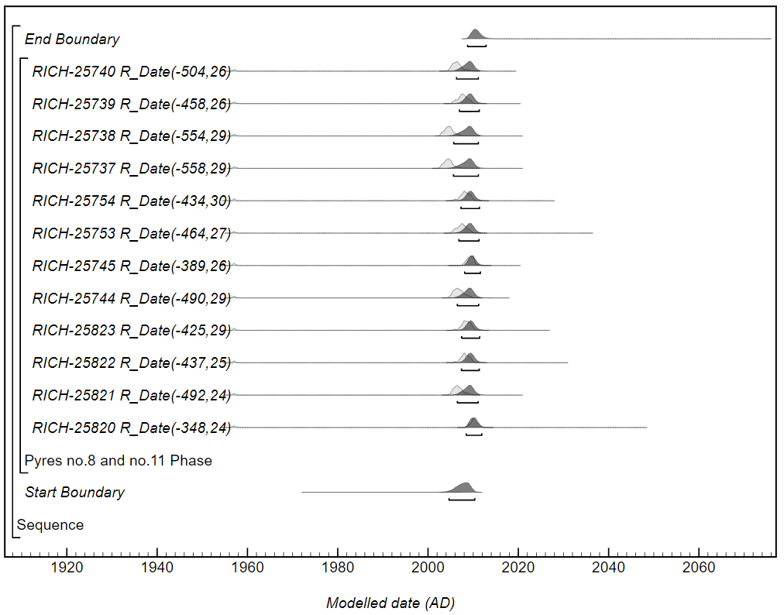

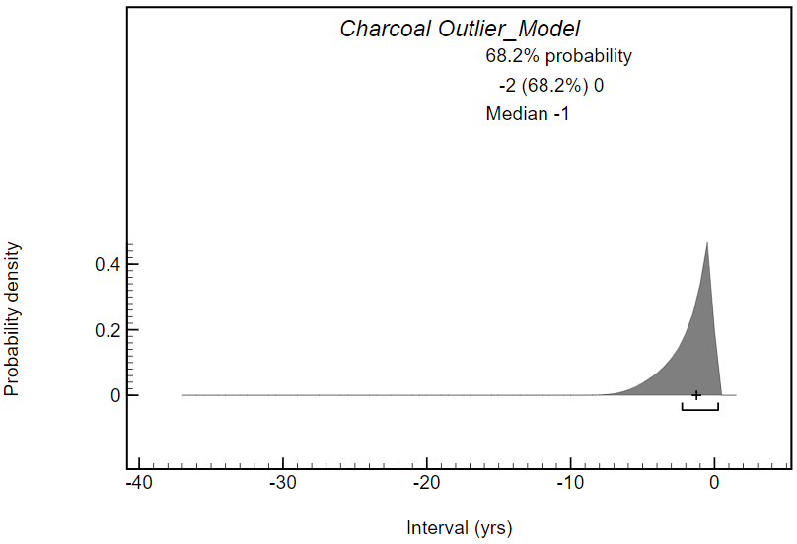
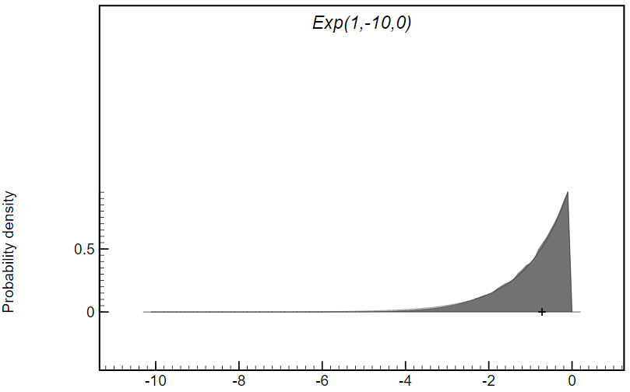
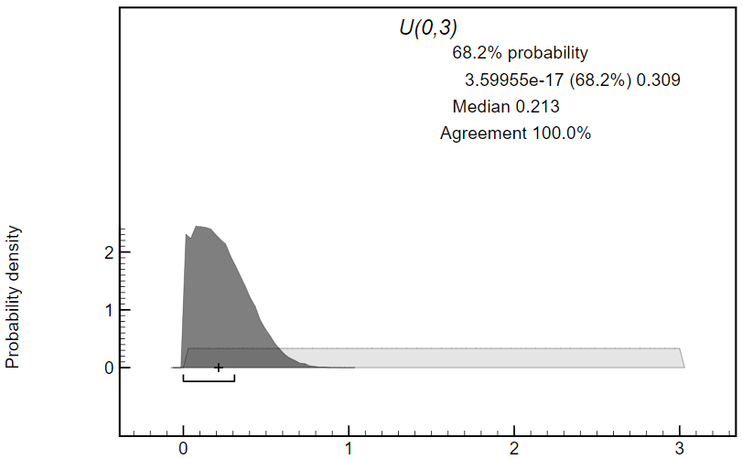

Model 4 with Cremation OM
Options()
{
Resolution=0.5;
Curve="bomb13NH1NEW.14c";
Outlier_Model ("Cremation", Exp(0.9,-10,-0.1), U(1,3),"t");
Sequence()
{
Boundary("Start");
Phase("Pyres no.8 and no.11")
{
R_Date ("RICH-25820",-348, 24)
{
Outlier("Cremation", 1);
};
R_Date ("RICH-25821",-492, 24)
{
Outlier("Cremation", 1);
};
R_Date ("RICH-25822",-437, 25)
{
Outlier("Cremation", 1);
};
R_Date ("RICH-25823",-425, 29)
{
Outlier("Cremation", 1);
};
R_Date ("RICH-25744",-490, 29)
{
Outlier("Cremation", 1);
};
R_Date ("RICH-25745",-389, 26)
{
Outlier("Cremation", 1);
};
R_Date ("RICH-25753",-464, 27)
{
Outlier("Cremation", 1);
};
R_Date ("RICH-25754",-434, 30)
{
Outlier("Cremation", 1);
};
R_Date ("RICH-25737",-558, 29)
{
Outlier("Cremation", 1);
};
R_Date ("RICH-25738",-554, 29)
{
Outlier("Cremation", 1);
};
R_Date ("RICH-25739",-458, 26)
{
Outlier("Cremation", 1);
};
R_Date ("RICH-25740",-504, 26)
{
Outlier("Cremation", 1);
};
};
Boundary("End");
};
};

Bronk Ramsey C. 2009. Bayesian analysis of radiocarbon dates. Radiocarbon 51(1):337-60.
Hammer S, Levin I. 2017. Monthly mean atmospheric D¹⁴CO₂ at Jungfraujoch and Schauinsland from 1986 to 2016. heiDATA Dataverse.
Hua Q, Barbetti M, Rakowski AZ. 2013. Atmospheric Radiocarbon for the Period 1950–2010. Radiocarbon 55(04):2059-72.
Levin I, Kromer B, Hammer S. 2013. Atmospheric Δ14CO2 trend in Western European background air from 2000 to 2012. Tellus B: Chemical and Physical Meteorology 65(1):20092.
Minami M, Mukumoto H, Wakaki S, Nakamura T. 2019. Effect of crystallinity of apatite in cremated bone on carbon exchanges during burial and reliability of radiocarbon dating. Radiocarbon:1-12.
Olsen J, Heinemeier J, Bennike P, Krause C, Margrethe Hornstrup K, Thrane H. 2008. Characterisation and blind testing of radiocarbon dating of cremated bone. Journal of Archaeological Science 35(3):791-800.
Olsen J, Heinemeier J, Hornstrup KM, Bennike P, Thrane H. 2013. 'Old wood' effect in radiocarbon dating of prehistoric cremated bones? Journal of Archaeological Science 40(1):30-4.
Reimer PJ, Bard E, Bayliss A, Beck JW, Blackwell PG, Ramsey CB, Buck CE, Cheng H, Edwards RL, Friedrich M, Grootes PM, Guilderson TP, Haflidason H, Hajdas I, Hatté C, Heaton TJ, Hoffmann DL, Hogg AG, Hughen KA, Kaiser KF, Kromer B, Manning SW, Niu M, Reimer RW, Richards DA, Scott EM, Southon JR, Staff RA, Turney CSM, van der Plicht J. 2013. IntCal13 and Marine13 Radiocarbon Age Calibration Curves 0–50,000 Years cal BP. Radiocarbon 55(04):1869-87.

