Supplementary materials

Fig S1. (a) 14C content (black dots) and its long-term trend obtained by linear fitting (red line) plotted together with the IntCal13 (blue line) [11]. (b) 14C anomaly obtained by subtracting the linear trend. The gray lines show ±1 error range. (c) 14C anomaly obtained by subtracting the IntCal13 curve. The gray lines show ±1 error range.

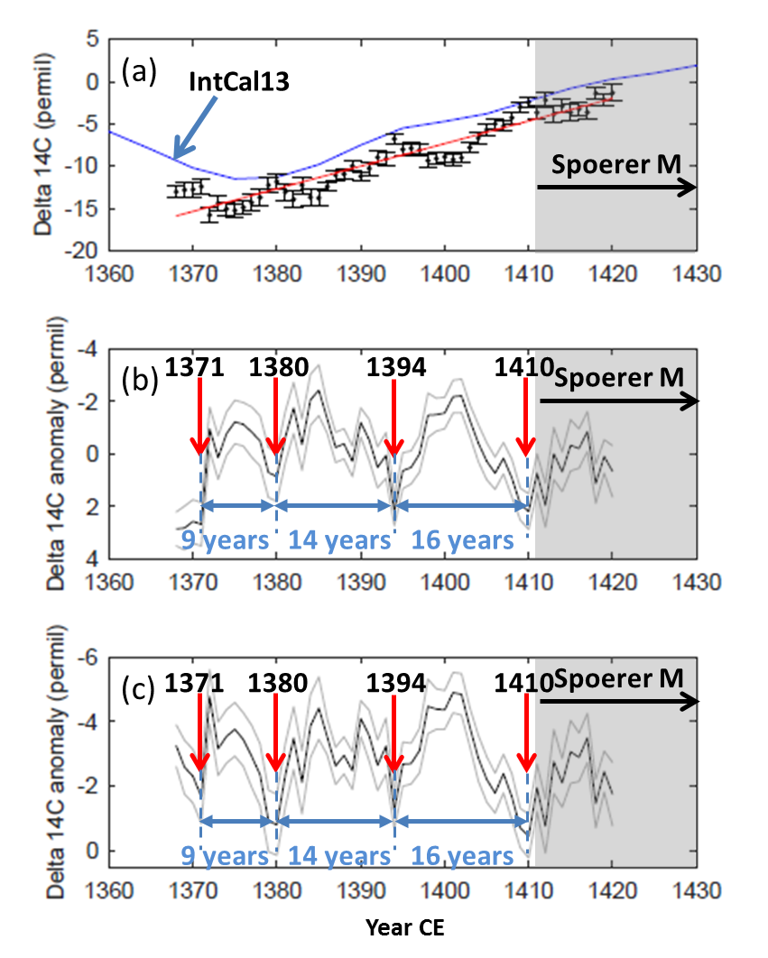

Table S1. A list of Δ14 C, error, and the 13C values. Measurements were conducted for up to 12 cathodes per each annual tree-ring sample. Laboratory Code assigned to the latest cathode for each annual sample is listed in the table.

