Revisiting the timing of the northern lobe of the White River Ash volcanic event in eastern Alaska and western Yukon – Supplemental Materials: Radiocarbon Date Combinations and Model Structures and Outputs

Stuiver et al. (1964) and Lerbekmo et al. (1975) Combinations
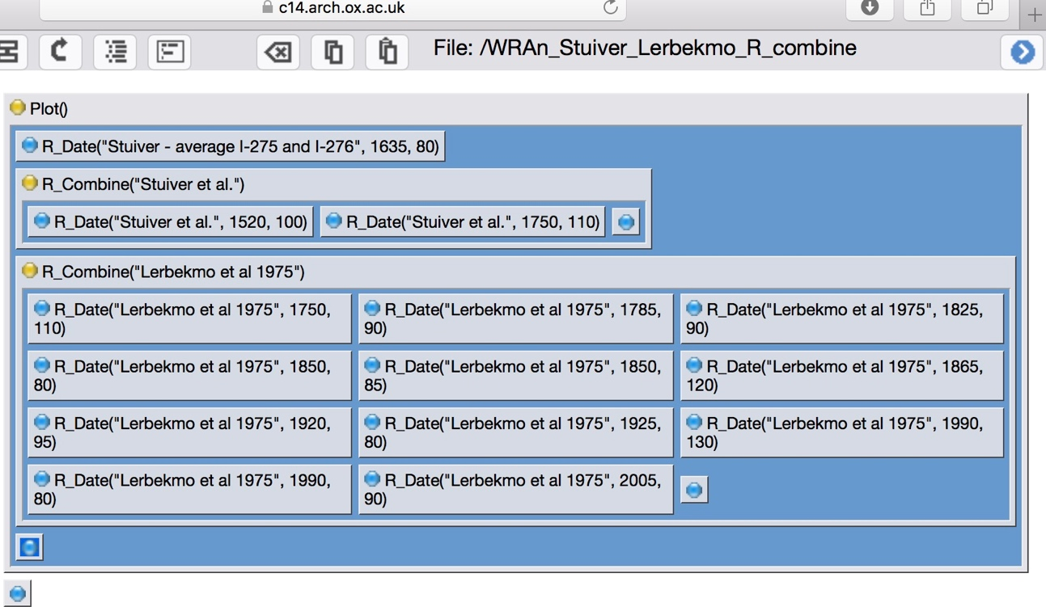
Figure S16. Structures of combinations based on Stuiver et al. (1964) and Lerbekmo et al. (1975) studies.

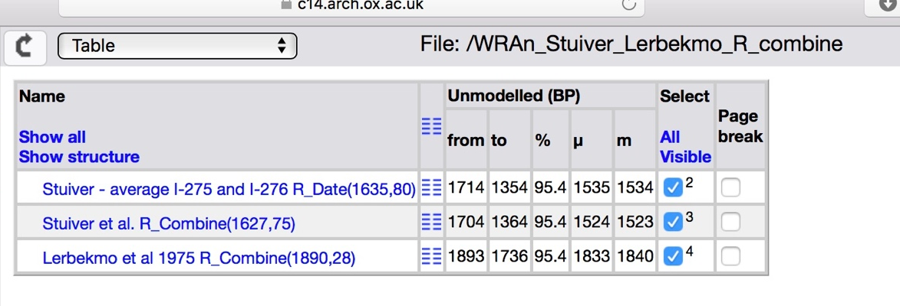
Figure S17. Unmodelled ages of combinations based on Stuiver et al. (1964) and Lerbekmo et al. (1975) studies.

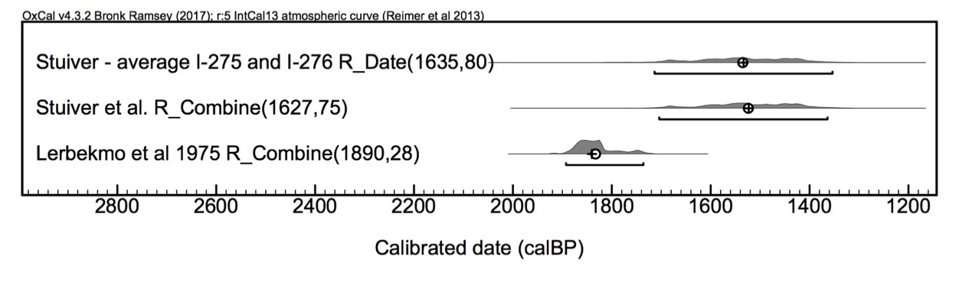
Figure S18. Distribution of calibrated unmodelled age ranges (2σ) of combinations based on Stuiver et al. (1964) and Lerbekmo et al. (1975) studies.

Combination 1 – All Ages with No Outlier Analysis Performed
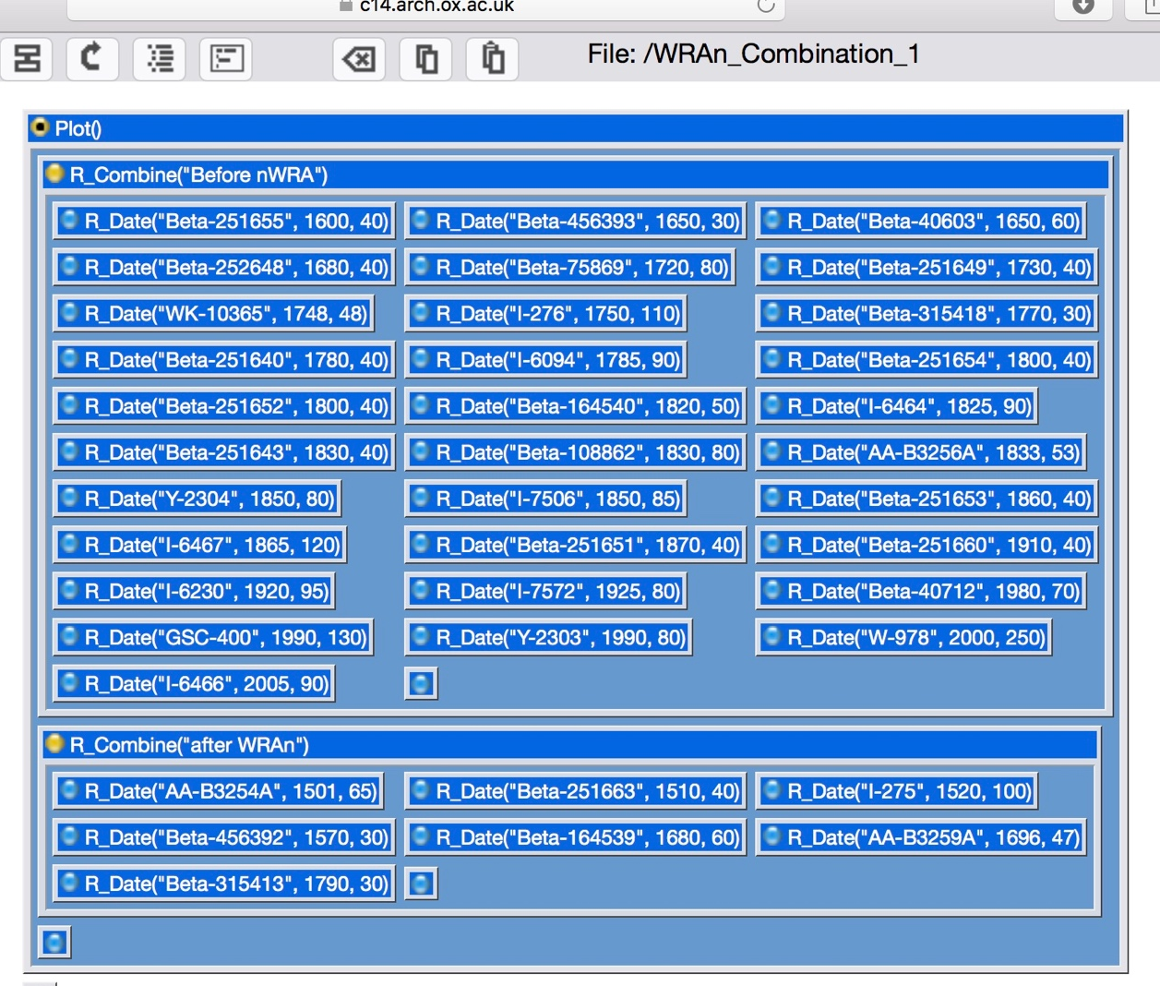
Figure S19. Structures of Combination 1 above and below the WRAn unit.

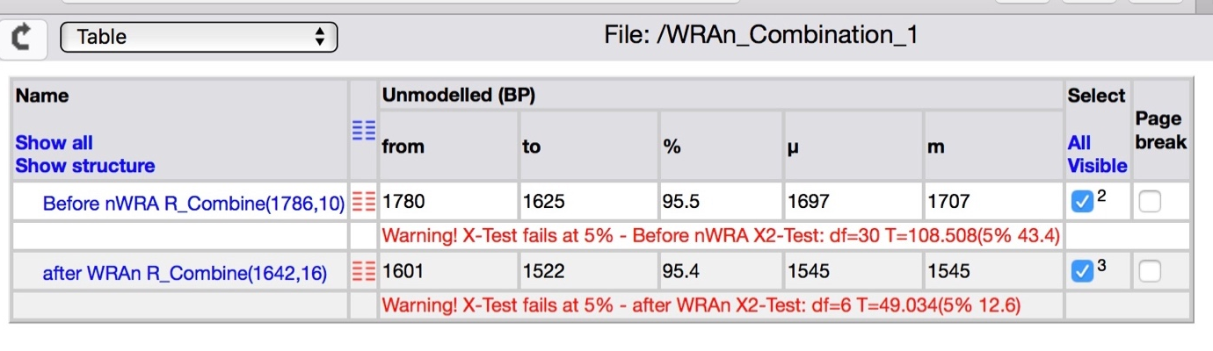
Figure S20. Unmodelled ages for Combination 1 above and below the WRAn unit.

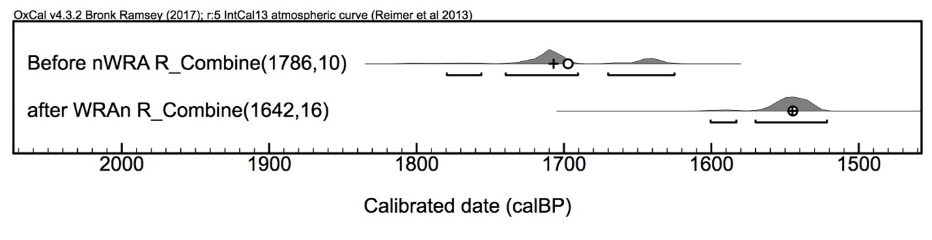
Figure S21. Distribution of calibrated unmodelled age ranges (2σ) for Combination 1 above and below the WRAn unit.

Combination 2 – Outlier Analysis 2 Performed
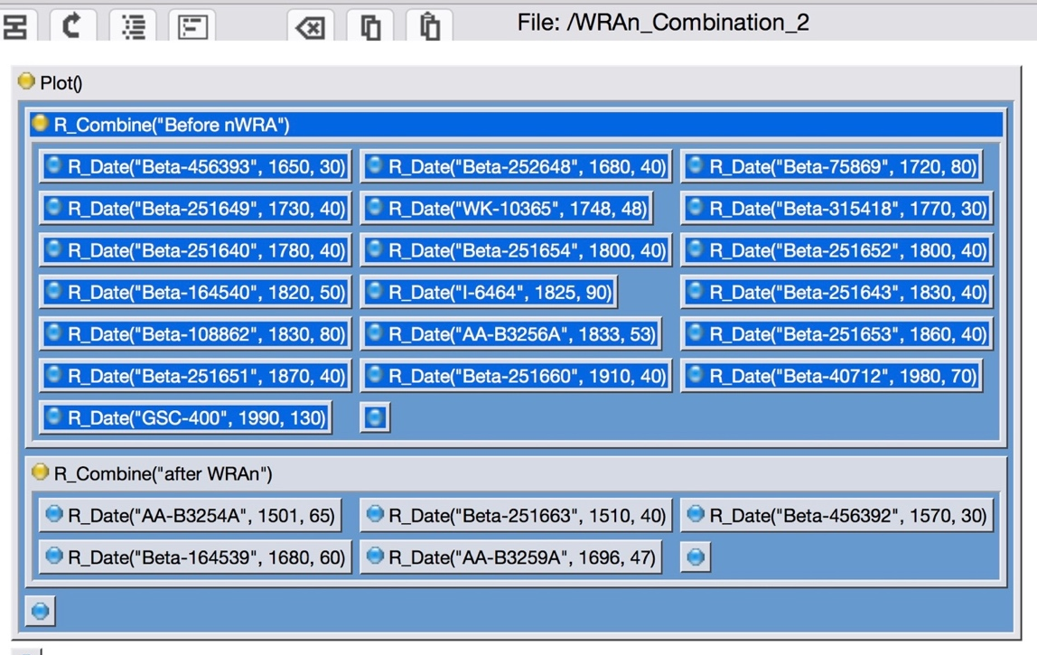
Figure S22. Structures of Combination 2 above and below the WRAn unit.

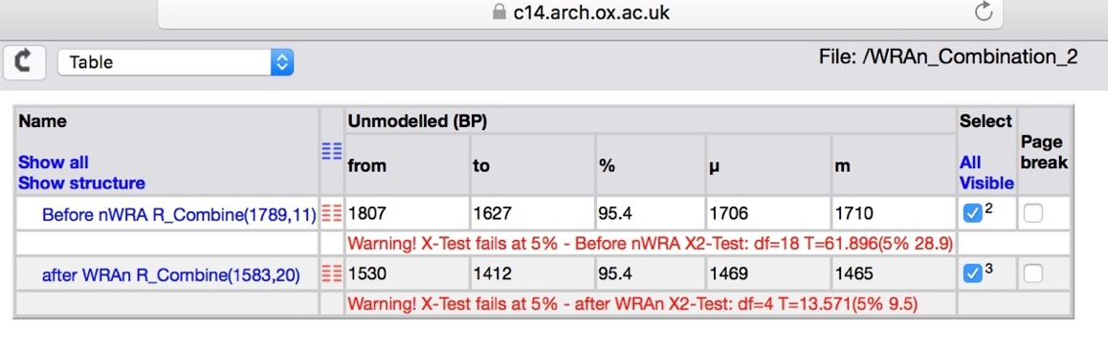
Figure S23. Unmodelled ages for Combination 2 above and below the WRAn unit.

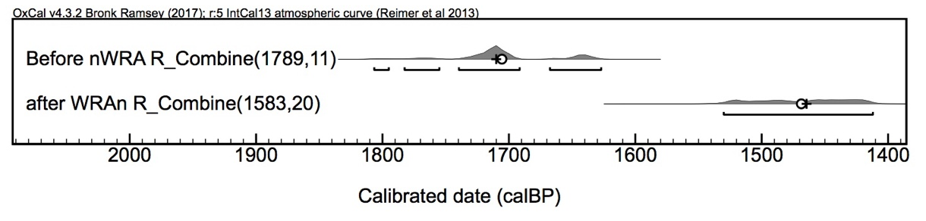
Figure S24. Distribution of calibrated unmodelled age ranges (2σ) for Combination 2 above and below the WRAn unit.

Combination 3 – Outlier Analysis 4 Performed
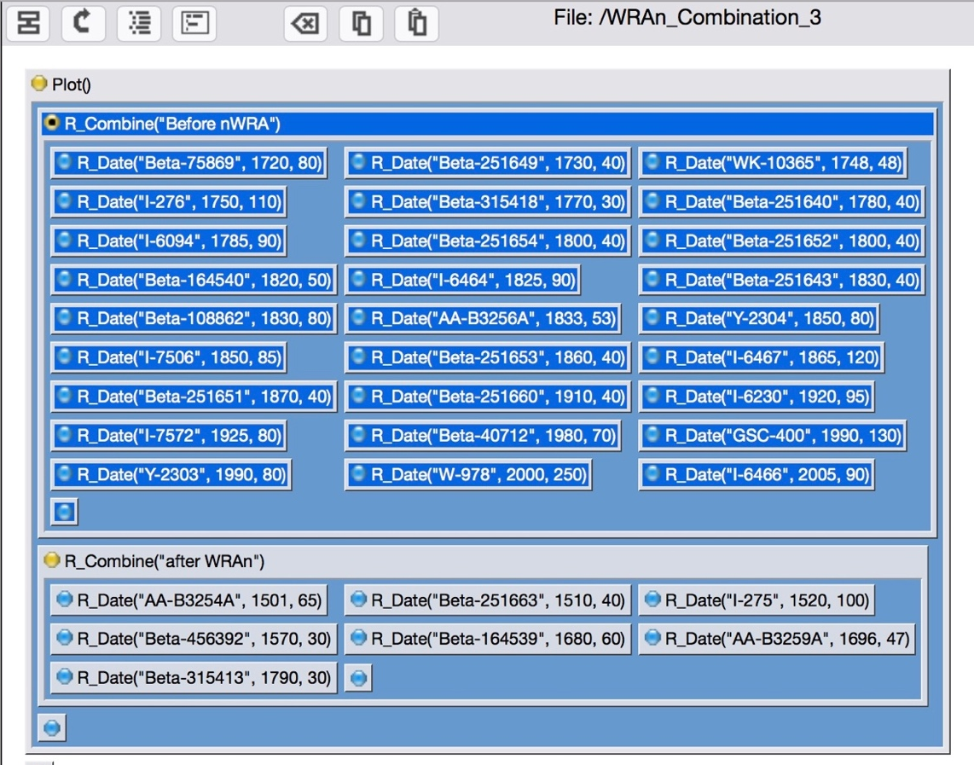
Figure S25. Structures of Combination 3 above and below the WRAn unit.

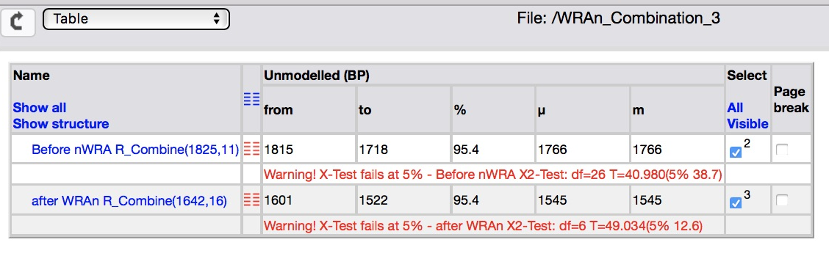
Figure S26. Unmodelled ages for Combination 3 above and below the WRAn unit.

Figure S27. Distribution of calibrated unmodelled age ranges (2σ) for Combination 3 above and below the WRAn unit.

Model 1 – All Ages with No Outlier Analysis Performed
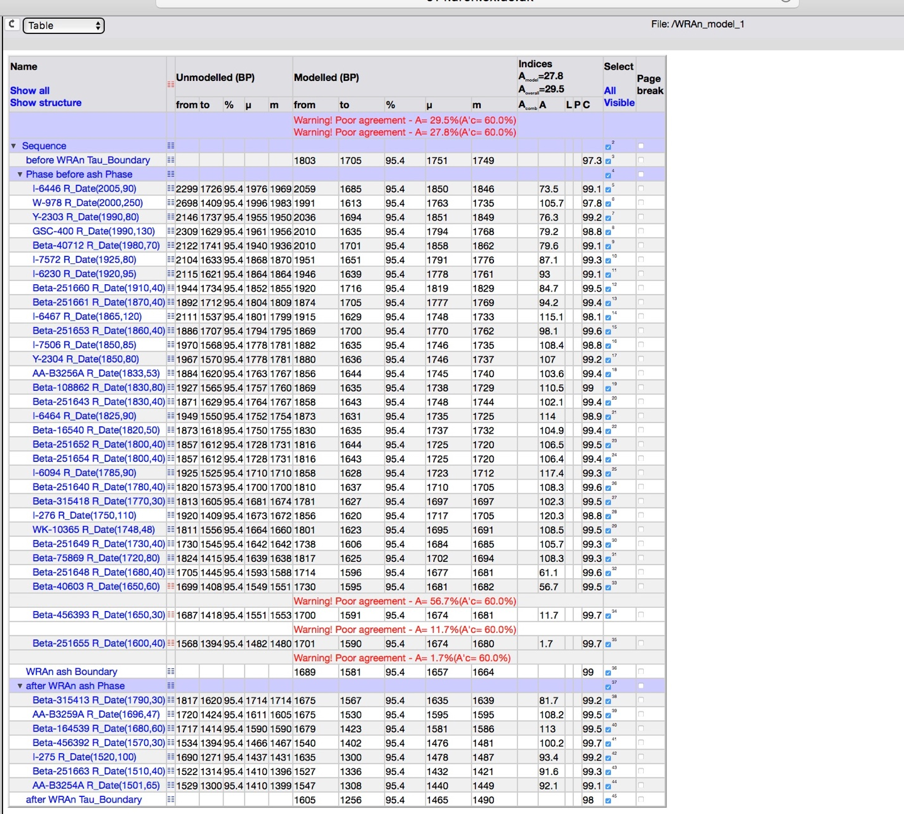
Figure S28. Structure of Model 1.
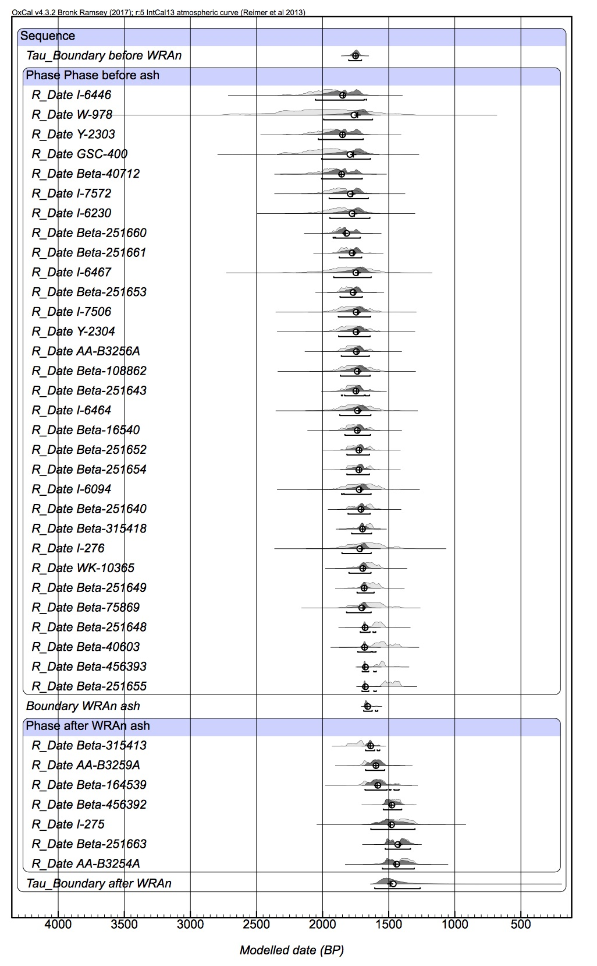
Figure S29. Overall results for Model 1.

Figure S30. Distribution of calibrated modelled age ranges (2σ) for boundaries of Model 1.

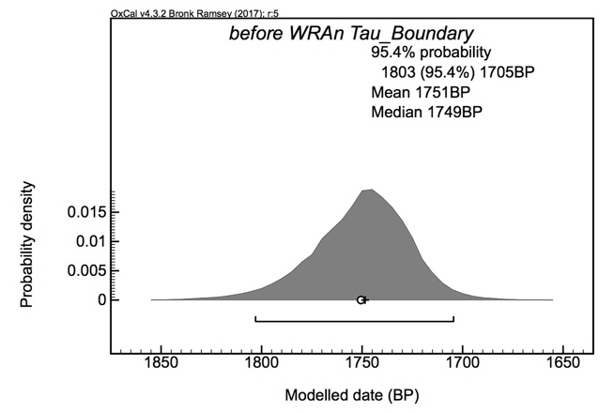
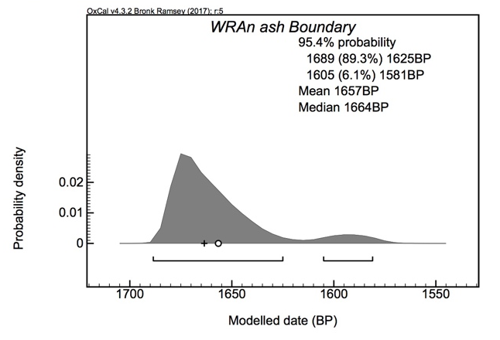
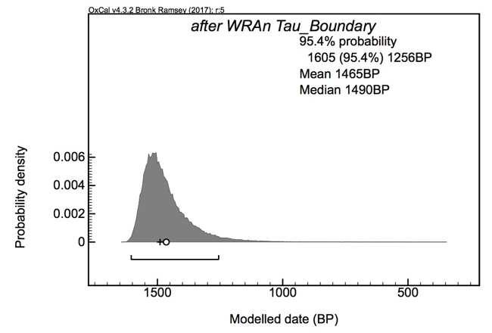
Figure S31. Probability distributions of calibrated modelled age ranges (2σ) for boundaries of Model 1.

Model 2 – Outlier Analysis 1 Performed
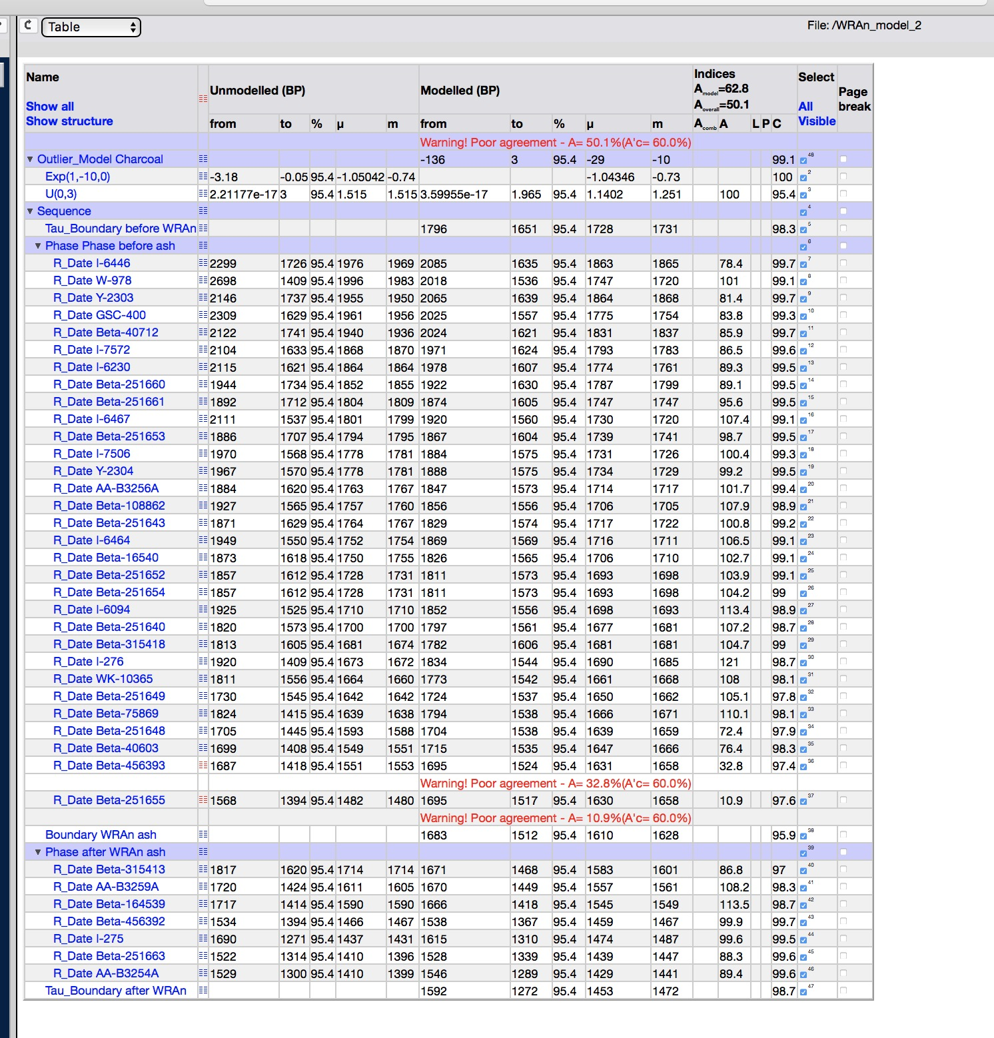
Figure S32. Structure of Model 2.

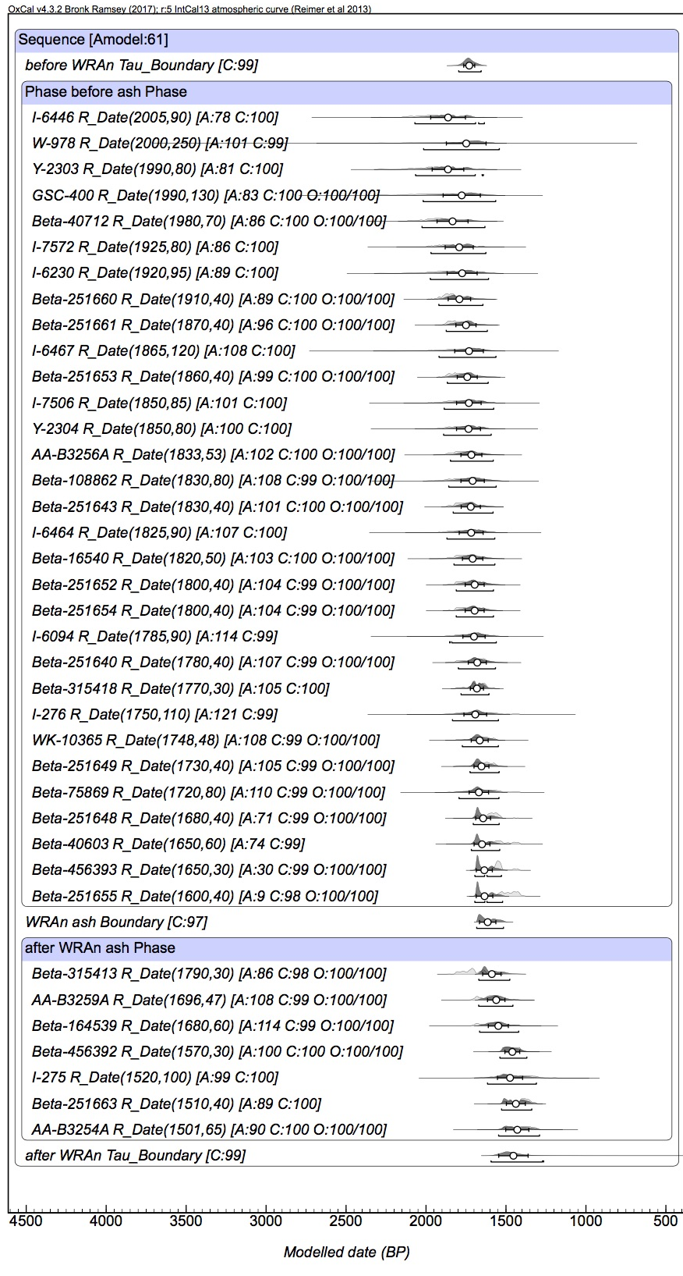
Figure S33. Overall results for Model 2.

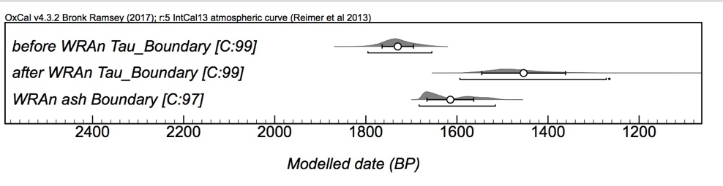
Figure S34. Distribution of calibrated modelled age ranges (2σ) for boundaries of Model 2.

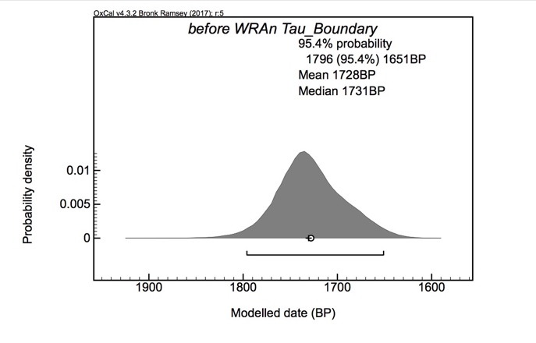
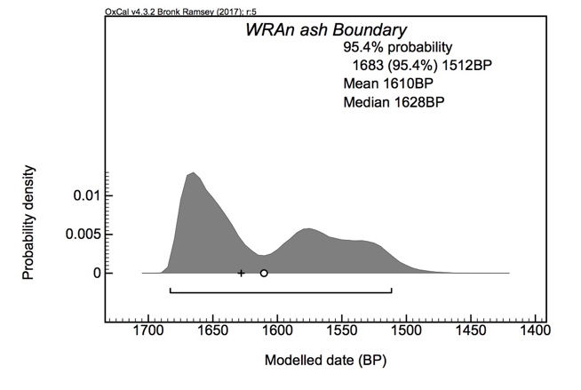
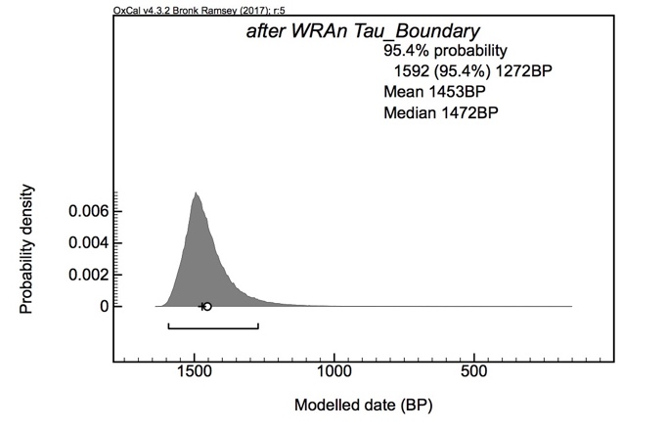
Figure S35. Probability distributions of calibrated modelled age ranges (2σ) for boundaries of Model 2.

Model 3 – Outlier Analysis 2 Performed
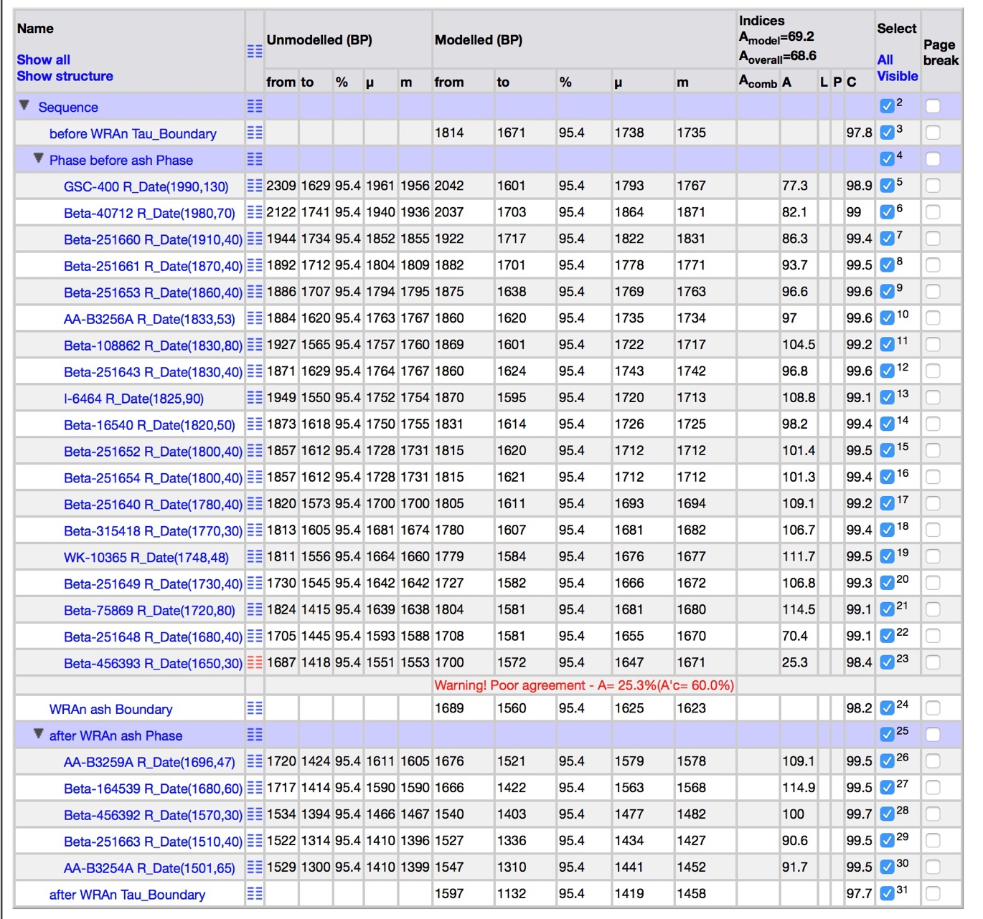
Figure S36. Structure of Model 3.

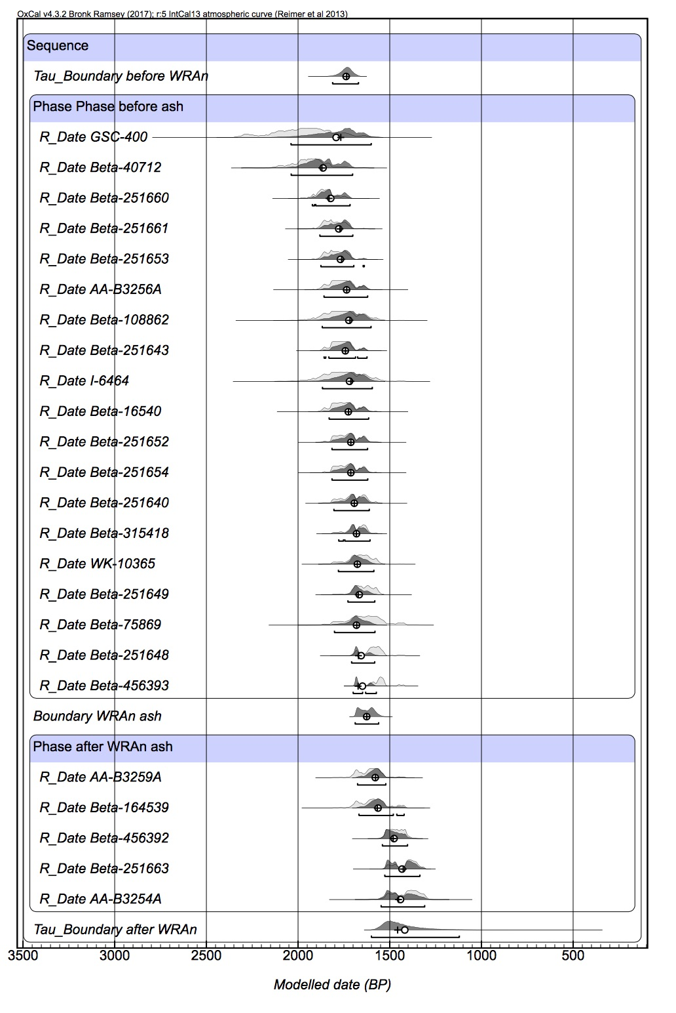
Figure S37. Overall results for Model 3.

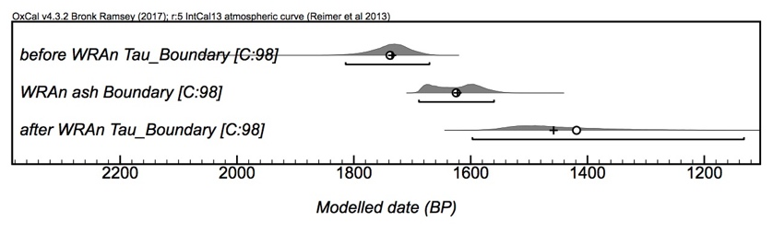
Figure S38. Distribution of calibrated modelled age ranges (2σ) for boundaries of Model 3.

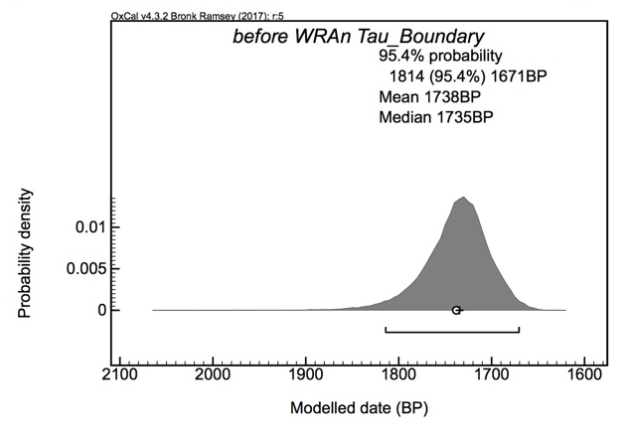
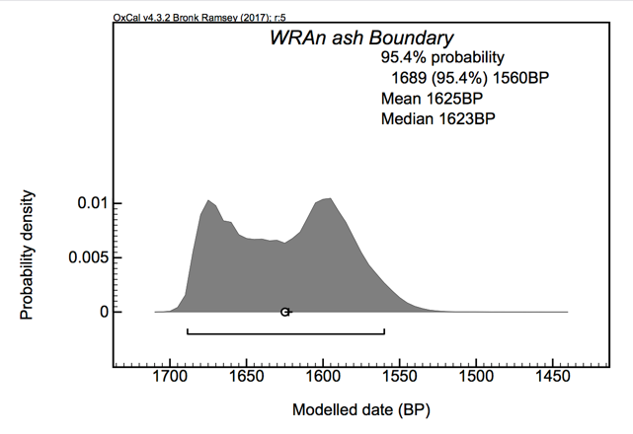
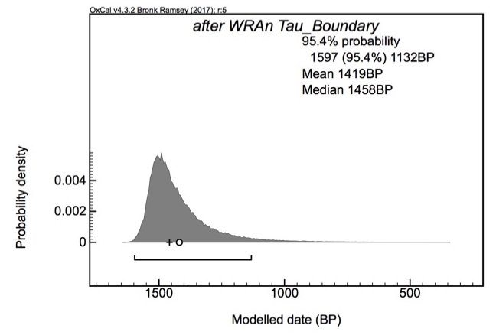
Figure S39. Probability distributions of calibrated modelled age ranges (2σ) for boundaries of Model 3.

Model 4 – Outlier Analysis 1 and 2 Performed
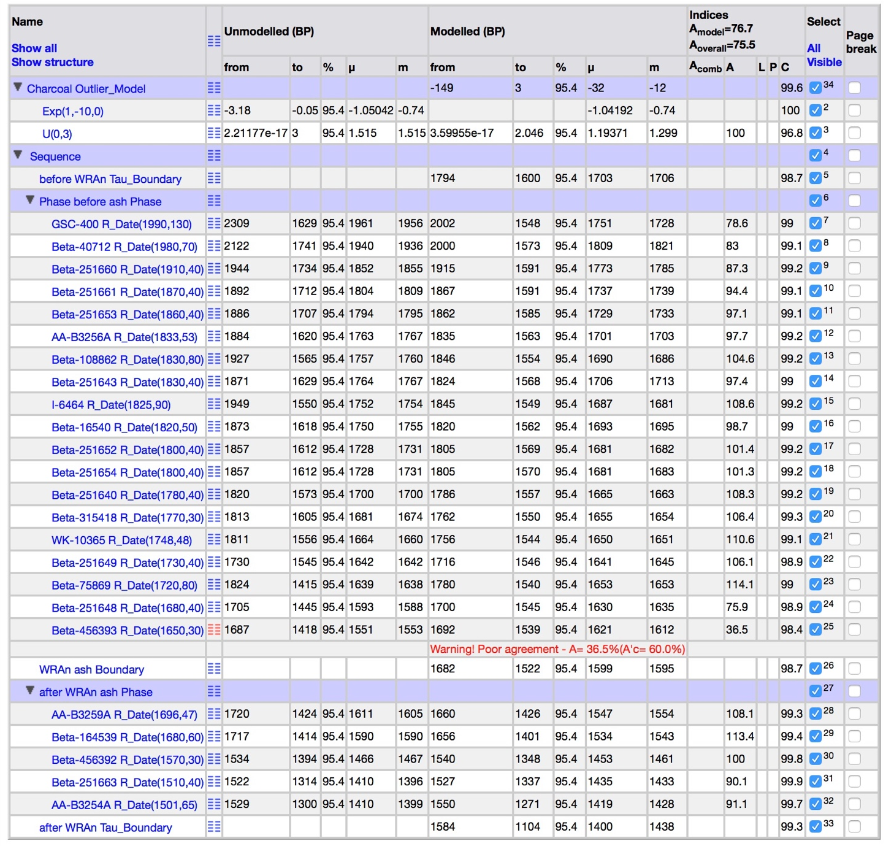
Figure S40. Structure of Model 4.

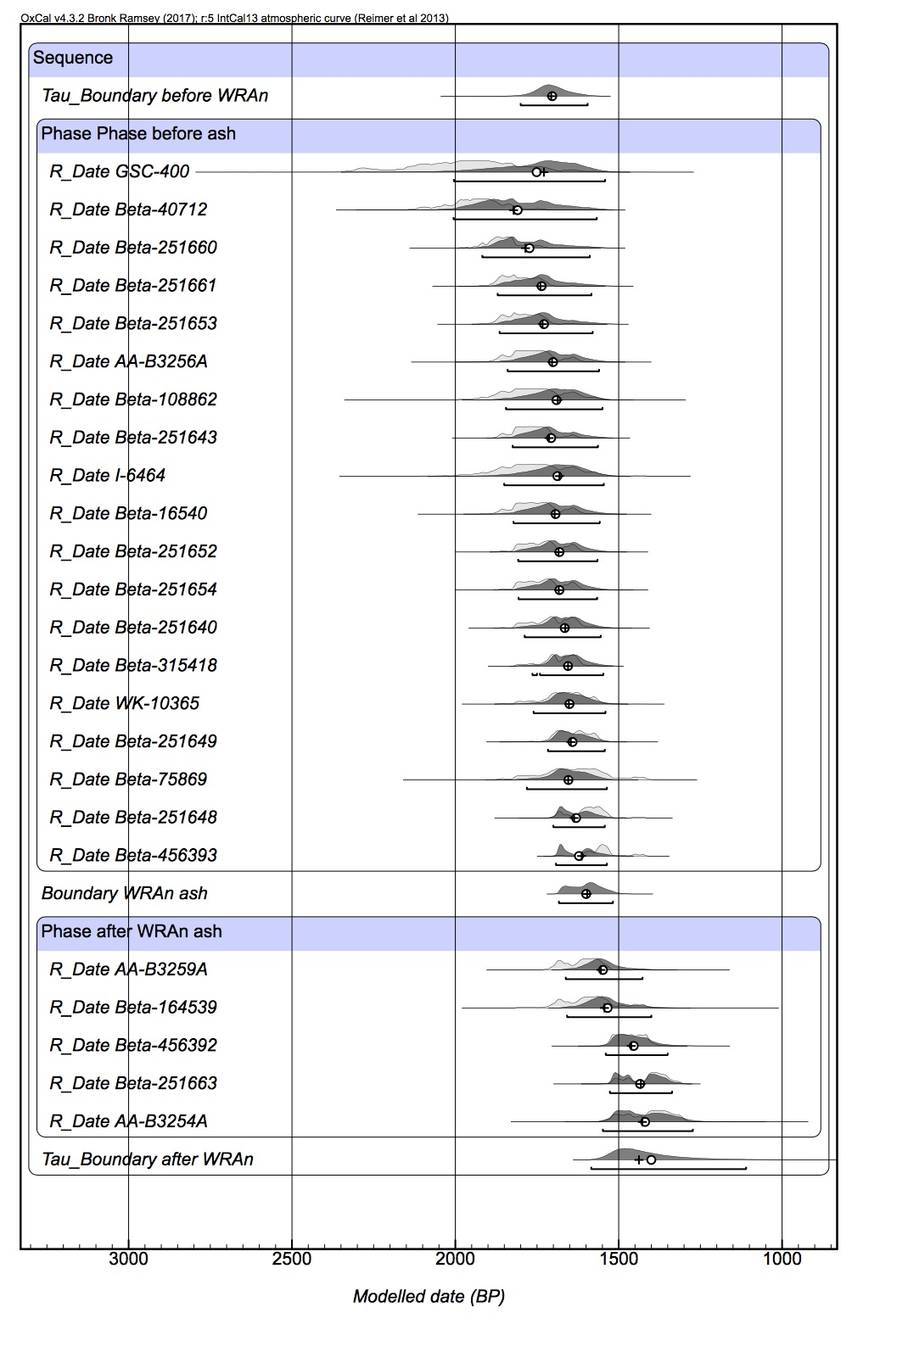
Figure S41. Overall results for Model 4.

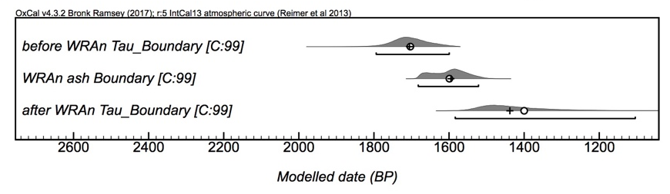
Figure S42. Distribution of calibrated modelled age ranges (2σ) for boundaries of Model 4.

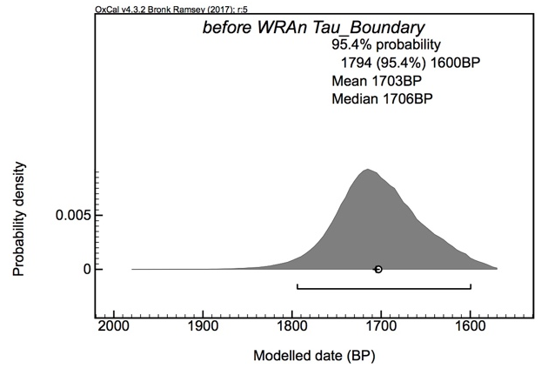
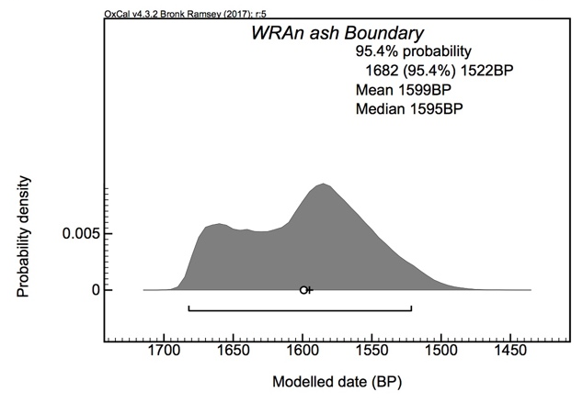
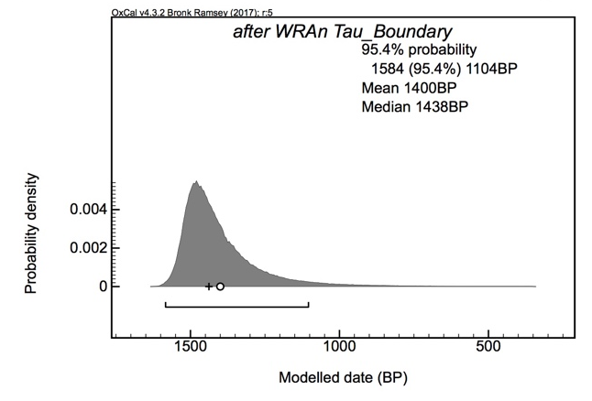
Figure S43. Probability distributions of calibrated modelled age ranges (2σ) for boundaries of Model 4.

Model 5 – Outlier Analysis 3 Performed
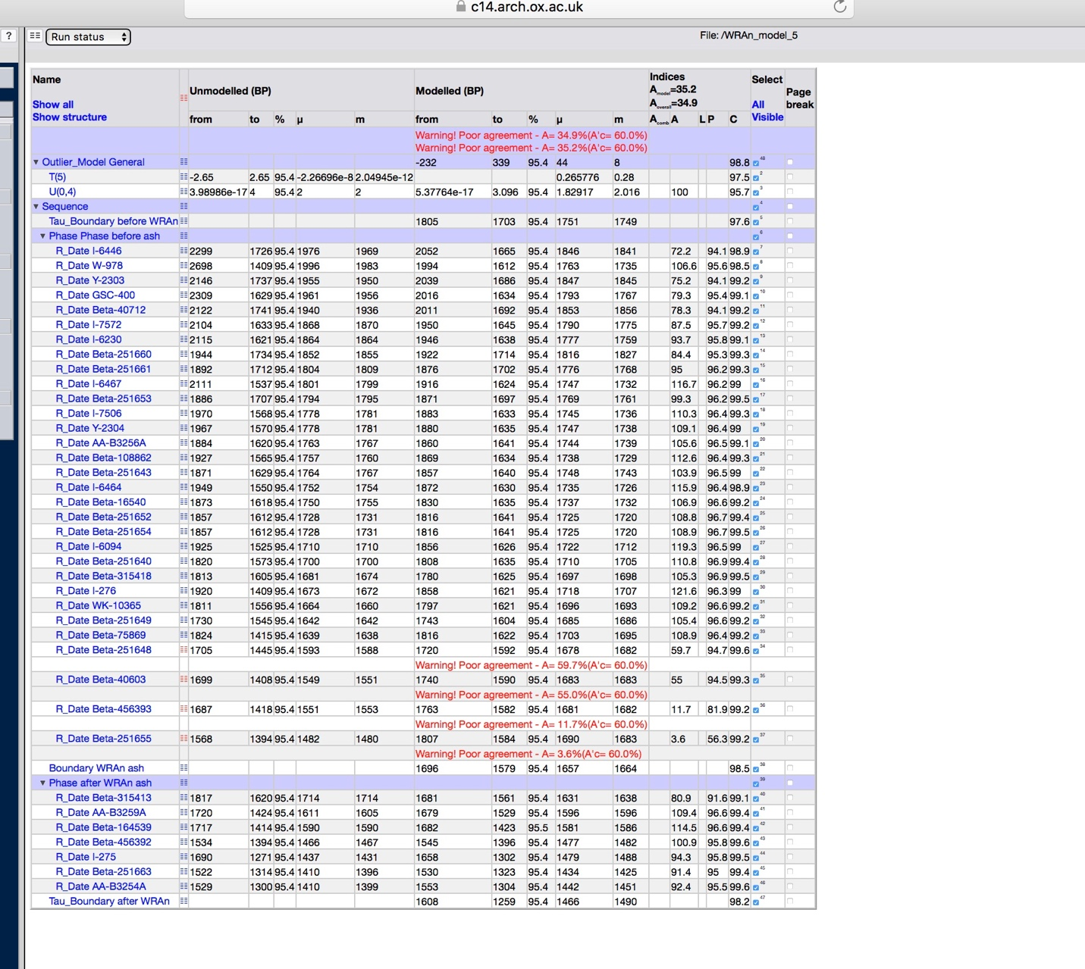
Figure S44. Structure of Model 5.

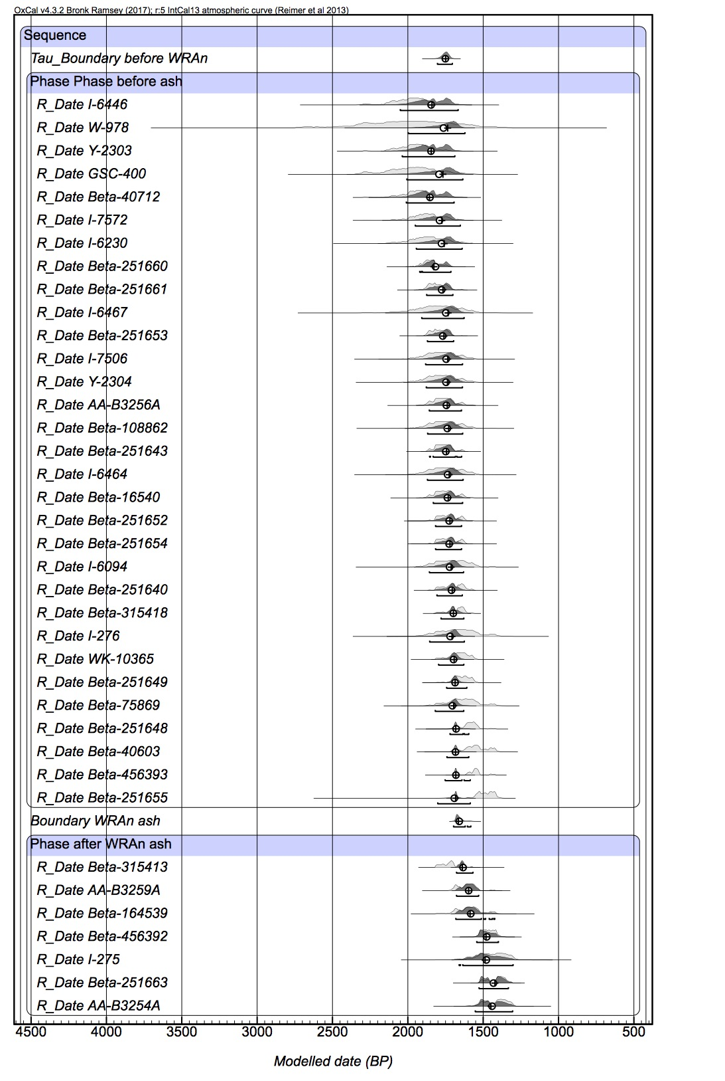
Figure S45. Overall results for Model 5.

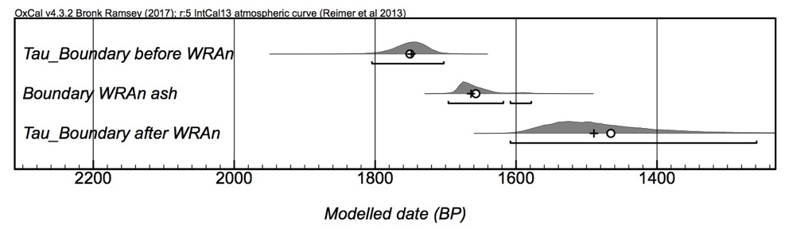
Figure S46. Distribution of calibrated modelled age ranges (2σ) for boundaries of Model 5.

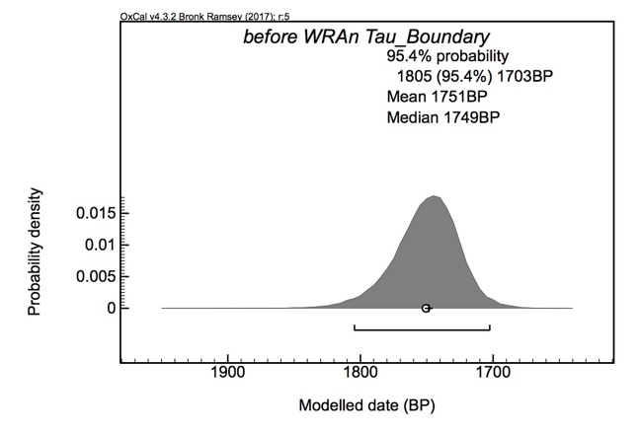
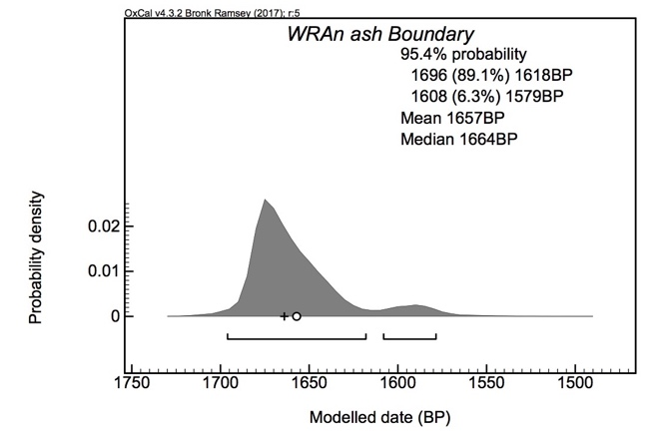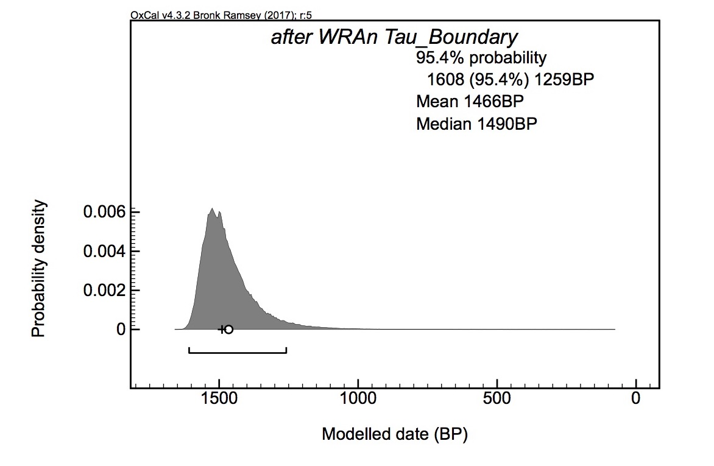
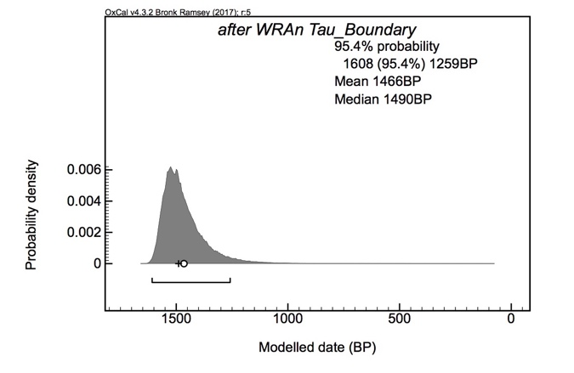
Figure S47. Probability distributions of calibrated modelled age ranges (2σ) for boundaries of Model 5.

Model 6 – Outlier Analysis 4 Performed
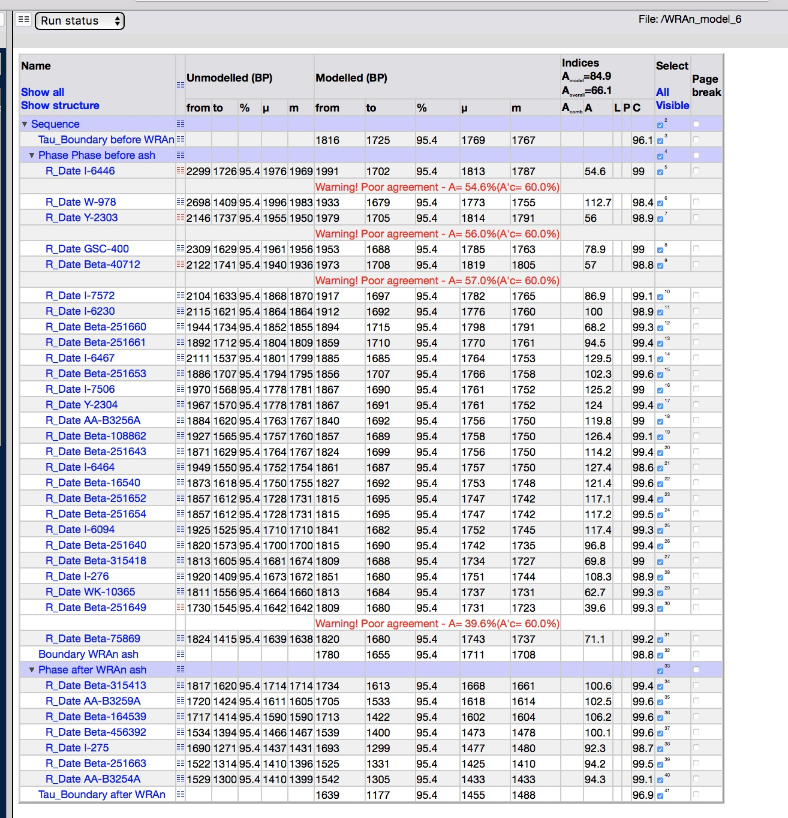
Figure S48. Structure of Model 6.

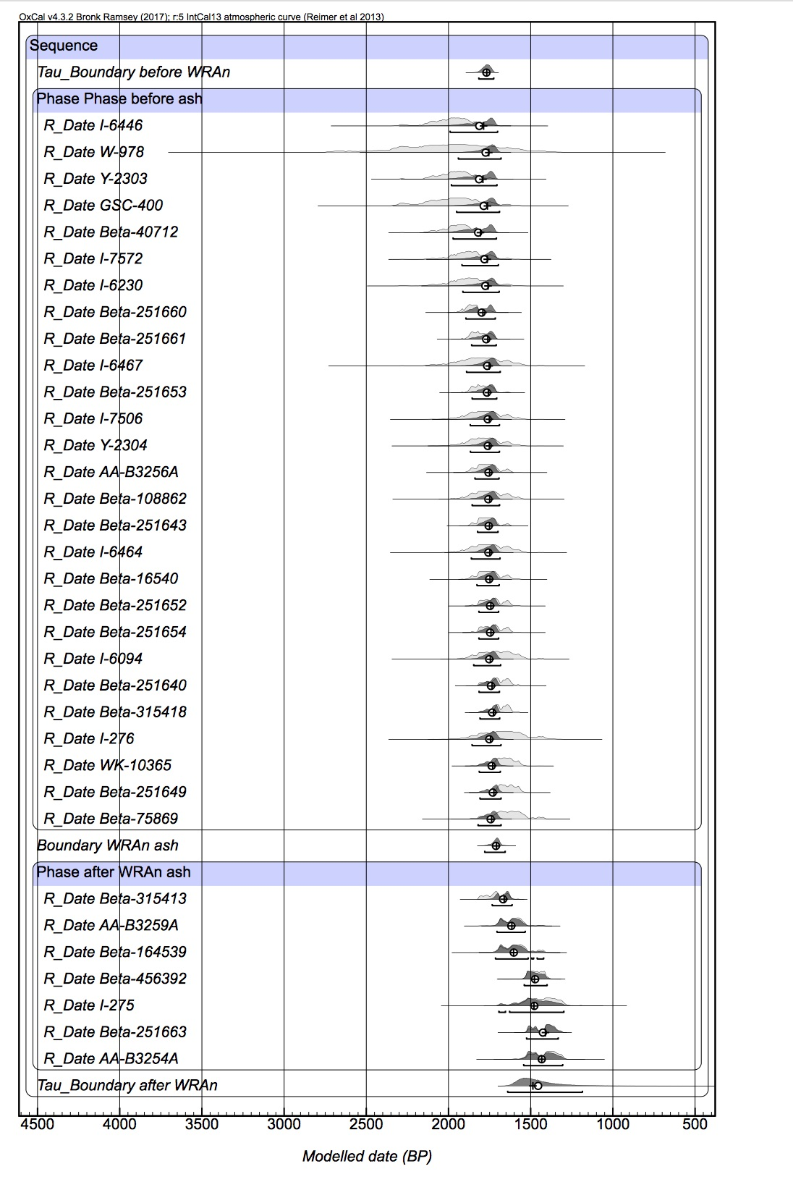
Figure S49. Overall results for Model 6.

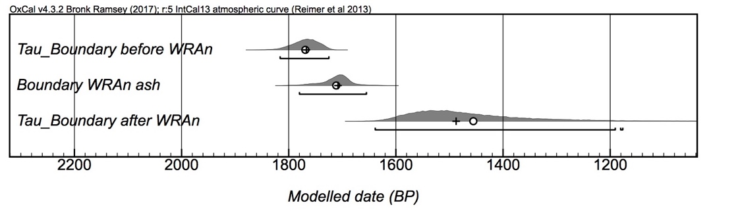
Figure S50. Distribution of calibrated modelled age ranges (2σ) for boundaries of Model 6.

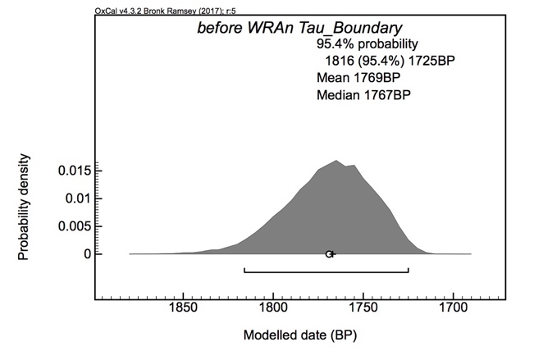
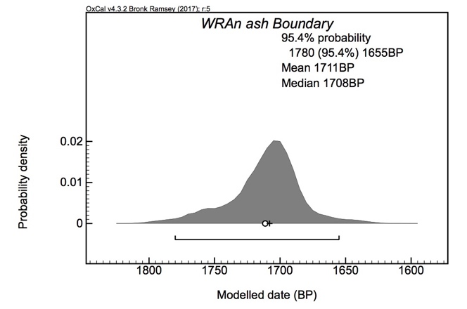
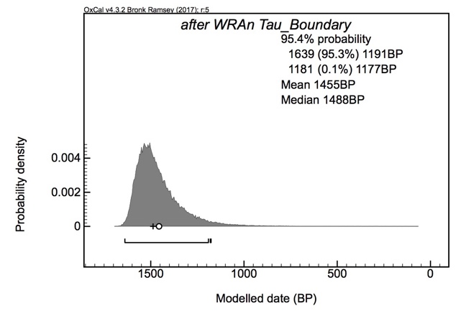
Figure S51. Probability distributions of calibrated modelled age ranges (2σ) for boundaries of Model 6.

Model 7 – Outlier Analysis 1 and 4 Performed
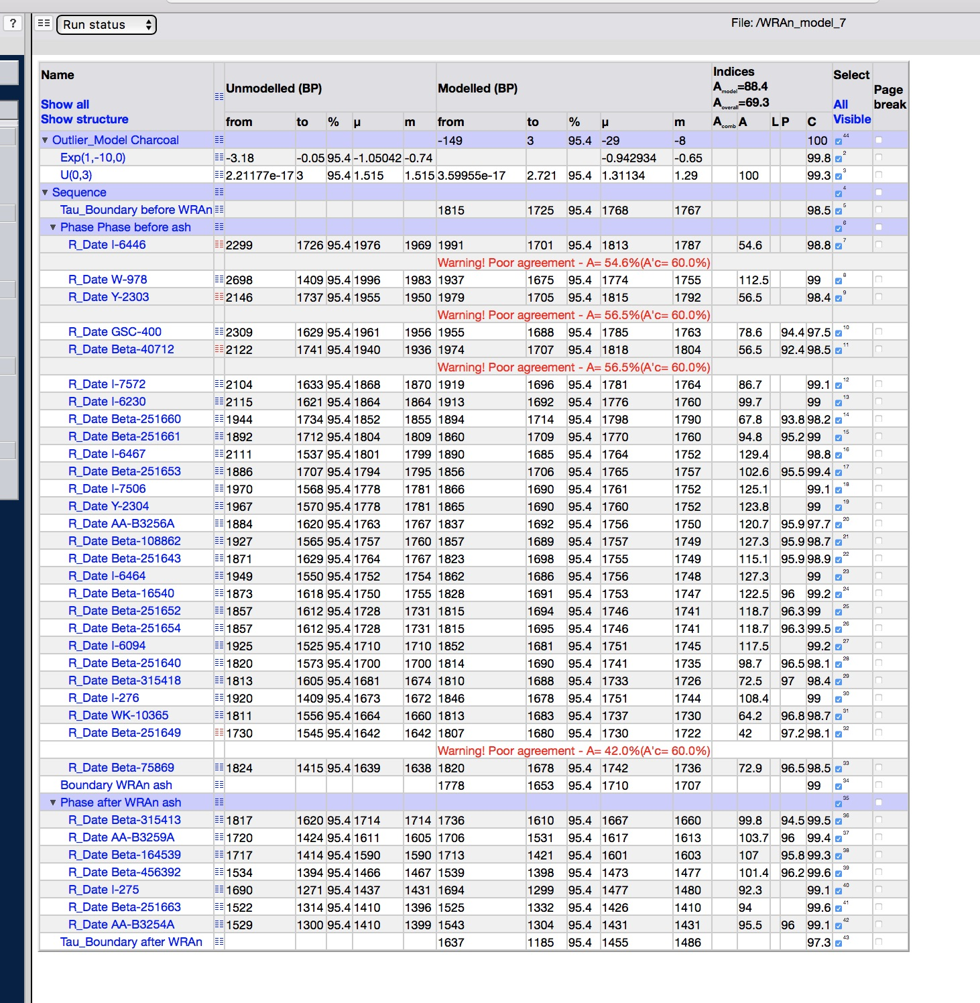
Figure S52. Structure of Model 7.
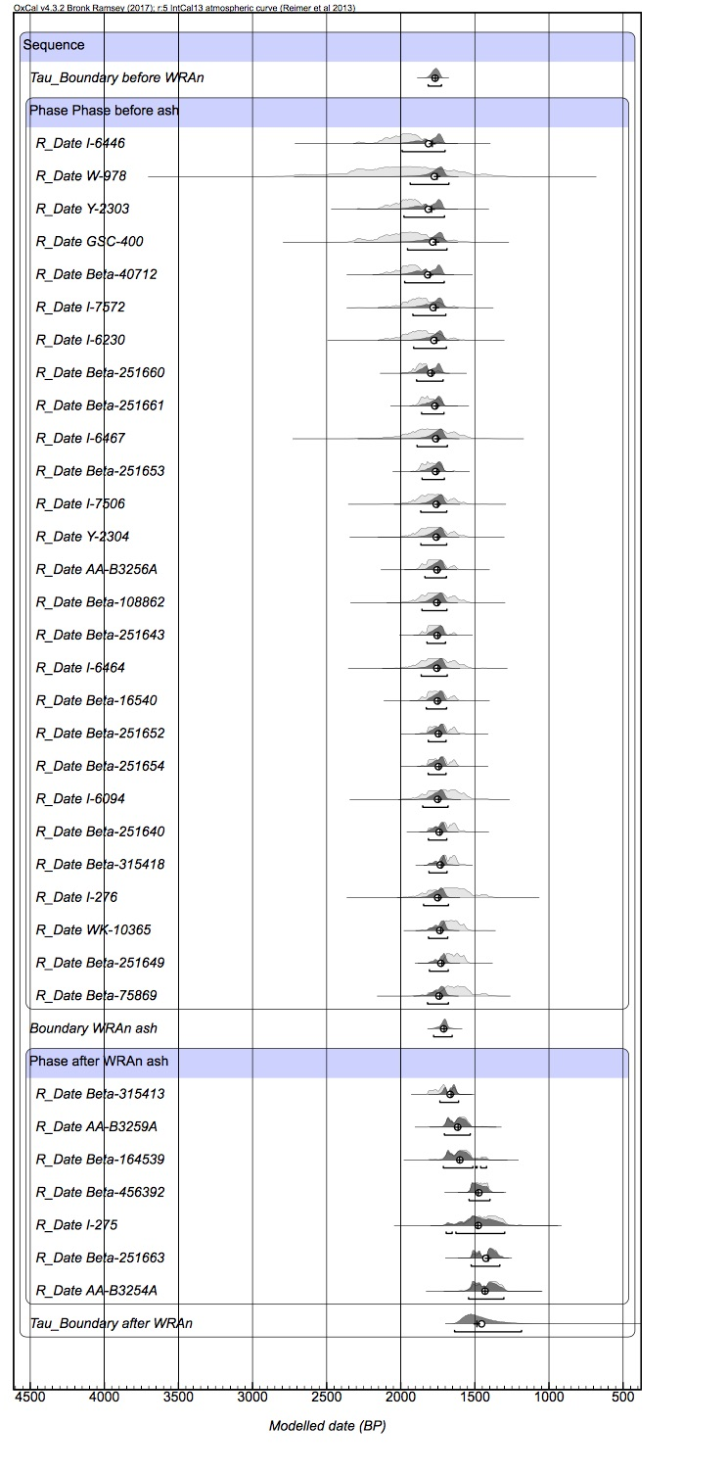
Figure S53. Overall results for Model 7.
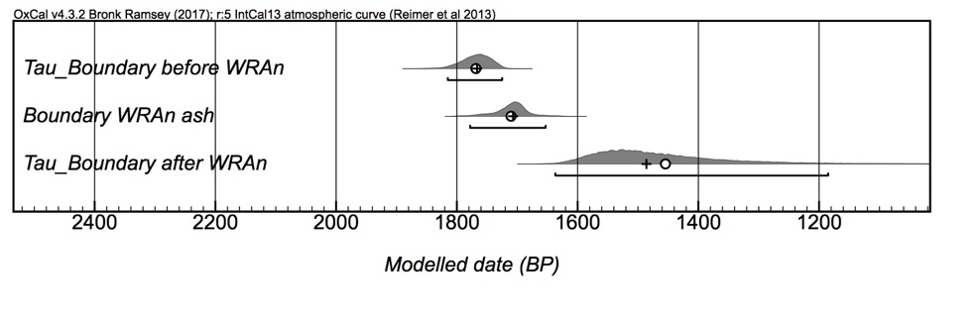
Figure S54. Distribution of calibrated modelled age ranges (2σ) for boundaries of Model 7.

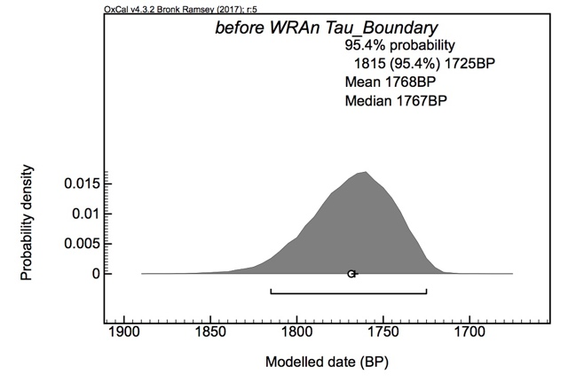
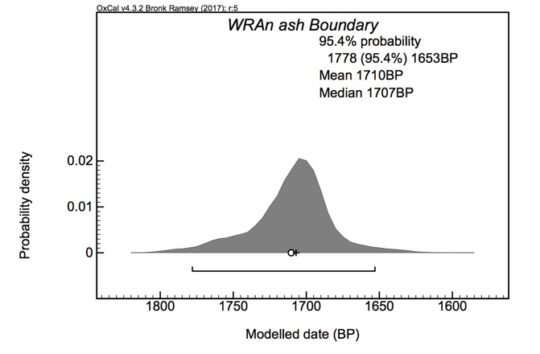
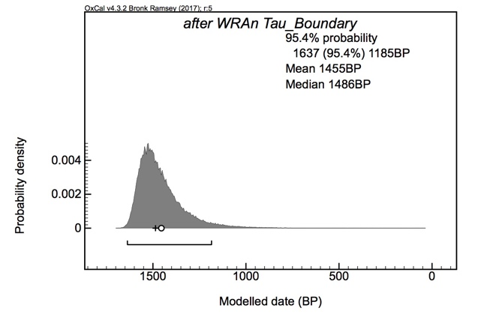
Figure S55. Probability distributions of calibrated modelled age ranges (2σ) for boundaries of Model 7.

