Figure S1: Δ¹⁴C values (‰) of cellulose samples from a Scots pine growing in central Norway, eight increments per year. Samples were taken from three wood cores, where two provided the rings from 1953-1956 and 1957-1965, respectively from the west side of the tree and one provided the rings from 1952-1965 from the east side of the tree. Twenty-four measurements from the west core were repeated. Error bars are too small to show in the figure.
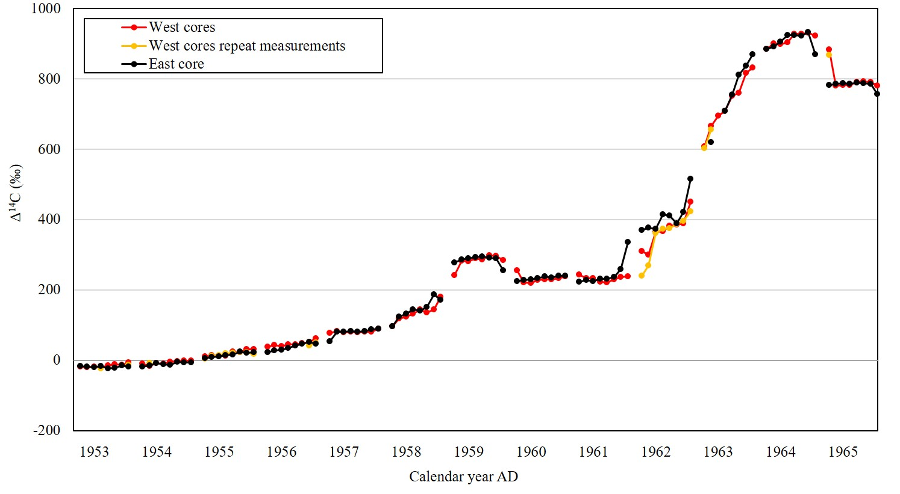
Figure S2: Sub-annual cellulose Δ¹⁴C values in two wood cores from a Scots pine from central Norway in 1963, compared to direct measurements of atmospheric Δ¹⁴C from Vermunt in Austria, Kapp Linné on Spitsbergen, Abisko in northern Sweden, Trondheim in central Norway, Lindesnes in southern Norway, and Fruholmen, N-Norway.
