Supplementary Tables and Figures Caption

Table S1 | ¹⁴C data for new samples from Maria Ponsee

Table S2 | Calibrated and modelled data from all graveyards used in the sequence.

Figure S1 | Multiplot of the calibrated dates of twenty three Maria Ponsee bone samples. The magenta bar represent the period of the Lombard occupation of the region, where the graveyard is located (505-568 AD). Outlying samples are colored in red.

Figure S2 | Illustration of the unfavorable form of the calibration curve in the ~1580 BP region showing the Maria Ponsee sample VERA-5994.

Table S1
Lab. # | Grave # | Groupª | MA^{b} | Sample  material^{c} | Collagen  yield^{d} [%] | ¹⁴C age^{e,f,g} [BP] | Calibrated age^{g}
VERA-5990 | 1 | N | - | fb | 1.9 | 1655 ± 35 | 255 AD ( 3.8%) 285 AD  320 AD (81.1%) 435 AD  450 AD ( 1.6%) 470 AD  485 AD ( 8.9%) 535 AD
VERA-5991 | 7 | S | 45 | fb | 2.0 | 1620 ± 25 | 385 AD (62.2%) 475AD  480 AD (33.2%) 540 AD
VERA-5992 | 8 | S | 32.5 | fb | 12.5 | 1595 ± 30 | 400 AD (95.4%) 540 AD
VERA-5993 | 9 | - | 32.5 | fb | 1.9 | 1635 ± 20 | 345 AD ( 3.0%) 370 AD  380 AD (82.1%) 435 AD  490 AD (10.3%) 535 AD
VERA-6024 | 9 | - | - | hf | 2.6 | 1535 ± 35 | 425 AD (95.4%) 600 AD
VERA-5994 | 15 | S | 26 | fb | 0.9 | 1565 ± 30 | 415 AD (95.4%) 560 AD
VERA-5995 | 18 | N | 42.5 | fb | 2.7 | 1610 ± 25 | 395 AD (95.4%) 540 AD
VERA-5996 | 20 | W | 39.5 | fb | 1.1 | 1540 ± 35 | 425 AD (95.4%) 595 AD
VERA-5997 | 35 | S | 32.5 | fb | 1.2 | 1560± 25 | 420 AD (95.4%) 555 AD
VERA-5998 | 42 | N | 45 | fb | 1.6 | 1590 ± 25 | 410 AD (95.4%) 540 AD
VERA-6000 | 43 | S | 30 | fb | 2.2 | 1565 ± 20 | 425 AD (95.4%) 545 AD
VERA-6025 | 52 | S | - | hf | 6.8 | 1535 ± 35 | 425 AD (95.4%) 600 AD
VERA-6016 | 53 | S | 37.5 | hb | 3.9 | 1620 ± 35 | 350 AD ( 2.9%) 370 AD  375 AD (92.5%) 540 AD
VERA-6017 | 54 | S | 4.5 | fb | 5.5 | 1545 ± 30 | 420 AD (95.4%) 580 AD
VERA-6018 | 56 | S | 10.5 | fb | 1.8 | 1545 ± 25 | 425 AD (95.4%) 575AD
VERA-6021 | 71 | N | 30 | fb | 1.5 | 1595 ± 35 | 390 AD (95.4%) 545 AD
VERA-6026 | 72 | S | - | hf | 2.1 | 1575 ± 40 | 400 AD (95.4%) 570 AD
VERA-6023 | 75 | S | 31 | fb | 1.4 | 1565 ± 40 | 405 AD (95.4%) 580 AD
VERA-6031 | 79 | N | 32.5 | fb | 4.1 | 1520 ± 35 | 425 AD (95.4%) 610 AD
VERA-6032 | 81 | N | 10 | fb | 16.0 | 1595 ± 35 | 390 AD (95.4%) 545 AD
VERA-6033 | 86 | N | 47.5 | fb | 17.1 | 1595 ± 25 | 405 AD (95.4%) 540 AD
VERA-6034 | 88 | N | 32 | fb | 3.6 | 1550 ± 35 | 420 AD (95.4%) 585 AD
VERA-6035 | 95 | N | 30 | fb | 2.0 | 1650 ± 35 | 260 AD ( 2.5%) 280 AD  325 AD (81.2%) 475AD  485 AD (11.7%) 535 AD
ª Grave groups: N = northern, S = southern, W = western (Klement 2014)
^{b} Morphological age of death estimation (Klement 2014).
^{c} Sample material abbreviated as follows: fb = femoral bone; hf = horse fragments; hb = humeral bone.
^{d} Calculated as the ratio of acquired amount of collagen (gelatin) to amount of starting bone material.
^{e} Given with 1σ uncertainty, rounded by 5.
^{f} Radiocarbon age of the double-dated samples was calculated with the R_Combine function of the OxCal program.
^{g} At 95.4% probability, rounded to the nearest 5.

Table S2
Graveyard | Lab. # | ¹⁴C age^{a,b,c} [BP] | Calibrated age^{c} |  | Modelled age^{c}
 |  |  | at the 68.2% level | at the 95.4% level | at the 68.2% level | at the 95.4% level
Unterlan-zendorf | VERA-4117 | 1755 ± 35 | 240 AD (68.2%) 335 AD | 145 AD ( 0.3%) 150 AD  170 AD ( 2.7%) 195 AD  210 AD (92.4%) 385 AD | 365 AD (68.2%) 390 AD | 330 AD (95.4%) 400 AD
 | VERA-4119 | 1660 ± 35 | 345 AD (68.2%) 420 AD | 255 AD ( 6.0%) 295 AD  320 AD (83.1%) 435 AD  490 AD ( 6.4%) 530 AD | 370 AD (68.2%) 395 AD | 345 AD (95.4%) 405 AD
 | VERA-4120 | 1695 ± 40 | 260 AD (11.5%) 280 AD  325 AD (56.7%) 400 AD | 245 AD (95.4%) 420 AD | 365 AD (68.2%) 395 AD | 340 AD (95.4%) 405 AD
Zlechov | VERA-4122 | 1700 ± 35 | 260 AD (12.2%) 280 AD  325 AD (56.0%) 395 AD | 250 AD (95.4%) 410 AD | 365 AD (68.2%) 395 AD | 340 AD (95.4%) 400 AD
 | VERA-4123 | 1655 ± 35 | 345 AD (68.2%) 420 AD | 260 AD ( 3.8%) 280 AD  325 AD (81.1%) 435 AD  450 AD ( 1.6%) 470 AD  485 AD ( 8.9%) 535 AD | 370 AD (68.2%) 395AD | 345 AD (95.4%) 410 AD
 | VERA-4146 | 1690 ± 40 | 260 AD ( 8.2%) 275 AD  330 AD (60.0%) 400 AD | 260 AD ( 8.2%) 275 AD  330 AD (60.0%) 400 AD | 365 AD (68.2%) 395 AD | 340 AD (95.4%) 400 AD
Mödling | VERA-313 | 1595 ± 35 | 415 AD (14.7%) 435 AD  445 AD (17.0%) 470 AD  485 AD (36.5%) 535 AD | 395 AD (95.4%) 545 AD | 535 AD (68.2%) 545 AD | 520 AD (95.4%) 550 AD
 | VERA-561 | 1685 ± 35 | 265 AD ( 2.4%) 270 AD  330 AD (65.8%) 405 AD | 255 AD (16.9%) 300 AD  315 AD (78.5%) 420 AD | 365 AD (68.2%) 395 AD | 345 AD (95.4%) 405 AD
 | VERA-562 | 1680 ± 35 | 335 AD (68.2%) 405 AD | 255 AD (14.7%) 305 AD  315 AD (80.7%) 425 AD | 365 AD (68.2%) 395 AD | 345 AD (95.4%) 405 AD
Schwar-zenbach | VERA-1666 | 1635 ± 35 | 355 AD ( 3.5%) 365 AD  380 AD (46.6%) 430 AD  490 AD (18.1%) 530 AD | 340 AD (73.0%) 475 AD  485 AD (22.4%) 535 AD | 415 AD (68.2%) 465 AD | 400 AD (95.4%) 510 AD
Sommerein | VERA-2739 | 1575 ± 30 | 430 AD (32.2%) 475 AD  485 AD (36.0%) 535 AD | 410 AD (95.4%) 550 AD | 420 AD (68.2%) 465 AD | 415 AD (95.4%) 505 AD
Břeclav-Líbivá | VERA-1921 | 1570 ± 40 | 430 AD (47.0%) 495 AD  505 AD (21.2%) 535 AD | 400 AD (95.4%) 570 AD | 420 AD (68.2%) 465 AD | 410 AD (95.4%) 505 AD
Laa an der Thaya | VERA-4113 | 1555 ± 40 | 430 AD (46.0%) 495 AD  505 AD (22.2%) 545 AD | 415 AD (95.4%) 590 AD | 420 AD (68.2%) 465 AD | 415 AD (95.4%) 505 AD
Ladendorf | VERA-4148 | 1585 ± 40 | 420 AD (33.1%) 475 AD  485 AD (35.1%) 535 AD | 395 AD (95.4%) 560 AD | 450 AD (68.2%) 510 AD | 440 AD (95.4%) 530 AD
Asparn Schletz | VERA-4121 | 1520 ± 35 | 435 AD ( 8.0%) 450 AD  470 AD ( 8.9%) 485AD  535 AD (51.3%) 595 AD | 425 AD (95.4%) 610 AD | 450 AD (62.9%) 490 AD  510 AD ( 5.3%) 515 AD | 440 AD (95.4%) 530 AD
Hauskir-chen | VERA-270 | 1600 ± 35 | 410 AD (18.2%) 435 AD  450 AD (13.1%) 470 AD  485 AD (36.9%) 535 AD | 390 AD (95.4%) 545 AD | 505 AD (68.2%) 535 AD | 455 AD (11.3%) 480 AD  485 AD (84.1%) 540 AD
 | VERA-272 | 1570 ± 35 | 430 AD (49.2%) 495 AD  505 AD (19.0%) 535 AD | 410 AD (95.4%) 565 AD | 500 AD (68.2%) 535 AD | 460 AD (95.4%) 540 AD
Lužice | VERA-2233 | 1575 ± 40 | 430AD (32.2%) 475 AD  485AD (36.0%) 535 AD | 400 AD (95.4%) 565 AD | 500 AD (68.2%) 535 AD | 460 AD (95.4%) 540 AD
 | VERA-2235 | 1565 ± 40 | 430 AD (46.0%) 495 AD  505 AD (22.2%) 540 AD | 405 AD (95.4%) 575 AD | 500 AD (68.2%) 535 AD | 460 AD (95.4%) 540 AD
 | VERA-2234 | 1555 ± 40 | 430 AD (46.0%) 495 AD  505 AD (22.2%) 545 AD | 415 AD (95.4%) 590 AD | 500 AD (68.2%) 535 AD | 460 AD (95.4%) 535 AD
 | VERA-2236 | 1555 ± 35 | 430AD (48.2%) 495 AD  510AD ( 7.1%) 520 AD  525AD (12.9%) 545 AD | 420 AD (95.4%) 580 AD | 500 AD (68.2%) 535 AD | 460 AD (95.4%) 540 AD
Rohrendorf | VERA-318 | 1555 ± 35 | 430 AD (48.2%) 495AD  510 AD ( 7.1%) 520AD  525 AD (12.9%) 545AD | 420 AD (95.4%) 570 AD | 500 AD (68.2%) 535 AD | 460 AD (95.4%) 540 AD
 | VERA-319 | 1555 ± 30 | 430 AD (50.5%) 495 AD  510 AD ( 5.4%) 520 AD  530 AD (12.3%) 545 AD | 420 AD (95.4%) 580 AD | 500 AD (68.2%) 535 AD | 460 AD (95.4%) 540 AD
Maria Ponsee | VERA-279 | 1595 ± 40 | 415 AD (15.1%) 440 AD  445 AD (18.1%) 475 AD  485 AD (34.9%) 535 AD | 385 AD (95.4%) 560 AD | 530 AD (68.2%) 540 AD | 485AD (95.4%) 540AD
 | VERA-280 | 1530 ± 35 | 430 AD (33.4%) 490 AD  530 AD (34.8%) 580 AD | 425 AD (95.4%) 600 AD | 530 AD (68.2%) 540 AD | 475 AD ( 5.6%) 495 AD  510 AD (89.8%) 545 AD
 | VERA-281 | 1540 ± 30 | 430 AD (42.4%) 490 AD  530 AD (25.8%) 565 AD | 425 AD (95.4%) 590 AD | 530 AD (68.2%) 540 AD | 475 AD ( 5.5%) 495 AD  510 AD (89.9%) 545 AD
 | VERA-283 | 1535 ± 35 | 430 AD (38.0%) 490 AD  530 AD (30.2%) 570 AD | 425 AD (95.4%) 600 AD | 530 AD (68.2%) 540 AD | 475 AD ( 5.4%) 495 AD  510 AD (90.0%) 545 AD
 | VERA-284 | 1545 ± 30 | 430 AD (46.8%) 490 AD  530 AD (21.4%) 560 AD | 425 AD (95.4%) 580 AD | 530 AD (68.2%) 540 AD | 475 AD ( 5.4%) 495 AD  510 AD (90.0%) 540 AD
 | VERA-285 | 1555 ± 35 | 430 AD (48.2%) 495 AD  510 AD ( 7.1%) 520 AD  525 AD (12.9%) 545 AD | 420 AD (95.4%) 580 AD | 530 AD (68.2%) 540 AD | 475 AD ( 4.6%) 495 AD  505 AD (90.8%) 540 AD
 | VERA-287 | 1530 ± 35 | 430 AD (33.4%) 490 AD  530 AD (34.8%) 580 AD | 425 AD (95.4%) 600 AD | 530 AD (68.2%) 540 AD | 475 AD ( 5.6%) 495 AD  510 AD (89.8%) 545 AD
 | VERA-288 | 1500 ± 35 | 540 AD (68.2%) 610 AD | 430 AD (15.6%) 490 AD  530 AD (79.8%) 640 AD | 530 AD (68.2%) 540 AD | 470 AD ( 6.3%) 490 AD  510 AD (89.1%) 545 AD
 | VERA-5991 | 1620 ± 25 | 395 AD (43.9%) 430 AD  490 AD (24.3%) 530 AD | 385 AD (62.2%) 475AD  485 AD (33.2%) 535 AD | 530 AD (68.2%) 540 AD | 490 AD (95.4%) 540 AD
 | VERA-5992 | 1595 ± 30 | 415 AD (14.4%) 435 AD  450 AD (14.8%) 470 AD  485 AD (39.0%) 535 AD | 400 AD (95.4%) 540 AD | 530 AD (68.2%) 540 AD | 490 AD (95.4%) 540 AD
 | VERA-5994 | 1565 ± 30 | 430 AD (50.5%) 495 AD  510 AD ( 8.5%) 520 AD  525 AD ( 9.2%) 540 AD | 420 AD (95.4%) 560 AD | 530 AD (68.2%) 540 AD | 480 AD (95.4%) 540 AD
 | VERA-5995 | 1610 ± 25 | 405 AD (25.3%) 430 AD  465 AD ( 1.6%) 465 AD  490 AD (41.2%) 530 AD | 400 AD (50.2%) 475 AD  480 AD (45.2%) 535 AD | 530 AD (68.2%) 540 AD | 490 AD (95.4%) 540 AD
 | VERA-5996 | 1540 ± 35 | 430 AD (42.1%) 490 AD  530 AD (26.1%) 565 AD | 425 AD (95.4%) 595 AD | 530 AD (68.2%) 540 AD | 475 AD ( 5.2%) 495 AD  510 AD (90.2%) 545 AD
 | VERA-5997 | 1560± 25 | 430 AD (58.4%) 490 AD 530 AD ( 9.8%) 540 AD | 425 AD (95.4%) 555 AD | 530 AD (68.2%) 540 AD | 475 AD ( 5.1%) 495 AD  505 AD (90.3%) 540 AD
 | VERA-5998 | 1590 ± 25 | 420 AD (11.5%) 435 AD  450 AD (15.0%) 470 AD  485 AD (41.7%) 535 AD | 410 AD (95.4%) 540 AD | 530 AD (68.2%) 540 AD | 490 AD (95.4%) 540 AD
 | VERA-6000 | 1565 ± 20 | 430 AD (52.0%) 495 AD  510 AD ( 9.0%) 520 AD  525 AD ( 7.2%) 535 AD | 420 AD (95.4%) 545 AD | 530 AD (68.2%) 540 AD | 480 AD (95.4%) 540 AD
 | VERA-6016 | 1620 ± 35 | 390 AD (37.1%) 430 AD  460 AD ( 1.7%) 465 AD  490 AD (29.4%) 530 AD | 350 AD ( 2.9%) 365 AD  380 AD (92.5%) 540 AD | 530 AD (68.2%) 540 AD | 490 AD (95.4%) 540 AD
 | VERA-6017 | 1545 ± 30 | 430 AD (46.8%) 490 AD  530 AD (21.4%) 560 AD | 425 AD (95.4%) 580 AD | 530 AD (68.2%) 540 AD | 472 AD ( 5.5%) 495 AD  510 AD (89.9%) 545 AD
 | VERA-6018 | 1545 ± 25 | 430 AD (48.3%) 490 AD  530 AD (19.9%) 555 AD | 425 AD (95.4%) 570 AD | 530 AD (68.2%) 540 AD | 475 AD ( 5.5%) 495 AD  510 AD (89.9%) 545 AD
 | VERA-6021 | 1595 ± 35 | 415 AD (14.7%) 435 AD  445 AD (17.0%) 470 AD  485 AD (36.5%) 535 AD | 395 AD (95.4%) 545 AD | 530 AD (68.2%) 540 AD | 490 AD (95.4%) 540 AD
 | VERA-6023 | 1565 ± 40 | 430 AD (46.0%) 495 AD  505 AD (22.2%) 540 AD | 405 AD (95.4%) 575 AD | 530 AD (68.2%) 540 AD | 480 AD (95.4%) 540 AD
 | VERA-6024 | 1535 ± 35 | 430 AD (38.0%) 490 AD  530 AD (30.2%) 570 AD | 425 AD (95.4%) 600 AD | 530 AD (68.2%) 540 AD | 475 AD ( 5.3%) 495 AD  510 AD (90.1%) 545 AD
 | VERA-6025 | 1535 ± 35 | 430 AD (38.0%) 490 AD  530 AD (30.2%) 570 AD | 425 AD (95.4%) 600 AD | 530 AD (68.2%) 540 AD | 475 AD ( 5.4%) 495 AD  510 AD (90.0%) 545 AD
 | VERA-6026 | 1575 ± 40 | 430 AD (32.2%) 475 AD  485 AD (36.0%) 535 AD | 400 AD (95.4%) 565 AD | 530 AD (68.2%) 540 AD | 485AD (95.4%) 540 AD
 | VERA-6031 | 1520 ± 35 | 435 AD ( 8.0%) 450 AD  470 AD ( 8.9%) 485 AD  535 AD (51.3%) 595 AD | 425 AD (95.4%) 610 AD | 530 AD (68.2%) 540 AD | 475 AD ( 5.5%) 495 AD  510 AD (89.9%) 545 AD
 | VERA-6032 | 1595 ± 35 | 415 AD (14.7%) 435 AD  445 AD (17.0%) 470 AD  485 AD (36.5%) 535 AD | 395 AD (95.4%) 545 AD | 530 AD (68.2%) 540 AD | 490 AD (95.4%) 540 AD
 | VERA-6033 | 1595 ± 25 | 415 AD (14.7%) 435 AD  450 AD (11.9%) 470 AD  485 AD (41.6%) 535 AD | 410 AD (95.4%) 540 AD | 530 AD (68.2%) 540 AD | 490 AD (95.4%) 540 AD
 | VERA-6034 | 1550 ± 35 | 430 AD (47.5%) 495 AD  510 AD ( 4.6%) 520 AD  530 AD (16.1%) 550 AD | 420 AD (95.4%) 585 AD | 530 AD (68.2%) 540 AD | 475 AD ( 4.8%) 495 AD  500 AD (90.6%) 540 AD
Pottenbrunn | VERA-2203 | 1505 ± 35 | 475 AD ( 2.8%) 485 AD  535 AD (65.4%) 610 AD | 430 AD (19.2%) 495 AD  510 AD ( 0.7%) 515 AD  530 AD (75.5%) 640 AD | 530 AD (68.2%) 540 AD | 470 AD ( 6.1%) 490 AD  510 AD (89.3%) 545 AD
 | VERA-2204 | 1540 ± 35 | 430 AD (42.1%) 490 AD  530 AD (26.1%) 565 AD | 425 AD (95.4%) 595 AD | 530 AD (68.2%) 540 AD | 475 AD ( 5.2%) 495 AD  510 AD (90.2%) 540 AD
 | VERA-2205 | 1550 ± 35 | 430 AD (47.5%) 495 AD  510 AD ( 4.6%) 520 AD  530 AD (16.1%) 550 AD | 420 AD (95.4%) 585 AD | 530 AD (68.2%) 540 AD | 475 AD ( 5.1%) 495 AD  505 AD (90.3%) 540 AD
 | VERA-2206 | 1530 ± 40 | 430 AD (33.7%) 490 AD  530 AD (34.5%) 585 AD | 425 AD (95.4%) 605 AD | 530 AD (68.2%) 540 AD | 475 AD ( 5.2%) 495 AD  510 AD (90.2%) 545 AD
 | VERA-2207 | 1500 ± 35 | 540 AD (68.2%) 610 AD | 430 AD (15.6%) 490 AD  530 AD (79.8%) 640 AD | 530 AD (68.2%) 540 AD | 470 AD ( 6.4%) 490 AD  510 AD (89.0%) 545 AD
Brunn am Gebirge | VERA-257 | 1570 ± 30 | 430 AD (51.6%) 495 AD  510 AD ( 9.4%) 520 AD  525 AD ( 7.2%) 535 AD | 415 AD (95.4%) 555 AD | 535 AD (68.2%) 545 AD | 525 AD (95.4%) 550 AD
 | VERA-258 | 1545 ± 25 | 430 AD (48.3%) 490 AD  530 AD (19.9%) 555 AD | 425 AD (95.4%) 570 AD | 535 AD (68.2%) 545 AD | 530 AD (95.4%) 550 AD
 | VERA-259 | 1550 ± 30 | 430 AD (50.0%) 490 AD  510 AD ( 2.5%) 515 AD  530 AD (15.7%) 550 AD | 420 AD (95.4%) 575 AD | 535 AD (68.2%) 545 AD | 525 AD (95.4%) 550 AD
 | VERA-260 | 1550 ± 30 | 430 AD (50.0%) 490 AD  510 AD ( 2.5%) 515 AD  530 AD (15.7%) 550 AD | 420 AD (95.4%) 575 AD | 535 AD (68.2%) 545 AD | 525 AD (95.4%) 550 AD
 | VERA-261 | 1560 ± 30 | 430 AD (52.6%) 495 AD  510 AD ( 5.4%) 520 AD  530 AD (10.2%) 540 AD | 420 AD (95.4%) 565 AD | 535 AD (68.2%) 545 AD | 525 AD (95.4%) 550 AD
 | VERA-443 | 1545 ± 35 | 430 AD (44.8%) 490 AD  510 AD ( 2.0%) 515 AD  530 AD (21.4%) 560 AD | 420 AD (95.4%) 590 AD | 535 AD (68.2%) 545 AD | 525 AD (95.4%) 550 AD
Schwechat | VERA-323 | 1540 ± 35 | 430 AD (42.1%) 490 AD  530 AD (26.1%) 565 AD | 425 AD (95.4%) 595 AD | 535 AD (68.2%) 545 AD | 525 AD (95.4%) 550 AD
 | VERA-324 | 1565 ± 40 | 430 AD (46.0%) 495 AD  505 AD (22.2%) 540 AD | 405 AD (95.4%) 575 AD | 535 AD (68.2%) 545 AD | 525 AD (95.4%) 550 AD
Nikitsch | VERA-979 | 1540 ± 35 | 430 AD (42.1%) 490 AD  530 AD (26.1%) 565 A | 425 AD (95.4%) 595 AD | 540 AD (68.2%) 555 AD | 535 AD (95.4%) 570 AD
 | VERA-980 | 1540 ± 35 | 430 AD (42.1%) 490 AD  530 AD (26.1%) 565 A | 425 AD (95.4%) 595 AD | 540 AD (68.2%) 555 AD | 535 AD (95.4%) 570 AD
 | VERA-981 | 1540 ± 35 | 430 AD (42.1%) 490 AD  530 AD (26.1%) 565 A | 425 AD (95.4%) 595 AD | 540 AD (68.2%) 555 AD | 535 AD (95.4%) 570 AD
 | VERA-982 | 1535 ± 35 | 430 AD (38.0%) 490 AD  530 AD (30.2%) 570 AD | 425 AD (95.4%) 600 AD | 540 AD (68.2%) 555 AD | 535 AD (95.4%) 570 AD
 | VERA-983 | 1545 ± 35 | 430 AD (44.8%) 490 AD  510 AD ( 2.0%) 515 AD  530 AD (21.4%) 560 AD | 420 AD (95.4%) 590 AD | 540 AD (68.2%) 555 AD | 535 AD (95.4%) 570 AD
Szentendre | VERA-1897 | 1460 ± 40 | 575 AD (68.2%) 640 AD | 480 AD ( 0.3%) 480 AD  535 AD (95.1%) 660 AD | 540 AD (68.2%) 555 AD | 535 AD (95.4%) 580 AD
ª Given with 1σ uncertainty.
^{b} Radiocarbon age of the double-dated samples was calculated with the R_Combine function of the OxCal program.
^{c} Rounded to the nearest 5.

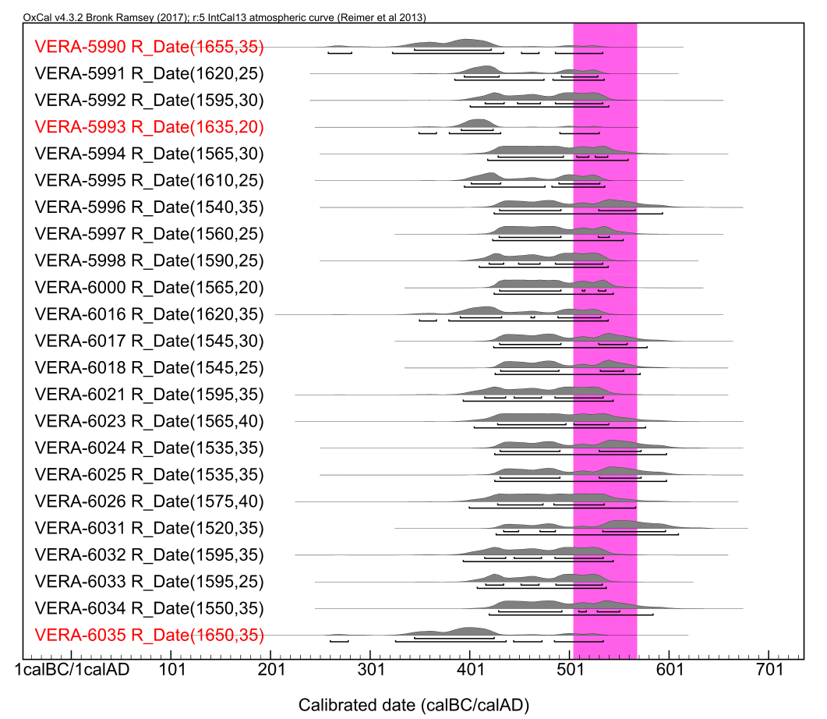

Figure S1

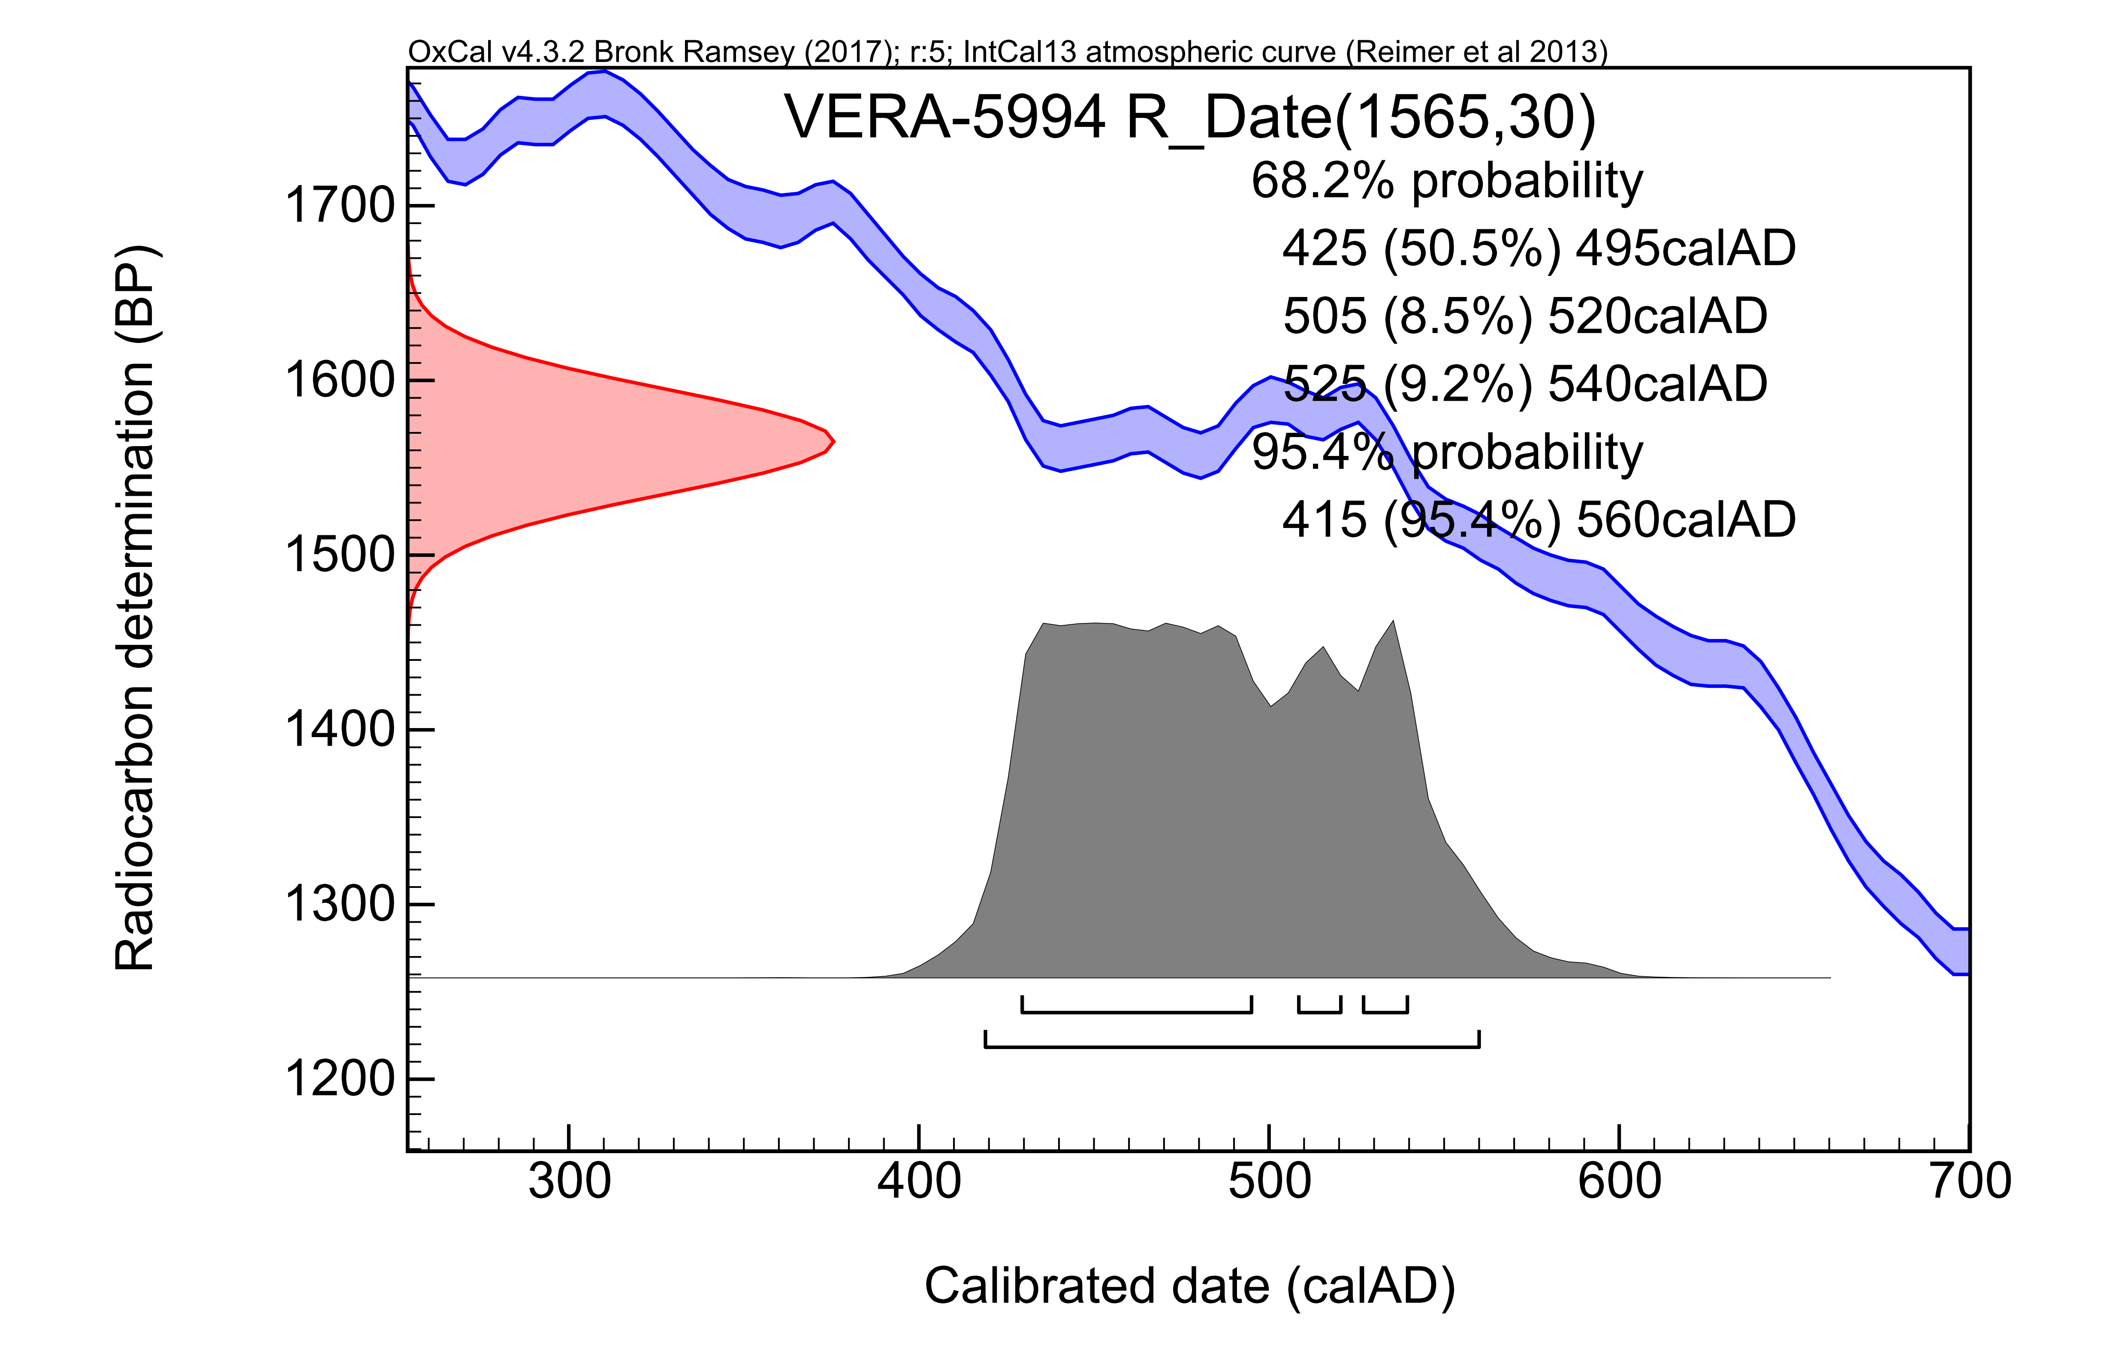

Figure S2

