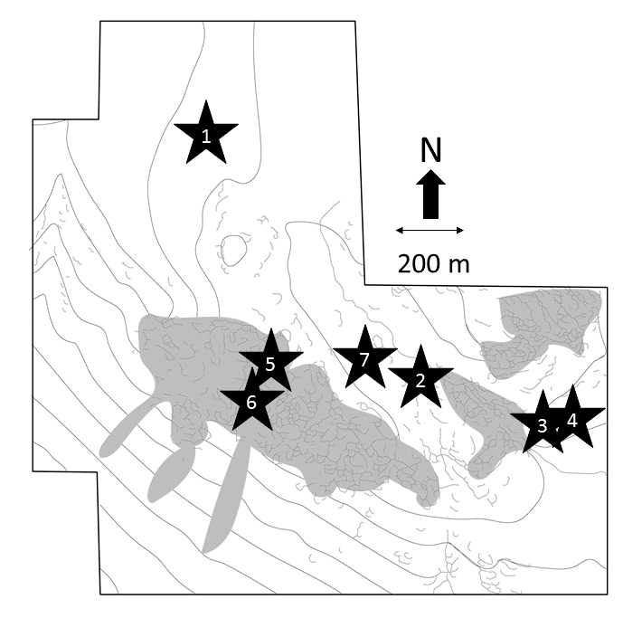Figure S1. Schematic location of the main excavated sites mentioned in text at Great Langdale (Bradley and Edmonds 1993, 107) 1. Stake Beck; 2. Dungeon Ghyll; 3. Harrison Stickle trench 4; Harrison Stickle, trenches 1-3; 5. Top Buttress site 95; 6, Top Buttress site 98; 7 Loft Crag. Figure adapted from Bradley and Edmonds 1993.

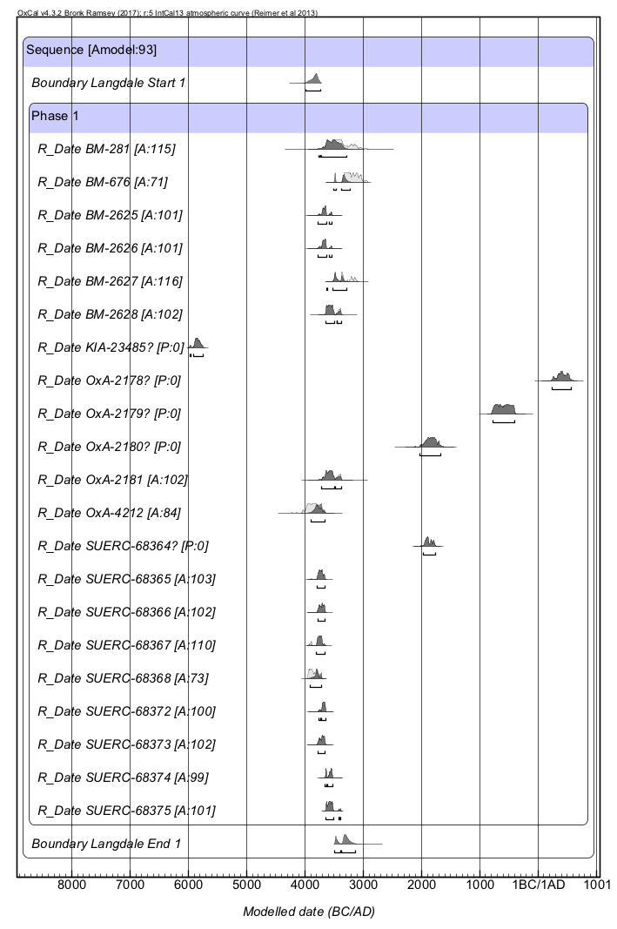
Figure S2. Langdale. OxCal single phase result. Horizontal bars under the distributions are at a 95.4% probability range. All available dates that are not clear outliers “?” [P=0] are then grouped into a single activity phase.

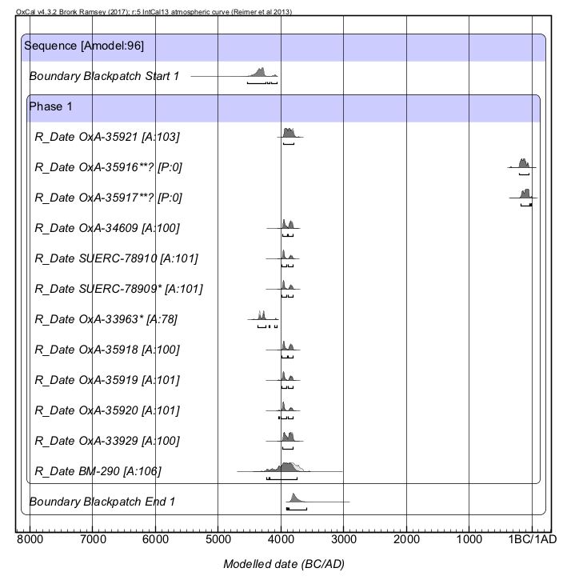
Figure S3. Alternative Blackpatch initial single activity phase model.
* sampled from the same artefact; **sampled from the same artefact.
Outlier results OxA-35916**? and OxA-35917**? are not included in this single activity phase model, although OxA-33963 is included here, for comparison with results in the main text. Horizontal bars under the distributions are at a 95.4% probability range.
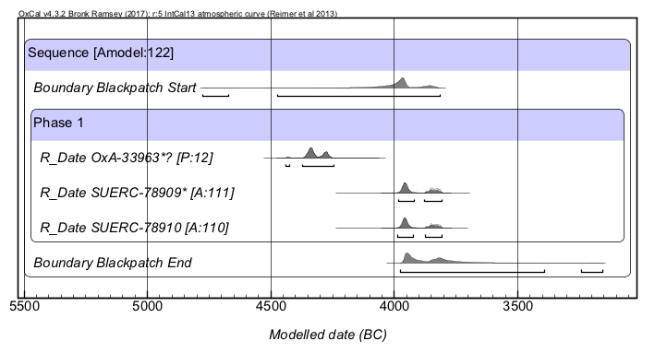
Figure S4. Blackpatch outlier test using OxCal Outlier command. All results are from the same archaeological context. Results OxA-33963* and SUERC-78909* are from the same artefact. OxA-33963* result is [P:12] provides a low probability that it is consistent with the other two samples. Horizontal bars under the distributions are at a 95.4% probability range.

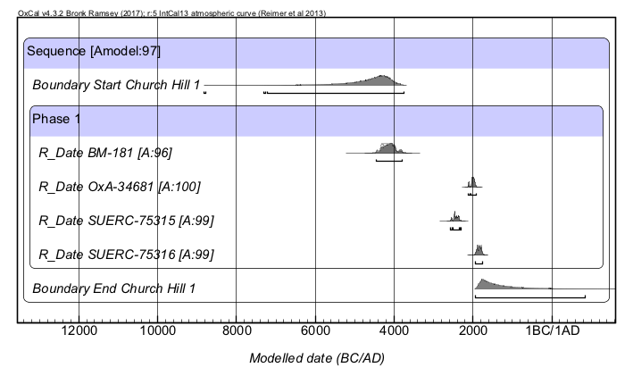
Figure S5. Church Hill OxCal Phase model with BM-181 not treated as an outlier. Horizontal bars under the distributions are at a 95.4% probability range.

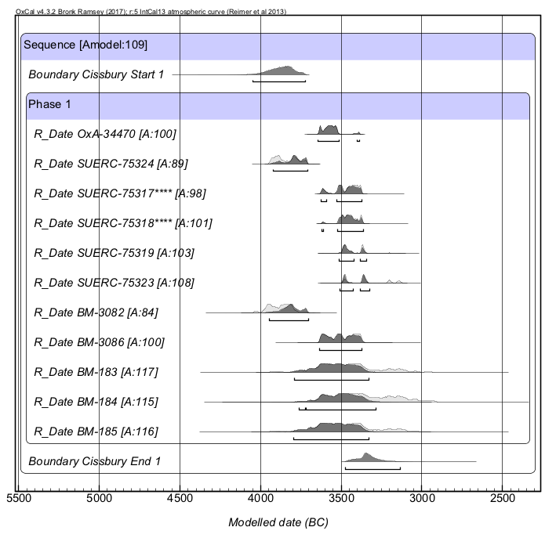
Figure S6. Cissbury OxCal Single phase activity model of all available dates.
****sampled from the same artefact. Horizontal bars under the distributions are at a 95.4% probability range.

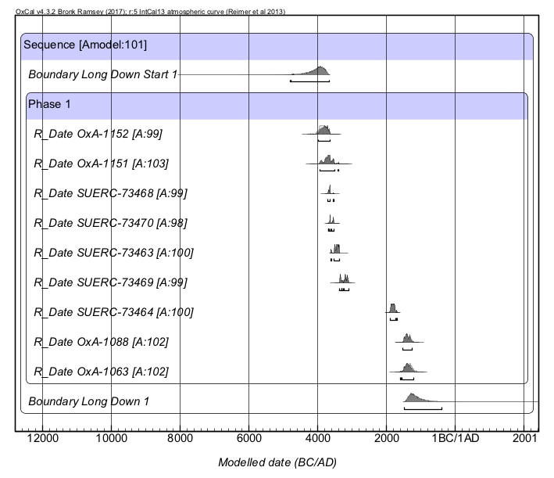
Figure S7. OxCal calibration model showing the Long Down data grouped into a single OxCal activity phase using all available dates. Horizontal bars under the distributions are at a 95.4% probability range.

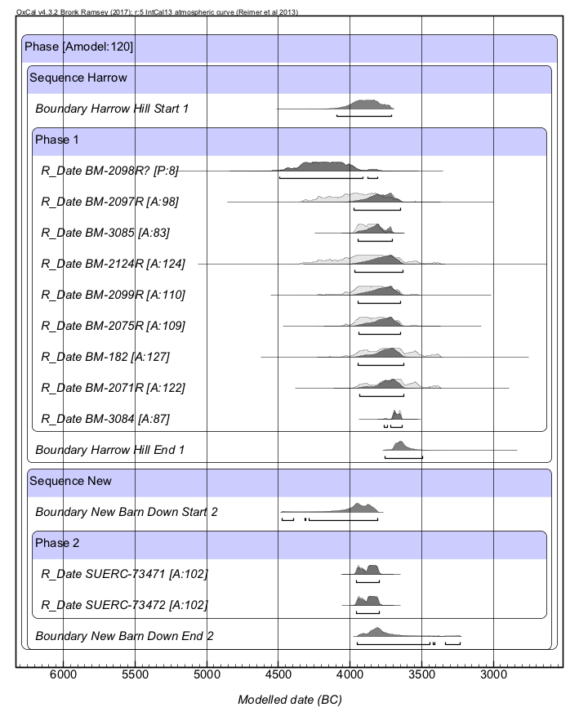
Figure S8. Overlapping OxCal calibration phase model of (previous) Harrow Hill and (new) New Barn Down radiocarbon data, the model is internally consistent [Amodel:120]. Horizontal bars under the distributions are at a 95.4% probability range. BM2098R(?) is plotted for reference, but is inconsistent with the other results and excluded from the modelling process [P:8].

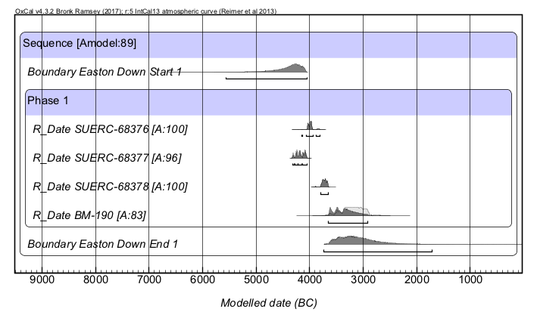

Figure S9. The OxCal phase model result for Easton Down, including the BM-190 result. Horizontal bars under the distributions are at a 95.4% probability range.

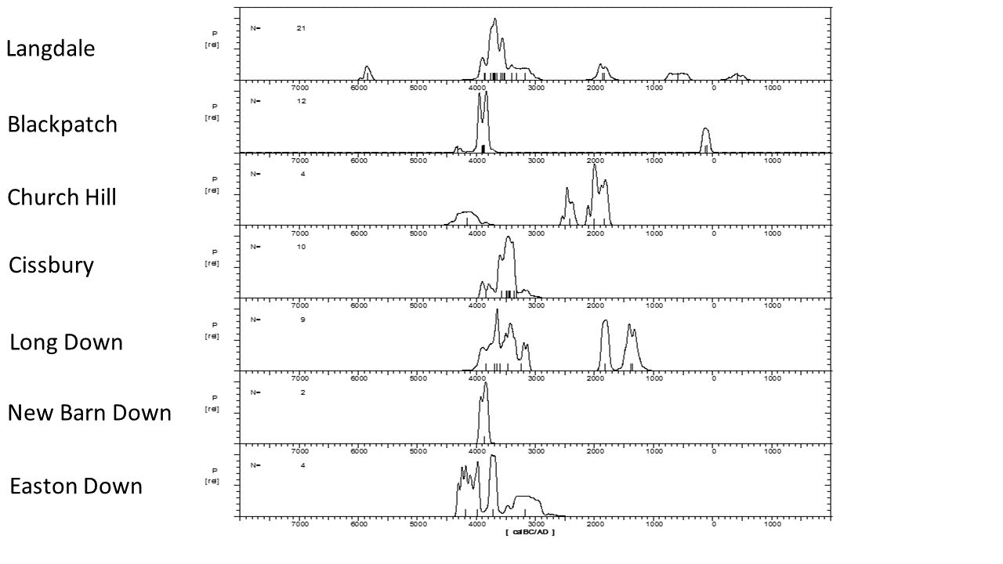
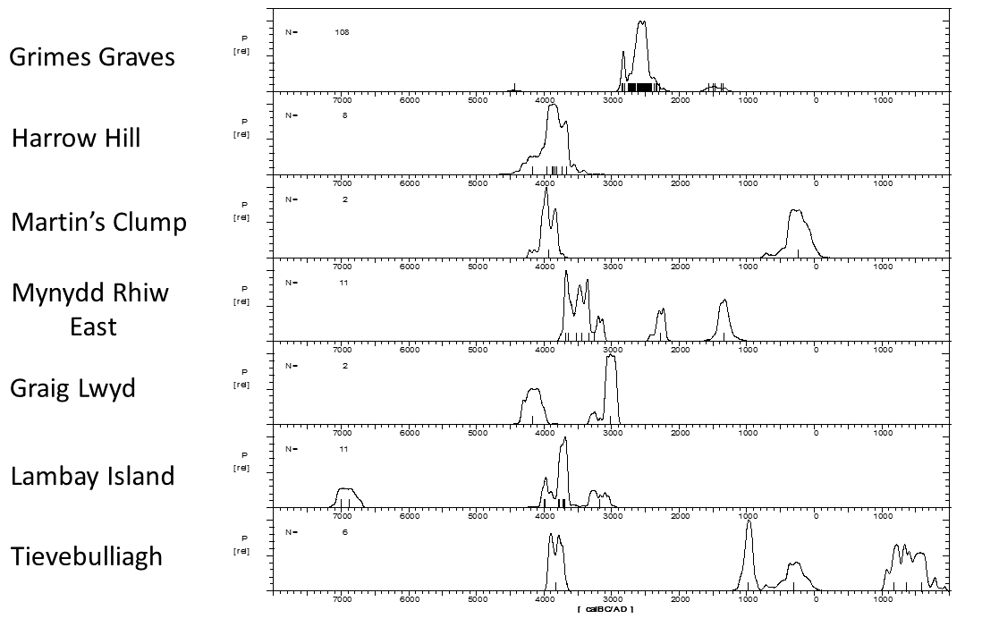

Fig S10. The CalPal model results using all available dates for mines and quarries mentioned in text.
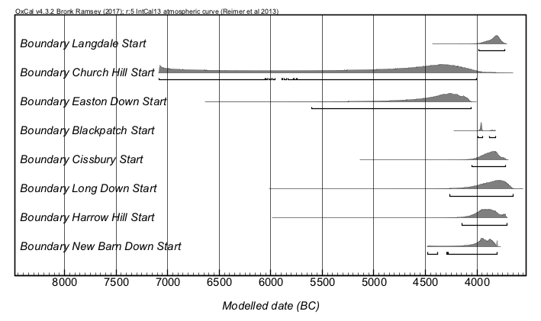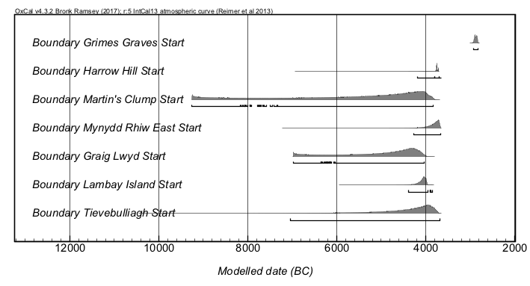
Figure S11. Upper panel: OxCal start date model for mines and quarries, with Church Hill’s early BM-181 result included. Lower Panel: OxCal start date model for other well-known mines and quarries mentioned in the text but not sampled by this project. Horizontal bars under the distributions are at a 95.4% probability range.

Site | Sample | Species | Lab Code | 14C age (years BP) | Error (1σ) | δ13C (‰) | Context | Reference
Great Langdale Stake Beck | charcoal | Salix/Populus sp. | OxA-2181 | 4790 | 80 | -25.5 | charcoal from Stake Beck | Hedges et al 1990
Great Langdale Harrison Stickle | charcoal | Betula sp., Pomoideae sp., Salix/Populus sp., Quercus sp. | BM-2625 | 4870 | 50 | -25.3 | comes from a composite sample of charcoal identified by Mark Robinson, from Trench 1, "axe finishing" site, where roughouts and blocks, extracted from elsewhere at Langdale, were worked. Sample associated with axe-finishing flakes in fill of shallow platform on hillside | Ambers and Bowman 1994; Bradley and Edmonds 1993: 126
Great Langdale Harrison Stickle | charcoal | Betula sp., Pomoideae sp., Salix/Populus sp. and Corylus avellana identified by Mark Robinson | BM-2626 | 4880 | 50 | -24.8 | from Trench IV; associated with axe-finishing flakes in fill of natural hollow in hillside | Bradley and Edmonds 1993
Great Langdale Top Buttress Site 95 | charcoal | Betula sp., Quercus sp., Salix/Populus sp. and Corylus avellana | BM-2627 | 4590 | 50 | -24.8 | from a composite sample of charcoal (Betula sp., Quercus sp., Salix/Populus sp. and Corylus avellana, identified by Mark Robinson) from a horizon of charcoal in the fill of a Neolithic quarry sealed by a tip of axe-making debris and sealing earlier fire-setting waste | Bradley and Edmonds 1993: 126
Great Langdale Top Buttress Site 95 | charcoal | Betula sp., Pomoideae sp., Salix/Populus sp. and Quercus sp. | BM-2628 | 4760 | 50 | -25.3 | comes from a composite sample of charcoal identified by Mark Robinson from a lower fill in the Neolithic quarry, sealed by fire-setting waste and sealing axe-making debris and freshly quarried rubble | Bradley and Edmonds 1993
Great Langdale Thorn Crag (site 187) | charcoal | N/A | OxA-4212 | 5080 | 90 | -25.6 | comes from wood charcoal from excavations carried out in 1991 at a Neolithic axe factory. The sample was taken from the interface between the natural subsoil and the lowest flake-filled loam deposit; worked flakes were found directly above the charcoal. The axe factory is a small in-situ flake deposit on a glacial bench below the summit of Thorn Crag, about I00m below the band of outcropping of fine grained (Group VI) volcanic tuff (Quatermaine, in Hedges et al. 1990). This sample was submitted in 1992 through English Heritage by Jaimie Quartermaine of Lancaster University Archaeological Unit, now Oxford North | Hedges et al 1994
Environmental samples at Great Langdale
Great Langdale Plateau behind faces of Pike of Stickle and Loft Crag, Site 123 | charcoal | Empetrum nigrum | KIA-23485 | 6965 | 30 | ? | environmental; comes from a charred Empetrum nigrum seed from within the flake deposit (Schofield 2009). The flakes containing the charcoal were within a very humified organic soil at the base of the peat | Schofield 2009
Great Langdale Stake Beck/Thunacar Knott | charcoal | N/A | BM-281 | 4680 | 135 | N/A | environmental; comes from an environmental sample of charcoal, 90 cm below the surface of peat associated with several stone implements and chippings, submitted by H. Godwin. Taken as an environmental date, it is not securely located | Clough 1976
Great Langdale Stake Beck/Thunacar Knott | charcoal | N/A | BM-676 | 4474 | 52 | N/A | environmental; comes from charcoal in a secure layer of axe chippings representing a working site of Langdale (Group VI) Neolithic axes | Clough 1973
Great Langdale Dungeon Ghyll | charcoal | N/A | OxA-2178 | 1640 | 70 | -27.3 | environmental; comes from ericaceous charcoal, related to an episode of burning associated with evidence of contemporary land use and sealed by a small tip of flaking debris | Hedges et al. 1990
Great Langdale Langdale Combe | carbonised twig | Betula sp. | OxA-2179 | 2450 | 70 | -29.2 | environmental; samples excavated in 1986 and 1987 | Bradley and Edmonds 1993; Hedges et al. 1990
Great Langdale Combe | charcoal | Betula sp. | OxA-2180 | 3510 | 70 | -25.5 | excavated in 1986 and 1987 | Bradley and Edmonds 1993;Hedges et al. 1990
Black Patch | antler pick | N/A | BM–290 | 5090 | 130 | N/A | obtained on an antler pick excavated by John Pull from gallery belonging to Shaft 4 | Barber et al 1999
Church Hill | antler pick | N/A | BM-181 | 5340 | 150 | N/A | collected from an unknown gallery excavated by John Pull, and submitted by Gale Sieveking of the British Museum (Barker et al 1969) | Barker et al 1969
Cissbury | antler pick | N/A | BM-183 | 4720 | 150 | N/A | sampled from antler picks from a gallery, shaft/s unknown collected by John Pull ca.1952 | Barker et al 1969
Cissbury | antler pick | N/A | BM-184 | 4650 | 150 | N/A | sampled from antler picks from a gallery, Collected 1877 by Park Harrison | Barker et al 1969
Cissbury | antler pick | N/A | BM-185 | 4730 | 150 | N/A | sampled from antler picks from a gallery, possibly shaft 6, but shaft/s unknown collected 1878 by Park Harrison | Barker et al 1969
Cissbury | antler (bulk sample) | Cervus elaphus | BM-3082 | 5100 | 60 | -19.2 | from unknown shaft base/South Gallery, identifications by D. Searjeantson, University of Southampton | Ambers and Bowman 2003, 533
Cissbury | antler (bulk sample) | Cervus elaphus | BM-3086 | 4710 | 60 | -22.1 | from base of Shaft 27 (Layer 12) identifications by D. Searjeantson, University of Southampton | Ambers and Bowman 2003, 533
Easton Down | antler pick | N/A | BM-190 | 4480 | 150 | N/A | obtained from antler picks from a gallery excavated by J.F.S. Stone 1930-34 (Barber et al 1991) | Barber and Field 1991
Grime's Graves | antler | N/A | GrA-38913 | 4060 | 35 | -22.9 | 1971 Pit A620 | Healy et al. 2014: 75
Grime's Graves | antler | N/A | GrA-38914 | 4070 | 35 | -23.4 | Pit to NE of 1971 Pit A653 | Healy et al. 2014: 75
Grime's Graves | antler | N/A | GrA-38915 | 4035 | 35 | -22.2 | 1971 Pit A743 | Healy et al. 2014: 75
Grime's Graves | antler | N/A | GrA-38924 | 4065 | 35 | -22.8 | 1971 Pit A603 | Healy et al. 2014: 75
Grime's Graves | antler | N/A | GrA-39260 | 4100 | 35 | -22.9 | 1971 Pit A619a | Healy et al. 2014: 76
Grime's Graves | antler | N/A | OxA-20591 | 3231 | 28 | -22.1 | 105 GG76 1581+1578 | Healy et al. 2014: 76
Grime's Graves | antler | N/A | OxA-20709 | 4007 | 33 | -22.1 | 1971 Pit A598a | Healy et al. 2014: 76
Grime's Graves | antler | N/A | OxA-20710 | 3978 | 34 | -23.8 | 1971 Pit A601 | Healy et al. 2014: 76
Grime's Graves | antler | N/A | OxA-20711 | 4046 | 35 | -22.3 | 1971 Pit A611a | Healy et al. 2014: 76
Grime's Graves | antler | N/A | OxA-20712 | 4081 | 35 | -24 | Pit to NE of 1971 Pit A675 | Healy et al. 2014: 76
Grime's Graves | antler | N/A | OxA-20713 | 4054 | 37 | -23.1 | Pit to NE of 1971 Pit A680 | Healy et al. 2014: 76
Grime's Graves | antler | N/A | OxA-20714 | 4025 | 34 | -23.1 | Pit to NE of 1971 Pit A682 | Healy et al. 2014: 76
Grime's Graves | antler | N/A | OxA-20715 | 3995 | 34 | -23.6 | Pit to NE of 1971 Pit A746 | Healy et al. 2014: 76
Grime's Graves | antler | N/A | OxA-20716 | 4065 | 45 | -23 | 6 GG73 161 | Healy et al. 2014: 76
Grime's Graves | antler | N/A | OxA-20717 | 4083 | 33 | -23.5 | 7 GG74 sf 182 | Healy et al. 2014: 76
Grime's Graves | antler | N/A | OxA-20720 | 3226 | 33 | -21.8 | 105 GG76 1548+1549 | Healy et al. 2014: 76
Grime's Graves | antler | N/A | OxA-20750 | 3973 | 31 | -20.3 | Pit 12 '1933 gallery 2' a | Healy et al. 2014: 76
Grime's Graves | antler | N/A | OxA-20751 | 4029 | 31 | -21.9 | Pit 12 '1933 entrance to gallery 2' | Healy et al. 2014: 76
Grime's Graves | antler | N/A | OxA-20752 | 4009 | 30 | -20.9 | Pit 12 '1933 gallery 2 centre' | Healy et al. 2014: 76
Grime's Graves | antler | N/A | OxA-20753 | 4056 | 31 | -21.1 | Pit 12 '1933 gallery3 just inside' | Healy et al. 2014: 77
Grime's Graves | antler | N/A | OxA-20754 | 4004 | 31 | -22.8 | Pit 12 'gallery 3' | Healy et al. 2014: 77
Grime's Graves | antler | N/A | OxA-20755 | 3998 | 32 | -20.9 | Pit 14 1936 'filling of gallery near wall' | Healy et al. 2014: 77
Grime's Graves | antler | N/A | OxA-20756 | 4031 | 31 | -20.1 | Pit 14 'filling of gallery 3' | Healy et al. 2014: 77
Grime's Graves | antler | N/A | OxA-20757 | 4033 | 31 | -22.2 | Pit 14 '8 ft in chalk' | Healy et al. 2014: 77
Grime's Graves | antler | N/A | OxA-20758 | 4063 | 29 | -22.4 | Pit 14 '8 ft in chalk' | Healy et al. 2014: 77
Grime's Graves | antler | N/A | OxA-20804 | 3933 | 29 | -24.7 | 1971 Pit GG71 sample 216 | Healy et al. 2014: 77
Grime's Graves | antler | N/A | OxA-20983 | 3942 | 29 | -25.3 | 1971 Pit GG71 sample 227 | Healy et al. 2014: 77
Grime's Graves | antler | N/A | OxA-21187 | 3960 | 31 | -21.9 | F6 GG73 159 | Healy et al. 2014: 78
Grime's Graves | antler | N/A | OxA-21188 | 3988 | 32 | -23 | F7 GG74 136 B | Healy et al. 2014: 78
Grime's Graves | antler | N/A | OxA-21189 | 3946 | 31 | -22.4 | F7 GG74 168 | Healy et al. 2014: 78
Grime's Graves | antler | N/A | OxA-21191 | 4015 | 31 | -22.7 | F7 GG74 183 | Healy et al. 2014: 78
Grime's Graves | antler | N/A | OxA-22531 | 3194 | 26 | -20.4 | Pit 6 'Pit VI 12-6' | Healy et al. 2014: 79
Grime's Graves | antler | N/A | OxA-22577 | 3943 | 31 | -27.2 | Greenwell's Pit C 611a (BM 1987 2-2 213) | Healy et al. 2014: 79
Grime's Graves | antler | N/A | OxA-23095 | 4054 | 27 | -22.4 | Greenwell's Pit 530 | Healy et al. 2014: 79
Grime's Graves | antler | N/A | OxA-23096 | 4083 | 28 | -23 | Greenwell's Pit 538 | Healy et al. 2014: 79
Grime's Graves | antler | N/A | OxA-23097 | 3969 | 27 | -22.7 | Greenwell's Pit C 647 | Healy et al. 2014: 79
Grime's Graves | antler | N/A | OxA-23098 | 4092 | 27 | -22.7 | Greenwell's Pit D 720 | Healy et al. 2014: 79
Grime's Graves | antler | N/A | OxA-23099 | 4130 | 27 | -22.6 | Greenwell's Pit D 720 | Healy et al. 2014: 79
Grime's Graves | antler | N/A | OxA-23100 | 4120 | 29 | -22.8 | Greenwell's Pit D 733 | Healy et al. 2014: 79
Grime's Graves | antler | N/A | OxA-23101 | 4048 | 28 | -23.4 | Greenwell's Pit E 843 | Healy et al. 2014: 79
Grime's Graves | antler | N/A | OxA-23102 | 3930 | 27 | -22.3 | Greenwell's Pit E 845 | Healy et al. 2014: 79
Grime's Graves | antler | N/A | OxA-23103 | 3978 | 27 | -21.7 | Greenwell's Pit A 923 | Healy et al. 2014: 79
Grime's Graves | antler | N/A | OxA-23104 | 3932 | 27 | -22.7 | Greenwell's Pit A 974b | Healy et al. 2014: 79
Grime's Graves | antler | N/A | OxA-23106 | 4071 | 28 | -23 | Pit 11 A 308 | Healy et al. 2014: 80
Grime's Graves | antler | N/A | OxA-23107 | 4029 | 27 | -22.7 | Pit 11 A 311 | Healy et al. 2014: 80
Grime's Graves | antler | N/A | OxA-23108 | 4133 | 28 | -22.1 | Pit 11 E 315 | Healy et al. 2014: 80
Grime's Graves | antler | N/A | OxA-23109 | 4007 | 28 | -21.6 | Pit 11 D 332a | Healy et al. 2014: 80
Grime's Graves | antler | N/A | OxA-23110 | 4112 | 28 | -23.9 | Pit 11 F 344 | Healy et al. 2014: 80
Grime's Graves | antler | N/A | OxA-23111 | 4076 | 27 | -22.8 | Pit 15 C 50 | Healy et al. 2014: 80
Grime's Graves | antler | N/A | OxA-23112 | 4102 | 28 | -22.9 | Pit 15 C 56 B | Healy et al. 2014: 80
Grime's Graves | antler | N/A | OxA-23144 | 3943 | 47 | -22.4 | Pit 15 C 58 | Healy et al. 2014: 80
Grime's Graves | antler | N/A | OxA-23145 | 3933 | 27 | -22.4 | Pit 15 C/K 1546 | Healy et al. 2014: 80
Grime's Graves | antler | N/A | OxA-23146 | 4003 | 29 | -22.2 | Pit 15 C/K 1551 (1) | Healy et al. 2014: 80
Grime's Graves | antler | N/A | OxA-23147 | 3922 | 29 | -22.6 | Pit 15 C/K 1557 | Healy et al. 2014: 80
Grime's Graves | antler | N/A | OxA-24082 | 4004 | 29 | -26.8 | 1971 Pit GG71 sample 240 | Healy et al. 2014: 80
Grime's Graves | antler | N/A | SUERC-18820 | 4125 | 30 | -22.1 | 1971 Pit A619b | Healy et al. 2014: 80
Grime's Graves | antler | N/A | SUERC-18821 | 4065 | 30 | -22.3 | 1971 Pit A624 | Healy et al. 2014: 80
Grime's Graves | antler | N/A | SUERC-18822 | 4120 | 30 | -22.4 | 1971 Pit A730 | Healy et al. 2014: 80
Grime's Graves | antler | N/A | SUERC-18823 | 4085 | 30 | -20.8 | 1971 Pit A751 | Healy et al. 2014: 80
Grime's Graves | antler | N/A | SUERC-24096 | 4090 | 30 | -22 | Pit 12 ' S side in chalk at 6 ft' | Healy et al. 2014: 80
Grime's Graves | antler | N/A | SUERC-24097 | 3975 | 35 | -22.9 | Pit 12 'gallery 2' | Healy et al. 2014: 81
Grime's Graves | antler | N/A | SUERC-24098 | 4015 | 30 | -21.9 | Pit 12 '1933 gallery 2' b | Healy et al. 2014: 81
Grime's Graves | antler | N/A | SUERC-24099 | 4040 | 30 | -22.5 | Pit 12 'gallery 3' b | Healy et al. 2014: 81
Grime's Graves | antler | N/A | SUERC-24100 | 4015 | 30 | -22.6 | Pit 14 '2ft from bottom, in filling' | Healy et al. 2014: 81
Grime's Graves | antler | N/A | SUERC-24101 | 4055 | 30 | -22.9 | Pit 14 'Filling at back of S. Gal. Near floor'. | Healy et al. 2014: 81
Grime's Graves | antler | N/A | SUERC-24102 | 4030 | 30 | -21.2 | Pit 14 'filling of gallery 3' b | Healy et al. 2014: 81
Grime's Graves | antler | N/A | SUERC-24106 | 4045 | 30 | -20.2 | Pit 14 'NE sector at 7 ft' | Healy et al. 2014: 81
Grime's Graves | antler | N/A | SUERC-24108 | 3295 | 30 | -21.3 | Pit 15 D 251 | Healy et al. 2014: 81
Grime's Graves | antler | N/A | SUERC-24110 | 4040 | 30 | -21.8 | 1971 Pit A598b | Healy et al. 2014: 81
Grime's Graves | antler | N/A | SUERC-24111 | 4085 | 30 | -21.7 | 1971 Pit A611b | Healy et al. 2014: 81
Grime's Graves | antler | N/A | SUERC-24112 | 4095 | 30 | -23.3 | Pit to NE of 1971 Pit A688 | Healy et al. 2014: 81
Grime's Graves | antler | N/A | SUERC-24116 | 4155 | 35 | -22 | Pit to NE of 1971 Pit A763 | Healy et al. 2014: 81
Grime's Graves | antler | N/A | SUERC-24117 | 4090 | 30 | -22.7 | Pit to NE of 1971 Pit A771 | Healy et al. 2014: 81
Grime's Graves | antler | N/A | SUERC-24118 | 3855 | 30 | -23.5 | 1972-74 knapping floor GG73 L186 | Healy et al. 2014: 81
Grime's Graves | antler | N/A | SUERC-24119 | 3945 | 30 | -22.4 | 1972-74 knapping floor GG74 L403 | Healy et al. 2014: 82
Grime's Graves | antler | N/A | SUERC-24128 | 3095 | 30 | -22.2 | Pit X GG76 221 | Healy et al. 2014: 82
Grime's Graves | antler | N/A | SUERC-24130 | 4045 | 30 | -28 | 1971 Pit GG71 sample 224 | Healy et al. 2014: 82
Grime's Graves | antler | N/A | SUERC-25711 | 4010 | 40 | -20.1 | F6 GG73 152 | Healy et al. 2014: 82
Grime's Graves | antler | N/A | SUERC-25712 | 4095 | 40 | -22 | F6 GG73 154 | Healy et al. 2014: 82
Grime's Graves | antler | N/A | SUERC-25713 | 4065 | 40 | -22.8 | F6 GG73 158 | Healy et al. 2014: 82
Grime's Graves | antler | N/A | SUERC-25717 | 4220 | 40 | -21.5 | F7 GG74 165 | Healy et al. 2014: 82
Grime's Graves | antler | N/A | SUERC-25718 | 4065 | 40 | -22.9 | F7 GG74 136 A | Healy et al. 2014: 82
Grime's Graves | antler | N/A | SUERC-28748 | 3295 | 35 | -21.3 | Pit 6 'Pit VI Bottom' | Healy et al. 2014: 83
Grime's Graves | antler | N/A | SUERC-28749 | 3950 | 35 | -22.3 | Pit 10 'Pit 10 under W wall in cove at 6 ft' | Healy et al. 2014: 83
Grime's Graves | antler | N/A | SUERC-28750 | 3830 | 35 | -22.4 | Pit 10 'Pit 10. N side in rubble at 6 ft (1)' | Healy et al. 2014: 83
Grime's Graves | antler | N/A | SUERC-28751 | 5620 | 35 | -23.8 | Pit 11 E 318 | Healy et al. 2014: 83
Grime's Graves | antler | N/A | SUERC-28752 | 4055 | 35 | -23.5 | Pit 15 C 54 | Healy et al. 2014: 83
Grime's Graves | antler | N/A | SUERC-28757 | 3090 | 35 | -27.2 | Black Hole Longworth cat. no. 239 b | Healy et al. 2014: 83
Grime's Graves | antler | N/A | SUERC-28763 | 3130 | 35 | -26.1 | Pit X GG76 L2409, L2420 | Healy et al. 2014: 83
Grime's Graves | antler | N/A | SUERC-30903 | 4095 | 35 | -22.9 | Pit 15 C 47 | Healy et al. 2014: 84
Grime's Graves | antler | N/A | SUERC-30905 | 4085 | 35 | -22.3 | Pit 15 C 57 | Healy et al. 2014: 84
Grime's Graves | antler | N/A | SUERC-30906 | 4250 | 30 | -22.6 | Pit 15 C 59 | Healy et al. 2014: 84
Grime's Graves | antler | N/A | SUERC-30907 | 3890 | 35 | -22.8 | Pit 15 C/K 1550 (2) | Healy et al. 2014: 84
Grime's Graves | antler | N/A | SUERC-30911 | 3970 | 30 | -23.2 | Pit 15 C/K 1552 (2) | Healy et al. 2014: 84
Grime's Graves | antler | N/A | SUERC-30912 | 3945 | 30 | -21.5 | Pit 11 D 304 B | Healy et al. 2014: 84
Grime's Graves | antler | N/A | SUERC-30914 | 4030 | 35 | -22.2 | Pit 11 E 314 | Healy et al. 2014: 84
Grime's Graves | antler | N/A | SUERC-30915 | 4000 | 35 | -23 | Pit 11 E 320 | Healy et al. 2014: 84
Grime's Graves | antler | N/A | SUERC-30916 | 3955 | 30 | -23 | Pit 11 F 342 | Healy et al. 2014: 84
Grime's Graves | antler | N/A | SUERC-30917 | 4240 | 35 | -22.4 | Pit 11 F 343 A | Healy et al. 2014: 84
Grime's Graves | antler | N/A | SUERC-30921 | 4040 | 35 | -22.6 | Greenwell's Pit 503 | Healy et al. 2014: 84
Grime's Graves | antler | N/A | SUERC-30922 | 4055 | 35 | -22.8 | Greenwell's Pit 523 | Healy et al. 2014: 84
Grime's Graves | antler | N/A | SUERC-30923 | 4045 | 35 | -22.3 | Greenwell's Pit 531 | Healy et al. 2014: 84
Grime's Graves | antler | N/A | SUERC-30924 | 3865 | 35 | -22.7 | Greenwell's Pit C 627 | Healy et al. 2014: 84
Grime's Graves | antler | N/A | SUERC-30925 | 4030 | 35 | -22.5 | GreenwellD's Pit 719 | Healy et al. 2014: 84
Grime's Graves | antler | N/A | SUERC-30926 | 4045 | 35 | -22.3 | GreenwellD's Pit 736 | Healy et al. 2014: 84
Grime's Graves | antler | N/A | SUERC-30927 | 4135 | 35 | -23.1 | Greenwell's Pit E 844 | Healy et al. 2014: 84
Grime's Graves | antler | N/A | SUERC-30931 | 3955 | 35 | -23 | Greenwell's Pit E 846 | Healy et al. 2014: 84
Grime's Graves | antler | N/A | SUERC-30932 | 3960 | 35 | -22.4 | Greenwell's Pit A 974a | Healy et al. 2014: 84
Harrow Hill | antler pick | N/A | BM-182 | 4930 | 150 | N/A | from gallery excavated by Curwen 1924-5 | Barber et al 1999
Harrow Hill | antler pick | N/A | BM-2071R | 4900 | 120 | N/A | Excavated by Gale Sieveking 1982, antler from basal fill of shaft 13 | Barber et al 1999
Harrow Hill | antler pick | N/A | BM-2075R | 5020 | 110 | N/A | Excavated by Gale Sieveking 1982, charcoal from basal fill of shaft 13 | Barber et al 1999
Harrow Hill | antler pick | N/A | BM-2097R | 5140 | 150 | N/A | Excavated by Gale Sieveking 1982, charcoal from shaft 13 fill | Barber et al 1999
Harrow Hill | antler pick | N/A | BM-2098R | 5350 | 150 | N/A | Excavated by Gale Sieveking 1982, antler from basal fill of shaft 13 | Barber et al 1999
Harrow Hill | antler pick | N/A | BM-2099R | 5040 | 120 | N/A | Excavated by Gale Sieveking 1982, charcoal from fill of shaft 13 | Barber et al 1999
Harrow Hill | antler pick | N/A | BM-2124R | 4800 | 170 | N/A | Excavated by Gale Sieveking 1982, charcoal from fill of shaft 13 | Barber et al 1999
Harrow Hill | antler pick | N/A | BM-3084 | 4880 | 30 | N/A | Antler from the base of shaft 27 | Barber et al 1999
Harrow Hill | antler pick | N/A | BM-3085 | 5070 | 50 | N/A | Antler from the base of shaft 25 | Barber et al 1999
Long Down | charcoal | Corylus avellana | OxA-1063 | 3110 | 80 | N/A | Trench A, A2/17 30; excavated by Rob Holgate 1984 | Hedges et al. 1988
Long Down | charcoal | Corylus avellana | OxA-1088 | 3130 | 60 | N/A | Trench A, A1/16 10; excavated by Rob Holgate 1984 | Hedges et al. 1988
Long Down | charcoal | Cervus elaphus | OxA-1151 | 4900 | 100 | N/A | Trench A, A1/16 5; excavated by Rob Holgate 1984 | Hedges et al. 1988
Long Down | charcoal | Bos taurus | OxA-1152 | 5050 | 100 | N/A | Trench A, A1/15 8; excavated by Rob Holgate 1984 | Hedges et al. 1988
Martin’s Clump | ox bone | N/A | HAR-681 | 2200 | 120 | N/A | from bottom of ditch | Ride 1998
Martin’s Clump | antler tine | Cervus elaphus | BM-3083 | 5150 | 70 | N/A | from base of the back fill of Shaft 2 coming from a red deer antler tine that had been detached from the beam | Field and Baber 1998
Mynydd Rhiw | charcoal | Quercus sp. | Q-387 | 3094 | 90 | N/A | charcoal comes from fire pit 4 | Godwin and Willis 1961
Mynydd Rhiw | charcoal | Quercus sp. | UBA-7774 | 4738 | 28 | -21 | charcoal comes from the main trench | Burrow 2011, 255
Mynydd Rhiw | charcoal | Quercus sp. | UBA-7776 | 4567 | 27 | -17 | charcoal comes from the main trench | Burrow 2011, 255
Mynydd Rhiw | charcoal | Quercus sp. | UBA-7778 | 4658 | 25 | -25 | charcoal comes from the main trench | Burrow 2011, 255
Mynydd Rhiw | charcoal | Prunus sp. | UBA-7779 | 4917 | 24 | -25 | charcoal comes from the main trench | Burrow 2011, 255
Mynydd Rhiw | charcoal | Prunus sp. | UBA-7780 | 3833 | 26 | -25 | charcoal comes from the main trench | Burrow 2011, 255
Mynydd Rhiw | charcoal | Corylus sp. | UBA-7781 | 4895 | 32 | -31 | charcoal comes from the main trench | Burrow 2011, 255
Mynydd Rhiw | charcoal | Corylus sp. | UBA-7782 | 4843 | 24 | -26 | charcoal comes from the main trench | Burrow 2011, 255
Mynydd Rhiw | charcoal | Corylus sp. | UBA-7801 | 4558 | 43 | -23 | charcoal comes from the main trench | Burrow 2011, 255
Mynydd Rhiw | charcoal | Corylus sp. | UBA-7802 | 3081 | 42 | -27 | charcoal comes from the top hearth | Burrow 2011, 255
Mynydd Rhiw | charcoal | Corylus sp. | UBA-7803 | 4589 | 36 | -25 | charcoal comes from the second hearth from top | Burrow 2011, 255
Graig Lwyd | charcoal | N/A | Beta-128505 | 4400 | 40 | N/A | charcoal comes from the lowest level of scree | Williams, J. L. and Davidson 1998
Graig Lwyd | charcoal | N/A | SWAN-142 | 5330 | 90 | N/A | charcoal comes from below cairn 67 | Lynch and Musson 2001, 35
Tievebulliagh | charcoal | N/A | UB-2707 | 320 | 90 | N/A | come from Trench 3, an orange layer with porcellanite chips and roughouts. (Mallory 1990) | Mallory 1990
Tievebulliagh | charcoal | N/A | UB-2708 | 2245 | 120 | N/A | come from Trench 9, Layer 2 (Mallory 1990, 22) | Mallory 1990
Tievebulliagh | charcoal | N/A | UB-2709 | 830 | 70 | N/A | comes from Trench 8, Layer 6, top of cobbling | Mallory 1990
Tievebulliagh | charcoal | N/A | UB-2710 | 575 | 70 | N/A | comes from Trench 8, Layer 6, hearth feature 2 | Mallory 1990
Tievebulliagh | charcoal | N/A | UB-3079 | 5020 | 50 | N/A | environmental results 82-84 cm comes from “the second clearance phase” | Weir 1993
Tievebulliagh | charcoal | N/A | UB-3080 | 2820 | 45 | N/A | environmental results 53-54 cm comes from “the most dramatic clearance phase” | Weir 1993
Lambay Island | charcoal | Prunus sp. | SUERC-4129 | 4925 | 40 | -25.3 | from a Debitage layer | Cooney et al 2011
Lambay Island | charcoal | Prunus sp. | SUERC-4130 | 8070 | 40 | -24.7 | from C1108, porphyry debitage layer associated with the production of stone axeheads | Cooney et al 2011
Lambay Island | charcoal | Prunus sp. | SUERC-4131 | 4990 | 35 | -24.4 | from Prunus sp. C1109 debitage layer | Cooney et al 2011
Lambay Island | charcoal | Prunus sp. | SUERC-4132 | 7965 | 40 | -24.8 | from Prunus sp. C1112, porphyry debitage layer associated with the production of stone axeheads | Cooney et al 2011
Lambay Island | charcoal | Corylus avellana | SUERC-4133 | 5170 | 35 | -25.1 | from Corylus avellana, Main area, C904. Deliberate deposit of worked flint, charcoal, jasper and other cultural material | Cooney et al 2011
Lambay Island | charcoal | Alnus glutinosa | SUERC-4134 | 4980 | 40 | -25.9 | from Alnus glutinosa, Main area, C910 a deliberate deposit of worked flint, charcoal, jasper and other cultural material | Cooney et al 2011
Lambay Island | charcoal | Prunus sp. | SUERC-4138 | 4460 | 35 | -26.2 | from the main area, F25, linear cut | Cooney et al 2011
Lambay Island | charcoal | Prunus sp. | SUERC-4139 | 4910 | 35 | -25.3 | from the main area, F37. Polygonal slab setting | Cooney et al 2011
Lambay Island | charcoal | Alnus glutinosa | SUERC-4141 | 4920 | 35 | -29.3 | from the main area, F38, from a deposit of porphyry debitage and associated sediment in a hollow | Cooney et al 2011
Lambay Island | charcoal | Quercus sp. | SUERC-4142 | 5180 | 45 | -25.3 | from the main area, F58 | Cooney et al 2011
Lambay Island | charcoal | Prunus sp. | UCD-9826 | 4930 | 175 | N/A | from the main area pit F1, a stratigraphically isolated pit containing rich artefacts assemblage | Cooney et al 2011

Table S1. Legacy data from sites mentioned in text and modelled in SI.

Supplementary Bibliography

Ambers J, Bowman S. 1994. British Museum natural radiocarbon measurements XXIII. Radiocarbon 36(1):95-111.

Ambers, J, Bowman S. 2006. Radiocarbon measurements from the British Museum: Datelist XXVI Archaeometry 45, 3: 531-540

Baczkowski J, Holgate R. 2017. Breaking Chalk: the archaeological investigation of early neolithic flint mines at Long Down and Harrow Hill, West Sussex, 1984-86. Sussex Archæological Collections vol. 155: 1-29.

Barker, H, Burleigh, R, Meeks N. 1969. British Museum natural radiocarbon measurements VI. Radiocarbon 11(2):278-94.

Barber, M. 2005. Mining, burial and chronology: the West Sussex flint mines in the Late Neolithic and Early Bronze Age. In Topping, P. and Lynott, M. (eds) The Cultural Landscape of Prehistoric Mines: 94-109. Oxford: Oxbow.

Barber M, Field D, Topping P. 1999. The Neolithic Flint Mines of England, English Heritage.

Booth, A, Stone, JFS. 1952 A trial flint mine at Durrington, Wiltshire. Wiltshire archaeological and natural history magazine 54: 381-8.

Bradley, R, Edmonds M. 1993. Interpreting the axe trade: production and exchange in Neolithic Britain. Cambridge University Press; 2005 Feb 17.

Burleigh, R, Hewson A, Meeks N. 1976. British Museum natural radiocarbon measurements VIII. Radiocarbon 18(1):16-42.

Burrow, S. 2011. The Mynydd Rhiw stone extraction site and its implications for the axe trade. In Davis, V and Edmonds, M, eds. "Stone axe studies, volume 3." York: Council for British Archaeology: 248-260.

Clough, T. 1973. Excavations on a Langdale axe chipping site in 1969 and 1970. Transactions of the Cumberland and Westmorland Antiquarian and Archaeological Society (73) 25-46.

Cooney, G, Bayliss A, Healy F, Whittle A, Danaher E, Cagney L, Mallory J, Smyth J, Kador T, O'Sullivan MT, O'Sullivan, M. 2011. Chapter 12: Ireland. In, Whittle, A, Healy F, Bayliss A (eds). Gathering time: dating the early Neolithic enclosures of southern Britain and Ireland. Oxford: Oxbow Books: 562-669.

Curwen, E, C. 1934. A Late Bronze Age farm and a Neolithic pit-dwelling on New Barn Down, Sussex Archaeological Collections (75): 137-70.

Darvill, TC. 1989. The circulation of Neolithic stone and flint axes: a case study from Wales and the mid-west of England. Proceedings of the Prehistoric Society 55: 27-43.

Field, D, Barber M. 1998. The Neolithic Flint mines at Martin's Clump, Over Wallop, Hampshire. Royal Commission on the Historical Monuments of England: Swindon.

Fox, AL. 1876. Excavations in Cissbury Camp, Sussex; Being a Report of the Exploration
Committee of the Anthropological Institute for the Year 1875. The Journal of the Anthropological Institute of Great Britain and Ireland (5): 357-390.

Godwin, H, Willis EH. 1961 Cambridge University natural radiocarbon measurements III. Radiocarbon (3): 60-76.

Goodman, CH, Frost, M., Curwen, E. and Curwen, E. C., 1924. Blackpatch flint mine excavations, 1922: report prepared on behalf of the Worthing Archaeological Society. Sussex Archaeological Collections 65: 69-111.

Griffiths, S. 2011. Chronological modelling of the mesolithic–neolithic transition in the midlands and north of England (Doctoral dissertation, Cardiff University).

Healy, F, Marshall PD, Bayliss A, Cook G, Ramsey, CB, van der Plicht J. and Dunbar E, 2014. Grime's Graves, Weeting-with-Broomhill, Norfolk: Radiocarbon Dating and Chronological Modelling. English Heritage.

Hedges, RE, Housley RA, Bronk CR, Van Klinken GJ. 1990. Radiocarbon dates from the Oxford AMS system: Archaeometry datelist 11. Archaeometry (2):211-37.

Hedges, RE, Housley RA, Ramsey CB, Van Klinken GJ. 1994. Radiocarbon dates from the Oxford AMS system: Archaeometry datelist 18. Archaeometry (2):337-74.

Lynch, FM, Musson C. 2001. A prehistoric and early medieval complex at Llandegai, near Bangor, North Wales. Archaeologia Cambrensis (150): 17-142.

Mallory, JP. 1990. Trial excavations at Tievebulliagh, Co. Antrim. Ulster Journal of Archaeology (53), 3rd Series: 15-28.

McNabb, JP, Felder J, Kinnes I, and Sieveking G, 1996. An archive report on Recent excavations at Harrow Hill, Sussex. Sussex Archæological Collections (134): 21-38.

Ride, D. 1998 Excavation of a linear earthwork and flint mines at Martin's Clump. Proceedings of the Hampshire Field Club Archaeological Society (53): 1-23.

Russell, M. 2001. The Early Neolithic Architecture of the South Downs. BAR Brit. Ser. (321).

Salisbury, E. F. 1961. Prehistoric Flint Mines on Long Down. Sussex Archaeology Collections (99): 66-73.

Schofield, P. 2009. Axe Working Sites on Path Renewal Schemes, Cumbria: Archaeological Survey Report. Oxford North.

Stone, JFS 1933a. Excavations at Easton Down, Winterslow 1931-32. The Wiltshire Archaeological and Natural History Magazine 46: 225-242.

Stone, JFS 1933b. A Middle Bronze Age urnfield at Easton Down, Winterslow. The Wiltshire Archaeological and Natural History Magazine. 46: 218-224.

Stone, JFS 1934. A case of Bronze Age cephalotaphy at Easton Down in Wiltshire. The Wiltshire Archaeological and Natural History Magazine. 46: 563-567.

Stone, JFS 1935. Excavations at Easton Down, Winterslow 1933-4. The Wiltshire Archaeological and Natural History Magazine. 47 68-80.

Stone, JFS n.d. Notes on Excavations and Other References: Volume 1. Salisbury Museum: Unpublished.

Topping, P. 2005. Shaft 27 revisited: an ethnography of Neolithic flint extraction. In Topping, P. and Lynott, M. (eds) The Cultural Landscape of Prehistoric Mines: 63-93. Oxford: Oxbow.

Weir, DA. 1993. Pollen analysis of a small basin deposit, Tievebulliagh, Co. Antrim. Ulster Journal of Archaeology (56), 3rd Series: 18-24.

Williams, JL, Davidson A. 1998 Survey and excavation at the Graiglwyd Neolithic axe factory, Penmaenmawr, Archaeology in Wales 38: 3-21.

