Supplementary information

SEM images of lead white before and after heating at 400 (MM1), 500 (MM2) and 600 °C (MM3).
Lead white is formed of sub-micrometric grains. From 400°C to 600 °C, the lead white grain size is increasing as a function of the heating temperature.
In the picture of MM2 and MM3, pores due the CO₂ release are visible
EDX analysis shows lower amounts of C and O in MM1, MM2 and MM3 than in the pristine lead white powder, confirming the CO₂ release.
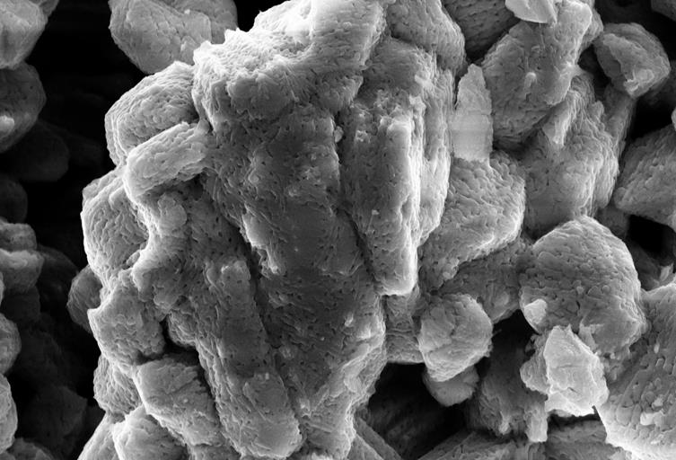
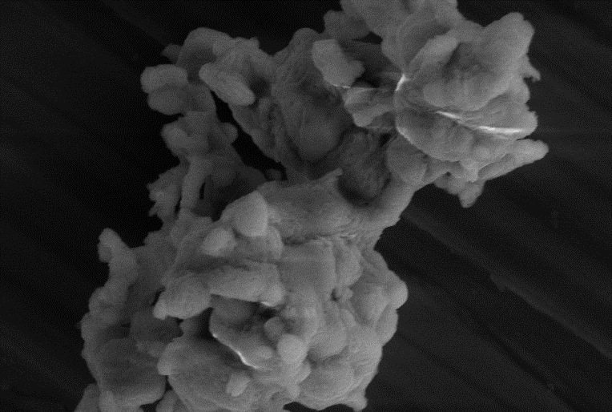
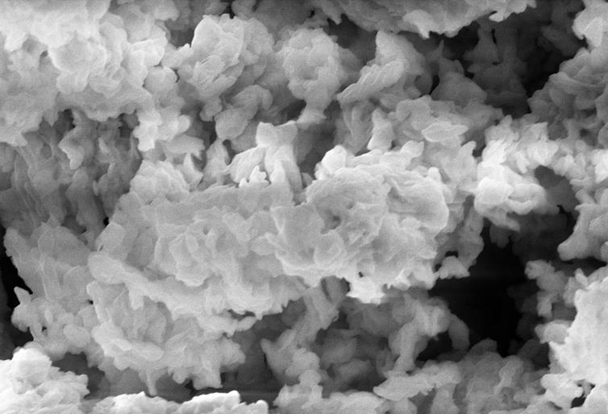
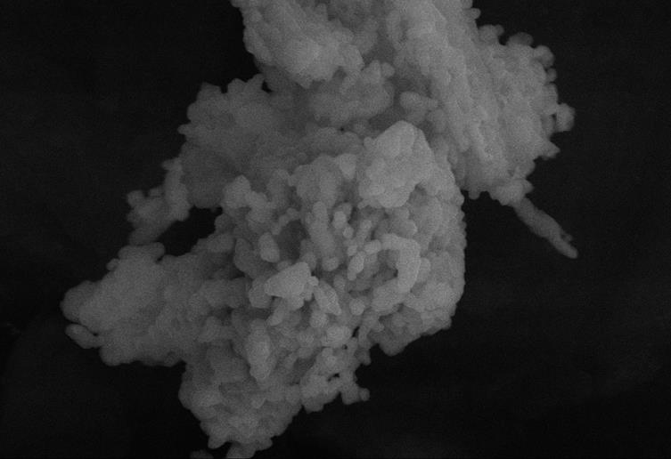
MM3
MM2
MM1
Lead white powder
400°C
600°C

