Supplementary materials

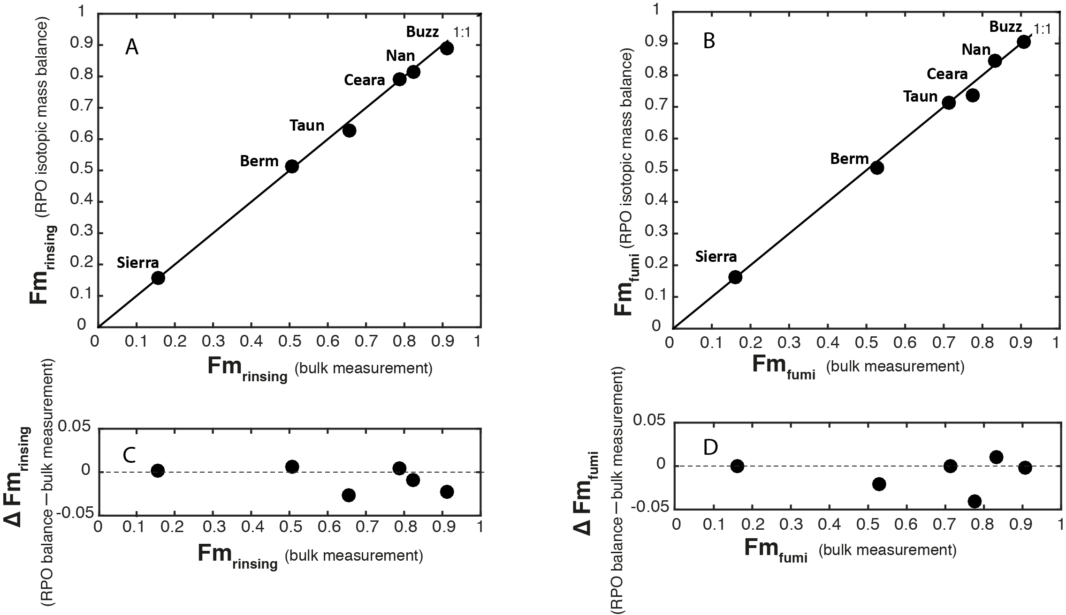

Figure S1. Fm values comparisons between calculated (from RPO isotopic mass balance) and measured bulk values under the Rinse_{HCl} (A) and Fume_{HCl} (B). ∆Fm (offset between calculated and measured Fm values) against measured bulk values under the Rinse_{HCl} (C) and Fume_{HCl} (D).

A blank assessment was performed on the RPO system using methodologies detailed in Hemingway et al. (2017a). For the samples analyzed here, applying the blank correction shifts resulting isotope values by < 0.001 for Fm and < 0.1 ‰ for δ¹³C, within analytical uncertainty. Calculated bulk Fm values, reconstructed using Fm values of thermal windows and their mass percentages, are compared with measured bulk Fm values in Figure S1. The calculated Fm values are indistinguishable from measured bulk values for both Rinse_{HCl} and Fume_{HCl}. However, calculated δ¹³C values are displaced from the 1:1 line (Supplementary Fig. 3). According to Hemingway et al. (2017a) and Rosenheim et al. (2013), stable carbon isotopic fractionation on the order of ~1–2 ‰ may occur during the reaction of OM in the RPO (without Chemical Oven). Nevertheless, this does not affect ¹⁴C results since Fm values are corrected for isotope fractionation (Stuiver and Polach 1977; Rosenheim et al. 2013; Longworth et al. 2015).

A complicating factor is whether the acid treatments redistribute OM into pools of carbon with different thermal stability. If OC were redistributed dramatically, we would expect the isotopic compositions to change as well. For example, moving thermally labile, and young, carbon to a more thermally stable portion of the thermogram should reduce the age of the higher temperature portions of the thermogram. We don’t observe this (Table 2). Our results thus suggest that there is no marked redistribution of OC with the removal of IC.

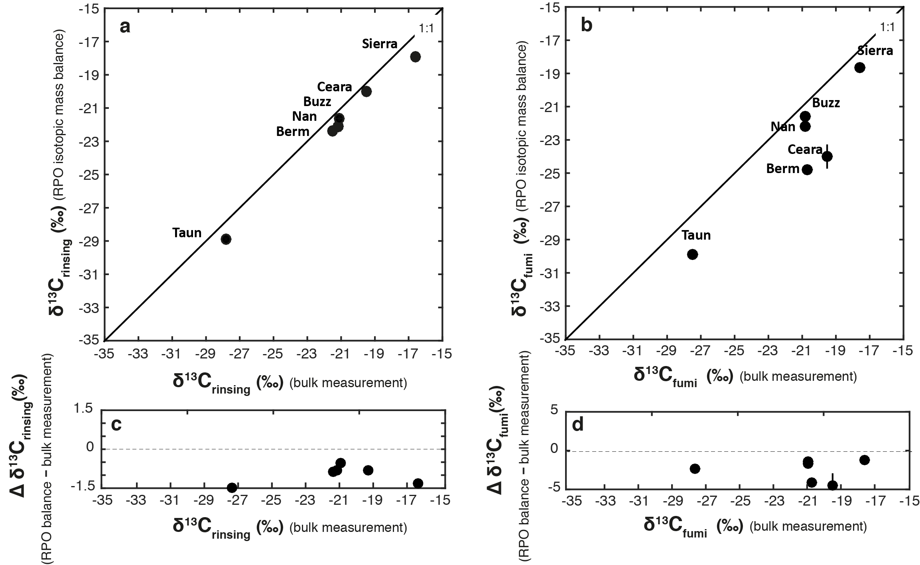
Figure S2. δ¹³C values comparisons between calculated (from RPO isotopic mass balance) and measured bulk values under the Rinse_{HCl} (a) and Fume_{HCl} (b). ∆ δ¹³C (offset between calculated and measured Fm values) against measured bulk values under the Rinse_{HCl} (c) and Fume_{HCl} (d).

Assessment of chemical oven:

In order to minimize the influence of HCl remained in fumigated sample during experimental operation, we developed an external oven (so-called: Chemical Oven) at ~520 ºC. It contains a glass tube with a few grams CuO, Ag, and Mn (Froelich, 1980) which was connected with reactor and CO₂ analyzer to purify the gases. Residual gas analyzer (RGA) detected a sharp decrease of chlorine concentration (signal) of the gaseous impurities from the reactor when connected to this Chemical Oven (no shown).

In addition, a comparison of released CO₂ amounts before and after connection with chemical oven was examined. In Figure S3, the thermograms show similar patterns of normalized CO₂ concentration at a range of reactor temperature, suggesting that there is no marked alteration when the chemical oven is connected for removing impurities.

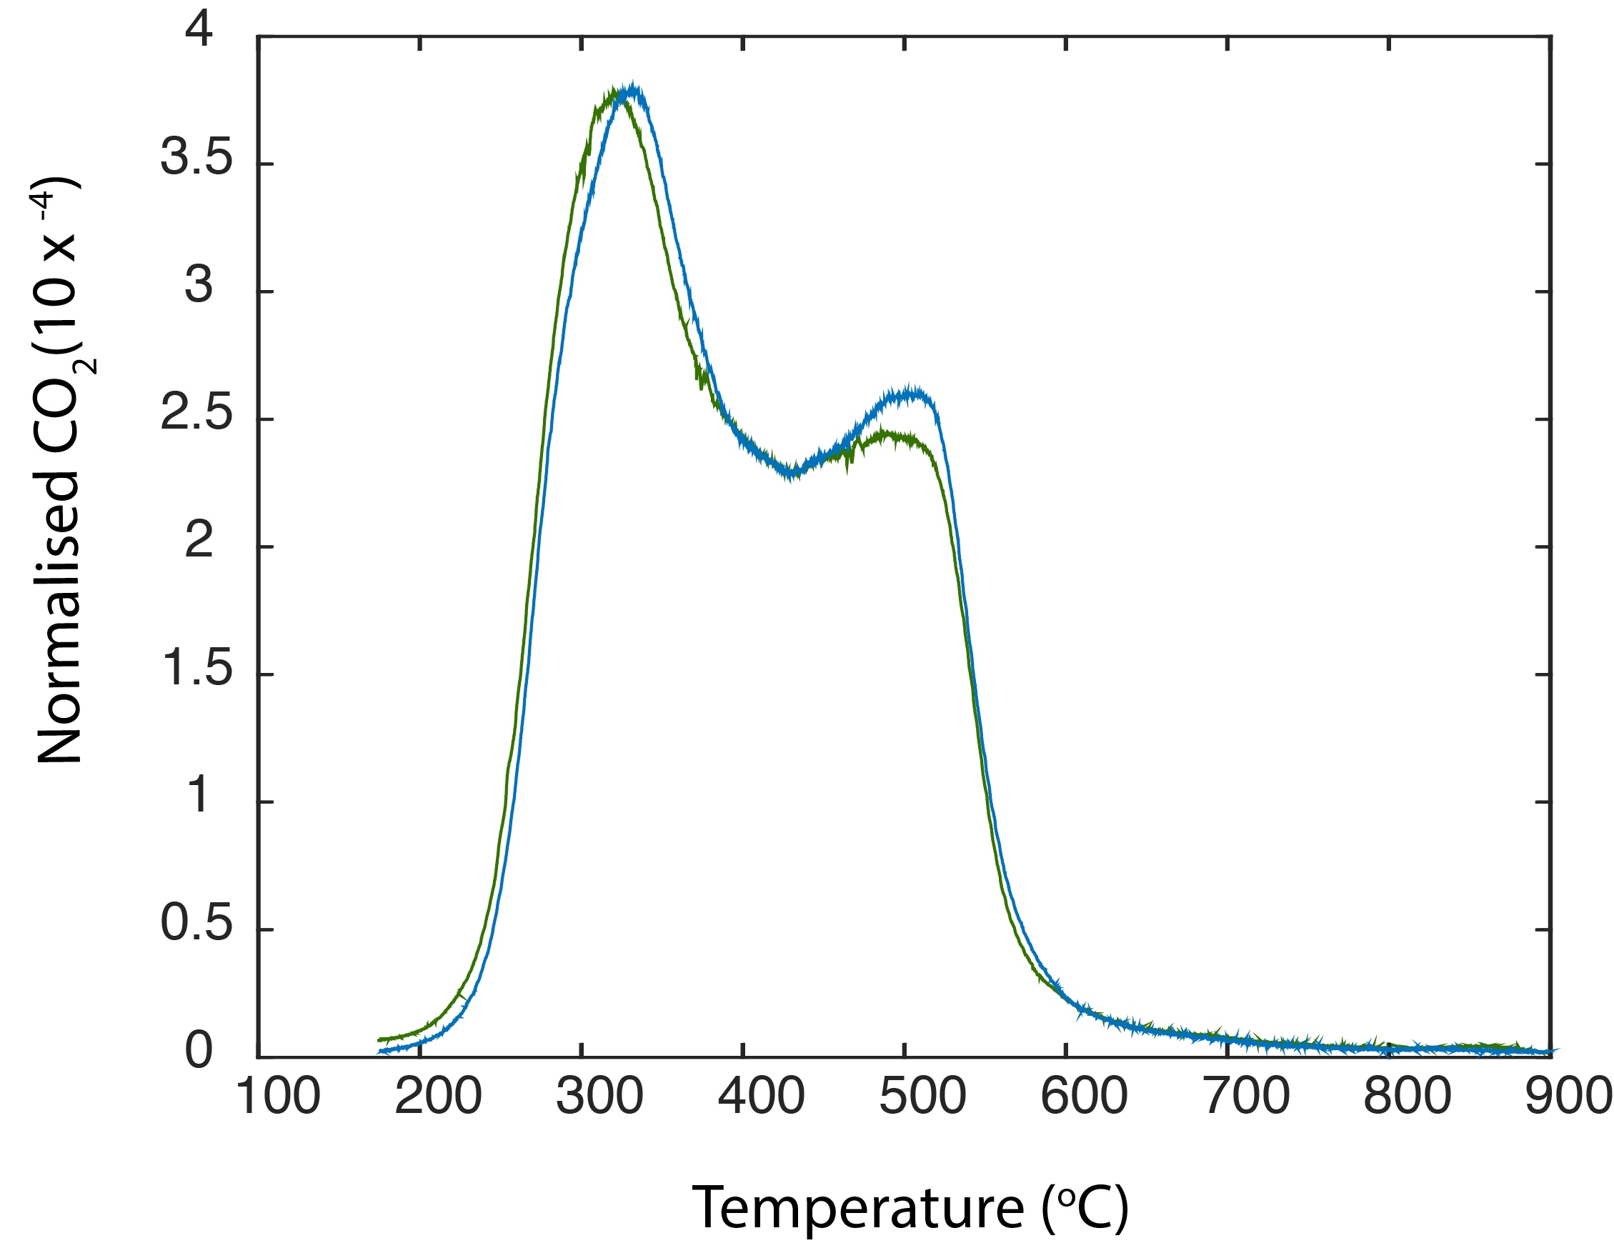

Figure S3. Comparison of CO₂ thermograms before (blue) and after (green) connection with Chemical Oven. Both mass recovery rates are similar, ~98 %.

Furthermore, a stable carbon isotopic mass balance was conducted to test the occurrence of carbon isotopic fractionation in the Chemical Oven. Here, we present the stable carbon isotopic mass balances on raw sample standard (from Nantucket mud) for three measurements: a) non-connection with chemical oven but reactor with catalyze wire; b) connection with Chemical Oven but reactor without catalyze wire; c) connection with chemical oven and reactor with catalyze wire. The offsets between calculated and measured δ¹³C values are similar: -1.6 ‰, -2.0 ‰, -1.2 ‰ with 0.5 ‰ error, respectively (Table S1). Considering the isotopic fraction (~1-2 ‰) in the reactor (Hemingway et al., 2017a), our assessment suggests that there is no marked isotopic excursion (fractionation) occurred in the Chemical Oven.

Table S1. The stable carbon isotopic mass balances among the uses of chemical oven and catalyze wire.

Chemical Oven | 1 fraction | 2  fraction | 3  fraction | 4  fraction | 5  fraction | Mass balanced bulk (‰) | Combusted bulk (‰)  (n = 1) | Offset  (‰)
Non-connection, reactor with catalyze wire  Measured δ¹³C (‰) | -24.3 | -21.2 | -19.9 | -18.3 | -22.3
Mass% | 0.25 | 0.26 | 0.26 | 0.17 | 0.06
Stable carbon isotopic balance | -6.1 | -5.6 | -5.1 | -3.1 | -1.3 | -21.2±0.5 | -19.6±0.2 | -1.6±0.5
Connection, reactor without catalyze wire  Measured δ¹³C (‰) | -26.1 | -25.1 | -21.9 | -19.0 | -22.3
Mass% | 0.03 | 0.18 | 0.37 | 0.36 | 0.06
Stable carbon isotopic balance | -0.9 | -4.6 | -8.1 | -6.8 | -1.3 | -21.6±0.5 | -19.6±0.2 | -2.0±0.5
Connection, reactor with catalyze wire  Measured δ¹³C (‰) | -25.6 | -23.8 | -21.0 | -18.4 | -21.9
Mass% | 0.02 | 0.21 | 0.36 | 0.35 | 0.06
Stable carbon isotopic balance | -0.6 | -5.0 | -7.5 | -6.4 | -1.4 | -20.8±0.5 | -19.6±0.2 | -1.2±0.5

Note: The first fraction was trapped at ~125ºC, the fifth fraction was stopped at ~900 ºC. The error is ±2σ.

Supplementary Table S2. Calculation of RPO mass isotopic balance.

 | Sample |  | Fm
Low-carbonate | Nan |  | 1 Fraction | 2 Fraction | 3 Fraction | 4 Fraction | 5 Fraction |  | RPO balance | Bulk measurement | Offset
Rinse_{HCl} |  | Mass % | 0.22 | 0.23 | 0.24 | 0.24 | 0.07
 |  | Measurement | 0.8970 | 0.8725 | 0.8611 | 0.7581 | 0.3854
 |  | ∑ | 0.1995 | 0.1985 | 0.2076 | 0.1823 | 0.0264 |  | 0.8143 | 0.8236 | -0.0093
 | Buzz |  | 1 Fraction | 2 Fraction | 3 Fraction | 4 Fraction | 5 Fraction
 |  | Mass % | 0.19 | 0.20 | 0.29 | 0.24 | 0.08
 |  | Measurement | 1.0162 | 0.9796 | 0.9399 | 0.8293 | 0.3565
 |  | ∑ | 0.1975 | 0.1925 | 0.2695 | 0.2026 | 0.0278 |  | 0.8899 | 0.9121 | -0.0222
 | Taun |  | 1 Fraction | 2 Fraction | 3 Fraction | 4 Fraction | 5 Fraction | 6 Fraction
 |  | Mass % | 0.10 | 0.23 | 0.31 | 0.19 | 0.09 | 0.07
 |  | Measurement | 0.9197 | 0.9007 | 0.7689 | 0.3950 | 0.1154 | 0.0337
 |  | ∑ | 0.0956 | 0.2047 | 0.2376 | 0.0770 | 0.0104 | 0.0025 | 0.6279 | 0.6519 | -0.0240
Fume_{HCl} | Nan |  | 1 Fraction | 2 Fraction | 3 Fraction | 4 Fraction | 5 Fraction
 |  | Mass % | 0.37 | 0.27 | 0.22 | 0.11 | 0.03
 |  | Measurement | 0.9098 | 0.8943 | 0.8395 | 0.6753 | 0.2327
 |  | ∑ | 0.3404 | 0.2384 | 0.1829 | 0.0768 | 0.0064 |  | 0.8449 | 0.8324 | 0.0125
 | Buzz |  | 1 Fraction | 2 Fraction | 3 Fraction | 4 Fraction | 5 Fraction
 |  | Mass % | 0.40 | 0.22 | 0.23 | 0.11 | 0.04
 |  | Measurement | 1.0398 | 1.0048 | 0.8767 | 0.5800 | 0.1779
 |  | ∑ | 0.4146 | 0.2173 | 0.2009 | 0.0646 | 0.0079 |  | 0.9053 | 0.9073 | -0.0020
 | Taun |  | 1 Fraction | 2 Fraction | 3 Fraction | 4 Fraction | 5 Fraction | 6 Fraction
 |  | Mass % | 0.16 | 0.24 | 0.28 | 0.17 | 0.07 | 0.08
 |  | Measurement | 0.9381 | 0.8508 | 0.6566 | 0.4673 | 0.1230 | 0.1064
 |  | ∑ | 0.1533 | 0.2014 | 0.1813 | 0.0791 | 0.0090 | 0.6241 | 0.7133 | 0.7133 | 0.0000
High-carbonate | Berm |  | 1 Fraction | 2 Fraction | 3 Fraction | 4 Fraction | 5 Fraction
Rinse_{HCl} |  | Mass % | 0.25 | 0.24 | 0.26 | 0.17 | 0.08
 |  | Measurement | 0.6282 | 0.5865 | 0.5160 | 0.3637 | 0.2544
 |  | ∑ | 0.1574 | 0.1398 | 0.1327 | 0.0633 | 0.0203 |  | 0.5135 | 0.5072 | 0.0063
 | Ceara |  | 1 Fraction | 2 Fraction | 3 Fraction | 4 Fraction | 5 Fraction
 |  | Mass % | 0.16 | 0.24 | 0.27 | 0.28 | 0.05
 |  | Measurement | 0.8147 | 0.7986 | 0.8097 | 0.8231 | 0.4209
 |  | ∑ | 0.1279 | 0.1929 | 0.2192 | 0.2306 | 0.0213 |  | 0.7919 | 0.7874 | 0.0045
 | Serria |  | 1 Fraction | 2 Fraction | 3 Fraction | 4 Fraction | 5 Fraction
 |  | Mass % | 0.19 | 0.30 | 0.30 | 0.17 | 0.03
 |  | Measurement | 0.1672 | 0.1465 | 0.1589 | 0.1775 | 0.1007
 |  | ∑ | 0.0322 | 0.0440 | 0.0483 | 0.0308 | 0.0030 |  | 0.1583 | 0.1563 | 0.0020
Fume_{HCl} | Berm |  | 1 Fraction | 2 Fraction | 3 Fraction | 4 Fraction | 5 Fraction
 |  | Mass % | 0.16 | 0.27 | 0.31 | 0.20 | 0.06
 |  | Measurement | 0.6281 | 0.5865 | 0.5169 | 0.3637 | 0.2544
 |  | ∑ | 0.1010 | 0.1571 | 0.1627 | 0.0725 | 0.0145 |  | 0.5079 | 0.5284 | -0.0205
 | Ceara |  | 1 Fraction | 2 Fraction | 3 Fraction | 4 Fraction | 5 Fraction
 |  | Mass % | 0.16 | 0.22 | 0.32 | 0.27 | 0.03
 |  | Measurement | 0.5653 | 0.7934 | 0.7864 | 0.7557 | 0.5086
 |  | ∑ | 0.0926 | 0.1753 | 0.2505 | 0.2012 | 0.01553 |  | 0.7351 | 0.7756 | -0.0405
 | Serria |  | 1 Fraction | 2 Fraction | 3 Fraction | 4 Fraction | 5 Fraction
 |  | Mass % | 0.20 | 0.18 | 0.16 | 0.16 | 0.16
 |  | Measurement | 0.2048 | 0.1778 | 0.1589 | 0.1562 | 0.1615
 |  | ∑ | 0.0072 | 0.0219 | 0.0578 | 0.0668 | 0.0082 |  | 0.1618 | 0.1619 | -0.0001
 |  |  | δ¹³C
Low-carbonate | Nan |  | 1 Fraction | 2 Fraction | 3 Fraction | 4 Fraction | 5 Fraction |  | RPO balance | Bulk measurement | Offset
Rinse_{HCl} |  | Mass % | 0.22 | 0.23 | 0.24 | 0.24 | 0.07
 |  | Measurement | -22.30 | -21.60 | -21.20 | -22.80 | -23.80
 |  | ∑ | -4.96 | -4.91 | -5.11 | -5.48 | -1.63 |  | -22.10 | -21.30 | -0.80
 | Buzz |  | 1 Fraction | 2 Fraction | 3 Fraction | 4 Fraction | 5 Fraction
 |  | Mass % | 0.19 | 0.20 | 0.29 | 0.24 | 0.08
 |  | Measurement | -21.50 | -20.80 | -21.20 | -22.20 | -23.70
 |  | ∑ | -4.18 | -4.09 | -6.08 | -5.42 | -1.85 |  | -21.62 | -21.10 | -0.52
 | Taun |  | 1 Fraction | 2 Fraction | 3 Fraction | 4 Fraction | 5 Fraction | 6 Fraction
 |  | Mass % | 0.10 | 0.23 | 0.31 | 0.19 | 0.09 | 0.07
 |  | Measurement | -30.90 | -30.80 | -29.20 | -28.10 | -26.30 | -25.40
 |  | ∑ | -3.21 | -7.00 | -9.02 | -5.48 | -2.37 | -1.90 | -28.98 | -27.40 | -1.58
Fume_{HCl} | Nan |  | 1 Fraction | 2 Fraction | 3 Fraction | 4 Fraction | 5 Fraction
 |  | Mass % | 0.37 | 0.27 | 0.22 | 0.11 | 0.03
 |  | Measurement | -23.20 | -20.50 | -22.20 | -26.10 | -23.40
 |  | ∑ | -8.68 | -5.46 | -4.84 | -2.97 | -0.65 |  | -22.60 | -20.90 | -1.70
 | Buzz |  | 1 Fraction | 2 Fraction | 3 Fraction | 4 Fraction | 5 Fraction
 |  | Mass % | 0.40 | 0.22 | 0.23 | 0.11 | 0.04
 |  | Measurement | -22.50 | -20.10 | -21.90 | -25.70 | -24.80
 |  | ∑ | -8.97 | -4.35 | -5.02 | -2.86 | -1.10 |  | -22.30 | -20.90 | -1.40
 | Taun |  | 1 Fraction | 2 Fraction | 3 Fraction | 4 Fraction | 5 Fraction | 6 Fraction
 |  | Mass % | 0.16 | 0.24 | 0.28 | 0.17 | 0.07 | 0.08
 |  | Measurement | -31.80 | -31.30 | -32.00 | -27.60 | -24.70 | -24.10
 |  | ∑ | -5.20 | -7.41 | -8.84 | -4.67 | -1.81 | -1.95 | -29.88 | -27.50 | -2.38
High-carbonate | Berm |  | 1 Fraction | 2 Fraction | 3 Fraction | 4 Fraction | 5 Fraction
Rinse_{HCl} |  | Mass % | 0.25 | 0.24 | 0.26 | 0.17 | 0.08
 |  | Measurement | -21.90 | -21.10 | -21.80 | -23.80 | -26.40
 |  | ∑ | -5.49 | -5.03 | -5.61 | -4.14 | -2.11 |  | -22.37 | -21.50 | -0.87
 | Ceara |  | 1 Fraction | 2 Fraction | 3 Fraction | 4 Fraction | 5 Fraction
 |  | Mass % | 0.16 | 0.24 | 0.27 | 0.28 | 0.05
 |  | Measurement | -21.40 | -20.10 | -19.40 | -20.40 | -22.30
 |  | ∑ | -3.36 | -4.85 | -5.25 | -5.71 | -1.13 |  | -20.31 | -19.50 | -0.81
 | Serria |  | 1 Fraction | 2 Fraction | 3 Fraction | 4 Fraction | 5 Fraction
 |  | Mass % | 0.19 | 0.30 | 0.30 | 0.17 | 0.03
 |  | Measurement | -21.60 | -17.10 | -16.50 | -16.90 | -22.70
 |  | ∑ | -4.16 | -5.14 | -5.01 | -2.94 | -0.67 |  | -17.91 | -16.60 | -1.31
Fume_{HCl} | Berm |  | 1 Fraction | 2 Fraction | 3 Fraction | 4 Fraction | 5 Fraction
 |  | Mass % | 0.16 | 0.27 | 0.31 | 0.20 | 0.06
 |  | Measurement | -23.20 | -24.20 | -21.50 | -31.50 | -27.80
 |  | ∑ | -3.73 | -6.48 | -6.77 | -6.28 | -1.58 |  | -24.85 | -20.70 | -4.15
 | Ceara |  | 1 Fraction | 2 Fraction | 3 Fraction | 4 Fraction | 5 Fraction
 |  | Mass % | 0.16 | 0.22 | 0.32 | 0.27 | 0.03
 |  | Measurement | -24.4 | -23.0 | -21.3 | -29.2 | -
 |  | ∑ | -3.904 | -5.06 | -6.816 | -7.884 | - |  | -24.45±0.5 | -19.50 | -4.95
 | Serria |  | 1 Fraction | 2 Fraction | 3 Fraction | 4 Fraction | 5 Fraction
 |  | Mass % | 0.20 | 0.18 | 0.16 | 0.16 | 0.16
 |  | Measurement | -22.4 | -21.4 | -17.2 | -18.2 | -26.1
 |  | ∑ | -4.48 | -3.852 | -2.752 | -2.912 | -4.176 |  | -18.8 | -17.60 | -1.20

n
Note: - indicates that the ¹³C composition of the 5th fraction was not measured. ∑ indicated mass % multiplied by measured isotopic values.

