Supplementary

Figure S1. Specimen of Giant Sequoia (Sequoiadendron giganteum) from the Laboratory of Tree-Ring Research Collection and Archives, University of Arizona, used in this study.
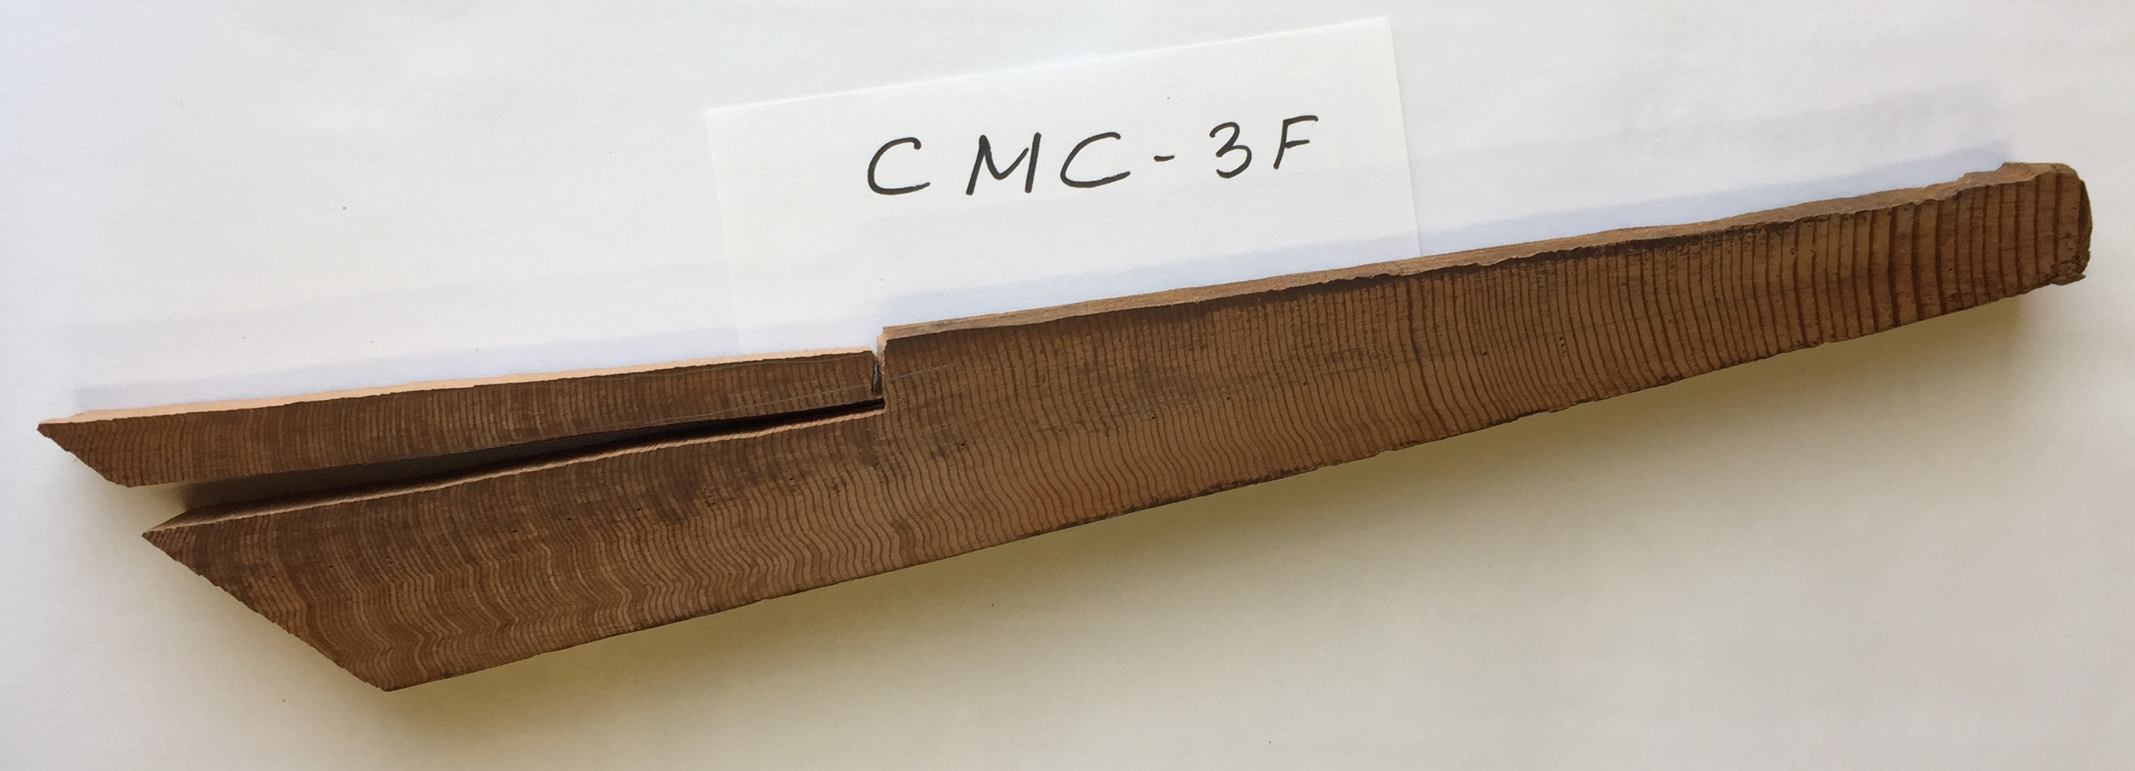

Table S1. Radiocarbon sequence 835-778 BC measured from Giant Sequoia rings at the Institute of Nuclear Research in Debrecen, Hungary.

Year BC | Years BP | ¹⁴C Age | Error | Delta ¹⁴C | Error
835 | 2784 | 2721 | 17 | -1.97 | 2.12
834 | 2783 | 2716 | 17 | -1.46 | 2.12
833 | 2782 | 2719 | 17 | -1.96 | 2.12
832 | 2781 | 2746 | 17 | -5.43 | 2.12
831 | 2780 | 2706 | 16 | -0.58 | 1.99
830 | 2779 | 2706 | 17 | -0.70 | 2.12
829 | 2778 | 2653 | 17 | 5.79 | 2.12
828 | 2777 | 2679 | 17 | 2.42 | 2.12
827 | 2776 | 2679 | 17 | 2.30 | 2.12
826 | 2775 | 2697 | 17 | -0.07 | 2.12
825 | 2774 | 2728 | 17 | -4.04 | 2.12
824 | 2773 | 2710 | 17 | -1.93 | 2.12
823 | 2772 | 2717 | 20 | -2.92 | 2.49
822 | 2771 | 2697 | 20 | -0.55 | 2.49
821 | 2770 | 2732 | 20 | -5.02 | 2.49
820 | 2769 | 2702 | 20 | -1.42 | 2.49
819 | 2768 | 2690 | 20 | -0.04 | 2.49
818 | 2767 | 2652 | 20 | 4.58 | 2.49
817 | 2766 | 2684 | 20 | 0.46 | 2.49
816 | 2765 | 2692 | 20 | -0.66 | 2.49
815 | 2764 | 2662 | 20 | 2.96 | 2.49
814 | 2763 | 2737 | 20 | -6.48 | 2.49
813 | 2762 | 2689 | 28 | -0.64 | 3.49
812 | 2761 | 2,690 | 20 | -0.89 | 2.49
811 | 2760 | 2,673 | 19 | 1.11 | 2.38
810 | 2759 | 2,692 | 20 | -1.38 | 2.49
809 | 2758 | 2,685 | 20 | -0.63 | 2.49
808 | 2757 | 2,675 | 18 | 0.49 | 2.26
807 | 2756 | 2,661 | 18 | 2.12 | 2.27
806 | 2755 | 2,638 | 18 | 4.87 | 2.28
805 | 2754 | 2,651 | 19 | 3.12 | 2.30
804 | 2753 | 2,606 | 18 | 8.64 | 2.23
803 | 2752 | 2,623 | 18 | 6.38 | 2.19
802 | 2751 | 2,609 | 19 | 8.02 | 2.37
801 | 2750 | 2,637 | 35 | 4.39 | 4.36
800 | 2749 | 2,617 | 30 | 6.77 | 3.73
799 | 2748 | 2,613 | 35 | 7.15 | 4.36
798 | 2747 | 2,610 | 15 | 7.40 | 1.87
797 | 2746 | 2,619 | 19 | 6.21 | 2.37
796 | 2745 | 2,605 | 19 | 7.80 | 2.37
795 | 2744 | 2,633 | 19 | 4.14 | 2.38
794 | 2743 | 2,619 | 19 | 5.84 | 2.32
793 | 2742 | 2,606 | 19 | 7.34 | 2.39
792 | 2741 | 2,615 | 19 | 6.10 | 2.38
791 | 2740 | 2,584 | 19 | 9.82 | 2.37
790 | 2739 | 2,614 | 19 | 5.99 | 2.39
789 | 2738 | 2,600 | 19 | 7.56 | 2.40
788 | 2737 | 2,608 | 19 | 6.43 | 2.42
787 | 2736 | 2,620 | 19 | 4.86 | 2.36
786 | 2735 | 2,584 | 20 | 9.16 | 2.50
785 | 2734 | 2,618 | 21 | 4.81 | 2.59
784 | 2733 | 2,593 | 20 | 7.79 | 2.54
783 | 2732 | 2,578 | 20 | 9.59 | 2.55
782 | 2731 | 2,588 | 21 | 8.24 | 2.65
781 | 2730 | 2,577 | 21 | 9.45 | 2.55
780 | 2729 | 2,622 | 16 | 3.71 | 1.99
779 | 2728 | 2,571 | 21 | 10.02 | 2.58
778 | 2727 | 2,565 | 17 | 10.61 | 2.12

Table S2. Radiocarbon sequence 829-777 BC measured from Japanese Cedar rings at the Nagoya University.

Year Delta Error
BC ¹⁴C
777 11.10 2.56
779 10.66 2.56
781 6.41 2.55
783 8.20 2.64
785 8.26 2.54
787 9.74 3.54
789 3.35 2.54
791 2.07 2.56
793 4.16 2.55
795 6.38 2.58
797 4.33 2.54
799 4.29 2.55
801 -1.62 2.56
803 0.93 2.56
805 -3.07 2.51
807 3.26 2.56
809 -0.34 2.52
811 -0.46 2.54
813 -2.03 2.49
815 3.88 2.55
817 -0.80 2.50
819 2.65 2.55
821 -4.39 2.52
823 1.16 2.55
825 -1.88 2.52
827 0.67 2.54
829 -1.41 2.51

