The emergence of extra-mural cemeteries in Neolithic southeast Europe: a formally modelled chronology for Cernica, Romania

Susan Stratton, Seren Griffiths, Raluca Kogălniceanu, Angela Simalcsik, Alexandru Morintz, Cristian Eduard Ştefan, Valentin Dumitraşcu, Christopher Bronk Ramsey, Olaf Nehlich, Nancy Beavan, Dušan Borić and Alasdair Whittle

Online Supplement

FRUITS Bayesian modelling

Baseline diet data for the modelling was taken for terrestrial herbivores and freshwater fish from the Danube Gorges region (Nehlich et al. 2010), for terrestrial herbivores from the Cernica settlement (this paper), and for cereals and pulses from archaeological wheat, barley and pulses from the region (Ogrinc and Budja 2005), and modern cereals (Fraser et al. 2013). Stable isotope values of sulphur, carbon and nitrogen from the human population at Cernica were compared with the terrestrial animal dataset and the freshwater dataset in order to calculate dietary endpoints for 100% terrestrial and 100% freshwater fish diets (Nehlich et al. 2010:1136). The proportional use of different dietary resources was then estimated (Table 1; online data supplement).

FRUITS Bayesian modelling of the Cernica human diet
The FRUITS model by Fernandes et al. (2014) is a tool for estimating the proportions of given resources by a Bayesian model. The first FRUITS model (model 1) which was applied was a concentration independent, non-weighted model, including estimates for four food sources — terrestrial herbivores, freshwater fish, cereals and legumes (see Online Supplement Table 1). Based on the literature cited above, food source values listed in Online Supplement Table 1 were included in the model, with a δ¹³C offset of 2.3±0.5‰, and a δ¹⁵N offset of 4.8±0.5‰ from food sources to human. These offsets were derived from the isotopic value difference between the average human δ¹³C and δ¹⁵N and the average δ¹³C and δ¹⁵N of food sources used in these calculations, plus a conservation error of ±0.5. The resulting offset values employed here are comparable to the mid-range of offsets cited in dietary estimation literature.

Online Supplement Table 1. Carbon and nitrogen isotope mean values used in the FRUITS model 1 for estimating diet proportions, derived from relevant archaeological, and modern analogue examples.
Food source | δ¹³C ± 1SD (‰) | δ¹⁵N ± 1SD (‰) | Literature used for source values
Terrestrial herbivores | –21.25±1.32 | 6.08±2.28 | This paper
Freshwater fish | –21.32±2.43 | 9.23±2.03 | Archaeological freshwater fish values (n=16) Vlasac, Lepenski Vir (Bonsall et al. 2015 and references therein)
Cereals (average of cited literature) | –25.7±0.5 | 3.4±0.7 | Archaeological wheat values (n=12) Ajdovska jama cave (Ogrinc and Budja 2005)  Archaeological barley values (n=6) Ajdovska jama cave (Ogrinc and Budja 2005)  Contemporary einkorn wheat with added ‘Suess effect’ (n=2 uncharred; 2=charred) (Fraser et al. 2013)
Legumes | –23.2±0.1 | 1.9±0.1 | Archaeological pea values (n=4) Ajdovska jama cave (Ogrinc and Budja 2005)

Online Supplement Table 2. Carbon, nitrogen and sulphur isotope mean values used in FRUITS model 2.
Food source | δ ¹³C ± 1SD (‰) | δ ¹⁵N ± 1SD (‰) | δ ³⁴S ± 1SD (‰) | Literature used for source values
terrestrial animals | –22.0±1.2 | 6.4±1.3 | 4.1±1.1 | This paper; Nehlich et al. 2010
terrestrial sucklings | –21.4±0.2 | 13.0±0.2 | 3.2±0.5 | Nehlich et al. 2010
freshwater fish | –19.6±0.6 | 7.3±0.5 | 14.1±0.1 | This paper; Nehlich et al. 2010

Only stable carbon and nitrogen isotope dietary proxies were available for all 25 radiocarbon measurements on human bones. This approach uses carbon and nitrogen isotope values of the food groups for interpreting dietary patterns in the consumer group. However, this approach lacks the precision of a three-isotope model, but represents the best possible estimation given the data set. We considered including the potential for a C₄ dietary contribution from Panicum miliaceum (millet), but recent work by Motuzaite-Matuzeviciute et al. (2013) detailed radiocarbon measurements on millet samples purported on archaeological grounds to be associated with Linearbandkeramik activity in Germany, the Sopot culture in Hungary, the Dudeşti culture in Romania, the Butmir culture in Bosnia-Herzegovina and an Early Neolithic site in Bulgaria. However, these direct measurements on charred millet macrofossils demonstrated that while millet may be present — perhaps as a weed component (cf. Bogaard and Walker 2011; Filipović and Obradović 2013; Kreuz et al. 2005) — no directly dated examples exist prior to 5000 cal BC, with most of the dates from the middle of the second millennium cal BC (Motuzaite-Matuzeviciute et al. 2013:1080). For the results presented here we have therefore excluded millet as a potential dietary source for the Cernica human population.

To obtain the best results, it is necessary to access all available resource data, so carbon, nitrogen and sulphur isotope data from Nehlich et al. (2010) and this publication were taken in the second model (model 2). Following Nehlich et al. (2010) three food groups were chosen: (1) terrestrial animals, (2) terrestrial sucklings and (3) freshwater fish (see Online Supplement Table 2). The model was concentration independent and non-weighted. For 13 measurements (ten human and three animal) carbon, nitrogen and sulphur values were available. The applied offsets for the different isotope elements were taken from the literature (Bocherens and Drucker 2003; Nehlich 2015): δ¹³C = 1.5±0.5‰; δ¹⁵N = 4.0±1.0‰; δ³⁴S = –0.5±1.5‰.

We subsequently applied FRUITS modelling using all the dietary sources outlined above. The proportional use of freshwater fish resources was then estimated for each model (see Table 1 in the main text of the article). The results we obtained through the FRUITS calculation for the dietary proportions produced a quandary. The FRUITS calculation of all three isotopes (carbon, nitrogen and sulphur: model 2) on individuals having all three isotope data sets showed no or marginal inputs of freshwater proteins in the diets of the analysed individuals (between 7.1% and 15.5%, mean 12.7±9%, n = 10). However, the remaining individuals, which had only carbon and nitrogen isotope values for modelling, produced in FRUITS results for model 1 that suggested on average higher estimates of dietary input of freshwater foods (between 13.1% and 20.7%, mean 15.3±9%, n = 25). There could be two possible explanations for these differences. The first hypothesis would be to suggest that there actually were different freshwater fish contributions in the diets of the measured individuals. The second hypothesis would be to suggest that the FRUITS Bayesian model based on two isotopes, in this case carbon and nitrogen, is less reliable than the one using all three available isotope values, and may produce systematically biased results leading to erroneous proportional dietary estimates, such as higher freshwater dietary intake. We suggest that the second explanation is more likely for the differential estimates obtained by the two models. The addition of sulphur data in model 2 provides a more precise proxy for the fish dietary input, given the greater quantity of sulphur amino acids in fish flesh as compared to mammalian meat (Eastoe 1957; Nehlich and Richards 2009). This leads to a higher shift in sulphur than in carbon and nitrogen at low levels of fish inputs, and we therefore expect a much smaller error range for CNS compared to CN only models. That three-isotope models are more accurate in determining dietary proportions of fish is also supported by results from modern wildlife ecological studies using isotopes and subsequent Bayesian modelling for data analysis and interpretation (e.g. Phillips and Koch 2002). In these studies, it has been shown that multiple isotope dietary analyses refined with Bayesian modelling enhance the overall precision of the model. We therefore rely on the proportional estimations of freshwater fish produced by model 2.

Model 2: FRUITS estimated dietary contributions when modelling carbon, nitrogen and sulphur isotope values differentiating contributions of terrestrial, terrestrial sucklings and freshwater fish in diet.

C-1: Burial 171 (OxA-27427)
Estimates – food intake
Food | Mean | sd | 2.5pc | median | 97.5pc
terread | 0.6894 | 0.1336 | 0.4179 | 0.6948 | 0.9232
terresuck | 0.1633 | 0.108 | 0.0089 | 0.147 | 0.4074
freshwater | 0.1473 | 0.1007 | 0.007531 | 0.1306 | 0.3782
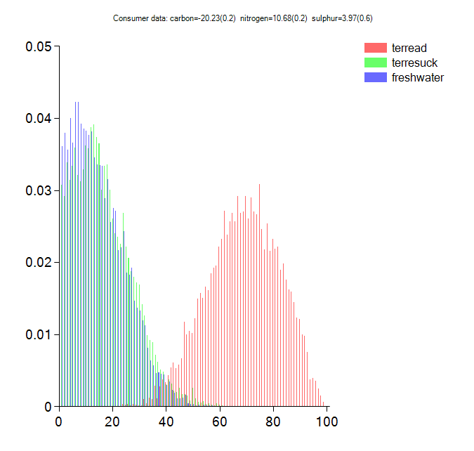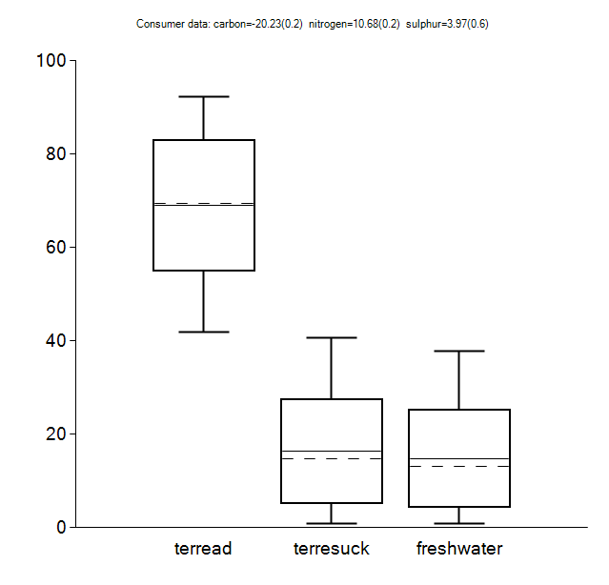

C-2: Burial 173 (OxA-27428)
Estimates – food intake
Food | Mean | sd | 2.5pc | median | 97.5pc
terread | 0.7499 | 0.1178 | 0.5023 | 0.7576 | 0.945
terresuck | 0.1531 | 0.1033 | 0.008066 | 0.1365 | 0.3954
freshwater | 0.09702 | 0.07608 | 0.003633 | 0.07983 | 0.2795
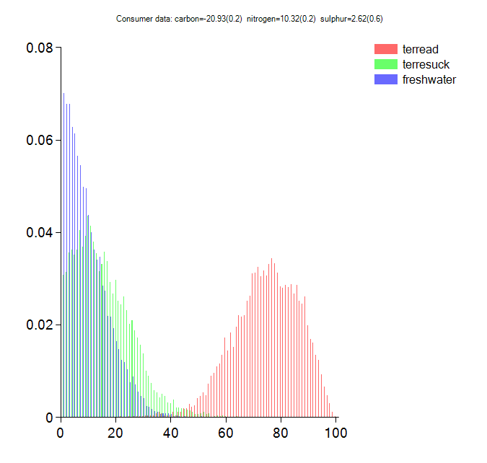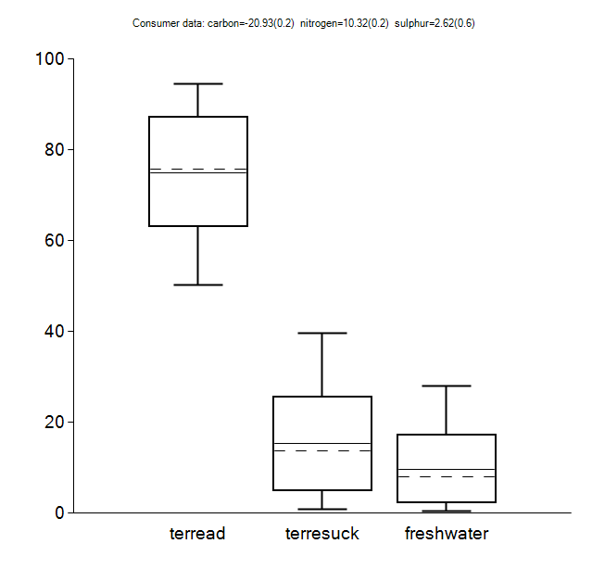

C-3: Burial 188 (OxA-27429)
Estimates – food intake
Food | Mean | sd | 2.5pc | median | 97.5pc
terread | 0.6914 | 0.1327 | 0.422 | 0.6956 | 0.9311
terresuck | 0.1532 | 0.1092 | 0.006582 | 0.1343 | 0.4118
freshwater | 0.1554 | 0.1001 | 0.008222 | 0.1435 | 0.3759
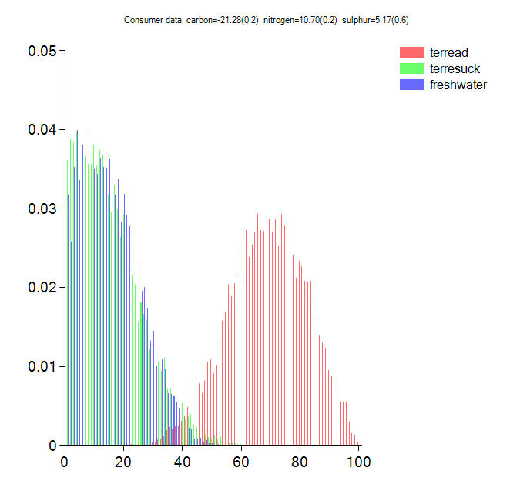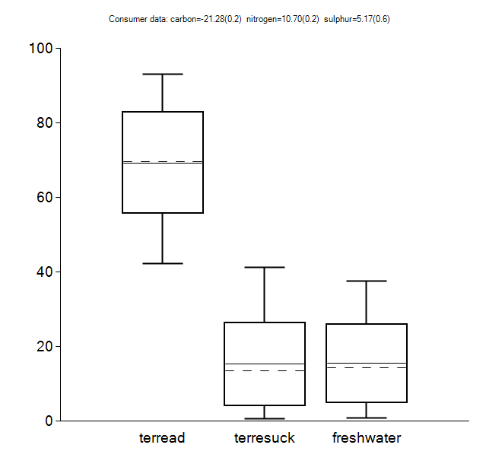

C-4: Burial 193 (OxA-27430)
Estimates – food intake
Food | Mean | sd | 2.5pc | median | 97.5pc
terread | 0.814 | 0.1047 | 0.5806 | 0.829 | 0.9719
terresuck | 0.1147 | 0.08867 | 0.004387 | 0.09335 | 0.3282
freshwater | 0.07132 | 0.06215 | 0.002057 | 0.0546 | 0.2341
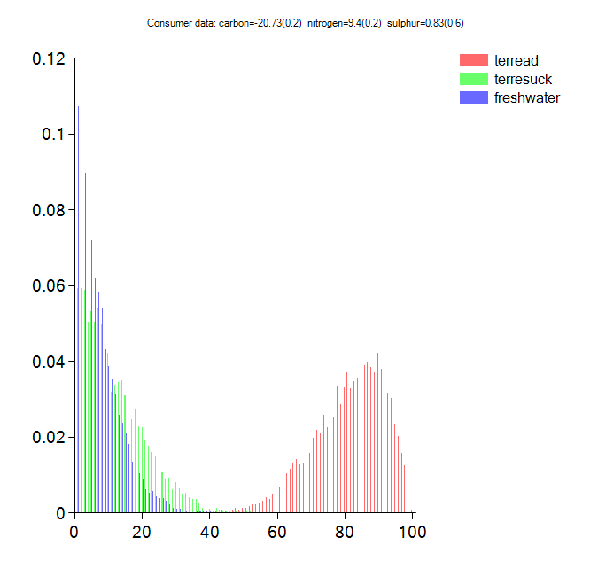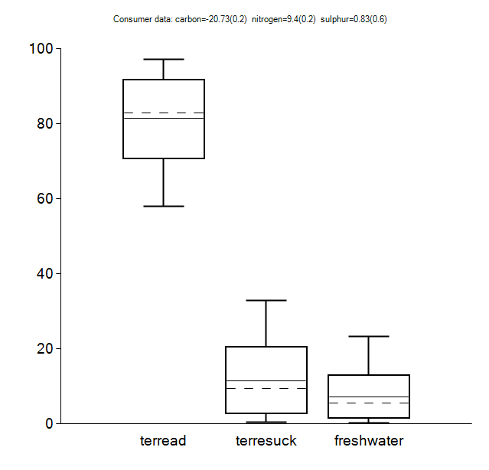

C-5: Burial 194 (OxA-27620)
Estimates – food intake
Food | Mean | sd | 2.5pc | median | 97.5pc
terread | 0.7618 | 0.1135 | 0.5162 | 0.7718 | 0.9509
terresuck | 0.09029 | 0.07196 | 0.003138 | 0.07424 | 0.2653
freshwater | 0.1479 | 0.09825 | 0.008132 | 0.1331 | 0.3671
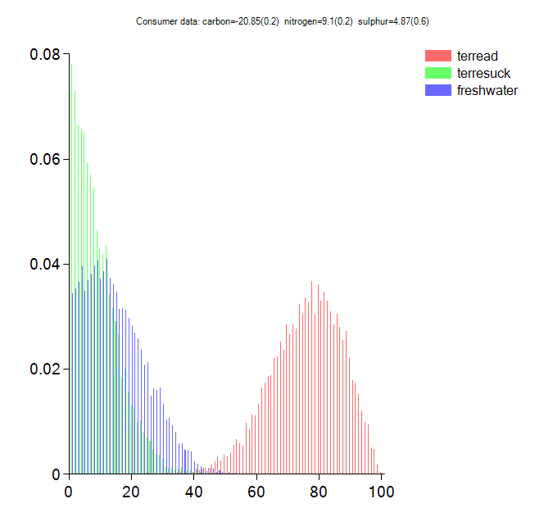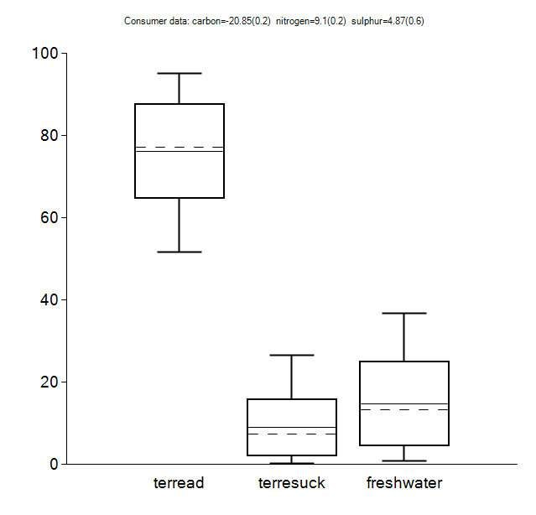

C-6: Burial 198 (OxA-27431)
Estimates – food intake
Food | Mean | sd | 2.5pc | median | 97.5pc
terread | 0.7667 | 0.1186 | 0.5144 | 0.7784 | 0.961
terresuck | 0.109 | 0.08589 | 0.003318 | 0.08921 | 0.3202
freshwater | 0.1243 | 0.09082 | 0.005069 | 0.1074 | 0.3353
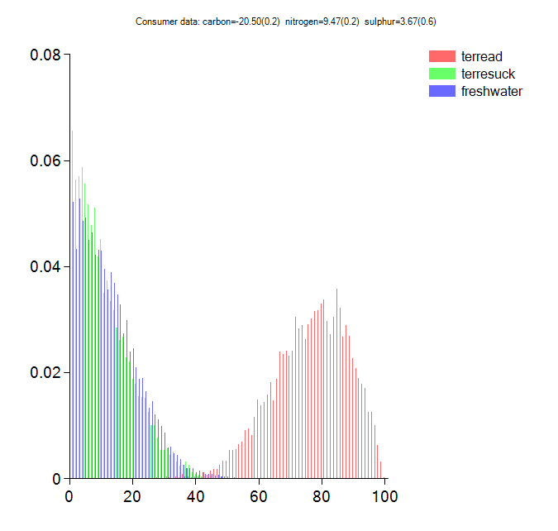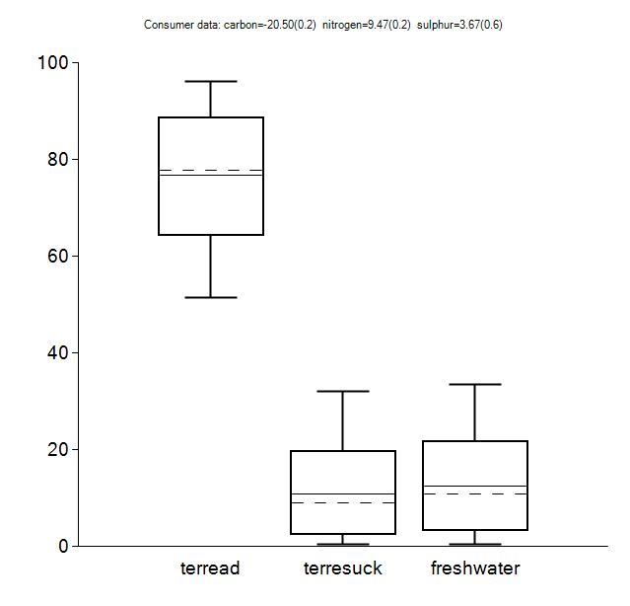

C-7: Burial 267 (OxA-27432)
Estimates – food intake
Food | Mean | sd | 2.5pc | median | 97.5pc
terread | 0.7509 | 0.119 | 0.497 | 0.7591 | 0.9519
terresuck | 0.1414 | 0.09604 | 0.007318 | 0.1286 | 0.3612
freshwater | 0.1078 | 0.08114 | 0.004219 | 0.09205 | 0.3055
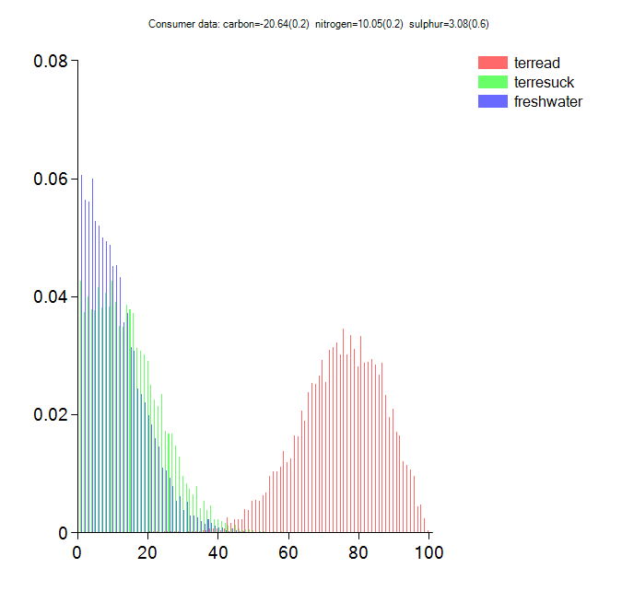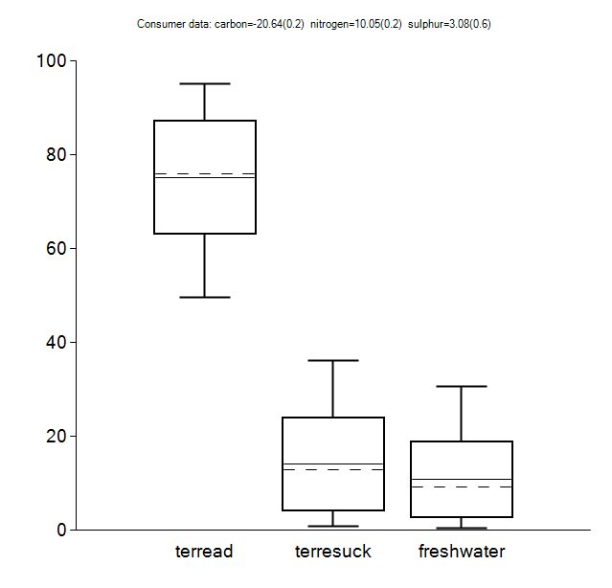

C-12: Burial 303 (OxA-27630) – neonate
Estimates – food intake
Food | Mean | sd | 2.5pc | median | 97.5pc
terread | 0.6313 | 0.1574 | 0.3057 | 0.6394 | 0.9109
terresuck | 0.2212 | 0.1327 | 0.0147 | 0.2058 | 0.5031
freshwater | 0.1476 | 0.1006 | 0.007832 | 0.1304 | 0.3819
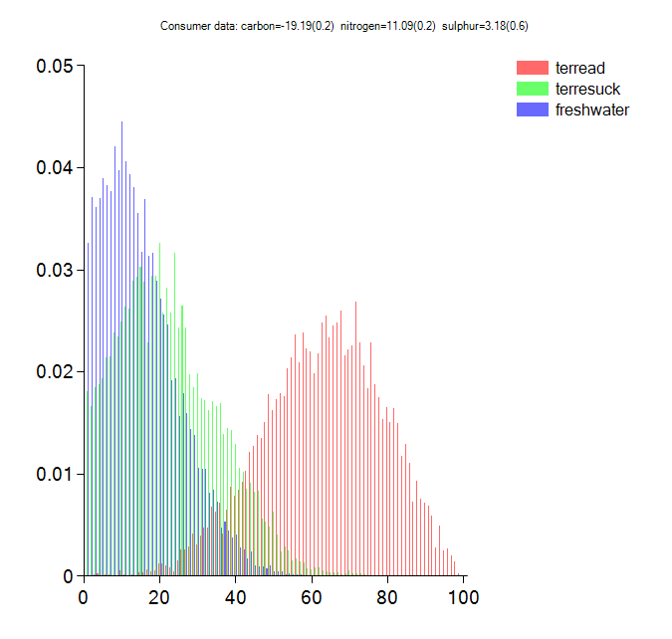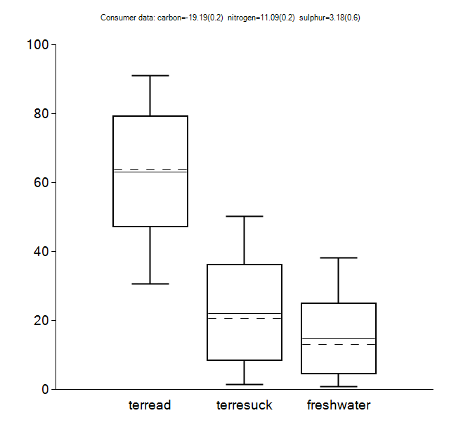

C-13: Burial 62 (OxA-28281)
Estimates – food intake
Food | Mean | sd | 2.5pc | median | 97.5pc
terread | 0.7677 | 0.1133 | 0.5292 | 0.7773 | 0.953
terresuck | 0.09337 | 0.07385 | 0.003622 | 0.0764 | 0.2757
freshwater | 0.139 | 0.09673 | 0.00649 | 0.122 | 0.36
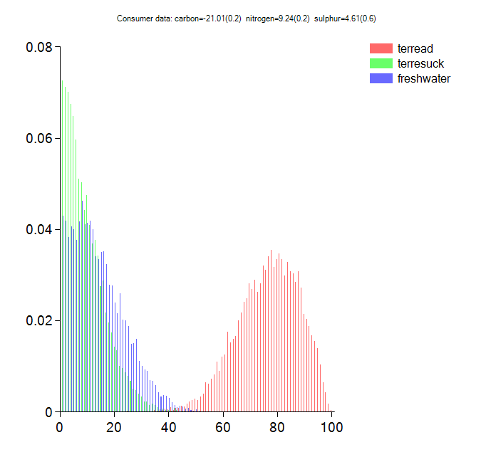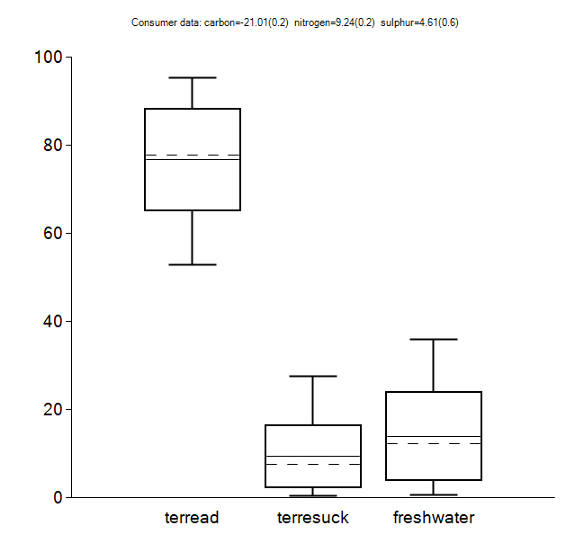

C-14: Burial 97 (OxA-28282)
Estimates – food intake
Food | Mean | sd | 2.5pc | median | 97.5pc
terread | 0.7563 | 0.1166 | 0.4969 | 0.7649 | 0.95
terresuck | 0.1081 | 0.08191 | 0.003395 | 0.09021 | 0.3
freshwater | 0.1356 | 0.09656 | 0.005997 | 0.1191 | 0.365
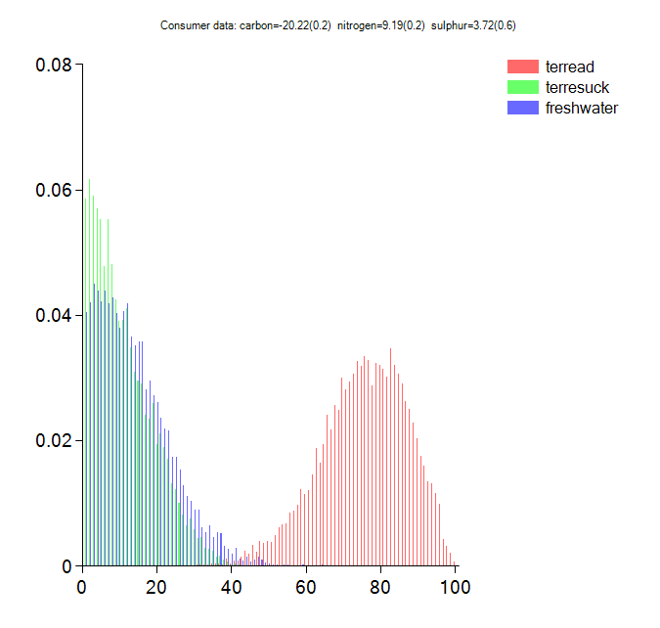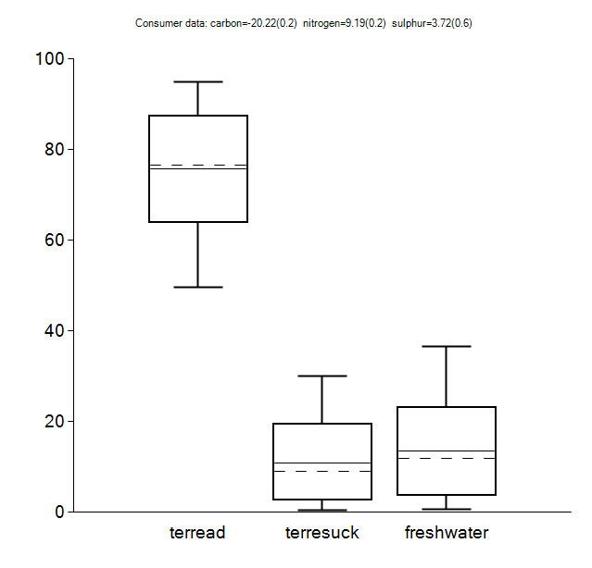

OxCal code used for Bayesian modelling of the radiocarbon dates from the Cernica cemetery and settlement with no offset correction applied

Plot()
{
Sequence()
{
Boundary("Start Cernica cemetery")
{
color="Green";
};
Phase("Cernica cemetery")
{
Phase("northern area")
{
Phase("27422")
{
R_Date("OxA-27422", 6149, 35)
{
color="Greeen";
};
};
Phase("27423")
{
R_Date("OxA-27423", 6266, 34)
{
color="Greeen";
};
};
Phase("27630")
{
R_Date("OxA-27630", 6117, 34)
{
color="Greeen";
};
};
Phase("Sample_15")
{
R_Combine("Sample 15")
{
color="Greeen";
R_Date("OxA-27584", 6200, 37);
R_Date("OxA-27560", 6145, 45);
};
};
Phase("Sample_11")
{
R_Combine("Sample 11")
{
color="Greeen";
R_Date("OxA-27583", 6160, 45);
R_Date("OxA-27559", 6165, 34);
};
};
Phase("27659")
{
R_Date("OxA-27659", 6256, 34)
{
color="Greeen";
};
};
Phase("28281")
{
R_Date("OxA-28281", 6206, 31)
{
color="Greeen";
};
};
Phase("28282")
{
R_Date("OxA-28282", 6172, 32)
{
color="Greeen";
};
};
First("FirstNorthCemetery");
Last("LastNorthCemetery");
};
Phase("southern area")
{
Phase("27425")
{
R_Date("OxA-27425", 6092, 35)
{
color="Greeen";
};
};
Phase("27427")
{
R_Date("OxA-27427", 6121, 35)
{
color="Greeen";
};
};
Phase("27428")
{
R_Date("OxA-27428", 6181, 35)
{
color="Greeen";
};
};
Phase("27429")
{
R_Date("OxA-27429", 6370, 40)
{
color="Greeen";
};
};
Phase("27430")
{
R_Date("OxA-27430", 6122, 33)
{
color="Greeen";
};
};
Phase("27561")
{
R_Date("OxA-27561", 6195, 37)
{
color="Greeen";
};
};
Phase("27426")
{
R_Date("OxA-27426", 6157, 33)
{
color="Greeen";
};
};
Phase("27424")
{
R_Date("OxA-27424", 6232, 33)
{
color="Greeen";
};
};
Phase("Grave321")
{
R_Combine("Grave321")
{
color="Greeen";
R_Date("OxA-27563", 6081, 37);
R_Date("OxA-27586", 6143, 35);
};
};
Phase("27432")
{
R_Date("OxA-27432", 6284, 34)
{
color="Greeen";
};
};
Phase("27620")
{
R_Date("OxA-27620", 6175, 35)
{
color="Greeen";
};
};
Phase("27431")
{
R_Date("OxA-27431", 6110, 35)
{
color="Greeen";
};
};
Phase("52598")
{
R_Date("Poz-52598", 6095, 35)
{
color="Greeen";
};
};
First("FirstSouthCemetery")
{
color="Green";
};
Last("LastSouthCemetery")
{
color="Green";
};
};
Span("Duration_cemetery");
};
Boundary("End Cernica cemetery")
{
color="Green";
};
};
Sequence()
{
Boundary("Start settlement")
{
color="Green";
};
Phase("Cernica settlement")
{
Phase("feature 102")
{
R_Date("OxA-27434", 6099, 34)
{
color="Green";
};
};
Phase("pit 10")
{
R_Date("OxA-X-2511-19", 6096, 34)
{
color="Green";
};
R_Combine("sample 30")
{
color="Green";
R_Date("OxA-27433", 6176, 34);
R_Date("OxA-27564", 6216, 35);
};
R_Combine("sample 31")
{
color="Green";
R_Date("OxA-27587", 6025, 50);
R_Date("OxA-27565", 6045, 40);
};
Span("DurationPit10");
};
Span("Duration settlement");
First("FirstSettlement")
{
color="Green";
};
Last("LastSettlement")
{
color="Green";
};
};
Boundary("End settlement")
{
color="Green";
};
};
};

OxCal code used for Bayesian modelling of the radiocarbon dates from the Cernica cemetery and settlement with the offset correction applied

Plot()
{
Curve("IntCal13","IntCal13.14c");
Sequence()
{
Boundary("Start Cernica cemetery")
{
color="Blue";
};
Phase("Cernica cemetery")
{
Phase("northern area")
{
Phase("27422")
{
Delta_R("IronGatesFreshwater27422",545,70);
Mix_Curve("Mixed27422","IntCal13","IronGatesFreshwater27422",12.7,9);
R_Date("OxA-27422", 6149, 35)
{
color="Blue";
};
};
Phase("27423")
{
Delta_R("IronGatesFreshwater27423",545,70);
Mix_Curve("Mixed27423","IntCal13","IronGatesFreshwater27423",12.7,9);
R_Date("OxA-27423", 6266, 34)
{
color="Blue";
};
};
Phase("27630")
{
Delta_R("IronGatesFreshwater27630",545,70);
Mix_Curve("Mixed27630","IntCal13","IronGatesFreshwater27630",14.8,10.1);
R_Date("OxA-27630", 6117, 34)
{
color="Blue";
};
};
Phase("Sample_15")
{
Delta_R("IronGatesFreshwaterSample_15",545,70);
Mix_Curve("MixedSample_15","IntCal13","IronGatesFreshwaterSample_15",12.7,9);
R_Combine("Sample 15")
{
color="Blue";
R_Date("OxA-27584", 6200, 37);
R_Date("OxA-27560", 6145, 45);
};
};
Phase("Sample_11")
{
Delta_R("IronGatesFreshwaterSample_11",545,70);
Mix_Curve("MixedSample_11","IntCal13","IronGatesFreshwaterSample_11",12.7,9);
R_Combine("Sample 11")
{
color="Blue";
R_Date("OxA-27583", 6160, 45);
R_Date("OxA-27559", 6165, 34);
};
};
Phase("27659")
{
Delta_R("IronGatesFreshwater27659",545,70);
Mix_Curve("Mixed27659","IntCal13","IronGatesFreshwater27659",12.7,9);
R_Date("OxA-27659", 6256, 34)
{
color="Blue";
};
};
Phase("28281")
{
Delta_R("IronGatesFreshwater28281",545,70);
Mix_Curve("Mixed28281","IntCal13","IronGatesFreshwater28281",13.9,9.7);
R_Date("OxA-28281", 6206, 31)
{
color="Blue";
};
};
Phase("28282")
{
Delta_R("IronGatesFreshwater28282",545,70);
Mix_Curve("Mixed28282","IntCal13","IronGatesFreshwater28282",13.6,9.7);
R_Date("OxA-28282", 6172, 32)
{
color="Blue";
};
};
First("FirstNorthCemetery")
{
color="Blue";
};
Last("LastNorthCemetery")
{
color="Blue";
};
};
Phase("southern area")
{
Phase("27425")
{
Delta_R("IronGatesFreshwater27425",545,70);
Mix_Curve("Mixed27425","IntCal13","IronGatesFreshwater27425", 12.7,9);
R_Date("OxA-27425", 6092, 35)
{
color="Blue";
};
};
Phase("27427")
{
Delta_R("IronGatesFreshwater27427",545,70);
Mix_Curve("Mixed227427","IntCal13","IronGatesFreshwater27427", 14.7,10.1);
R_Date("OxA-27427", 6121, 35)
{
color="Blue";
};
};
Phase("27428")
{
Delta_R("IronGatesFreshwater27428",545,70);
Mix_Curve("Mixed27428","IntCal13","IronGatesFreshwater27428", 9.7,7.6);
R_Date("OxA-27428", 6181, 35)
{
color="Blue";
};
};
Phase("27429")
{
Delta_R("IronGatesFreshwater27429",545,70);
Mix_Curve("Mixed27429","IntCal13","IronGatesFreshwater27429", 15.5,10);
R_Date("OxA-27429", 6370, 40)
{
color="Blue";
};
};
Phase("27430")
{
Delta_R("IronGatesFreshwater27430",545,70);
Mix_Curve("Mixed27430","IntCal13","IronGatesFreshwater27430", 7.1,6.2);
R_Date("OxA-27430", 6122, 33)
{
color="Blue";
};
};
Phase("27561")
{
Delta_R("IronGatesFreshwater27561",545,70);
Mix_Curve("Mixed27561","IntCal13","IronGatesFreshwater27561", 12.7,9);
R_Date("OxA-27561", 6195, 37)
{
color="Blue";
};
};
Phase("27426")
{
Delta_R("IronGatesFreshwater27426",545,70);
Mix_Curve("Mixed27426","IntCal13","IronGatesFreshwater27426", 12.7,9);
R_Date("OxA-27426", 6157, 33)
{
color="Blue";
};
};
Phase("27424")
{
Delta_R("IronGatesFreshwater27424",545,70);
Mix_Curve("Mixed27424","IntCal13","IronGatesFreshwater27424", 12.7,9);
R_Date("OxA-27424", 6232, 33)
{
color="Blue";
};
};
Phase("Grave321")
{
Delta_R("IronGatesFreshwaterGrave321",545,70);
Mix_Curve("MixedGrave321","IntCal13","IronGatesFreshwaterGrave321", 12.7,9);
R_Combine("Grave321")
{
color="Blue";
R_Date("OxA-27563", 6081, 37);
R_Date("OxA-27586", 6143, 35);
};
};
Phase("27432")
{
Delta_R("IronGatesFreshwater27432",545,70);
Mix_Curve("Mixed27432","IntCal13","IronGatesFreshwater27432", 10.8,8.1);
R_Date("OxA-27432", 6284, 34)
{
color="Blue";
};
};
Phase("27620")
{
Delta_R("IronGatesFreshwater27620",545,70);
Mix_Curve("Mixed27620","IntCal13","IronGatesFreshwater27620", 14.8,9.8);
R_Date("OxA-27620", 6175, 35)
{
color="Blue";
};
};
Phase("27431")
{
Delta_R("IronGatesFreshwater27431",545,70);
Mix_Curve("Mixed27431","IntCal13","IronGatesFreshwater27431", 12.4,9.1);
R_Date("OxA-27431", 6110, 35)
{
color="Blue";
};
};
Phase("52598")
{
Delta_R("IronGatesFreshwater52598",545,70);
Mix_Curve("Mixed52598","IntCal13","IronGatesFreshwater52598", 12.7,9);
R_Date("Poz-52598", 6095, 35)
{
color="Blue";
};
};
First("FirstSouthCemetery")
{
color="Blue";
};
Last("LastSouthCemetery")
{
color="Blue";
};
};
Span("Duration_cemetery");
};
Boundary("End Cernica cemetery")
{
color="Blue";
};
};
Sequence()
{
Boundary("Start settlement")
{
color="Green";
};
Phase("Cernica settlement")
{
Phase("feature 102")
{
R_Date("OxA-27434", 6099, 34)
{
color="Green";
};
};
Phase("pit 10")
{
R_Date("OxA-X-2511-19", 6096, 34)
{
color="Green";
};
R_Combine("sample 30")
{
color="Green";
R_Date("OxA-27433", 6176, 34);
R_Date("OxA-27564", 6216, 35);
};
R_Combine("sample 31")
{
color="Green";
R_Date("OxA-27587", 6025, 50);
R_Date("OxA-27565", 6045, 40);
};
Span("DurationPit10");
};
Span("Duration settlement");
First("FirstSettlement")
{
color="Green";
};
Last("LastSettlement")
{
color="Green";
};
};
Boundary("End settlement")
{
color="Green";
};
};
};

Online Supplement References

Bogaard A, Walker A. 2011. Plant use and management at Măgura-Buduiasca (Teleor 003), southern Romania: preliminary report on the archaeobotanical analysis. Report prepared for the European Union, Brussels.

Bocherens H, Drucker D. 2003. Trophic level isotopic enrichment of carbon and nitrogen in bone collagen: case studies from recent and ancient terrestrial ecosystems. International Journal of Osteoarchaeology 13(1–2):46–53.

Eastoe JE. 1957. The amino acid composition of fish collagen and gelatin. Biochemical Journal 65:363–368.

Fernandes R, Millard A, Brabec M, Nadeau M-J, Grootes P. 2014. Food reconstruction using isotopic transferred signals (FRUITS): A Bayesian model for diet reconstruction. PLoS One 9:1–9.

Filipović D, Obradović D. 2013. Archaeobotany at Neolithic sites in Serbia: a critical overview of the methods and results. In: Miladinović-Radmilović N, Vitezović S, editors. Bioarchaeology in the Balkans: balance and perspectives. Belgrade – Sremska Mitrovica: Srpsko arheološko društvo – Blago Sirmijuma. p. 25–54.

Fraser R, Bogaard A, Charles M, Styring A, Wallace M, Jones G, Ditchfield P, Heaton T. 2013. Assessing natural variation and the effects of charring, burial and pre-treatment on the stable carbon and nitrogen isotope values of archaeobotanical cereals and pulses. Journal of Archaeological Science 40:4754–4766.

Kreuz A, Marinova E, Schäfer E, Wiethold J. 2005. A comparison of Early Neolithic crop and weed assemblages from the Linearbandkeramik and the Bulgarian Neolithic cultures: differences and similarities. Vegetation History and Archeobotany 14:237–58.

Motuzaite-Matuzeviciute G, Staff R, Hunt H, Liu X, Jones M. 2013. The early chronology of broomcorn millet (Panicum miliaceum) in Europe. Antiquity 87:1073–85.

Nehlich O. 2015. The application of sulphur isotope analyses in archaeological research: a review. Earth Science Reviews 142: 1–17.

Nehlich O, Borić D, Stefanović S, Richards M. 2010. Sulphur isotope evidence for freshwater fish consumption: a case study from the Danube Gorges, SE Europe. Journal of Archaeological Science 37:1131–39.

Nehlich O, Richards MP. 2009. Establishing collagen quality criteria for sulphur isotope analysis of archaeological bone collagen. Archaeological and Anthropological Sciences 1:59–75.

Ogrinc N, Budja M. 2005. Paleodietary reconstruction of a Neolithic population in Slovenia: a stable isotope approach. Chemical Geology 218:103–16.

Phillips DL, Koch PL. 2002. Incorporating concentration dependence in stable isotope mixing models. Oecologia 130(1):114–25.

