Supplementary Information
Table S1a: Extracted POC-masses from blank ice samples produced by freezing of ultrapure water and prepared like normal samples in the REFILOX system.
Sample name | Ice mass [g] | POC mass [µgC]
Blank ice 1 800°C total | 335 | 0.5 ± 0.3
Blank ice 2 800°C total | 330 | 2.5 ± 0.3
Blank ice 3 340°C | 250 | < 0.3 ± 0.3
Blank ice 4 340°C | 250 | < 0.3 ± 0.3
Blank ice 5 340°C | 400 | 0.3 ± 0.3
Blank ice 5 800°C | 400 | 3.3 ± 0.3
Blank ice 6 340°C | 375 | < 0.3 ± 0.3
Blank ice 6 800°C | 375 | 7.0 ± 0.3
Blank ice 7 340°C | 1280 | < 0.3 ± 0.3
Blank ice 8 340°C | 320 | < 0.3 ± 0.3

Table S1b: Sample masses and ¹⁴C-contents of standard material samples combusted in the REFILOX system.
Material type | Sample mass input [µg] | Sample mass  output [µgC] | ¹⁴C content  [F¹⁴C]
Cellulose (800°C) | 55 ± 5 | 7.8 | 1.245 ± 0.022
Cellulose (800°C) | 80 ± 5 | 28.0 | 1.265 ± 0.011
Cellulose (800°C) | 120 ± 5 | 46.6 | 1.284 ± 0.014
Cellulose (800°C) | 120 ± 5 | 36.9 | 1.301 ± 0.013
Cellulose (800°C) | 65 ± 5 | 19.1 | 1.318 ± 0.020
Oxalic acid (800°C) | 270 ± 5 | 34.8 | 1.347 ± 0.014
Oxalic acid (340°C) | 230 ± 5 | 22.7 | 1.339 ± 0.013
Oxalic acid (340°C) | 180 ± 5 | 17.3 | 1.314 ± 0.015
Brown coal (800°C) | 160 ± 5 | 60.2 | 0.023 ± 0.002
Brown coal (800°C) | 90 ± 5 | 38 | 0.042 ± 0.002
Brown coal (800°C) | 40 ± 5 | 13.5 | 0.076 ± 0.005

Table S2a: Organic carbon concentrations retrieved in the REFILOX system from aerosol filters compared to carbon concentrations extracted with the CARBOSOL system
Sample name | TC  CARBOSOL  [µgC/m³] | TC  REFILOX  [µgC/m³] | OC1+OC2  CARBOSOL  [µgC/m³] | REFILOX 340°C  [µgC/m³] | EC+PC+OC3  CARBOSOL  [µgC/m³] | REFILOX  380°C+800°C  [µgC/m³]
SBO 32 | 1.91 | 1.72 | 0.60 | 0.57 | 1.31 | 1.15
AVE 03 | 4.37 | 5.64 | 1.01 | 1.32 | 3.37 | 4.32
SIL 02/08 | 0.87 | 0.82 | 0.14 | 0.27 | 0.72 | 0.55
SIL 3/24 | 4.07 | 4.56 | 1.05 | 1.62 | 3.02 | 2.94
SIL 3/28 | 3.99 | 4.37 | 1.04 | 1.32 | 2.95 | 2.86
SIL 3/28-W | 3.99 | 2.43 | 1.04 | 1.26 | 2.95 | 1.17
HU 04 | 4.80 | 4.48 | 0.77 | 1.32 | 4.03 | 3.15
HU 04-W | 4.80 | 2.71 | 0.77 | 0.89 | 4.03 | 1.82

Table S2b: Radiocarbon contents retrieved from different combustion temperature fractions compared to average values by (May et al. 2009), 1σ error ranges are shown.
Sample name | F¹⁴C | Average F¹⁴C | (May, et al., 2009) F¹⁴C
SBO 32-340°C | 0.902 ± 0.027 | 0.818 ± 0.014 | SBO summer average  0.794 ± 0.018
SBO 32-380°C | 0.875 ± 0.033
SBO 32-800°C | 0.751 ± 0.019
AVE 03-340°C | 1.011 ± 0.017 | 0.747 ± 0.007 | AVE summer average  0.772 ± 0.006
AVE 03-380°C | 0.804 ± 0.019
AVE 03-800°C | 0.620 ± 0.009
SIL 02/08-340°C | 1.044 ± 0.023 | 0.753 ± 0.014 | SIL winter average  0.731 ± 0.006
SIL 02/08-380°C | 0.833 ± 0.028
SIL 02/08-800°C | 0.453 ± 0.016
SIL 3/24-340°C | 0.933 ± 0.011 | 0.804 ± 0.006 | SIL summer average  0.856 ± 0.005
SIL 3/24-380°C | 0.915 ± 0.016
SIL 3/24-800°C | 0.679 ± 0.008
SIL 3/28-340°C | 0.939 ± 0.009 |  | SIL 3/28 (May 2009)  0.820 ± 0.006
SIL 3/28-380°C | 0.870 ± 0.012 | 0.782 ± 0.005
SIL 3/28-800°C | 0.615 ± 0.007
SIL 3/28-W-340°C | 0.922 ± 0.012 |  | SIL 3/28 (May 2009)  0.820 ± 0.006
SIL 3/28-W-380°C | 0.750 ± 0.025 | 0.694 ± 0.009
SIL 3/28-W-800°C | 0.407 ± 0.009
SIL 3/28-W-total | 0.706 ± 0.008
HU 04-340°C | 0.977 ± 0.019 |  | KPZ summer average  0.873 ± 0.012
HU 04-380°C | 0.964 ± 0.033 | 0.843 ± 0.009
HU 04-800°C | 0.769 ± 0.010
HU 04-W-340°C | 0.886 ± 0.020 |  | KPZ summer average  0.873 ± 0.012
HU 04-W-380°C | 0.664 ± 0.027 | 0.660 ± 0.010
HU 04-W-800°C | 0.513 ± 0.012

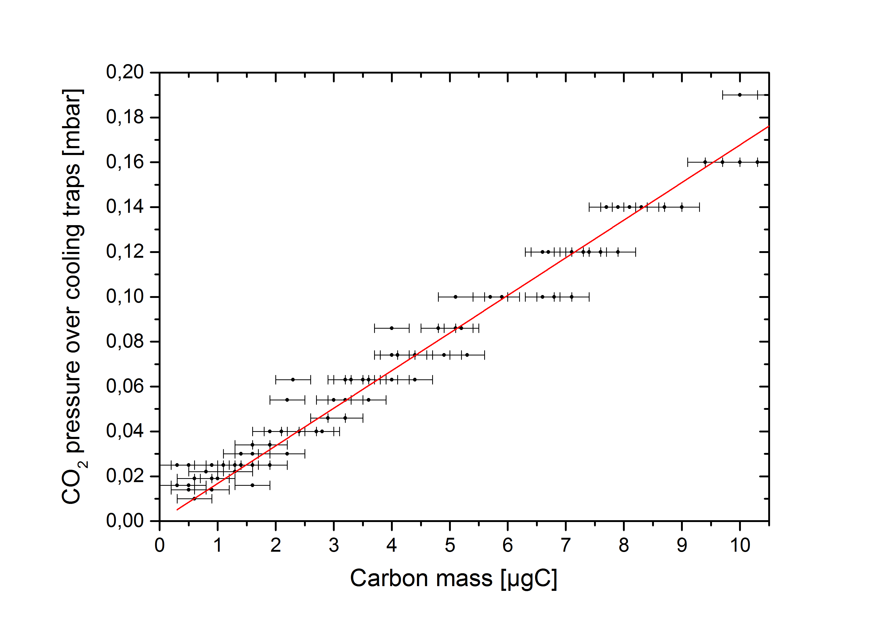
Figure S1: Linear correlation between measured carbon masses of 100 samples in the measuring volume and the pressure in the extraction line after heating up of the cooling traps and release of CO₂ to the gas phase. This correlation was used for determination of the very small blank masses.

