Supplementary Online Material
Figure X1: Tel Azekah phase S2-6
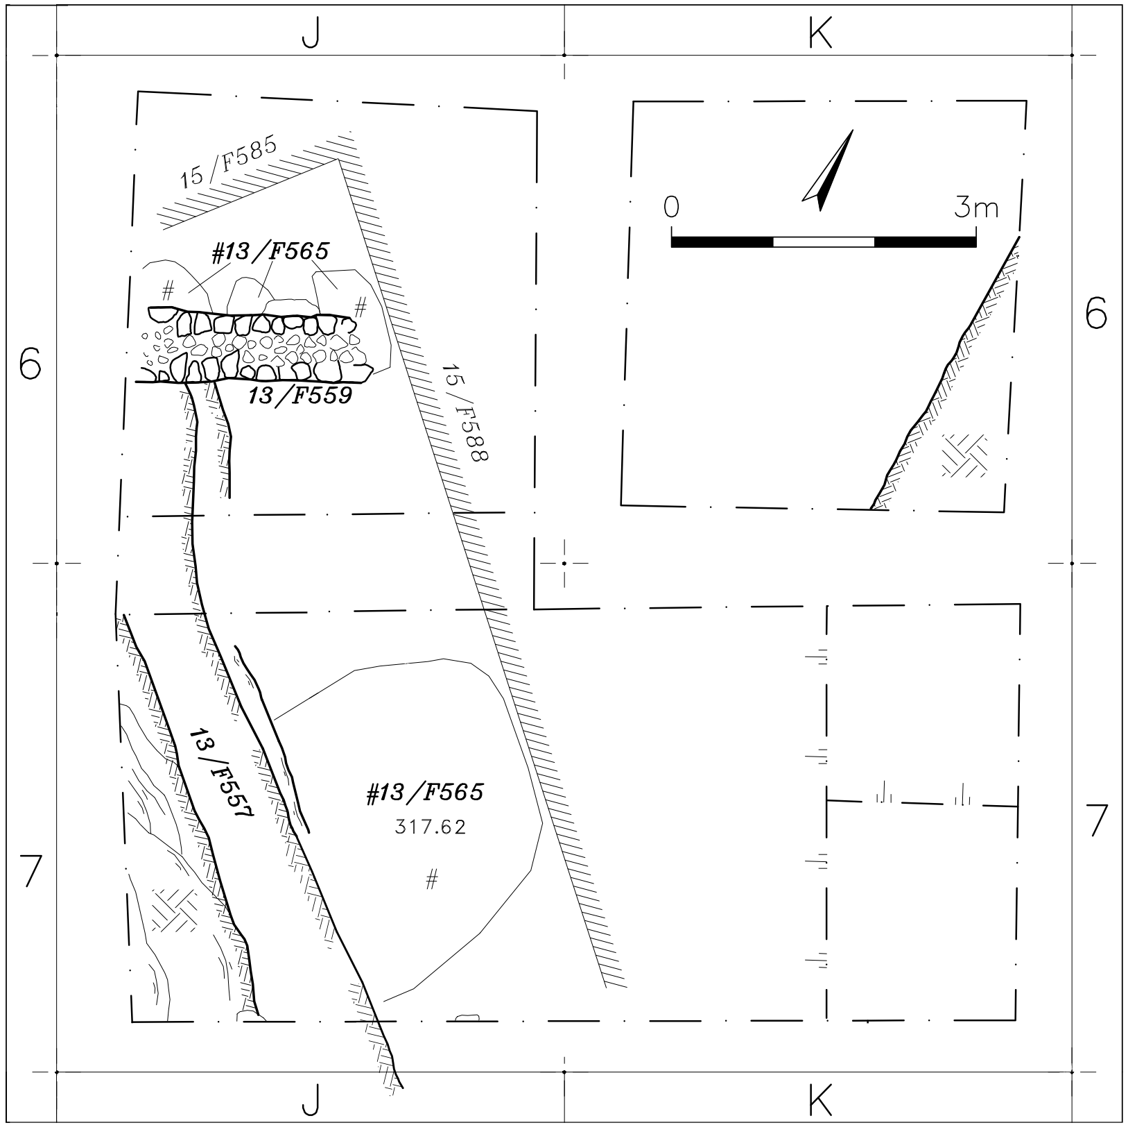
Figure X2: Tel Azekah phase S2-5b
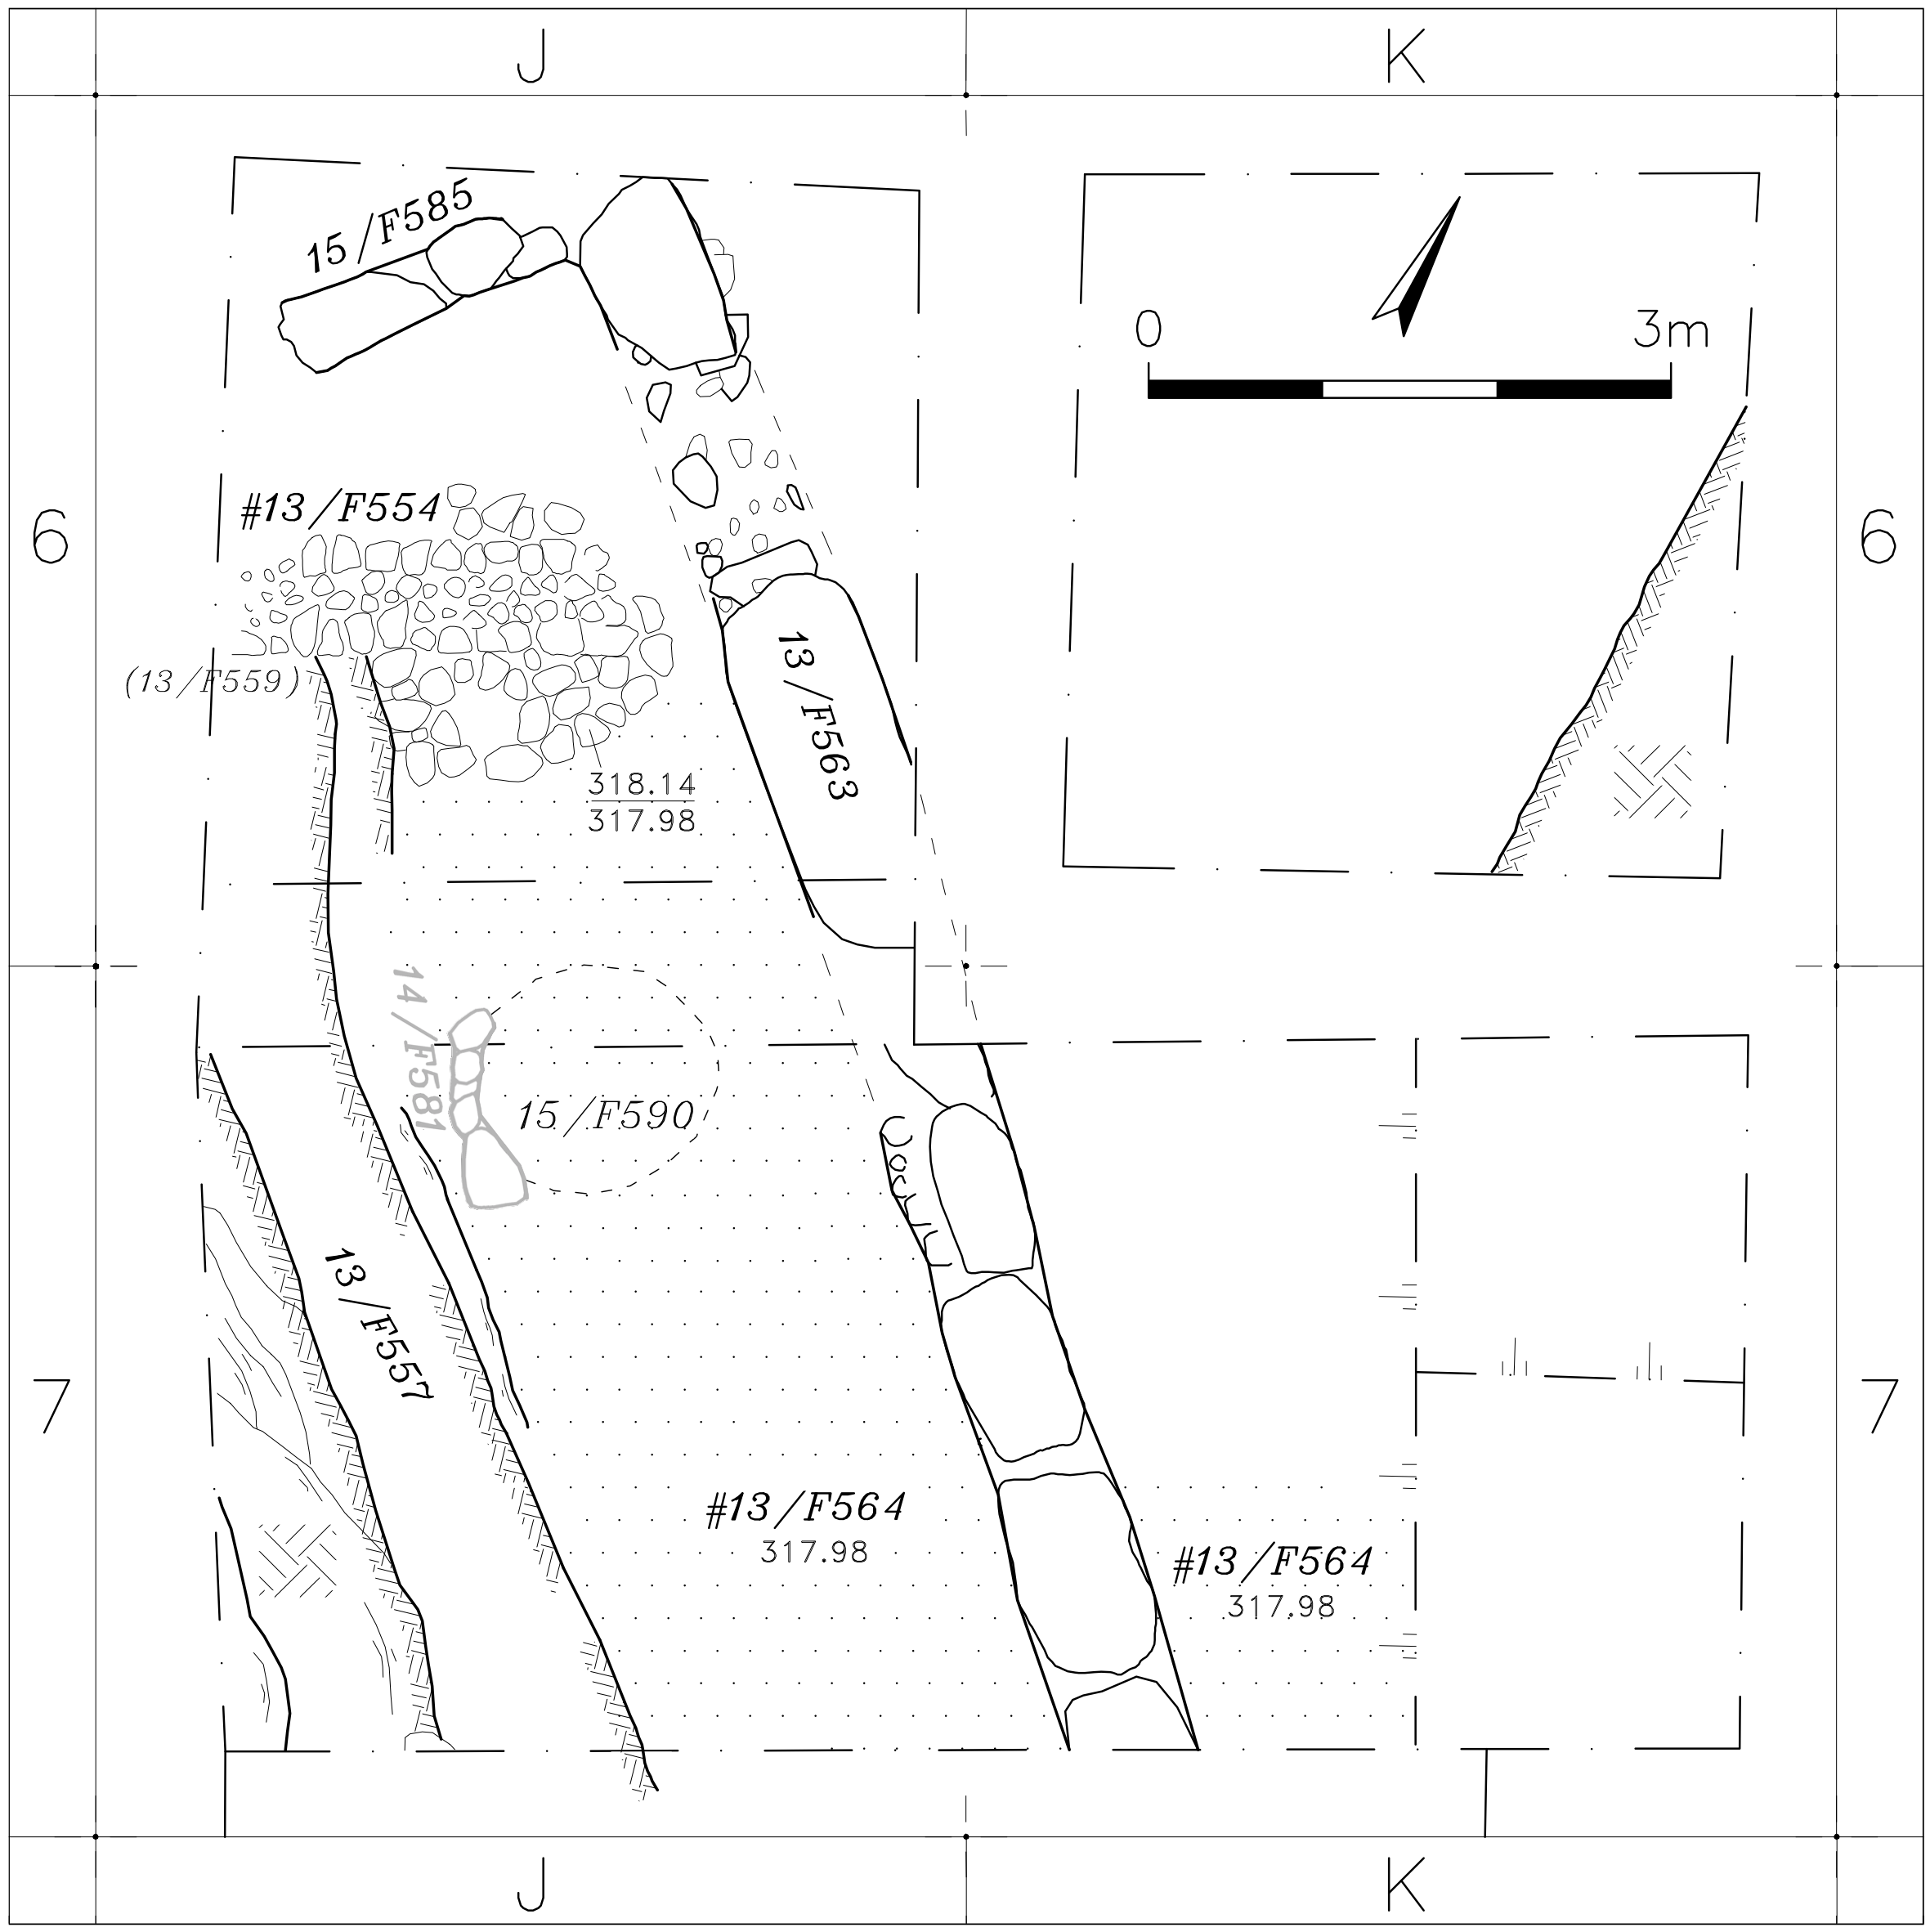

Figure X3: Tel Azekah phase S2-5a
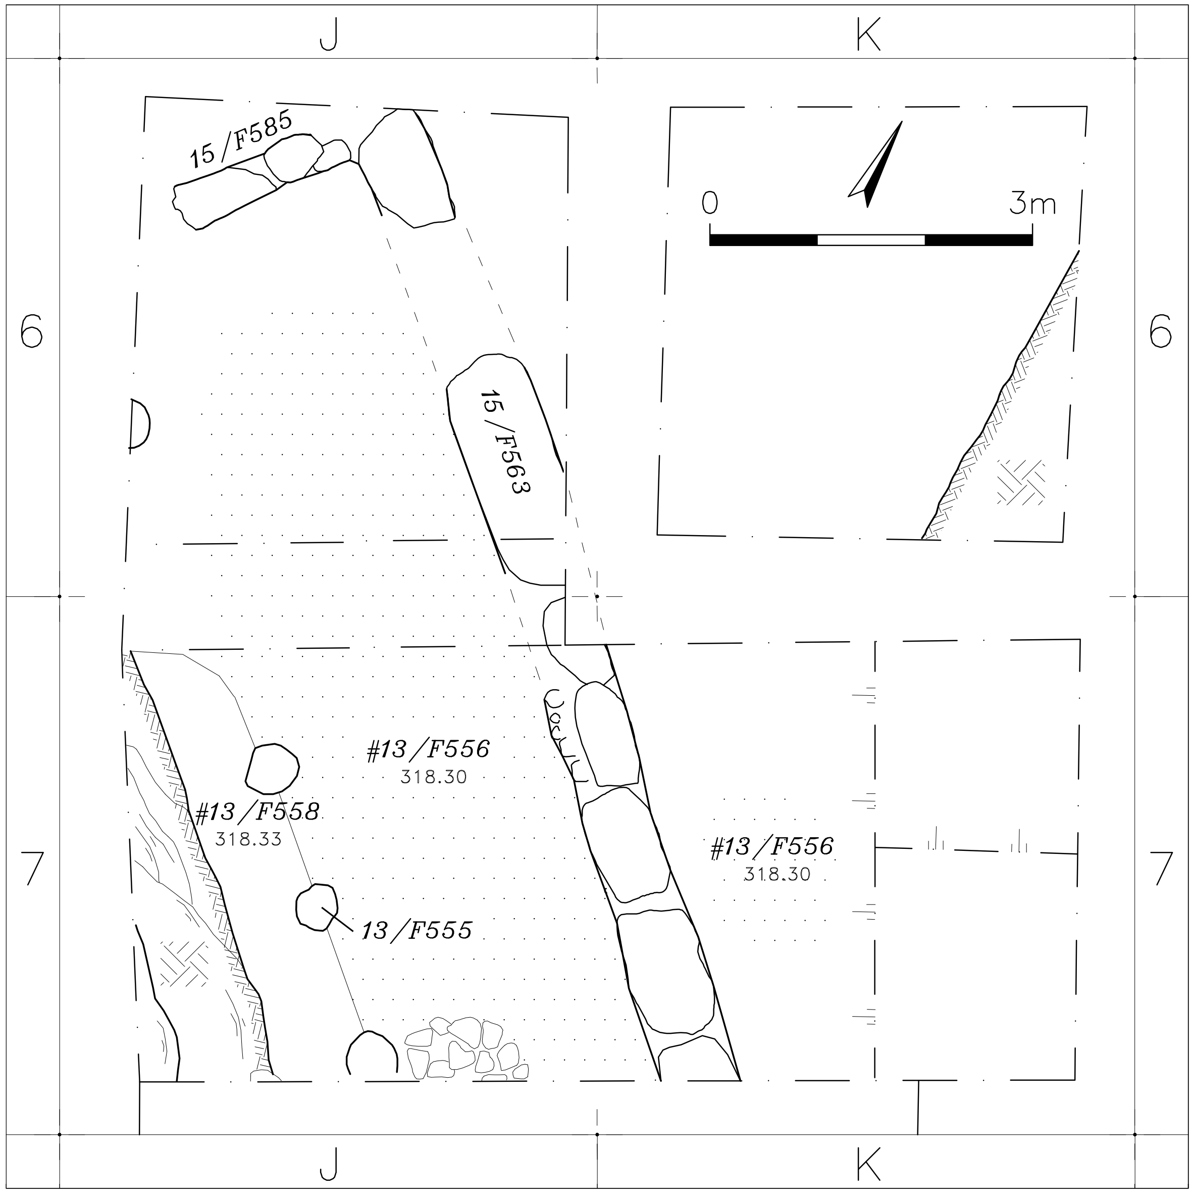
Figure X4: Tel Azekah phase S2-4
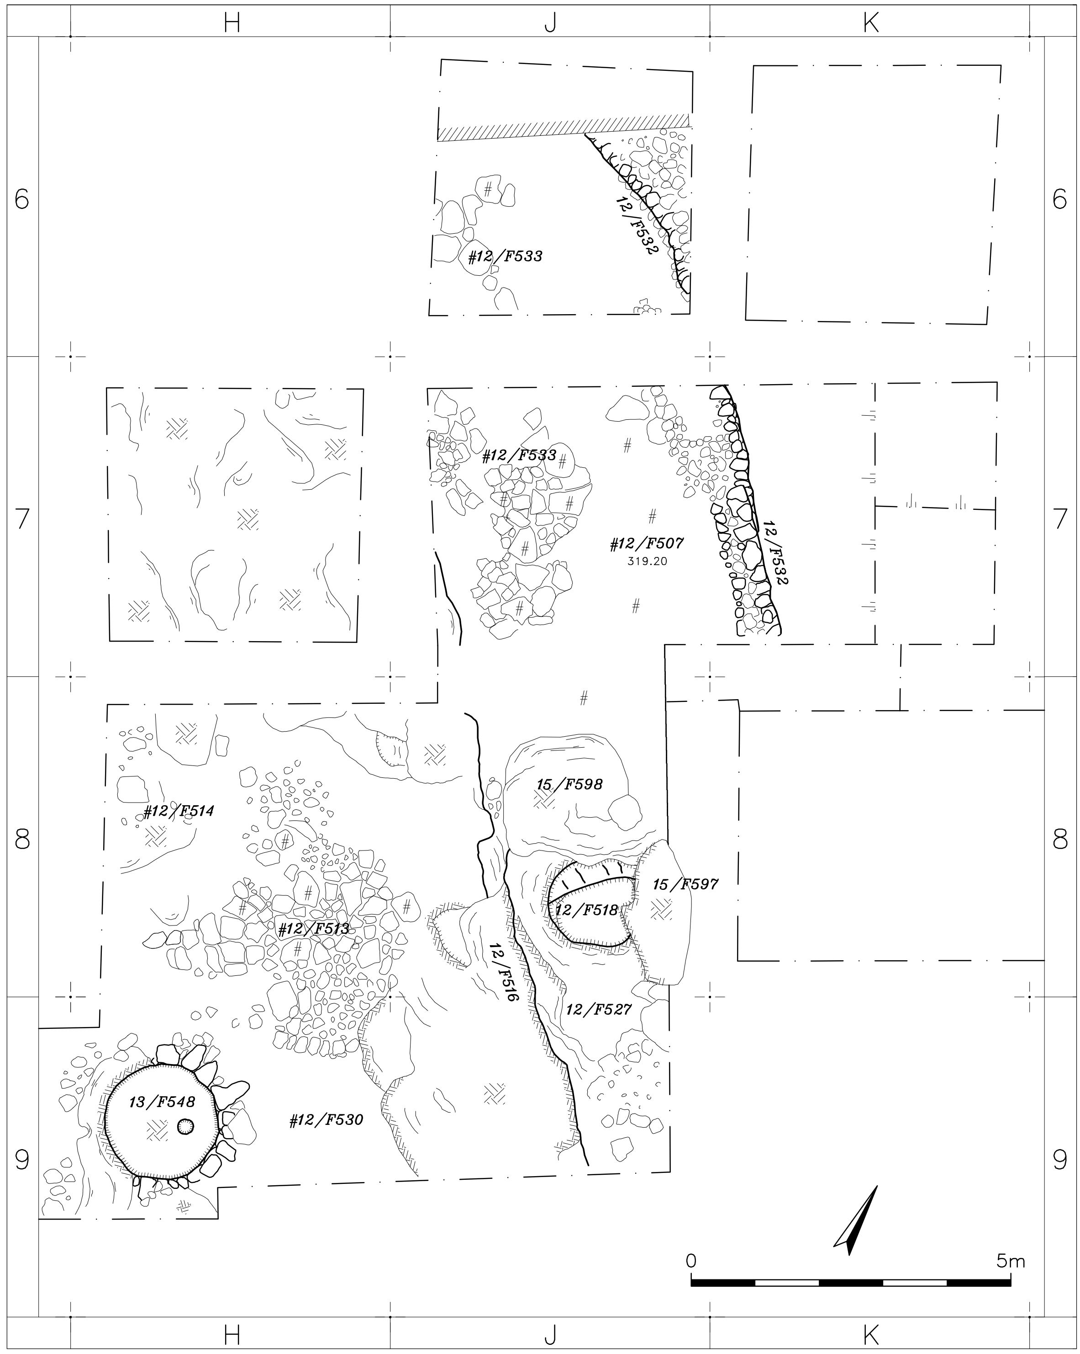
Figure X5: Tel Azekah phase T2-3
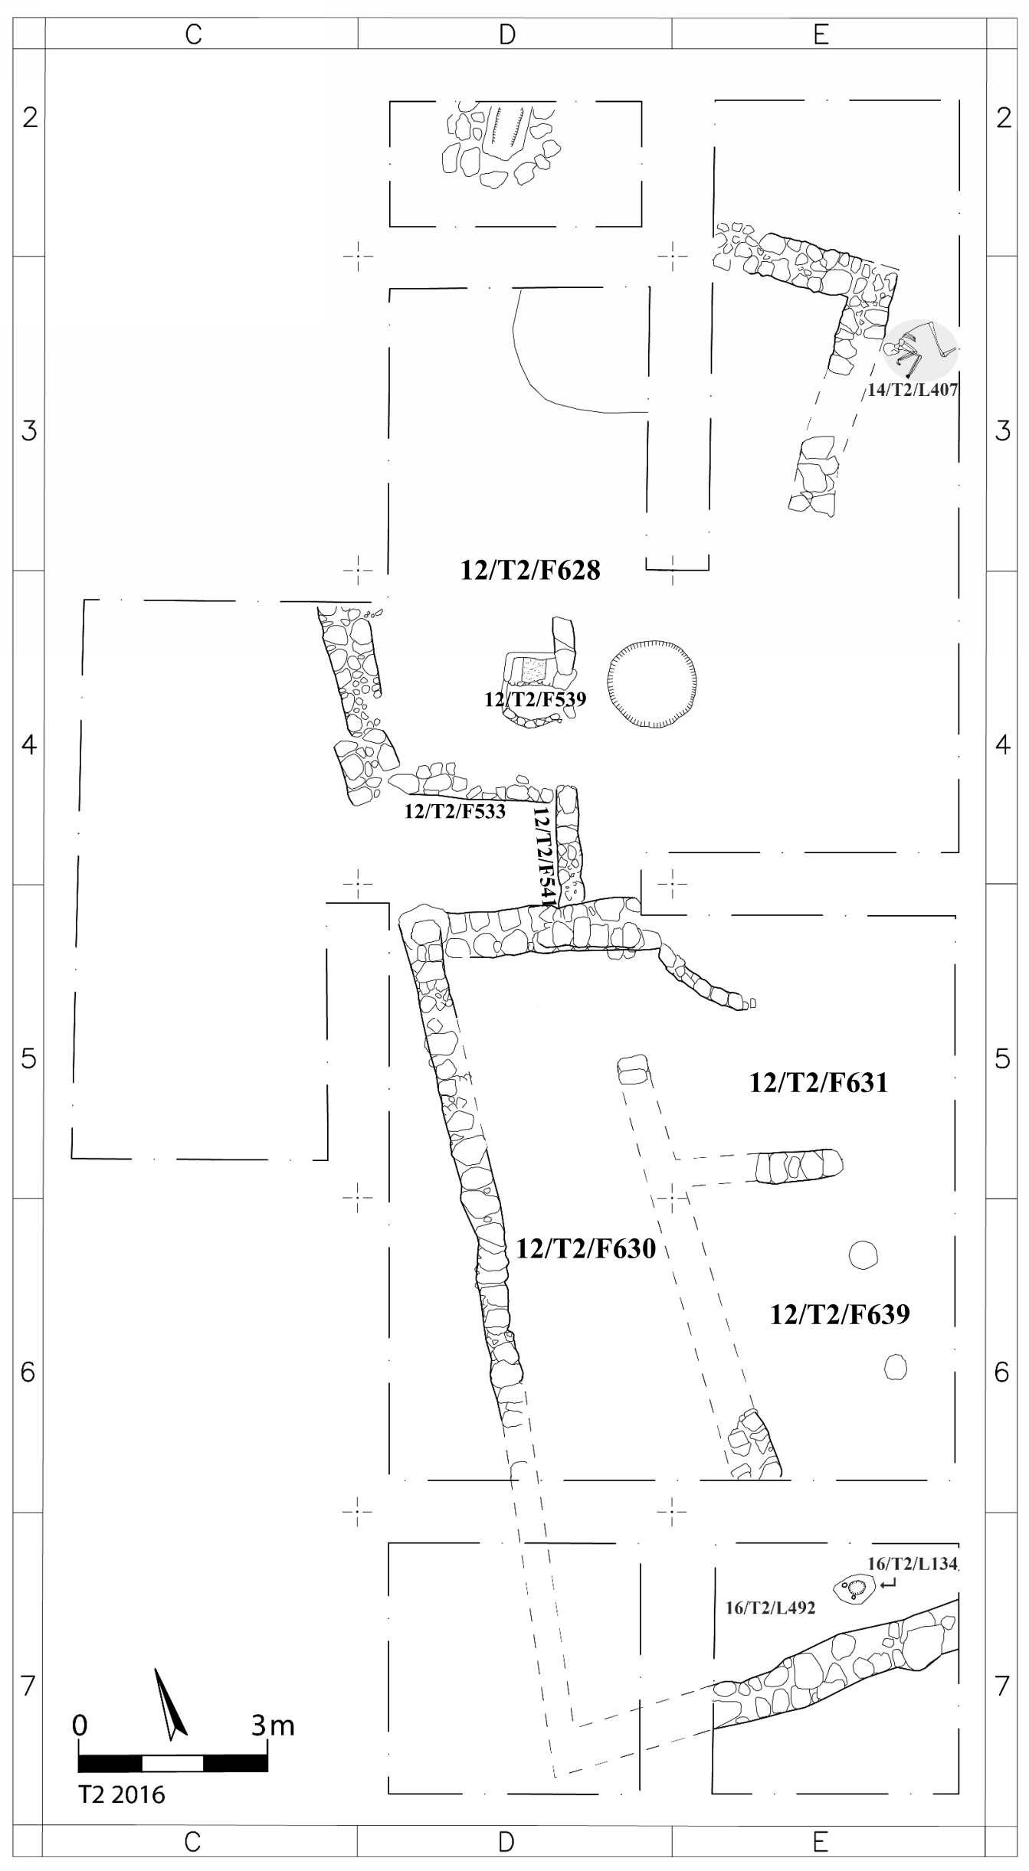

Figure X6: Curve plot of individual calibrated dates from Tel Azekah Area S2 Late Bronze phases.
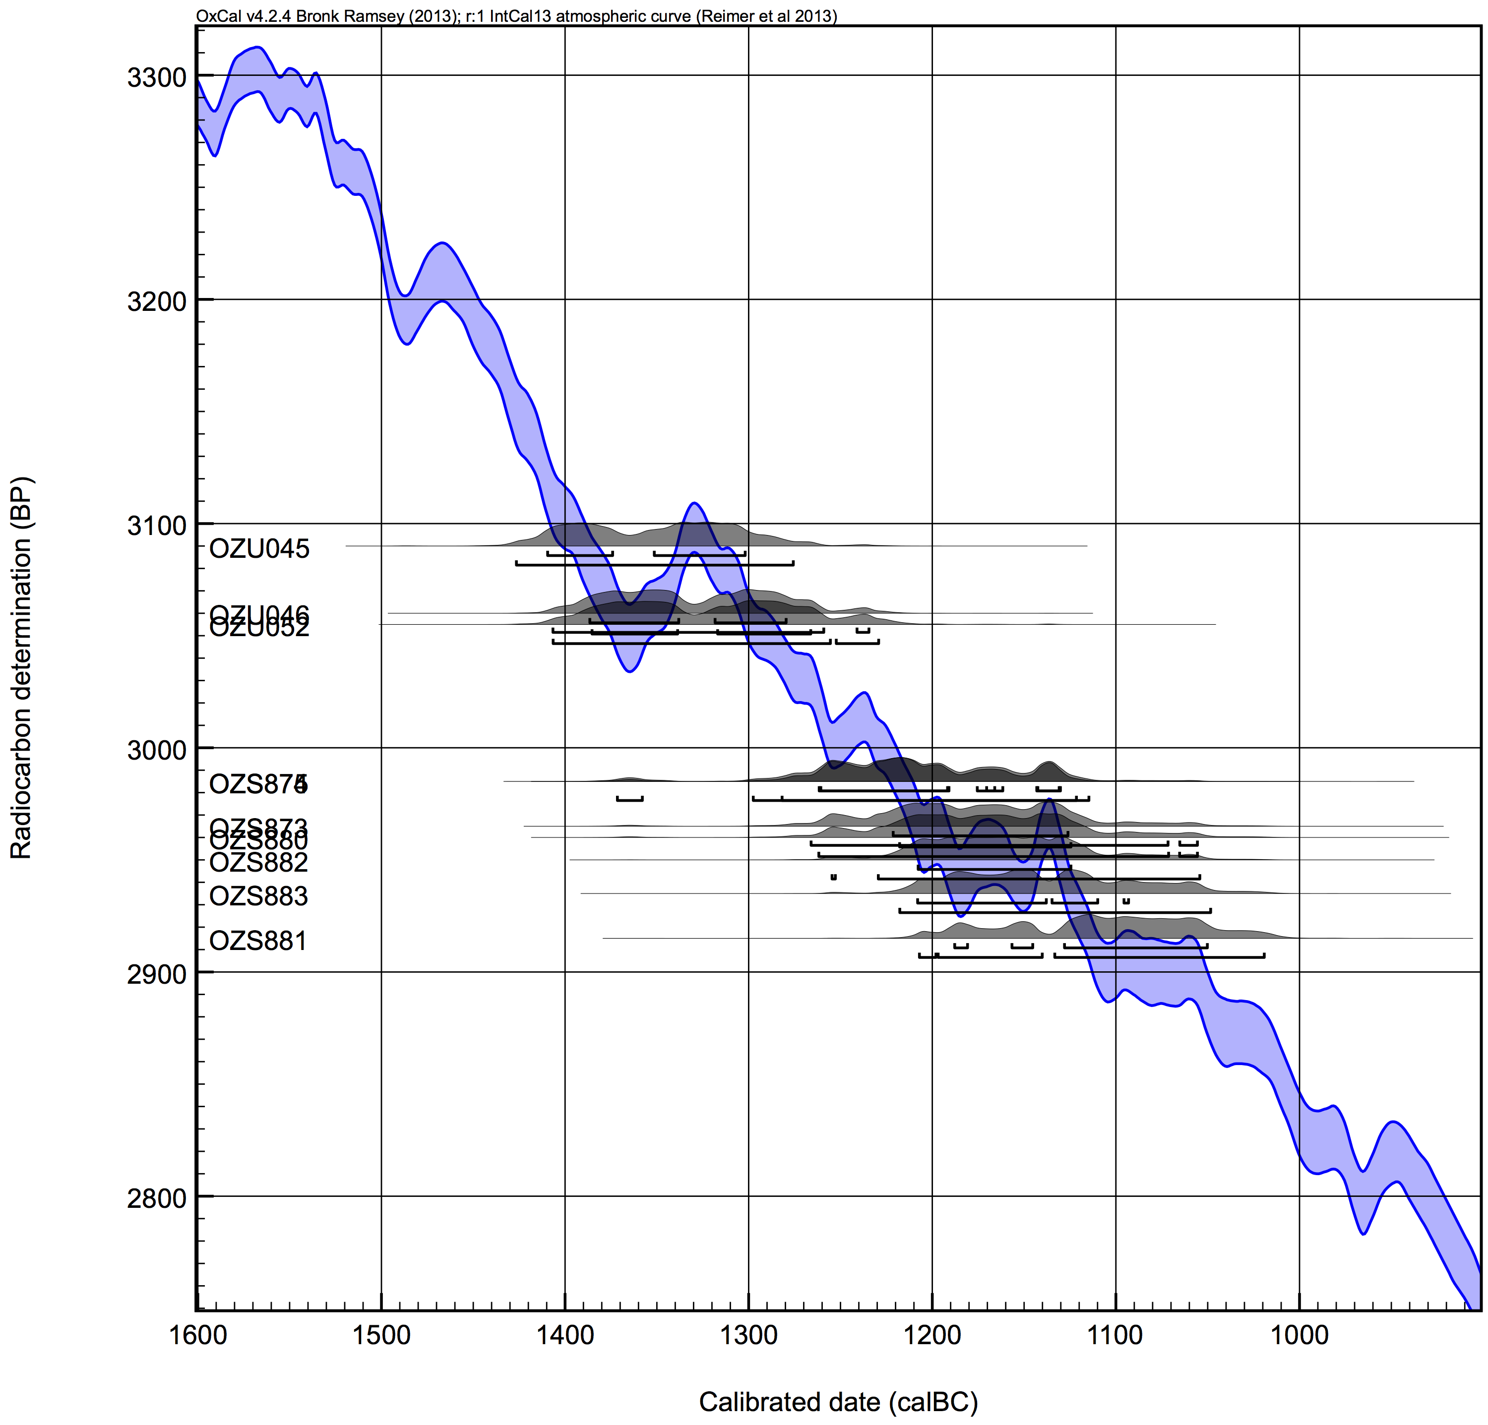

Figure X7: Bayesian model following the initial stratigraphic association of OZS882 and OZS883 with Phase S2-6, and excluding the more recently dated sample (cluster OZU045/046/052). (Refer also to Webster 2015: 73-74, but note that phase numbering has since been updated).
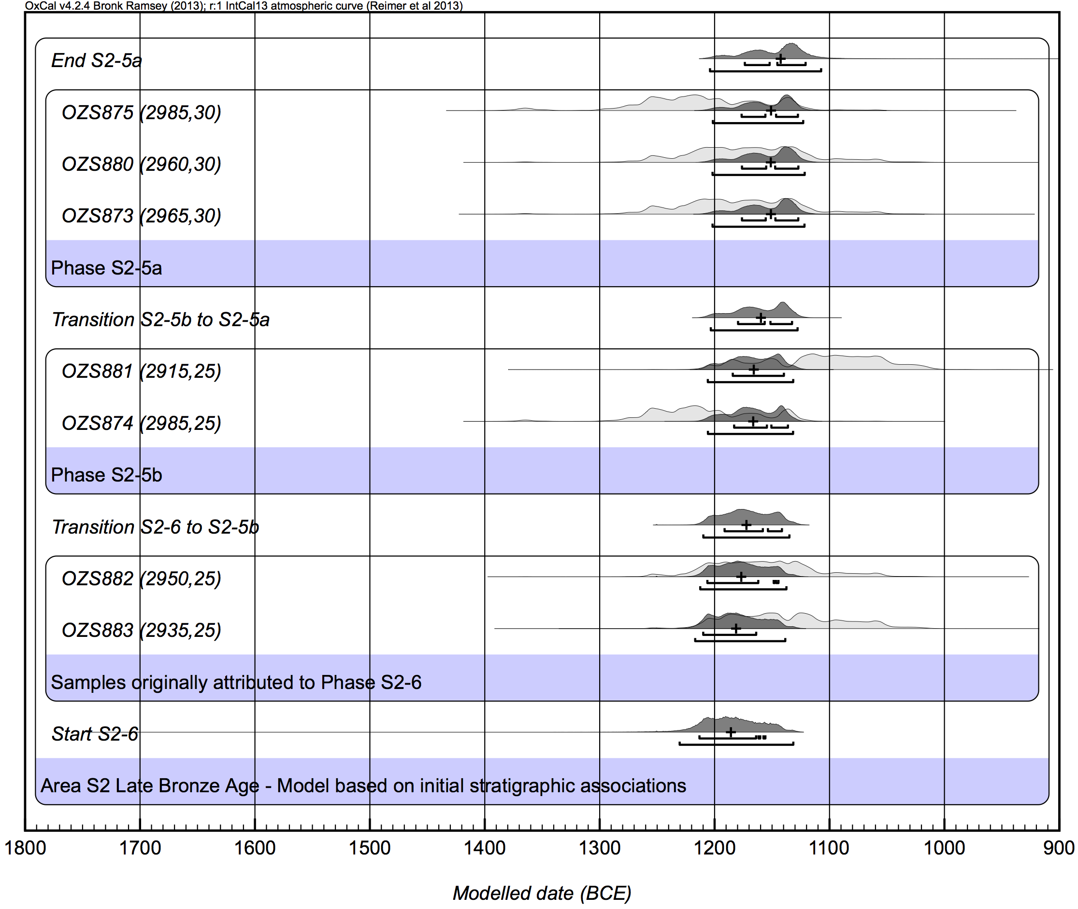
Figure X8: Narrow span of S2-6 through S2-5a under the original stratigraphic association of OZS882 and OZS883 with phase S2-6 (model shown in Figure X7).
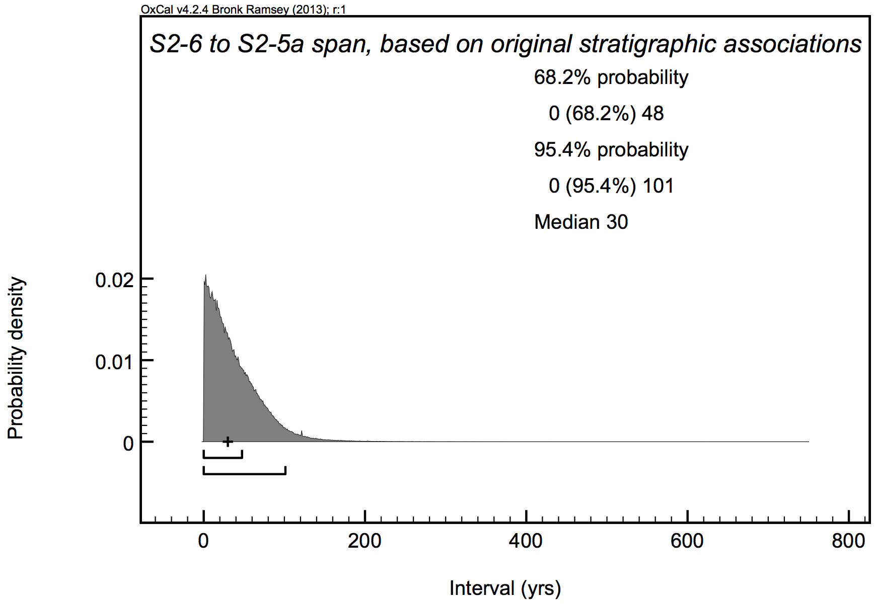

Figure X9: Modelled interval between S2-6 and S2-5b (Area S2 Model A, Figure 7).
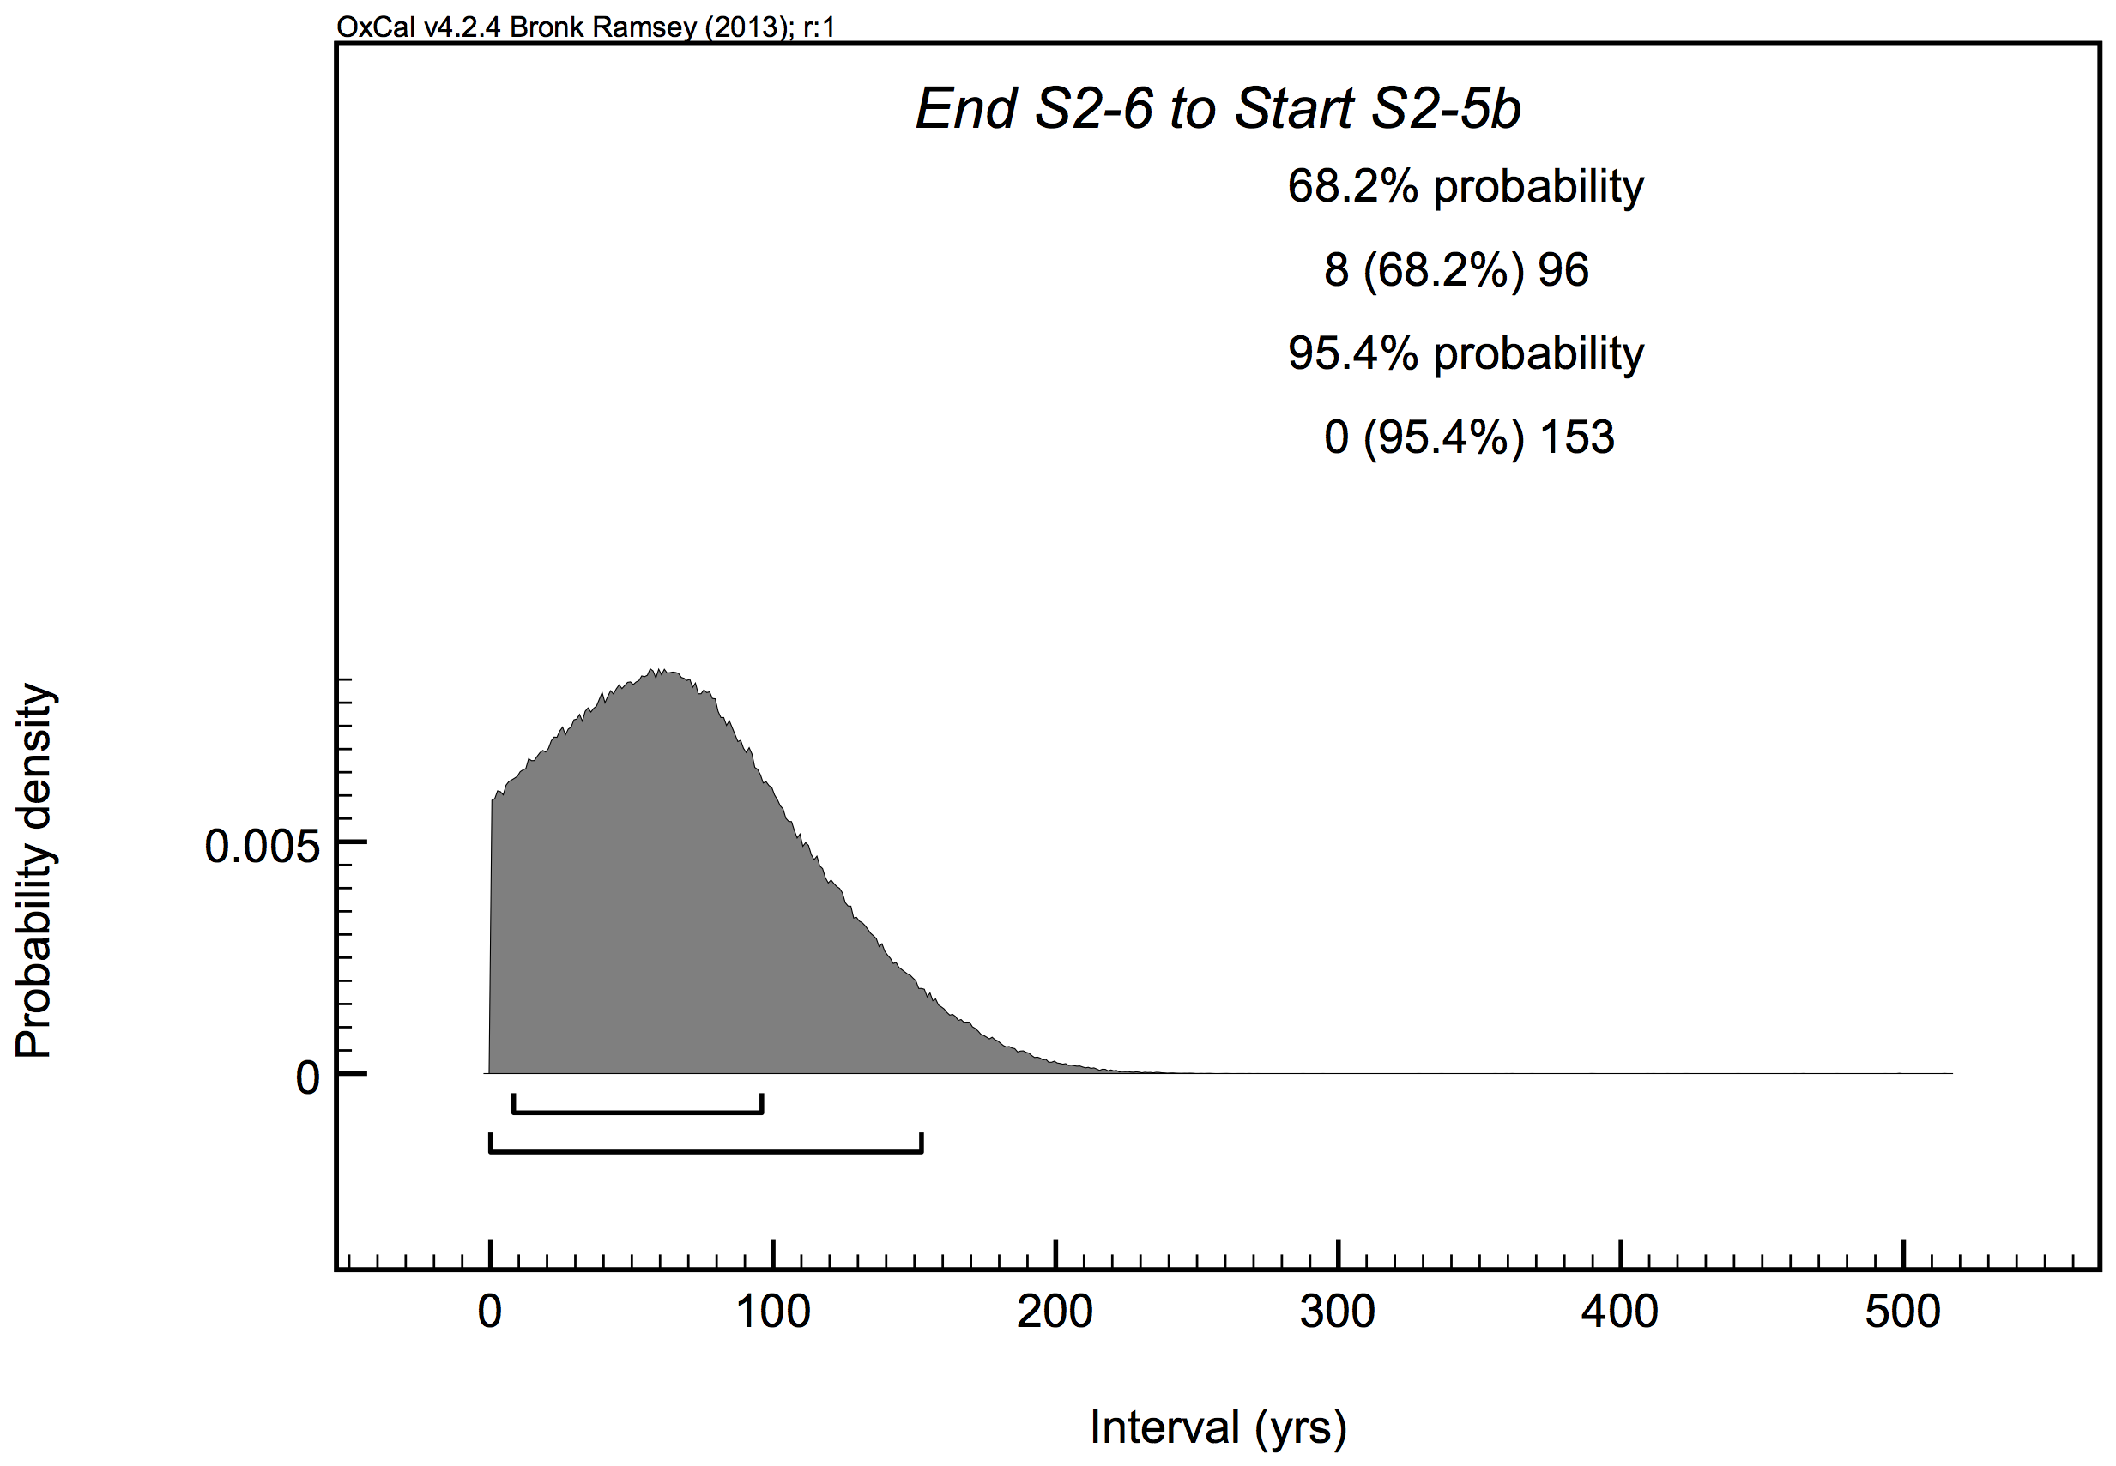

Table X1: Late Bronze phases and transitions at Lachish according to two models: 1) short-lived samples only (Model A, Figure 8); 2) all data (Model B, Figure 9).

Boundary or Phase | Cultural Period | 1σ range (BCE) |  |  | 2σ range (BCE)
 |  | Model A | Model B | Model A |  | Model B
End VI |  | 1187-1092 | 1155-1069 | 1209-1015 |  | 1186-1017
VI | LB III | 1192-1110 | 1166-1090 | 1211-1067 |  | 1191-1048
Transition VII to VI |  | 1203-1128 | 1174-1119 | 1224-1094 |  | 1200-1088
VII | LB IIB | 1218-1153 | 1196-1135 | 1253-1117 |  | 1228-1105
Start VII |  | 1237-1162 | 1216-1151 | 1286-1124 |  | 1253-1120
End S-2 |  |  | 1278-1188 |  |  | 1330-1151
S-2 | LB IIA |  | 1305-1212 |  |  | 1354-1177
Transition S-3 to S-2 |  | 1296-1194  (End S-3) | 1336-1238 | 1373-1156  (End S-3) |  | 1378-1200
S-3 | LB IIA | 1371-1209 | 1375-1256 | 1427-1163 |  | 1426-1216
Start S-3 |  | 1383-1225 | 1401-1281 | 1488-1138 |  | 1468-1224

OXCAL MODELS

Tel Azekah – Area S2 Model A

Options()
{
Resolution=1;
};
Plot()
{
Outlier_Model("General",T(5),U(0,3),"t");
Sequence("TEL AZEKAH LATE BRONZE PHASES, AREA S2")
{
Boundary("Start S2-6");
Phase("Phase S2-6 (LB IIA)")
{
Label("(Three measurements from a cluster.)");
R_Date("OZU045", 3090, 30)
{
Outlier("General",0.05);
};
R_Date("OZU046", 3060, 25)
{
Outlier("General",0.05);
};
R_Date("OZU052", 3055, 30)
{
Outlier("General",0.05);
};
};
Boundary("End S2-6");
Interval("End S2-6 to Start S2-5b");
Boundary("Start S2-5b");
Phase("Phase S2-5b (LB IIB)")
{
R_Date("OZS874", 2985, 25)
{
Outlier("General",0.05);
};
R_Date("OZS881", 2915, 25)
{
Outlier("General",0.05);
};
};
Boundary("Transition S2-5b to S2-5a");
Phase("Phase S2-5a (LB IIB)")
{
R_Date("OZS873", 2965, 30)
{
Outlier("General",0.05);
};
R_Date("OZS880", 2960, 30)
{
Outlier("General",0.05);
};
R_Date("OZS875", 2985, 30)
{
Outlier("General",0.05);
};
};
Boundary("End S2-5a");
};
};

Tel Azekah – Area S2 Model B
(elimination of OZS881 using agreement indices rather than outlier analysis)

Options()
{
Resolution=1;
};
Plot()
{
Sequence("TEL AZEKAH LATE BRONZE PHASES, AREA S2")
{
Boundary("Start S2-6");
Phase("Phase S2-6 (LB IIA)")
{
Label("(Three measurements from a cluster.)");
R_Date("OZU045", 3090, 30);
R_Date("OZU046", 3060, 25);
R_Date("OZU052", 3055, 30);
};
Boundary("End S2-6");
Interval("End S2-6 to Start S2-5b");
Boundary("Start S2-5b");
Phase("Phase S2-5b (LB IIB)")
{
R_Date("OZS874", 2985, 25);
};
Boundary("Transition S2-5b to S2-5a");
Phase("Phase S2-5a (LB IIB)")
{
R_Date("OZS873", 2965, 30);
R_Date("OZS880", 2960, 30);
R_Date("OZS875", 2985, 30);
};
Boundary("End S2-5a");
};
};

Tel Azekah – Area T2

Options()
{
Resolution=1;
};
Plot()
{
Outlier_Model("General",T(5),U(0,4),"t");
Sequence("TEL AZEKAH LATE BRONZE PHASES, AREA T2")
{
Boundary("Start T2-3b");
Phase("T2-3b (LB III)")
{
R_Combine("Av. OZV243, 52509")
{
Outlier("General",0.05);
R_Date("52509",2953, 24);
R_Date("OZV243", 2925, 30);
};
};
Boundary("Transition T2-3b to T2-3a");
Phase("T2-3a (LB III)")
{
R_Combine("Av. OZV265, 52510")
{
Outlier("General",0.05);
R_Date("52510",2955, 23);
R_Date("OZV265", 2890, 25);
};
};
Boundary("End T2-3a");
};
};

Tel Lachish Model A (short-lived samples, Area S)

Options()
{
Resolution=1;
};
Plot()
{
Outlier_Model("General",T(5),U(0,3),"t");
Sequence("LACHISH LATE BRONZE LEVELS (short-lived samples, Area S)")
{
Boundary("Start S3");
Phase("Level S-3 (LBIIA)")
{
R_Date("RT-3152", 2945, 65)
{
Outlier("General", 0.05);
};
R_Date("RT-3153", 3125, 55)
{
Outlier("General", 0.05);
};
};
Boundary("End S3");
Label("Unspecified gap allowed for Levels S2 through VIIb")
Interval("End S3 to Start VIIa");
Boundary("Start VIIa");
Phase("Level VIIa (LBIIB)")
{
R_Date("Pta-3320", 2940, 70)
{
Outlier("General", 0.05);
};
R_Date("RT-2906", 2955, 35)
{
Outlier("General", 0.05);
};
};
Boundary("Transition VII to VI");
Phase("Level VI (LB III)")
{
R_Date("RT-2912", 2915, 25)
{
Outlier("General", 0.05);
};
R_Date("RT-2755", 2955, 25)
{
Outlier("General", 0.05);
};
};
Boundary("End VI");
};
};

Tel Lachish Model B (wood charcoal and short-lived samples)
Note: For the Charcoal Plus model data, refer to Dee and Bronk Ramsey (2014, SOM).

Options()
{
Resolution=1;
};
Plot()
{
Outlier_Model("General",T(5),U(0,4),"t");
Outlier_Model("Charcoal_p",Prior("Charcoal_p.prior"),U(0,3),"t");
Sequence("LACHISH LATE BRONZE LEVELS (wood charcoal and short-lived samples)")
{
Boundary("Start S-3");
Phase("Area S Level S-3 (LB IIA)")
{
R_Date("RT-2756", 3080, 25)
{
Outlier("Charcoal_p", 1);
};
R_Date("RT-2916", 3210, 25)
{
Outlier("Charcoal_p", 1);
};
R_Date("RT-3152 (s)", 2945, 65)
{
Outlier("General", 0.05);
};
R_Date("RT-3153 (s)", 3125, 55)
{
Outlier("General", 0.05);
};
};
Boundary("Transition S-3 to S-2");
Phase("Area S Level S-2 (LB IIA)")
{
R_Date("RT-2754 (s)", 3945, 25)
{
Outlier("General", 0.05);
};
R_Date("RT-2918", 3090, 40)
{
Outlier("Charcoal_p", 1);
};
};
Boundary("End S-2");
Label("Unspecified gap allowed for Area S Level S-1");
Interval();
Boundary("Start VII");
Phase("General Level VII (LB IIB)")
{
Label("Area S Level VIIa");
R_Date("RT-3154", 2955, 25)
{
Outlier("Charcoal_p", 1);
};
R_Date("Pta-3320", 2940, 70)
{
Outlier("Charcoal_p", 1);
};
R_Date("RT-2906 (s)", 2955, 35)
{
Outlier("General", 0.05);
};
R_Date("RT-2757", 2995, 25)
{
Outlier("Charcoal_p", 1);
};
R_Date("RT-3155", 3055, 20)
{
Outlier("Charcoal_p", 1);
};
R_Date("RT-2910", 2885, 35)
{
Outlier("Charcoal_p", 1);
};
R_Date("RT-3156", 3025, 25)
{
Outlier("Charcoal_p", 1);
};
Label("Area P Level P-1");
R_Date("RT-2913", 3855, 40)
{
Outlier("General",0.05);
};
};
Boundary("Transition VII to VI");
Phase("General Level VI (LB III)")
{
Label("Area S (Pillared Building)");
R_Date("RT-2912 (s)", 2915, 25)
{
Outlier("General", 0.05);
};
R_Date("RT-2755 (s)", 2955, 25)
{
Outlier("General", 0.05);
};
R_Date("RT-2914", 2985, 30)
{
Outlier("Charcoal_p", 1);
};
Label("Area GE (Inner City Gate)");
R_Date("RT-2920", 2850, 40)
{
Outlier("Charcoal_p", 1);
};
R_Date("RT-3157", 2955, 25)
{
Outlier("Charcoal_p", 1);
};
Label("Area P (Temple)");
R_Date("Hel-810", 3090, 120)
{
Outlier("Charcoal_p", 1);
};
R_Date("Hel-1421", 3000, 100)
{
Outlier("Charcoal_p", 1);
};
R_Date("Hel-1417 (s)", 2810, 100)
{
Outlier("General", 0.05);
};
R_Date("Pta-3370", 3090, 60)
{
Outlier("Charcoal_p", 1);
};
R_Date("Hel-1028", 3510, 120)
{
Outlier("Charcoal_p", 1);
};
};
Boundary("End VI");
};
};

