Supplemental File (online only)

Uptake of carbon for cellulose production in A white oak from western Oregon USA

William F. Cain, S.J.¹, Sheila Griffin ², Kevin C. Druffel-Rodriguez ^{2,3}, Ellen R.M. Druffel ²

¹ Loyola Marymount University, Los Angeles, CA 90045
² Department of Earth System Science, University of California, Irvine, CA 92697-3100
³ 4th Marine Division, Delta Company, Knoxville, TN 37920

To determine the contribution that non-structural C (NSC) would have on the SNO ∆¹⁴C values, we used a mass balance approach. We performed two sets of calculations. First, we assumed that the NSC was photosynthesized during the previous year of the ring being formed, e.g. band 1963 used NSC that was produced from 1962 air CO₂. We used three amounts of NSC incorporated, 5%, 15% and 25% of the total. We calculated the monthly ∆¹⁴C values for tree ring cellulose using the variable amounts of NSC. The calculated values for the 15% NSC (open diamonds) are plotted in Figure S1 and produced the closest fit of the three amounts of NSC used. There were poor fits with all of these amounts of NSC with the data of 1962–1963, where calculated values are generally higher than the observations.

Second, we assumed that the NSC had a mean residence time of 10 years, as found for red maple trees [Carbone et al., 2013]. The ∆¹⁴C of the NSC was calculated using equation (1):
∆¹⁴C_{t} = 0.342*∆¹⁴C_{t-1} + 0.226*∆¹⁴C_{t-2} + 0.147*∆¹⁴C_{t-3} + 0.101*∆¹⁴C_{t-4} + 0.067*∆¹⁴C_{t-5}
+ 0.045*∆¹⁴C_{t-6} + 0.029*∆¹⁴C_{t-7} + 0.02*∆¹⁴C_{t-8} + 0.014*∆¹⁴C_{t-9} + 0.009*∆¹⁴C_{t-10} (1)

We used 15% of the NSC ∆¹⁴C values to calculate the ∆¹⁴C values for tree ring cellulose, and the values are plotted in Figure S2 (open diamonds). The calculated values were equal to or lower than the observations in the 1960–1962 and 1964–1965, and equal to or higher than the observations during the other years. Varying the percentage of NSC made the fits worse (not shown). Also, changing the mean residence time of NSC, from 5 years to 15 years, made the fits worse (not shown).

We conclude that the use of NSC produced during earlier years was not the sole explanation for the reduction in SNO ∆¹⁴C values compared with atmospheric CO₂ ∆¹⁴C values. However, NSC produced during earlier years may have played a minor role.

Figure S1. Calculated ∆¹⁴C values of tree ring cellulose using input of 15% NSC that had been stored from the previous year. Also shown are SNO near-monthly ∆¹⁴C values and atmospheric CO₂ ∆¹⁴C records in zone 1 and 2 in the northern hemisphere [Hua et al., 2013].
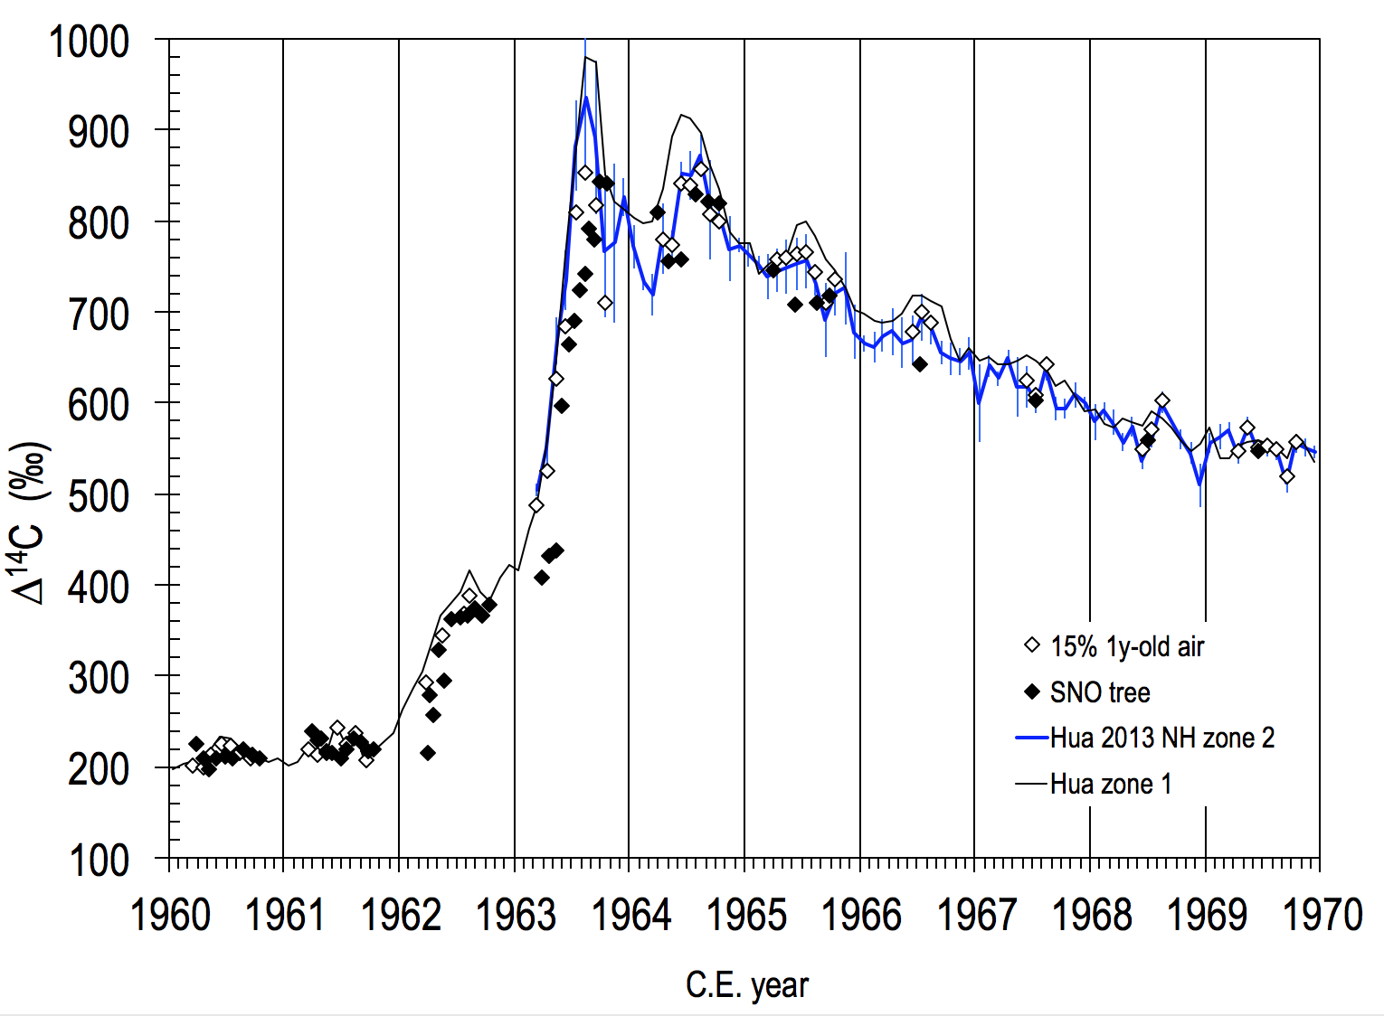

Figure S2. Calculated ∆¹⁴C values of tree ring cellulose using input of 15% NSC that had a mean residence time of 10 years using equation (1), along with SNO near-monthly ∆¹⁴C values and atmospheric CO₂ ∆¹⁴C records in zones 1 and 2 in the northern hemisphere [Hua et al., 2013].
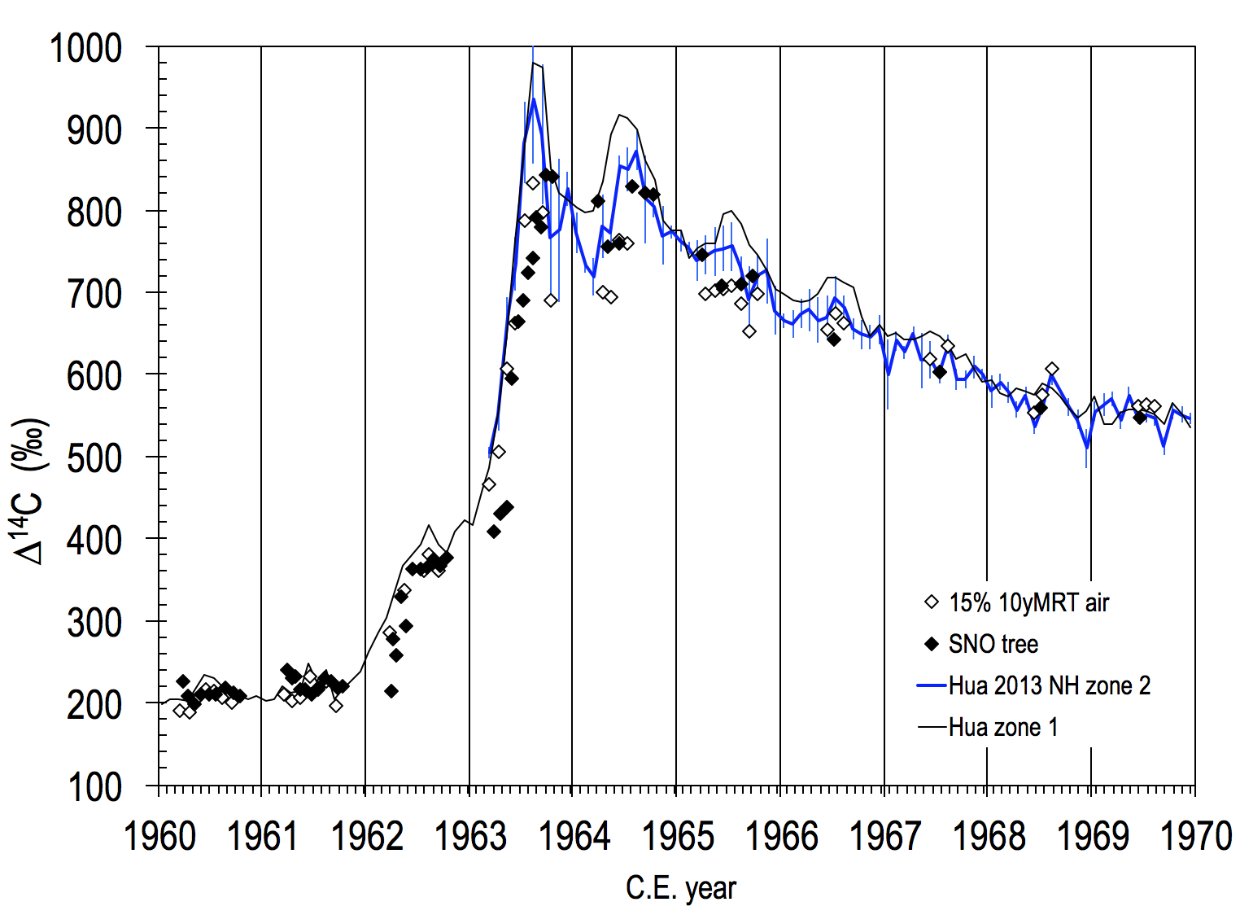

References
Carbone, M., C. Czimczik, T. Keenan, P. Murakami, N. Pederson, P. Schaberg, X. Xu, and A. Richardson (2013), Age, allocation and availability of nonstructural carbon in mature red maple trees, New Phytologist, 200, 1145-1155, doi:10.1111/nph.12448.
Hua, Q., M. Barbetti, and A. Rakowski (2013), Atmospheric radiocarbon for the period 1950-2010, Radiocarbon, 55(4), 2059-2072.

